Week – 7

Hands on Lab Questions

# Table: Students

|  |  |  |  |  |  |  |  |
| --- | --- | --- | --- | --- | --- | --- | --- |
|  | **Student_ID** | **Firstname** | **Lastname** | **Age** | **Gender** | **Grade** |  |
|  | 1 | Rakesh | Shrestha | 19 | Male | A |  |
|  | 2 | Binita | Bhandari | 21 | Female | B |  |
|  | 3 | Bobby | Sherpa | 20 | Male | C |  |
|  | 4 | Sagar | Parajuli | 22 | Male | A |  |
|  | 5 | Prajina | KC | 21 | Female | B |  |

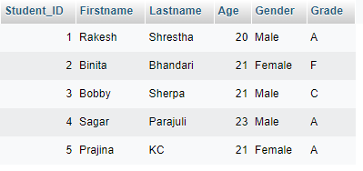

Queries:

* 1. Retrieve all data from the Students Table

* 1. Retrieve first name and last name of all students

* 1. Retrieve only the students who have a grade A

* 1. Retrieve only the students who are older than 20

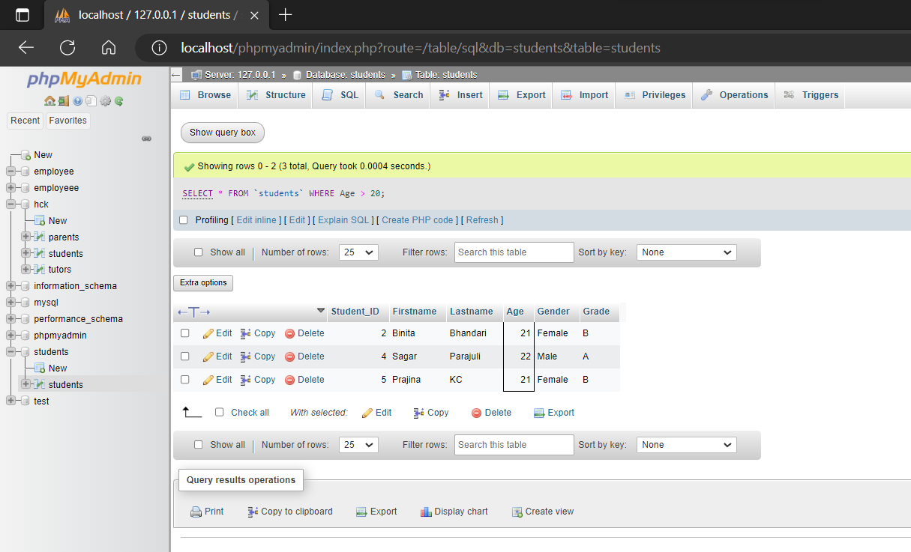

* 1. Retrieve the count of male and female students

* 1. Update the grade of a specific student (e.g. StudentID=3)

* 1. Increment the age of all male students by 1

* 1. Update the grade of all female students who have a grade of 'B' to 'A'

# Table: Customers

|  |  |  |  |  |  |
| --- | --- | --- | --- | --- | --- |
| **Customer_ID** | **Firstname** | **Lastname** | **Age** | **Gender** | **Email** |
| 1 | Kabir | Sharma | 25 | Male | [kabir@gmail.com](mailto:kabir@gmail.com) |
| 2 | Haris | Shrestha | 30 | Male | [haris@gmail.com](mailto:haris@gmail.com) |
| 3 | Deepti | Singh | 26 | Female | [deepti@gmail.com](mailto:deepti@gmail.com) |

**Table: Orders**

|  |  |  |  |
| --- | --- | --- | --- |
| **OrderID** | **CustomerID** | **OrderDate** | **Total** |
| 1 | 1 | 2023-04-06 | 1000 |
| 2 | 1 | 2023-04-01 | 3000 |
| 3 | 2 | 2023-03-22 | 3500 |
| 4 | 3 | 2023-04-04 | 2300 |

# Table: OrderItems

|  |  |  |  |  |
| --- | --- | --- | --- | --- |
| **OrderItemID** | **OrderID** | **ProductItems** | **Quantity** | **Price** |
| 1 | 1 | Product A | 2 | 1200 |
| 2 | 1 | Product B | 3 | 1345 |
| 3 | 2 | Product C | 4 | 1360 |

|  |  |  |  |  |
| --- | --- | --- | --- | --- |
| 4 | 3 | Product D | 5 | 950 |
| 5 | 3 | Product E | 1 | 1125 |
| 6 | 4 | Product F | 2 | 1780 |
| 7 | 4 | Product G | 1 | 1560 |
| 8 | 3 | Product H | 3 | 1220 |

Queries:

* 1. Retrieve all orders along with the customer details

* 1. Retrieve all orders along with the customer details and order items

* 1. Retrieve the customer details for a specific order (e.g. OrderID=2)

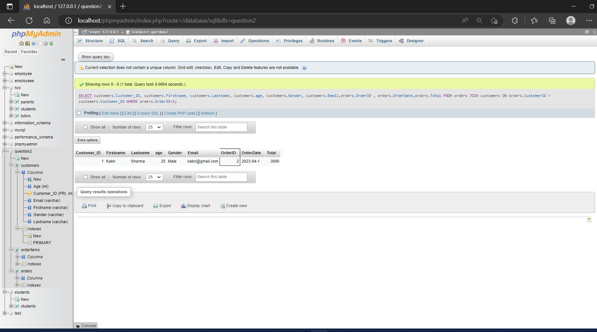

* 1. Retrieve all orders for a specific customer (e.g. CustomerID=1)

* 1. Retrieve the total revenue generated by each customer

