There are multiple ways we can run the build, below one is one of the way to execute the scripts.

**Run POM.xml through command prompt**

**Steps -**

- Install java version "**17**" 2021-09-14 LTS and set the environment variable

- Install latest chrome browser

- Go to <https://maven.apache.org/download.cgi>

- Download Binary zip archive

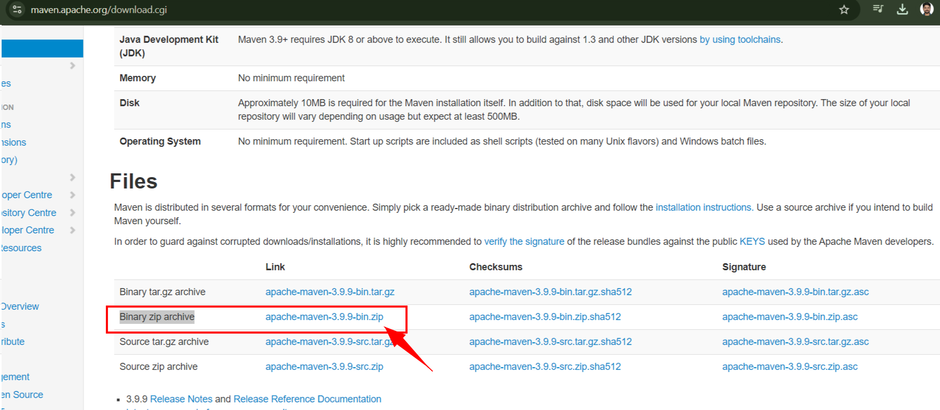

- Extract it and keep the folder anywhere in C - drive

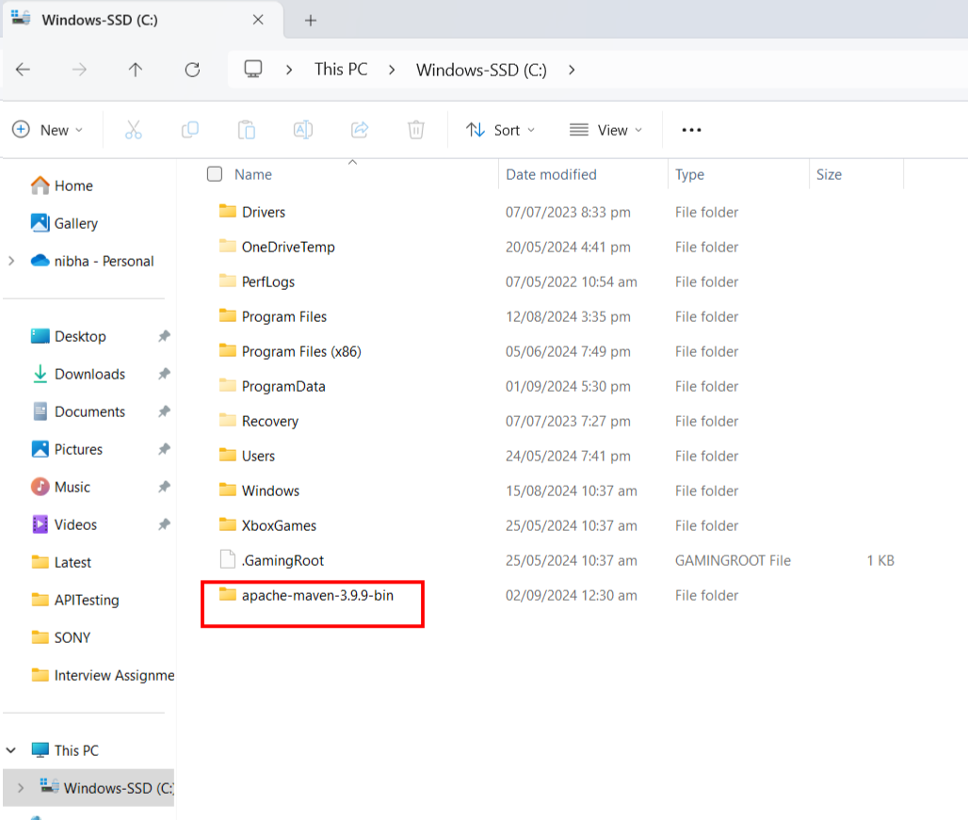

- open the folder till bin and copy the path

Eg. C:\apache-maven-3.9.9-bin\apache-maven-3.9.9\bin

- Set the Environment variable

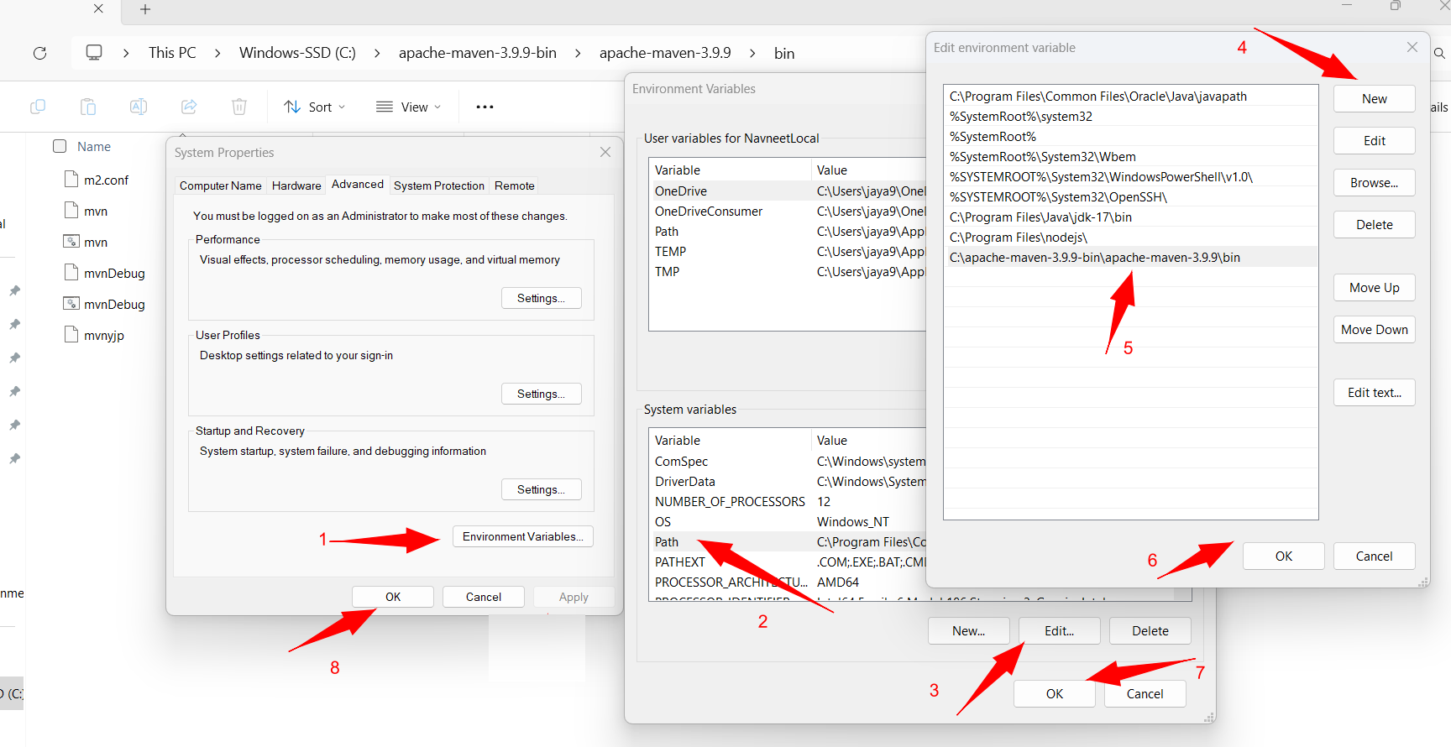

- Open CMD nad type **“mvn -version”** then enter to check maven installed successfully.

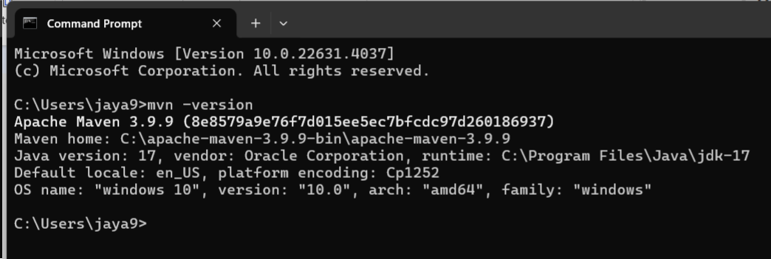

- Download the complete Project from Git Hub repository and copy the path. Now open CMD and change the directory

Eg. cd C:\Users\jaya9\OneDrive\Documents\Navneet\Testing\Interview\AcharyaPrashant\acharyaprashant.org

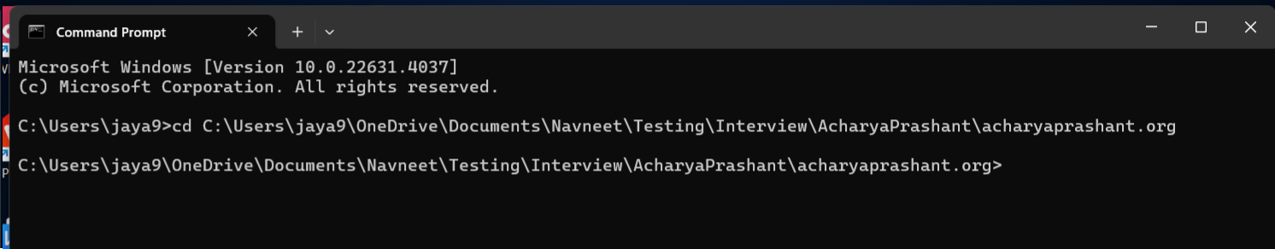

- Now type command **“mvn clean install”** Script will be start executing.

-------------------------------------------------------------------------------------------------------------------

**To review the detailed results for more information.**  
  
**To view the Allure HTML report please complete the small configuration in your system.**  
  
**Step 1 -** Download the Allure Reports binary from the below link  
             <https://github.com/allure-framework/allure2/releases>   
             Choose latest "allure-x.xx.x.zip" file

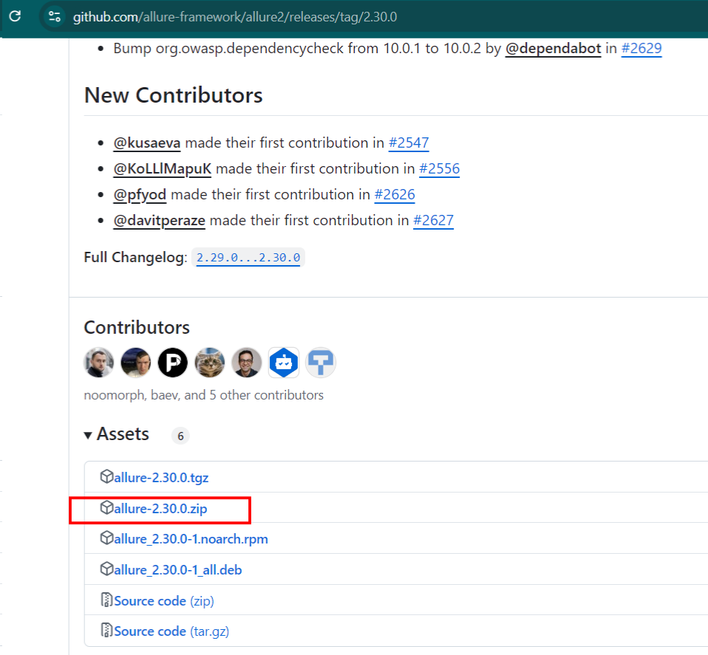

**Step 2 -** Extract the file and put it in C:\Program Files

**Step 3 -** Open the binary folder and copy the path to the bin folder  
             **eg.** C:\Program Files\allure-2.23.0\bin

**Step 4 -** Set the path in system level environment variable  
  
  
**To Generate allure HTML report:-**  
  
**Step 1 -** Go to project directory and open “allure-results”

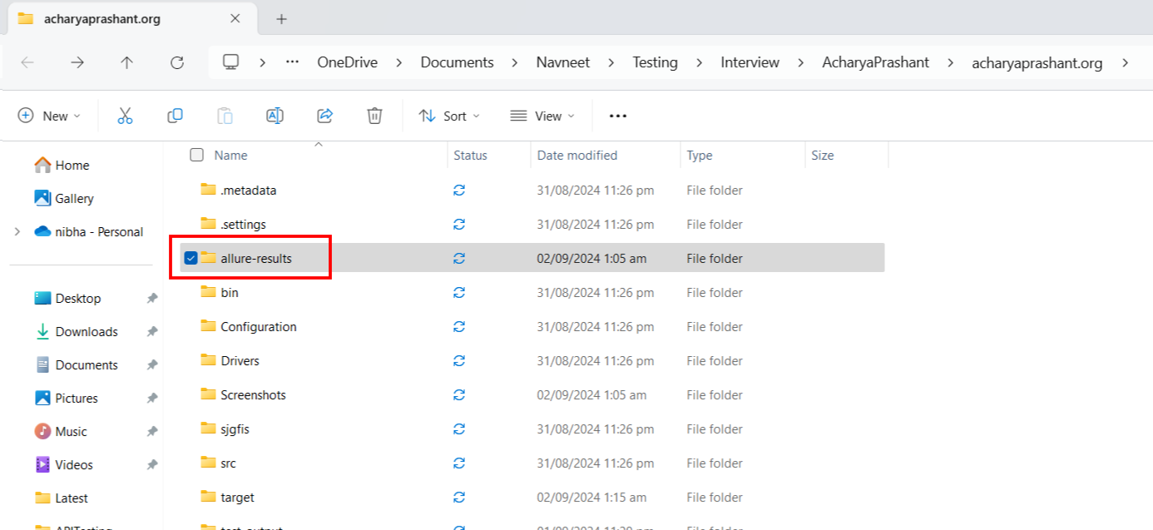

**Step 2 -** Open the folder and copy the path

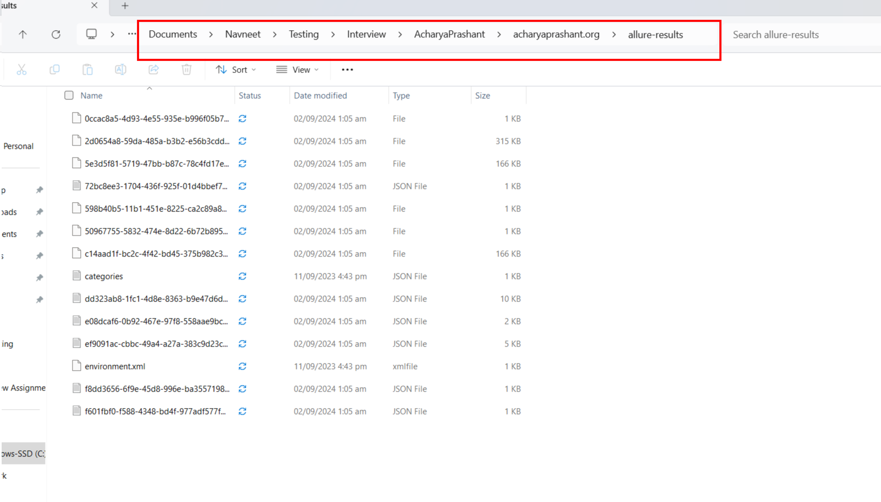

**Step 3 -** Open CMD

**Step 4-** Type allure serve path of the allure-results folder  
             **eg.** allure serve C:\Users\Downloads\allure-results  
  
It will open an HTML report in your default browser.