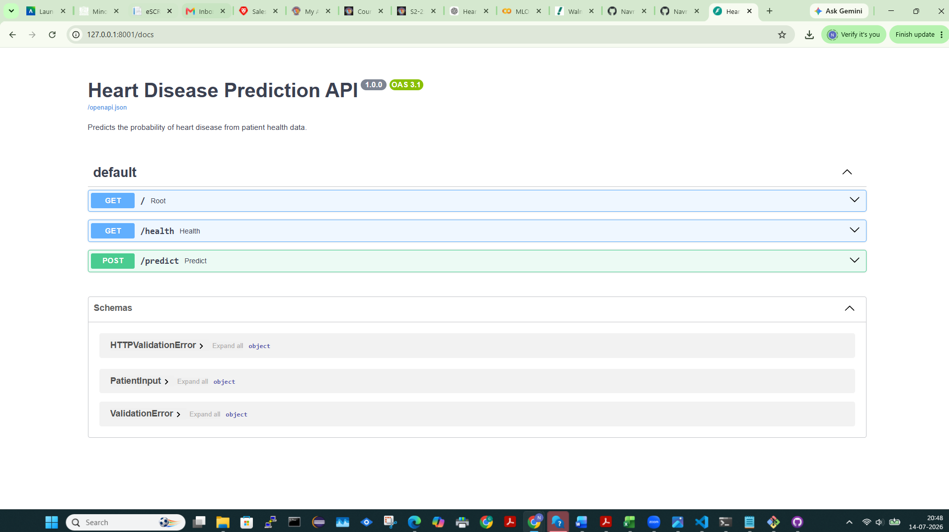

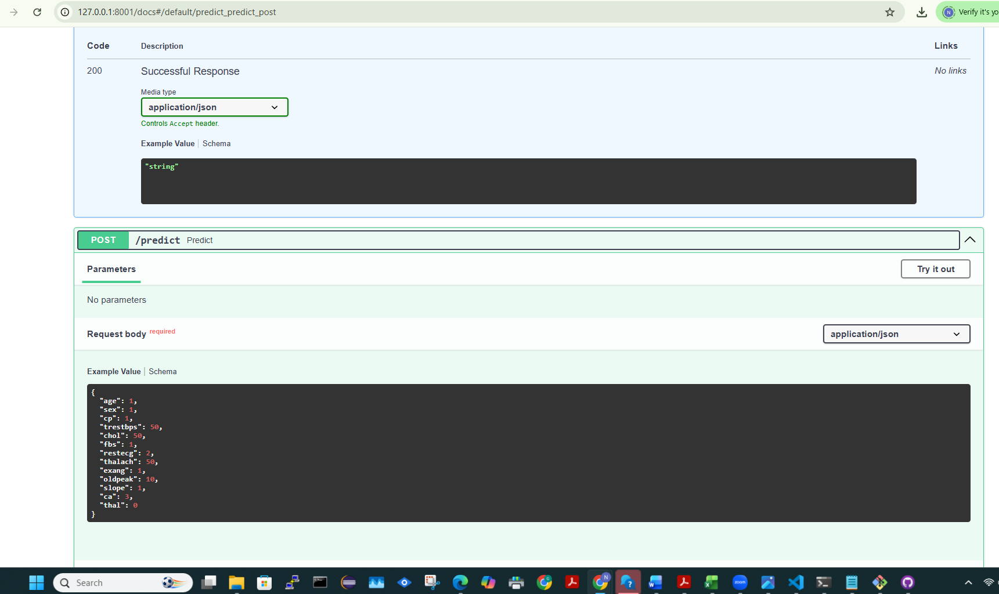

http://127.0.0.1:8001/health
{"status":"healthy","model_loaded":true,"model_path":"C:\\Users\\Navneet Kang\\Desktop\\heart-disease-mlops\\heart-disease-mlops\\models\\heart_disease_pipeline.joblib","error":null}

