Q-TAC MTTA Automation
Air Canada In-Flight Connectivity — MTTA Automation Tool
Author: Navneet Rao
Q-TAC Team | April 2026

1. Overview
This document covers the full R&D process behind the Q-TAC MTTA Automation Tool — from problem identification, API research, Python script development, to final browser extension deployment.

Outcome: MTTA drafting time reduced from 30+ minutes to under 5 minutes. Human calculation error eliminated.

Field | Detail
Problem | Manual MTTA process caused reporting errors and missed 15-min windows
Solution | Python script + Chrome/Edge browser extension (AC-SES)
Data source | Quvia API — ac-intelsat.hub.quvia.ai
Author | Navneet Rao — Q-TAC
Date | April 2026

2. Research — API Discovery

2.1 Identifying the Data Source
The Quvia dashboard was opened in Chrome. Developer Tools (F12 → Network tab) was used to inspect all API calls the dashboard makes when loading the Status History page. This revealed the exact endpoint, authentication method, and request payload structure.

Step 1 — Extract Bearer Token
Every request from the dashboard carries an Authorization header with a Bearer token. This token is issued on login and used by all API calls. It was identified by clicking any network request and inspecting the Headers tab.

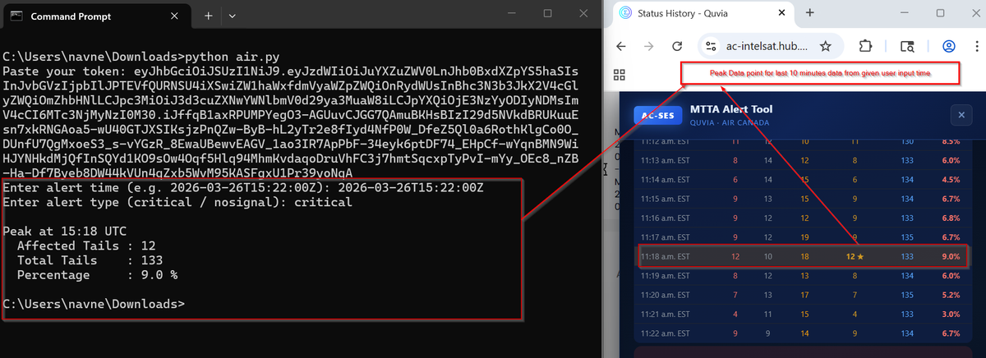
Figure 1 — Left: Bearer token visible in Authorization header (Network tab). Right: Live per-minute status data returned by the API.

Step 2 — Identify the API Endpoint
The status-history/v3 endpoint was identified as the source of per-minute aircraft connectivity data. It uses HTTP POST, returns JSON, and responds with 200 OK when a valid Bearer token and payload are supplied.

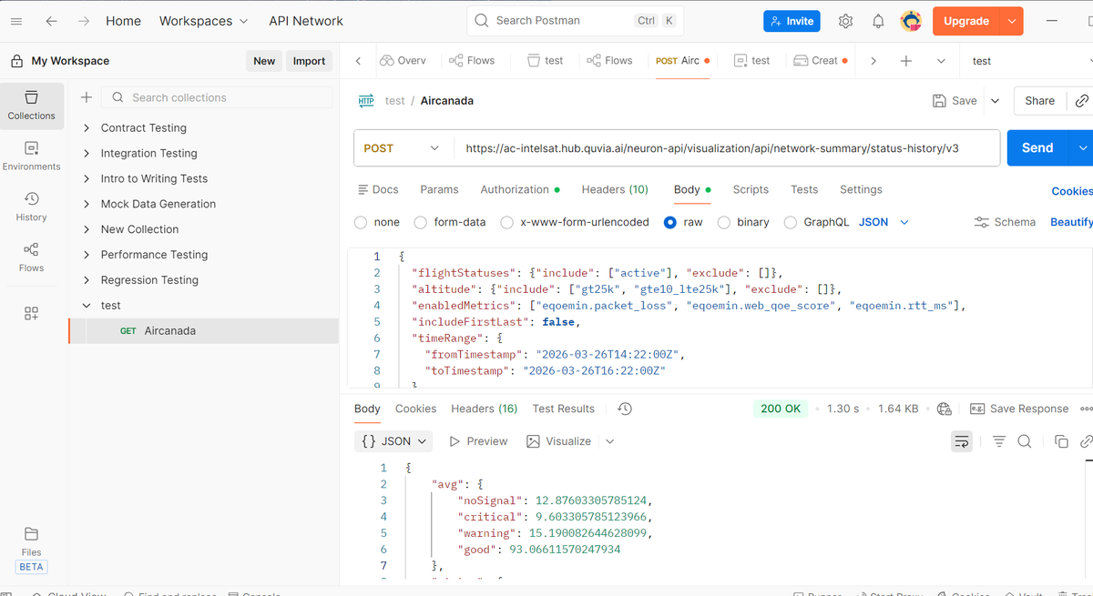
Figure 2 — POST https://ac-intelsat.hub.quvia.ai/neuron-api/visualization/api/network-summary/status-history/v3 — Status: 200 OK.

Step 3 — Inspect the Request Payload
The Payload tab revealed the exact JSON body the dashboard sends. Key filters: flight status (active only), altitude (gt25k and gte10_lte25k), metrics (packet_loss, web_qoe_score, rtt_ms), and a special nosignal filter (site.custom_string_6 = FALSE for InOp aircraft).

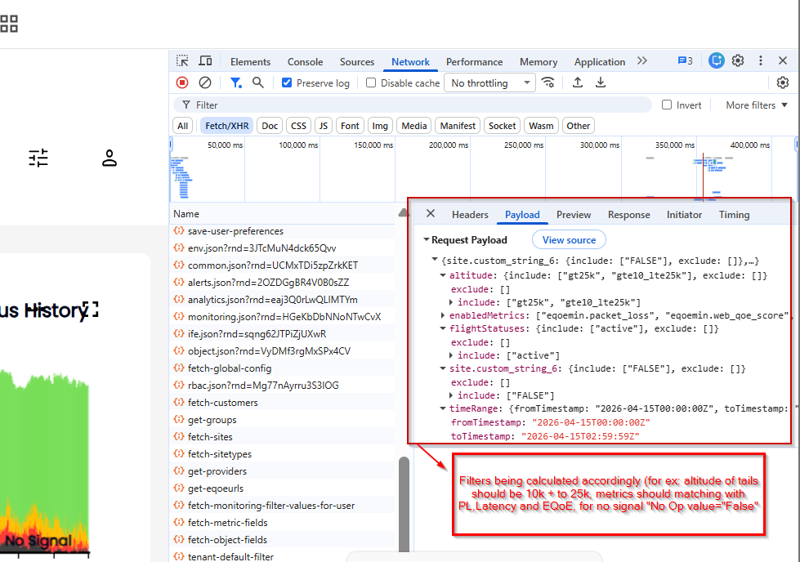
Figure 3 — Request payload showing all filters: altitude bands, metrics, timeRange, and No Signal InOp=FALSE filter.

3. API Validation — Postman
Before writing any code, the API was tested in Postman to confirm the request structure worked independently of the browser. The Bearer token was pasted into the Authorization header, the payload was built manually, and the request was sent.

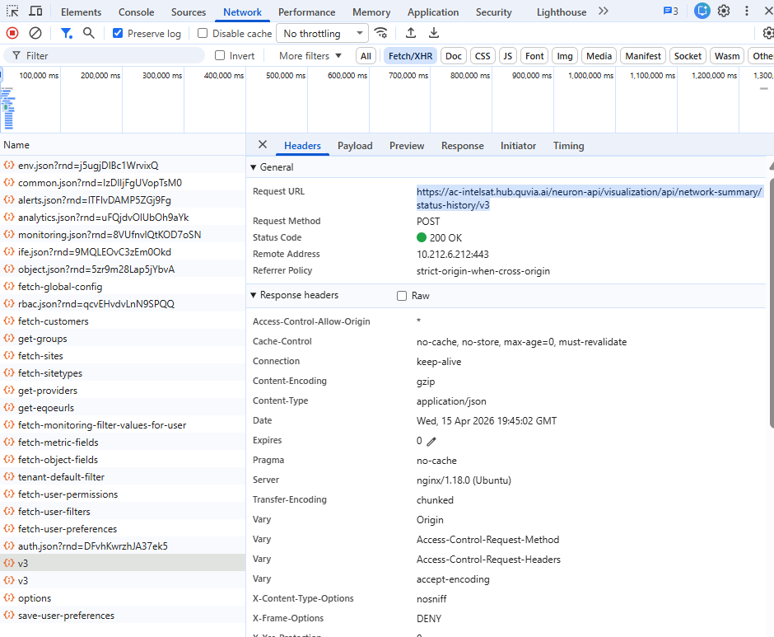
Figure 4 — Postman: POST request to Quvia API. Response shows per-minute noSignal, critical, warning, and good aircraft counts. Status: 200 OK, 1.30s.

Field | Detail
Method | POST
Endpoint | https://ac-intelsat.hub.quvia.ai/neuron-api/visualization/api/network-summary/status-history/v3
Auth | Bearer token in Authorization header
Content-Type | application/json (auto-set by requests library)
Response | 200 OK — JSON with per-minute status counts
Response time | ~1.3 seconds

4. Python Script — Development

4.1 Libraries Used
Field | Detail
requests | Sends HTTP POST request to Quvia API — pip install requests
sys | Stops the script with sys.exit() if API returns an error — built-in, no install needed

4.2 Script Flow

1 | Collect inputs  Script asks user for: Bearer token, alert type (critical / nosignal), FROM timestamp, TO timestamp. All via input() prompts — no hardcoding.

2 | Build payload  Constructs the JSON body with all required filters: active flights, altitude bands, metrics, time range. Adds InOp=FALSE filter only for nosignal alerts.

3 | Call API  Sends POST request with Bearer token in headers. If status code is not 200 — prints error and exits. No silent failures.

4 | Parse response  Reads the 'status' section from the JSON response. Loops through every minute. For each: reads critical / noSignal / warning / good counts, calculates total and affected percentage.

5 | Find peak  Compares affected count across all minutes. The minute with the highest affected count is the peak — used in the MTTA email.

6 | Print result  Prints peak minute data as key-value pairs: time, critical, noSignal, warning, good, affected, total, percent.

4.3 Full Script

IMPORTS
import requests # sends HTTP requests to the Quvia API
import sys # used to stop the script on error

USER INPUTS
TOKEN = input('Token : ')
ALERT_TYPE = input('Alert type (critical / nosignal) : ')
FROM_TIMESTAMP = input('From (e.g. 2026-06-17T04:10:00Z) : ')
TO_TIMESTAMP = input('To (e.g. 2026-06-17T04:20:00Z) : ')

# ALERT_TYPE controls:
# critical → affected = critical count
# nosignal → affected = noSignal count + adds InOp=FALSE filter to payload

API ENDPOINT
API_URL = 'https://ac-intelsat.hub.quvia.ai/neuron-api/visualization/api/network-summary/status-history/v3'

BUILD PAYLOAD
payload = {
'flightStatuses': {'include': ['active'], 'exclude': []},
# active only — no ground aircraft

'altitude': {'include': ['gt25k', 'gte10_lte25k'], 'exclude': []},
# above 25k ft AND 10k–25k ft

'enabledMetrics': ['eqoemin.packet_loss', 'eqoemin.web_qoe_score', 'eqoemin.rtt_ms'],
# packet loss, web QoE score, round-trip time

'includeFirstLast': False,

'timeRange': {
'fromTimestamp': FROM_TIMESTAMP, # user-defined start
'toTimestamp': TO_TIMESTAMP, # user-defined end
},
}

# nosignal alerts — add InOp = FALSE filter
if ALERT_TYPE == 'nosignal':
payload['site.custom_string_6'] = {'include': ['FALSE'], 'exclude': []}

SEND API REQUEST
headers = {'Authorization': 'Bearer ' + TOKEN}
# requests auto-sets Content-Type: application/json when json= is used

response = requests.post(API_URL, json=payload, headers=headers)

# stop immediately if API returns anything other than 200
if response.status_code != 200:
print('Error:', response.status_code, response.text)
sys.exit()

PARSE RESPONSE
# response.json() converts raw JSON string → Python dictionary
# .get('status', {}) reads the 'status' section
# if 'status' key missing → returns {} (empty dict) → loop runs 0 times, no crash
status_data = response.json().get('status', {})

# status_data looks like:
# {
# '2026-06-17T04:18': { 'critical': 2, 'noSignal': 1, 'warning': 5, 'good': 90 },
# '2026-06-17T04:19': { 'critical': 3, 'noSignal': 2, 'warning': 4, 'good': 88 },
# }

rows = [] # will hold one dictionary per minute

for timestamp_string, counts in status_data.items():
# read counts for this minute (.get returns 0 if key missing)
critical = counts.get('critical', 0)
no_signal = counts.get('noSignal', 0)
warning = counts.get('warning', 0)
good = counts.get('good', 0)
total = critical + no_signal + warning + good

# 'affected' depends on alert type
if ALERT_TYPE == 'nosignal':
affected = no_signal
else: # critical
affected = critical

# percentage (guard against divide-by-zero)
if total > 0:
pct = round(affected / total * 100, 1)
else:
pct = 0.0

rows.append({
'time': timestamp_string,
'critical': critical,
'nosignal': no_signal,
'warning': warning,
'good': good,
'affected': affected,
'total': total,
'pct': pct,
})

FIND PEAK & PRINT RESULT
if len(rows) == 0:
print('No data found. Check your token or timestamps.')
else:
# find minute with highest affected count
# start assuming first row is worst, replace if we find a higher one
peak_row = rows[0]
for row in rows:
if row['affected'] > peak_row['affected']:
peak_row = row

# set label for output
if ALERT_TYPE == 'nosignal':
label = 'No Signal'
else:
label = 'Critical'

# print peak minute as key-value pairs
print('')
print('Peak —', label, 'Alert')
print('Time :', peak_row['time'])
print('Critical :', peak_row['critical'])
print('No Signal:', peak_row['nosignal'])
print('Warning :', peak_row['warning'])
print('Good :', peak_row['good'])
print('Affected :', peak_row['affected'])
print('Total :', peak_row['total'])
print('Percent :', str(peak_row['pct']) + '%')

4.4 Key Design Decisions

Field | Detail
No datetime module | User supplies FROM and TO timestamps directly — no automatic calculation needed. Simpler and gives full control.
No hardcoded values | All inputs via input() — token, alert type, timestamps. No editing the script between runs.
sys.exit() on error | Stops immediately with a clear error message if API fails. No silent wrong results.
.get('key', 0) | Safe dictionary read — returns 0 if a count is missing from API response. Prevents KeyError crashes.
Peak only output | Only the worst minute is printed — gives the NOC engineer the exact data point needed for the MTTA email instantly.
ALERT_TYPE drives logic | One flag controls: which count is 'affected', whether InOp filter is added, and the output label. Single point of control.

5. Testing & Validation

5.1 Live Test
The script was tested against a live critical alert at 2026-03-26T15:22:00Z. The output was cross-validated against the Quvia dashboard.

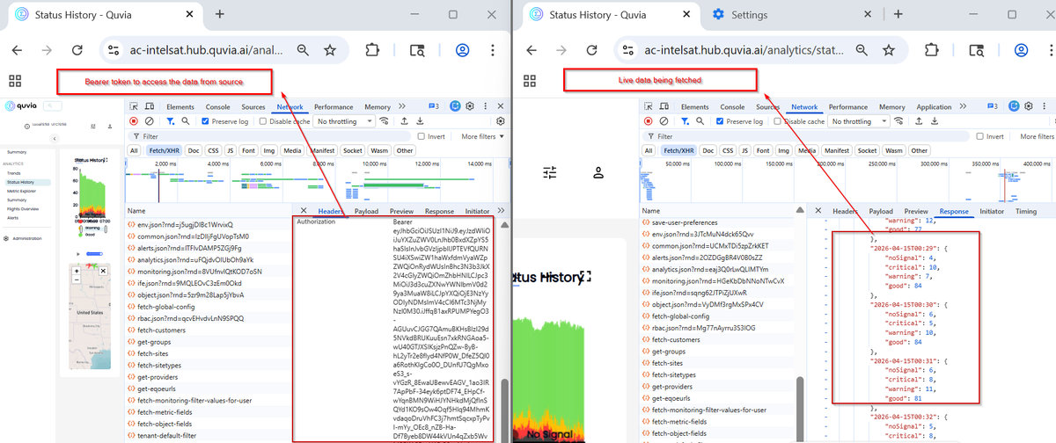
Figure 5 — Left: Script output — peak at 15:18 UTC, 12 affected, 133 total, 9.0%. Right: Quvia dashboard — 11:18 a.m. EST (= 15:18 UTC), 12★ critical, 9.0%. Exact match.

Result: Script output exactly matched the Quvia dashboard — peak minute, affected count, total active, and percentage all identical.

6. Business Logic Reference

6.1 Filters
Field | Detail
Flight status | Active only
Altitude | Above 25k ft AND 10k–25k ft
Metrics | Packet Loss · Web QoE Score · RTT
No Signal extra | InOp Report = FALSE (site.custom_string_6)

6.2 Threshold & Peak Rules
Field | Detail
Threshold | ≥ 15% of active fleet affected → MTTA required
Critical — valid if | ANY minute in 10-min window ≥ 15%
No Signal — valid if | ALL 10 minutes ≥ 15% (strict)
Peak minute | The minute with the highest affected count — used in the email

7. Installation & Usage

7.1 Python Script
# install once
pip install requests

# run
python quvia_fetch.py

# then enter when prompted:
# Token : eyJ...
# Alert type : critical
# From : 2026-06-17T04:10:00Z
# To : 2026-06-17T04:20:00Z

