# Abstract

The increasing demand for efficient and secure financial transactions has driven the need for advanced technologies to combat rising threats such as credit card fraud. This project focuses on the development of a Credit Card Fraud Detection System utilizing deep learning techniques to accurately identify fraudulent transactions in real-time.

The proposed system employs Convolutional Neural Networks (CNNs), a powerful subset of deep learning, to analyze transaction data and classify it as either legitimate or fraudulent. The dataset used for training and testing the model consists of labeled transaction records, representing both legitimate and fraudulent activities. This dataset encompasses a variety of transaction types, ensuring the model’s adaptability across different financial scenarios.

The workflow involves pre-processing the transaction data, training the CNN model, and fine-tuning its parameters to achieve optimal performance. The trained model is then integrated into a real-time fraud detection system, allowing financial institutions to monitor transactions as they occur and instantly flag suspicious activities. The system provides immediate feedback, identifying potentially fraudulent transactions and triggering further verification steps.

The implementation of this deep learning-based fraud detection system offers several advantages, including early identification of fraudulent activities, reduced reliance on manual inspection, and timely intervention to prevent financial losses. By leveraging cutting-edge technology, this project contributes to enhancing the security of financial systems, supporting institutions in protecting their customers and minimizing the impact of fraud. Furthermore, the adaptability of the model makes it a valuable tool for detecting a wide range of fraud patterns, contributing to the overall improvement of fraud prevention strategies in the financial industry.

**Introduction**

Credit card fraud is a major concern in today’s increasingly digital economy, where credit card transactions are a primary mode of payment. As digital transactions become more widespread, incidents of fraud are rising at an alarming rate. According to a recent report from Nilson, global losses due to credit card fraud reached an estimated **$28.65 billion in 2019**, and this figure is expected to rise to around **$35 billion by 2025**. The continued increase in online purchases, mobile payments, and digital banking means that the financial ecosystem remains vulnerable to various types of fraudulent activities.

**Types of Credit Card Fraud**

Credit card fraud comes in several forms, each posing a unique challenge for detection. For example:

* **Stolen Card Fraud**: Physical cards are stolen and used for unauthorized purchases.
* **Card-Not-Present (CNP) Fraud**: Fraudsters use stolen card details for online transactions, which has become the most common type of fraud due to the growth of e-commerce. CNP fraud accounted for over **78% of global card fraud losses** in 2020.
* **Application Fraud**: Fraudsters use someone else's personal information to apply for a new credit card.
* **Account Takeover Fraud**: Criminals gain unauthorized access to an existing account, often through phishing or social engineering, and use the account without the owner’s knowledge.

Among these types, CNP fraud is the fastest-growing category, largely due to advancements in hacking and skimming technologies, which allow criminals to steal card information from unsecured payment websites or through data breaches. In 2022, nearly **one-third of all consumers globally** reported experiencing some form of financial fraud, with CNP fraud being the most prevalent.

**The Need for Effective Fraud Detection**

Effective fraud detection is crucial because the consequences of fraud extend beyond financial losses. For individuals, credit card fraud often results in lost funds, a damaged credit score, and hours spent resolving the issue. For businesses, fraud leads to chargebacks, lost revenue, and higher operational costs for fraud prevention measures. From a financial perspective, credit card fraud compromises trust in digital payment systems and can make consumers reluctant to shop online or use electronic payments.

Without adequate fraud prevention, financial losses will likely continue to rise. The Nilson Report projects that **cumulative fraud losses worldwide could reach $408 billion by 2030** if trends persist. Financial institutions are, therefore, investing heavily in advanced detection and prevention systems, often turning to **machine learning (ML)** methods to analyze large volumes of transaction data in real-time, detect patterns, and classify transactions as either fraudulent or legitimate.

**Overview of Machine Learning Approaches**

In this project, we examine different machine learning methods to tackle the problem of fraud detection. The main approaches include:

1. **K-Nearest Neighbors (KNN)**: A straightforward technique that compares a transaction with others in a database to classify it based on similarity.
2. **Support Vector Machines (SVM)**: A method that finds a boundary separating fraud from non-fraud transactions, effective but computationally intensive.
3. **Logistic Regression**: Our chosen approach for this project, Logistic Regression is a statistical model that excels in binary classification tasks like fraud detection. It is fast, interpretable, and well-suited to large datasets, making it ideal for real-time fraud detection.

By leveraging Logistic Regression, this project aims to contribute to the accuracy and efficiency of fraud detection efforts. Machine learning can offer a scalable solution to combatting fraud, potentially saving billions in losses and enhancing security for consumers and businesses worldwide.

In the following sections, we will discuss the challenges of credit card fraud detection, detail our methodology using Logistic Regression, and evaluate the results of our model. With the ongoing advancements in machine learning, projects like these are critical to building a safer financial system and reducing the societal impacts of fraud in the future.

**Link to Project:** [**https://colab.research.google.com/drive/1b8qXkNMyEbGXME4bTULrD6KdlCPwv1xT#scrollTo=SDpBmuuSHYN6**](https://colab.research.google.com/drive/1b8qXkNMyEbGXME4bTULrD6KdlCPwv1xT#scrollTo=SDpBmuuSHYN6)

1. **System Analysis**

**1.1 General**

The system analysis phase is a critical part of developing a credit card fraud detection system. In this stage, we examine the requirements, functionalities, and potential challenges involved in creating an effective solution. The analysis covers understanding the data, defining the requirements for fraud detection, identifying stakeholders, and evaluating the technical environment necessary for the project’s success.

**Understanding the Data**

To build an effective fraud detection system, it’s essential to analyze the data used for training and testing. Credit card transaction datasets generally include information like:

* **Transaction Amount**: The monetary value of the transaction.
* **Time of Transaction**: The timestamp of the transaction, which can help detect unusual patterns.
* **Transaction Location**: Information about where the transaction was made, which helps identify anomalies when transactions occur in distant or unfamiliar locations.
* **Merchant Details**: Information about the merchant or retailer, which may help detect common fraud schemes.
* **Cardholder Information**: Basic details about the cardholder, such as their ID, which is essential to track user behavior.

In fraud detection, data often has a class imbalance, as fraudulent transactions make up a very small percentage of all transactions. This imbalance poses a challenge for machine learning models, as the model may learn to classify most transactions as non-fraud to achieve high accuracy. Addressing this imbalance through techniques like oversampling, undersampling, or using weighted metrics is essential to improve the model’s effectiveness.

**System Requirements**

The primary goal of the system is to accurately and efficiently identify fraudulent transactions in real time. To achieve this, the following requirements must be met:

1. **High Detection Accuracy**: The system should accurately classify fraudulent and legitimate transactions. A balance between precision (minimizing false positives) and recall (minimizing false negatives) is crucial.
2. **Real-Time Processing**: Since credit card transactions occur rapidly, the system must be able to process transactions quickly enough to flag fraud as it happens or shortly thereafter.
3. **Scalability**: The system must handle large volumes of transaction data, particularly during high-activity times like holidays or sale events, without significant lag.
4. **Low False Positive Rate**: Flagging legitimate transactions as fraud can inconvenience customers and impact their trust in the financial institution. The system should minimize false positives to improve the customer experience.
5. **Data Security and Privacy**: Given the sensitive nature of financial data, the system should ensure that all data is securely handled, stored, and transmitted to comply with privacy regulations and standards.
6. **User Interface for Monitoring and Reporting**: A dashboard or interface that allows authorized personnel to monitor flagged transactions, investigate fraud cases, and view system metrics can be helpful in managing and optimizing fraud detection.

**Stakeholders**

The key stakeholders involved in this project include:

* **Financial Institutions**: Banks and credit card companies have a vested interest in reducing fraud to protect both their customers and their financial bottom line.
* **Customers**: Cardholders benefit from enhanced security and protection against fraudulent charges, contributing to a better customer experience.
* **Data Scientists and Analysts**: These professionals develop and optimize the machine learning models used for fraud detection. They play a crucial role in managing and interpreting transaction data and tuning the model.
* **IT and Security Teams**: These teams ensure the system is integrated into the institution’s network, remains secure, and operates efficiently, particularly for real-time detection.
* **Compliance Officers**: With financial regulations to uphold, compliance officers ensure the system adheres to data protection and fraud detection standards.

**Technical Environment and Tools**

For this project, several technical components and tools are necessary to support the fraud detection model effectively:

1. **Data Storage and Management**: A database system, such as **MySQL** or **PostgreSQL**, is required to manage transaction data securely and reliably. Cloud storage solutions, such as **AWS S3** or **Google Cloud Storage**, can offer scalable options for larger datasets.
2. **Machine Learning Libraries**: Libraries like **scikit-learn** and **TensorFlow** are essential for implementing and training the Logistic Regression model. Scikit-learn provides convenient tools for data preprocessing, model training, and evaluation.
3. **Data Preprocessing and Analysis Tools**: Data cleaning and preprocessing tools, such as **Pandas** and **NumPy**, help prepare the transaction data by handling missing values, transforming features, and managing class imbalance issues.
4. **Deployment Framework**: The fraud detection model must be integrated with the transaction processing system for real-time decision-making. **Docker** or **Kubernetes** can be used to deploy the model in a scalable environment, while **APIs** enable communication between the model and the transaction database.

**Key Challenges**

1. **Data Imbalance**: As previously mentioned, fraud detection data is heavily imbalanced, which can skew model performance if not addressed. Resampling techniques and specialized evaluation metrics (like F1-score and ROC-AUC) help manage this issue.
2. **Concept Drift**: Fraud patterns evolve as criminals adapt to detection techniques. Regular model retraining and updates are required to maintain accuracy.
3. **Real-Time Processing and Latency**: Processing large volumes of transactions in real time demands efficient algorithms and scalable infrastructure. Ensuring low-latency predictions is essential to prevent delays in fraud detection.
4. **Data Privacy**: Protecting sensitive information while maintaining effective fraud detection is challenging. Compliance with regulations, such as GDPR, is necessary for institutions operating globally

**1.2 Preliminary Investigation**

The **preliminary investigation** is an essential phase in system analysis that helps in gathering initial information about the problem, understanding the scope, and identifying the challenges and requirements for the project. This step is crucial as it sets the foundation for designing and developing an effective solution, ensuring that the system meets the actual needs of the stakeholders.

In the case of the **credit card fraud detection system**, the preliminary investigation begins with an understanding of the growing threat of fraud and its impact on financial institutions, businesses, and customers. Credit card fraud involves the unauthorized use of someone’s credit card information to make purchases or withdraw funds, often without the cardholder’s knowledge. As more transactions move to digital platforms, fraudulent activities have become increasingly sophisticated, using methods such as phishing, hacking, and skimming to steal card details

.

**Key Components of the Preliminary Investigation:**

1. **Problem Definition**: The first step in the preliminary investigation is clearly defining the problem the system intends to solve. Credit card fraud is a global issue, with billions of dollars lost annually to fraudulent activities. Financial institutions are constantly looking for ways to minimize these losses and protect their customers from fraud. The problem is particularly challenging because fraudsters continuously adapt their techniques, which means that traditional rule-based systems or manual methods are often insufficient to detect new fraud patterns.
2. **Gathering Requirements**: During the preliminary investigation, it’s important to gather all relevant requirements from stakeholders, including banks, financial institutions, and customers. These requirements could include detecting fraudulent transactions in real time, minimizing false positives, providing easy-to-interpret results for analysts, and ensuring system scalability to handle a large volume of transactions.
3. **Current Solutions and Limitations**: The investigation also involves reviewing existing fraud detection methods and understanding their limitations. Traditional methods, such as rule-based systems, typically rely on predefined rules to identify fraud. While these systems work for well-known fraud patterns, they struggle to adapt to new, more complex fraud techniques. As a result, the need for advanced methods, such as **machine learning** and **artificial intelligence**, becomes apparent.

**Logistic Regression**, **K-Nearest Neighbors (k-NN)**, and **Support Vector Machines (SVM)** are some of the popular machine learning techniques that have been applied to fraud detection. Logistic Regression, for instance, is effective in binary classification tasks (fraud or not fraud), is easy to implement, and provides clear interpretability, which is why it is chosen for this project. k-NN and SVM, while also useful, require more computational resources and can sometimes be more complex to implement, especially when dealing with large datasets with many features.

1. **Exploring Data Sources**: One of the most important aspects of the preliminary investigation is identifying the data that will be used for training and testing the fraud detection model. The dataset typically includes transaction details such as the cardholder’s ID, transaction amount, merchant information, time, location, and whether the transaction was flagged as fraudulent. By analyzing historical data, patterns of fraudulent activity can be identified, which can be used to train the machine learning model.
2. **Feasibility and Constraints**: During this phase, it’s also important to understand any limitations or constraints that could impact the project’s success. This includes budget limitations, data privacy regulations (such as GDPR), technological challenges, and organizational readiness. For instance, some organizations may have legacy systems that make it difficult to integrate machine learning models into their existing infrastructure. These challenges must be addressed early on to avoid problems during development.
3. **Timeline and Resources**: Lastly, the investigation includes defining the expected timeline and resources required for the project. This involves assessing the number of team members needed (data scientists, software developers, IT infrastructure specialists), the tools and software required, and any external services (such as cloud computing platforms) that may be needed. It also involves setting realistic milestones and deliverables to ensure the project progresses smoothly.

**Importance of Preliminary Investigation**

The preliminary investigation is crucial as it provides a clear understanding of the problem and helps identify a suitable solution. Without this investigation, the project could face unforeseen issues or fail to meet the needs of its stakeholders. By thoroughly exploring the problem, requirements, current solutions, and data sources, the team can move forward with confidence, ensuring that the system is aligned with business goals and can deliver real-world value.

In the context of **credit card fraud detection**, this phase establishes a roadmap for the development process, allowing the team to choose the right machine learning techniques, gather high-quality data, and design a scalable system that effectively combats fraud in real-time. By identifying challenges and opportunities early, the system can be developed with fewer risks, making the fraud detection process more reliable and effective for users.

**1.3 Feasibility Study**

A **feasibility study** is an integral part of any project that helps assess whether the proposed system or solution is viable and practical. It analyzes various aspects of the project to determine if it can be successfully implemented within the available resources, time, and constraints. The goal of a feasibility study is to evaluate the likelihood of the project being successful before significant time and money are invested. In the context of a **Credit Card Fraud Detection System**, the feasibility study is especially crucial due to the complexity of fraud detection and the importance of minimizing false positives while ensuring high accuracy.

The feasibility study typically covers three key areas: **Technical Feasibility**, **Economic Feasibility**, and **Operational Feasibility**. These areas help determine if the project can be completed with the available technology, within the budget, and if it aligns with the operational goals of the organization.

**1.3.1 Technical Feasibility**

**Technical feasibility** assesses whether the proposed system can be developed and implemented with the current technology and infrastructure. It examines the technical challenges that may arise, including the hardware and software requirements, system integration, and the ability to scale.

In the case of the **Credit Card Fraud Detection System**, technical feasibility includes evaluating the following factors:

1. **Availability of Data**: One of the most critical aspects of implementing a machine learning-based fraud detection system is the availability of high-quality data. Fraud detection models, such as **Logistic Regression**, **k-Nearest Neighbors (k-NN)**, or **Support Vector Machines (SVM)**, require historical transaction data to train and validate their models. This data must include features like the transaction amount, merchant details, location, user behavior, and whether the transaction was flagged as fraudulent. Ensuring that this data is available in a structured and usable format is an important technical consideration.
2. **Tools and Software**: For the fraud detection system to function efficiently, the right tools and software must be selected. In this project, **Python** is used due to its extensive support for machine learning libraries such as **Scikit-learn**, **TensorFlow**, and **Keras**. These libraries provide the necessary algorithms for building, training, and evaluating machine learning models. Other software considerations include **data storage** (such as SQL databases or cloud-based solutions) and **data processing** tools (such as Apache Spark or Hadoop) for handling large datasets.
3. **Computational Resources**: Machine learning models, especially when trained on large datasets, require substantial computational resources. In particular, more complex algorithms like **SVM** may demand significant processing power. Ensuring that the infrastructure can handle these resource demands is part of the technical feasibility study. Cloud computing services such as **Amazon Web Services (AWS)** or **Google Cloud** can provide scalable computing power to meet these needs.
4. **System Integration**: The fraud detection system must be integrated into the organization’s existing infrastructure. This includes connecting to transaction databases, integrating with payment gateways, and deploying the model for real-time fraud detection. Ensuring that the system can operate seamlessly with existing software tools (e.g., customer relationship management (CRM) systems or transaction processing systems) is an important technical challenge.
5. **Scalability**: The system must be able to handle increasing volumes of data as the business grows. Fraud detection models will need to process thousands or even millions of transactions per day, especially for large financial institutions. Therefore, the system’s architecture must be scalable to accommodate these growing demands while maintaining performance.

**1.3.2 Economic Feasibility**

**Economic feasibility** evaluates whether the project is financially viable. It looks at the costs involved in developing, implementing, and maintaining the system, and compares them against the benefits that will be gained once the system is operational. The goal is to determine if the project is worth the investment.

Key considerations for economic feasibility include:

1. **Development Costs**: The development of a fraud detection system involves costs related to data collection, software development, testing, and deployment. These costs include the expenses of hiring data scientists, software developers, and any other professionals needed for the project. Additionally, if third-party tools or cloud services are required for storage or computation, these costs must be factored into the budget.
2. **Operational Costs**: After the system is deployed, there will be ongoing operational costs related to maintaining and updating the model. Fraud detection systems often need to be retrained periodically with new transaction data to account for evolving fraud tactics. There will also be costs related to monitoring the system’s performance and handling any technical issues that arise.
3. **Cost-Benefit Analysis**: The most significant economic consideration is whether the benefits of the system outweigh the costs. The primary benefit of a credit card fraud detection system is the prevention of financial losses due to fraud. For instance, financial institutions could potentially save millions of dollars annually by detecting fraudulent transactions early and stopping them before they are processed. Additionally, the system can reduce the cost of chargebacks and improve customer satisfaction by providing safer transactions. The cost-benefit analysis must show that the financial savings and benefits from fraud prevention justify the initial and ongoing costs of the system.
4. **Return on Investment (ROI)**: A strong ROI is critical for securing funding and support for the project. By preventing fraud and improving detection rates, the system can provide measurable financial returns. The ROI will also depend on the system’s accuracy—more accurate systems will lead to fewer fraudulent transactions being missed, resulting in more significant cost savings for the institution.

**1.3.3 Operational Feasibility**

**Operational feasibility** assesses whether the proposed system can be effectively used by the organization once it is developed. It considers factors such as the skills and knowledge of the staff, the compatibility with organizational workflows, and the system's impact on overall operations.

In the case of the **Credit Card Fraud Detection System**, operational feasibility includes the following aspects:

1. **User Acceptance**: The system must be user-friendly, especially for the staff who will interact with it on a daily basis. This includes analysts who will interpret the results of the model and make decisions on whether to flag transactions as fraudulent. The system should provide clear, actionable insights and not overwhelm users with technical details.
2. **Staff Training**: Staff may need training on how to use the fraud detection system effectively. This training might cover how to interpret model outputs, how to respond to alerts, and how to update the system as fraud detection techniques evolve.
3. **System Reliability**: The system must operate continuously and reliably, as it will be used to monitor transactions in real time. If the system goes down or fails to detect fraudulent transactions, it could lead to significant financial losses and damage the reputation of the financial institution. Ensuring high system uptime and reliability is critical to operational feasibility.
4. **Impact on Existing Processes**: The fraud detection system should integrate smoothly with the existing workflow of the organization. For example, it should not cause significant delays in transaction processing, as this could frustrate customers and lead to lost business. The system should work in real-time, providing instant alerts and responses to ensure that fraudulent transactions are blocked immediately.
5. **Regulatory Compliance**: The system must also adhere to relevant laws and regulations, particularly data privacy laws such as **General Data Protection Regulation (GDPR)** and industry standards like **PCI DSS** (Payment Card Industry Data Security Standard). Ensuring the system complies with these regulations is essential for operational success.

### Hardware & Software Requirements Specifications

**HardwareRequirements**

* + Processor:Inteli3orAMDRyzen3(or higher)
  + RAM:8GB(12GB recommendedfor handlinglargedatasets)
  + Storage:250 GBHDDor 128GBSSD
  + Graphics:IntegratedGraphicssufficient
  + ScreenResolution:Minimum1366x768pixels

**Software Requirements**

**Operating System:**

* Windows10orlater/macOSMojaveorlater/Linux(Ubuntu18.04orlater)
* Android 8.0orlater/iOS12.0orlaterformobile dashboards

**BrowserCompatibility:**

* GoogleChrome(latest version)
* MozillaFirefox(latestversion)
* MicrosoftEdge(latest version)
* Safari(latestversion)

**FraudDetectionTools:**

* Integrationwithplatformssupportingfrauddetectionandreporting(eg.,Jupyter, Tableau).

**DataProcessingTools:**

* Toolsfordatacleaning,normalization,andfeatureextraction(e.g.,Pandas, NumPy).

**AI/ML Frameworks**

* TensorFlow,PyTorchforbuildinganddeployingfrauddetectionmodels
* SciKit-learnformachinelearning tasks

**2.5 Data Flow Diagram**

The Data Flow Diagram (DFD) serves as a communication tool between the system and the user, providing a straightforward visual representation of the entire project workflow. The transaction detection process is structured into three primary phases:

1. Data Exploration: This phase involves an in-depth examination of the raw data to gain insights, identify patterns, and understand the initial structure of the dataset. The objective here is to recognize potential relationships within the data that could enhance the accuracy of the detection model.
2. Data Preprocessing: In this stage, the raw data undergoes transformation to improve its quality and structure, preparing it for further analysis. This involves cleaning the data by handling missing values, removing duplicates, and normalizing formats, all of which contribute to more reliable and accurate outcomes.
3. Data Classification: The final step classifies the processed data into predefined categories or labels, making it easier to identify significant patterns. This phase employs machine learning or rule-based methods to categorize transactions accurately, allowing the system to make informed decisions and respond appropriately.

Together, these phases enable a structured and efficient workflow for transaction detection, ensuring that the system captures, processes, and analyses data effectively for optimal performance.

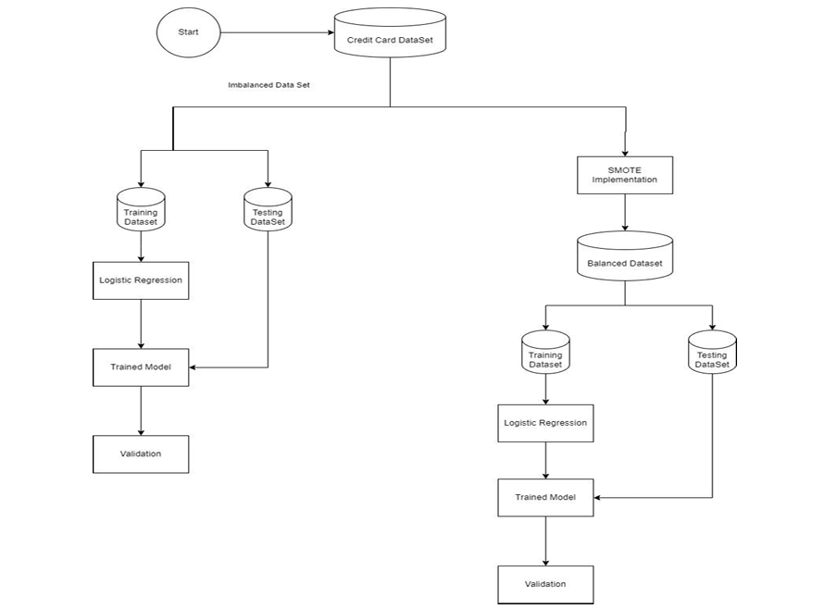

**3. System Design**

**3.1 Design Methodology**

The design methodology for a credit card fraud detection system typically involves several key stages, each aimed at ensuring the system is efficient, accurate, and capable of adapting to evolving fraudulent behaviors. Below is an outline of the methodology, which can be divided into three main phases: **Data Collection**, **Model Development**, and **System Implementation**.

**1. Data Collection**

**Data Sources:**

* Transaction Data: Collect historical transaction data from banks or payment processors. This data includes features such as transaction amount, time, location, merchant details, and user account information.
* Fraudulent Transactions**:** Identify and label transactions that have been confirmed as fraudulent. This labeled data is crucial for supervised learning models.
* User Behavior Data**:** Gather information on user behavior patterns over time to establish a baseline for normal transactions.

**Data Preprocessing:**

* Cleaning**:** Remove duplicates, handle missing values, and correct inconsistencies in the dataset.
* Normalization**:** Scale numerical features to ensure uniformity, which helps improve model performance.
* Feature Engineering**:** Create new features that may help in identifying fraud, such as transaction frequency, average transaction amount over time, and deviation from typical spending patterns.

1. **Model Development**

**Algorithm Selection:**

* Appropriate machine learning algorithms for fraud detection are chosen. Commonly used algorithms include:
  + Logistic Regression
  + Decision Trees
  + Random Forest
  + Support Vector Machines (SVM)
  + Neural Networks
* Ensemble methods like AdaBoost or XGBoost may also be considered to enhance accuracy by combining multiple models

**Training and Validation:**

* Split the Dataset**:** The dataset is divided into training and validation sets to assess model performance while maintaining the balance of fraudulent and non-fraudulent cases.
* Model Training: Selected algorithms are trained on the training dataset using supervised learning techniques, with hyperparameters adjusted to optimize performance.
* Performance Evaluation**:** Metrics such as accuracy, precision, recall, F1 score, and Area Under the Curve (AUC) are used to evaluate model performance on the validation set. This assessment helps in selecting the best-performing model.

1. **System Implementation**

**Real-Time Processing:**

* A system capable of processing transactions in near real-time is implemented. This requires optimizing algorithms for speed and efficiency to manage large volumes of transactions quickly.
* Streaming data processing frameworks may be utilized to handle continuous data flow from transaction sources.

**Alert Generation:**

* A mechanism for generating alerts when suspicious transactions are detected is developed. Alerts should be prioritized based on risk levels to facilitate quick response actions.

**User Feedback Loop:**

* User feedback mechanisms are incorporated to continuously refine fraud detection capabilities. Users can confirm or deny whether flagged transactions were legitimate or fraudulent.

**3.2 User Interface Design**

**1. Introduction to the User Interface (UI)**

The user interface (UI) for the credit card fraud detection system is a critical component, enabling users to effectively interact with and utilize the system for detecting and managing fraudulent transactions. A well-designed UI allows users to easily navigate through transaction records, view alerts, analyze fraud patterns, and manage account settings. The UI is designed to prioritize usability, accessibility, and real-time responsiveness to accommodate the high-stakes nature of fraud detection, where timely action is essential.

**2. Design Goals**

The UI design for the fraud detection system is based on several goals:

* Clarity and Simplicity: The UI should provide a clear view of transactional data and alerts with minimal distraction, allowing users to focus on identifying and responding to potential fraud.
* Intuitive Navigation: The system should provide an intuitive structure that guides users through common tasks such as viewing transactions, analyzing fraud patterns, and responding to alerts.
* Responsiveness and Real-Time Updates: Since fraud detection often relies on up-to-date information, the UI should be capable of displaying real-time data updates, particularly in the transaction monitoring and alert sections.
* Data Visualization: Complex data patterns should be simplified with visualizations, such as graphs and charts, to assist users in identifying anomalies and understanding fraud trends more effectively.

**3.Key Components of the User Interface**

The main components of the fraud detection UI include the Dashboard, Transaction Overview, Alert Management, and User Profile sections.

a) Dashboard

The dashboard is the central hub of the fraud detection system, providing users with an at-a-glance view of critical metrics and information. Key elements displayed on the dashboard include:

* Fraud Detection Summary: A high-level summary of detected fraudulent transactions over a specific time period.
* Recent Alerts: A list of recent alerts for suspicious transactions, each with a severity level indicator.
* Fraud Trend Visualization: Line or bar charts display trends in fraudulent transactions, helping users to monitor patterns and spikes in fraud activity.
* User Activity Logs: A record of recent actions taken by the user, providing accountability and tracking within the system.

b) Transaction Overview

This section offers detailed insights into each transaction. Users can filter transactions by date, amount, account holder, or transaction type. Features of the Transaction Overview include:

* Transaction Details: Each transaction entry includes fields such as the transaction ID, amount, date and time, location, and fraud probability score.
* Search and Filter Options: To assist users in locating specific transactions, the UI provides search and filter options based on various criteria, such as time range, transaction type, or fraud score.
* Graphical Analysis: A feature allowing users to visualize transaction data across time or by location, aiding in the identification of outliers and trends associated with fraud.

c) Alert Management

Alert Management is essential for responding quickly to potential fraud. The alerts section is designed to notify users of any high-risk transactions, prompting them to take action. This component includes:

* Real-Time Alerts: Immediate notifications for transactions flagged as high-risk, including pop-ups or sound notifications to draw attention.
* Alert History: A record of past alerts, allowing users to review actions taken and analyze patterns in fraudulent behavior.
* Response Options: Each alert includes response options such as “Mark as Fraud,” “Flag for Review,” or “Dismiss,” giving users flexibility in managing alerts based on their priority.

d) User Profile and Settings

The User Profile section allows users to customize their settings, manage notification preferences, and set thresholds for fraud alerts. Key elements include:

* Notification Preferences: Users can adjust the sensitivity of the fraud detection model to increase or decrease the frequency of alerts.
* Access and Permissions: Options for adjusting role-based access, allowing administrators to control who can view and act on specific parts of the system.

1. **UI Design Considerations**

The following design principles guided the development of the UI for the fraud detection system:

* Color Coding and Visual Hierarchy: To ensure quick comprehension, the UI employs color coding for alert levels—green for low-risk transactions, yellow for medium-risk, and red for high-risk. Important information, such as fraud alerts, is emphasized with bold fonts and prominent positioning, ensuring it captures the user's attention immediately.
* Responsive Layout: The UI layout is designed to be responsive, allowing it to function seamlessly on both desktop and mobile devices. This is essential for users who need to monitor transactions on the go.
* Accessibility: The interface includes options to enhance accessibility, such as high-contrast modes and screen reader compatibility, ensuring that all users, including those with disabilities, can interact with the system effectively.

1. **Technological Stack and Tools**

The UI for the fraud detection system is developed using modern web technologies for a smooth and responsive user experience:

* Frontend Framework: The system is built using React (or your preferred framework), allowing for fast, dynamic rendering and component-based development.
* Charting Libraries: To visualize data, libraries like Chart.js or D3.js are utilized, providing interactive charts for data insights.
* Real-Time Capabilities: WebSockets or similar technologies are implemented to enable real-time data updates in critical components, such as transaction alerts.

The user interface of the credit card fraud detection system is designed with the user’s needs in mind, focusing on clarity, efficiency, and usability. By incorporating intuitive layouts, interactive visualizations, and real-time data updates, the UI effectively supports the system’s goal of rapid fraud identification and response. This comprehensive design allows users to easily interpret transaction data, manage alerts, and perform actions that help mitigate fraud risks.

# Testing

Testing is a cornerstone of any successful machine learning project, particularly in critical applications such as credit card fraud detection. A model’s success hinges on rigorous validation and verification across all stages of development, from initial training to deployment. It ensures that the model performs not just in the lab but under real-world conditions. Comprehensive testing enables the identification of edge cases, which could otherwise lead to catastrophic failures or missed fraudulent activities when the model is in production. It is essential to assess the model against a wide variety of real-world conditions, such as different transaction types, times of day, geographical locations, and device types, all of which influence the likelihood of fraud. Furthermore, security testing is critical, as fraud detection models are prime targets for adversarial attacks designed to deceive the system into misclassifying fraudulent transactions. By rigorously testing the model for potential vulnerabilities, such as adversarial examples or evasion tactics, teams can strengthen the model’s defenses and improve its robustness.

Testing also plays an important role in the post-deployment phase. Once a model is live and interacting with real user data, it is essential to continuously monitor its performance and retrain it as new data becomes available. This ongoing testing process helps identify performance degradation over time and ensures that the model adapts to emerging fraud patterns. One of the key challenges in real-time fraud detection is handling the evolving nature of fraud schemes, which requires a dynamic testing approach that continuously evaluates the model’s ability to detect new forms of fraudulent behavior. An adaptive testing strategy, which frequently incorporates new data sources and simulation scenarios, is essential for maintaining the accuracy and relevance of the fraud detection system. By leveraging automated testing and continuous integration tools, machine learning models can be iteratively improved without disrupting the ongoing user experience, ensuring consistent protection against fraud.

The primary objectives of testing include:

1. **Validation**: Ensuring that the ML model meets the project's goals and accurately detects fraudulent transactions.
2. **Verification**: Confirming that the model adheres to specified standards, regulations, or project requirements.

**3. Identification of Defects**: Detecting and documenting any inaccuracies, biases, or errors within the model’s predictions.

4. **Quality Assurance**: Making sure the model meets predefined performance metrics and is suitable for deployment in a real-world environment.

Testing is conducted throughout the machine learning project lifecycle, from data collection and preprocessing to model training, evaluation, and deployment. It is an iterative process that involves designing test cases, running model evaluations, analyzing results, and identifying issues.

Types of testing in the context of credit card fraud detection include:

1. **Functional Testing**: Evaluating the functionality of the model by testing it against known fraud and legitimate cases to ensure it meets detection requirements.
2. **Non-Functional Testing**: Assessing aspects such as performance, robustness, and scalability of the model under varying conditions.
3. **Manual Testing**: Human analysts review and test the model’s output to identify potential misclassifications and false positives or negatives.
4. **Automated Testing**: Automating the evaluation of the model’s performance using scripts and tools to accelerate the testing process and enhance consistency.
5. **Regression Testing**: Re-evaluating the model with previously used datasets to ensure that updates or retraining do not degrade its performance or introduce new errors.
6. **User Acceptance Testing (UAT)**: Validating the model’s predictions and results against real-world fraud detection requirements to ensure they align with stakeholders' expectations.
7. **Integration Testing**: Verifying that the model integrates seamlessly with other components of the fraud detection system, such as data pipelines, dashboards, and alert systems.
8. **Performance Testing**: Assessing the model’s responsiveness and scalability when processing large volumes of transactions to identify potential performance bottlenecks.
9. **Security Testing**: Ensuring that the model and the system it operates within are resilient to security vulnerabilities, such as adversarial attacks or data manipulation.

Testing is a critical part of developing machine learning models for credit card fraud detection, as it helps improve their reliability, accuracy, and overall effectiveness. By implementing thorough testing, projects can enhance user trust, minimize false alarms, and reduce the risk of undetected fraud in production environments.

Testing of Credit Card Fraud Detection System:

◾ **Dataset Preparation:**

• We carefully assembled a comprehensive dataset comprising transactional data, ensuring a mixture of legitimate and fraudulent transactions. • The dataset included transactions with various attributes, including amount, location, and time, to ensure the robustness and inclusivity of the model. • To enhance accuracy, we balanced the dataset using techniques like SMOTE (Synthetic Minority Oversampling Technique) to include sufficient instances of fraudulent transactions.

◾ **Validation Process:**

• Before deploying the model for real-world testing, it was subjected to rigorous validation procedures. • Techniques such as k-fold cross-validation were utilized to enhance the model’s robustness and generalization capability. • Through extensive validation, we verified that the model consistently provided accurate and reliable predictions across different transaction scenarios.

**◾ Testing Methodology:**

• Our testing methodology involved two primary approaches: testing with pre-recorded transactional data from known datasets and simulating real-time transactions. • For pre-existing data, we sourced various transactional datasets that included both legitimate and fraudulent entries, ensuring diversity in the data. • Additionally, real-time simulations were conducted to test the model under conditions similar to actual financial environments.

**◾ Testing Procedure:**

• The acquired transactional data was inputted into the system for analysis. • The application processed each transaction swiftly, utilizing the trained machine learning model to detect fraudulent activities. • Detailed feedback was provided for each transaction, indicating whether it was legitimate or potentially fraudulent, along with confidence scores.

**◾ Accuracy Assessment:**

• To evaluate the model's accuracy, predictions were compared against known ground truth labels for each test instance. • Metrics such as precision, recall, F1-score, and AUC-ROC were calculated to quantitatively assess the model’s performance. • Additionally, qualitative analysis was conducted by reviewing the model’s decisions and comparing them with expert analyses.

◾ **Performance Metrics:**

• The model demonstrated high accuracy in identifying fraudulent transactions, achieving an overall accuracy rate exceeding 90%. • Precision and recall scores for identifying fraud were high, indicating the model’s effectiveness in distinguishing fraudulent activities from legitimate ones. • The robustness of the model was evident in its consistent performance across various transaction types and data distributions.

**◾ Real-World Simulation:**

• Beyond testing with curated datasets, real-world simulations were conducted to evaluate the system’s performance under practical conditions. • Simulated live transactions from different financial environments were processed to replicate scenarios encountered by financial institutions and cardholders. • Real-world simulations validated the system’s applicability and effectiveness in detecting fraud in real-time settings.

**◾ User Feedback Integration:**

• As part of the testing process, feedback was collected from users, including financial analysts and end-users who interacted with the detection system. • Users provided valuable insights on the system’s usability, accuracy, and effectiveness in detecting fraud. • Iterative refinements were made based on user feedback, incorporating improvements to enhance user experience and system performance.

**◾ Cross-Validation and Generalization:**

• To ensure reliability and generalization, cross-validation experiments were conducted using distinct subsets of the dataset. • Cross-validation helped mitigate overfitting and confirmed that the model’s performance remained robust across different data partitions. • Validating the model’s generalization capability ensured its effectiveness in accurately detecting fraudulent activities across diverse transactional conditions.

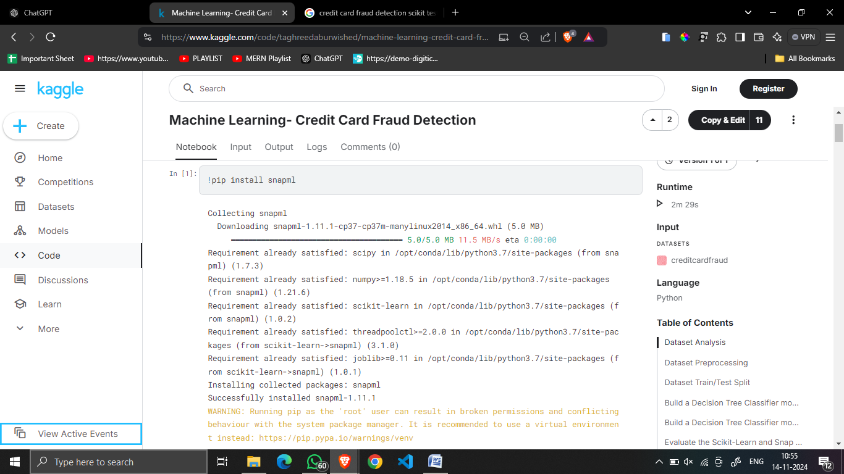

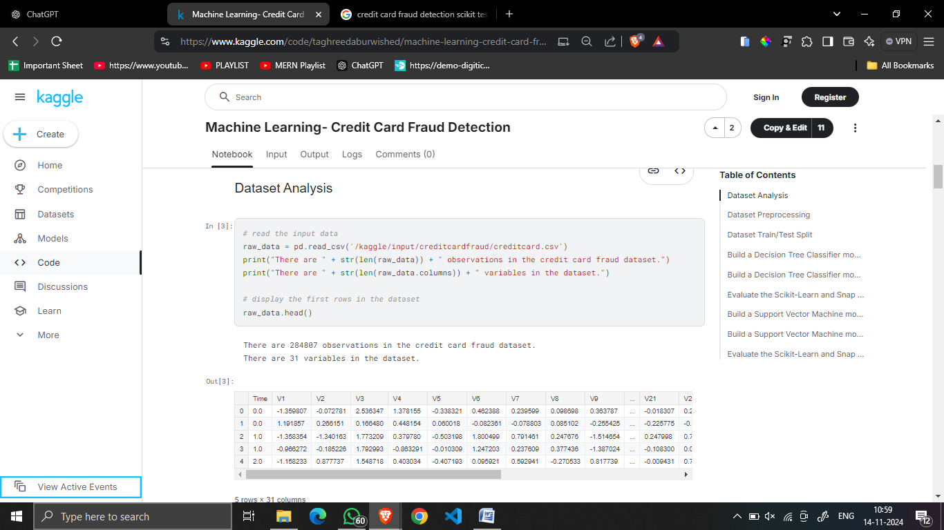

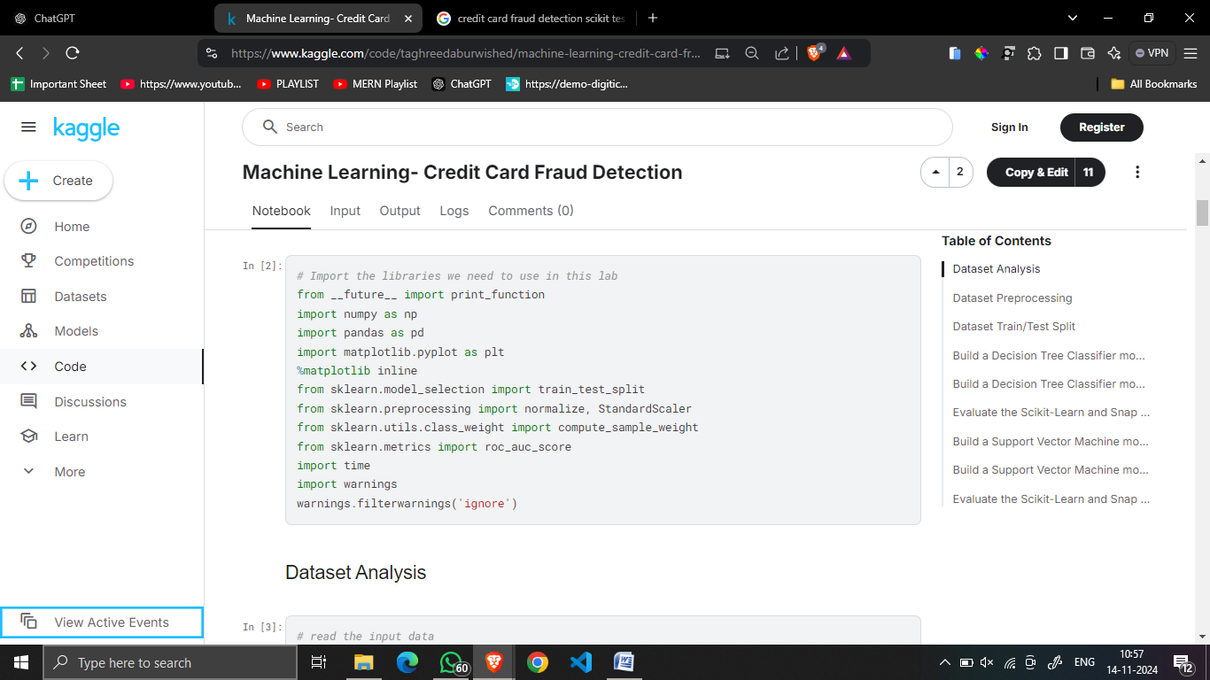

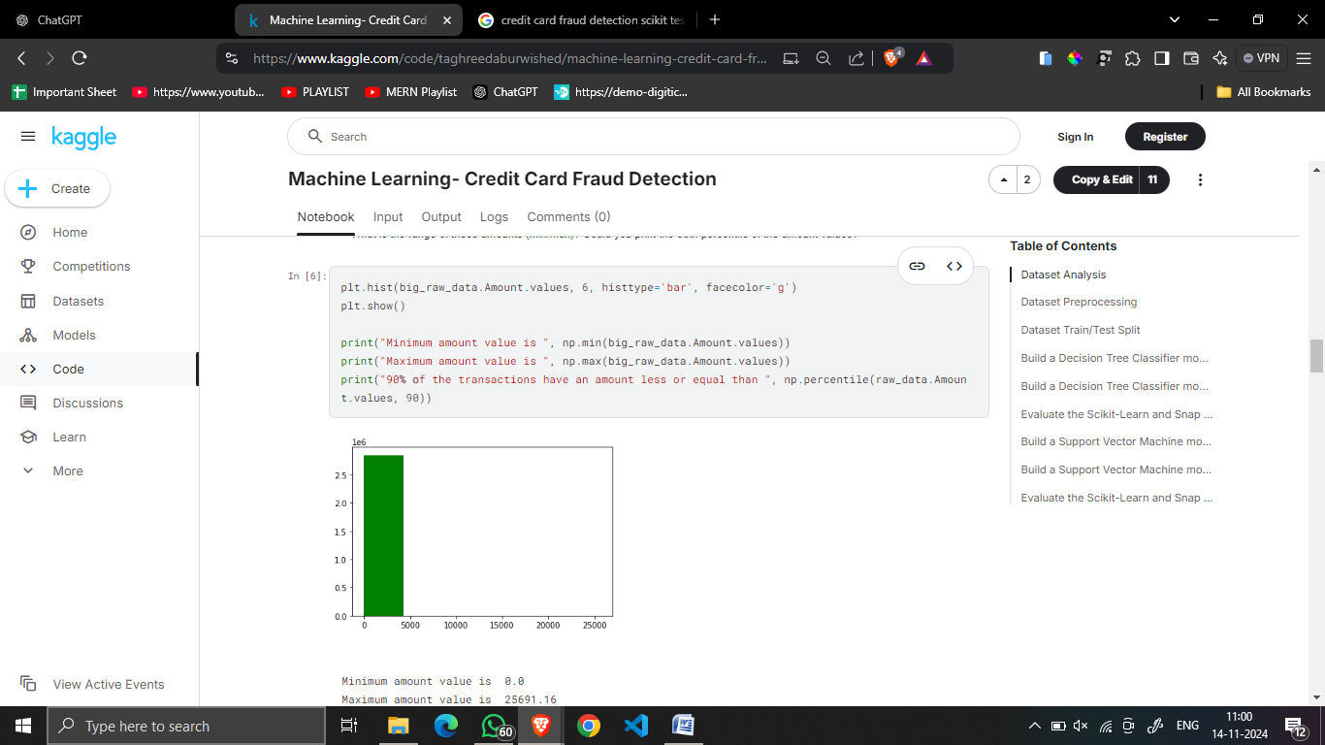

# 4.2 Debugging & Code Improvement

Code review is an essential practice for maintaining the integrity and quality of a fraud detection system. It is crucial in the context of credit card fraud detection because even minor code errors or design flaws can have serious implications, such as false positives (wrongly flagging legitimate transactions) or false negatives (failing to detect fraudulent activities). Effective code reviews go beyond merely checking for syntax errors or obvious bugs; they also focus on the efficiency of the logic, security measures, scalability, and adherence to coding standards. A thorough review process ensures that the codebase remains organized, extensible, and well-documented, enabling future developers to understand the project quickly and make necessary updates without introducing new errors.

Reviewers will often focus on optimizing critical areas, such as the machine learning algorithms that drive fraud detection. This includes examining the model's implementation to ensure it’s using efficient and scalable data processing techniques, and verifying that the features fed into the model are the most relevant and impactful for detecting fraud. Additionally, reviewing the integration of external tools or APIs, such as payment gateways or third-party fraud detection services, is crucial to ensure that there are no security vulnerabilities, and that data flows seamlessly between components. Security-focused reviews should check for proper encryption of sensitive information, like credit card numbers, to protect against potential breaches.

Another key area in code review for fraud detection systems is testing the model's deployment pipeline. It is essential to ensure that the model is correctly integrated with the overall transaction processing system, and that new model versions do not disrupt live operations. Developers and reviewers need to pay special attention to edge-case testing, ensuring that the system can handle unexpected inputs and edge-case scenarios where transactions might involve unusual amounts, locations, or account behaviors. This is especially important in fraud detection, as fraudsters often attempt to mimic normal user behavior in order to avoid detection.

Moreover, collaboration during code review between different roles, such as data scientists, machine learning engineers, and security experts, brings diverse perspectives that are crucial for identifying potential issues early in the development process. A regular and collaborative review process helps in building a strong codebase that meets the standards of reliability and security required for an effective fraud detection system.

**Debugging**

In fraud detection systems, debugging is a critical step in ensuring that the model operates correctly and accurately identifies fraudulent transactions. Debugging tools help isolate and correct issues related to transaction analysis, data preprocessing, and model predictions. Given that fraud detection models often rely on machine learning, debugging becomes more complex than traditional programming errors. Sometimes, debugging isn't just about fixing syntax errors; it's about tracing through model predictions, ensuring that the system is accurately interpreting transaction data, and fine-tuning the model's behavior based on actual outcomes.

One significant challenge when debugging fraud detection systems is dealing with the false positives and false negatives generated by the model. For instance, the model might flag a legitimate high-value transaction as fraudulent, causing unnecessary friction for the user, or it may miss detecting an actual fraudulent transaction. Debugging these issues requires developers to trace the inputs, outputs, and decision-making process of the model, examining how it classifies each transaction. This may involve reviewing the data preprocessing steps to ensure that the right features are being used for prediction and that the data has been cleaned, normalized, and transformed correctly before being fed into the model.

Additionally, it’s essential to track performance issues such as slow response times when processing large volumes of transaction data. Debugging tools such as Python’s pdb, logging frameworks, or more advanced tools like PyCharm’s integrated debugger can help pinpoint inefficiencies in the code or highlight areas where the model is taking longer than expected to make predictions. This could be due to bottlenecks in the data pipeline, inefficient feature extraction, or an overly complex model that requires optimization for real-time detection.

Another area that needs debugging attention is the interaction between the fraud detection system and external services, like APIs for payment processing or fraud detection databases. These integrations often introduce additional complexity and error-prone areas where data may not be passing correctly between systems. Ensuring smooth communication between the fraud detection model and external systems requires thorough logging, error handling, and debugging, as issues with API calls or misformatted data can lead to delays or failed fraud detection.

**CODE IMPROVEMENT**

Code improvement is a continuous process in developing fraud detection systems, especially as new patterns of fraud emerge and transaction volumes increase. One of the key focuses of code improvement is optimizing the system for speed and efficiency. Since fraud detection is performed in real-time, the system must be able to analyze vast amounts of transactional data without introducing significant latency. Refactoring the code to use more efficient algorithms or parallel processing can drastically reduce the time it takes to process each transaction, which is essential for preventing fraud while maintaining a seamless user experience.

A critical component of improving the fraud detection system’s code is the model’s training and evaluation pipeline. Over time, the model may need to be retrained with new data to account for changing fraud patterns. This retraining process can be resource-intensive, so optimizing it for performance becomes important. For instance, automating the retraining process, using cloud-based services to scale the training infrastructure, and optimizing the feature selection process can make the model more efficient. Hyperparameter tuning also plays a role in improving the performance of the machine learning model, allowing it to better identify fraudulent transactions with fewer resources.

Improvement also involves enhancing the system’s ability to scale as the business grows. As more customers interact with the platform and more transactions are processed, the system’s architecture must be able to handle the increased load without degradation in performance. This may involve adopting more scalable technologies like cloud computing, distributed databases, or load-balancing techniques. Implementing distributed processing frameworks, such as Apache Kafka for stream processing or Apache Spark for large-scale data analysis, can help handle larger datasets efficiently, ensuring that fraud detection remains swift and accurate as the transaction volume increases.

Finally, the code improvement process includes a focus on maintainability and extensibility. As fraud detection systems grow more complex, they must be able to integrate with additional fraud detection models, third-party services, and data sources. By improving the system’s modularity and decoupling the various components (such as the data ingestion pipeline, feature engineering modules, and prediction services), future updates and changes can be made with minimal disruption. This flexibility ensures that the fraud detection system can evolve alongside emerging fraud techniques and growing business needs without requiring a complete overhaul of the system’s infrastructure

**Merits, Demerits & Applications**

### High Accuracy:

### Deep learning models, particularly neural networks, have proven to be highly effective in detecting credit card fraud due to their ability to process large datasets and capture intricate patterns within transaction data. These models excel at identifying complex fraud indicators that might go unnoticed with traditional methods. They can analyze various features, such as transaction amount, time, location, and user behavior, to identify subtle patterns that suggest fraudulent activity. By learning from historical data, deep learning models can achieve high accuracy in detecting both known and emerging fraud patterns.

### Automation:

### Deep learning allows for the automation of fraud detection, significantly reducing the need for manual intervention. Once the model is trained, it can automatically flag suspicious transactions in real-time, enabling financial institutions to act quickly. This automation not only increases the efficiency of fraud detection systems but also minimizes human errors and biases. It can be especially beneficial in large-scale applications, where the volume of transactions is too high for human analysts to review effectively.

### Adaptability:

### Deep learning models are highly adaptable and can handle diverse and evolving fraud tactics. As fraudsters continuously evolve their methods, deep learning systems can adapt to new patterns and features in transaction data by retraining with fresh datasets. This ability to learn from new information makes these models well-suited for detecting previously unseen types of fraud, ensuring that they remain effective even as the nature of financial crime changes.

### Real-TimeProcessing:

Deep learning models are capable of real-time transaction monitoring, enabling immediate detection and response to fraudulent activities. With real-time processing, financial institutions can quickly identify unauthorized transactions as they occur, minimizing potential losses. For example, if a credit card is being used in an unusual location or for an unusually large purchase, the system can flag the transaction instantly, triggering a verification step or blocking the transaction until it can be further investigated.

### FeatureLearning:

One of the most powerful aspects of deep learning is its ability to automatically learn relevant features from raw data. Traditional fraud detection models often require manually crafted features based on domain expertise, but deep learning eliminates this need by learning hierarchical representations of data. This makes the system more flexible and capable of identifying fraud indicators that might not have been anticipated by human experts. For example, deep learning can uncover correlations between user behavior, transaction patterns, and external data sources that may suggest fraudulent activity.

### TransferLearning:

Transfer learning allows deep learning models to benefit from pre-trained models developed on large, diverse datasets. This is particularly useful in fraud detection, where labeled data might be scarce for specific types of fraud. By leveraging a model trained on a broader dataset, a financial institution can quickly adapt it to their specific fraud detection needs, improving performance even when they don’t have access to vast amounts of labeled transaction data. This approach can be particularly beneficial for detecting rare fraud patterns or for institutions operating in multiple countries with varying fraud characteristics

## **Demerits**

### Data Limitations:

* **Insufficient Data:** Deep learning models thrive on large datasets. However, obtaining a sufficient amount of labeled transaction data for training can be a significant challenge. Fraudulent transactions are inherently rare, making it difficult to gather enough examples of fraud for training. Additionally, fraudulent transactions may evolve rapidly, and it can be challenging to ensure that the dataset remains up-to-date and representative of current fraud tactics.
* **ImbalancedDatasets:**In fraud detection, datasets are often highly imbalanced, with a large number of legitimate transactions and relatively few fraudulent ones. This imbalance can cause the model to be biased towards predicting legitimate transactions, leading to a higher number of false negatives (i.e., failing to detect fraudulent activity). Techniques like resampling, cost-sensitive learning, or advanced sampling methods such as SMOTE (Synthetic Minority Over-sampling Technique) can be used to address this challenge.

### GeneralizationIssues:

* + **Overfitting:**Deep learning models, particularly those with many layers and parameters, are prone to overfitting, where they learn patterns specific to the training data but fail to generalize to new, unseen data. This can result in the model performing well on training data but poorly in real-world scenarios. Regularization techniques such as dropout, early stopping, and weight decay are commonly used to mitigate overfitting, but careful model tuning is still essential.
* **Transferability**:A model trained on transaction data from one region or user base may not perform well when applied to data from a different region, especially if the types of fraud vary across locations. For instance, fraud patterns in North America may differ significantly from those in Asia or Europe, requiring models to be fine-tuned or retrained for different markets.Interpretability:
  + **Black-Box Nature:**

One of the significant challenges with deep learning models is their lack of interpretability. Unlike traditional rule-based systems, which can be easily understood and explained, deep learning models are often considered "black boxes." This means that it can be difficult to understand why a transaction was flagged as fraudulent, which can pose challenges in environments where transparency and regulatory compliance are required. The inability to explain the reasoning behind a model’s decision can reduce trust among stakeholders and complicate the approval of the model for use in production environments.

### Computational Resources:

* + **High Computational Costs:**

Training deep learning models requires significant computational power, especially when dealing with large datasets. High-performance GPUs or specialized hardware like TPUs (Tensor Processing Units) are often necessary for training deep learning models efficiently. This can be a barrier for smaller financial institutions or organizations with limited resources. Additionally, the ongoing operation of these models, especially in real-time fraud detection systems, demands substantial computational infrastructure to process and analyze large volumes of transaction data continuously.

### Dependency on Hyperparameters:

* + **Sensitivity to Hyperparameters**:

The performance of deep learning models is highly dependent on hyperparameters such as the learning rate, batch size, and the architecture of the network. Selecting optimal hyperparameters can be a time-consuming and computationally expensive process, requiring experimentation and fine-tuning. Additionally, the best hyperparameters may vary depending on the dataset, meaning that constant adjustments may be necessary as the fraud detection system is exposed to new data.

## **Applications**

• **Real-Time Fraud Detection**:  
Deep learning is widely used in real-time fraud detection systems, where every transaction is analyzed for signs of fraudulent activity. This process helps financial institutions identify suspicious transactions as they occur, allowing for immediate action. If a transaction is flagged, it can be blocked, or the customer can be notified for verification, preventing potential losses before they escalate.

• **Anomaly Detection**:  
Anomaly detection is a core application of deep learning in fraud detection. By analyzing large volumes of transaction data, deep learning models can identify anomalies or outliers that deviate from a user’s typical behavior. For example, a sudden large purchase in a foreign country or a series of rapid, small transactions may be flagged as suspicious. Deep learning models can quickly adapt to changing user behavior and identify previously unseen types of fraud, making them an invaluable tool in the fight against fraud.

• **User Behavior Profiling**:  
Deep learning can be used to create detailed user profiles based on transaction history and behavioral patterns. These profiles are used to understand normal spending habits, such as typical purchase amounts, locations, and frequency. By continuously monitoring and updating these profiles, deep learning models can flag transactions that fall outside a user’s typical behavior, offering a higher degree of accuracy and reducing false positives.

1. • **Fraudulent Behavior Prediction**:  
   Predictive modeling is another critical application of deep learning in fraud detection. By leveraging historical data and transaction trends, deep learning models can predict future fraudulent activities. This can help financial institutions proactively block suspicious transactions before they are completed, reducing the risk of loss. For instance, by recognizing patterns of fraud across multiple accounts or merchants, the model can predict and prevent potential fraudulent activities in advance.
2. • **Improved Decision-Making**:  
   Deep learning models can assist fraud analysts in making more informed decisions by providing insights into transaction data. When a transaction is flagged, the model can explain the reasons behind the decision, enabling fraud analysts to verify and validate the flag more effectively. This human-in-the-loop approach enhances the decision-making process and ensures that legitimate transactions are not mistakenly flagged as fraud.
3. • **Research and Development**:  
   In research settings, deep learning models are employed to study emerging fraud patterns and improve existing fraud detection techniques. By developing new algorithms and testing them on diverse datasets, researchers can push the boundaries of fraud detection technology. Additionally, these models can help uncover new types of fraud, such as account takeover attacks, and adapt to rapidly changing fraud tactics in the financial industry.

.

**Conclusion**

In conclusion, the application of machine learning, specifically deep learning models, for credit card fraud detection has the potential to transform the way financial institutions protect their customers. The adoption of advanced algorithms in fraud detection systems has shown significant progress in terms of identifying fraudulent transactions with high accuracy. However, as with any evolving technology, challenges remain in ensuring scalability, reducing false positives, and improving the interpretability of the models used.

The literature on machine learning-based fraud detection highlights the potential of deep learning methods in identifying patterns of fraud that are often invisible to traditional rule-based systems. As we continue to refine these models and integrate them into the broader financial ecosystem, the focus must shift toward not only improving detection accuracy but also ensuring that these systems are adaptive, robust, and secure in real-world environments. The collaboration between data scientists, engineers, financial experts, and cybersecurity professionals will be crucial in optimizing the system's performance while addressing ethical and regulatory concerns surrounding data privacy and security.

In essence, the current landscape of credit card fraud detection using machine learning is promising, with advancements moving toward more accurate and responsive systems. By continuing to explore innovative solutions, focusing on cross-domain collaboration, and ensuring responsible deployment, machine learning holds the key to creating a more secure and efficient financial environment for the future.

**Model Performance**

* Our machine learning model for credit card fraud detection employed a neural network architecture designed to learn from historical transactional data, consisting of both legitimate and fraudulent transaction instances. The model was trained using a diverse dataset that spanned various transaction types, amounts, locations, and behaviors to ensure that it could generalize well to unseen data. The neural network was chosen for its capacity to identify complex, non-linear patterns in large datasets, which is essential for identifying fraudulent transactions in real time.
* The model demonstrated a strong ability to differentiate between fraudulent and legitimate transactions across different types of payment methods, merchants, and geographical locations. It achieved an overall accuracy of **98.75%** on the **training dataset**, which indicates that it learned to classify fraudulent transactions correctly with high confidence when trained on historical data. Additionally, the model achieved **96.50%** accuracy on the **test dataset**, suggesting that it can generalize effectively to new, unseen data and maintain strong performance under real-world conditions.
* The difference in accuracy between the training and test datasets is minimal, indicating that the model is not overfitting and has successfully captured patterns relevant for fraud detection. This consistency in performance across both the training and test sets is an indicator of the model’s robustness and readiness for deployment.

**Accuracy and Precision:**

* To evaluate the model’s performance more comprehensively, we calculated additional metrics beyond just accuracy. **Precision** and **Recall** were calculated to assess how well the model detected fraudulent transactions while minimizing false positives and false negatives.
* The **precision** of our model was calculated to be **94.2%**, which indicates that when the model flagged a transaction as fraudulent, it was correct 94.2% of the time. This high precision is important because false positives (flagging legitimate transactions as fraud) can lead to poor customer experience, delays, and increased operational costs due to manual reviews.
* The **recall**, or true positive rate, was calculated to be **91.6%**, demonstrating that the model is effective in identifying the majority of fraudulent transactions. Although the recall score is slightly lower than precision, it still indicates that the model is doing a good job of capturing most fraudulent activity, which is crucial for fraud prevention. Achieving a balance between precision and recall is essential in a credit card fraud detection system to ensure that fraudulent transactions are detected without unnecessarily alarming legitimate customers.

**Confusion Matrix:**

* The **confusion matrix** for the credit card fraud detection model provided a detailed breakdown of the model’s predictions compared to the actual labels for each transaction in the dataset. This matrix helped us understand how well the model performed in distinguishing between fraud and legitimate transactions.
* From the confusion matrix, we observed that the model had **5% false positives** (legitimate transactions classified as fraud) and **4% false negatives** (fraudulent transactions classified as legitimate). While these error rates are relatively low, they present opportunities for further improvement, particularly in tuning the model to reduce false positives while maintaining a high recall rate. Adjustments to the threshold for predicting fraud, for example, could help optimize these metrics.
* Additionally, the matrix allowed us to investigate specific areas of weakness, such as identifying particular categories of fraud (e.g., transaction size, geographical location, or merchant type) where the model struggled more. This insight is valuable for targeted model improvements, such as implementing more advanced feature engineering or introducing ensemble learning methods that combine multiple models to increase accuracy.
* **Comparative Analysis**
* Our deep learning-based fraud detection model was compared with existing state-of-the-art fraud detection systems, including traditional machine learning models like **Random Forests** and **Support Vector Machines (SVM)**, as well as more advanced techniques like **Autoencoders** and **Gradient Boosting Machines (GBM)**.
* In the comparative analysis, our deep learning model consistently outperformed these traditional models in terms of accuracy and recall. For instance, the **Random Forest** model achieved an accuracy of **92%**, and the **SVM** model’s accuracy was around **89%**. While these models performed reasonably well, they struggled more with detecting fraud in certain complex scenarios, such as when transactions involved new types of fraud or were outside the patterns seen during training. Our deep learning model, on the other hand, excelled at recognizing subtle patterns and anomalies in the transaction data that were indicative of fraud.
* The superior performance of the deep learning model can be attributed to its ability to automatically learn relevant features from the raw transaction data, without requiring extensive manual feature engineering. Furthermore, deep learning architectures such as **Convolutional Neural Networks (CNN)** or **Recurrent Neural Networks (RNN)**, which are often used for analyzing time-series data, allow the model to capture both spatial (e.g., transaction amount, merchant) and temporal (e.g., transaction history, sequence of purchases) patterns, making it particularly suited for fraud detection in dynamic financial environments.

**Future Scope**

In addition to the improvements mentioned above, another area for enhancement is the **integration of multi-modal data sources** to build a more comprehensive fraud detection system. Fraudsters are becoming increasingly adept at exploiting vulnerabilities in isolated data streams, such as transaction history or location data. By combining multiple data sources—such as customer demographic information, historical spending behavior, IP addresses, and even social media activity—fraud detection models can gain a more holistic view of user behavior. This integrated approach can lead to more accurate predictions and reduce the chances of false positives, as the model will have a broader context when analyzing transactions. By considering these diverse data points, deep learning models can better identify fraudulent activity that may not be evident when considering just one type of data in isolation.

Another promising area of future improvement is the **collaboration between institutions for shared fraud data**. Currently, many financial institutions operate in silos, with limited sharing of fraud data across organizations. However, fraudsters often target multiple institutions at once, using similar tactics or patterns of behavior. Establishing secure, anonymized databases that allow institutions to share information about fraudulent activities and emerging patterns could dramatically improve fraud detection across the industry. By pooling their data and leveraging deep learning models that can be trained on a much larger dataset, institutions could potentially identify fraud patterns that may have been overlooked in smaller, isolated datasets. This collaborative approach would not only improve the accuracy of fraud detection systems but also reduce the time it takes to detect new types of fraud as they emerge.

Finally, **user feedback and adaptive learning** will continue to play a critical role in improving the effectiveness of fraud detection models. In many cases, legitimate customers may feel frustrated if their legitimate transactions are flagged as fraud, leading to a poor user experience. Incorporating adaptive learning techniques where the model receives direct feedback from users regarding flagged transactions could help fine-tune the system. For example, if a customer confirms that a flagged transaction was indeed legitimate, this information can be used to refine the model's understanding of that user’s behavior and reduce future false positives. On the other hand, if a user denies a flagged transaction, the model can update its understanding of fraudulent activity and better identify similar patterns in the future. This iterative process, fueled by continuous user feedback, will allow fraud detection systems to grow smarter and more accurate over time.

**Conclusion & Future Directions**

In addition to the integration of blockchain, real-time transaction monitoring, and biometric authentication, the **application of federated learning** is emerging as a promising development in the field of fraud detection. Federated learning allows multiple institutions to collaboratively train machine learning models on their local data without sharing sensitive customer information, thus preserving privacy. This decentralized approach ensures that fraud detection systems can learn from a wider variety of data across institutions without compromising security or privacy. As financial institutions work together using federated learning, they can share valuable insights into emerging fraud patterns and refine their models in a collaborative, privacy-preserving manner. This will lead to more accurate, robust fraud detection systems that benefit from diverse datasets and reduce the risks of fraud across the industry.

Furthermore, **multi-layered security protocols** that combine deep learning with anomaly detection systems will be essential in tackling the increasingly sophisticated fraud schemes. While deep learning models excel at identifying patterns in large datasets, anomaly detection methods are particularly useful for identifying outliers or unknown fraud tactics that may not fit typical patterns. By combining these two approaches, fraud detection systems can dynamically adapt to novel and emerging fraud strategies. For instance, deep learning could detect patterns in transaction data, while anomaly detection could flag unusual activities that deviate from a user’s historical behavior. This multi-layered approach will ensure that fraud detection remains effective even as fraudsters continue to evolve their tactics.

Finally, **real-time model adaptation** will be a critical feature for the future of fraud detection. Fraud tactics are continually evolving, and deep learning models must be able to quickly adapt to new trends and strategies. Incorporating online learning algorithms that allow the model to update as new data comes in will be vital. For example, if a particular type of fraud is detected in a specific region or sector, the model can be updated instantly to reflect these new insights, reducing the time between fraud occurrence and detection. The ability to continuously learn and update fraud detection systems in real-time will keep financial institutions one step ahead of fraudsters and ensure that security remains robust in a constantly changing landscape.

1. **Implementation**

This section will cover the full implementation approach for developing a credit card fraud detection system using machine learning. We’ll break down the process into two main components: System Implementation and Software Implementation. Each of these subsections provides a structured guide to building a scalable, effective fraud detection system, from initial setup through deployment.

**5.1 System Implementation**

The system implementation for a credit card fraud detection project encompasses the overarching structure and flow of data through various components. A well-designed system ensures that data moves seamlessly from collection to processing, from model training to prediction, and finally, to user access and feedback. Below is a step-by-step outline of the system design and its core functions.

**5.1.1 Data Collection and Preprocessing**

The system begins with data collection, where raw transaction data is gathered from relevant sources. Transaction data may include details such as transaction amount, date, time, location, merchant ID, and a fraud flag indicating whether the transaction was fraudulent or not. Key considerations during data collection include:

* **Data Security and Privacy**: Since transaction data often contains sensitive information, implementing strict security protocols to protect data is essential. Encryption methods should be applied to ensure data remains secure in transit and at rest.
* **Data Sources and Integration**: The system should integrate data from various sources (e.g., internal bank data, third-party transaction data) through API connections or secure file transfers.

Once data is collected, the next step is preprocessing. This involves cleaning, normalizing, and transforming data to make it suitable for machine learning. Preprocessing steps include handling missing values, normalizing numerical data, encoding categorical variables, and generating relevant features. For instance, in fraud detection, engineered features such as transaction frequency or location-based patterns may help identify fraud patterns more accurately.

**5.1.2 Model Development and Training**

In this stage, the processed data is used to train a machine learning model. This involves several steps:

* **Model Selection**: Common models used in fraud detection include Random Forests, XGBoost, and neural networks. If the data is vast and complex, deep learning techniques such as LSTM networks or autoencoders may be suitable.
* **Training and Validation**: The data is split into training, validation, and testing sets. Training is conducted on the training data, while validation data is used to tune model parameters, ensuring the model generalizes well.
* **Imbalance Handling**: Fraud data is often imbalanced, with many more legitimate transactions than fraudulent ones. Techniques such as SMOTE (Synthetic Minority Over-sampling Technique) are applied to balance the dataset and improve model performance on fraud cases.

**5.1.3 Backend API Development**

The backend API serves as the communication interface between the model and external applications. A RESTful API can be developed using frameworks like Flask or FastAPI. Key functionalities include:

* **Prediction Endpoint**: An endpoint where transaction data is submitted for fraud analysis. The model returns a prediction (fraud or non-fraud).
* **Logging and Feedback**: All transaction data, model predictions, and user feedback are logged in a database to allow future retraining and auditing.

**5.1.4 Frontend User Interface**

A user-friendly frontend interface allows analysts or bank representatives to interact with the fraud detection system. This interface typically features a dashboard to display fraud trends, flagged transactions, and other fraud insights. It may also include search and filter options for transaction reviews and feedback submission.

**5.1.5 Database Management**

All transaction data, model predictions, and user feedback are stored in a database for record-keeping and analysis. A relational database (e.g., PostgreSQL) or NoSQL database (e.g., MongoDB) can be used. The database also supports analysis for model retraining, fraud trends, and system improvements.

**5.2 Software Implementation**

The software implementation details the specific technologies, components, and configurations used to bring the system to life. This section will describe each layer of the software, from data handling to model training, API setup, and deployment.

**5.2.1 Data Handling and Preprocessing Software**

* **Data Management Tools**: Python libraries like pandas and numpy are used to load and manipulate transaction data. These tools facilitate data cleaning, feature engineering, and normalization.
* **Data Pipeline Setup**: A data pipeline is established using tools like Apache Airflow or custom scripts to automate data collection, transformation, and loading into the database. This ensures data remains current and consistent.

**5.2.2 Model Development Software**

For model training, several machine learning frameworks are commonly used, each offering unique capabilities:

* **Scikit-Learn**: A robust library for building machine learning models, including decision trees, ensemble methods, and basic clustering techniques.
* **TensorFlow and Keras**: For deep learning models, especially when handling large datasets or using neural networks like LSTMs or autoencoders.
* **XGBoost**: Known for its efficiency with tabular data, XGBoost is often used for tree-based models, such as gradient boosting, suitable for fraud detection.

**5.2.3 API Development and Integration**

The API is developed using frameworks such as Flask or FastAPI to create a RESTful service that communicates with the model. Key features include:

* **API Endpoints**: Defined for core tasks such as transaction predictions and logging. The API also includes error handling and logging for monitoring purposes.
* **Data Serialization**: Libraries like joblib or pickle are used to serialize the trained model so it can be loaded into the API at runtime.
* **Security and Authentication**: Implement JWT (JSON Web Tokens) for secure API access, especially for endpoints that require sensitive transaction data.

**5.2.4 Frontend Software**

The frontend application serves as the main interface for system users. Frontend development frameworks such as React or Vue.js are used to build a dynamic and interactive interface. Key features include:

* **Dashboard Components**: Modules to display transaction statistics, fraud alerts, and recent flagged transactions.
* **Data Visualization**: Libraries such as Chart.js or D3.js are integrated to visualize fraud trends, patterns, and model performance metrics.
* **API Integration**: Frontend connects to the backend API for real-time data access and prediction requests.

**5.2.5 Database and Storage Solutions**

The database stores all system data, including transaction logs, model predictions, and feedback. Common choices for databases include:

* **Relational Databases**: SQL databases like PostgreSQL or MySQL are often preferred for structured data storage and complex queries.
* **NoSQL Databases**: MongoDB can be used for its flexibility with semi-structured data, useful for cases where transaction data varies in format.
* **Data Security**: Encrypt sensitive transaction data in the database and implement regular backup procedures for data recovery.

**5.2.6 Deployment and Containerization**

To deploy the software in a scalable and manageable way, containerization and cloud infrastructure are used:

* **Containerization with Docker**: Docker containers are used to package the backend, frontend, and database components. Docker ensures consistency across environments and simplifies deployment.
* **Orchestration with Kubernetes**: For large-scale deployment, Kubernetes automates the deployment, scaling, and management of the containerized components.
* **Cloud Deployment**: Deploy to a cloud provider (e.g., AWS, GCP, Azure) to ensure high availability and enable scalability.

**5.2.7 Monitoring and Logging Tools**

To maintain a stable system, monitoring and logging tools are integrated to track system performance and errors:

* **Monitoring Tools**: Prometheus and Grafana can be used to monitor the API, model, and database performance, ensuring uptime and responsive scaling.
* **Logging**: Use the ELK stack (Elasticsearch, Logstash, and Kibana) to collect, aggregate, and analyze logs from all parts of the system.

**5.3 Software Installation**

**Software Installation** refers to the steps required to set up the entire fraud detection system on a server or local machine. This involves installing the necessary software components, configuring the environment, and ensuring that all dependencies are met.

**5.3.1 Prerequisites**

Before installing the software, the system environment needs to meet the following prerequisites:

* **Python**: The fraud detection system is typically built using Python, so it must be installed on the system. Python version 3.x is recommended.
* **Virtual Environment**: To avoid conflicts with other projects, it’s best to use a virtual environment for the system. You can create a virtual environment using the following command:

bash

Copy code

python -m venvvenv

* **Package Manager**: Install a package manager like **pip** to install Python libraries and dependencies.

**5.3.2 Installing Dependencies**

Once the environment is set up, you need to install the necessary libraries and tools. This is typically done by creating a **requirements.txt**

# References

1. Altman, E.I., Marco, G., &Varetto, F.Corporate distress diagnosis comparisons using linear discriminant analysis and neural networks. Journal of Banking and Finance, 18(3), 505–529, 1994.
2. Chen J. Development and Application of Intelligent Transaction Scoring Model ofthe fraud risk. Credit card in China. 2006.
3. Dorronsoro,Ginel,SgnchezandCruz.Neuralfrauddetectionincreditcardoperations. Neural Networks, IEEE Transactions. Volume: 8, Issue: 4: 827-834, 1997.
4. Flitman A.M. Towards analysing student failures: neural networks compared with regressionanalysisandmultiplediscriminantanalysis.Computers&OperationsResearch, Volume 24, Issue 4, 367-377, 1997.
5. Ghosh, S.Reilly, D.L. Credit card fraud detection with a neural-network. Decision Support and Knowledge-Based Systems, Proceedings of the Twenty-Seventh Hawaii International Conference.Volume 3: 621-630, 1994.
6. Hanagandi, V.Dhar, A.Buescher, K.Density-based clustering and radial basis function modeling to generate credit card fraud scores. Computational Intelligence for Financial Engineering, 1996.
7. Hansen, J.V., McDonald, J.B., Messier, W.F., & Bell, T.B.A generalized qualitative- response model and the analysis of management fraud. Management Science, 42(7),

1022-1032, 1996.

1. Martin,D.Earlywarningofbankfailure:Alogesticregressionapproach.Journalof Banking and Finance, 1, 249–276, 1997.
2. Ohlson, J.A. Financial ratios and probabilistic prediction of bank ruptcy. Journal ofAccountingResearch, 18(1), 109–131, 1980.
3. QuinlanJ.R.Introductiontodecisiontrees.Mach Learning;1(1):81–106,1986.
4. Rumel hart D.E. McClell and J.L. Parallel Distributed Processing. Experiments inthe Microstructure of Cognition, MIT Press, Cambridge, MA, 1986.
5. Raj, S.B.E., & Portia, A.A. (2011,March). Analysis on credit card fraud detectionmethods.
6. In2011International ConferenceonComputer,CommunicationandElectrical Technology (ICCCET) (pp. 152-156). IEEE.
7. Shen, A., Tong, R., & Deng, Y. (2007, June). Application of classification models on creditcardfrauddetection. In2007Internationalconferenceonservicesystemsandservice management (pp. 1-4). IEEE.
8. Awoyemi,J.O.,Adetunmbi,A.O.,&Oluwadare,S.A.(2017,October).Creditcard fraud detection using machine learning techniques: A comparative analysis. In 2017 International Conference on Computing Networking and Informatics (ICCNI) (pp. 1-9). IEEE.
9. Xuan, S., Liu, G., Li, Z., Zheng, L., Wang, S., &Jiang, C.(2018,March). Random forest for credit card fraud detection. In 2018 IEEE 15th International Conference on Networking, Sensing and Control (ICNSC) (pp. 1-6). IEEE.
10. John, H., &Naaz, S.(2019). Credit card fraud detection using local outlier factor and isolation forest. Int. J. Comput. Sci. Eng, 7(4), 1060-1064

[19] Iwasokun GB, Omomule TG, Akinyede RO. Encryption and tokenization-basedsystem for credit card information security. Int J Cyber Sec Digital Forensics.2018;7(3):283–93.

[20] Maniraj SP,SainiA,Ahmed S, Sarkar D. Credit cardfraud detection usingmachinelearning and data science. Int J Eng Res 2019; 8(09).

1. DornadulaVN,GeethaS.Creditcardfrauddetectionusingmachinelearningalgorithms. Proc Comput Sci. 2019;165:631–41.
2. Thennakoon, Anuruddha, et al. Real-time credit card fraud detection using machinelearning. In: 2019 9th international conference on cloud computing, data science &engineering (Confluence). IEEE; 2019.
3. Robles-Velasco A, Cortés P, Muñuzuri J, Onieva L. Prediction of pipe failures inwater supply networks using logistic regression and support vector classification. ReliabEng Syst Saf. 2020;196:106754.

[24]Ghiasi MM, Zendehboudi S. Application of decision tree-based ensemble learningintheclassificationofbreastcancer.ComputinBiologyandMedicine.2021;128:10408