Author Name- Navneet kaur Bhatti

Student ID – 100368904

Assignment number- 03

Course number – Info 1113

Section number- S10

Instructor Name - Dr. Abhijit Sen

Date – 15/sept/2018

Web URL - https://sites.google.com/view/navneetbhatti

github URL - <https://github.com/navneet131/NAVNEET.git>

Table of Contents

Title

**1**

introduction2

functions3

**use-case diagram4**

use-case description5

comments

conclusion6

INTRODUCTION

## The main goals of this project is to helps the people and the police authorities too to find out any person if he/she is lost or any problem has arrived. to accomplish this goal we have to use GSM module and real time location interface in our cell phones.

## the main goal of this project is to send our current location to some designated contacts automatically just before the phone gets off and it should be traced even after the phone is not working.

**Functions**

## This application will have three main functions.

## first off all , it will automatically send the location of a cell phone to designated contacts just before our cell phone run out of battery.

## second , it will continue to trace a phone even after the phone is switch off.

## last but not the least, it can send a particular messages to particular contacts according to the wish of user.

**Use-case diagram**

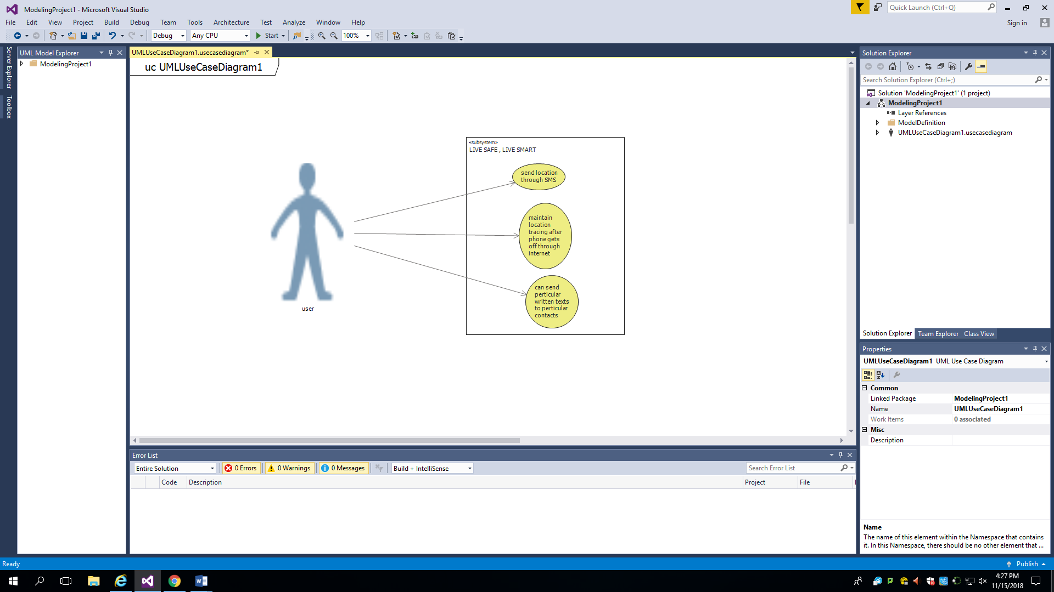

**Use-case Description**

|  |
| --- |
| Use case title – live safe, live smart |
| Primary actor - user |
| Level - Kite |
| Stakeholder - user |
| Preconditions – user access to application through play store or app store |
| Minimal guarantee – send location through SMS |
| Success guarantee- trace after phone gets off |
| Triggers – user access to application login page |
| Main success scenarios:   1. User can send the location whenever they want. 2. Any particular message can be sent to any particular contact just by one click. |
| Extensions:   1. If SMS is not send – people can recheck their settings 2. If location is wrong – users can check their location settings . 3. If login problem occur – reinstall the application. |

**Comments**

1. It was not possible in visual studio 2017 and I did not had easy access to visual studio 2015.
2. I just got one use case description because my team members were not here so I had to face a lot of difficulty.

**Conclusion**

### To conclude I would say this application will be very helpful to each and everyone and this will serve to make our society more safe and it will *do something to help the society specially the women of society.*