Fall of Tenochtitlan
From Wikipedia, the free encyclopedia
Jump to: navigation, search

Siege of Tenochtitlan
Part of the Spanish conquest of the Aztec Empire
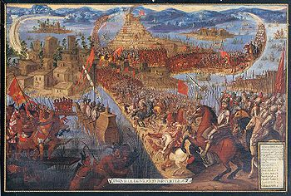
"Conquista de México por Cortés". Unknown artist, second half of the 17th century. Note that the depiction of the Aztecs' clothing and weaponry is inaccurate.
Date | May 26 - August 13, 1521
Location | Tenochtitlan, present-day Mexico City, Mexico
Result | Decisive Spanish and Tlaxcallan victory

Belligerents
Spain  Tlaxcallān | Aztec Empire
Commanders and leaders
Hernán Cortés  Pedro de Alvarado | Cuitláhuac †  Cuauhtémoc (POW)
Strength
16 guns^{[1]}  13 brigantines  80,000–200,000 native allies  86–96 cavalry  900–1,300 infantry^{[1]} | 300,000 warriors^{[2]}(including war acallis)
Casualties and losses
450–860 Spanish^{[1]}  20,000 Tlaxcallan | 100,000 warriors  100,000 civilians

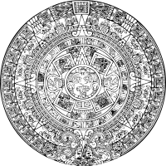
Aztec civilization
Aztec society
Nahuatl language
Religion · Mythology · Philosophy · Calendars
Human sacrifice · Medicine

