VISVESVARAYA TECHNOLOGICAL UNIVERSITY
“JnanaSangama”, Belgaum -590014,Karnataka.

MOBILE APPLICATION DEVELOPMENT REPORT on
PROJECT TITLE
Submitted by

NAVNEET KUMAR DUBEY(1BF24CS194)

Under the Guidance of
Assistant Professor, BMSCE
in partial fulfillment for the award of the degree of
BACHELOR OF ENGINEERING
in
COMPUTER SCIENCE AND ENGINEERING


B.M.S. COLLEGE OF ENGINEERING
(Autonomous Institution under VTU)
BENGALURU-560019
Feb-2026 to June-2026

1
B. M. S. College of Engineering,
Bull Temple Road, Bangalore 560019
(Affiliated To Visvesvaraya Technological University, Belgaum)
Department of Computer Science and Engineering

CERTIFICATE
This is to certify that the project work entitled “MEDISYNC” carried out by NAVNEET KUMAR DUBEY (1BF24CS194), who are bonafide students of B. M. S. College of Engineering. It is in partial fulfillment for the award of Bachelor of Engineering in Computer Science and Engineering of the Visveswaraiah Technological University, Belgaum during the year 2024-2025. The project report has been approved as it satisfies the academic requirements in respect of Mobile Application Development (23CS4AEMAD) work prescribed for the said degree.
Signature of the Guide Signature of the HOD Dr. Kavitha Sooda
Assistant Professor, Dept. of CSE Prof.& Head, Dept. of CSE BMSCE, Bengaluru BMSCE, Bengaluru
External Viva
Name of the Examiner Signature with date 1._____________________________ ________________________ 2. _____________________________ _________________________

B.M.S. COLLEGE OF ENGINEERING
DEPARTMENT OF COMPUTER SCIENCE AND ENGINEERING 
DECALARATION
We, name(USN), name(USN), name(USN), name(USN), students of 4th Semester, B.E, Department of Computer Science and Engineering, B. M. S. College of Engineering, Bangalore, hereby declare that, this Mobile Application Development entitled "Project Title" has been carried out by us under the guidance of Name of the faculty, Assistant Professor, Department of CSE, B. M. S. College of Engineering, Bangalore during the academic semester Feb-2026 to June-2026
We also declare that to the best of our knowledge and belief, the development reported here is not from part of any other report by any other students.
Signature
NAVNEET KUMAR DUBEY (1BF24CS194)

ABSTRACT
MediSync is an Android-based telemedicine application designed to bridge the gap between patients and healthcare providers through a unified digital platform. In the contemporary healthcare landscape, patients frequently encounter difficulties in scheduling appointments with qualified doctors, maintaining organised medical records, and accessing timely medical guidance. MediSync addresses these challenges by offering a comprehensive suite of features encompassing appointment management, real-time doctor-patient communication, medical record storage, AI-assisted health guidance, and video consultation.

The application supports two primary user roles, namely patients and doctors. Patients can register using their mobile number through OTP-based authentication, create a detailed health profile, search for doctors by name or medical speciality, book online or offline appointments, communicate with doctors via real-time chat, store and retrieve medical reports, and consult the AI health assistant for general health queries. Doctors, on the other hand, can manage their professional profiles, set up clinic locations using Google Maps, create weekly slot templates or custom appointment schedules, view and manage incoming appointments, and communicate with patients through chat and video calls.

The application is built using Kotlin with Jetpack Compose for the Android frontend, following the MVVM (Model-View-ViewModel) architectural pattern with a Repository layer for clean separation of concerns. The backend is developed using Node.js with Express.js and TypeScript, exposing RESTful APIs secured with JSON Web Tokens (JWT). Real-time features such as chat and video call signaling are implemented using WebSocket (Socket.io). The primary database is PostgreSQL, while MinIO serves as the object storage solution for medical reports and profile images. Redis is used for caching, Firebase Cloud Messaging for push notifications, and the Gemini API powers the AI health assistant module.

The deployment infrastructure consists of a Linux cloud server running Docker containers for PostgreSQL, Redis, and MinIO, with the Node.js backend managed by PM2 for process reliability. The project demonstrates practical application of modern Android development practices, cloud deployment techniques, real-time communication protocols, and integration of external services such as Google Maps and AI APIs, making it a full-stack, production-oriented healthcare solution.

TABLE OF CONTENTS

CHAPTER 1: INTRODUCTION

1.1 Background
The rapid proliferation of smartphones and mobile internet connectivity has fundamentally transformed the manner in which individuals access and manage healthcare services. Traditional healthcare systems, which rely on physical visits to clinics, manual appointment booking through telephone calls, and paper-based medical records, present numerous inconveniences for both patients and healthcare providers. Patients often experience long waiting times, difficulty in locating appropriate specialists, and challenges in maintaining a continuous record of their health history. Doctors, on the other hand, struggle with managing appointment slots efficiently, communicating with patients post-consultation, and organising patient-related documents.

The COVID-19 pandemic accelerated the adoption of telemedicine globally, underscoring the need for robust digital platforms that enable remote consultation. Even in post-pandemic scenarios, telemedicine continues to be a preferred mode of consultation for non-emergency conditions, follow-up appointments, mental wellness support, and situations where physical access to a clinic is inconvenient or impractical.

Mobile application development has emerged as a critical enabler of telemedicine solutions. Applications such as Practo, Apollo 247, and similar platforms have demonstrated the viability and user acceptance of digital healthcare services in the Indian context. These platforms, however, often lack tight integration between appointment booking, real-time consultation, and medical record management within a single cohesive application.

1.2 Problem Statement
The principal problems addressed by MediSync are as follows. First, patients lack a convenient mechanism to search for doctors by speciality and book appointments in real time without telephonic interaction. Second, medical records are scattered across physical documents, email attachments, and various applications, making it difficult for patients to present a consolidated health history during consultations. Third, there is no seamless channel for asynchronous communication between patients and doctors between appointments. Fourth, patients who have booked offline (in-person) appointments have no easy way to locate the clinic on a map within the same application. Fifth, patients with minor health queries must either wait for an appointment or rely on unverified information from the internet.

1.3 Proposed Solution
MediSync proposes an integrated Android application that addresses each of the aforementioned problems. The application provides OTP-based authentication using Firebase Phone Auth, ensuring secure access for both patients and doctors. Patients can search for doctors using a search bar that queries by doctor name or speciality, browse available time slots categorised by morning and evening, and book appointments with a single interaction. Medical records can be uploaded directly from the chat interface or through the dedicated Records section, and are stored securely in MinIO object storage with metadata persisted in PostgreSQL.

Real-time chat is facilitated through a WebSocket-based messaging system, allowing doctors and patients to exchange text messages and file attachments during and between consultations. For online appointments, a video calling feature enables face-to-face consultation through WebRTC-based signaling over WebSocket. Clinic locations are displayed using Google Maps within the doctor profile and appointment detail screens, enabling patients to navigate to the clinic effortlessly. The integrated AI health assistant, powered by the Gemini API, provides general health guidance, symptom analysis, and medicine-related information while clearly indicating that AI responses are not a substitute for professional medical advice.

1.4 Scope of the Project
MediSync is designed as a two-sided platform serving patients and doctors within the context of a laboratory project for the Mobile Application Development course. The application covers the full lifecycle of a telemedicine interaction, from user registration and profile creation through appointment booking, consultation, and post-consultation record management. The project demonstrates the integration of multiple technologies including Android, Node.js, PostgreSQL, WebSocket, Firebase, Google Maps, MinIO, and the Gemini API. The scope excludes features such as payment gateway integration, prescription generation, and an administrative dashboard, which are identified as future enhancements.

CHAPTER 2: OBJECTIVES
The objectives of the MediSync project are as follows.

1. To design and develop an Android-based telemedicine application that serves both patients and doctors on a unified platform.

2. To implement a secure, OTP-based mobile authentication mechanism using Firebase Phone Authentication and JWT-protected REST APIs.

3. To enable patients to search for doctors by name and speciality, view detailed doctor profiles including qualifications, clinic information, and consultation modes, and book appointments based on available slots.

4. To provide doctors with the ability to manage their weekly and custom appointment schedules, set consultation fees and durations, and receive and manage appointment requests from patients.

5. To implement a real-time bidirectional chat system using WebSocket that supports text messages and file/image sharing between doctors and patients.

6. To develop a medical records module that allows patients to upload, store, and retrieve reports in image or PDF format, with files stored in MinIO and metadata persisted in PostgreSQL.

7. To integrate the Gemini API as an AI health assistant that can respond to patient queries related to symptoms, medications, diet, and health information, with appropriate safety disclaimers.

8. To implement a clinic location feature using the Google Maps SDK that allows doctors to set and save their clinic coordinates, and enables patients to view the clinic location within the application.

9. To support online video consultations through a WebRTC-based signaling mechanism over WebSocket, enabling real-time audio and video communication between doctors and patients.

10. To deploy the backend application on a Linux cloud server using Docker for service orchestration and PM2 for process management, ensuring reliability and availability.

11. To follow the MVVM architectural pattern with a Repository layer on the Android client, ensuring separation of concerns, testability, and maintainability of the codebase.

12. To validate the application through scenario-based testing covering all major modules, ensuring functional correctness and robustness under various user interactions.

CHAPTER 3: HARDWARE AND SOFTWARE REQUIREMENTS

3.1 Hardware Requirements

3.1.1 Development Machine
A computer with a minimum of 8 GB RAM and a quad-core processor is required for development. This specification is necessary to run Android Studio, the Node.js development server, PostgreSQL, and Docker containers concurrently without performance degradation. A 64-bit operating system is mandatory to run the Android emulator with hardware acceleration.

A minimum of 50 GB of free storage is required to accommodate Android Studio, the Android SDK, Docker images, and project source files. An SSD is recommended to reduce build times.

3.1.2 Android Device or Emulator
A physical Android device running Android 8.0 (API Level 26) or higher is required for testing. The device must support 4G/LTE connectivity for OTP reception and real-time communication. A minimum screen resolution of 1080 x 1920 pixels is recommended to accurately represent the application UI. An Android emulator with at least 4 GB of allocated RAM may be used as an alternative for development and testing purposes; however, a physical device is strongly preferred for testing Firebase Phone Authentication, camera access, and real-time video calling.

3.1.3 Cloud Server
A Linux-based cloud server instance (Ubuntu 20.04 LTS or higher) with a minimum of 2 vCPUs and 4 GB of RAM is required for backend deployment. The server must have port 3000 (or the configured application port), port 5432 (PostgreSQL), port 9000 (MinIO), and port 6379 (Redis) accessible as required. Sufficient disk space (minimum 20 GB) is required for PostgreSQL data, MinIO object storage, and Docker volumes.

3.2 Software Requirements

3.2.1 Android Studio
Android Studio Hedgehog (2023.1.1) or a later stable release is required as the Integrated Development Environment for Android application development. Android Studio provides the Gradle build system, Android SDK Manager, layout editor, and Logcat, all of which are essential for building and debugging the Jetpack Compose-based UI.

3.2.2 Kotlin
Kotlin version 1.9.x or higher is used as the primary programming language for Android development. Kotlin offers null safety, coroutines for asynchronous programming, and concise syntax, making it the officially recommended language for Android development by Google.

3.2.3 Jetpack Compose
Jetpack Compose, Google's modern declarative UI toolkit for Android, is used to build the application's user interface. Compose eliminates the need for XML-based layouts and enables UI components to be written entirely in Kotlin, resulting in reduced boilerplate and improved maintainability. Compose BOM version 2024.x or higher is required.

3.2.4 Node.js and Express.js
Node.js version 18.x LTS or higher is required to run the backend server. Express.js is used as the web application framework to define and handle REST API endpoints. The combination of Node.js and Express.js, written in TypeScript for type safety, provides a lightweight and performant server suitable for handling concurrent API requests and WebSocket connections.

3.2.5 PostgreSQL
PostgreSQL version 14 or higher is used as the primary relational database management system. PostgreSQL is chosen for its robustness, support for complex queries, ACID compliance, and wide community adoption. It stores all structured data including user records, doctor profiles, appointment slots, appointments, chat messages, and medical report metadata.

3.2.6 Docker
Docker is used to containerise the PostgreSQL, Redis, and MinIO services on the deployment server. Docker Compose facilitates the orchestration of these services with a single configuration file, ensuring consistent environments across development and production deployments.

3.2.7 MinIO
MinIO is an open-source, S3-compatible object storage system used to store medical reports (images and PDFs) and user profile photographs. Its S3-compatible API allows the backend to interact with it using standard AWS SDK calls. MinIO provides high performance and is suitable for self-hosted deployments.

3.2.8 Firebase
Firebase is used for two purposes. Firebase Phone Authentication provides OTP-based mobile number verification during user registration and login. Firebase Cloud Messaging (FCM) is used to deliver push notifications to users for events such as new messages, appointment confirmations, and upcoming appointment reminders.

3.2.9 Google Maps SDK for Android
The Google Maps SDK for Android is integrated into the application to provide interactive map views within the Clinic Location screen and the Appointment Details screen. It enables doctors to place a marker on the map to designate their clinic location, and enables patients to view the clinic on a map and navigate to it.

3.2.10 Gemini API
The Gemini API, provided by Google, powers the AI health assistant feature within MediSync. It enables patients to ask natural language health questions and receive informative responses about symptoms, medications, diet, and general health topics. The API is integrated through the backend to maintain API key security.

3.2.11 Redis
Redis is an in-memory data structure store used for caching frequently accessed data such as doctor lists and appointment slot information, reducing the load on PostgreSQL and improving API response times.

3.2.12 PM2
PM2 is a production-grade process manager for Node.js applications. It is used on the deployment server to keep the backend application running continuously, automatically restarting it in the event of a crash, and providing logging and monitoring capabilities.

CHAPTER 4: SYSTEM DESIGN AND ARCHITECTURE

4.1 Overview
MediSync follows a client-server architecture in which the Android application acts as the client and a Node.js server provides the backend services. The client communicates with the backend through two primary channels: RESTful HTTP APIs for standard data operations, and a persistent WebSocket connection for real-time communication features including chat and video call signaling. Third-party services are integrated at both the client and server levels.

4.2 Client-Server Architecture
The Android client initiates communication with the backend server by making HTTP requests to the REST API endpoints. These endpoints are protected by JWT-based authentication, whereby the client includes a Bearer token in the Authorization header of every authenticated request. The server validates the token, processes the request, interacts with PostgreSQL or MinIO as required, and returns a JSON response.

For real-time features, the client establishes a WebSocket connection to the server upon login. The WebSocket connection is maintained throughout the session, enabling the server to push messages, typing indicators, and video call signaling events to the client without the overhead of repeated HTTP polling.

4.3 Android MVVM Architecture
The Android application strictly follows the Model-View-ViewModel (MVVM) architectural pattern, which is the officially recommended architecture by Google for Android development. The architecture is organised into three primary layers.

The View layer consists of Jetpack Compose composable functions that render the UI. Composables observe state exposed by the ViewModel through Kotlin's StateFlow and Compose's collectAsState mechanism. The View layer does not contain any business logic; it solely renders the UI based on the observed state and delegates user interactions to the ViewModel.

The ViewModel layer acts as the intermediary between the View and the data layer. It holds the UI state, processes user interactions, and calls the appropriate Repository methods to fetch or mutate data. ViewModels survive configuration changes such as screen rotation, ensuring that the UI state is not lost during such events. Kotlin Coroutines are used extensively within ViewModels to perform asynchronous operations without blocking the main thread.

The Repository layer abstracts the data sources from the ViewModel. Each Repository may interact with one or more data sources, such as the backend REST API (via Retrofit), the local Room database for caching, or the WebSocket connection. This abstraction enables the ViewModel to remain agnostic of where the data comes from, making the codebase easier to test and maintain.

4.4 Backend API Architecture
The backend is organised as a modular Express.js application written in TypeScript. Each domain area, such as authentication, appointments, chat, and medical records, is encapsulated in a dedicated router module with its associated controller and service files. Middleware functions handle cross-cutting concerns such as JWT verification, request logging, and error handling.

API requests follow a standard flow: the request is received by Express, passed through authentication middleware, forwarded to the appropriate controller function, processed by the service layer which contains the business logic, and the result is returned as a JSON response. Database interactions are performed using a PostgreSQL client library (pg), with parameterised queries to prevent SQL injection.

4.5 WebSocket Architecture
Socket.io is used to implement the WebSocket server. Upon establishing a connection, the client authenticates by sending its JWT token, which the server validates. Users join named rooms corresponding to their chat room IDs. When a message is sent, the server broadcasts it to all participants in the corresponding room. The WebSocket layer also handles video call signaling events, including call initiation, ICE candidate exchange, and call termination, facilitating the WebRTC peer-to-peer connection setup between doctor and patient.

4.6 Database and File Storage Architecture
All structured application data is stored in PostgreSQL. The database schema consists of interconnected tables representing users, profiles, appointments, chat rooms, messages, and medical records. Foreign key constraints ensure referential integrity across all relationships.

Binary files including medical reports and user profile photographs are stored in MinIO. When a file is uploaded, the backend uploads it to MinIO and stores the resulting object key in the corresponding PostgreSQL record. When a client requests a file, the backend generates a presigned URL from MinIO, which the client uses to fetch the file directly from MinIO, reducing the load on the application server.

CHAPTER 5: DATABASE DESIGN

5.1 Overview
The MediSync database is implemented in PostgreSQL. The schema is designed to support all application modules, including user management, doctor and patient profiles, appointment slot management, appointment booking, real-time chat, medical record storage, and doctor ratings. The primary key for most tables is a serial integer, and foreign keys are used to establish relationships between tables, ensuring data integrity.

5.2 Entity-Relationship Diagram
The Entity-Relationship (ER) diagram below illustrates the primary tables in the MediSync database and the relationships between them. The central entity is the users table, from which patient and doctor profile tables are derived. Doctor-specific tables govern slot settings and clinic information. The appointments table links patients, doctors, and appointment slots. Chat rooms are created per appointment, and chat messages are associated with a chat room. Medical reports are linked to patients and chat rooms.

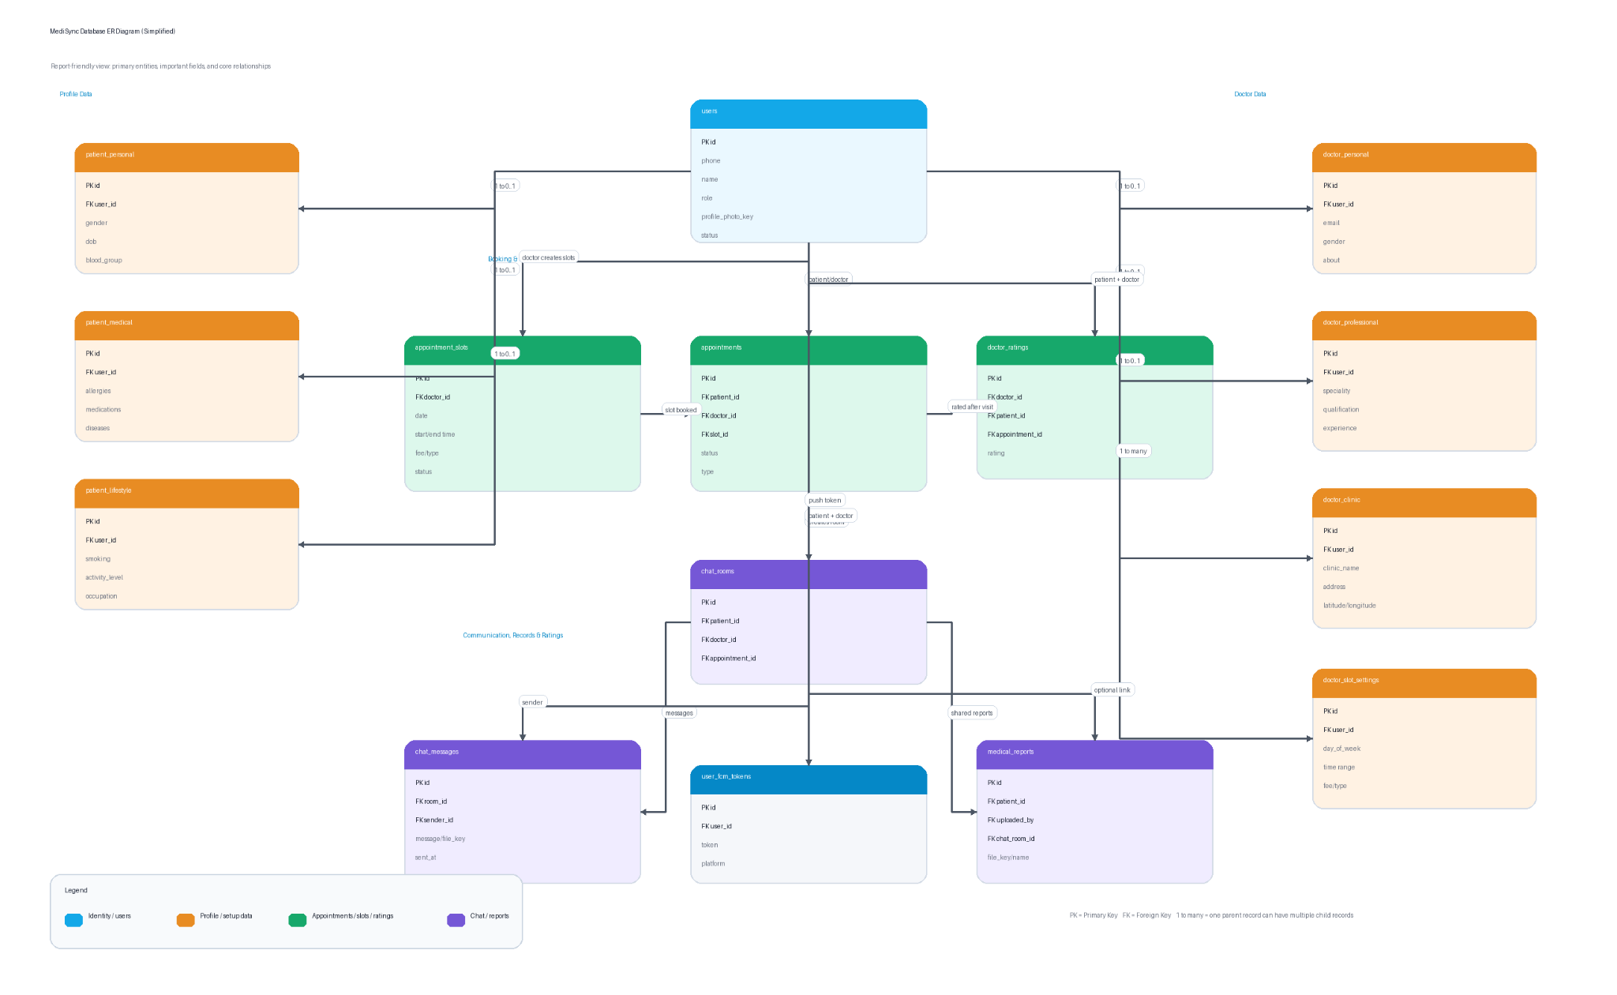

Figure 5.1: Entity-Relationship Diagram of the MediSync Database

5.3 Table Descriptions

5.3.1 users Table
The users table is the root entity of the schema. It stores core identity information common to all users regardless of their role. Key columns include id (primary key), phone (unique mobile number), name, role (either "patient" or "doctor"), profile_photo_key (MinIO object key for the profile photograph), status, created_at, and updated_at. The role column determines which profile tables are populated for a given user.

Figure 5.2: users Table - Data

5.3.2 doctor_slot_settings Table
The doctor_slot_settings table stores the weekly recurring slot template configured by a doctor. Each row represents a single slot within a day of the week. Key columns include id, user_id (foreign key referencing the doctor's user record), day_of_week (e.g., "Mon", "Tue"), start_time, end_time, slot_duration_minutes, consultation_type (Online or Offline), and consultation_fee. These settings are used to auto-generate appointment_slots for upcoming dates.
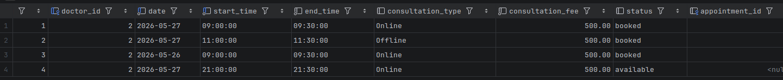
Figure 5.4: doctor_slot_settings Table - Schema

5.3.3 appointment_slots Table
The appointment_slots table contains the actual bookable slot instances for each doctor on a specific date. Each slot includes doctor_id, date, start_time, end_time, consultation_type, consultation_fee, status (either "available" or "booked"), and appointment_id (populated once the slot is booked). Slots are generated from the doctor_slot_settings template or added individually through the custom schedule feature.
Figure 5.5: appointment_slots Table - Data

5.3.4 appointments Table
The appointments table records every appointment booking. It references the patient, doctor, and the specific appointment slot. Key columns include id, patient_id, doctor_id, slot_id, status (e.g., "accepted", "pending", "cancelled"), type (Online or Offline), and created_at. When an appointment is confirmed, the corresponding slot in appointment_slots is marked as "booked" and the appointment_id foreign key is set.
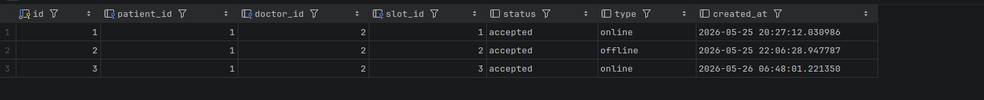

Figure 5.6: appointments Table - Data

5.3.5 chat_rooms Table
A chat room is created for each patient-doctor pair associated with a specific appointment. The chat_rooms table stores patient_id, doctor_id, and appointment_id. Once created, the chat room persists and is reused for all messages between the same patient-doctor pair related to that appointment.
Figure 5.7: chat_rooms Table - Data

5.3.6 chat_messages Table
The chat_messages table stores individual messages within a chat room. Key columns include id, room_id (foreign key referencing chat_rooms.id), sender_id, message_type (text or file), file_name (populated for file/image messages), is_read (read receipt flag), and sent_at. Message content for text messages is stored in a separate content column.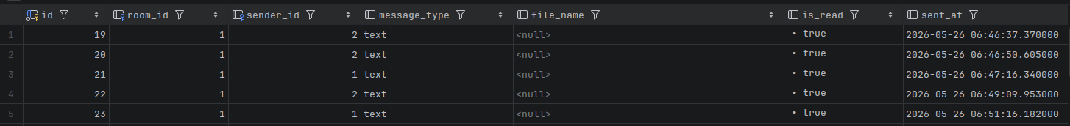
Figure 5.8: chat_messages Table - Data

5.3.7 medical_reports Table
The medical_reports table stores metadata for medical reports uploaded by patients. Each record links to a patient through patient_id, and to the chat room through chat_room_id. Additional columns include uploaded_by (the user ID of the uploader), file_name (the original filename), file_type, file_size, and created_at. The actual file is stored in MinIO, and the object key is retained in this table.

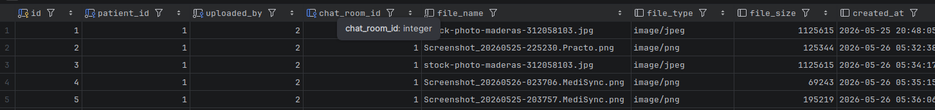
Figure 5.9: medical_reports Table - Data

5.3.8 doctor_ratings Table
The doctor_ratings table allows patients to submit ratings for doctors following a completed appointment. Key columns include id, doctor_id, patient_id, appointment_id, rating (an integer value, typically 1 to 5), comment, and created_at. The appointment_id foreign key ensures that each rating is linked to a specific consultation.
Figure 5.10: doctor_ratings Table - Data

5.4 Key Relationships
The users table is the central hub of the schema. Patient and doctor profile tables reference users.id through user_id or patient_id/doctor_id foreign keys. The doctor_slot_settings and appointment_slots tables reference the doctor's user record. The appointments table references the patient, doctor, and the specific slot. Each appointment creates a corresponding chat_rooms record, which in turn is referenced by chat_messages and medical_reports. The doctor_ratings table references the appointment, patient, and doctor, ensuring that ratings are traceable to specific consultations.

CHAPTER 6: IMPLEMENTATION AND SCREENSHOTS

6.1 Authentication Module

6.1.1 Login Screen
The login screen is the entry point of the MediSync application. It presents the application logo, tagline ("Healthcare, Connected."), a phone number input field with the +91 country code prefix, and a "Send OTP" button. Upon entering a valid 10-digit mobile number and tapping the button, the application triggers Firebase Phone Authentication to send a 6-digit OTP to the entered number. The button is disabled until a valid phone number is entered,preventing premature submissions.
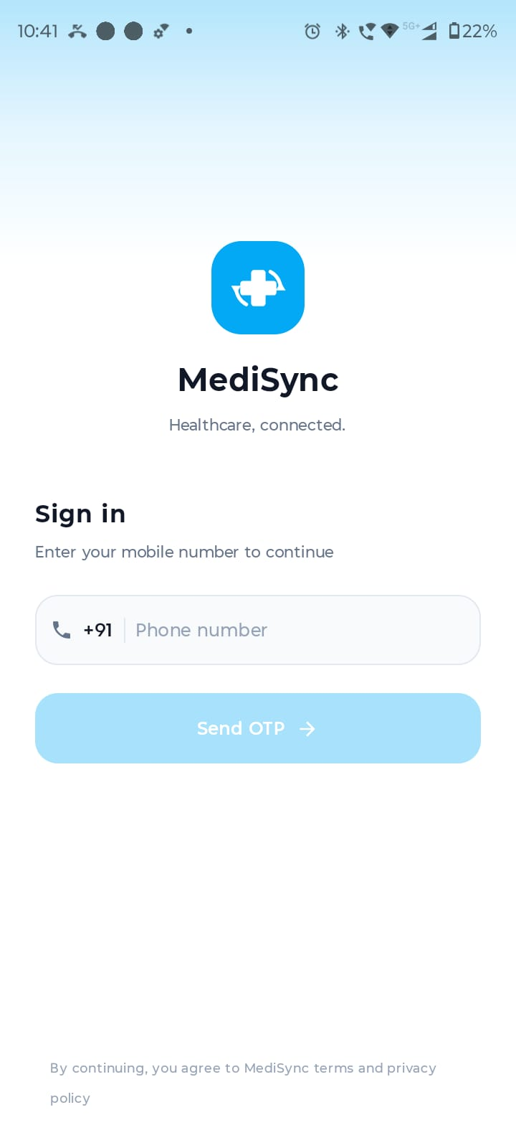

Figure 6.1: Login Screen - Mobile Number Entry

6.1.2 OTP Verification Screen
The OTP verification screen prompts the user to enter the 6-digit code sent to their registered mobile number. The screen displays the destination number for confirmation and provides six individual input boxes for OTP entry. A "Verify" button submits the entered code to Firebase for verification. A countdown timer is shown alongside a "Resend" option that becomes active after the timer expires. Upon successful verification, the application checks whether the user has an existing profile and navigates accordingly.
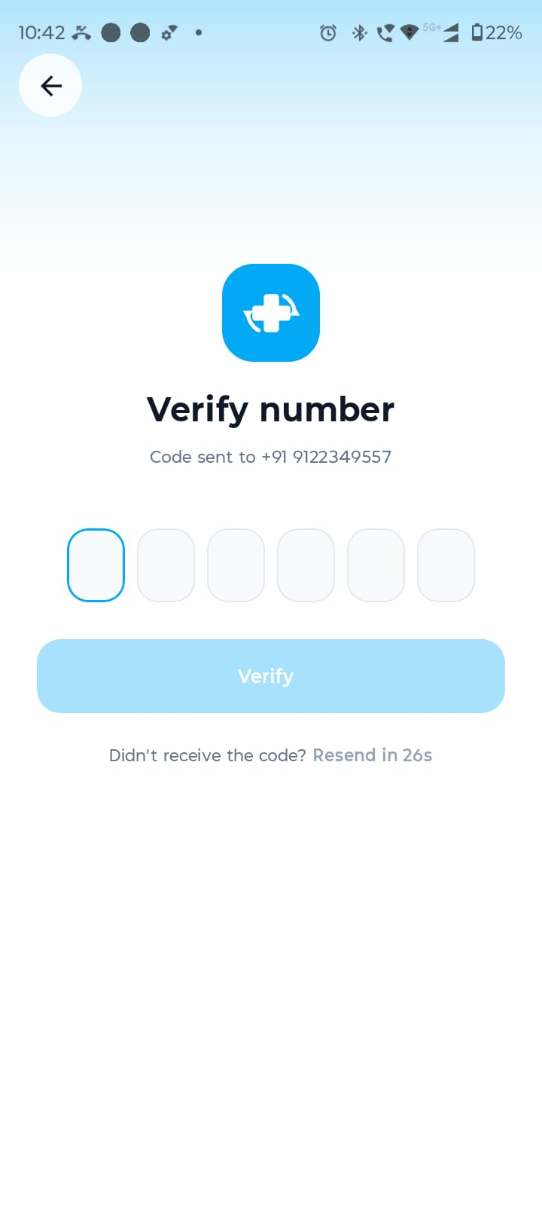

Figure 6.2: OTP Verification Screen

6.2 Patient Module

6.2.1 Patient Home Dashboard
The patient home dashboard is the primary screen for patient users. It features a search bar for finding doctors or specialities, a personalised greeting with the current date, two prominent action cards for Physical Appointment and Instant Video Consult, a speciality browser grid displaying commonly consulted categories, and a bottom navigation bar with tabs for Home, Appointments, Chat, and Records. A floating action button provides quick access to the AI health assistant. The screen dynamically loads data from the backend on launch.
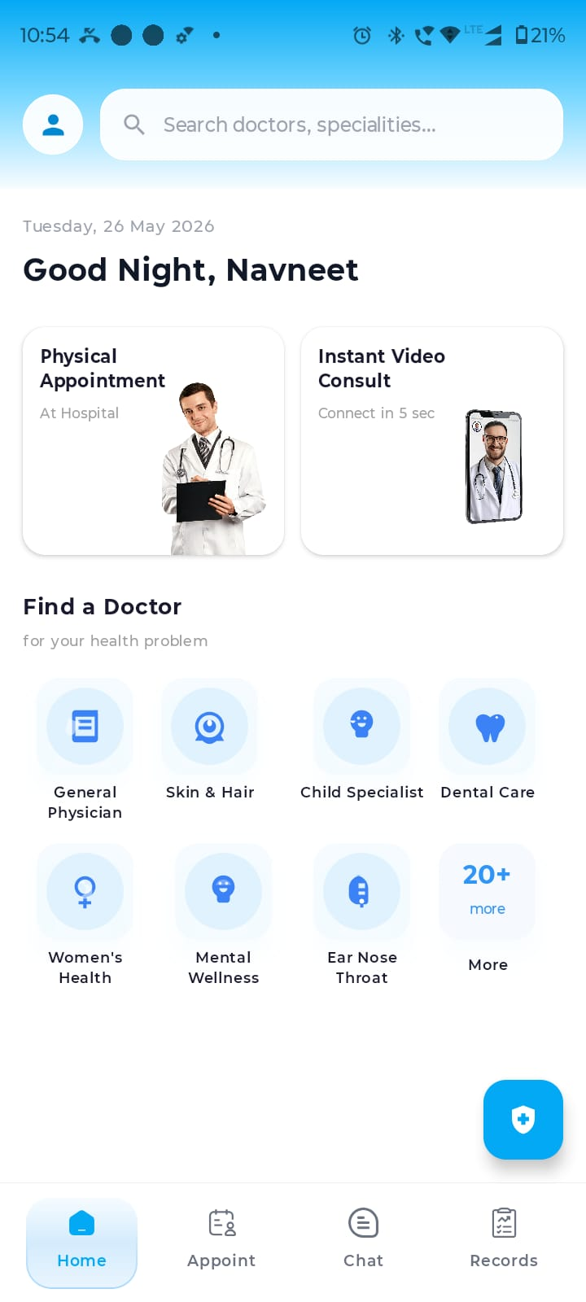

Figure 6.3: Patient Home Dashboard

6.2.2 Specialities Screen
Tapping the search bar or the "More" option in the speciality grid opens a full speciality browser. This screen lists all available medical specialities with associated icons, including COVID, Skin and Hair, Women's Health, General Physician, Dental Care, Bones and Joints, Mental Wellness, Ear Nose Throat, Sexual Health, and Child Specialist, among others. A search bar at the top allows filtering of specialities by name.
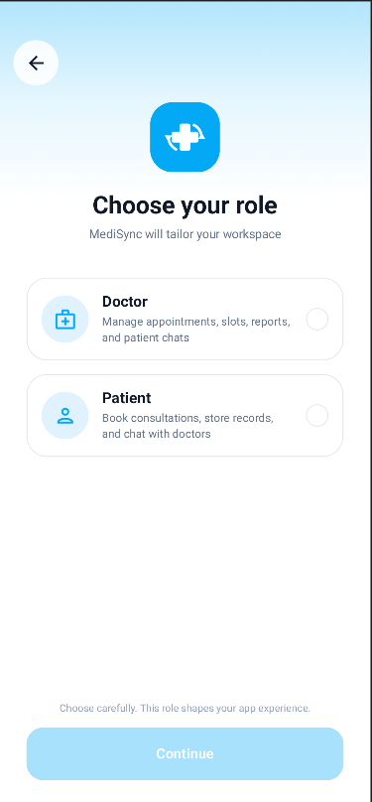

Figure 6.4: Specialities Screen

6.2.3 Find a Doctor Screen
The Find a Doctor screen displays the list of doctors matching the search query or selected speciality. Each doctor card shows the doctor's name, speciality, years of experience, and a "Book" button for direct navigation to the appointment booking flow. A filter option is available at the top right to apply additional search criteria. The result count is displayed prominently below the search bar.
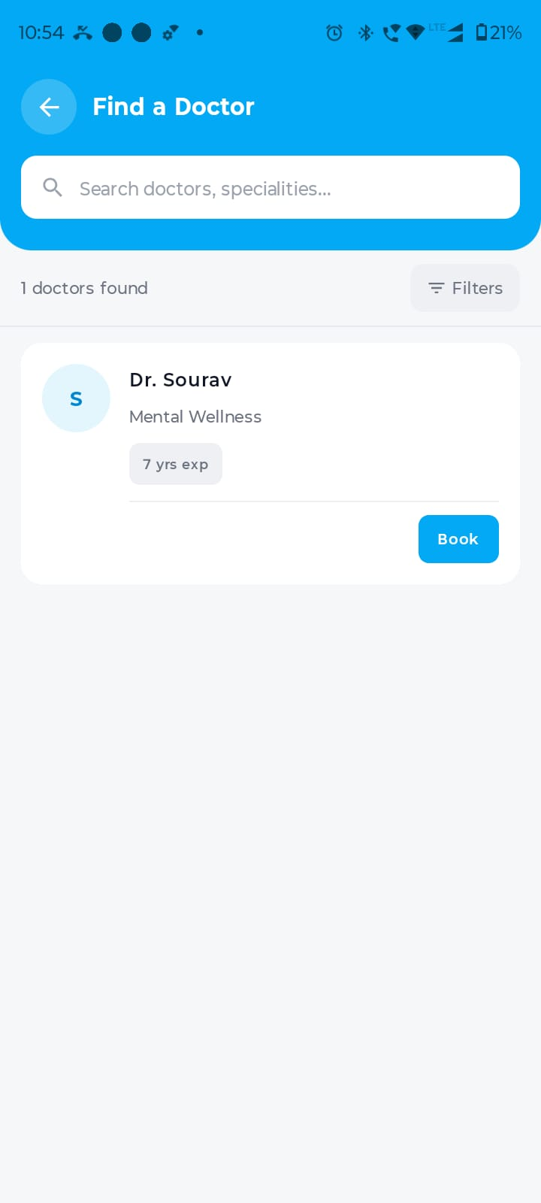

Figure 6.5: Find a Doctor Screen

6.2.4 Doctor Profile Screen
The Doctor Profile screen presents comprehensive information about a selected doctor. It displays the doctor's name, speciality, star rating, sub-speciality, qualification, clinic name, supported languages, consultation mode (Online, Offline, or Both), and an embedded Google Maps view showing the clinic location. The full address with latitude and longitude is shown below the map. A "Book Appointment" button at the bottom initiates the appointment booking flow.
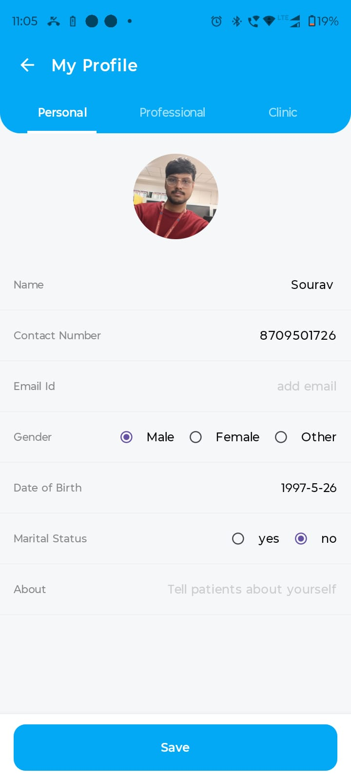

Figure 6.6: Doctor Profile Screen

6.2.5 Book Appointment Screen
The Book Appointment screen displays available slots for the selected doctor on the chosen date. The date is shown at the top in a card format. Slots are grouped into Morning (before 12:00 PM) and Evening (after 4:00 PM) categories, with each group showing the count of available slots. Each slot card displays the start time, consultation type (Online or Offline), and duration. Booked or unavailable slots are displayed in a greyed-out
state. The patient selects a slot and confirms the booking.

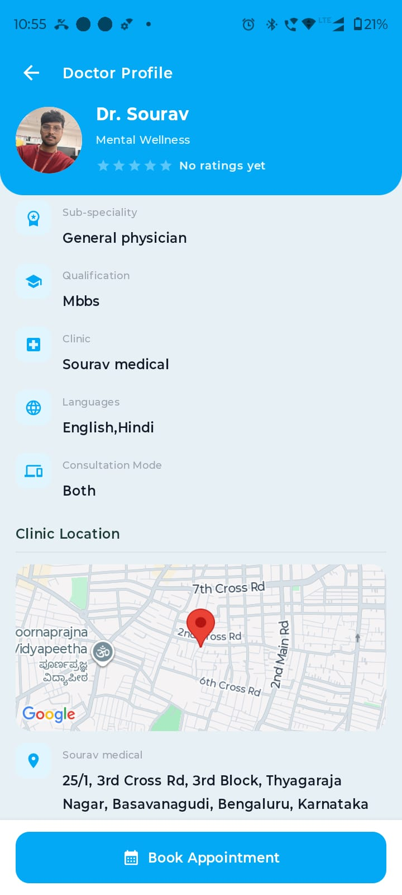
Figure 6.7: Book Appointment Screen

6.2.6 Appointments List Screen
The Appointments screen provides a searchable and filterable list of all appointments booked by the patient. Filter tabs at the top allow switching between All, Upcoming, Past, Online, and Offline views. Each appointment entry shows the doctor's profile photo, name, speciality, appointment type (Online or Offline with colour coding), and the appointment date and time.
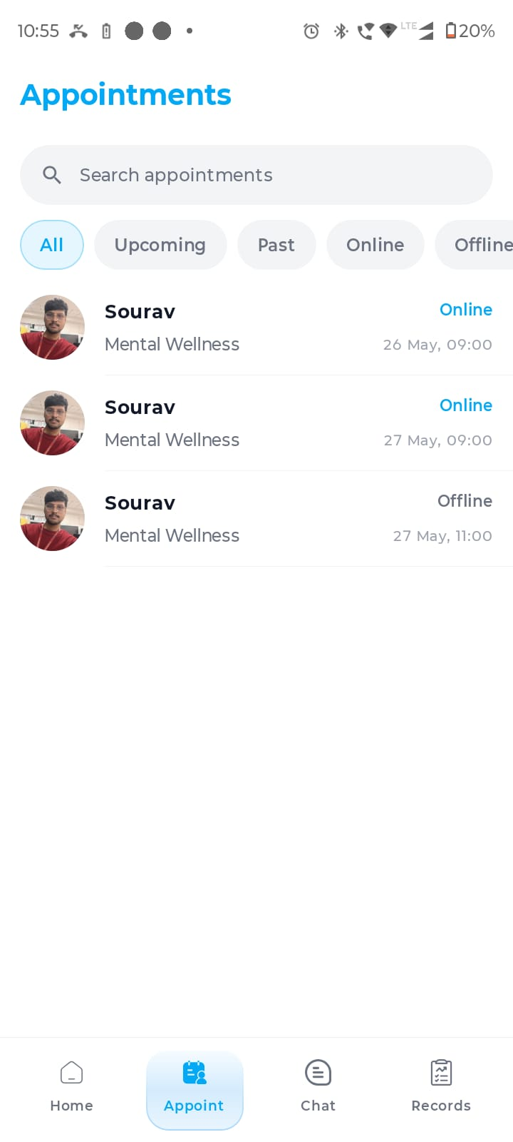
Figure 6.8: Patient Appointments List Screen

6.2.7 Appointment Details Screen
Tapping on an appointment entry opens the Appointment Details screen. This screen presents the doctor's profile photo and name, speciality, appointment date, time, consultation type, consultation fee, and current status (e.g., Accepted). For offline appointments, an embedded Google Maps view displays the clinic location, with the full address shown below. A "Chat with Doctor" button at the bottom navigates directly to the chat room for this appointment.
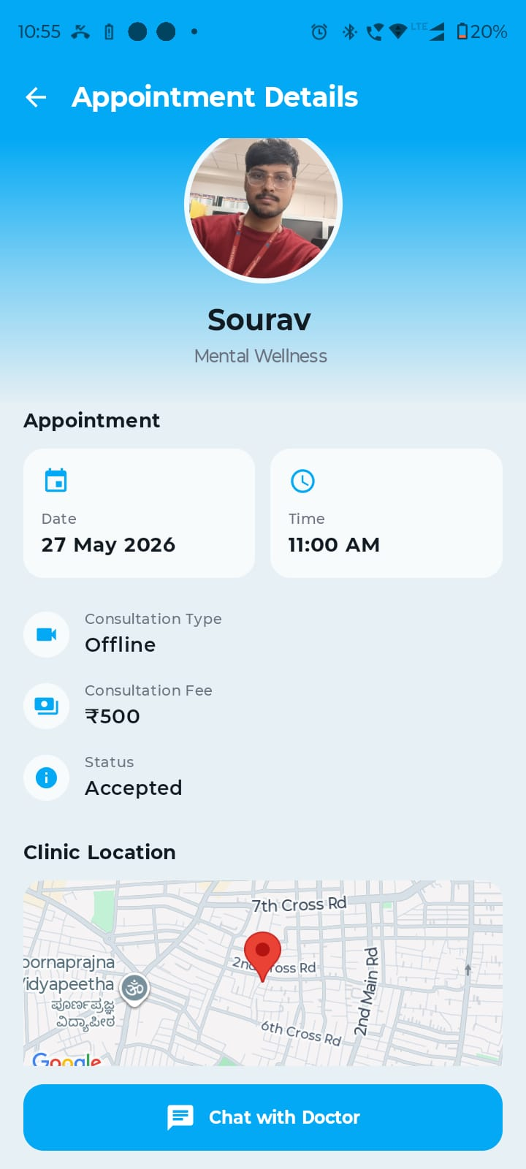

Figure 6.9: Appointment Details Screen

6.2.8 Chat List Screen
The Chat List screen displays all active chat conversations for the logged-in user. Each conversation entry shows the counterpart's profile photo, name, the last message preview, and the timestamp of the last message. Filter tabs allow viewing all conversations or filtering by Unread, Favourites, or Groups. A search bar facilitates finding a specific conversation by name.
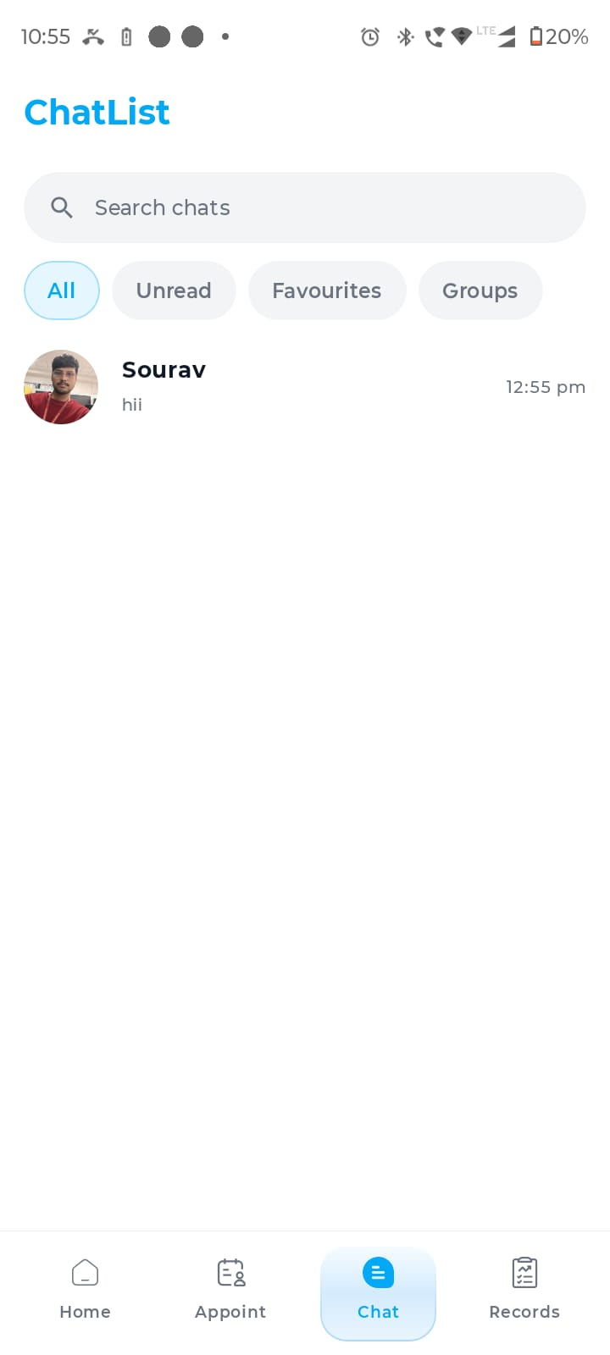

Figure 6.10: Chat List Screen

6.2.9 Chat Room Screen
The Chat Room screen provides a real-time messaging interface between the patient and doctor. Sent messages are displayed on the right in a blue bubble, and received messages appear on the left in a white bubble with timestamps and read receipts. The screen supports text messages as well as file and image sharing through an attachment icon. Appointment detail cards can be shared within the chat. A "Join" button in the header navigates to the video call for online appointments. The message input field at the bottom includes an emoji button and an attachment option.
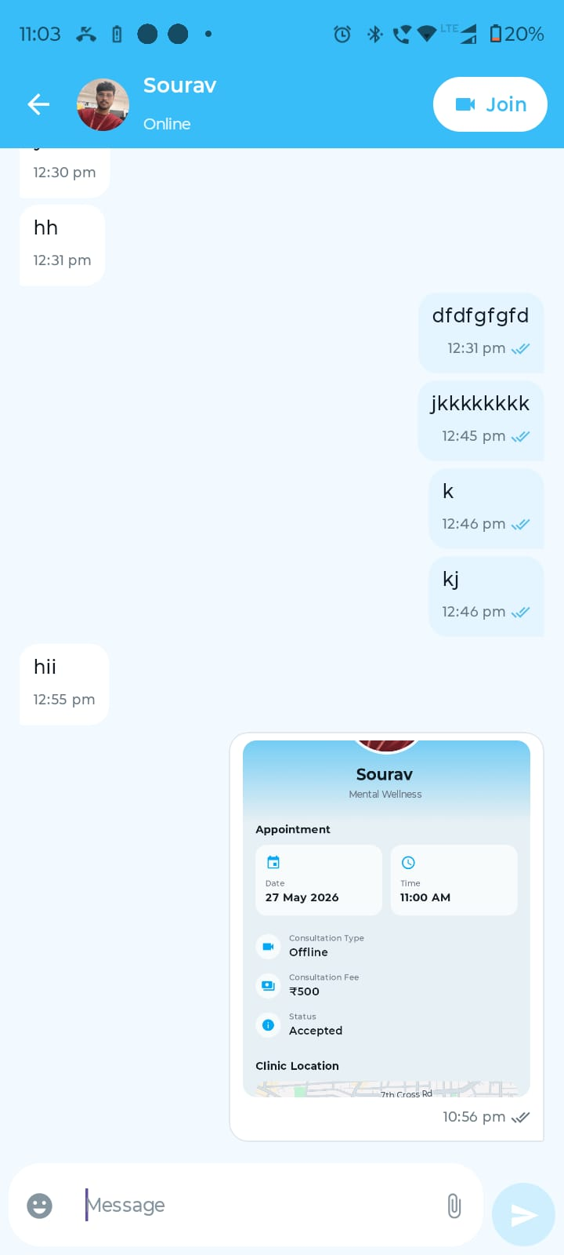

Figure 6.11: Chat Room Screen

6.2.10 Medical Records Screen
The Medical Records screen presents a chronological list of all medical reports associated with the patient. Each record entry displays a thumbnail icon indicating the file type, the file name, the uploader's name, and the upload date and time. Filter chips at the top allow the patient to filter records by All, Images, or PDFs. A search bar enables text-based filtering, and a refresh button allows the patient to reload the list. Records can be tapped to view the full file.
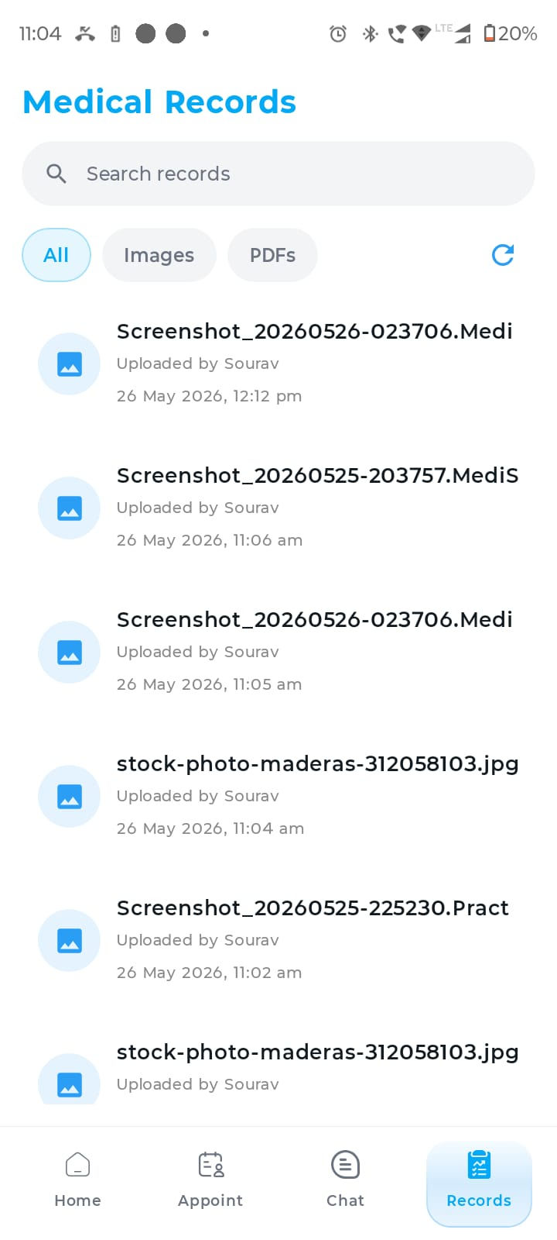

Figure 6.12: Medical Records Screen

6.2.11 AI Chat Screen
The AI Chat screen provides access to the MediSync AI health assistant, powered by the Gemini API. Upon opening the screen, the assistant greets the user and presents three primary interaction options: Analyze image or report (for uploading and analysing medical documents), Ask health question (for symptom, medicine, diet, and follow-up queries), and Find health info (for general guidance with safety checks). The user can type a query in the input field at the bottom or select an option to begin the interaction. The AI assistant provides responses with appropriate safety disclaimers.
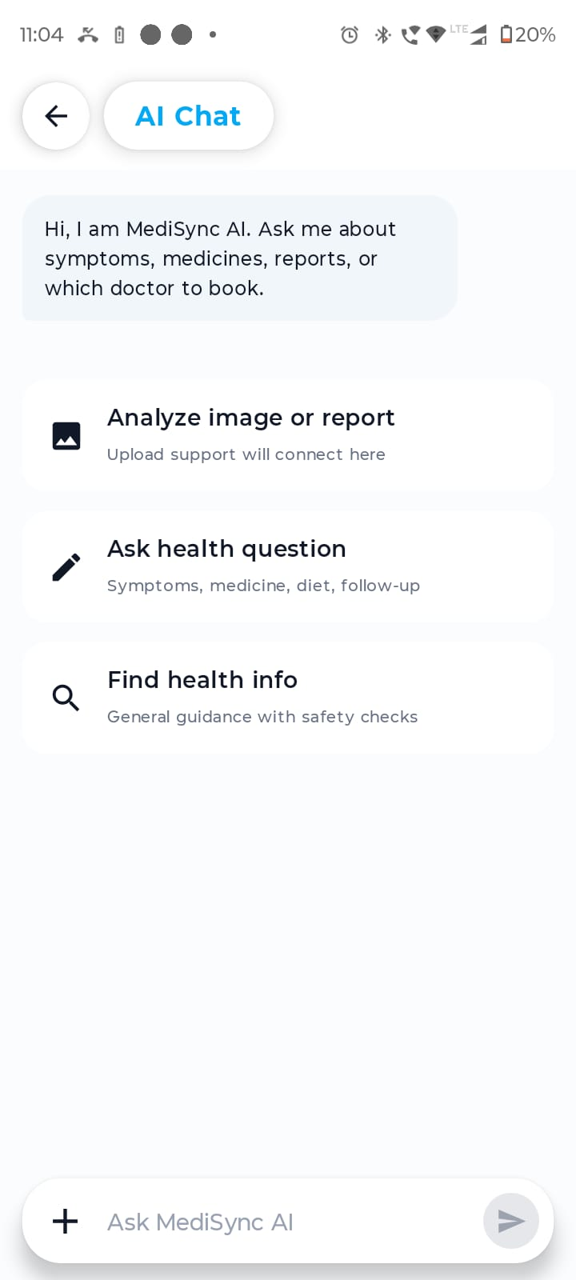

Figure 6.13: AI Health Chat Screen

6.2.12 Patient Profile Screen
The Patient Profile screen allows patients to view and edit their personal information. It is organised into three tabs: Personal (name, contact number, email, gender, date of birth, blood group, marital status, height, and emergency contact), Medical (existing conditions, allergies, and current medications), and Lifestyle (smoking, alcohol, diet, and activity level). A profile photo is displayed prominently and can b updated. A "Save" button persists changes to the backend.
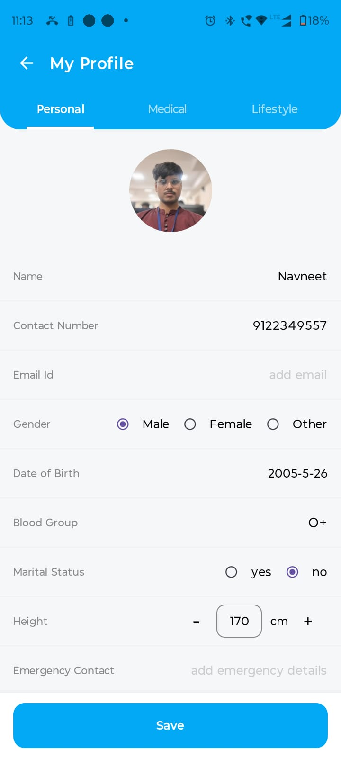

Figure 6.14: Patient Profile Screen

6.3 Doctor Module

6.3.1 Doctor Home Dashboard
The Doctor Home Dashboard provides a comprehensive overview of the doctor's daily schedule. Summary cards at the top display the count of today's appointments, upcoming scheduled appointments, and total completed appointments. The Next Patient section shows the immediately upcoming appointment with the patient's name, consultation type, time, and acceptance status. The Quick Actions section provides one-tap navigation to Manage Slots, Appointments, Messages, and Clinic Location. The Upcoming Today section lists all appointments scheduled for the current day. A bottom navigation bar provides tabs for Home, Appointments, Chat, and Slots.
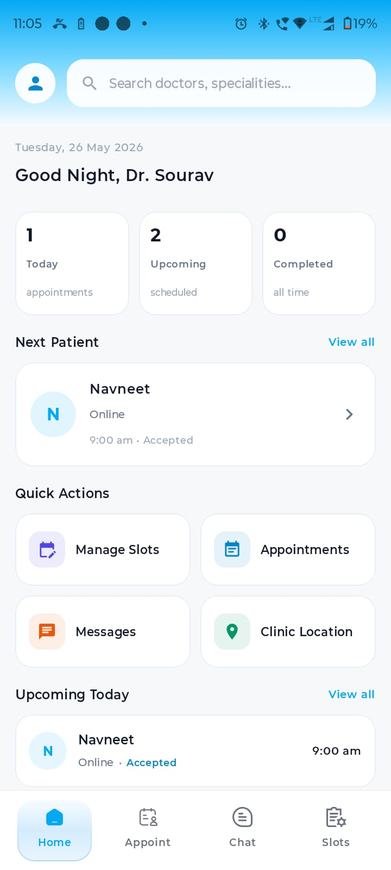

Figure 6.15: Doctor Home Dashboard

6.3.2 Doctor Side Drawer Navigation
The Doctor module features a side drawer navigation menu accessible from the home screen. The drawer displays the doctor's profile photo, name, and contact number at the top. Navigation options include Clinic Location, Schedule/Slots, Appointments, and Chat. A Logout option is provided at the bottom in red. This drawer provides quick access to all primary doctor functions without the need for a bottom navigation bar.
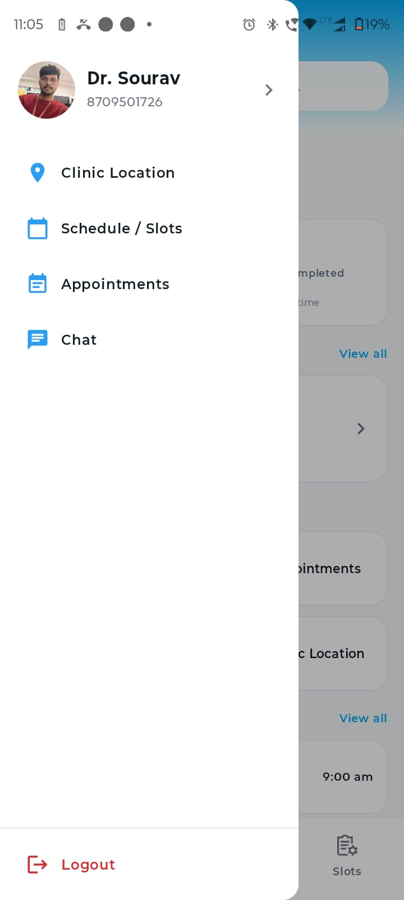

Figure 6.16: Doctor Side Drawer Navigation

6.3.3 Doctor Profile Edit Screen
The Doctor Profile Edit screen is organised into three tabs: Personal (name, contact number, email, gender, date of birth, marital status, and an About section for a professional bio), Professional (speciality, sub-speciality, qualification, years of experience, clinic name, supported languages, and consultation mode), and Clinic (clinic name, address, and the Google Maps location selector). A profile photo is displayed at the top and can be updated. A "Save" button persists all changes.


Figure 6.17: Doctor Profile Edit Screen (Personal Tab)

6.3.4 Weekly Template Screen
The Weekly Template screen enables doctors to define recurring slot schedules for each day of the week. Day tabs (Mon through Sat) allow the doctor to switch between days. For each day, the doctor can add slots using controls at the bottom of the screen: selection between Online and Offline consultation type, a Start Time picker, a Fee input field, and a Duration slider with increment/decrement buttons. A counter at the top right shows the total number of slots and hours configured. If no slots are defined for a day, a "No slots for [Day]" placeholder is displayed.

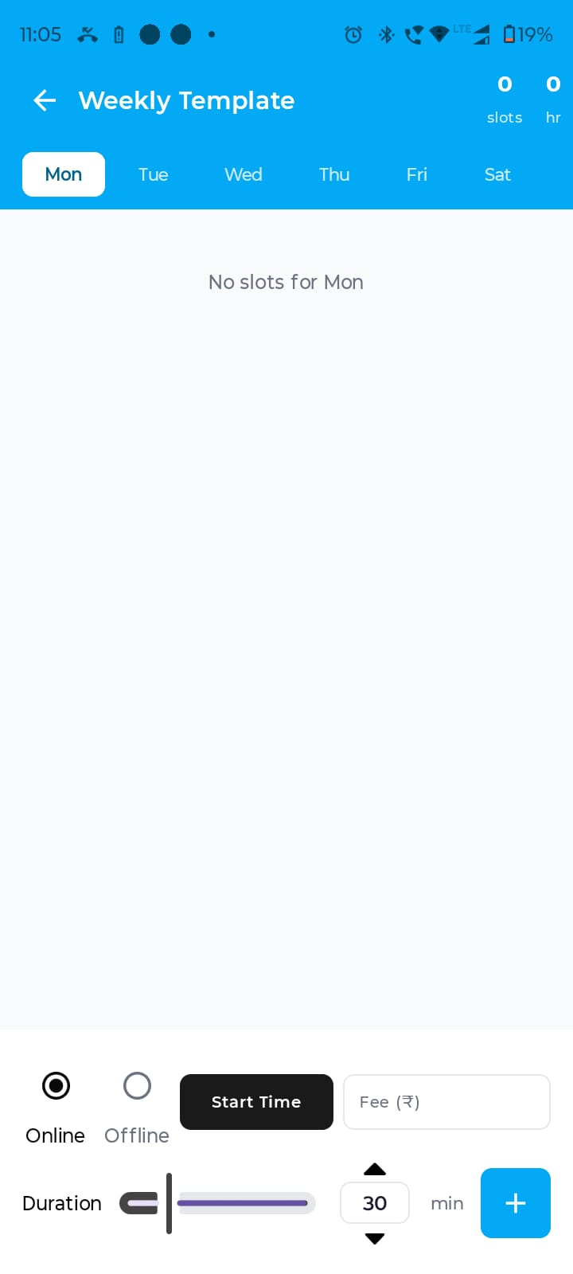

Figure 6.18: Weekly Template Screen

6.3.5 Custom Schedule Screen
The Custom Schedule screen allows doctors to create one-off appointment slots for specific dates. A full-month calendar at the top allows date selection, with dots indicating dates that already have slots configured. Below the calendar, the list of slots for the selected date is displayed. At the bottom, the doctor can configure a new slot by selecting Online or Offline, setting the Start Time, entering the Fee, and adjusting the Duration. A "+" button adds the configured slot to the selected date. The top right counter shows the total slots and hours for the current view.
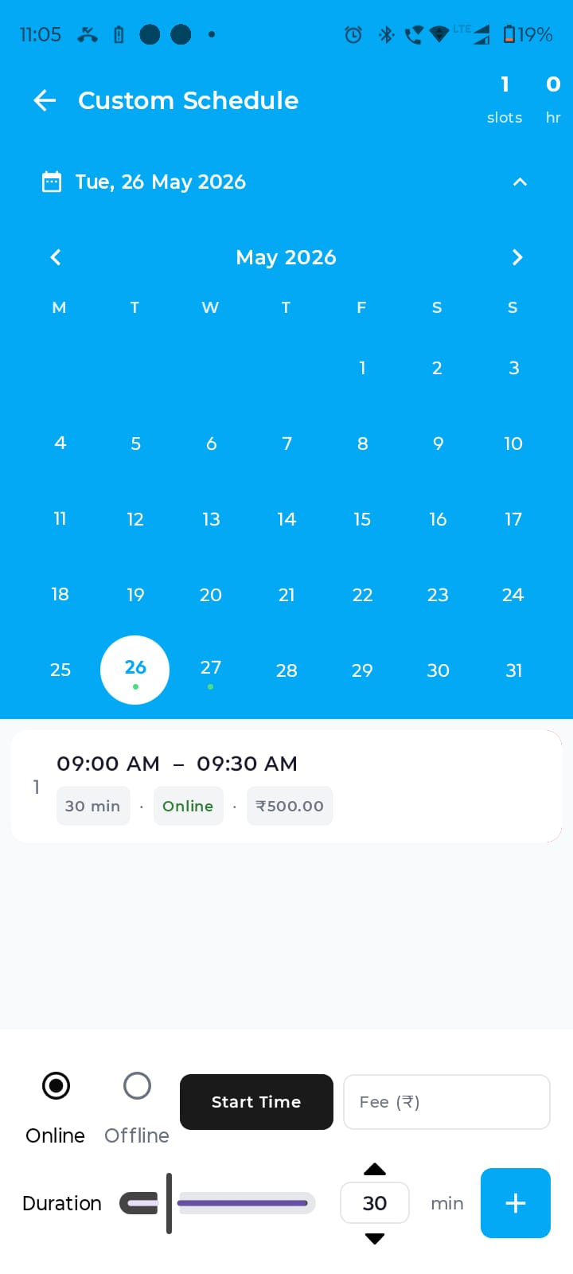

Figure 6.19: Custom Schedule Screen

6.3.6 Clinic Location Screen
The Clinic Location screen provides an interactive Google Maps view where the doctor can search for and pin their clinic location. The doctor can drag the map or use the current location button to place the marker. The selected address is displayed below the map in a text card, along with the precise latitude and longitude coordinates. A "Save Clinic Location" button at the bottom persists the coordinates and address to the backend. This information is subsequently displayed on the Doctor Profile and Appointment Details screens for patient reference.

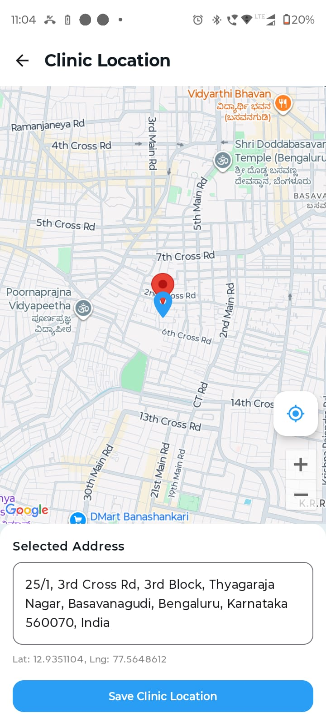

Figure 6.20: Clinic Location Setup Screen

6.4 Video Call Module

6.4.1 Video Call Screen
The Video Call screen facilitates real-time audio and video consultation between a doctor and a patient. The local video stream (the user's own camera feed) is displayed as a smaller picture-in-picture window in the top right corner. The remote video stream occupies the full screen. Control buttons at the bottom of the screen include camera toggle, speaker toggle, microphone mute/unmute, camera flip, and a red hang-up button to terminate the call. The call is initiated through a WebRTC signaling mechanism over the WebSocket connection.

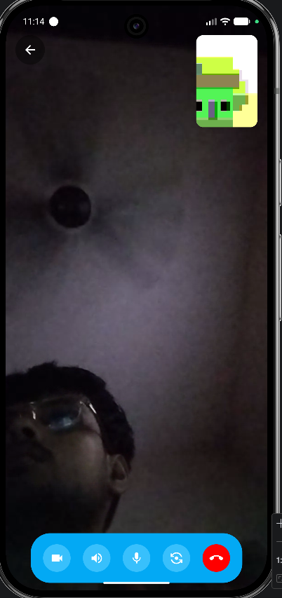

Figure 6.21: Video Call Screen

CHAPTER 7: TESTING

7.1 Testing Approach
Testing of MediSync was conducted using a scenario-based black-box testing approach. Each major module of the application was tested against predefined test cases covering normal flow, boundary conditions, and error conditions. Tests were executed on a physical Android device. The test cases are organised by module and presented in the table below.

TC ID | Module | Scenario | Steps | Expected Result | Actual Result | Status
TC-01 | Authentication | - User opens the app for the first time or after logout, enters a valid 10-digit mobile number, and requests OTP to begin authentication. | Enter a valid 10-digit number and tap Send OTP | OTP sent successfully; OTP screen displayed | OTP sent; screen navigated | Pass
TC-02 | Authentication | User enters an incomplete or invalid mobile number with fewer than 10 digits and attempts to continue. | Enter a 7-digit number and tap Send OTP | Send OTP button remains disabled or error shown | Button disabled for incomplete number | Pass
TC-03 | Authentication | User receives OTP on the registered mobile number, enters the correct 6-digit code, and completes authentication successfully. | Enter the correct 6-digit OTP received on phone | User is authenticated and navigated to home screen | Navigation to home screen | Pass
TC-04 | Authentication | - User enters a wrong OTP or expired OTP during verification and tries to continue. | Enter a wrong 6-digit OTP | Error message displayed: "Invalid OTP" | Error message displayed | Pass
TC-05 | Authentication | User does not receive OTP immediately, waits for the resend timer to finish, and requests a new OTP. | Wait for countdown to expire and tap Resend | New OTP sent to the registered mobile number | New OTP received | Pass
TC-06 | Authentication | A newly authenticated user without an existing profile is asked to choose between Patient and Doctor role. | Complete OTP verification as a new user | Role selection screen displayed with Patient and Doctor options | Role selection screen shown | Pass
TC-07 | Patient Module | New patient selects Patient role, enters basic profile information, and completes account creation. | Enter "Sourav" in search bar | Doctor card for Dr. Sourav displayed in results | Doctor card displayed | Pass
TC-08 | Patient Module | Search doctor by speciality | Select "Mental Wellness" from specialities | List of doctors with Mental Wellness speciality displayed | Relevant doctors listed | Pass
TC-09 | Patient Module | View doctor profile | Tap on a doctor card from search results | Doctor profile screen with full details and map displayed | Profile screen displayed | Pass
TC-10 | Appointment Module | Book an available slot | Select an available slot and confirm booking | Appointment created with status "Accepted" | Appointment created successfully | Pass
TC-11 | Appointment Module | Attempt to book an already booked slot | Select a greyed-out slot | Slot cannot be selected; no booking action triggered | Slot is unselectable | Pass
TC-12 | Appointment Module | View appointment list | Navigate to Appointments tab | All past and upcoming appointments listed correctly | Appointments displayed | Pass
TC-13 | Appointment Module | View appointment details for offline appointment | Tap on an offline appointment in the list | Details screen shows doctor info, date, time, fee, and clinic map | All details including map shown | Pass
TC-14 | Appointment Module | Filter appointments by Online type | Tap "Online" filter chip in appointment list | Only online appointments displayed | Filter applied correctly | Pass
TC-15 | Chat Module | Send a text message | Open chat room and type a message, tap send | Message appears in chat on both sender and receiver sides | Message delivered in real time | Pass
TC-16 | Chat Module | Share a file/image in chat | Tap attachment icon and select an image | Image appears in chat as a shared file message | Image shared and displayed | Pass
TC-17 | Chat Module | Read receipt update | Recipient opens the chat room | Message tick indicators update to read state | Read receipts updated | Pass
TC-18 | Chat Module | No network during message send | Disable network and attempt to send a message | Message send fails gracefully; error state shown | Error handled; no crash | Pass
TC-19 | Medical Records | Upload a medical report | Open Records, tap upload, select a PDF or image | Record appears in the list with correct name and date | Record uploaded and listed | Pass
TC-20 | Medical Records | Filter records by image type | Tap "Images" filter chip in medical records | Only image-type records displayed | Filter applied correctly | Pass
TC-21 | Medical Records | Search records by filename | Type a partial filename in the search bar | Matching records displayed | Search results correct | Pass
TC-22 | AI Chat | Ask a health question | Type "I have a headache" in AI Chat input | AI provides relevant health guidance with disclaimer | Relevant response received | Pass
TC-23 | AI Chat | Ask about a specific symptom | Ask about symptoms of fever and cough | AI provides informational response and suggests consulting a doctor | Informational response with disclaimer | Pass
TC-24 | Doctor Module | Create a weekly slot template | Navigate to Weekly Template, add a slot for Monday | Slot appears in Monday list; slot count increments | Slot added correctly | Pass
TC-25 | Doctor Module | Create a custom schedule slot | Navigate to Custom Schedule, select a date, add a slot | Slot appears for selected date; calendar dot indicator shown | Custom slot added | Pass
TC-26 | Doctor Module | Set clinic location | Navigate to Clinic Location, place marker, tap Save | Location saved; visible in doctor profile and appointment details | Location saved and displayed | Pass
TC-27 | Doctor Module | View doctor home dashboard | Log in as doctor and open Home screen | Appointment summary cards, next patient info, and quick actions displayed | Dashboard loaded correctly | Pass
TC-28 | Video Call | Initiate video call from chat | Tap "Join" button in chat room header | Video call screen opens; local video preview shown | Video call screen opened | Pass
TC-29 | Video Call | Mute microphone during call | Tap mute button during active call | Microphone muted; icon state changes | Mute toggled correctly | Pass
TC-30 | General | Application handles missing profile data gracefully | Log in with a user with incomplete profile | App does not crash; empty or placeholder values displayed | No crash observed | Pass
Table 7.1: MediSync Test Cases

CHAPTER 8: LEARNING OUTCOMES
The development of MediSync provided substantial practical learning across a wide range of technologies and engineering disciplines. The key learning outcomes are described below.

8.1 Android Development with Kotlin and Jetpack Compose
This project provided in-depth hands-on experience with Android application development using Kotlin. Working with Jetpack Compose demonstrated the benefits of a declarative UI approach, wherein the UI is a direct function of the application state. Key Compose concepts learned include composable functions, state hoisting, recomposition, side effects (LaunchedEffect, rememberCoroutineScope), navigation with NavHost and NavController, and theming with MaterialTheme. The project also reinforced the understanding of Android lifecycle management and how ViewModels survive configuration changes.

8.2 MVVM Architecture and Repository Pattern
Implementing the MVVM architecture with a dedicated Repository layer provided practical understanding of clean architecture principles. Separating the UI layer (composables), business logic layer (ViewModels), and data layer (Repositories) resulted in code that was easier to maintain, debug, and extend. The use of StateFlow and collectAsState for reactive UI updates deepened understanding of reactive programming principles in the context of Android development.

8.3 Backend API Development with Node.js, Express.js, and TypeScript
Developing the backend in TypeScript with Node.js and Express.js provided experience in building type-safe RESTful APIs. Key concepts learned include route organisation with Express Router, middleware functions for authentication and logging, JWT generation and verification, parameterised SQL queries for PostgreSQL interaction, and proper error handling patterns in an asynchronous Node.js environment.

8.4 Database Design with PostgreSQL
Designing the PostgreSQL schema for MediSync deepened understanding of relational database concepts including entity modelling, normalisation, foreign key constraints, and index creation for query optimisation. Writing SQL queries for complex join operations across multiple tables, such as fetching appointment details with doctor profile and slot information in a single query, reinforced practical database skills.

8.5 Real-Time Communication with WebSocket and Socket.io
Implementing the real-time chat module using Socket.io provided practical experience with event-driven, bidirectional communication. Key concepts learned include WebSocket connection lifecycle management, room-based broadcasting, event emission and handling on both client and server, and authentication of WebSocket connections using JWT tokens.

8.6 Object Storage with MinIO
Integrating MinIO for file storage provided exposure to object storage concepts and the S3-compatible API. Key operations learned include uploading objects using presigned URLs, generating time-limited presigned GET URLs for secure file access, and organising objects within MinIO buckets using structured key prefixes.

8.7 Firebase Authentication and Cloud Messaging
Integrating Firebase Phone Authentication provided practical experience with the Firebase SDK for Android and the associated backend verification process. Implementing Firebase Cloud Messaging for push notifications demonstrated the flow from server-side notification dispatch using the FCM Admin SDK to client-side notification receipt and handling in Android.

8.8 Google Maps SDK Integration
Integrating the Google Maps SDK for the clinic location feature provided experience with embedding interactive maps within a Jetpack Compose UI using the maps-compose library. Key skills included placing custom markers, handling map click events to update coordinates, reverse geocoding coordinates to human-readable addresses, and displaying a static map view within an appointment details card.

8.9 Deployment and DevOps
Deploying the backend on a Linux cloud server using Docker and PM2 provided foundational exposure to production deployment practices. Key skills learned include writing Dockerfiles and Docker Compose configurations, managing Docker volumes for data persistence, configuring environment variables for secure credential management, and using PM2 to manage Node.js process lifecycle including automatic restarts and log management.

8.10 Debugging and Problem Solving
The project provided extensive experience in debugging complex issues that span multiple system components, such as diagnosing WebSocket connection failures, resolving CORS issues in the backend API, debugging Jetpack Compose recomposition issues, and troubleshooting Docker networking problems between containers. This cross-stack debugging experience is invaluable for full-stack development.

CHAPTER 9: CONCLUSION AND FUTURE SCOPE

9.1 Conclusion
MediSync has been successfully designed, developed, and tested as a comprehensive Android-based telemedicine application that serves both patients and doctors on a unified digital platform. The application addresses the core challenges of manual appointment booking, fragmented medical record management, lack of real-time doctor-patient communication, and absence of accessible health information.

The project demonstrates the successful integration of a diverse technology stack including Kotlin with Jetpack Compose for the Android frontend, Node.js with Express.js and TypeScript for the backend, PostgreSQL for relational data storage, MinIO for object storage, Socket.io for real-time communication, Firebase for authentication and notifications, the Google Maps SDK for location services, and the Gemini API for AI-assisted health guidance.

All primary objectives of the project have been met. The authentication module provides secure, OTP-based user registration and login. The patient module enables complete appointment booking and management workflows. The doctor module supports comprehensive schedule management and patient communication. The chat module delivers real-time bidirectional messaging with file sharing. The medical records module provides a centralised repository for patient health documents. The AI chat module offers immediate, accessible health guidance. The clinic location module enables patients to locate their doctor's clinic with ease. The video call module supports online consultations through a WebRTC-based implementation.

The project also demonstrates adherence to software engineering best practices, including the MVVM architectural pattern, REST API design principles, secure credential management through environment variables, and a modular, maintainable codebase. The scenario-based testing conducted across all major modules confirms the functional correctness and robustness of the application.

9.2 Future Scope
While MediSync has achieved its primary objectives as a laboratory project, several enhancements are identified for future development.

Payment Gateway Integration: A payment module supporting UPI, net banking, and card payments will be integrated to enable patients to pay consultation fees directly within the application. This will be implemented using a standard payment gateway API such as Razorpay or Stripe.

Digital Prescriptions: Doctors will be able to generate and share digital prescriptions within the application following a consultation. Prescriptions will be generated as PDF documents, stored in MinIO, and linked to the corresponding appointment record.

Administrator Panel: A web-based administrator dashboard will be developed to manage user accounts, monitor platform activity, handle grievances, review and approve doctor profiles, and generate analytics reports.

Enhanced AI Safety and Accuracy: The AI health assistant will be enhanced with domain-specific prompt engineering and retrieval-augmented generation techniques to improve the relevance and safety of responses. Guardrails will be added to prevent the AI from providing specific diagnoses or treatment recommendations.

Analytics Dashboard for Doctors: A dedicated analytics section within the doctor's application will provide insights into appointment statistics, patient demographics, consultation duration trends, and rating history.

Multi-Language Support: The application will be localised to support regional Indian languages including Hindi, Kannada, Tamil, and Telugu, expanding accessibility for non-English speaking users.

Play Store Deployment: The application will be prepared for production deployment on the Google Play Store, including performance optimisation, security hardening, compliance with Play Store policies, and comprehensive end-to-end testing on a range of device configurations.

Improved Video Call Stability: The video call module will be enhanced with adaptive bitrate streaming, network quality indicators, and automatic reconnection logic to improve call reliability under varying network conditions.

REFERENCES
[1] Android Developers, "Jetpack Compose documentation," Google LLC. [Online]. Available: https://developer.android.com/jetpack/compose

[2] Android Developers, "Guide to app architecture," Google LLC. [Online]. Available: https://developer.android.com/topic/architecture

[3] JetBrains, "Kotlin documentation," JetBrains s.r.o. [Online]. Available: https://kotlinlang.org/docs/home.html

[4] Firebase, "Firebase Authentication documentation," Google LLC. [Online]. Available: https://firebase.google.com/docs/auth

[5] Firebase, "Firebase Cloud Messaging documentation," Google LLC. [Online]. Available: https://firebase.google.com/docs/cloud-messaging

[6] PostgreSQL Global Development Group, "PostgreSQL 14 documentation," 2022. [Online]. Available: https://www.postgresql.org/docs/14/

[7] MinIO Inc., "MinIO object storage documentation," 2023. [Online]. Available: https://min.io/docs/minio/linux/index.html

[8] Google Maps Platform, "Maps SDK for Android documentation," Google LLC. [Online]. Available: https://developers.google.com/maps/documentation/android-sdk

[9] Node.js Foundation, "Node.js documentation," OpenJS Foundation. [Online]. Available: https://nodejs.org/en/docs/

[10] Express.js, "Express 4.x API Reference," OpenJS Foundation. [Online]. Available: https://expressjs.com/en/4x/api.html

[11] Socket.io, "Socket.IO documentation," 2023. [Online]. Available: https://socket.io/docs/v4/

[12] Google AI, "Gemini API documentation," Google LLC. [Online]. Available: https://ai.google.dev/docs

[13] Docker Inc., "Docker documentation," Docker Inc., 2023. [Online]. Available: https://docs.docker.com/

[14] Unitech, "PM2 process manager documentation," 2023. [Online]. Available: https://pm2.keymetrics.io/docs/usage/quick-start/

Detailed Scenario-Based Test Cases
The following test cases describe detailed user scenarios across authentication, patient workflows, doctor workflows, appointments, chat, records, AI chat, video call, notification, and general stability modules. These scenarios validate normal use cases and important edge cases such as missing data, offline access, unavailable slots, and backend connectivity issues.
TC ID | Module | Scenario | Steps | Expected Result | Actual Result | Status
TC-01 | Authentication | User opens the app and enters a valid 10-digit mobile number to request OTP for login or registration. | Open app; enter valid mobile number; tap Send OTP. | OTP request should be sent successfully and OTP verification screen should open. | OTP screen opened successfully. | Pass
TC-02 | Authentication | User enters an incomplete mobile number with fewer than 10 digits and tries to continue. | Enter invalid mobile number and observe Send OTP button. | Send OTP button should remain disabled or validation should be shown. | Button remained disabled for invalid number. | Pass
TC-03 | Authentication | User enters the correct OTP received on the mobile number and completes authentication. | Enter correct OTP and tap Verify. | User should be authenticated and redirected to home or role selection screen. | User was authenticated successfully. | Pass
TC-04 | Authentication | User enters an incorrect or expired OTP during verification. | Enter wrong OTP and tap Verify. | Error message should be displayed and user should remain on OTP screen. | Error message displayed. | Pass
TC-05 | Authentication | New user completes OTP verification and is asked to choose Patient or Doctor role. | Verify OTP using a new mobile number. | Role selection screen should appear with Patient and Doctor options. | Role selection screen displayed. | Pass
TC-06 | Authentication | User selects a role and creates a basic profile with name. | Select role; enter name; tap Continue. | Profile should be created and user should enter correct dashboard. | Profile created successfully. | Pass
TC-07 | Patient Module | Patient searches for a doctor by entering a doctor name in the search bar. | Open Find Doctor screen and search doctor name. | Matching doctor card should be displayed. | Doctor card displayed. | Pass
TC-08 | Patient Module | Patient searches doctors by selecting a speciality such as Mental Wellness, Dental Care, or General Physician. | Tap speciality card from home screen. | Doctor list should open with selected speciality filter applied. | Filtered doctor list displayed. | Pass
TC-09 | Patient Module | Patient opens doctor profile before booking to view doctor details. | Tap doctor card from search results. | Doctor profile should show name, speciality, qualification, experience, rating, clinic location, and booking option. | Doctor profile opened correctly. | Pass
TC-10 | Patient Module | Doctor profile contains missing optional fields such as rating, clinic address, or profile photo. | Open profile of doctor with incomplete data. | App should hide missing fields or show placeholder without crashing. | Screen loaded safely. | Pass
TC-11 | Appointment Module | Patient books an available appointment slot from doctor profile. | Open doctor profile; tap Book Appointment; select available slot; confirm booking. | Appointment should be created and slot should become booked. | Appointment booked successfully. | Pass
TC-12 | Appointment Module | Patient tries to select a slot that is already booked or unavailable. | Open slot picker and tap unavailable slot. | Booked slot should not be selectable and booking should not proceed. | Unavailable slot was disabled. | Pass
TC-13 | Appointment Module | Patient views all booked appointments from the appointment list screen. | Open Appointments tab. | Upcoming and past appointments should be listed correctly. | Appointments displayed correctly. | Pass
TC-14 | Appointment Module | Patient searches appointments by doctor name, date, or appointment information. | Type search text in appointment search bar. | Matching appointments should be filtered and displayed. | Search result displayed. | Pass
TC-15 | Appointment Module | Patient filters appointments by Online, Offline, Upcoming, or Past category. | Tap appointment filter chips. | Only appointments matching selected filter should be shown. | Filter applied correctly. | Pass
TC-16 | Appointment Module | Patient opens online appointment details. | Tap an online appointment from list. | Screen should show doctor details, date, time, fee, status, and chat option without clinic map. | Online appointment details displayed. | Pass
TC-17 | Appointment Module | Patient opens offline appointment details. | Tap an offline appointment from list. | Screen should show doctor details, date, time, fee, status, chat option, and clinic map. | Offline appointment details displayed. | Pass
TC-18 | Appointment Module | Patient navigates from appointment detail screen to chat with doctor. | Tap Chat with Doctor button. | Correct chat room should open with doctor. | Chat room opened. | Pass
TC-19 | Appointment Module | Patient submits rating for doctor after appointment. | Open past appointment and tap Rate Doctor. | Rating should be saved and reflected in doctor profile. | Rating submitted successfully. | Pass
TC-20 | Doctor Module | Doctor views home dashboard after login. | Login as doctor and open home screen. | Dashboard should show appointment counts, next patient, upcoming appointments, and quick actions. | Dashboard loaded correctly. | Pass
TC-21 | Doctor Module | Doctor opens an appointment from dashboard or appointment list. | Tap upcoming appointment or next patient card. | Appointment detail screen should open with correct patient and appointment data. | Appointment detail opened. | Pass
TC-22 | Doctor Module | Doctor creates a weekly slot template for recurring availability. | Open Slot Management; choose Weekly Template; enter time, duration, type, and fee. | Slot should be added for selected day and visible to patients. | Weekly slot added. | Pass
TC-23 | Doctor Module | Doctor creates a custom schedule slot for a selected date. | Open Custom Schedule; select date; enter slot details; tap add. | Custom slot should be created for selected date. | Custom slot added. | Pass
TC-24 | Doctor Module | Doctor sets clinic location using map picker. | Open Clinic Location; select location on map; save address. | Clinic coordinates and address should be saved and visible to patients. | Clinic location saved. | Pass
TC-25 | Doctor Module | Doctor updates an already saved clinic location. | Move marker to new location and tap Save. | Old clinic location should be replaced with updated location. | Location updated successfully. | Pass
TC-26 | Chat Module | User opens chat list to view existing patient-doctor conversations. | Open Chat tab. | Chat rooms should be displayed with name, profile photo, and latest message. | Chat list displayed. | Pass
TC-27 | Chat Module | User searches chat by patient or doctor name. | Type name in chat search bar. | Matching chat room should be displayed. | Filtered chat displayed. | Pass
TC-28 | Chat Module | User sends a text message in chat room. | Open chat; type message; tap send. | Message should appear in chat and be saved in database. | Message sent successfully. | Pass
TC-29 | Chat Module | Receiver is online and receives message in real time. | Keep receiver chat open and send message from another device. | Message should appear instantly without manual refresh. | Real-time message received. | Pass
TC-30 | Chat Module | Receiver is offline when message is sent. | Send message while receiver app is closed or offline. | Message should be stored and push notification should be sent if token exists. | Message stored successfully. | Pass
TC-31 | Chat Module | User shares an image in chat. | Tap attachment; select image; send. | Image should upload and appear in chat for both users. | Image displayed in chat. | Pass
TC-32 | Chat Module | User shares a PDF file in chat. | Tap attachment; select PDF; send. | PDF should appear as file message and should be openable. | PDF shared successfully. | Pass
TC-33 | Medical Records | Patient opens medical records screen to view uploaded reports. | Open Records tab. | Medical reports should be listed with file name, uploader, and date. | Records displayed. | Pass
TC-34 | Medical Records | Patient searches medical records by file name. | Type partial file name in search bar. | Matching records should be displayed. | Search worked correctly. | Pass
TC-35 | Medical Records | Patient filters records by Images or PDFs. | Tap Images or PDFs filter chip. | Only selected file type should be shown. | Filter applied correctly. | Pass
TC-36 | Medical Records | Patient opens records screen without internet after records were previously cached. | Turn off internet and open Records tab. | Cached records should remain visible and app should not crash. | Cached records displayed. | Pass
TC-37 | Medical Records | Patient refreshes records while backend is unreachable. | Turn off internet and tap refresh. | Old record list should remain visible and error should not clear data. | Old records retained. | Pass
TC-38 | AI Chat | Patient opens AI Chat from home screen or sidebar. | Tap AI Chat button. | AI chat screen should open with greeting, suggestions, and input field. | AI chat opened. | Pass
TC-39 | AI Chat | Patient asks a general health-related question. | Type symptom-related question and send. | AI should provide helpful general guidance with safety disclaimer. | AI response received. | Pass
TC-40 | AI Chat | Patient asks a casual non-medical question. | Type casual question such as greeting and send. | AI should respond normally instead of blocking conversation. | Response received. | Pass
TC-41 | AI Chat | Patient sends an image with a written prompt. | Select image; type prompt; tap send. | Image should not auto-send; AI should analyze based on typed prompt. | Image analyzed correctly. | Pass
TC-42 | AI Chat | Patient selects a saved medical record and asks AI about it. | Attach medical record; type question; send. | AI should respond based on selected report or file context. | Relevant response received. | Pass
TC-43 | Video Call | User starts video call from chat screen. | Open chat and tap Join/video button. | Video call screen should open with camera preview and controls. | Call screen opened. | Pass
TC-44 | Video Call | One user starts call and waits before the other user joins. | Start call from one device only. | Call screen should remain stable and wait for second user. | Waiting state handled. | Pass
TC-45 | Video Call | Second user joins an already waiting call. | Open same chat from second user and tap Join. | Both users should connect and see remote video/audio. | Call connected. | Pass
TC-46 | Video Call | User mutes and unmutes microphone during active call. | Tap microphone button during call. | Microphone state should toggle correctly. | Mute toggled. | Pass
TC-47 | Video Call | User switches camera during active call. | Tap switch camera button. | Camera should switch between front and back camera. | Camera switched. | Pass
TC-48 | Video Call | User ends the call manually. | Tap end call button. | Call should close safely and user should return to previous screen. | Call ended safely. | Pass
TC-49 | Video Call | Network disconnects during active video call. | Turn off internet during call. | App should not crash and call should show disconnected or end safely. | No crash observed. | Pass
TC-50 | Profile Module | User opens profile screen online. | Open profile from sidebar. | Profile data and photo should load from backend. | Profile loaded. | Pass
TC-51 | Profile Module | User opens profile screen offline after cache exists. | Load profile once online; turn off internet; reopen profile. | Cached profile data and photo should be visible. | Cached data displayed. | Pass
TC-52 | Profile Module | User updates profile photo. | Select new photo and save profile. | Updated photo should appear in profile, sidebar, chat, and appointment screens. | Photo updated. | Pass
TC-53 | Notification Module | User receives chat notification while offline. | Close receiver app and send message from another user. | Push notification should be received if FCM token is available. | Notification received. | Pass
TC-54 | Notification Module | User taps chat notification. | Tap received chat notification. | App should open chat list or correct chat navigation flow with proper back behavior. | Chat navigation opened. | Pass
TC-55 | Notification Module | User receives appointment reminder or appointment update notification. | Trigger appointment notification event. | Notification should show correct appointment-related information. | Appointment notification received. | Pass
TC-56 | Navigation Module | User switches between main bottom navigation screens. | Tap Home, Appoint, Chat, and Records tabs. | Each screen should open without losing session or crashing. | Navigation worked. | Pass
TC-57 | Sidebar Module | Patient opens sidebar menu. | Tap profile icon from patient home. | Sidebar should show profile, AI Chat, appointments, chat, medical records, and logout options. | Patient sidebar displayed. | Pass
TC-58 | Sidebar Module | Doctor opens sidebar menu. | Tap profile icon from doctor home. | Sidebar should show profile, clinic location, schedule/slots, appointments, chat, and logout options. | Doctor sidebar displayed. | Pass
TC-59 | General | App handles missing profile photo. | Open screens where user has no profile photo. | Default avatar should be shown and app should not crash. | Placeholder avatar shown. | Pass
TC-60 | General | App handles backend connection failure. | Disconnect backend or internet and open app screen. | App should show error or cached data without crashing. | App remained stable. | Pass
Table 7.1: Detailed Scenario-Based Test Cases for MediSync

