Titanic Dataset – Exploratory Data Analysis (EDA)
Objective:
The objective of this project is to explore and analyze the Titanic dataset to understand the factors that influenced passenger survival. This analysis uses visual exploration to identify patterns related to survival, focusing on class and gender. Each visualization is analyzed with a clear aim, observation, conclusion, and reasoning to demonstrate analytical thinking.

Overall Survival Distribution
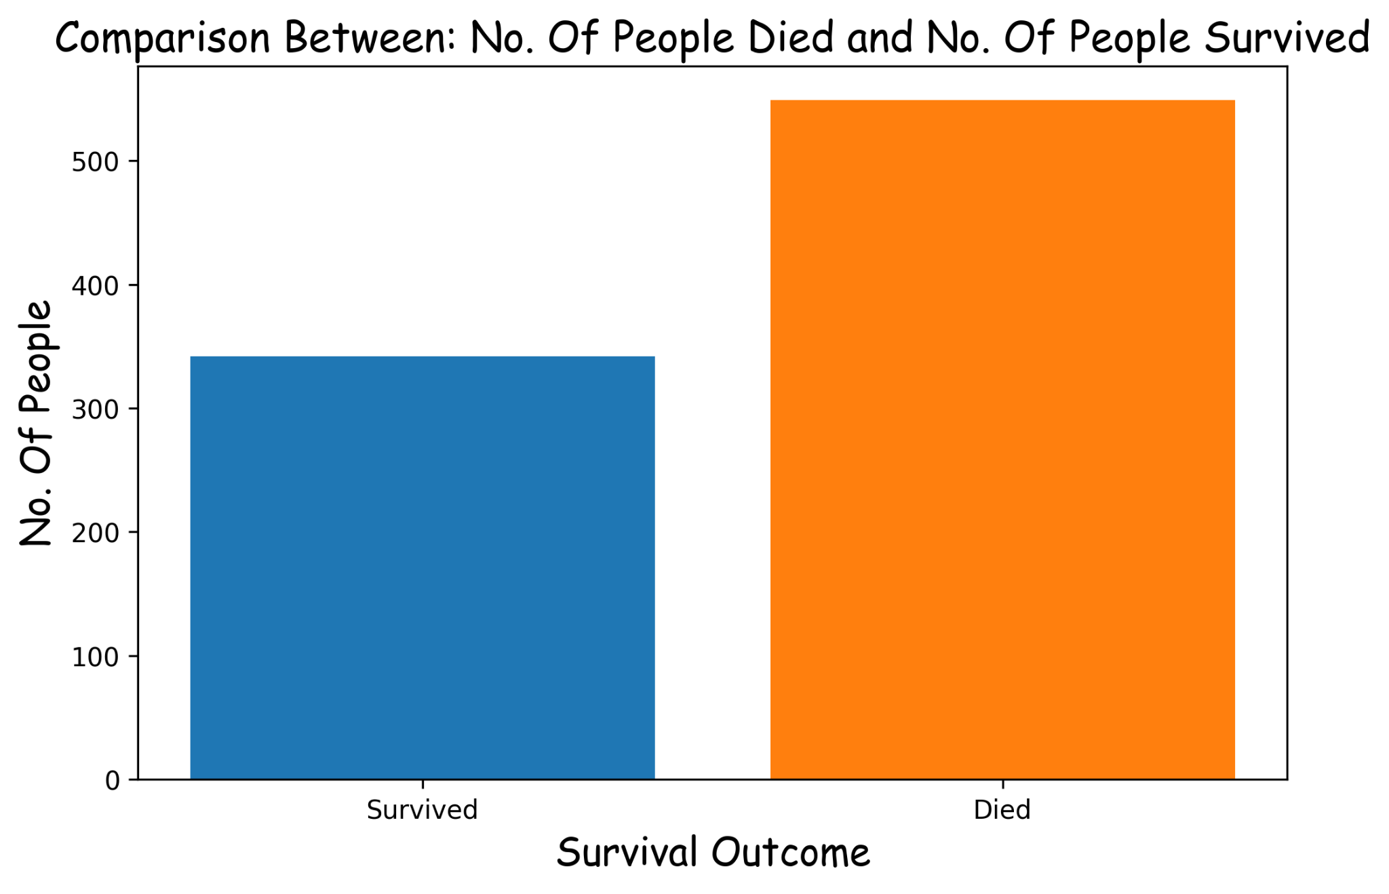
Aim:
The aim of this graph is to understand the overall survival outcome of passengers onboard the Titanic. It provides a high-level view of how many passengers survived versus how many did not.
Observation:
The graph clearly shows that the number of passengers who died is significantly higher than the number of passengers who survived. The difference is large enough to indicate that survival was not evenly distributed and depended on several constraints.
Conclusion:
The majority of passengers on the Titanic did not survive the disaster.
Reasoning:
This outcome can be attributed to limited lifeboat capacity, lack of emergency preparedness, and the sudden nature of the accident, which did not allow sufficient time for orderly evacuation.
Note:
This graph does not consider passenger categories such as class or gender, which are explored in subsequent analyses.

Survival by Passenger Class (Count)
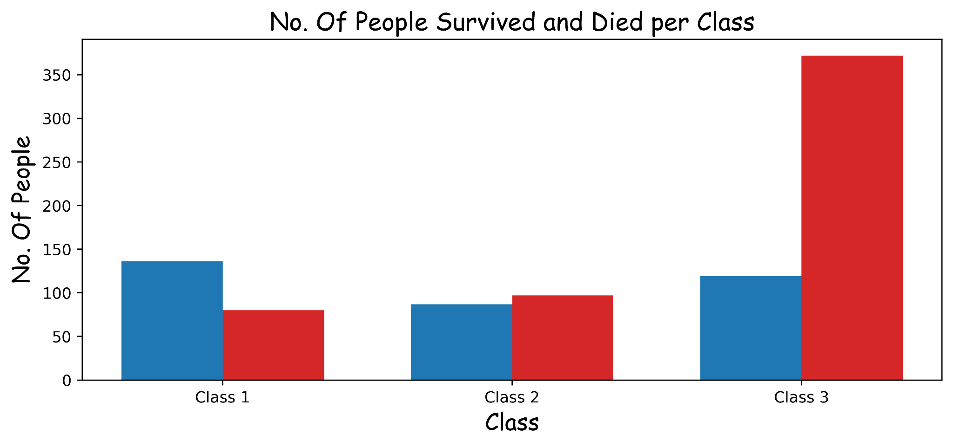
Aim:
The aim of this graph is to examine how survival outcomes varied across different passenger classes based on absolute numbers.
Observation:
Third-class passengers show the highest number of deaths, while first-class passengers show the highest number of survivors in comparison.
Conclusion:
Passenger class appears to have influenced survival outcomes.
Reasoning:
Higher-class passengers were located closer to lifeboats and likely received evacuation priority, while third-class passengers faced restricted access and delays.
Note:
This analysis may be misleading because the total number of passengers in each class is not equal. For a fair comparison, percentage-based analysis is required.

Survival by Passenger Class (Percentage)
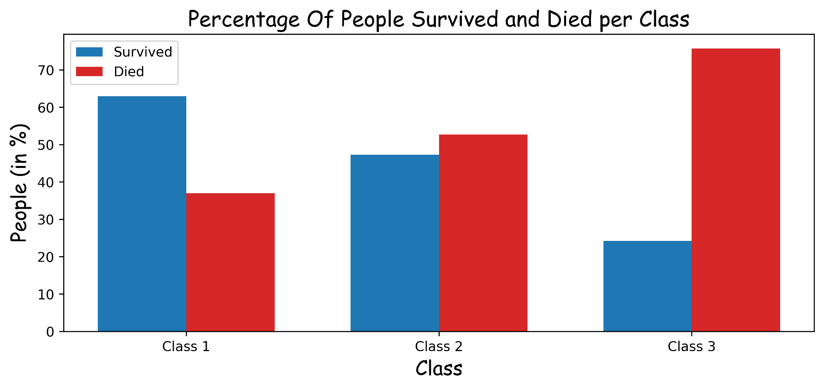
Aim:
The aim of this graph is to remove population bias by normalizing survival counts into percentages.
Observation:
First-class passengers have the highest survival percentage, followed by second-class, with third-class having the lowest survival rate.
Conclusion:
Passenger class had a strong impact on survival probability, not just raw survival counts.
Reasoning:
Percentage-based analysis reveals the true survival likelihood within each class, highlighting structural inequality in evacuation procedures.
Note:
This graph provides a more accurate interpretation than absolute counts.

Survival by Gender (Count)
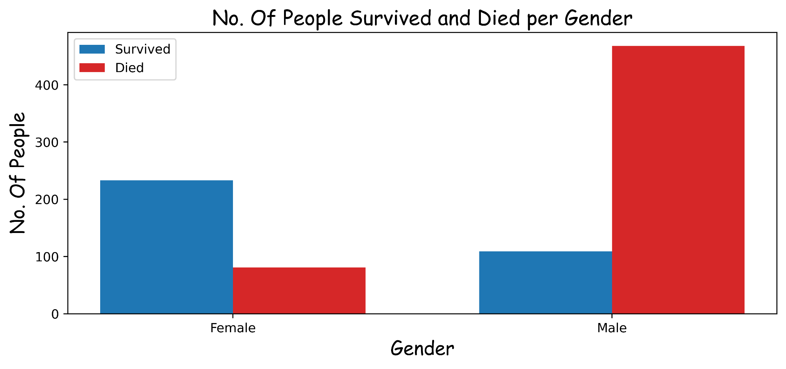
Aim:
The aim of this graph is to compare survival outcomes between male and female passengers using absolute numbers.
Observation:
A significantly higher number of male passengers died compared to female passengers.
Conclusion:
Female passengers had a survival advantage over male passengers.
Reasoning:
Evacuation protocols followed the 'women first' principle, resulting in higher female survival.
Note:
Absolute counts alone do not fully capture survival probability differences.

Survival by Gender (Percentage)
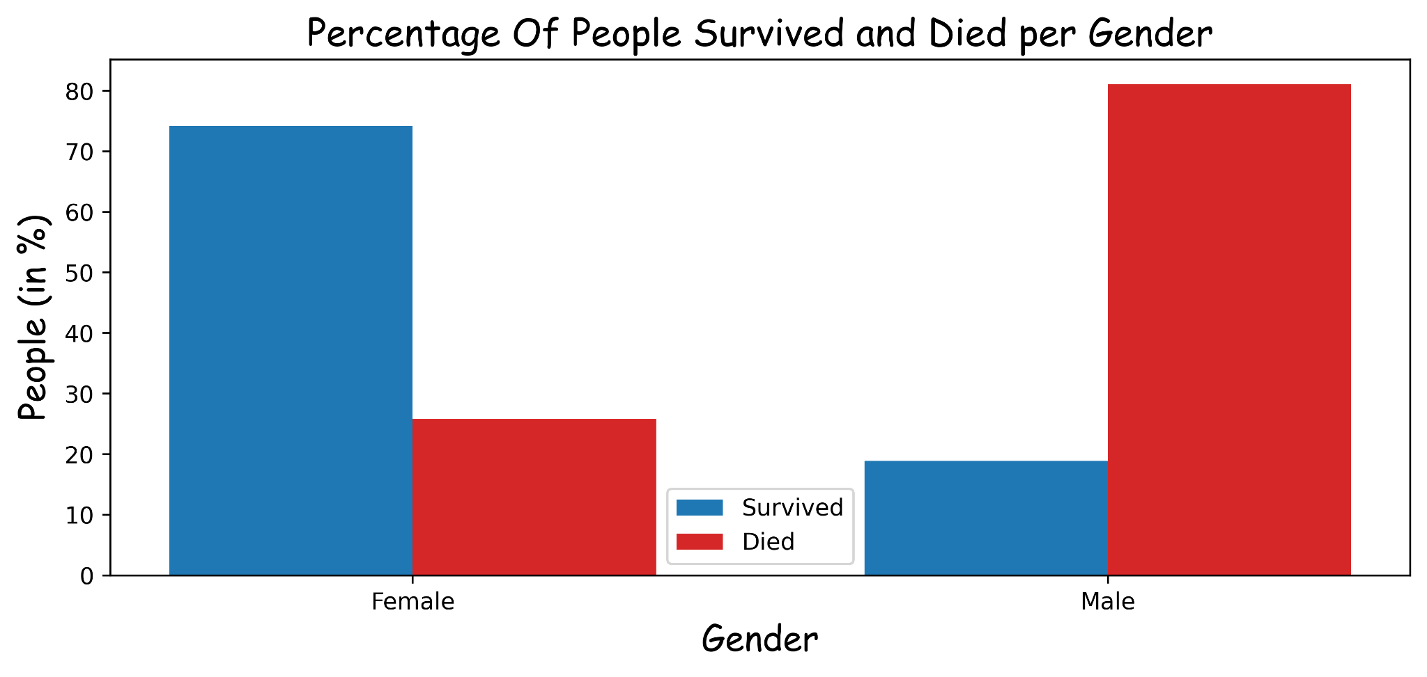
Aim:
The aim of this graph is to compare survival probability between genders using percentages.
Observation:
Female passengers have a dramatically higher survival rate compared to male passengers.
Conclusion:
Gender was one of the strongest factors influencing survival on the Titanic.
Reasoning:
Social norms, evacuation rules, and crew enforcement prioritized women, leading to a large survival gap.
Note:
This visualization clearly demonstrates why percentage-based analysis is critical in EDA.

