**Survey Results**

For requirement gathering, a survey form was implemented. As the targeted audience of the intended application are students, this survey form was shared with students. Survey form was made using [Google Forms](https://docs.google.com/forms/d/e/1FAIpQLSev3O4ZiodtNAWl53V9Za56rF6F9ygh4Kr0z17rPMO7hSLeOg/viewform). A series of 7 questions were asked related to To Do applications.

In this form, relevancy of three different features were questioned. Participants had to rate the feature as relevant, very relevant, or not relevant. As displayed below in screenshot, features focused in this form were sorting of tasks, reminders, and managing tasks.

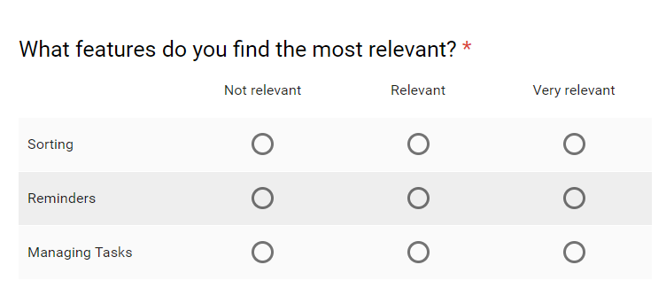

Figure 1: Question from survey form

Responses received were saved in excel sheet and corresponding data is displayed using chart below.

Figure 2: Graph representation of Responses

From the chart, it is observed that more than 40% found the reminder as a very relevant feature in To Do applications. And around 20% found it relevant. They want the application to remind them about the tasks in form of an alert notification. This will help them in easy tracking and better management. However, they do not want notification on sub tasks, as it is irrelevant and annoying to see notification of pending items in every sub task. Hence, the notification of every pending sub task items could be removed due to its irrelevancy and lack of value to user.

Above 30% of the participants found sorting feature to be relevant. Whereas, 15% found the sorting of task to very relevant. Based on this, the sorting feature can be used to a minimal level, where the user sets the priority of either high, medium or low.

More than 55% found task management feature as a valuable functionality for the application. This is the basic functionality needed in To Do applications. It includes adding, deleting, and updating tasks and items. Also, a location is tagged to each task for location-based notification which is an added functionality.