**Mission statement for clients**

We will be providing Information systems (IS) consulting to a locally based small to medium sized business or organization (as client). This client provides customized solutions to its end users on comparing schools and national rankings on three graduate degree programs in the US with the help of an application consisting of front end graphical interface and a database management system.

* **Mission objective**

This application provides rankings of university with locations for a particular program from a particular source from a particular year. Therefore, customers can compare ranks of universities with respect to source, year, program name, Program type, source and year are taken as inputs from the user which will return the university rankings as output.

Besides, for those who want to check programs of specific location or fee range, we use filter to show universities of different fee range and location. We want to implement this application through the design and development of a database consisting of universities, year, source, and program types as different entities. We want to provide rankings of universities specifically for year, source, and program type. All the above-mentioned entities are in quaternary relationship which is the rank.

* Finalized ERD

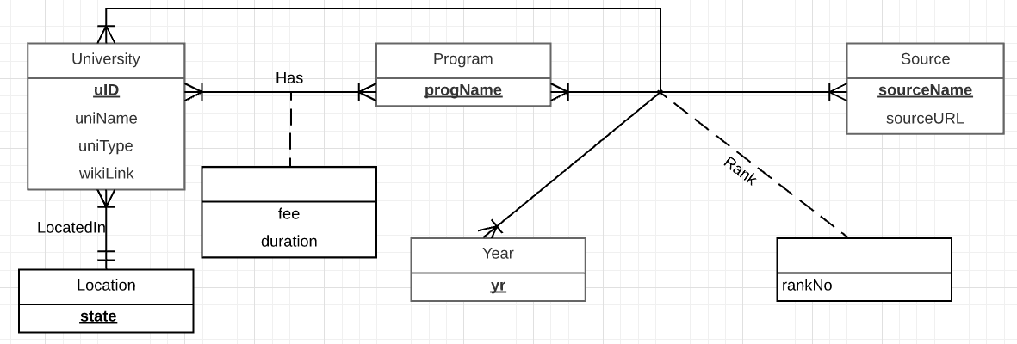

* Relational schema

Relations:

University(**uID**, uniName, uniType, wikiLink, *state*)

Location(**state**)

Has(***uID, progName,*** fee, duration)

Rank( ***uID, progName, sourceName, yr***, rankNo)

Program (**progName**)

Year(**yr**)

Source(**sourceName**, sourceUrl)

* Determine functional dependencies and perform normalization to 3NF.

Functional Dependencies:

uID -> uniName, uniType, wikiLink,state- primary key

State -> - primary key *Note*: can’t be omitted

uID, progName -> fee, duration - primary key

uID, progName, sourceName, year -> rankNo - primary key

progName -> -primary key -*Note:* can’t be omitted

Yr -> -primary key - *Note:* can’t be omitted

sourceName-> sourceUrl -primary key

Normalization:

University (**uID**, uniName, uniType, wikiLink, *state*) =3NF

Location(**state**) =3NF

Has (***uID, progName,*** fee, duration) =3NF

Rank (***uID, progName, sourceName, yr***, rankNo) =3NF

ProgramName(**progName**) =3NF

Year(**yr**) =3NF

Source (**sourceName**, sourceUrl) =3NF

* Generate business rules and determine referential integrity actions.

Business rules:

[R1] When a university is deleted from the database, the corresponding Has should be deleted from the database.

[R2] When a university is changed from the database, the corresponding Has should be changed from the database.

[R3] When a program is deleted from the database, the corresponding Has should be deleted from the database.

[R4] When a program is changed from the database, the corresponding Has should be changed from the database.

[R5] A university cannot be deleted from the database, if there is rank of the university in the database.

[R6] A university cannot be changed from the database, if there is rank of the university in the database.

[R7] A program cannot be deleted from the database, if there is rank of the program in the database.

[R8] A program cannot be changed from the database, if there is rank of the program in the database.

[R9] A source cannot be deleted from the database, if there is rank of the source in the database.

[R10] A source cannot be changed from the database, if there is rank of the source in the database.

[R11] A year cannot be deleted from the database, if there is rank of the year in the database.

[R12] A year cannot be changed from the database, if there is rank of the year in the database.

2.Referential integrity:

|  |  |  |  |  |  |  |  |
| --- | --- | --- | --- | --- | --- | --- | --- |
| Relation | Foreign Key | Base Relation | Primary Key | Constraint:  ON DELETE | Business  Rule | Constraint:  ON UPDATE | Business  Rule |
| Has | uId | University | uId | CASCADE | R1 | CASCADE | R2 |
| Has | progName | Program | progName | CASCADE | R3 | CASCADE | R4 |
| Rank | uId | University | uId | NO ACTION | R5 | NO ACTION | R6 |
| Rank | programName | Program | progName | NO ACTION | R7 | NO ACTION | R8 |
| Rank | sourceName | Source | sourceName | NO ACTION | R9 | NO ACTION | R10 |
| Rank | yr | Year | yr | NO ACTION | R11 | NO ACTION | R12 |

* Describe sample data for every relation.

University

|  |  |  |  |  |
| --- | --- | --- | --- | --- |
| uId | uniName | uniType | wikiLink | state |
| 01 | Massachusetts Institute of Technology | Private | https://en.wikipedia.org/wiki/Massachusetts_Institute_of_Technology | MA |

uId is the unique identification for universities, 01 was assigned to MIS by us. uniType shows whether this university is private or public. wikiLink is the information of this university in wikipedia. State is for location.

Location

|  |
| --- |
| state |
| MA |

It has the information about Location.

Program

|  |
| --- |
| progName |
| MBA |
| MS-IS |
| MS-BA |

We provide 3 programs’ information.

Has

|  |  |  |  |
| --- | --- | --- | --- |
| uId | progName | fee | duration |
| 01 | MS-IS | $48,452.00 | 12 months |

Has defines a specific program in a university. Fee and duration describe the program.

Rank

|  |  |  |  |  |
| --- | --- | --- | --- | --- |
| uId | progName | sourcename | yr | rankNo |
| 01 | MS-IS | USNEWS | 2016 | 1 |

Source

|  |  |
| --- | --- |
| sourceName | sourceUrl |
| USNEWS | http://www.usnews.com/ |

Year

|  |
| --- |
| yr |
| 2016 |

Year is the time for rank.