1. SQL CREATE TABLE and drop table

CREATE TABLE Location(

state CHAR(2) NOT NULL,

CONSTRAINT pk_Location_state

PRIMARY KEY(state),

);

CREATE TABLE University(

uID CHAR(3)NOT NULL,

uniName VARCHAR (40),

uniType VARCHAR (20),

wikiLink VARCHAR(50),

state CHAR(2),

CONSTRAINT pk_University_uID

PRIMARY KEY(uID),

Constraint fk_University_state

Foreign key (state)

references Location (state)

ON DELETE NO ACTION ON UPDATE CASCADE

);

CREATE TABLE Program(

progName VARCHAR(10) NOT NULL,

CONSTRAINT pk_Program_progName

PRIMARY KEY(progName)

);

CREATE TABLE Year(

yr CHAR(4) NOT NULL

CONSTRAINT pk_Year_year

PRIMARY KEY(yr));

CREATE TABLE Has(

uID CHAR(3) NOT NULL,

ProgName VARCHAR(10) NOT NULL,

duration VARCHAR(30),

fee Money,

CONSTRAINT pk_Has_uID_progName

PRIMARY KEY(uID,progName),

Constraint fk_Has_uID

Foreign key (uID)

references University(uID)

ON DELETE CASCADE ON UPDATE CASCADE,

Constraint fk_Program_progName

Foreign key (progName)

references Program(progName)

ON DELETE CASCADE ON UPDATE CASCADE

);

CREATE TABLE Source(

sourceName CHAR(30) NOT NULL,

sourceUrl VARCHAR(50),

CONSTRAINT pk_Source_sourceName

PRIMARY KEY(sourceName)

);

CREATE TABLE Rank(

uID CHAR(3) NOT NULL,

progName VARCHAR(10) NOT NULL,

sourceName CHAR(30) NOT NULL,

yr CHAR(4) NOT NULL,

rankNo integer,

CONSTRAINT pk_Rank_progName_uID_sourceName_yr

PRIMARY KEY(progName, uID, SourceName, yr),

Constraint fk_Rank_progName

Foreign key (progName)

references Program(progname)

ON DELETE NO ACTION ON UPDATE NO ACTION,

Constraint fk_Rank_uID

Foreign key (uID)

references University(uID)

ON DELETE NO ACTION ON UPDATE NO ACTION,

Constraint fk_Rank_sourceName

Foreign key (sourceName)

references Source(sourceName)

ON DELETE NO ACTION ON UPDATE NO ACTION,

Constraint fk_year

Foreign key (yr)

references Year(yr)

ON DELETE NO ACTION ON UPDATE NO ACTION

);

drop table Rank;

drop table Source;

drop table Has;

drop table Year;

drop table Program;

drop table University;

drop table Location;

1. SQL CREATE VIEW

A view URank was created to show programs’ ranks with name of university.

Create View URank

As

Select u.uniName, r.progName,r.sourceName, r.yr, r.rankNo

From Rank r, University u

Where r.uID= u.uID;

1. INSERT INTO statements

INSERT INTO Location VALUES

('CA'),

('NY'),

('IL'),

('VA'),

('MA'),

('PA'),

('AZ');

INSERT INTO University VALUES

('21','Harvard University','Private','MA'),

('22','Stanford University','Private','CA'),

('11','New York University','Private','NY'),

('20','University of Southern California','Private','CA'),

('26','University of Rochester','Public','NY'),

('01','Massachusetts Institute of Technology','Private','MA'),

('02','Carnegie Mellon University','Private','PA'),

('03','University of Arizona','Public','AZ'),

('24','University of Chicago','Private','IL'),

('23','Northwestern University','Private','IL'),

('30','University of Virginia','Public','VA');

;

INSERT INTO Year VALUES

('2017'),

('2016'),

('2015'),

('2014');

INSERT INTO Program VALUES

('MBA'),

('MS-IS'),

('MS-BA');

INSERT INTO Has VALUES

('21','MBA','24months',139000),

('22','MBA','24months',127000),

('01','MS-BA','16 months',77568.00),

('02','MS-BA','16 months',67100.00),

('11','MS-BA','16 months',70800.00),

('20','MS-BA','16 months',58674.00),

('26','MS-BA','16 months',63000.00),

('24','MBA','21 months',127960.00),

('23','MBA','21months', 128118.00),

('30','MBA','21months', 127240.00),

('01','MS-IS','24 months',48452.00),

('02','MS-IS','12/16 months',52040.00),

('03','MS-IS','24 months',30025.00);

INSERT INTO Source VALUES

('USNEWS','http://www.usnews.com/'),

('Forbes','http://www.forbes.com/'),

('Times Higher Education','https://www.timeshighereducation.com/'),

('mastersindatascience','http://www.mastersindatascience.org/'),

('TFE Times','www.tfetimes.com'),

('ECONOMIST','http://www.economist.com/');

INSERT INTO Rank VALUES

('21','MBA','USNEWS','2016',1),

('22','MBA','USNEWS','2016',2),

('24','MBA','USNEWS','2016',3),

('01','MS-BA','mastersindatascience','2016',1),

('02','MS-BA','mastersindatascience','2016',2),

('11','MS-BA','USNEWS','2015',1),

('20','MS-BA','USNEWS','2015',2),

('26','MS-BA','USNEWS','2015',3),

('24','MBA','ECONOMIST','2016',1),

('23','MBA', 'ECONOMIST','2016',2),

('30','MBA', 'ECONOMIST','2016',3),

('01','MS-IS','USNEWS','2016',1),

('02','MS-IS','USNEWS','2016',2),

('03','MS-IS','USNEWS','2016',3);

1. SQL SELECT COUNT(*)

SELECT COUNT (*) AS 'number of sources' FROM Source;

SELECT COUNT (*) AS 'number of years' FROM Year;

SELECT COUNT (*) AS 'number of programs' FROM Program;

SELECT COUNT (*) AS 'number of states' FROM Location;

SELECT COUNT (*) AS 'number of universities'FROM University;

SELECT COUNT (*) AS 'number of ranks' FROM Rank;

SELECT COUNT (*) AS 'number of has' FROM Has;

SELECT COUNT (*) AS 'number of Uranks' FROM URank;

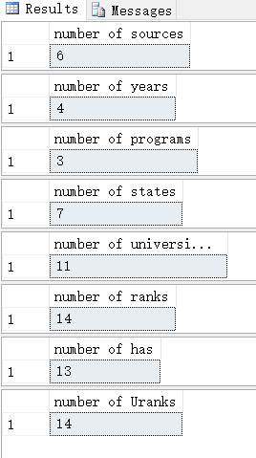

1. Business transactions as question statements and SQL SELECT statements to test/answer every business transaction
2. What will be university ranking for MBA from USNEWS in 2016?

SELECT r.rankNo AS 'Rank', r.sourceName,r.yr, u.uniName AS 'University Name',u.state AS 'Location', u.uniType AS 'University Type', h.progName AS 'Program', h.duration, h.fee

FROM Rank r, University u, Has h

WHERE r.uID =u.uID AND r.uID = h.uID AND r.sourceName = 'USNEWS' AND r.yr = '2016' AND r.progName = 'MBA' ORDER BY r.rankNo

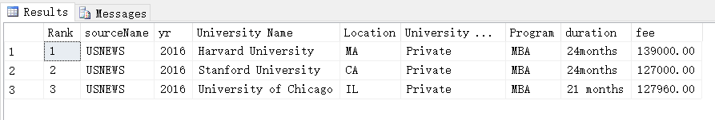

1. What will be university ranking for MBA from Economist in 2016?

SELECT r.rankNo AS 'Rank', r.sourceName,r.yr, u.uniName AS 'University Name',u.state AS 'Location', u.uniType AS 'University Type', h.progName AS 'Program', h.duration, h.fee

FROM Rank r, University u, Has h

WHERE r.uID =u.uID AND r.uID = h.uID AND r.sourceName = 'ECONOMIST' AND r.yr = '2016' AND r.progName = 'MBA' ORDER BY r.rankNo

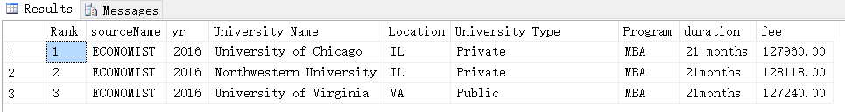

1. What will be university ranking for MS-BA from USNEWS in 2015?

SELECT r.rankNo AS 'Rank', r.sourceName,r.yr, u.uniName AS 'University Name',u.state AS 'Location', u.uniType AS 'University Type', h.progName AS 'Program', h.duration, h.fee

FROM Rank r, University u, Has h

WHERE r.uID =u.uID AND r.uID = h.uID AND r.sourceName = 'USNEWS' AND r.yr = '2015' AND r.progName = 'MS-BA' ORDER BY r.rankNo

