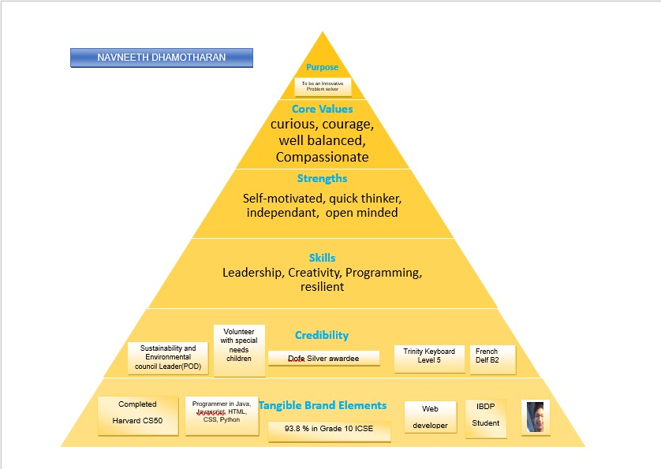

|  |  |  |
| --- | --- | --- |
|  | Navneeth Dhamotharan  To be an avid data scientist who can solve real-life problems and a lifelong learner. |  |

|  |  |
| --- | --- |
|  |  |
| Contact +971 56 821 2830  +971 50 661 4182  navneethd8@gmail.com | Honors and Awards **Duke Of Edinburgh’s Bronze and Silver Award**  **DELF A1-B2 Pass**  **Trinity College London Electronic Keyboard exams completed till grade 5 [Grade 6 Ongoing]**  **Winning Team- The IB Group 4 Project TCL Communication Grade 4** |
| Education GEMS Modern Academy, Dubai  Dubai, UAE  Grade 10 ICSE (93.8% overall)  IBDP Year 1(34/42)  SAT 1310 – 93rd percentile (English:640, Mathematics 670)  IBDP-Predicted 36 | SKILL DEVELOPMENT FOR DATA SCIENCE To reach my career goal to be a data scientist, I have been learning and strengthening my knowledge in computer science and mathematics.  **After school robotics class-** **[2018]**  First time, I learnt python as a language to code circuits along with the basic block coding for the Lego Mindstorm NXT’s brick. I also learnt about basic condition statements for data validation and verification.  **Artificial Intelligence Bootcamp with Digital Media Academy- [2019]**  Further strengthened my knowledge in python and was able to create a chatbot in python along with Google’s Dialog Flow and IBM’s Watson Digital Assistant along with python. In the final presentations for the bootcamp which was a competition to gauge our progress over the course of the bootcamp and in that I was able to come in a close second place. I also learnt about neural networks which is essential in speeding up the data processing process.  **Courses with IBM- [2020]**  Completed the ‘Introduction to Data Science and Analytics’ course with IBM Acclaim and developed my Java skills which I have learnt in school using one of the courses on the platform.  **Harvard University’s CS50 course-[2021]**  Equipped with more programming languages like Java Script and C which helped strengthen my coding knowledge.  **Elements of AI by the University of Helsinki -[2021]**  Learnt more about machine learning and Neural networks which helps in the sorting of data in a faster manner.  **Microeconomics Principles with the University of Illinois-Coursera[2022]**  Enhanced my microeconomic principles and business concepts  **An Introduction to Calculus by the University of Sydney-Coursera[2022]**  Expanded my mathematical and statistical knowledge  **The IB Group 4 Project[2022]- ‘Life on Mars - designed a self-sustaining POD to survive on Mars’**  The IB Group 4 Project was a way for me to express my computational and mathematical knowledge in a way where I was handling all the data from my team’s experimentation and was able to use my computational and mathematical knowledge to win the Group 4 project competition. |
| Key Skills **Programming** (Java, JavaScript, Python, Visual Basic, Basic, CSS)  **Leadership** (Pledge officer on duty- Environmental and Sustainability Council, Co-leader- the Leimone Magazine, Head-GMA Purplebell)  **Creativity**(Done through Music and Website development)  **Resilience**(DofE) | Volunteering and Service **Special Families Support Group[2022]**  Volunteered with the SFS or the special family support group in order to assist the children of determination on a trip to Dubai Frame for two hours.  **Concursos [2019]**  Participated in Concursos 2019 in an effort to give moments of happiness to children of determination.  **French Mentoring [2021]**  Mentored Students in the French Language for a term/semester of school in my junior year/ grade 11  **Computer Mentoring [2022]**  Coaching a low performing peer in my computer science class how to create a website for his computer project using Javascript**.**  **Work with Samiksha Foundation [2019,2021]**  Volunteered at Samiksha Foundation in 2019 and 2021 during the onset of the COVID-19 pandemic and devised an elaborate syllabus for the students to learn until government e-learning facilities were put in place and in early 2021 when they were initiated, I worked online with the people there in order to transcribe the videos from English into multiple regional languages which helped these children with cancer living under the care of the foundation with a chance to learn during the unsettling time. |
| Languages Known **English**-Intermediate level [Speaking, Reading, Writing]  **French**- Intermediate level  [Speaking, Reading, Writing]  **Arabic**- Beginner level-  [Speaking, Reading, Writing]  **Tamil**- Beginner Level[Speaking] | Extracurriculars **Work with GMA’s Environmental Club and the Environmental and Sustainability Council[2020-2022]:** Having Joined the little steps GMA environmental club back in my sophomore year of school when the club was first in its initial stages, I was able to learn more about the sustainability campaigns of the school and spearheaded multiple initiatives within the council such as project carta, the conversion of GMA Revive into a student led initiative, the creation of the club’s Instagram account and Winning the reputed green flag award for sustainable schools.  In my junior year of high school, I was allowed to become a Pledge officer on duty for the year old created environmental and sustainability council. As A POD, I organized a series of assemblies for primary school children in creating awareness about environmental issues and how to become an eco-friendly citizen along with the yearly earth day and Environmental day assemblies. I have also been able to inspire children through these assemblies and campaigns, which may result in them becoming future environmental leaders in the school system.  **DELF[2018-2021]:**  I have completed DELF French exams from A1 to B2 consecutively over the period of four years. This experience increased my proficiency in all abilities in French.  **ELECTRONIC KEYBOARD Trinity College London Exams[Bridge Flexi Finale][Organizing CAS Fiesta][2013,2022]**:  I have completed Level 5 of Trinity Electronic Keyboard with distinction. I have been able to use the knowledge that I have gained for learning for these exams by performing songs during the Flexi module finale for both my junior and senior years of school. I was also able to organize “CAS Fiesta” a showcase of the musical talents where I also performed.  **DofE[2019-2022]**:  Having achieved The Duke of Edinburgh’s Bronze and Silver awards, I gained a lot of key skills that are present in a workplace like collaboration, resilience, patience, and finally Leadership as I was the leader of my group for all four of my DofE treks.  **Volunteered in the IT Box at School[2021]:**  When involved in organizing different programs for sustainability and environment council, the responsibility also included technological support to showcase the programs. This introduced me to work with the IT Box which was from where the Assemblies were being streamed online to other sections of the school and for the parents. I learnt about *stream overlays, stream decks*, how to effectively use sound and lighting equipment such as the audio dials for the mic levels and more. Using this knowledge will help me in the future when organizing an event in the virtual sphere or on stage.  **The Leimone multilinguistic magazine[2021]:**  In my junior year of high school, I chose to be in a team to revive the Leimone magazine, which was an editorial showcasing the language prowess of our school. I was the head editor of the team, and I was able to form a team of linguistic experts in languages like Spanish, French, English, Hindi, and German along with an open invite to students at the schools to send in their writings from a plethora of different languages. Through this the school was able to showcase the linguistic talents of students of different grades and I was able inspire more students to become budding writers in different languages.  **Web Development with GMA Purplebell[2021-Ongoing]:**  The GMA Purplebell is a website that I began in my junior year of high school which showcases all the initiatives of the IBDP section of the school. As the only member of the web development team, I had the huge responsibility of setting the website up along with collecting information about initiatives and people who wanted to showcase their talents.  Through this I was able to create a place where my batch could project on all the initiatives taking place in the school and even sign up for a few of them which resulted in multiple amazing initiatives such as Modern’s first blood donation drive, Fridge Friends etc.  **Participant- The Harvard Innovation and Sustainability Challenge[2022]:**  As an active member of the school’s sustainability council and the eco-club I was one of fifteen students from all across the school to represent them at the Harvard Innovation and Sustainability challenge. Through this I was able to gain more knowledge about up-and-coming environmental problems along with different methods of solving existing ones. As a part of the challenge, all the participants were tasked with producing a solution to an issue of environmental significance using concepts that I have learnt during my business classes in school. Although my team did not win, I learnt to suggest a few viable solutions for implementation at school. |