COMPUTER SCIENCE

INTERNAL ASSEMENT

CRTIERION B

|  |  |  |  |
| --- | --- | --- | --- |
| Page Name | Description | Admin/User | Methods/Functions |
| Admin Home Page | Home page for the admins where they can access | Admin | Static Page |
| Approve Videos | Enables the Admin to approve the videos | Admin | Async function which sends a query to the database to display only the unapproved videos |
| Upload Worksheets | Enables the Admins to upload Worksheets that the user can download | Admin | Async function user_email: sends the mail  Two other async functions to upload the files.[upload:async function; async function] |
| Upload Categorical Questions | Enables Admin to upload questions based on category | Admin | Static Page |
| Approve Difficult Quiz Questions | Enables admin to approve the difficult quiz questions that the user uploads | Admin | Async function which sends a query to the database to display only the unapproved difficult questions |
| Show List of questions based on categories to Admin | For each category selected, the Admin should be able to see the questions present in the database | Admin | Async function to display questions from database based on category |
| View Worksheets | Enables the Users and Admins to view the worksheets uploaded | User and Admin | Async function to list worksheets based on category chosen |
| Home | General Home Page for Users | User | Static Page |
| About | About the Company etc. | User | Static Page |
| List Videos | Lists all the videos that the user can watch after the admin has approved of them | User | Async function to list approved videos based on category |
| FAQ | FAQ for Users | User | Static Page |
| View worksheets | Enables users to view the worksheets that the admin has uploaded | User | Async function to display worksheets from database based on category |
| View Syllabus | Enables the user to view the syllabus of the SAT | User | Static Page |
| Upload Difficult Questions | Uploads the difficult questions based on category | User | Static Page |
| View Quiz | Enables the user to view the quiz | User | Async function to display random questions based on input category with a limit of 10 |
| Print Quiz | Enables the user to print the quiz | User | Uses default window.print() function |
| Error Pages | In case there is an error, the user should be redirected to error pages other than the specific 404 and a 505 error pages | User | Static page |
| Evaluate quiz | Corrects the quiz for the user | User | Method check answer takes the input and verify the input if it is correct or not. If not, an answer explanation is shown with the correct answer. |
| Login | Enables users to login with a specific condition for separate admins | User and Admin | Async function to validate users and redirect them to the login page. Admins are at the moment hardcoded. |
| Signup | Enables users to sign up and new admins to set up their account in the website | User and Admin | Async function Sends a sign up email to the user. |
| Forgot Password | Enables users and admins to facilitate the reset of their password | User and Admin | Async function to send an email with a recovery password link leading to the reset password page |
| Reset Password | Resets the passwords for the users and admins | User and Admin | Async function to update the password |
| Upload Videos | Enables the user to upload videos on the website and they can see them once the admin has approved of these videos | User and Admin | Async function user_email: sends the mail  Two other async functions to upload the files.[upload:async function; async function] |
| Confirm | Enables first time users to confirm their accounts | User and Admin | Async function to enable user to add the values into the database |

**TEST PLAN**

|  |  |  |  |
| --- | --- | --- | --- |
| Success Criteria Tested | Description of test | Test method | Expected outcome |
| 1 and 8 | Client should be able to enter Name, email, and password for registering for the product and a confirmation email should be sent to the user’s email id | A test email id, name and password will be inputted into the program.  Checking for invalid names such as ‘1234’ should happen. | The user should get a confirmation email asking them to confirm their registration and their name, email id and password should be stored in the users table in the database. |
| 1 and 8 | Client should be able to enter their email id and password in order to login to the website. | The same test email id and password from the previous step will be used and inputted into the program. | The user, if in the database should be able to login and after that the page has to redirect the user to the home after sign in page.  If the user is not in the database, we output an error saying that this user is not in the database and ask them to register. |
| 1 and 8 | Client should be able to reset their password | The same test email will be used with an email mechanism in place for the program to send the user a mail to reset their password by inputting the new password.  First the program has to check for the validity of the email as to whether it is a part of the user database or not. If yes, the program has to prompt the user to enter the new password and then redirect them to the login page, where they can login again. | The user should be able to reset their password and re login successfully. |
| 2 | All static and dynamic pages should be visible on the sidebar | Check That the sidebar is accessible for each page and linking properly to each page | The sidebar links to each page |
| 4 and 3 | Client upload his resource materials such as worksheets and questions. | The client should be able to upload the documents, questions and videos to the respective databases using upload forms with the appropriate data types. | The client/admin is able to properly upload all documents, videos and questions |
| 5 and 8 and 3 | User upload of videos | User should be able to upload videos with the correct category to the database and send a mail to the user after they have successfully uploaded their videos. | The video is sent for approval with an email being sent up to them when they upload their video. |
| 6 and 8 | Allow client to approve or deny resources | Check if email has been sent to a test account once a test video has been approved | When the client approves a video, an email should be sent to the user saying that their video has been approved. |
| 7 and 8 and 3 | Allow users to upload questions | Use a test form to see if a test user can upload questions based on the fields such as questions, answers1-4 in MCQ, category, correct answer(1,2,3,4) and the answer explanation | All values appear properly in the difficult database and the client should be able to approve /reject the questions. |
| 9 and 10 | Page so that users can test themselves on the questions that the user and client have uploaded | Only 10 random questions from the category chosen by the user should be display with radio buttons present for the user to choose.  At the end of the quiz the user should be able to evaluate and print the quiz report. | Proper evaluation of correct answer and the user is prompted to print the page if the user asked to print the page.  After evaluation, the An email of the report should be sent to the user. |

**CRITERION B: RECORD OF TASKS**

|  |  |  |  |  |  |
| --- | --- | --- | --- | --- | --- |
|  | Candidate: | | | | |
| **Task number** | **Planned action** | **Planned outcome** | **Time estimate** | **Target completion date** | **Criterion** |
| 1 | Initial Contact with Client | Get an idea of what the client wants and the expectations of the client with regards to the product | 1 Hour | 20th May 2022 | A |
| 2 | Meeting with client | Discuss success criteria of the product with the client and get his feedback and modify based on the changes given by the client | 30 minutes | 22nd May 2022 | A |
| 3 | Meeting with teacher | To check if the solution is viable and complex enough | 15 minutes | 25th May 2022 | A |
| 4 | Creation of Basic designs for each of the pages that the client wants | Create simple designs using Microsoft word which the client can easily understand | 4 hours | 25th June 2022 | B |
| 5 | Creation of Flowcharts and relationship diagrams | Creation of Flowcharts, Data flow diagrams and entity relationship diagrams(ERD) in order to visualize how exactly the product will function | 6 Hours | 30th June 2022 | B |
| 6 | Second meeting with client | Meet with the client to show the designs to them and gauge if there are any changes to be made to the designs. | 1 Hour | 2nd July 2022 | B |
| 7 | Design Changes | Amend basic design based on feedback given | 3 hours | 6th July 2022 | B |
| 8 | Design on Basic GUI | To create all the pages which will be viewed by the user of the program along with a sidebar and jumbotron with the title of each page. | 5 Hours | 8th July 2022 | B/C |
| 9 | Create Database tables and Schemas | Set up a SQL based database and configure it to work with the programs. Create Database Schemas for User, quiz, files, questions, and video tables in the sat decoded database | 3 Hours | 10th July 2022 | B/C |
| 10 | Third meetup with the client | Check if the basic frontend design is fine and get the frontend content for the static pages. | 30 minutes | 15th July 2022 | B/C |
| 11 | Code the controllers | Write programs for the following controllers:  Confirm Registration, forgot password, login, register, reset password, videos, quiz, quiz-questions, view approved videos and approve videos. | 15 Hours | 30th July 2022 | C |
| 12 | Complete the full functionality of the login and registration process. | Connect frontend with backend for the registration and login process along with enabling the email functionality in case the user forgot their password or has to confirm their registration. | 7 hours | 1st August 2022 | C |
| 13 | Complete the full functionality of video uploading | Connect the frontend form for a user to upload the video with the database along with sending an email that the video has been sent for approval. This is the first stage in the video upload process | 3 hours | 8th August 2022 | C |
| 14 | Allow Admin/client login | Create a separate admin home page with the tasks that the admin has to do along with a special condition in the login controller for the admin logins. | 1 hour | 12th August 2022 | C |
| 15 | Complete the full functionality of the approval of videos by the admin | Connect the frontend form for an admin to approve the uploaded videos from the database along with sending an email to the user that their video has approved/rejected. This is the second stage in the video upload process. After this the video has to be viewable on the website. | 4 hours | 19th August 2022 | C |
| 16 | Complete the full functionality of the viewing of approved videos from the user’s perspective. | Once the video has been approved, the video has to be listed on the view videos page on the website. This is the third and final stage of the video upload process. | 3 hours | 25th August 2022 | C |
| 17 | Progress update with Client and Teacher | Show the client what has been achieved so far and what has to be done in order to be changed/ improved.  After that meet, the teacher in order to see whether the product is complex enough and weather the progress being made is good enough. | 1hour-With client  20 minutes: with teacher | 30th August and 8th September 2022 respectively | C |
| 17 | Creation of functionality for puzzling questions | A similar process to the videos the puzzling questions that a user has faced can be uploaded in one section of the website, thereby creating a repository of tough questions which may attract more people to the website. After being uploaded, these questions will be subject to approval from an admin or the client himself. After approval, the questions will be added to the category of tough questions for the next section of the product which is the quiz section. | 5 hours | 15th September 2022 | C |
| 18 | Creation of functionality for the Client to upload questions based on category for the quizzes | Through this process, the client/ admin will be able to upload questions based on categories to the quiz database. | 2 hours | 19th September 2022 | C |
| 19 | Creation of the front-end form for the quiz | Through this, the user should be able to choose which category of quiz the user the user wants to evaluate themselves in. | 1 Hour | 24th September 2022 | C |
| 20 | Creation of randomly generate quiz questions. | Modify the main quiz controller to randomly generate ten questions based on the category chosen. | 3 hours | 30th September 2022 | C |
| 21 | Correction of quiz questions | Create a validation in the quiz controller in order to correct the questions from the quiz. | 2 hours | 5th October 2022 | C |
| 22 | Printing of report | Enable the user to download a printable copy of the quiz with the correct questions and the wrong questions with an explanation of what the correct answer is. | 3 hours | 9th October 2022 | C |
| 23 | Email report | Enable the user to send the report to them using the email functionality of the product | 1 hour | 13th October 2022 | C |
| 24 | Check success criteria and receive feedback from the client | Consult with the client to see whether the product is up to the mark. | 2 hours | 19th October 2022 | A/C/E |
| 25 | Fixes | Make the necessary changes required to improve the product and then check if all aspects of the test plan are working | 2 hours | 23rd October 2022 | A/C/E |
| 26 | Final Application | Give the final application to the client for testing so that the client can use the programs to assess for errors or problems. | 3 hours | 31st October 2022 | A/C/E |
| 27 | Resolve additional problems | Any recent problems are fixed, and the program is evaluated again | 4 hours | 2nd November 2022 | A/C/E |
| 28 | Creation of Final Product video | - | 3 hours | 8th November 2022 | D |
| 29 | Evaluate the project | Identify the strengths and weaknesses of the of the product and what could have been done better. | 2 Hours | 14th November 2022 | E |
| 30 | Discuss future improvements | Discuss what can be done to improve the product in the future and what can be added with the client. | 30 minutes | 20th November 2022 | E |

**Database Schemas**

Difficult Questions Schema

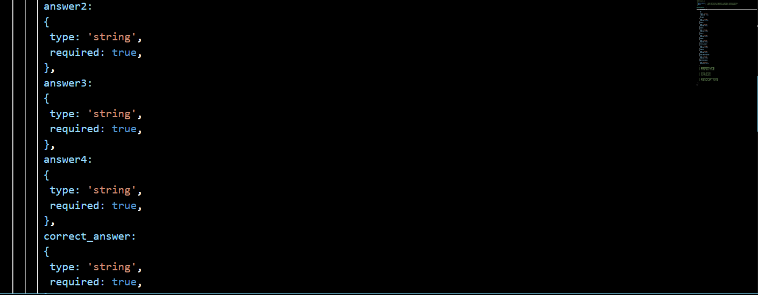

Worksheets Database schema

Question Database

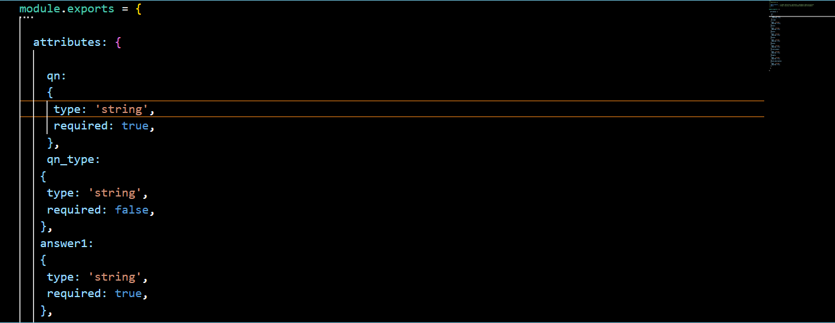

User Database Schema

Videos Database Schema

Page Designs

Sidebar- Users

X

[About](http://localhost:1337/about.html)  
[Syllabus](http://localhost:1337/list_syllabus.html)

[View Videos](http://localhost:1337/list_videos)

[Upload a video](http://localhost:1337/video_upload.html)

[View Worksheets](http://localhost:1337/worksheets_view.html)

[FAQ](http://localhost:1337/faq.html)

[Generate Quiz](http://localhost:1337/formquiz.html)

[Generate Quiz of Difficult Questions](http://localhost:1337/generate_difficult_quiz.html) [Upload Difficult Questions!](http://localhost:1337/difficult_questions.html)

[Back to Home](http://localhost:1337/home_after_sign_in.html)

Sidebar- Admin

X

[Approve Videos!](http://localhost:1337/approve_videos)

[Upload Worksheets](http://localhost:1337/worksheets_upload.html) [Upload Categorical Questions](http://localhost:1337/upload_questions)

[Approve Difficult Questions](http://localhost:1337/approve)

[List Questions Based on Category](http://localhost:1337/display_quiz_admin.html)

[Back to Admin Home](http://localhost:1337/admin_after_sign_in.html)

[Back to User Home](http://localhost:1337/home_after_sign_in.html)

About Page

☰ SATDecoded

About Us

Lorem Ipsum dolor sit amet, consectetur adipiscing elit, sed do eiusmod tempor incididunt ut labore et dolore magna aliqua. Ut enim ad minim veniam, *quis nostrud exercitation ullamco laboris nisi ut aliquip ex ea commodo consequat.* Duis aute irure dolor in reprehenderit in voluptate velit esse cillum dolore eu fugiat nulla pariatur. Excepteur sint occaecat cupidatat non proident, sunt in culpa qui officia deserunt mollit anim id est laborum.

Home after sign in Page

☰ SATDecoded

You have successfully logged in!

Syllabus

☰ SATDecoded

Syllabus for the SAT

Lorem Ipsum dolor sit amet, consectetur adipiscing elit, sed do eiusmod tempor incididunt ut labore et dolore magna aliqua. Ut enim ad minim veniam, *quis nostrud exercitation ullamco laboris nisi ut aliquip ex ea commodo consequat.* Duis aute irure dolor in reprehenderit in voluptate velit esse cillum dolore eu fugiat nulla pariatur. Excepteur sint occaecat cupidatat non proident, sunt in culpa qui officia deserunt mollit anim id est laborum.

FAQ

☰ SATDecoded

FAQ

Lorem Ipsum dolor sit amet, consectetur adipiscing elit, sed do eiusmod tempor incididunt ut labore et dolore magna aliqua. Ut enim ad minim veniam, *quis nostrud exercitation ullamco laboris nisi ut aliquip ex ea commodo consequat.* Duis aute irure dolor in reprehenderit in voluptate velit esse cillum dolore eu fugiat nulla pariatur. Excepteur sint occaecat cupidatat non proident, sunt in culpa qui officia deserunt mollit anim id est laborum.

List Videos

☰ SATDecoded

List Videos

Category

Filename.mp4

VIDEO

Upload a video

☰ SATDecoded

Upload your videos

Please choose your category and click the submit button

Choose file

Submit

View Worksheets

☰ SATDecoded

View Worksheets

Submit

☰ SATDecoded

List Worksheets

[Download](http://localhost:1337/Worksheets/190e1b93-161e-419c-b520-9fbfe2850411.pdf)

Category

Filename.pdf/.docx

Generate quiz

☰ SATDecoded

Choose your Quiz!

Submit

Upload Questions to a quiz-Admin only

☰ SATDecoded

Upload Quiz!

Enter Question Here

Answer 1

Answer 2

Answer 3

Answer 4

Correct Answer

Correct Category

Answer Explanation

Generate Difficult Quiz

☰ SATDecoded

Choose your Difficulty!

Submit

Upload Difficult Questions to a quiz-

☰ SATDecoded

Upload Difficult Quiz!

Enter Question Here

Answer 1

Answer 2

Answer 3

Answer 4

Correct Answer

Correct Category

Answer Explanation

View Quiz

☰ SATDecoded

View Quiz!

Question?

Top of Form

 Answer1  
 Answer2  
 Answer3  
 Answer4

Bottom of Form

Question?

Top of Form

 Answer1  
 Answer2  
 Answer3  
 Answer4

Bottom of Form

Print Quiz

Evaluate

View Quiz of Difficult Questions

☰ SATDecoded

View Difficult Quiz!

Question?

Top of Form

 Answer1  
 Answer2  
 Answer3  
 Answer4

Bottom of Form

Question?

Top of Form

 Answer1  
 Answer2  
 Answer3  
 Answer4

Bottom of Form

Print Quiz

Evaluate

Index page

☰ SATDecoded

Welcome to SAT Decoded!

Sign Up

Sign In

Admin after sign in

☰ SATDecoded

Welcome Admin!

Approve Videos-Admin Only

☰ SATDecoded

Approve Videos

Approve

Category

Filename.mp4

VIDEO

Approve Difficult Questions- Admin only

☰ SATDecoded

Approve Difficult Questions

|  |  |  |  |  |  |  |  |  |
| --- | --- | --- | --- | --- | --- | --- | --- | --- |
| Qn | 1 | 2 | 3 | 4 | Correct Ans | Category | It is correct | Approve |

Upload Worksheets – Admin Only

☰ SATDecoded

Upload your worksheets

Please choose your category and click the submit button

Choose file

Submit

List Questions based on category-Admin only

☰ SATDecoded

Choose your Quiz!

Submit

☰ SATDecoded

List Questions based on category!

|  |  |  |  |  |  |  |  |  |  |  |  |  |  |  |
| --- | --- | --- | --- | --- | --- | --- | --- | --- | --- | --- | --- | --- | --- | --- |
| |  |  |  |  |  |  |  | | --- | --- | --- | --- | --- | --- | --- | | Question | A1 | A2 | A3 | A4 | answer1 | category | |  |  |  |  |  |  |  |

Flowcharts

Sign Up

Log in

Forgot Password

Reset Password

Confirm

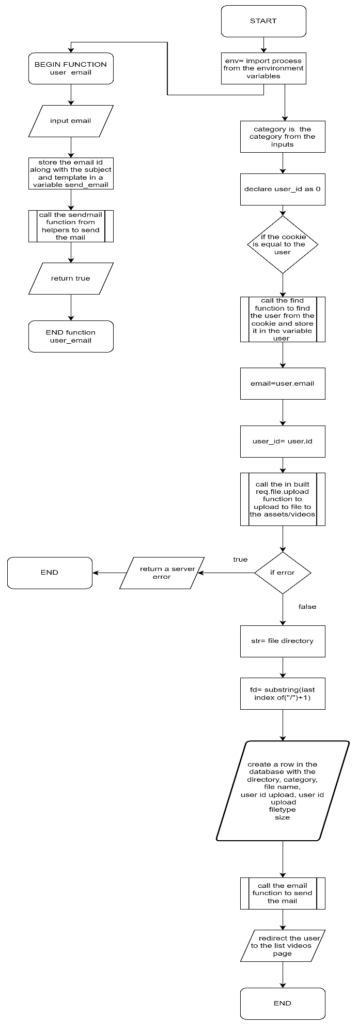

Video Upload

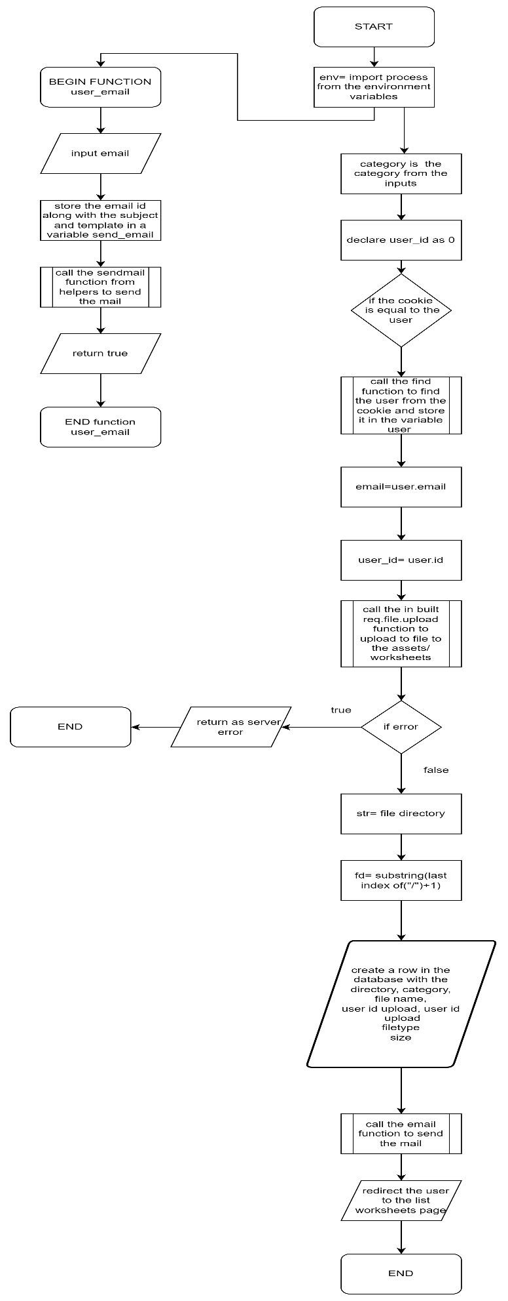

File/Worksheet Upload

Upload difficult questions

Upload normal questions

Approve Difficult Quiz

Approve user uploaded Videos

View quiz

View difficult quiz

List worksheets

List questions

List videos

Generate new jwt token

Send mail helper

