

University of Vavuniya, Sri Lanka

# Salon Appointment Management System

Project Proposal

Software Engineering – TICT3153

2024

2019/ICTS/176

Submitted by

P.V.N.N Jayalath

Submitted to

Ms. Sandani Samarasekara

Date of Submission : 06-06-2024

1. **Introduction**
   1. Company / Client Background

SALON INOKA, nestled in the heart of Deraniyagala, Sri Lanka, stands as a beacon of elegance and excellence in the local beauty and wellness industry. With a rich legacy spanning two decades, SALON INOKA has earned the trust and loyalty of its clientele through its commitment to delivering premium services and personalized care. However, despite its illustrious reputation, the salon continues to grapple with outdated manual booking and record-keeping processes, which not only hamper operational efficiency but also pose challenges in meeting the evolving needs of its discerning customers.

In response to these challenges, SALON INOKA is embarking on a transformative journey towards modernization by undertaking the development of an automated salon appointment application. This groundbreaking initiative seeks to revolutionize the salon's operations, enhance customer experience, and propel it into the digital age. By leveraging cutting-edge technology and innovative solutions, SALON INOKA aims to redefine the standards of service excellence, ensuring that every customer interaction is seamless, efficient, and tailored to their unique preferences. Through this project, SALON INOKA reaffirms its commitment to staying at the forefront of the industry, setting new benchmarks for innovation, and reaffirming its position as a trusted destination for beauty and wellness in Deraniyagala, Sri Lanka.

1.2 Problem Statements And Difficulties

**Difficulty in managing and retrieving client records**

* All client information is recorded on paper, making it time-consuming and error-prone to retrieve and update records.

**Inefficiencies in booking and scheduling appointments**

* The manual appointment booking process often leads to double bookings, missed appointments, and scheduling conflicts.

**Challenges in handling staff schedules and payroll**

* Staff schedules and payroll are managed manually, leading to potential errors and difficulties in coordinating staff availability.

**Risks of data misplacement or redundancy**

* Important records and data are at risk of being lost, misplaced, or duplicated due to the lack of a centralized digital system.

**Inconvenience for clients in booking and managing their appointments**

* Clients must call or visit the salon to book or modify appointments, which can be inconvenient and time-consuming.

**Difficulty in adjusting open and close times during natural disasters and other unforeseen events**

* Manual processes make it challenging to quickly adjust operating hours in response to emergencies, leading to confusion and potential loss of business.

## Solutions

The proposed solution is to develop a web-based salon appointment application designed to enhance the customer experience at Salon Inoka. This application will feature a comprehensive database to manage client and appointment details, ensuring efficient storage and retrieval of all necessary information. Clients will benefit from an intuitive interface that allows them to easily book, modify, and cancel appointments online at their convenience, eliminating the need for time-consuming phone calls or visits to the salon.

To keep clients informed and engaged, the system will send automated notifications for upcoming appointments and special offers, ensuring that clients never miss an appointment or a promotion. The application will also prioritize the security of client data, providing secure storage and easy retrieval of records to maintain privacy and accuracy.

Additionally, the application will include a feature that allows clients to preview various hairstyles and beard styles before making their selection. This visual aid will help clients make informed decisions about their desired look, enhancing their overall satisfaction with the salon's services.

Overall, this web-based salon appointment application aims to streamline the booking process, improve client communication, and offer a more personalized and convenient service experience at Salon Inoka.

1. **Benefits Of The System**

The proposed salon appointment system offers a multitude of benefits tailored to meet the needs of both Salon Inoka's administrators and its valued clientele.

For administrators, the system streamlines appointment management processes, significantly reducing the likelihood of double bookings or scheduling conflicts. Through automation, scheduling becomes seamless, enabling real-time tracking and updates to appointments. This not only enhances organizational efficiency but also minimizes administrative burdens, freeing up staff to focus on more strategic initiatives.

Moreover, the system's automation translates to reduced operational costs for the salon, optimizing resource allocation and maximizing productivity. With less time spent on manual tasks, administrators can allocate their energy towards improving customer experiences and enhancing service quality.

1. **System Overview**

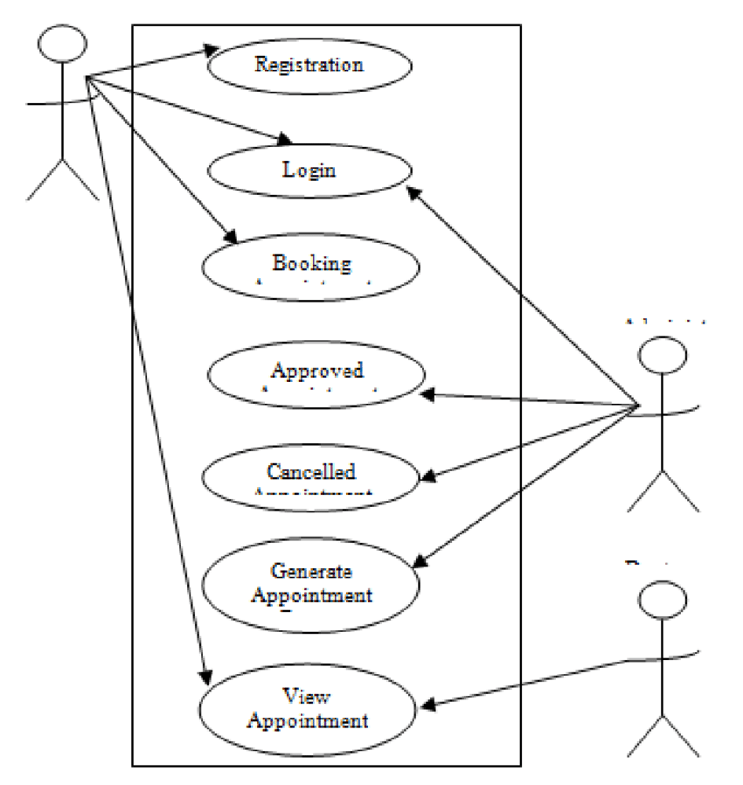

Server side

Client side

The system will be a responsive web application accessible from various devices such as desktops, tablets, and smartphones. It will store all data in a centralized database, ensuring secure and reliable access to information for both clients and staff.

1. **System Function**

4.1 Functional Requirements

4.1.1 Client Management Function

* Clients Registration: Clients can register on the system by providing their personal details such as name, contact information, and service preferences.
* Administrative Control: Administrators have the ability to add, update, or remove client information as needed. This includes managing client profiles and preferences.
* Client Self-Service: Clients have access to their profiles where they can view and update their personal information, preferences, and booking history.

4.1.2 Staff Management Function

* Staff Registration: Staff members register on the system by providing their personal and professional details including qualifications, certifications, and areas of expertise.
* Schedule Management: Administrators have control over staff schedules, assigning shifts, managing leave requests, and updating payroll information.
* Staff Self-Service: Staff members can access their profiles to update personal information, view assigned schedules, and manage their availability.

4.1.3 Appointment Management Function

* Appointment Booking: Clients can easily book, reschedule, or cancel appointments through the system. They can select preferred dates, times, and services.
* Administrative Control: Administrators have the ability to manage and update appointment slots, ensuring optimal scheduling and resource allocation.
* Automated Notifications: The system sends automated reminders and notifications to clients for upcoming appointments, reducing no-shows and enhancing customer experience

4.1.4 Notification Management Function

* Automated Notifications: The system provides automated notifications for various events including appointment confirmations, reminders, promotions, and special events.
* Customized Messaging: Administrators can send customized messages to clients and staff, informing them about new services, promotions, or important updates.
* Delivery Channels: Notifications are delivered via preferred channels such as email or SMS, ensuring timely communication with clients and staff.

4.2 Non-Functional Requirements

* Accuracy
* Privacy
* Backup
* Capacity
* Data Integrity
* Development

1. **Technologies**

To develop our Salon Inoka Appointment System, we have decided to leverage the MERN (MongoDB, Express.js, React.js, Node.js) stack for both client-side and server-side technologies.

**Client-Side (Front-end) Development**

For the client-side of our application, we have chosen React.js as our front-end framework. React.js is a powerful JavaScript library known for its lightweight nature and strong integration capabilities. With its reactive two-way data binding, React.js facilitates smooth user interactions, making it ideal for creating dynamic and responsive user interfaces. Its simplicity and flexibility will enable our team to quickly grasp its concepts and develop efficiently within our project timeline.

**Server-Side (Back-end) Development**

On the server-side, we will be using Node.js along with Express.js framework. Node.js provides a runtime environment for executing JavaScript code server-side, while Express.js simplifies the development of web applications by providing a robust set of features and tools. By adhering to the model-view-controller (MVC) architectural pattern, Express.js ensures a structured and organized codebase, enhancing maintainability and scalability. The lightweight nature of Node.js and Express.js enables rapid development, saving both time and resources. Additionally, their compatibility with various third-party tools and adherence to industry best practices ensure the reliability and efficiency of our backend system.

**Database Management System**

We will continue to use MongoDB as our database management system. MongoDB is a scalable, flexible, and high-performance NoSQL database known for its ease of use and flexibility. Its document-oriented nature makes it well-suited for storing and managing unstructured data such as client information, appointment details, and staff schedules. MongoDB's compatibility with the MERN stack and its robust features make it an ideal choice for our Salon Inoka Appointment System.

**Development Tools**

Our development process will be supported by a suite of tools including Visual Studio Code, MongoDB Compass, and Git Version Control System. Visual Studio Code is a feature-rich source-code editor that supports debugging, syntax highlighting, and seamless integration with Git. Its user-friendly interface and extensive plugin ecosystem enhance our development experience. MongoDB Compass provides a visual interface for MongoDB, offering features such as the Visual Performance Dashboard and easy import/export functionality. Git Version Control System enables collaborative development by providing version control and code management capabilities, ensuring code consistency and reliability throughout the development lifecycle.

With the MERN stack and our chosen development tools, we are confident that we can deliver a robust, scalable, and user-friendly Salon Inoka Appointment System that meets the unique requirements of our salon business.

1. **Gantt Chart**

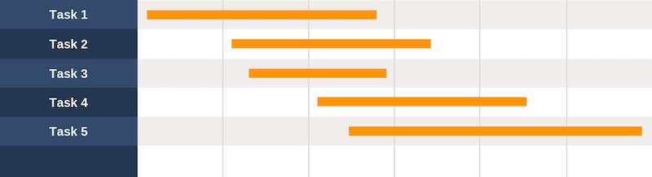

Task 1. Definition & Requirement Analysis

Task 2. Planning

Task 3. Design

Task 4. Development

Task 5. Testing & Launch

1. **References**
2. **MERN Stack Development**

**Documentation**

* MongoDB, Express.js, React.js, Node.js official documentation will serve as the primary reference for understanding the core components of the MERN stack.

**Courses**

* Udemy, Coursera, FreeCodeCamp, and The Net Ninja offer comprehensive courses covering each technology in the MERN stack. These courses will provide structured learning and practical exercises.

**Tutorials**

* YouTube channels like M Code Frontend and The Net Ninja offer a plethora of tutorials covering various aspects of MERN stack development, catering to different learning styles.

1. **Salon System Development**

**Courses**

* Courses available on platforms like Udemy and Coursera focus on building management systems, offering valuable insights and methodologies that can be adapted to develop a salon system.

**GitHub Repositories**

* Explore open-source management systems on GitHub to gain inspiration and insights into the architecture and functionalities of similar systems.

**Online Communities**

* Engage with online communities such as Stack Overflow, Reddit's r/webdev, and dev.to to participate in discussions, seek advice, and learn from the experiences of others in developing similar systems.