USE CASE DIAGRAM AND CLASS DIAGRAM

USE CASE DIAGRAM

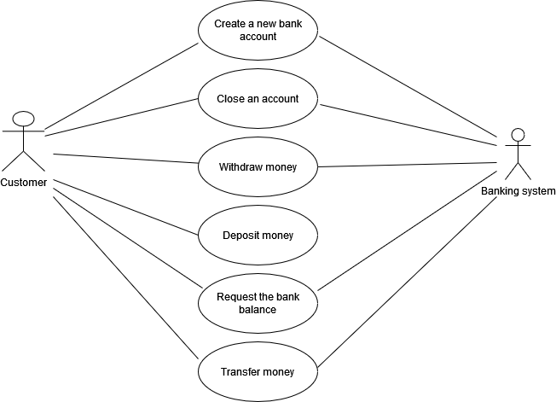

CLASS DIAGRAM

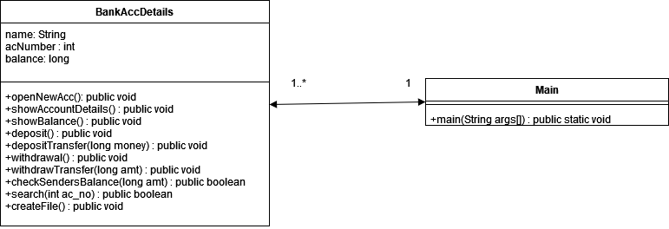

* In this diagram main class is the banking system
* In BancAccDetails class, it can perform all the functions related to the system

Open a new account

Show account details

Show balance of the account

Deposit

Withdrawal

Transfer functions:

depositTransfer: deposit the senders amount in the recievers account

withdrawTransfer: withdraw the amount to be transferred from the senders account

checkSendersBalance: check if the sender’s account balance is sufficient to perform transaction

search: search whether a account exist

createFile: save final balance in the text file

* One bank system (Main class) can maintain one or many bank accounts but, one bank account (BankAccDetails) can have only one bank system.