# **DL -lab-3**

### Database Image (ryan_1.jpg)

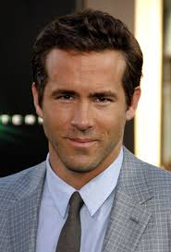

### Verify Image (ryan_2.jpg)

## Outputs



