LAB MANUAL

of

**Compiler Design Laboratory (CSE606)**

**Bachelor of Technology (CSE)**

By

Samarth Desai (22000413 - A2)



Department of Computer Science and Engineering

School Engineering and Technology

Navrachana University, Vadodara

6th Semester

(2025)

**List of Experiments**

|  |  |  |
| --- | --- | --- |
| **Sr. No.** | **Name of Experiment** | **Page No.** |
| 1 | a) Write a program to recognize strings starts with ‘a’ over {a, b}.  b) Write a program to recognize strings end with ‘a’.  c) Write a program to recognize strings end with ‘ab’. Take the input from text file.  d) Write a program to recognize strings contains ‘ab’. Take the input from text file. | 3 |
| 2 | a) Write a program to recognize the valid identifiers and keywords.  b) Write a program to recognize the valid operators.  c) Write a program to recognize the valid number.  d) Write a program to recognize the valid comments.  e) Program to implement Lexical Analyzer. | 9 |
| 3 | To Study about Lexical Analyzer Generator (LEX) and Flex (Fast Lexical Analyzer) | 27 |
| 4 | Implement following programs using Lex.  a) Write a Lex program to take input from text file and count no of characters, no. of lines & no. of words.  b) Write a Lex program to take input from text file and count number of vowels and consonants.  c) Write a Lex program to print out all numbers from the given file.  d) Write a Lex program which adds line numbers to the given file and display the same into different file.  e) Write a Lex program to printout all markup tags and HTML comments in file. | 28 |
| 5 | a) Write a Lex program to count the number of C comment lines from a given C program. Also eliminate them and copy that program into separate file.  b) Write a Lex program to recognize keywords, identifiers, operators, numbers, special symbols, literals from a given C program. | 32 |
| 6 | Program to implement Recursive Descent Parsing in C. | 35 |
| 7 | a) To Study about Yet Another Compiler Compiler(YACC).  b) Create Yacc and Lex specification files to recognizes arithmetic expressions involving +, -, * and /.  c) Create Yacc and Lex specification files are used to generate a calculator which accepts integer type arguments.  d) Create Yacc and Lex specification files are used to convert infix expression to postfix expression | 37 |

Lab – 1:

A: Write a program to recognize strings starts with ‘a’ over {a, b}.

**Code:**

#include<stdio.h>

void main()

{

char input[100];

int state = 0, i = 0;

FILE *fp = fopen("input_1_a.txt", "r");

if (fp == NULL) {

printf("Error opening file.\n");

return;

}

fgets(input, sizeof(input), fp);

fclose(fp);

while(input[i] != '\0') {

switch (state)

{

case 0:

if (input[i] =='a'){

state = 1;

}

else if (input[i]=='b'){

state = 2;

}

else{

state = 2;

}

break;

case 1:

if (input[i] == 'a' || input[i] == 'b'){

state = 1;

}

else{

state = 2;

}

break;

case 2:

break;

}

i++;

}

if (state == 1) {

printf("input string '%s' is Accepted !\n", input);

} else {

printf("Not Accepted\n");

}

}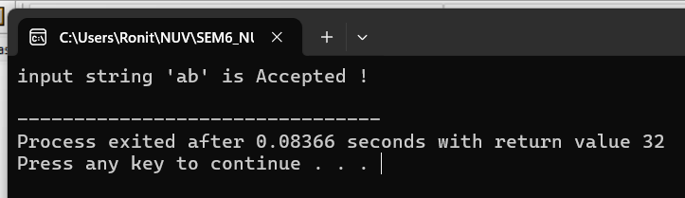

B: Write a program to recognize strings end with ‘a’.

**Code:**

#include<stdio.h>

void main(){

// program ends with 'a'.

char input[100];

int i = 0,state=0;

FILE *fp = fopen("input_1_b.txt","r");

if(fp == NULL){

printf("Error opening file\n");

return;

}

fscanf(fp,"%s",input);

while(input[i] != '\0'){

switch(state){

case 0:

if(input[i]== 'a'){

state = 1;

}else{

state = 0;

}

break;

case 1:

if(input[i] == 'a'){

state = 1;

}else{

state = 0;

}

break;

}

i++;

}

if(state == 1){

printf("String '%s' is Accepted\n",input);

}else{

printf("Not Accepted\n");

}

}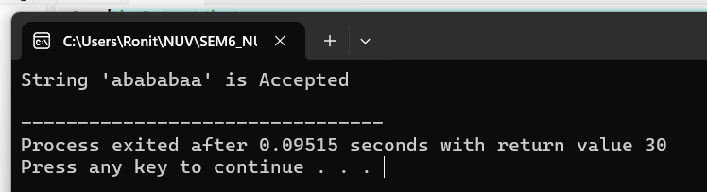

C: Write a program to recognize strings end with ‘ab’. Take the input from text file.

**Code:**

#include<stdio.h>

void main(){

// program ends with 'ab'.

char input[100];

int i = 0,state=0;

FILE *fp = fopen("input_1_c.txt","r");

fscanf(fp,"%s",input);

fclose(fp);

while(input[i] != '\0'){

switch(state){

case 0:

if(input[i]=='a'){

state = 1;

}

else{

state = 0;

}

break;

case 1:

if(input[i] == 'b'){

state = 2;

}

else if(input[i] == 'a'){

state = 1;

}

else{

state = 0;

}

break;

case 2:

if(input[i] == 'a'){

state = 1;

}

else{

state = 0;

}

break;

}

i++;

}

if(state == 2){

printf("String '%s' is Accepted\n",input);

}else{

printf("Not Accepted\n");

}

}

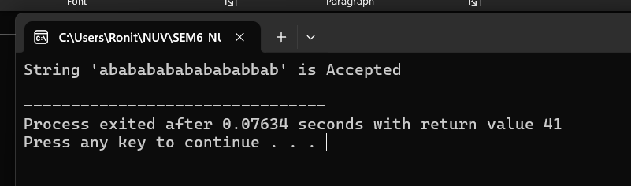

D: Write a program to recognize strings contains ‘ab’. Take the input from text file.

**Code:**

#include<stdio.h>

void main(){

char input[100];

int i=0,state=0;

FILE *fp = fopen("input_1_d.txt","r");

fscanf(fp,"%s",input);

fclose(fp);

while(input[i] != '\0'){

switch(state){

case 0:

if(input[i]=='a'){

state=1;

}

else{

state=0;

}

break;

case 1:

if(input[i]=='b'){

state=2;

}

else if(input[i]=='a'){

state=1;

}

else{

state=0;

}

break;

case 2:

state=2;

break;

}

i++;

}

if(state==2){

printf("String '%s' is Accepted\n",input);

}else{

printf("Not Accepted\n");

}

}

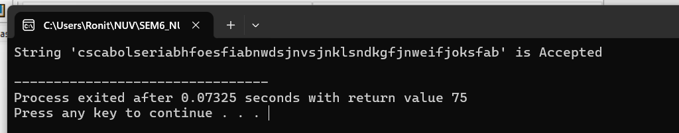

Lab – 2:

A: Write a program to recognize the valid identifiers and keywords.

**Code:**

#include<stdio.h>

#include<conio.h>

// Q2a. Write a program to recognize the valid identifiers.(and keyword but only int.)

int main()

{

char input[10];

int state = 0 , i=0;

printf("Enter Input:");

scanf("%s",input);

while (i<=10)

{

switch (state)

{

case 0:

if(input[i]=='i'){

state = 1;

}

else if((input[i] >= '0' && input[i] <= '9') || (input[i] >= 'A' && input[i] <= 'Z') || (input[i] >= 'a' && input[i] <= 'z') ||( input[i] == '_'))

{

state = 5;

}

break;

case 1:

if(input[i]=='n'){

state = 2;

}

else if((input[i] >= '0' && input[i] <= '9') || (input[i] >= 'A' && input[i] <= 'Z') || (input[i] >= 'a' && input[i] <= 'z') ||( input[i] == '_'))

{

state = 5;

}

break;

case 2:

if(input[i]=='t'){

state = 3;

}

else if((input[i] >= '0' && input[i] <= '9') || (input[i] >= 'A' && input[i] <= 'Z') || (input[i] >= 'a' && input[i] <= 'z') ||( input[i] == '_'))

{

state = 5;

}

else{

state = 0;

}

break;

case 3:

if(input[i]=='\0'){

state = 0;

}

else if((input[i] >= '0' && input[i] <= '9') || (input[i] >= 'A' && input[i] <= 'Z') || (input[i] >= 'a' && input[i] <= 'z') ||( input[i] == '_'))

{

state = 5;

}

break;

case 5:

if((input[i] >= '0' && input[i] <= '9') || (input[i] >= 'A' && input[i] <= 'Z') || (input[i] >= 'a' && input[i] <= 'z') ||( input[i] == '_'))

{

state = 5;

}

else if(input[i]=='\0'){

state=0;

}

break;

}

i++;

}

printf("\n");

if(state == 0){

printf("Accepted\n");

}

else {

printf("The input is not recognized.(%d) \n",state);}

return 0;

}

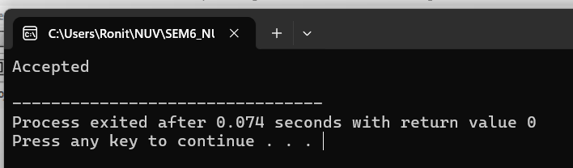

B: Write a program to recognize the valid operators.

**Code:**

#include <stdio.h>

#include <ctype.h>

#include <string.h>

void main() {

char c, buffer[1000], lexeme[10];

int i = 0, j = 0, f = 0, state = 0;

FILE *fp = fopen("input_operators.txt", "r");

if (!fp) {

printf("Error opening file.\n");

return;

}

// Read entire file into buffer

while ((c = fgetc(fp)) != EOF && j < 1000) {

buffer[j++] = c;

}

buffer[j] = '\0';

fclose(fp);

printf("File read.\n");

i = 0;

while (buffer[i] != '\0') {

c = buffer[i];

switch (state) {

case 0:

if (isspace(c)) {

// Skip spaces

} else if (c == '=') {

lexeme[f++] = c;

state = 1;

} else if (c == '!') {

lexeme[f++] = c;

state = 2;

} else if (c == '<') {

lexeme[f++] = c;

state = 3;

} else if (c == '>') {

lexeme[f++] = c;

state = 4;

} else if (c == '&') {

lexeme[f++] = c;

state = 5;

} else if (c == '|') {

lexeme[f++] = c;

state = 6;

} else if (c == '+' || c == '-' || c == '*' || c == '/' || c == '%' || c == '^' || c == '~') {

lexeme[0] = c;

lexeme[1] = '\0';

printf("Valid Operator: %s\n", lexeme);

f = 0;

} else {

printf("Invalid character encountered: %c\n", c);

}

break;

case 1: // after '='

if (c == '=') {

lexeme[f++] = c;

lexeme[f] = '\0';

printf("Valid Relational Operator: %s\n", lexeme); // ==

} else {

lexeme[f] = '\0';

printf("Valid Assignment Operator: %s\n", lexeme); // =

i--; // reprocess current char

}

f = 0;

state = 0;

break;

case 2: // after '!'

if (c == '=') {

lexeme[f++] = c;

lexeme[f] = '\0';

printf("Valid Relational Operator: %s\n", lexeme); // !=

} else {

lexeme[f] = '\0';

printf("Invalid Operator: %s\n", lexeme); // only ! is invalid here

i--;

}

f = 0;

state = 0;

break;

case 3: // after '<'

if (c == '=') {

lexeme[f++] = c;

lexeme[f] = '\0';

printf("Valid Relational Operator: %s\n", lexeme); // <=

} else {

lexeme[f] = '\0';

printf("Valid Relational Operator: %s\n", lexeme); // <

i--;

}

f = 0;

state = 0;

break;

case 4: // after '>'

if (c == '=') {

lexeme[f++] = c;

lexeme[f] = '\0';

printf("Valid Relational Operator: %s\n", lexeme); // >=

} else {

lexeme[f] = '\0';

printf("Valid Relational Operator: %s\n", lexeme); // >

i--;

}

f = 0;

state = 0;

break;

case 5: // after '&'

if (c == '&') {

lexeme[f++] = c;

lexeme[f] = '\0';

printf("Valid Logical Operator: %s\n", lexeme); // &&

} else {

lexeme[f] = '\0';

printf("Valid Bitwise Operator: %s\n", lexeme); // &

i--;

}

f = 0;

state = 0;

break;

case 6: // after '|'

if (c == '|') {

lexeme[f++] = c;

lexeme[f] = '\0';

printf("Valid Logical Operator: %s\n", lexeme); // ||

} else {

lexeme[f] = '\0';

printf("Valid Bitwise Operator: %s\n", lexeme); // |

i--;

}

f = 0;

state = 0;

break;

default:

printf("Unknown error.\n");

f = 0;

state = 0;

break;

}

i++;

}

}

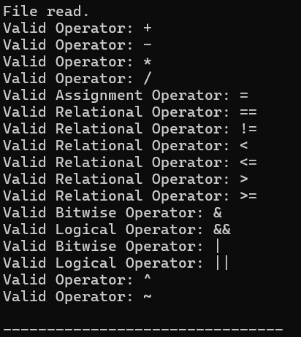

C: Write a program to recognize the valid number.

**Code:**

#include<stdio.h>

#include <ctype.h>

#include <stdlib.h>

#include <string.h>

void main(){

char c,buffer[1000],lexeme[1000];

int i = 0, state =0, f = 0,j = 0;

FILE *fp = fopen("input_2_Number.txt","r");

while((c = fgetc(fp)) != EOF && j < 1000){

buffer[j++] = c;

}

buffer[j] = '\0';

printf("File read.");

fclose(fp);

while(buffer[i] != '\0'){

c = buffer[i];

switch(state){

case 0:

if(isdigit(c)){

state = 1;

lexeme[f++] = c;

}

else if(c == '+' || c == '-'){

state = 0;

lexeme[f++] = c;

}

else if(isspace(c)){

}

else{

state = 99;

}

break;

case 1:

if(isdigit(c)){

state = 1;

lexeme[f++] = c;

}

else if(c == '.'){

state = 2;

lexeme[f++] = c;

}

else if(c == 'e' || c == 'E'){

state = 4;

lexeme[f++] = c;

}

else{

lexeme[f] = '\0';

printf("The input %s is a valid integer.\n", lexeme);

f = 0;

state = 0;

i--;

}

break;

case 2:

if(isdigit(c)){

state = 3;

lexeme[f++] = c;

}

else{

lexeme[f] = '\0';

printf("%s is an invalid floating point input.\n", lexeme);

f = 0;

state = 0;

i--;

}

break;

case 3:

if(isdigit(c)){

state = 3;

lexeme[f++] = c;

}

else if(c == 'e' || c == 'E'){

state = 4;

lexeme[f++] = c;

}

else{

lexeme[f] = '\0';

printf("The input %s is a valid floating-point number.\n", lexeme);

f = 0;

state = 0;

i--;

}

break;

case 4:

if(isdigit(c)){

state = 6;

lexeme[f++] = c;

}

else if(c == '+' || c == '-'){

state = 5;

lexeme[f++] = c;

}

else{

lexeme[f] = '\0';

printf("%s is an invalid scientific notation.\n", lexeme);

f = 0;

state = 0;

i--;

}

break;

case 5:

if(isdigit(c)){

state = 6;

lexeme[f++] = c;

}

else{

lexeme[f] = '\0';

printf("%s is an invalid scientific notation.\n", lexeme);

f = 0;

state = 0;

i--;

}

break;

case 6:

if(isdigit(c)){

state = 6;

lexeme[f++] = c;

}

else{

lexeme[f] = '\0';

printf("The input %s is a valid scientific notation number.\n", lexeme);

f = 0;

state = 0;

i--;

}

break;

default:

printf("Invalid character encountered: %c\n", c);

f = 0;

state = 0;

break;

}

i++;

}

// Final Token Check

if(f != 0){

lexeme[f] = '\0';

if(state == 1)

printf("The input %s is a valid integer.\n", lexeme);

else if(state == 3)

printf("The input %s is a valid floating-point number.\n", lexeme);

else if(state == 6)

printf("The input %s is a valid scientific notation number.\n", lexeme);

}

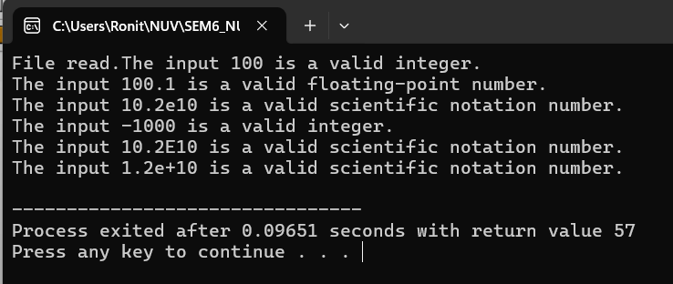

D: Write a program to recognize the valid comments.

**Code:**

#include <stdio.h>

#include <string.h>

// Write a program to recognize the valid comment.(Both single and multi-line)

int main() {

char str[100];

FILE *file;

file = fopen("Hello.txt", "r");

if (file == NULL) {

printf("Error opening file.\n");

return 1;

}

if (fgets(str, sizeof(str), file) == NULL) {

printf("Error reading from file.\n");

return 1;

}

int state = 0, i = 0;

while (i < strlen(str)) {

switch (state) {

case 0:

if (str[i] == '/') {

state = 1;

} else {

state = 3;

}

break;

case 1:

if (str[i] == '/') {

state = 2;

} else if (str[i] == '*') {

state = 4;

} else {

state = 3;

}

break;

case 2:

state = 2;

break;

case 4:

if (str[i] == '*') {

state = 5;

} else {

state = 4;

}

break;

case 5:

if (str[i] == '/') {

state = 6;

} else {

state = 4;

}

break;

case 6:

state = 6;

break;

}

i++;

}

if (state == 2) {

printf("Input (%s) is a single-line comment.\n", str);

} else if (state == 6) {

printf("Input (%s) is a multi-line comment.\n", str);

} else {

printf("Input (%s) is not a comment.\n", str);

}

fclose(file);

return 0;

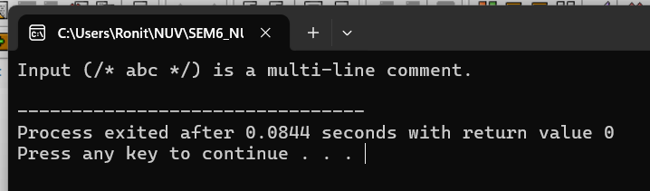

E: Program to implement Lexical Analyzer.

**Code:**

#include <stdio.h>

#include <stdlib.h>

#include <ctype.h>

#include <string.h>

#define BUFFER_SIZE 1000

void check_keyword_or_identifier(char *lexeme);

void recognize_number(char *lexeme);

void recognize_operator(char c);

void recognize_comment(char *buffer, int *index);

void main() {

FILE *f1;

char *buffer;

char lexeme[50];

char c;

int i = 0, f = 0, state = 0;

f1 = fopen("input.txt", "r");

if (f1 == NULL) {

printf("Error: Could not open input.txt\n");

return;

}

fseek(f1, 0, SEEK_END);

long file_size = ftell(f1);

rewind(f1);

buffer = (char *)malloc(file_size + 1);

fread(buffer, 1, file_size, f1);

buffer[file_size] = '\0';

fclose(f1);

while (buffer[f] != '\0') {

c = buffer[f];

printf("DEBUG: Processing lexeme = [%s]\n", lexeme);

switch (state) {

case 0:

if (isalpha(c) || c == '_') {

state = 1;

lexeme[i++] = c;

}

else if (isdigit(c)) {

state = 2;

lexeme[i++] = c;

}

else if (c == '/' && (buffer[f + 1] == '/' || buffer[f + 1] == '*')) {

recognize_comment(buffer, &f);

state = 0;

}

else if (strchr("+-*/%=<>!", c)) {

recognize_operator(c);

state = 0;

}

else if (strchr(";,{}()", c)) {

printf("%c is a symbol\n", c);

state = 0;

}

else if (isspace(c)) {

state = 0;

}

break;

case 1:

if (isalnum(c) || c == '_') {

lexeme[i++] = c;

} else {

lexeme[i] = '\0';

check_keyword_or_identifier(lexeme);

lexeme[i] = '\0';

i = 0;

state = 0;

f--;

}

break;

case 2:

if (isdigit(c)) {

lexeme[i++] = c;

} else if (c == '.') {

state = 3;

lexeme[i++] = c;

} else if (c == 'E' || c == 'e') {

state = 4;

lexeme[i++] = c;

} else {

lexeme[i] = '\0';

recognize_number(lexeme);

i = 0;

state = 0;

f--;

}

break;

case 3:

if (isdigit(c)) {

lexeme[i++] = c;

} else {

lexeme[i] = '\0';

recognize_number(lexeme);

i = 0;

state = 0;

f--;

}

break;

case 4:

if (isdigit(c) || c == '+' || c == '-') {

state = 5;

lexeme[i++] = c;

} else {

lexeme[i] = '\0';

recognize_number(lexeme);

i = 0;

state = 0;

f--;

}

break;

case 5:

if (isdigit(c)) {

lexeme[i++] = c;

} else {

lexeme[i] = '\0';

recognize_number(lexeme);

i = 0;

state = 0;

f--;

}

break;

}

f++;

}

free(buffer);

}

void check_keyword_or_identifier(char *lexeme) {

int i =0;

char *keywords[] = {

"auto", "break", "case", "char", "const", "continue", "default", "do",

"double", "else", "enum", "extern", "float", "for", "goto", "if",

"inline", "int", "long", "register", "restrict", "return", "short", "signed",

"sizeof", "static", "struct", "switch", "typedef", "union", "unsigned",

"void", "volatile", "while"

};

for (i = 0; i < 32; i++) {

if (strcmp(lexeme, keywords[i]) == 0) {

printf("%s is a keyword\n", lexeme);

return;

}

}

printf("%s is an identifier\n", lexeme);

}

void recognize_number(char *lexeme) {

printf("%s is a valid number\n", lexeme);

}

void recognize_operator(char c) {

char operators[][3] = {"+", "-", "*", "/", "%", "=", "==", "!=", "<", ">", "<=", ">="};

char next = getchar();

char op[3] = {c, next, '\0'};

int i = 0;

for (i = 0; i < 12; i++) {

if (strcmp(op, operators[i]) == 0) {

printf("%s is an operator\n", op);

return;

}

}

printf("%c is an operator\n", c);

ungetc(next, stdin);

}

void recognize_comment(char *buffer, int *index) {

if (buffer[*index] == '/' && buffer[*index + 1] == '/') {

printf("// is a single-line comment\n");

while (buffer[*index] != '\n' && buffer[*index] != '\0') (*index)++;

}

else if (buffer[*index] == '/' && buffer[*index + 1] == '*') {

printf("/* is the start of a multi-line comment\n");

(*index) += 2;

while (!(buffer[*index] == '*' && buffer[*index + 1] == '/') && buffer[*index] != '\0') (*index)++;

if (buffer[*index] == '*' && buffer[*index + 1] == '/') {

printf("*/ is the end of a multi-line comment\n");

(*index) += 2;

}

}

}

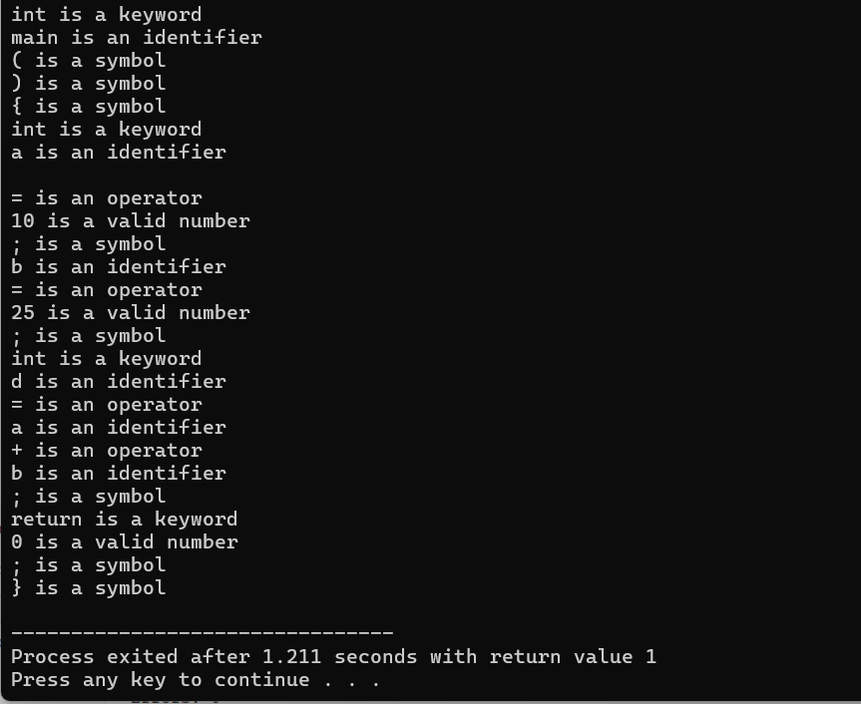

Lab – 3:

Aim: To Study about Lexical Analyzer Generator (LEX) and Flex (Fast Lexical Analyzer)

**Introduction:**

Lexical analysis is the first phase of a compiler, where the source code is converted into a sequence of tokens. Tokens are the basic building blocks of programming languages such as keywords, identifiers, constants, operators, and symbols. Writing a lexical analyzer manually is both time-consuming and error-prone. To address this, tools like **LEX** and **Flex** are used to automatically generate efficient lexical analyzers.

**LEX and Flex:**

**LEX** is a tool developed for generating lexical analyzers based on patterns described using regular expressions. It reads a given set of rules and produces a C program that can identify the corresponding lexical elements in the input stream.  
**Flex (Fast Lexical Analyzer)** is a free and open-source alternative to LEX. It is compatible with LEX specifications but provides improved performance and additional features. Flex scans the source code using the rules defined in a “.l” file and outputs a C source file that can be compiled to perform token recognition.

Both LEX and Flex are typically used in conjunction with parser generators like **YACC** or **Bison**, enabling the seamless integration of lexical and syntax analysis in compiler construction.

Lab – 4:

A: Write a Lex program to take input from text file and count no of characters, no. of lines & no. of words.

Code:

%{

#include <stdio.h>

int letters = 0, words = 0, Lines = 0, chars = 0;

int inWord = 0;

%}

%%

[a-zA-Z] {letters++;chars++;if (!inWord) {words++;inWord = 1;}}

[\t \n] {chars++;Lines++;inWord = 0;}

. { chars++; }

%%

int main() {

yyin = fopen("input.txt", "r");

if (!yyin) {

printf("Cannot open the file.\n");

return 1;

}

printf("File has opened.\n");

yylex();

printf("This file has %d letters.\n", letters);

printf("This file has %d words.\n", words);

printf("This file has %d lines.\n", Lines + 1);

printf("This file has %d characters.\n", chars);

return 0;

}

int yywrap() { return 1; }

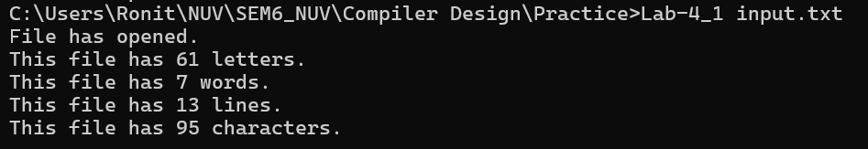

B: Write a Lex program to take input from text file and count number of vowels and consonants.

Code:

%{

#include<stdio.h>

int consonants = 0;

int vowels = 0;

%}

%%

[aeiouAEIOU] {vowels++;}

[a-zA-Z] {consonants++;}

. ;

%%

int main(){

yyin=fopen("input.txt","r");

if(yyin){printf("file opened.");}

yylex();

printf("This file has %d consonants. \n",consonants);

printf("This file has %d vowels. \n",vowels);

return 0;

}

int yywrap(){

return 1;

}

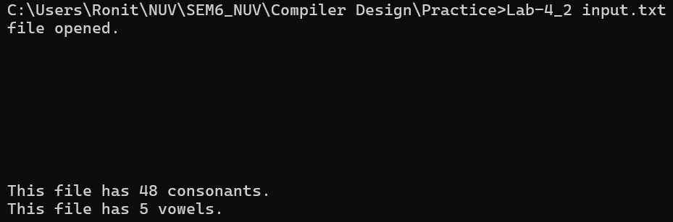

C: Write a Lex program to print out all numbers from the given file.

Code:

%{

#include<stdio.h>

char i=0;

%}

%%

[0-9]+(\.[0-9]+)?([eE][+-]?[0-9]+)? {i++;printf("%s",yytext);}

. {i++;}

%%

void main(){

yyin = fopen("input.txt","r");

yylex();

}

int yywrap(){return 1;}

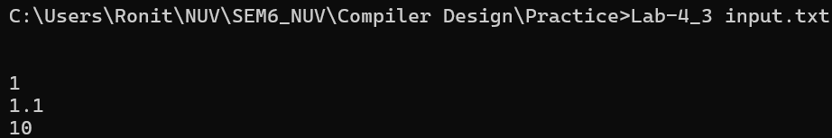

D: Write a Lex program which adds line numbers to the given file and display the same into different file.

Code:

%{

#include<stdio.h>

int i = 0;

char line[1000]; // Buffer to store line content

int line_pos = 0; // Position in line buffer

%}

%%

[^\n] {line[line_pos++] = yytext[0];}

[\n] {i++; line[line_pos] = '\0';fprintf(yyout, "%d - %s\n", i, line);line_pos = 0;}

%%

int main() {

yyin = fopen("input.txt", "r");

yyout = fopen("output.txt", "w");

yylex();

fclose(yyin);

fclose(yyout);

return 0;

}

int yywrap() {

return 1;

}

**OUTPUT:**

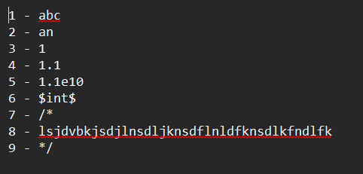

E: Write a Lex program to printout all markup tags and HTML comments in file.

Code:

%{

#include <stdio.h>

%}

%%

"<!--"(.|\n)*"-->" { printf("Comment: %s\n", yytext); }

"<"[^>]*">" { printf("Tag: %s\n", yytext); }

. ;

%%

void main() {

yyin=fopen("Test.txt","r");

printf("File has opened.");

yylex();

}

int yywrap() {

return 1;

}

**OUTPUT:**

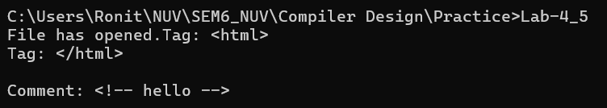

Lab – 5:

A: Write a Lex program to count the number of C comment lines from a given C program. Also eliminate them and copy that program into separate file.

Code:

%{

#include <stdio.h>

#include <string.h>

int comment_lines = 0;

%}

%%

"/*"[^*/]*"*/" {fprintf(yyout, "");comment_lines++;}

"//".* {fprintf(yyout, "");comment_lines++; }

.* { fprintf(yyout, "%s",yytext); }

%%

void main() {

yyin = fopen("input.txt", "r");

yyout = fopen("output.txt", "w");

yylex();

printf("Number of comment lines removed: %d\n", comment_lines);

fclose(yyin);

fclose(yyout);

}

int yywrap() {

return 1;

}

**OUTPUT:**



B: Write a Lex program to recognize keywords, identifiers, operators, numbers, special symbols, literals from a given C program.

%{

#include<stdio.h>

%}

%%

"#include"[ \t]*["<"]?[a-zA-Z0-9\.]+[">"]? {printf("include statement: %s \n",yytext);}

auto|int|main|if|else|float|char|printf|return {printf("Keyword: %s \n",yytext);}

[a-zA-Z_]([0-9|a-zA-Z])* {printf("Identifier: %s \n ",yytext);}

"+"|"-"|"++"|"--" {printf("Operator: %s \n",yytext);}

[0-9]+(\.[0-9]+)?([eE][+-]?[0-9]+)? {printf("Number: %s \n",yytext);}

";"|"."|"["|"]"|"{"|"}"|"("|")" {printf("Special Symbol: %s \n",yytext);}

\"[^"\n]*\" {printf("String Literals: %s \n",yytext);}

\'[^'\n]*\' {printf("Char Literals: %s \n",yytext);}

. {printf("");}

%%

int main() {

yyin = fopen("input.c", "r");

yylex();

fclose(yyin);

return 0;

}

int yywrap() {

return 1;

}

**OUTPUT:**

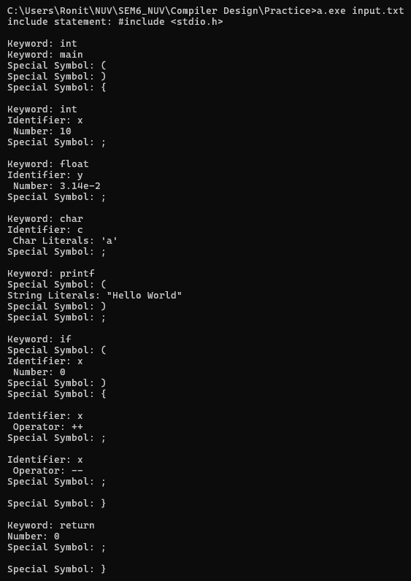

Lab – 6:

Aim: Program to implement Recursive Descent Parsing in C.

Code:

#include <stdio.h>

#include <stdlib.h>

char s[20];

int i = 1;

char l;

int match(char l);

int E1();

int E()

{

if (l == 'i')

{

match('i');

E1();

}

else

{

printf("Error parsing string");

exit(1);

}

return 0;

}

int E1()

{

if (l == '+')

{

match('+');

match('i');

E1();

}

else

{

return 0;

}

}

int match(char t)

{

if (l == t)

{

l = s[i];

i++;

}

else

{

printf("Syntax Error");

exit(1);

}

return 0;

}

void main()

{

printf("Enter the string: ");

scanf("%s", &s);

l = s[0];

E();

if (l == '$')

{

printf("parsing successful");

}

else

{

printf("Error while parsing the string\n");

}

}

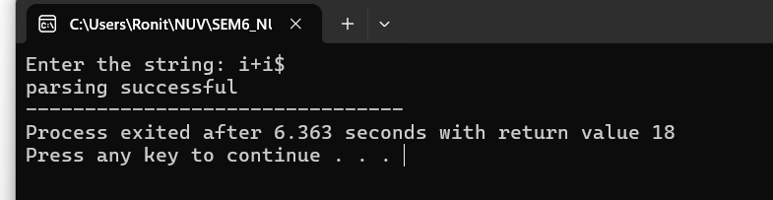

Lab – 7:

A: To Study about Yet Another Compiler-Compiler(YACC).

Code:

**Introduction:**

**YACC (Yet Another Compiler-Compiler)** is a parser generator developed to automate the process of creating the syntax analysis phase of a compiler. It reads a grammar specification written in a format similar to Backus-Naur Form (BNF) and generates a parser in the C programming language. This parser can recognize the syntax of a programming language and build syntax trees or perform semantic actions.

YACC is typically used in combination with **LEX/Flex**, where LEX handles lexical analysis and YACC handles syntax analysis. Together, they allow for the development of efficient and structured compilers. The grammar rules in YACC are written in the form of production rules, and associated C code (semantic actions) can be embedded within these rules to define what happens when a rule is recognized.

**YACC Features:**

* Supports LALR(1) parsing.
* Allows easy embedding of semantic actions using C code.
* Automatically handles parsing tables and parser generation.
* Provides error-handling mechanisms for syntax errors.
* Easily integrates with Flex for complete compiler front-end development.

B: Create YACC and Lex specification files to recognizes arithmetic expressions involving +, -, * and / .

Code:

YACC:

%{

#include<stdlib.h>

#include<stdio.h>

#include<string.h>

void yyerror(char *);

int yylex(void);

extern FILE *yyin;

%}

%union{

char *str;

int num;

}

%token <str> ID

%token <num> INT

%left '+' '-'

%left '*' '/'

%%

S:E '\n' {printf("The string is valid.");}

E:E '+' T { }

| E '-' T { }

| T { }

T:T '*' F { }

| T '/' F { }

| F { }

F:INT { }

| ID { }

%%

void yyerror(char *s){

fprintf(stderr,"%s\n",s);

}

int main(int argc, char **argv){

if(argc<2){

printf("Usage: %s <input>",argv[0]);

exit(1);

}

FILE *input = fopen(argv[1],"r");

if(!input){

printf("Error Opening File.");

exit(1);

}

yyin=input;

yyparse();

fclose(input);

return 0;

}

LEX:

%{

#include<stdlib.h>

#include<stdio.h>

#include<string.h>

void yyerror(char *);

#include "yacc.tab.h"

%}

%%

[0-9]+ {yylval.num=atoi(yytext); return INT;}

[A-Za-z][A-Za-z0-9_]* {yylval.str=strdup(yytext); return ID;}

[-+*/] {return *yytext;}

\n {return '\n';}

[ \t] { }

. {yyerror("Invalid input.");}

%%

int yywrap(){return 0;}

INPUT.txt:

1+2+3+5+8

OUTPUT:



C: Create YACC and Lex specification files are used to generate a calculator which accepts integer type arguments.

Code:

YACC:

%{

#include <stdio.h>

int yylex(void);

void yyerror(char *);

extern FILE *yyin;

%}

%token NUM

%%

S:E {printf("%d\n",$1); return 0;}

E:E'+'T {$$ = $1 + $3;}

| E'-'T {$$ = $1 - $3;}

| T {$$ = $1}

T: T '*' F {$$ = $1 * $3;}

| T '/' F {$$ = $1 / $3;}

| F {$$ = $1}

F: NUM {$$ = $1}

%%

void yyerror(char* s){

fprintf(stderr,"%s\n",s);

}

int main( int argc,char *argv[] ) {

if (argc < 1) {

fprintf(stderr, "Usage: %s <input_file>\n", argv[0]);

return 1;

}

FILE *input_file = fopen(argv[1], "r");

if (!input_file) {

perror("Error opening file");

return 1;

}

yyin = input_file;

yyparse();

fclose(input_file);

return 0;

}

LEX:

%{

#include <stdlib.h>

void yyerror(char *);

#include "yacc.tab.h"

%}

%%

[0-9]+ {yylval=atoi(yytext);return NUM;}

[-+*/\n] {return *yytext;}

[ \t] { }

. {yyerror("invalid character.");}

%%

int yywrap(){

return 0;

}

INPUT.txt:

5*8+9*6+8

OUTPUT:



D: Create YACC and Lex specification files are used to convert infix expression to postfix expression.

Code:

YACC:

%{

#include<stdio.h>

#include<stdlib.h>

int yylex(void);

void yyerror(char *);

extern FILE *yyin;

%}

%union{

char *str;

int num;

}

%token <str> ID

%token <num> INT

%left '+' '-'

%left '*' '/'

%%

S:E '\n' {return 0;}

| E {return 0;}

E:E '+' T {printf("+ ");}

| E '-' T {printf("- ");}

| T { }

T: T '*' F {printf("* ");}

| T '/' F {printf("/ ");}

| F { }

F:INT {printf("%d ",$1);}

| ID {printf("%s ",$1);}

%%

void yyerror(char *s){

fprintf(stderr,"%s\n",s);

}

int main(int argc, char *argv[]){

if(argc<1){

printf("Usage: %s <input>",argv[0]);

}

FILE *input = fopen(argv[1], "r");

if(!input){

printf("Error Opening File.\n");

return 1;

}

yyin=input;

yyparse();

fclose(input);

return 0;

}

LEX:

%{

#include<stdio.h>

#include<stdlib.h>

#include<string.h>

#include "parser.tab.h"

void yyerror(char *);

%}

%%

[0-9]+ {yylval.num=atoi(yytext);return INT;}

[A-Za-z_]+ {yylval.str=strdup(yytext);return ID;}

[-+/*] {return *yytext;}

\n {return '\n';}

<<EOF>> { return 0; }

[ \t] { }

. {yyerror("invalid input.");}

%%

int yywrap(){

return 0;

}

INPUT.txt:

a+1+2

OUTPUT:

