**Lab Manual**

Of

**Compiler Design**

**LABORATORY**

By

**Zainab– 22000425**

**3rd Year, Semester 6**

***Course In-charge: Prof. Vaibhavi Patel***

Department of Computer Science and Engineering

School Engineering and Technology

Navrachana University, Vadodara

Spring semester 2025

|  |  |  |
| --- | --- | --- |
| **Sr No.** | **Experiment Title** | **Page no.** |
| 1 | 1. Write a program to recognize strings starts with ‘a’ over {a, b}. 2. Write a program to recognize strings end with ‘a’. 3. Write a program to recognize strings end with ‘ab’. Take the input from text file. 4. Write a program to recognize strings contains ‘ab’. Take the input from text file. | 4 |
| 2 | 1. Write a program to recognize the valid identifiers. 2. Write a program to recognize the valid operators. 3. Write a program to recognize the valid number. 4. Write a program to recognize the valid comments. 5. Write a program to implement Lexical Analyzer. | 14 |
| 3 | To Study about Lexical Analyzer Generator (LEX) and Flex(Fast Lexical Analyzer) | 30 |
| 4 | Implement following programs using Lex.  a. Write a Lex program to take input from text file and count no of characters, no. of lines & no. of words.  b. Write a Lex program to take input from text file and count number of vowels and consonants.  c. Write a Lex program to print out all numbers from the given file.  d. Write a Lex program which adds line numbers to the given file and display the same into different file.  e. Write a Lex program to printout all markup tags and HTML comments in file. | 34 |
| 5 | a. Write a Lex program to count the number of C comment lines from a given C program. Also eliminate them and copy that program into separate file.  b. Write a Lex program to recognize keywords, identifiers, operators, numbers, special symbols, literals from a given C program. | 41 |
| 6 | Program to implement Recursive Descent Parsing in C. | 47 |
| 7 | a. To Study about Yet Another Compiler-Compiler(YACC).  b. Create Yacc and Lex specification files to recognizes arithmetic expressions involving +, -, * and / .  c. Create Yacc and Lex specification files are used to generate a calculator which accepts integer type arguments.  d. Create Yacc and Lex specification files are used to convert infix expression to postfix expression. | 55 |

**Practical 1**

**AIM:**

**a. Write a program to recognize strings starts with ‘a’ over {a, b}.**

**b. Write a program to recognize strings end with ‘a’.**

**c. Write a program to recognize strings end with ‘ab’. Take the input from text file.**

**d. Write a program to recognize strings contains ‘ab’. Take the input from text file.**

1. **Write a program to recognize strings starts with ‘a’ over {a, b}.**

**CODE:**

//strings starts with 'a' over {a, b}.

#include<stdio.h>

int main(){

char input[100];

int state = 0, i=0;

printf("Enter the string: ");

scanf("%s",input);

while(input[i]!='\0'){

switch(state){

case 0:

if(input[i]=='a') state = 1;

else state = 2;

break;

case 1:

if(input[i]=='a' || input[i]=='b') state=1;

else state =2;

break;

case 2:

state = 2;

break;

}

i++;

}

if(state=='0'){

printf("The string is invalid.");

printf("\nState = %d",state);

}

else if(state==1){

printf("The string is valid.");

printf("\nState = %d",state);

}

else if(state==2){

printf("The string is invalid.");

printf("\nState = %d",state);

}

else {

}

return 0;

}

**OUTPUT:**

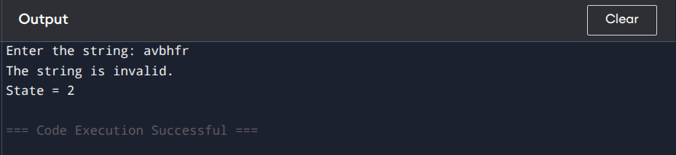

1. **Write a program to recognize strings end with ‘a’.**

**CODE:**

//strings end with 'a'.

#include<stdio.h>

int main(){

char input[100];

int state = 0, i=0;

printf("Enter the string: ");

scanf("%s",input);

while(input[i]!='\0'){

switch(state){

case 0:

if(input[i]=='a') state = 1;

else state = 0;

break;

case 1:

if(input[i]=='a') state=1;

else state =0;

break;

}

i++;

}

if(state==0){

printf("The string is invalid.");

printf("\nState = %d",state);

}

else if(state==1){

printf("The string is valid.");

printf("\nState = %d",state);

}

else {

}

return 0;

}

**OUTPUT:**

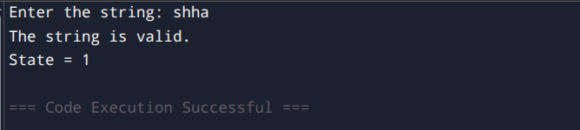

**c. Write a program to recognize strings end with ‘ab’. Take the input from text file.**

**CODE:**

//string ends with ab and take input from a file.

#include <stdio.h>

int main() {

char input[100];

int state = 0, i = 0;

FILE *file; // File pointer

file = fopen("input.txt", "r");

if (file == NULL) {

printf("Error: Could not open file.\n");

return 1;

}

if (fgets(input, sizeof(input), file) == NULL) {

printf("Error: Could not read from file or file is empty.\n");

fclose(file);

return 1;

}

fclose(file);

// Removing newline character, if present

for (i = 0; input[i] != '\0'; i++) {

if (input[i] == '\n') {

input[i] = '\0';

break;

}

}

i = 0; // Reset index for processing the string

while (input[i] != '\0') {

switch (state) {

case 0:

if (input[i] == 'a') {

state = 1;

} else if (input[i] == 'b') {

state = 0;

} else {

state = 0;

}

break;

case 1:

if (input[i] == 'b') {

state = 2;

} else if (input[i] == 'a') {

state = 1;

} else {

state = 0;

}

break;

case 2:

if (input[i] == 'a') {

state = 1;

} else if (input[i] == 'b') {

state = 0;

} else {

state = 0;

}

break;

}

i++;

}

if (state == 0) {

printf("String is invalid.\n");

printf("The state is: %d\n", state);

} else if (state == 1) {

printf("The string is invalid.\n");

printf("The state is: %d\n", state);

} else if (state == 2) {

printf("The string is valid.\n");

printf("The state is: %d\n", state);

}

return 0;

}

**OUTPUT:**

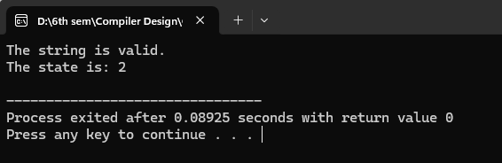

**d. Write a program to recognize strings contains ‘ab’. Take the input from text file.**

**CODE:**

//sting contains ab, and takes input from a file.

#include<stdio.h>

int main(){

char input[100];

int state=0,i=0;

FILE *file;

file=fopen("input1.txt","r");

if(file==NULL){

printf("Error: Couldn't open the file.\n");

return 1;

}

if(fgets(input,sizeof(input),file)==NULL){

printf("Error: Could not read from file or file is empty.\n");

fclose(file);

return 1;

}

fclose(file);

// Removing newline character, if present

for (i = 0; input[i] != '\0'; i++) {

if (input[i] == '\n') {

input[i] = '\0';

break;

}

}

i = 0; // Reset index for processing the string

/*printf("Enter the string: ");

scanf("%s",input);*/

while(input[i] != '\0'){

switch(state){

case 0:

if(input[i]=='a') state = 1;

else if(input[i]=='b') state = 0;

else state = 0;

break;

case 1:

if(input[i]=='a') state = 1;

else if(input[i]=='b') state =2;

else state = 0;

break;

case 2:

if(input[i]=='a' || input[i]=='b') state = 2;

else state = 2;

break;

}

i++;

}

if(state==0){

printf("The sring is invalid.");

printf("\nState is: %d",state);

}

else if(state==1){

printf("The sring is invalid.");

printf("\nState is: %d",state);

}

else if(state==2){

printf("The sring is valid.");

printf("\nState is: %d",state);

}

else{

}

return 0;

}

**OUTPUT:**

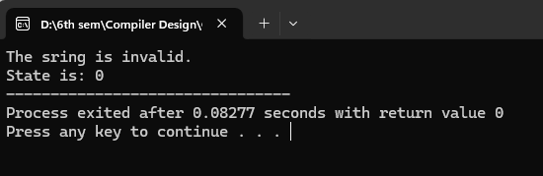

**Practical 2**

**AIM:**

**a. Write a program to recognize the valid identifiers.**

**b. Write a program to recognize the valid operators.**

**c. Write a program to recognize the valid number.**

**d. Write a program to recognize the valid comments.**

**e. Write a program to implement Lexical Analyzer.**

**a. Write a program to recognize the valid identifiers.**

**CODE:**

#include <stdio.h>

#include <ctype.h>

int main()

{

char a[10];

int flag, i=1;

printf("Enter an identifier:");

scanf("%s",&a);

if(isalpha(a[0])){

flag = 1; // If the first character is an alphabet, set flag = 1 (indicating a valid start).

}

else

printf("invalid identifier");

while (a[i] != '\0') {

if (!isalnum(a[i]) && a[i] != '_') {

flag = 0;

break;

}

i++;

}

if(flag == 1){

printf("Valid identifier");

}

//getch();

}

**OUTPUT:**

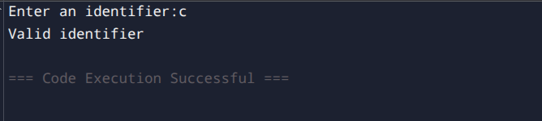

**b. Write a program to recognize the valid operators.**

**CODE:**

//to recognize the valid operators

#include <stdio.h>

#include <string.h>

#include <stdbool.h>

int main() {

char input[50];

const char *validOperators[] = {

"+", "-", "*", "/", "%", // Arithmetic

"=", "+=", "-=", "*=", "/=", "%=", // Assignment

"==", "!=", ">", "<", ">=", "<=", // Relational

"&&", "||", "!", // Logical

"&", "|", "^", "~", "<<", ">>", // Bitwise

"++", "--", // Increment/Decrement

",", ".", "->", // Structure/Union member access

"(", ")", "[", "]", "{", "}", // Parentheses, brackets, braces

"?", ":", // Ternary operator

"sizeof", // Unary operator

"->", "." // Pointer-to-member operators (less common)

};

int numOperators = sizeof(validOperators) / sizeof(validOperators[0]);

printf("Enter a potential C operator (or 'exit' to quit): ");

while (1) {

scanf("%49s", input);

if (strcmp(input, "exit") == 0) {

break;

}

bool found = false;

int i = 0; // Initialize loop counter

while (i < numOperators) { // While loop

switch (strcmp(input, validOperators[i])) { // Switch statement

case 0: // Match found

found = true;

i = numOperators; // A way to break the while loop

break;

default: // No match, go to next operator

i++;

break;

}

}

if (found) {

printf("\"%s\" is a valid C operator.\n", input);

} else {

printf("\"%s\" is NOT a valid C operator.\n", input);

}

printf("Enter another operator (or 'exit' to quit): ");

}

printf("Exiting.\n");

return 0;

}

**OUTPUT:**

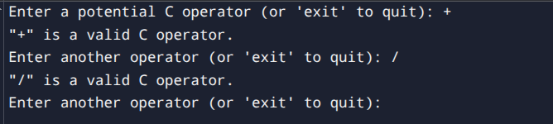

**c. Write a program to recognize the valid number.**

**CODE:**

#include <stdio.h>

#include <ctype.h>

#include <string.h>

void check_valid_number(char *input) {

int state = 0, i = 0;

char lexeme[100];

while (input[i] != '\0') {

char c = input[i];

switch (state) {

case 0:

if (isdigit(c)) {

state = 1; // Transition to integer state

} else if (c == '.') {

state = 2; // Starts with a dot, expecting digits

} else {

printf("Invalid number: %s\n", input);

return;

}

break;

case 1: // Integer state

if (isdigit(c)) {

state = 1;

} else if (c == '.') {

state = 3; // Transition to decimal part

} else if (c == 'E' || c == 'e') {

state = 5; // Transition to exponent part

} else {

printf("%s is a valid number\n", input);

return;

}

break;

case 2: // Starts with a dot

if (isdigit(c)) {

state = 3;

} else {

printf("Invalid number: %s\n", input);

return;

}

break;

case 3: // Decimal part

if (isdigit(c)) {

state = 3;

} else if (c == 'E' || c == 'e') {

state = 5;

} else {

printf("%s is a valid number\n", input);

return;

}

break;

case 5: // Exponent part

if (c == '+' || c == '-') {

state = 6;

} else if (isdigit(c)) {

state = 7;

} else {

printf("Invalid number: %s\n", input);

return;

}

break;

case 6: // Sign after exponent

if (isdigit(c)) {

state = 7;

} else {

printf("Invalid number: %s\n", input);

return;

}

break;

case 7: // Digits after exponent

if (isdigit(c)) {

state = 7;

} else {

printf("%s is a valid number\n", input);

return;

}

break;

}

i++;

}

// If loop exits normally, check if we ended in a valid state

if (state == 1 || state == 3 || state == 7) {

printf("%s is a valid number\n", input);

} else {

printf("Invalid number: %s\n", input);

}

}

int main() {

char input[100];

printf("Enter a number: ");

scanf("%s", input);

check_valid_number(input);

return 0;

}

**OUTPUT:**

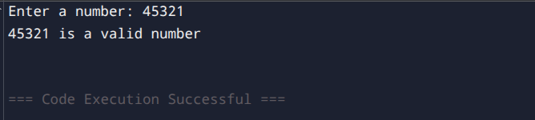

**d. Write a program to recognize the valid comments.**

**CODE:**

//accept only comments single line and multiline both.

#include<stdio.h>

int main(){

char input[100];

int state =0, i=0;

FILE *file;

file = fopen("input3.txt","r");

if(file==NULL){

printf("Error: Couldn't open the file.\n");

return 1;

}

if(fgets(input,sizeof(input),file)==NULL){

printf("Error: Couldn't read the file or file is empty.");

fclose(file);

return 1;

}

fclose(file);

for (i = 0; input[i] != '\0'; i++) {

if (input[i] == '\n') {

input[i] = '\0';

break;

}

}

i = 0;

while(input[i]!='\0'){

switch(state){

case 0:

if(input[i]=='/')state = 1;

else state =3;

break;

case 1:

if(input[i]=='/') state=2;

else if(input[i]=='*') state =4;

else state=3;

break;

case 2:

state = 2;

break;

case 3:

state =3;

break;

case 4:

if(input[i]='*')state=5;

else state=4;

break;

case 5:

if(input[i]=='/') state =6;

else state = 4;

break;

case 6:

state = 3;

break;

}

i++;

}

if(state==0){

printf("This is not a comment.");

printf("\nState is %d",state);

}

else if(state==1){

printf("This is not a comment.");

printf("\nState is %d",state);

}

else if(state==2){

printf("This is a single line comment.");

printf("\nState is %d",state);

}

else if(state==3){

printf("This is not a comment.");

printf("\nState is %d",state);

}

else if(state==4){

printf("This is not a comment.");

printf("\nState is %d",state);

}

else if(state==5){

printf("This is not a comment.");

printf("\nState is %d",state);

}

else if(state==6){

printf("This is a multiline comment.");

printf("\nState is %d",state);

}

return 0;

}

**input3.txt:**

/*dsjdbhsdbf *gdgsdg *dfd */

**OUTPUT:**

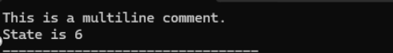

**e. Write a program to implement Lexical Analyzer.**

**CODE:**

#include <stdio.h>

#include <ctype.h>

#include <string.h>

// List of keywords

const char *keywords[] = {"int", "float", "if", "else", "while", "return", "for", "do", "switch", "case"};

#define NUM_KEYWORDS (sizeof(keywords) / sizeof(keywords[0]))

// Function to check if a string is a keyword

int isKeyword(char *str) {

int i;

for (i = 0; i < NUM_KEYWORDS; i++) {

if (strcmp(str, keywords[i]) == 0)

return 1;

}

return 0;

}

// Function to check if a character is an operator

int isOperator(char ch) {

char operators[] = "+-*/=<>!&|";

int i;

for (i = 0; operators[i] != '\0'; i++) {

if (ch == operators[i])

return 1;

}

return 0;

}

void lexicalAnalyzer(char *input) {

int i = 0;

char token[50];

int tokenIndex = 0;

while (input[i] != '\0') {

if (isspace(input[i])) {

i++;

continue;

}

if (isalpha(input[i])) { // Identifiers and Keywords

tokenIndex = 0;

while (isalnum(input[i])) {

token[tokenIndex++] = input[i++];

}

token[tokenIndex] = '\0';

if (isKeyword(token)) {

printf("Keyword: %s\n", token);

} else {

printf("Identifier: %s\n", token);

}

}

else if (isdigit(input[i])) { // Numbers

tokenIndex = 0;

while (isdigit(input[i])) {

token[tokenIndex++] = input[i++];

}

token[tokenIndex] = '\0';

printf("Number: %s\n", token);

}

else if (isOperator(input[i])) { // Operators

printf("Operator: %c\n", input[i]);

i++;

}

else { // Special characters

printf("Special Symbol: %c\n", input[i]);

i++;

}

}

}

int main() {

char input[100];

printf("Enter a string for lexical analysis: ");

fgets(input, sizeof(input), stdin);

lexicalAnalyzer(input);

return 0;

}  
  
**OUTPUT:**

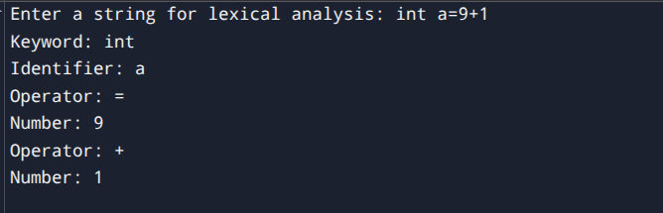

**Practical 3**

**AIM:**

**To Study about Lexical Analyzer Generator (LEX) and Flex(Fast Lexical Analyzer)**

**Introduction:**

A Lexical Analyzer converts an input stream (source code) into a sequence of tokens, which are then used by the parser in a compiler. Lex and Flex are tools designed for this purpose.

**1. Lexical Analyzer Generator (LEX)**

**LEX** is a tool used to generate lexical analyzers. It takes a set of **regular expressions** (token patterns) as input and produces a C program that can identify these tokens.

**Working of LEX:**

1. **Specification File:**  
    A LEX program consists of three sections:
   1. **Definition Section:** Declare header files and global variables.
   2. **Rules Section:** Define token patterns using regular expressions.
   3. **C Code Section:** Additional helper functions (optional).
2. **Compilation Process:**
   1. The **LEX file (.l)** is compiled using lex to generate lex.yy.c.
   2. The lex.yy.c file is compiled with a C compiler (gcc lex.yy.c -o output).
   3. The executable processes input and tokenizes it.

**Example LEX Program:**

%{

#include <stdio.h>

%}

%%

[0-9]+ { printf("Number: %s\n", yytext); }

[a-zA-Z]+ { printf("Identifier: %s\n", yytext); }

. { printf("Special Symbol: %s\n", yytext); }

%%

int main() {

yylex();

return 0;

}

int yywrap() { return 1; }

**Commands to Run:**

lex filename.l

gcc lex.yy.c -o output

./output < input.txt

**2. Fast Lexical Analyzer (FLEX)**

**Flex** is an improved and faster version of **Lex**. It provides better performance and extended functionality.

**Key Features of FLEX:**

* Works similarly to **Lex**, but faster.
* Generates a more optimized lex.yy.c.
* Supports additional options like debugging and performance tuning.

**Example FLEX Program:**

(Same structure as LEX)

%{

#include <stdio.h>

%}

%%

[0-9]+ { printf("Number: %s\n", yytext); }

[a-zA-Z]+ { printf("Identifier: %s\n", yytext); }

. { printf("Special Symbol: %s\n", yytext); }

%%

int main() {

yylex();

return 0;

}

int yywrap() { return 1; }

**Commands to Run:**

flex filename.l

gcc lex.yy.c -o output

./output < input.txt

**Comparison: LEX vs FLEX**

|  |  |  |
| --- | --- | --- |
| Feature | LEX | FLEX |
| Speed | Slower | Faster |
| Compatibility | Traditional UNIX tool | GNU version, supports more platforms |
| Debugging | Limited | More debugging options |
| Performance | Basic optimization | Highly optimized DFA |

**Conclusion:**

* Lex and Flex automate the creation of lexical analyzers.
* Flex is an enhanced version of Lex and is more commonly used today.
* These tools simplify token generation in compiler design.

**Practical 4**

**AIM:**

**Implement following programs using Lex.**

1. **Write a Lex program to take input from text file and count no of characters, no. of lines & no. of words.**
2. **Write a Lex program to take input from text file and count number of vowels and consonants.**
3. **Write a Lex program to print out all numbers from the given file.**
4. **Write a Lex program which adds line numbers to the given file and display the same into different file.**
5. **Write a Lex program to printout all markup tags and HTML comments in file.**

1. **Write a Lex program to take input from text file and count no of characters, no. of lines & no. of words.**

**Lex CODE: (count.l)**

%{

#include <stdio.h>

int char_count = 0, word_count = 0, line_count = 0;

%}

%%

\n { line_count++; char_count++; }

[^\n\t ]+ { word_count++; char_count += yyleng; }

. { char_count++; }

%%

int main() {

yylex();

printf("\nNumber of Characters: %d", char_count);

printf("\nNumber of Words: %d", word_count);

printf("\nNumber of Lines: %d\n", line_count);

return 0;

}

int yywrap() {

return 1;

}

**Input2.txt CODE:**

Hello World!

Lex is fun.

**Compile and run:**

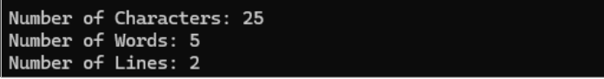

**b. Write a Lex program to take input from text file and count number of vowels and consonants.**

**Lex Code [count1.l]**

%{

int vowels = 0;

int consonants = 0;

FILE *yyin;

%}

%%

[aeiouAEIOU] { vowels++; }

[a-zA-Z] { consonants++; }

.|\n { /* Ignore other characters */ }

%%

int yywrap() {

return 1;

}

int main(int argc, char *argv[]) {

if (argc < 2) {

printf("Usage: %s input2.txt\n", argv[0]);

return 1;

}

FILE *file = fopen(argv[1], "r");

if (!file) {

printf("Cannot open file %s\n", argv[1]);

return 1;

}

yyin = file;

yylex();

printf("Number of vowels: %d\n", vowels);

printf("Number of consonants: %d\n", consonants);

fclose(file);

return 0;

}

**Input2.txt CODE:**

Hello World!

Lex is fun.

123

Apurva Depdhar born on 2nd oct. 2004

**Compile and run:**



**c. Write a Lex program to print out all numbers from the given file.**

**Lex Code [numbers.l]**

%{

#include <stdio.h>

%}

%%

[0-9]+(\.[0-9]+)? { printf("Number found: %s\n", yytext); }

.|\n { /* Ignore all other characters */ }

%%

int yywrap() {

return 1;

}

int main() {

yylex(); // Start the lexical analysis

return 0;

}

**Input2.txt CODE:**

Hello World!

Lex is fun.

123

Storm hit village on 2JAN 2004

**Compile and run:**

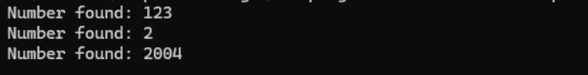

**d. Write a Lex program to printout all markup/open tags and HTML comments in file.**

**Lex Code [tags_comments.l]**

%{

#include <stdio.h>

%}

%%

"<!--"([^>]|[\n])*"-->" { printf("HTML Comment found: %s\n", yytext); }

"<"[a-zA-Z][a-zA-Z0-9]*">" { printf("Opening Tag found: %s\n", yytext); }

"</"[a-zA-Z][a-zA-Z0-9]*">" { printf("Closing Tag found: %s\n", yytext); }

"<"[a-zA-Z][^>]*"/>" { printf("Self-closing Tag found: %s\n", yytext); }

.|\n { /* Ignore other content */ }

%%

int yywrap() { return 1; }

int main() {

yylex();

return 0;

}  
   
**input3.html CODE:**

<html>

<head>

<!-- This is a comment -->

<title>Page Title</title>

</head>

<body>

<p>Welcome to the page!</p>

<!-- Another comment -->

</body>

</html>

**Compile and run:**

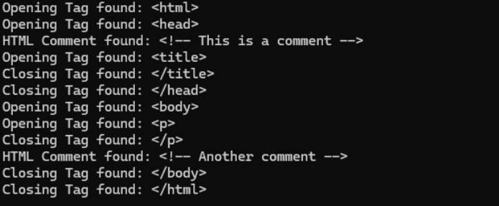

**Practical 5**

**AIM:**

**a. Write a Lex program to count the number of C comment lines from a given C program. Also eliminate them and copy that program into separate file.**

**b. Write a Lex program to recognize keywords, identifiers, operators, numbers, special symbols, literals from a given C program.**

1. **Write a Lex program to count the number of C comment lines from a given C program. Also eliminate them and copy that program into separate file.**

**CODE comment.l:**

%{

#include <stdio.h>

#include <stdlib.h>

int comment_count = 0;

%}

%%

\/\/.* { comment_count++; } // Single-line comments

\/\*[^*]*\*+([^/*][^*]*\*+)*\/ { comment_count++; } // Multi-line comments

.|\n { /* Ignore all characters, since we are not writing to a file */ }

%%

int yywrap() {

return 1;

}

int main() {

yyin = stdin; // Read input from standard input (CMD)

yylex();

printf("Number of Comment Lines: %d\n", comment_count);

return 0;

}

**input3.txt**

#include <stdio.h>

/* This is a multi-line comment

explaining the main function */

int main() {

// This is a single-line comment

printf("Hello, World!\n"); // Print statement

return 0; /* Return statement */

}

**Compile and run:**

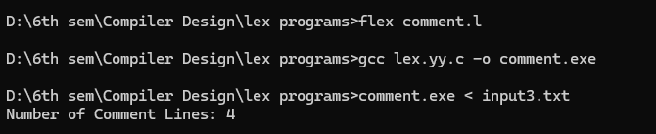

1. **Write a Lex program to recognize keywords, identifiers, operators, numbers, special symbols, literals from a given C program.**

**CODE tokenizer.l:**

%{

#include <stdio.h>

#include <stdlib.h>

%}

DIGIT [0-9]

LETTER [a-zA-Z]

IDENTIFIER {LETTER}({LETTER}|{DIGIT})*

NUMBER {DIGIT}+(\.{DIGIT}+)?

OPERATOR [+\-*/%=><|&!]

SPECIAL [(){}[\];,]

LITERAL \"(\\.|[^"\\])*\"

%%

"auto" { printf("Keyword: %s\n", yytext); }

"break" { printf("Keyword: %s\n", yytext); }

"case" { printf("Keyword: %s\n", yytext); }

"char" { printf("Keyword: %s\n", yytext); }

"const" { printf("Keyword: %s\n", yytext); }

"continue" { printf("Keyword: %s\n", yytext); }

"default" { printf("Keyword: %s\n", yytext); }

"do" { printf("Keyword: %s\n", yytext); }

"double" { printf("Keyword: %s\n", yytext); }

"else" { printf("Keyword: %s\n", yytext); }

"enum" { printf("Keyword: %s\n", yytext); }

"extern" { printf("Keyword: %s\n", yytext); }

"float" { printf("Keyword: %s\n", yytext); }

"for" { printf("Keyword: %s\n", yytext); }

"goto" { printf("Keyword: %s\n", yytext); }

"if" { printf("Keyword: %s\n", yytext); }

"int" { printf("Keyword: %s\n", yytext); }

"long" { printf("Keyword: %s\n", yytext); }

"register" { printf("Keyword: %s\n", yytext); }

"return" { printf("Keyword: %s\n", yytext); }

"short" { printf("Keyword: %s\n", yytext); }

"signed" { printf("Keyword: %s\n", yytext); }

"sizeof" { printf("Keyword: %s\n", yytext); }

"static" { printf("Keyword: %s\n", yytext); }

"struct" { printf("Keyword: %s\n", yytext); }

"switch" { printf("Keyword: %s\n", yytext); }

"typedef" { printf("Keyword: %s\n", yytext); }

"union" { printf("Keyword: %s\n", yytext); }

"unsigned" { printf("Keyword: %s\n", yytext); }

"void" { printf("Keyword: %s\n", yytext); }

"volatile" { printf("Keyword: %s\n", yytext); }

"while" { printf("Keyword: %s\n", yytext); }

{IDENTIFIER} { printf("Identifier: %s\n", yytext); }

{NUMBER} { printf("Number: %s\n", yytext); }

{OPERATOR} { printf("Operator: %s\n", yytext); }

{SPECIAL} { printf("Special Symbol: %s\n", yytext); }

{LITERAL} { printf("Literal: %s\n", yytext); }

[ \t\n] { /* Ignore whitespace and newlines */ }

. { printf("Unknown Token: %s\n", yytext); }

%%

int yywrap() {

return 1;

}

int main() {

yylex();

return 0;

}

**input4.txt**

int main() {

int a = 10, b = 20;

float c = 3.14;

char d = 'x';

printf("Hello, World!\n");

return 0;

}

**Compile and run:**

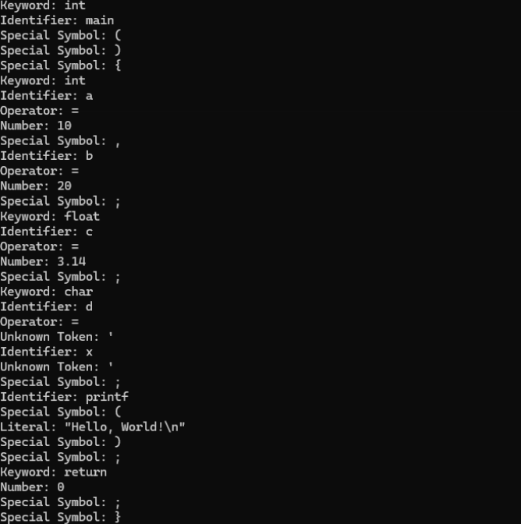

**Practical 6**

**AIM:**Program to implement Recursive Descent Parsing in C.

**CODE:**

#include <stdio.h>

#include <string.h>

#define SUCCESS 1

#define FAILED 0

// Function prototypes

int E(), Edash(), T(), Tdash(), F();

const char *cursor;

char string[64];

int main()

{

puts("Enter the string");

scanf("%s", string); // Read input from the user

cursor = string;

puts("");

puts("Input Action");

puts("--------------------------------");

// Call the starting non-terminal E

if (E() && *cursor == '\0')

{ // If parsing is successful and the cursor has reached the end

puts("--------------------------------");

puts("String is successfully parsed");

return 0;

}

else

{

puts("--------------------------------");

puts("Error in parsing String");

return 1;

}

}

// Grammar rule: E -> T E'

int E()

{

printf("%-16s E -> T E'\n", cursor);

if (T())

{ // Call non-terminal T

if (Edash())

{ // Call non-terminal E'

return SUCCESS;

}

else

{

return FAILED;

}

}

else

{

return FAILED;

}

}

// Grammar rule: E' -> + T E' | $

int Edash()

{

if (*cursor == '+')

{

printf("%-16s E' -> + T E'\n", cursor);

cursor++;

if (T())

{ // Call non-terminal T

if (Edash())

{ // Call non-terminal E'

return SUCCESS;

}

else

{

return FAILED;

}

}

else

{

return FAILED;

}

}

else

{

printf("%-16s E' -> $\n", cursor);

return SUCCESS;

}

}

// Grammar rule: T -> F T'

int T()

{

printf("%-16s T -> F T'\n", cursor);

if (F())

{ // Call non-terminal F

if (Tdash())

{ // Call non-terminal T'

return SUCCESS;

}

else

{

return FAILED;

}

}

else

{

return FAILED;

}

}

// Grammar rule: T' -> * F T' | $

int Tdash()

{

if (*cursor == '*')

{

printf("%-16s T' -> * F T'\n", cursor);

cursor++;

if (F())

{ // Call non-terminal F

if (Tdash())

{ // Call non-terminal T'

return SUCCESS;

}

else

{

return FAILED;

}

}

else

{

return FAILED;

}

}

else

{

printf("%-16s T' -> $\n", cursor);

return SUCCESS;

}

}

// Grammar rule: F -> ( E ) | i

int F()

{

if (*cursor == '(')

{

printf("%-16s F -> ( E )\n", cursor);

cursor++;

if (E())

{ // Call non-terminal E

if (*cursor == ')')

{

cursor++;

return SUCCESS;

}

else

{

return FAILED;

}

}

else

{

return FAILED;

}

}

else if (*cursor == 'i')

{

printf("%-16s F -> i\n", cursor);

cursor++;

return SUCCESS;

}

else

{

return FAILED;

}

}

**OUTPUT:**

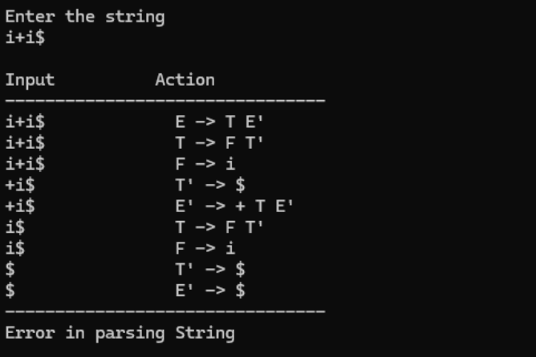

**Practical 7**

**AIM:**

1. **To Study about Yet Another Compiler-Compiler(YACC).**
2. **Create Yacc and Lex specification files to recognizes arithmetic expressions involving +, -, * and / .**
3. **Create Yacc and Lex specification files are used to generate a calculator which accepts integer type arguments.**
4. **Create Yacc and Lex specification files are used to convert infix expression to postfix expression.**

1. **To Study about Yet Another Compiler-Compiler(YACC).**

**What is YACC?**

* YACC (Yet Another Compiler-Compiler) is a tool used in compiler design to generate parsers. It helps you build the syntax analysis part of a compiler.
* It was developed by Stephen C. Johnson at AT&T Bell Labs.

**Why is YACC used?**

* Writing a parser manually (like recursive descent) is complex and error-prone.
* YACC automates this by generating C code for the parser from a grammar specification.
* It works well with lex, the lexical analyzer generator.

**How does YACC work?**

* You write a grammar using BNF (Backus-Naur Form) or similar syntax.
* You assign semantic actions to grammar rules (using C code).
* YACC generates a parser in C that uses a bottom-up parsing algorithm (usually LALR(1)).
* The parser works with lex to analyze tokens.

**Structure of a YACC file**

A YACC source file has three sections, separated by %%:

%{

// Declarations (C code, headers)

%}

%token ID NUM // Token definitions

%%

E : E '+' T { printf("Adding\n"); }

| T { /* do nothing */ }

;

T : T '*' F { printf("Multiplying\n"); }

| F { /* do nothing */ }

;

F : '(' E ')'

| ID

| NUM

;

%%

// Additional C code (main function etc.)

**YACC and LEX Integration**

* LEX handles scanning/tokenizing (splits input into tokens).
* YACC handles parsing (checks if token sequence is valid as per grammar).
* They work together to build front ends for compilers.

**Advantages of YACC**

* Speeds up parser development.
* Helps build robust parsers for programming languages.
* Well-suited for formal language processing tasks.

1. **Create Yacc and Lex specification files to recognizes arithmetic expressions involving +, -, * and / .**

**expr.l CODE:**

%{

#include "expr.tab.h"

#include <stdlib.h>

%}

%%

[0-9]+ { yylval.ival = atoi(yytext); return NUMBER; }

[a-zA-Z]+ { yylval.ival = 0; return ID; }

[ \t]+ ; // skip whitespace

\n { return '\n'; }

. { return yytext[0]; }

%%

int yywrap() {

return 1;

}

**expr.y CODE:**

%{

#include <stdio.h>

#include <stdlib.h>

void yyerror(const char *s);

int yylex(void);

%}

%union {

int ival;

}

%token <ival> NUMBER

%token <ival> ID

%type <ival> E

%left '+' '-'

%left '*' '/'

%%

input:

E '\n' { printf("Result = %d\n", $1); }

;

E:

E '+' E { $$ = $1 + $3; }

| E '-' E { $$ = $1 - $3; }

| E '*' E { $$ = $1 * $3; }

| E '/' E { $$ = $1 / $3; }

| '-' E { $$ = -$2; }

| '(' E ')' { $$ = $2; }

| NUMBER { $$ = $1; }

| ID { $$ = $1; }

;

%%

int main(void) {

printf("Enter the expression:\n");

yyparse();

return 0;

}

void yyerror(const char *s) {

fprintf(stderr, "Error: %s\n", s);

}

**OUTPUT:**

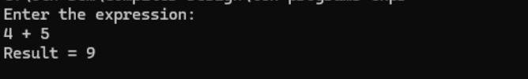

1. **Create Yacc and Lex specification files are used to generate a calculator which accepts integer type arguments.**

**calc.l CODE:**

%{

#include "calc.tab.h"

#include <stdlib.h>

%}

%%

[0-9]+ { yylval.ival = atoi(yytext); return NUMBER; }

[ \t]+ ; // skip whitespace

\n { return '\n'; }

. { return yytext[0]; }

%%

int yywrap() {

return 1;

}

**calc.y CODE:**

%{

#include <stdio.h>

#include <stdlib.h>

void yyerror(const char *s);

int yylex(void);

%}

%union {

int ival;

}

%token <ival> NUMBER

%type <ival> expr

%left '+' '-'

%left '*' '/'

%start input

%%

input:

expr '\n' { printf("Result = %d\n", $1); }

;

expr:

expr '+' expr { $$ = $1 + $3; }

| expr '-' expr { $$ = $1 - $3; }

| expr '*' expr { $$ = $1 * $3; }

| expr '/' expr {

if ($3 == 0) {

yyerror("Division by zero");

YYABORT; // Exit the parsing process immediately

} else {

$$ = $1 / $3;

}

}

| '(' expr ')' { $$ = $2; }

| NUMBER { $$ = $1; }

;

%%

int main() {

printf("Enter the expression:\n");

return yyparse();

}

void yyerror(const char *s) {

fprintf(stderr, "Error: %s\n", s);

}

**OUTPUT:**

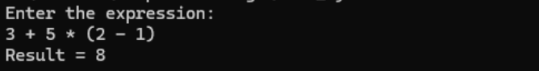

1. **Create Yacc and Lex specification files are used to convert infix expression to postfix expression.**

**infix_to_postfix.l CODE:**

%{

#include "infix_to_postfix.tab.h"

#include <stdlib.h>

#include <string.h>

%}

DIGIT [0-9]

WS [ \t\r]+

%%

{DIGIT}+ {

yylval.str = strdup(yytext);

return NUMBER;

}

"(" { return '('; }

")" { return ')'; }

"+" { return '+'; }

"-" { return '-'; }

"*" { return '*'; }

"/" { return '/'; }

{WS} { /* skip whitespace */ }

\n { return '\n'; }

. { return yytext[0]; }

%%

int yywrap() {

return 1;

}

**infix_to_postfix.y CODE:**

%{

#include <stdio.h>

#include <stdlib.h>

#include <string.h>

#include <stdarg.h>

// custom asprintf implementation for Windows

int asprintf(char **strp, const char *fmt, ...) {

va_list args;

va_start(args, fmt);

int size = vsnprintf(NULL, 0, fmt, args);

va_end(args);

if (size < 0) return -1;

*strp = (char *)malloc(size + 1);

if (!*strp) return -1;

va_start(args, fmt);

vsnprintf(*strp, size + 1, fmt, args);

va_end(args);

return size;

}

void yyerror(const char *s);

int yylex(void);

%}

%union {

char *str;

}

%token <str> NUMBER

%left '+' '-'

%left '*' '/'

%token '(' ')'

%type <str> expr

%%

input:

/* empty */

| input expr '\n' {

printf("Postfix: %s\n", $2);

free($2);

}

;

expr:

NUMBER { $$ = strdup($1); free($1); }

| expr '+' expr { asprintf(&$$, "%s %s +", $1, $3); free($1); free($3); }

| expr '-' expr { asprintf(&$$, "%s %s -", $1, $3); free($1); free($3); }

| expr '*' expr { asprintf(&$$, "%s %s *", $1, $3); free($1); free($3); }

| expr '/' expr { asprintf(&$$, "%s %s /", $1, $3); free($1); free($3); }

| '(' expr ')' { $$ = $2; }

;

%%

void yyerror(const char *s) {

fprintf(stderr, "Error: %s\n", s);

}

int main() {

printf("Enter an infix expression:\n");

yyparse();

return 0;

}

**OUTPUT:** 