SCHOOL OF ENGINEERING & TECHNOLOGY

BACHELOR OF TECHNOLOGY

COMPILER DESIGN

6TH SEMESTER

DEPARTMENT OF COMPUTER SCIENCE & ENGINEERING

|  |
| --- |
| Laboratory Manual |

**Done By :**

**Dhvanika Naik**

**22000741**

**TABLE OF CONTENT**

|  |  |
| --- | --- |
| **Sr. No** | **Experiment Title** |
|  |
| 1 | 1. Write a program to recognize strings starts with ‘a’ over {a, b}. 2. Write a program to recognize strings end with ‘a’. 3. Write a program to recognize strings end with ‘ab’. Take the input from text file. 4. Write a program to recognize strings contains ‘ab’. Take the input from text file. |
| 2 | 1. Write a program to recognize the valid identifiers and keywords. 2. Write a program to recognize the valid operators. 3. Write a program to recognize the valid number. 4. Write a program to recognize the valid comments. 5. Program to implement Lexical Analyzer. |
| 3 | To Study about Lexical Analyzer Generator (LEX) and Flex(Fast Lexical Analyzer) |
| 4 | Implement following programs using Lex.  a. Write a Lex program to take input from text file and count no of characters, no. of lines & no. of words.  b. Write a Lex program to take input from text file and count number of vowels and consonants.  c. Write a Lex program to print out all numbers from the given file.  d. Write a Lex program which adds line numbers to the given file and display the same into different file.  e. Write a Lex program to printout all markup tags and HTML comments in file. |
| 5 | a. Write a Lex program to count the number of C comment lines from a given C program. Also eliminate them and copy that program into separate file.  b. Write a Lex program to recognize keywords, identifiers, operators, numbers, special symbols, literals from a given C program. |
| 6 | Program to implement Recursive Descent Parsing in C. |
| 7 | a. To Study about Yet Another Compiler-Compiler(YACC).  b. Create Yacc and Lex specification files to recognizes arithmetic expressions involving +, -, * and / .  c. Create Yacc and Lex specification files are used to generate a calculator which accepts integer type arguments.  d. Create Yacc and Lex specification files are used to convert infix expression to postfix expression. |

**Q1 a Write a program to recognize strings starts with ‘a’ over {a, b}.**

**Code:**

#include<stdio.h>

int main(){

char input[10];

int i = 0;

printf("Enter input string to check in the automata: ");

scanf("%s", input);

int state = 0;

while(input[i]!= '\0'){

switch(state){

case 0:

if (input[i]=='a')

{

/* code */

state = 1;

}

else if (input[i] == 'b')

{

/* code */

state = 2;

}

else

{

state = 3;

}

break;

case 1:

if (input[i] == 'a' || input[i] == 'b')

{

/* code */

state = 1;

}

else

{

state = 3;

}

break;

case 2:

if (input[i] == 'a' || input[i] == 'b')

{

/* code */

state = 2;

}

else

{

state = 3;

}

break;

case 3:

state = 3;

}

i++;

}

if(state == 1) printf("Input string is valid");

else if(state == 2 || state == 0) printf("Input string is not valid");

else if(state == 3) printf("String is not recogized");

return 0;

}

**Output:**

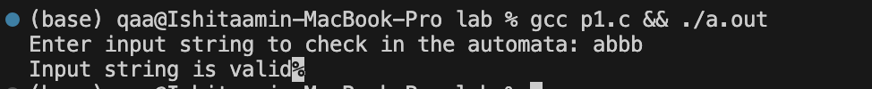

**Q1 b Write a program to recognize strings end with ‘a’.**

**Code:**

#include<stdio.h>

int main() {

char input[10];

int state=0, i=0;

printf("Enter the input string: ");

scanf("%s",input);

while(input[i]!='\0') {

switch(state) {

case 0:

if(input[i]=='a') state=1;

else state=0;

break;

case 1:

if(input[i]=='a') state=1;

else state=0;

break;

}

i++;

}

if(state==0) printf("String is invalid!");

else printf("String is valid!");

return 0;

}

**Output:**



**Q1 c Write a program to recognize strings end with ‘ab’. Take the input from text file.**

**Code:**

#include <stdio.h>

#include <stdlib.h>

int main() {

char input[100];

int i = 0, state = 0;

// Open the file for reading

FILE *file = fopen("input.txt", "r");

if (file == NULL) {

printf("Error: Could not open file.\n");

return 1;

}

// Read the string from the file

fscanf(file, "%s", input);

fclose(file); // Close the file after reading

// DFA logic to check if the string ends with "ab"

while (input[i] != '\0') {

switch (state) {

case 0:

if (input[i] == 'a') {

state = 1;

} else if (input[i] == 'b') {

state = 0;

} else {

state = 3; // Invalid character

}

break;

case 1:

if (input[i] == 'b') {

state = 2;

} else if (input[i] == 'a') {

state = 1;

} else {

state = 3;

}

break;

case 2:

if (input[i] == 'a') {

state = 1;

} else if (input[i] == 'b') {

state = 0;

} else {

state = 3;

}

break;

case 3:

state = 3;

break;

}

i++;

}

// Final check: only accept if last two characters were 'a' followed by 'b'

if (state == 2) {

printf("Input string is valid (ends with 'ab')\n");

} else {

printf("Input string is not valid (does not end with 'ab')\n");

}

return 0;

}

**Output:**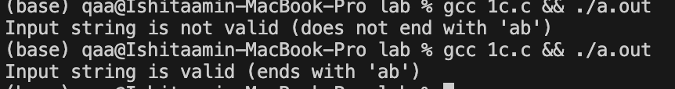



**Q1 d Write a program to recognize strings contains ‘ab’. Take the input from text file.**

**Code:**

#include <stdio.h>

int main() {

char input[10];

int i = 0;

printf("Enter input string to check in the automata: ");

scanf("%s", input);

int state = 0;

while (input[i] != '\0') {

switch (state) {

case 0:

if (input[i] == 'a') {

state = 1;

} else if (input[i] == 'b') {

state = 0;

} else {

state = 3;

}

break;

case 1:

if (input[i] == 'b') {

state = 2; // Transition to final state on "ab"

} else if (input[i] == 'a') {

state = 1;

} else {

state = 3;

}

break;

case 2:

if (input[i] == 'a' || input[i] == 'b') {

state = 2;

} else {

state = 3;

}

break;

case 3:

state = 3;

break;

}

i++;

}

if (state == 2) {

printf("Input string is valid (contains 'ab')");

} else {

printf("Input string is not valid (does not contain 'ab')");

}

return 0;

}

**Output:**



**2**

1. **Write a program to recognize the valid identifiers and keywords.**

**Code:**

#include <stdio.h>

#include <ctype.h>

#include <string.h>

int isKeyword(char *str) {

char *keywords[] = {"int","float","char","double","return","if","else","for","while"};

int numKeywords = sizeof(keywords) / sizeof(keywords[0]);

for (int i = 0; i < numKeywords; i++) {

if (strcmp(str, keywords[i]) == 0)

return 1;

}

return 0;

}

int isValidIdentifier(char *str) {

if (!isalpha(str[0]) && str[0] != '_')

return 0;

for (int i = 1; str[i] != '\0'; i++) {

if (!isalnum(str[i]) && str[i] != '_')

return 0;

}

return 1;

}

int main() {

FILE *file;

char filename[] = "input2a.txt";

char word[100];

int index = 0;

char ch;

file = fopen(filename, "r");

if (file == NULL) {

perror("Error opening file");

return 1;

}

printf("Results:\n");

while ((ch = fgetc(file)) != EOF) {

if (isalnum(ch) || ch == '_') {

word[index++] = ch;

} else if (index > 0) {

word[index] = '\0';

if (isKeyword(word))

printf("'%s' is a keyword\n", word);

else if (isValidIdentifier(word))

printf("'%s' is a valid identifier\n", word);

else

printf("'%s' is NOT a valid identifier\n", word);

index = 0; // Reset for next word

}

}

// Handle last word if file doesn't end with whitespace

if (index > 0) {

word[index] = '\0';

if (isKeyword(word))

printf("'%s' is a keyword\n", word);

else if (isValidIdentifier(word))

printf("'%s' is a valid identifier\n", word);

else

printf("'%s' is NOT a valid identifier\n", word);

}

fclose(file);

return 0;

}

**Output:**

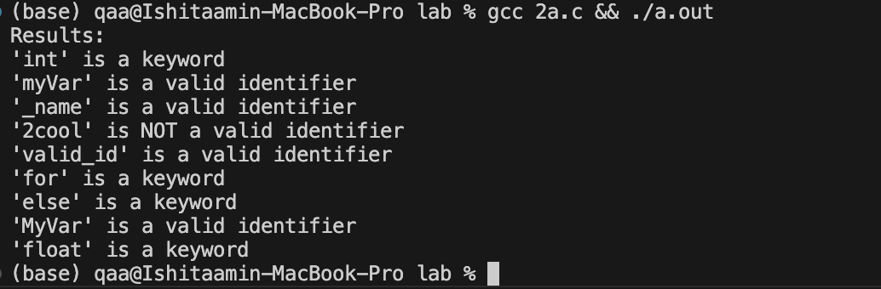

1. **Write a program to recognize the valid operators.**

**Code:**

#include <stdio.h>

#include <string.h>

int main() {

char input[10];

int i = 0;

printf("Enter input string to check in the automata: ");

scanf("%s", input);

int state = 50;

while (input[i] != '\0') {

switch (state) {

case 50:

if (input[i] == '+') {

if (input[i + 1] == '+') state = 100;

else if (input[i + 1] == '=') state = 101;

else if (input[i + 1] == '\0' || input[i + 1] == ' ') state = 102;

else state = -1;

}

else if (input[i] == '-') {

if (input[i + 1] == '-') state = 103;

else if (input[i + 1] == '=') state = 104;

else if (input[i + 1] == '\0' || input[i + 1] == ' ') state = 105;

else state = -1;

}

else if (input[i] == '*') {

if (input[i + 1] == '=') state = 107;

else if (input[i + 1] == '\0' || input[i + 1] == ' ') state = 108;

else state = -1;

}

else if (input[i] == '/') {

if (input[i + 1] == '=') state = 109;

else if (input[i + 1] == '\0' || input[i + 1] == ' ') state = 110;

else state = -1;

}

else if (input[i] == '%') {

if (input[i + 1] == '=') state = 111;

else if (input[i + 1] == '\0' || input[i + 1] == ' ') state = 112;

else state = -1;

}

else if (input[i] == '=') {

if (input[i + 1] == '=') state = 119;

else if (input[i + 1] == '\0' || input[i + 1] == ' ') state = 120;

else state = -1;

}

else {

state = -1;

}

break;

}

i++;

}

if (state == 100 || state == 103)

printf("Input string is a valid unary operator\n");

else if (state == 102 || state == 105 || state == 108 || state == 110 || state == 112)

printf("Input string is a valid arithmetic operator\n");

else if (state == 119)

printf("Input string is a valid relational operator\n");

else if (state == 101 || state == 104 || state == 107 || state == 109 || state == 111 || state == 120)

printf("Input string is a valid assignment operator\n");

else

printf("Invalid input\n");

return 0;

}

**Output:**



1. **Write a program to recognize the valid number.**

**Code:**

#include <stdio.h>

#include <ctype.h>

#include <string.h>

int main() {

FILE *file;

char filename[] = "number.txt";

char ch;

int state = 0;

int valid_found = 0;

char word[100];

int index = 0;

file = fopen(filename, "r");

if (file == NULL) {

perror("Error opening file");

return 1;

}

while ((ch = fgetc(file)) != EOF) {

switch (state) {

case 0:

if (isdigit(ch)) {

word[index++] = ch;

state = 1;

} else if (ch == ' ' || ch == '\n' || ch == '\t') {

// ignore whitespace

} else {

index = 0;

state = 0;

}

break;

case 1:

if (isdigit(ch)) {

word[index++] = ch;

state = 1;

} else if (ch == '.') {

word[index++] = ch;

state = 2;

} else if (ch == 'E' || ch == 'e') {

word[index++] = ch;

state = 4;

} else {

word[index] = '\0';

printf("Valid number: %s\n", word);

valid_found = 1;

index = 0;

state = 0;

ungetc(ch, file); // put back the extra character

}

break;

case 2:

if (isdigit(ch)) {

word[index++] = ch;

state = 3;

} else {

index = 0;

state = 0;

}

break;

case 3:

if (isdigit(ch)) {

word[index++] = ch;

state = 3;

} else if (ch == 'E' || ch == 'e') {

word[index++] = ch;

state = 4;

} else {

word[index] = '\0';

printf("Valid number: %s\n", word);

valid_found = 1;

index = 0;

state = 0;

ungetc(ch, file);

}

break;

case 4:

if (ch == '+' || ch == '-') {

word[index++] = ch;

state = 5;

} else if (isdigit(ch)) {

word[index++] = ch;

state = 6;

} else {

index = 0;

state = 0;

}

break;

case 5:

if (isdigit(ch)) {

word[index++] = ch;

state = 6;

} else {

index = 0;

state = 0;

}

break;

case 6:

if (isdigit(ch)) {

word[index++] = ch;

state = 6;

} else {

word[index] = '\0';

printf("Valid number: %s\n", word);

valid_found = 1;

index = 0;

state = 0;

ungetc(ch, file);

}

break;

}

}

// Handle if file ends directly after a number

if ((state == 1 || state == 3 || state == 6) && index > 0) {

word[index] = '\0';

printf("Valid number: %s\n", word);

valid_found = 1;

}

fclose(file);

if (!valid_found) {

printf("No valid number found.\n");

}

return 0;

}

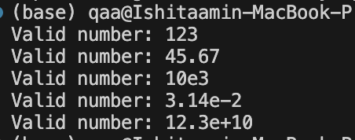

**Output:**

1. **Write a program to recognize the valid comments.**

**Code:**

// Write a program to the comment in the code

#include<stdio.h>

int main() {

FILE *file;

char filename[] = "comment.txt";

char ch;

int state=0,i=0;

file = fopen(filename, "r");

if (file == NULL) {

perror("Error opening file");

return 1;

}

while ((ch = fgetc(file)) != EOF) {

switch(state) {

case 0:

if(ch=='/') state=1;

else state=2;

break;

case 1:

if(ch=='/') state=3;

else if (ch=='*')

{

state=4;

}

else

{

state=2;

}

break;

case 2:

state=2;

break;

case 3:

state=3;

break;

case 4:

if(ch=='*') state=5;

else state=4;

break;

case 5:

if(ch=='/') state=6;

else state=4;

break;

case 6:

state=2;

break;

}

i++;

}

if(state == 1) printf("Input string is invalid");

else if(state == 2 || state == 0) printf("Input string is not any comment");

else if(state == 3) printf("String is single line comment");

else if(state == 4 || state==5) printf("String is not a valid comment");

else if(state == 6) printf("String is multiline comment");

return 0;

}

**Output:**



1. **Program to implement Lexical Analyzer.**

**Code:**

// Program to implement Lexical Analyzer

#include <stdio.h>

#include <stdlib.h>

#include <ctype.h>

#include <string.h>

#define BUFFER_SIZE 1000

void check(char *lexeme);

void main() {

FILE *f1;

char buffer[BUFFER_SIZE], lexeme[50];

char c;

int f = 0, state = 0, i = 0;

f1 = fopen("input.txt", "r");

if (!f1) {

printf("Error opening file.\n");

return;

}

int bytesRead = fread(buffer, sizeof(char), BUFFER_SIZE - 1, f1);

buffer[bytesRead] = '\0'; // Null terminate

fclose(f1);

while (buffer[f] != '\0') {

switch (state) {

case 0:

c = buffer[f];

if (isalpha(c) || c == '_') {

state = 1; // Identifier or Keyword

lexeme[i++] = c;

}

else if (isdigit(c)) {

state = 13; // Number

lexeme[i++] = c;

}

else if (c == '/') {

state = 11; // Potential comment

}

else if (c == ';' || c == ',' || c == '{' || c == '}' || c == '(' || c == ')') {

printf(" %c is a symbol\n", c);

}

else if (strchr("+-*/=<>!&|", c)) {

state = 20; // Operator

lexeme[i++] = c;

}

break;

case 1:

c = buffer[f];

if (isalnum(c) || c == '_') {

lexeme[i++] = c;

} else {

lexeme[i] = '\0';

check(lexeme);

i = 0;

state = 0;

f--;

}

break;

case 11:

c = buffer[f];

if (c == '/') {

while (buffer[f] != '\n' && buffer[f] != '\0') f++;

printf("Single-line comment detected\n");

}

else if (c == '*') {

f++;

while (buffer[f] != '\0' && !(buffer[f] == '*' && buffer[f + 1] == '/')) f++;

f += 2;

printf("Multi-line comment detected\n");

}

else {

printf("/ is an operator\n");

f--;

}

state = 0;

break;

case 13:

c = buffer[f];

if (isdigit(c)) {

lexeme[i++] = c;

} else if (c == '.') {

state = 14;

lexeme[i++] = c;

} else if (c == 'E' || c == 'e') {

state = 16;

lexeme[i++] = c;

} else {

lexeme[i] = '\0';

printf("%s is a valid number\n", lexeme);

i = 0;

state = 0;

f--;

}

break;

case 14:

c = buffer[f];

if (isdigit(c)) {

lexeme[i++] = c;

} else if (c == 'E' || c == 'e') {

state = 16;

lexeme[i++] = c;

} else {

lexeme[i] = '\0';

printf("%s is a valid floating point number\n", lexeme);

i = 0;

state = 0;

f--;

}

break;

case 16:

c = buffer[f];

if (isdigit(c) || c == '+' || c == '-') {

state = 17;

lexeme[i++] = c;

} else {

lexeme[i] = '\0';

printf("%s is a valid number\n", lexeme);

i = 0;

state = 0;

f--;

}

break;

case 17:

c = buffer[f];

if (isdigit(c)) {

lexeme[i++] = c;

} else {

lexeme[i] = '\0';

printf("%s is a valid scientific notation number\n", lexeme);

i = 0;

state = 0;

f--;

}

break;

case 20:

c = buffer[f];

if ((lexeme[0] == '=' && c == '=') ||

(lexeme[0] == '!' && c == '=') ||

(lexeme[0] == '>' && c == '=') ||

(lexeme[0] == '<' && c == '=') ||

(lexeme[0] == '&' && c == '&') ||

(lexeme[0] == '|' && c == '|')) {

lexeme[i++] = c;

lexeme[i] = '\0';

printf("%s is an operator\n", lexeme);

i = 0;

state = 0;

} else {

lexeme[i] = '\0';

printf("%s is an operator\n", lexeme);

i = 0;

state = 0;

f--;

}

break;

}

f++;

}

}

void check(char *lexeme) {

char *keywords[] = {

"auto", "break", "case", "char", "const", "continue", "default", "do",

"double", "else", "enum", "extern", "float", "for", "goto", "if",

"inline", "int", "long", "register", "restrict", "return", "short", "signed",

"sizeof", "static", "struct", "switch", "typedef", "union", "unsigned", "void", "volatile", "while"

};

for (int i = 0; i < 32; i++) {

if (strcmp(lexeme, keywords[i]) == 0) {

printf("%s is a keyword\n", lexeme);

return;

}

}

printf("%s is an identifier\n", lexeme);

}

**Output:**

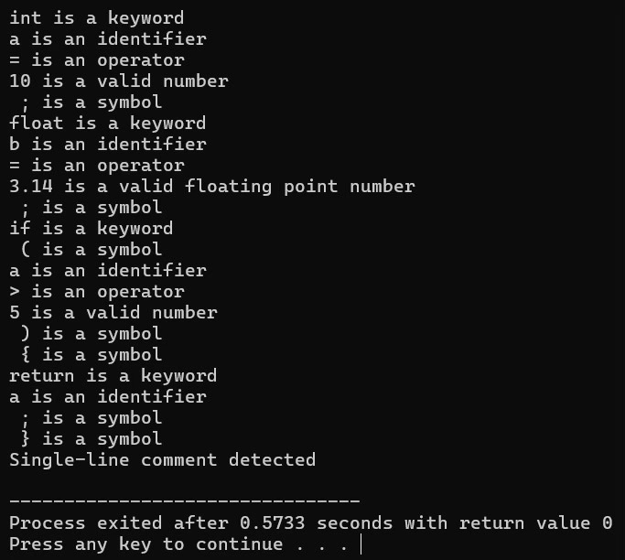

**3. To Study about Lexical Analyzer Generator (LEX) and Flex(Fast Lexical Analyzer)**

A **Lexical Analyzer** (or scanner/tokenizer) is a part of a compiler that:

* Reads the input source code (text file)
* Breaks it into **tokens** (smallest meaningful units like keywords, identifiers, numbers, symbols, etc.)
* Removes white spaces and comments
* Sends tokens to the **parser** for syntax analysis

**Strcture of Lex**

%{

// C declarations (optional)

%}

%%

// Rules section

pattern1 action1

pattern2 action2

%%

// Additional C code (optional)

**How lex works:**

* Write a .l file with patterns and actions.
* Run lex file.l – it creates a C file lex.yy.c.
* Compile with gcc lex.yy.c -lfl (link with LEX/FLEX library).
* Run the output program with your input.

**Flex** -Flex stands for Fast Lexical Analyzer.It is an improved, faster version of LEX.Works similarly to LEX but is more flexible and efficient.Compatible with LEX programs.

**4**

**a. Write a Lex program to take input from text file and count no of characters, no. of lines & no. of words.**

**Code:**

%{

#include <stdio.h>

int char_count = 0;

int word_count = 0;

int line_count = 0;

%}

%%

[^\n\t ]+ { word_count++; char_count += yyleng; } // Count words + their characters

[\n] { line_count++; char_count++; } // Count lines and newline characters

[ \t] { char_count++; } // Count spaces and tabs

. { char_count++; } // Count other characters (punctuation etc.)

%%

int yywrap() {

return 1;

}

int main() {

FILE *file = fopen("input.txt", "r");

if (!file) {

printf("Error: Could not open input.txt\n");

return 1;

}

yyin = file; // Set input source for Lex

yylex(); // Start scanning

fclose(file); // Close file after scanning

// Print results

printf("Total Characters: %d\n", char_count);

printf("Total Words : %d\n", word_count);

printf("Total Lines : %d\n", line_count);

return 0;

}

**Output:**

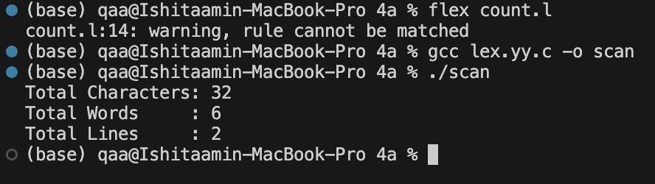

**b. Write a Lex program to take input from text file and count number of vowels and consonants.**

**Code:**

%{

#include <stdio.h>

int countv = 0;

int countc = 0;

%}

%%

[aeiouAEIOU] { countv++; }

[bcdfghjklmnpqrstvwxyzBCDFGHJKLMNPQRSTVWXYZ] { countc++; }

. ; // Ignore all other characters

%%

int yywrap() {

return 1;

}

int main() {

FILE *file = fopen("input.txt", "r");

if (!file) {

printf("Could not open input.txt\n");

return 1;

}

yyin = file;

yylex();

fclose(file);

printf("Total Vowels : %d\n", countv);

printf("Total Consonants: %d\n", countc);

return 0;

}

**Output:**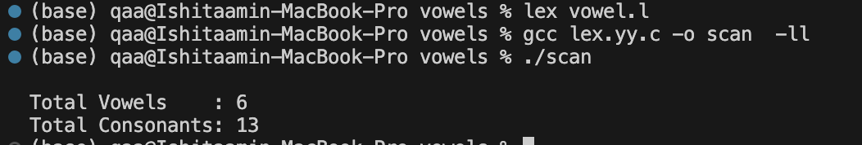

**c. Write a Lex program to print out all numbers from the given file.**

**Code:**

%{

#include <stdio.h>

%}

%%

[0-9]+(\.[0-9]+)?([eE][+-]?[0-9]+)? { printf("Number found: %s\n", yytext); }

. ; // Ignore all other characters

%%

int yywrap() {

return 1;

}

int main() {

yyin = fopen("input.txt", "r");

if (!yyin) {

printf("Error opening input.txt\n");

return 1;

}

yylex(); // Start scanning

fclose(yyin);

return 0;

}

**Output:**

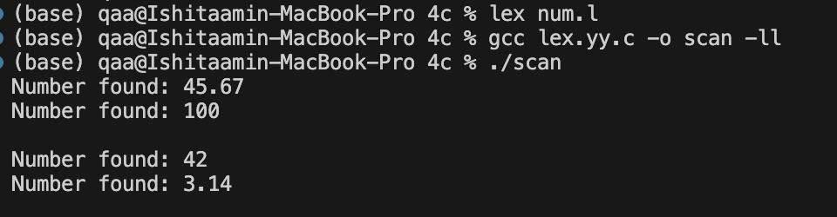

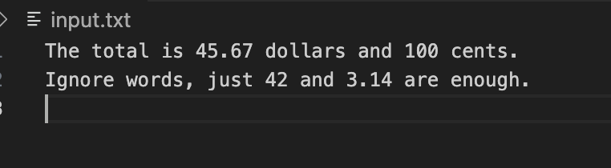

**d. Write a Lex program that adds line numbers to the given file and displays the same into a different file.**

**Code:**

%{

#include <stdio.h>

int line_number = 1;

FILE *out;

%}

%%

^.*\n {

fprintf(out, "%d: %s", line_number++, yytext);

}

.|\n {

// For any characters missed (like last line without newline)

fprintf(out, "%d: %s\n", line_number++, yytext);

}

%%

int yywrap() {

return 1;

}

int main() {

FILE *in = fopen("input.txt", "r");

out = fopen("output.txt", "w");

if (!in || !out) {

printf("Error opening files!\n");

return 1;

}

yyin = in;

yylex();

fclose(in);

fclose(out);

printf("Line numbers added successfully to output.txt\n");

return 0;

}

**Output:**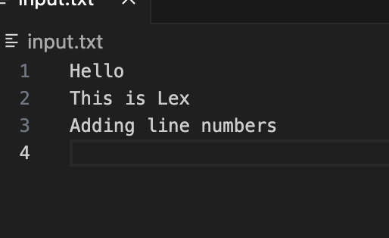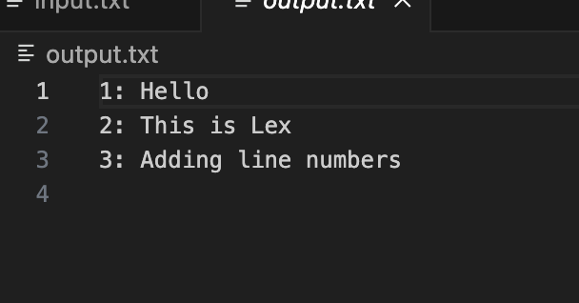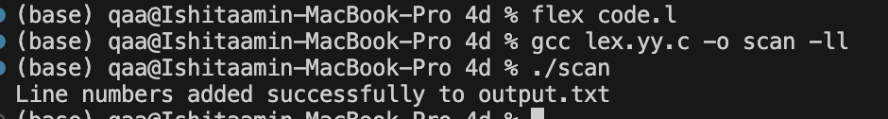

**e. Write a Lex program to printout all markup tags and HTML comments in file.**

**Code:**

%{

#include <stdio.h>

%}

%%

"<!--"([^<]|"<"[^!]|"<!"[^\-]|"<!-"[^-])*"-->" { printf("HTML Comment: %s\n", yytext); }

\<[^>]*\> { printf("HTML Tag: %s\n", yytext); }

.|\n ; // Ignore everything else

%%

int yywrap() {

return 1;

}

int main() {

yyin = fopen("input.html", "r");

if (!yyin) {

printf("Error opening input.html\n");

return 1;

}

yylex(); // start scanning

fclose(yyin);

return 0;

}

**Output:**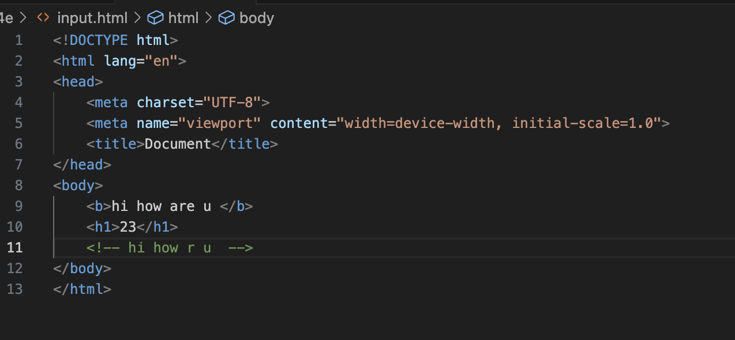

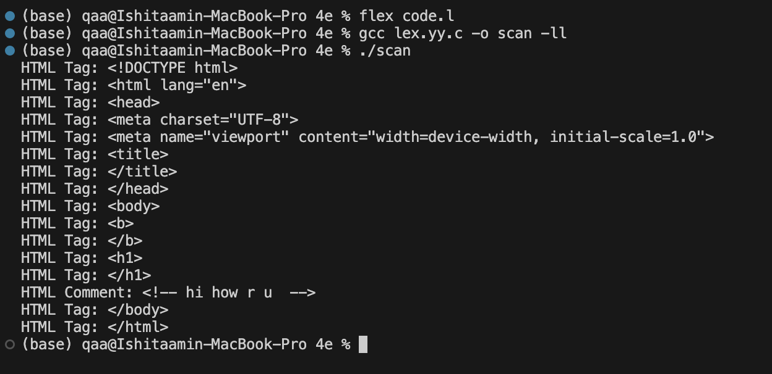

**5.**

1. **Write a Lex program to count the number of C comment lines from a given C program. Also eliminate them and copy that program into separate file.**

**Code:**

%{

#include <stdio.h>

int comment_count = 0;

FILE *out;

%}

%%

"//".* { comment_count++; /* Skip single-line comment */ }

"/*"([^*]*|\*+[^*/])*"*"+"/" { comment_count++; /* Skip multi-line comment */ }

.|\n { fputc(yytext[0], out); } // Copy other content

%%

int yywrap() {

return 1;

}

int main() {

FILE *in = fopen("source.c", "r");

out = fopen("cleaned.c", "w");

if (!in || !out) {

printf("Error opening file(s)\n");

return 1;

}

yyin = in;

yylex();

fclose(in);

fclose(out);

printf("Total comments removed: %d\n", comment_count);

printf("Cleaned code written to 'cleaned.c'\n");

return 0;

}

**Output:**

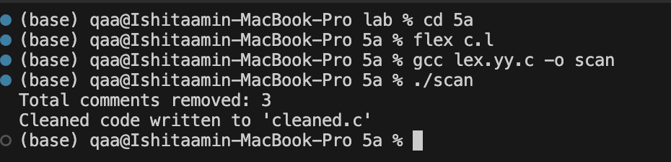

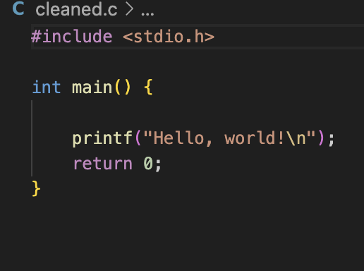

**b. Write a Lex program to recognize keywords, identifiers, operators, numbers, special symbols, literals from a given C program.**

**Code:**

%{

#include <stdio.h>

#include <string.h>

// List of C keywords

char *keywords[] = {

"auto","break","case","char","const","continue","default","do","double","else",

"enum","extern","float","for","goto","if","int","long","register","return",

"short","signed","sizeof","static","struct","switch","typedef","union",

"unsigned","void","volatile","while"

};

int isKeyword(char *str) {

for (int i = 0; i < sizeof(keywords)/sizeof(char*); i++) {

if (strcmp(str, keywords[i]) == 0)

return 1;

}

return 0;

}

%}

%option noyywrap

%%

[0-9]+(\.[0-9]+)? { printf("[Token] %-18s → %s\n", "Number", yytext); }

[a-zA-Z_][a-zA-Z0-9_]* {

if (isKeyword(yytext))

printf("[Token] %-18s → %s\n", "Keyword", yytext);

else

printf("[Token] %-18s → %s\n", "Identifier", yytext);

}

"++"|"--"|"+"|"-"|"=="|"="|"<="|">="|"!="|"&&"|"||"|"*"|"/"|"%" { printf("[Token] %-18s → %s\n", "Operator", yytext); }

[\[\]\{\}\(\),;\.:] { printf("[Token] %-18s → %s\n", "Special Symbol", yytext); }

\'([^\\\n]|(\\.))\' { printf("[Token] %-18s → %s\n", "Char Literal", yytext); }

\"([^\\\n]|(\\.))*\" { printf("[Token] %-18s → %s\n", "String Literal", yytext); }

[ \t\n]+ ; // Skip whitespace

. { printf("[Token] %-18s → %s\n", "Unknown", yytext); }

%%

int main() {

printf("Enter C code (Ctrl+D to end):\n\n");

yylex();

return 0;

}

**Output:**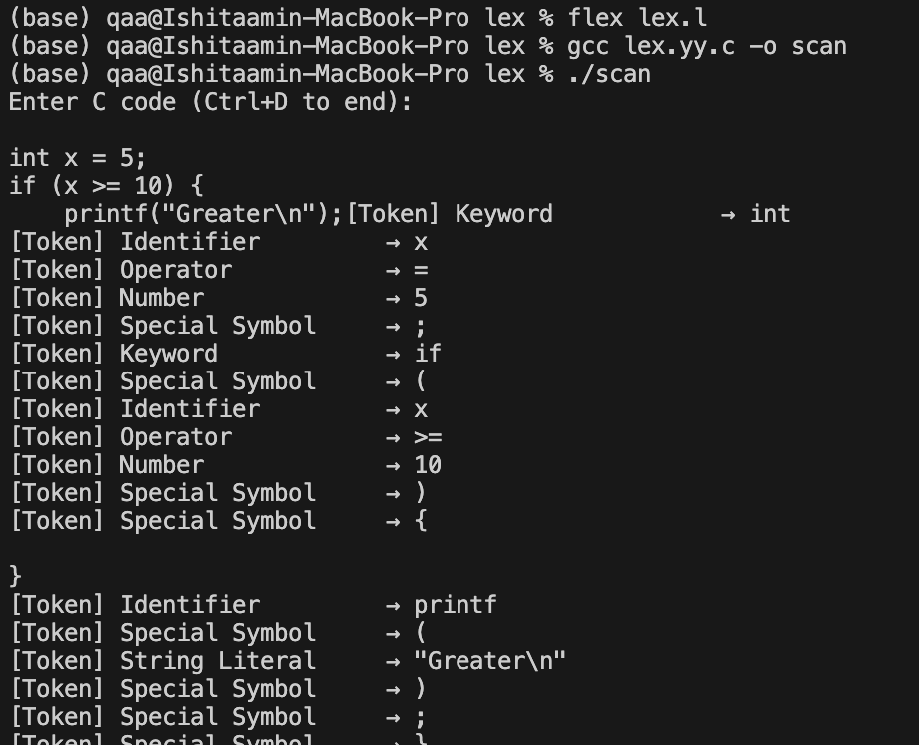

**6 Program to implement Recursive Descent Parsing in C.**

**Code:**

#include <stdio.h>

#include <stdlib.h>

#include <string.h>

const char *input;

int pos = 0;

int match(char exp) {

if (input[pos] == exp) {

pos++;

return 1;

} else {

printf("Syntax Error: Expected '%c' at position %d\n", exp, pos);

exit(1);

}

}

// Forward declarations

int E();

int E_p();

int T();

int T_p();

int F();

int E() {

T();

return E_p();

}

int E_p() {

if (input[pos] == '+') {

match('+');

T();

return E_p();

} else if (input[pos] == '-') {

match('-');

T();

return E_p();

}

return 1; // epsilon

}

int T() {

F();

return T_p();

}

int T_p() {

if (input[pos] == '*') {

match('*');

F();

return T_p();

} else if (input[pos] == '/') {

match('/');

F();

return T_p();

}

return 1; // epsilon

}

int F() {

if (input[pos] == 'i') {

match('i');

return 1;

} else {

printf("Syntax Error: Expected 'i' at position %d\n", pos);

exit(1);

}

}

int parse() {

E();

if (input[pos] == '\0') {

printf("Parsed successfully.\n");

return 1;

} else {

printf("Syntax Error: Unexpected characters at position %d\n", pos);

exit(1);

}

}

int main() {

input = "i+i*i-i/i";

parse();

return 0;

}

**Output:**

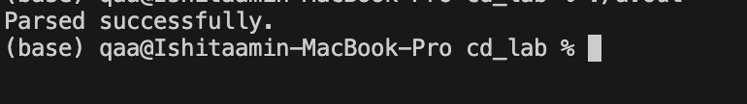

**7.  
a. To Study about Yet Another Compiler-Compiler(YACC).**

**YACC** stands for **Yet Another Compiler-Compiler**.  
It is a **tool used to generate parsers**, especially **LALR(1)** parsers, for interpreting structured input (like programming languages).

It works alongside **Lex**, which handles **lexical analysis** (tokenizing), while YACC does **syntax analysis** (parsing based on grammar).

**YACC helps:**

* Convert high-level grammar into a parser automatically.
* Enforce the **syntax rules** of a programming language.
* Act as the middle step in building **interpreters or compilers**.

**YACC takes:**

* **Tokens** from a lexical analyzer (like Flex/Lex).
* **Grammar rules** written in a BNF-like format.
* **Action code** (usually in C) to execute when rules match.

**It outputs:**

* A y.tab.c file (C code of the parser).
* This parser calls yylex() (defined by Lex) to get tokens and applies grammar rules to parse them.

**b. Create Yacc and Lex specification files to recognizes arithmetic expressions involving +, -, * and / .   
code:**

Lex file :  
  
%{

#include "sample.tab.h" // This header is auto-generated by Bison and includes token definitions like NUM

%}

%%

[0-9]+ { yylval = atoi(yytext); return NUM; }

[ \t] ;

[-+*/()\n] return yytext[0];

. { printf("Invalid character: %s\n", yytext); }

%%

int yywrap() {

return 1;

}

Yacc file:  
%{

#include <stdio.h>

#include <stdlib.h>

int yylex(void);

void yyerror(char *s);

%}

%token NUM

%%

S:

E '\n' { printf("Valid expression\n"); return 0; }

;

E: E '+' T

| E '-' T

| T

;

T:

T '*' F

| T '/' F

| F

;

F:

NUM

| '(' E ')'

;

%%

void yyerror(char *s) {

fprintf(stderr, "Error: %s\n", s);

}

int main() {

printf("Enter expression: ");

yyparse();

return 0;

}

**output:**

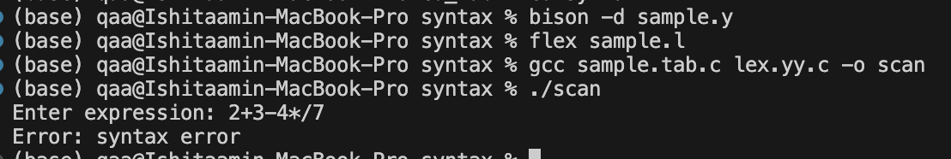

**c. Create Yacc and Lex specification files are used to generate a calculator which accepts integer type arguments.**

**Code:**

Flex file   
%{

#include "calc.tab.h"

%}

%%

[0-9]+ { yylval = atoi(yytext); return NUM; }

[ \t] ; // Ignore spaces and tabs

[-+*/()\n] return yytext[0];

. { printf("Invalid character: %s\n", yytext); }

%%

int yywrap() {

return 1;

}

Bison file   
%{

#include <stdio.h>

#include <stdlib.h>

int yylex(void);

void yyerror(char *s);

%}

%token NUM

%%

S : E '\n' { printf("Result = %d\n", $1); return 0; }

;

E : E '+' T { $$ = $1 + $3; }

| E '-' T { $$ = $1 - $3; }

| T { $$ = $1; }

;

T : T '*' F { $$ = $1 * $3; }

| T '/' F {

if ($3 == 0) {

yyerror("Division by zero");

exit(1);

}

$$ = $1 / $3;

}

| F { $$ = $1; }

;

F : NUM { $$ = $1; }

| '(' E ')' { $$ = $2; }

;

%%

void yyerror(char *s) {

fprintf(stderr, "Error: %s\n", s);

}

int main() {

printf("Enter an arithmetic expression:\n");

yyparse();

return 0;

}

**Output:**

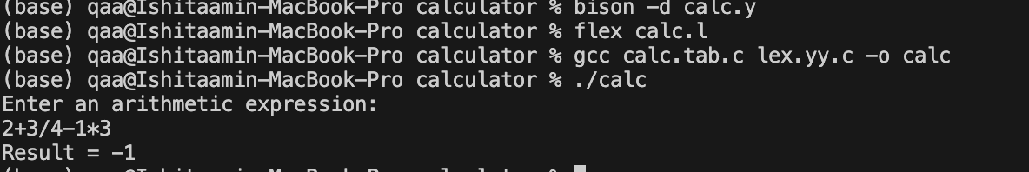

**d. Create Yacc and Lex specification files are used to convert infix expression to postfix expression.**

**Code:**

Flex file

%{

#include "practice.tab.h"

%}

%%

[0-9]+ { yylval = atoi(yytext); return NUMBER; }

[+\-*/()] { return yytext[0]; }

[\n] { return '\n'; }

[ \t] ;

. { return yytext[0]; }

%%

int yywrap(void) {

return 1;

}

Bison file   
%{

#include <stdio.h>

#include <stdlib.h>

void yyerror(const char *s);

int yylex(void);

%}

%token NUMBER

%left '+' '-'

%left '*' '/'

%left '(' ')'

%%

statement: expression '\n' { printf(); }

;

expression: expression '+' expression { printf("+"); }

| expression '-' expression { printf("-"); }

| expression '*' expression { printf("*"); }

| expression '/' expression { printf("/"); }

| '(' expression ')'

| NUMBER { printf("%d", yylval); }

;

%%

void yyerror(const char *s) {

fprintf(stderr, "syntax error %s\n", s);

}

int main() {

printf("Enter an expression: \n");

yyparse();

return 0;

}

**Output:**