Lab FILE

of

**COMPILER DESIGN LABORATORY**

**Bachelor of Technology (CSE608)**

By

RISHI MATHUR (22000908)

Second Year, Semester 6

*Course In-charge:* Prof. Vaibhavi Patel



Department of Computer Science and Engineering

School Engineering and Technology

Navrachana University, Vadodara

Spring Semester

2024 – 2025

**TABLE OF CONTENT**

|  |  |
| --- | --- |
| **Sr. No** | **Experiment Title** |
|  |
| 1 | 1. Write a program to recognize strings starts with ‘a’ over {a, b}. 2. Write a program to recognize strings end with ‘a’. 3. Write a program to recognize strings end with ‘ab’. Take the input from text file. 4. Write a program to recognize strings contains ‘ab’. Take the input from text file. |
| 2 | 1. Write a program to recognize the valid identifiers and keywords. 2. Write a program to recognize the valid operators. 3. Write a program to recognize the valid number. 4. Write a program to recognize the valid comments. 5. Program to implement Lexical Analyzer. |
| 3 | To Study about Lexical Analyzer Generator (LEX) and Flex(Fast Lexical Analyzer) |
| 4 | Implement following programs using Lex.  a. Write a Lex program to take input from text file and count no of characters, no. of lines & no. of words.  b. Write a Lex program to take input from text file and count number of vowels and consonants.  c. Write a Lex program to print out all numbers from the given file.  d. Write a Lex program which adds line numbers to the given file and display the same into different file.  e. Write a Lex program to printout all markup tags and HTML comments in file. |
| 5 | a. Write a Lex program to count the number of C comment lines from a given C program. Also eliminate them and copy that program into separate file.  b. Write a Lex program to recognize keywords, identifiers, operators, numbers, special symbols, literals from a given C program. |
| 6 | Program to implement Recursive Descent Parsing in C. |
| 7 | a. To Study about Yet Another Compiler-Compiler(YACC).  b. Create Yacc and Lex specification files to recognizes arithmetic expressions involving +, -, * and / .  c. Create Yacc and Lex specification files are used to generate a calculator which accepts integer type arguments.  d. Create Yacc and Lex specification files are used to convert infix expression to postfix expression. |

# Practical – 1

**AIM a:** Write a program to recognize strings starts with ‘a’ over {a, b}.

**PROGRAM CODE:**

#include <stdio.h> #include <stdlib.h> void main()

{ int n, i = 0, state = 0; printf("Enter the length of the string: "); scanf("%d", &n); char input[n]; printf("Enter the string: "); scanf("%s", &input); while (input[i] != '\0')

{ switch (state)

{ case 0:

if (input[i] == 'a')

{ state = 1; } else if (input[i] == 'b')

{ state = 2; } else state = 3; break; case 1:

if (input[i] == 'a' || input[i] == 'b')

state = 1;

else state = 3; break; case 2:

if (input[i] == 'a' || input[i] == 'b') state = 2; else state = 3; break; case 3:

state = 3;

break; } i++; } if (state == 0 || state == 2)

{ printf("String is invalid");

} else if (state == 1) { printf("String is valid"); } else printf("String is not recognized");

}

**OUTPUT:**

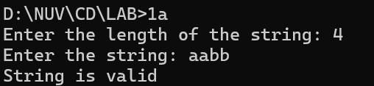

**AIM b:** Write a program to recognize strings end with ‘a’.

**PROGRAM CODE:**

#include <stdio.h> #include <stdlib.h> void main() { int n, i = 0, state = 0; printf("Enter the length of the string: "); scanf("%d", &n); char input[n]; printf("Enter the string: "); scanf("%s", &input); while (input[i] != '\0')

{ switch (state)

{ case 0:

if (input[i] == 'a')

{ state = 1; } else { state = 0; } break; case 1:

if (input[i] == 'a')

{ state = 1; } else {

state = 0; } break; } i++; }

if (state == 0) { printf("String is invalid"); } else if (state == 1) { printf("String is valid");

}

}

**OUTPUT:**

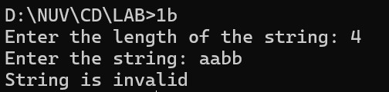

**AIM c:** Write a program to recognize strings end with ‘ab’. Take the input from text file.

**PROGRAM CODE:**

#include <stdio.h> void main()

{

int state = 0, i = 0; FILE *fptr; fptr = fopen("1c_in.txt", "r"); char input[100]; fgets(input, 100, fptr); printf("Input string: %s", input); fclose(fptr); while (input[i] != '\0')

{ switch (state)

{ case 0:

if (input[i] == 'a')

{ state = 1; } else { state = 0; } break; case 1:

if (input[i] == 'b')

{ state = 2; } else if (input[i] == 'a') { state = 1; } else { state = 0; }

break;

case 2: if (input[i] == 'a') { state = 1; } else { state = 0; } break; } i++; } if (state == 2) { printf("\nString is valid"); } else { printf("\nString is invalid");

}

}

**INPUT File:**

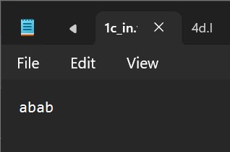

**OUTPUT:**

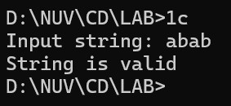

**AIM d:** Write a program to recognize strings contains ‘ab’. Take the input from text file.

**PROGRAM CODE:**

#include <stdio.h> void main()

{

int state = 0, i = 0; FILE *fptr; fptr = fopen("1c_in.txt", "r"); char input[100]; fgets(input, 100, fptr); printf("Input string: %s", input); fclose(fptr); while (input[i] != '\0')

{ switch (state)

{ case 0:

if (input[i] == 'a')

{ state = 1; } else { state = 0; } break; case 1:

if (input[i] == 'b')

{ state = 2; } else if (input[i] == 'a') { state = 1; } else { state = 0; }

break;

case 2: state = 2; break; } i++; } if (state == 2) { printf("\nString is valid"); } else { printf("\nString is invalid");

}

}

**INPUT File:**



**OUTPUT:**

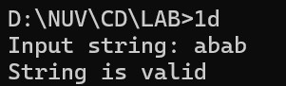

**Practical – 2**

**AIM a:** Write a program to recognize the valid identifiers.

**PROGRAM CODE:**

#include <stdio.h> #include <stdlib.h> #include <ctype.h> void main() {

int state = 0, i = 0; FILE *fptr; fptr = fopen("2a_in.txt", "r"); char input[100]; while (fgets(input, 100, fptr) != NULL)

{ printf("Input string: %s", input); i = 0; state = 0; while (input[i] != '\0' && input[i] != '\n')

{ switch (state)

{ case 0:

if (input[i] == 'i')

{ state = 1; }

else if (input[i] == '_' || isalpha(input[i]))

{ state = 4; } else {

state = 5; } break; case 1: if (input[i] == 'n')

{

state = 2; } else if (input[i] == '_' || isalpha(input[i]))

{ state = 4; } else { state = 5; } break; case 2: if (input[i] == 't')

{ state = 3; }

else if (input[i] == '_' || isalpha(input[i]))

{ state = 4; } else { state = 5; } break; case 3:

if (isalpha(input[i]) || isdigit(input[i]) || input[i] == '_') { state = 4; } else { state = 5; } break; case 4: if (isalpha(input[i]) || isdigit(input[i]) || input[i] == '_')

{ state = 4; } else

{

state = 5; } break; } i++; } if (state == 4) {

printf("\nString is Identifier\n");

} else if (state == 3)

{ printf("\nString is a valid Keyword\n");

} else if (state == 5)

{ printf("\nString is invalid string\n");

}

else { printf("\nString is empty\n");

} } fclose(fptr);

}

**INPUT File:**

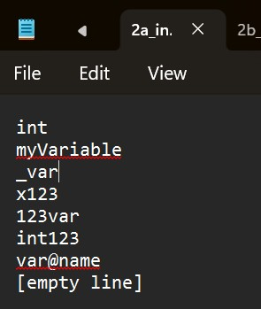

**OUTPUT:**

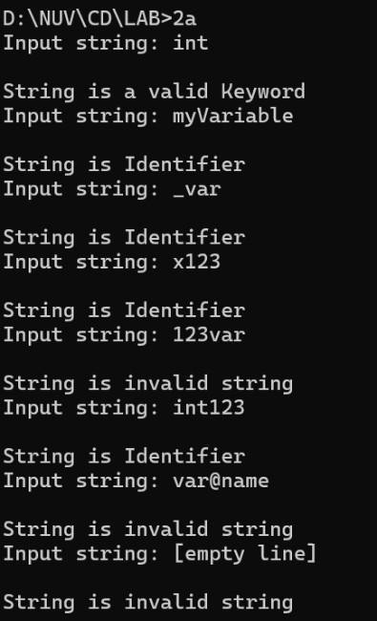

**AIM b:** Write a program to recognize the valid operators.

**PROGRAM CODE:**

#include <stdio.h> int main() { char input[100]; int state = 0, i = 0;

FILE *file = fopen("2b_in.txt", "r"); if (file == NULL)

{ printf("Error opening file.\n"); return 1; } fscanf(file, "%s", input); fclose(file); while (input[i] != '\0')

{ switch (state) { case 0:

if (input[i] == '+') state = 1; else if (input[i] == '-') state = 5; else if (input[i] == '*') state = 9; else if (input[i] == '/') state = 12; else if (input[i] == '%') state = 15; else if (input[i] == '&') state = 18; else if (input[i] == '|') state = 21; else if (input[i] == '<') state = 24; else if (input[i] == '>') state = 28; else if (input[i] == '!') state = 32; else if (input[i] == '~') state = 34; else if (input[i] == '^') state = 35; else if (input[i] == '=') state = 36; break; case 1: if (input[i] == '+') { state = 2;

printf("++ unary operator");

} else if (input[i] == '=') { state = 3; printf("+= assignment operator");

} else { state = 4; printf("+ arithmetic operator");

} break; case 5: if (input[i] == '-') { state = 6; printf("-- unary operator");

} else if (input[i] == '=') { state = 7; printf("-= assignment operator");

} else { state = 8; printf("- arithmetic operator"); } break; case 9: if (input[i] == '=') { state = 10; printf("*= assignment operator");

} else { state = 11; printf("* arithmetic operator");

} break; case 12:

if (input[i] == '=') { state = 13; printf("/= assignment operator");

} else { state = 14; printf("/ arithmetic operator");

} break; case 15: if (input[i] == '=') { state = 16; printf("%%= assignment operator");

} else { state = 17; printf("%% arithmetic operator");

} break; case 18: if (input[i] == '&') { state = 19; printf("&& Logical operator");

} else { state = 20; printf("& Bitwise operator");

} break; case 21: if (input[i] == '|') { state = 22; printf("|| Logical operator");

}

Else

{ state = 23; printf("| Bitwise operator");

} break; case 24: if (input[i] == '<') { state = 25; printf("<< Bitwise operator");

} else if (input[i] == '=') { state = 27; printf("<= Relational operator");

} else { state = 26; printf("< Relational operator");

} break; case 28: if (input[i] == '>') { state = 29; printf(">> Bitwise operator");

} else if (input[i] == '=') { state = 30; printf(">= Relational operator");

} else { state = 31; printf("> Relational operator");

} break; case 32: if (input[i] == '=')

{

state = 33; printf("!= Relational operator");

} break; case 36:

if (input[i] == '=')

{ state = 37; printf("== Relational operator");

} break; default: break; } i++; } printf("\nState is %d\n", state); switch (state) { case 1: break; case 5: printf("- arithmetic operator\n"); break; case 9: printf("* arithmetic operator\n"); break; case 12: printf("/ arithmetic operator\n"); break; case 15: printf("%% arithmetic operator\n"); break; case 18: printf("& Bitwise operator\n"); break; case 21: printf("| Bitwise operator\n"); break; case 24: printf("< Relational operator\n"); break; case 28: printf("> Relational operator\n"); break; case 32: printf("! Logical operator\n"); break; case 34: printf("~ Bitwise operator\n"); break; case 35: printf("^ Bitwise operator\n"); break; case 36: printf("= Assignment operator\n"); break;

} return 0; }

**INPUT File:**

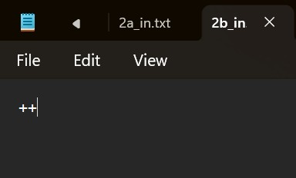

**OUTPUT:**

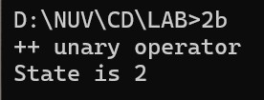

**AIM c:** Write a program to recognize the valid number.

**PROGRAM CODE:**

#include <stdio.h> #include <ctype.h> #include <stdlib.h> #include <string.h> int main() { char c, buffer[1000], lexeme[1000]; int i = 0, state = 0, f = 0, j = 0; FILE *fp = fopen("2c_in.txt", "r"); if (fp == NULL) { printf("Error opening file.\n"); return 1;

}

// Read file content into buffer while ((c = fgetc(fp)) != EOF && j < 1000) { buffer[j++] = c;

} buffer[j] = '\0'; fclose(fp); // DFA processing while (buffer[i] != '\0') { c = buffer[i]; switch (state) { case 0: if (isdigit(c)) { state = 1; lexeme[f++] = c;

} else if (c == '+' || c == '-') { state = 0; // Allow leading + or - lexeme[f++] = c; } else if (isspace(c)) {

// Skip whitespace

} else { state = 99; // Invalid character

} break; case 1:

if (isdigit(c)) { state = 1; lexeme[f++] = c;

} else if (c == '.') { state = 2; lexeme[f++] = c;

} else if (c == 'e' || c == 'E') { state = 4; lexeme[f++] = c; } else { lexeme[f] = '\0'; printf("The input %s is a valid integer.\n", lexeme); f = 0; state = 0; i--; // Re-check current character

} break; case 2: if (isdigit(c)) { state = 3; lexeme[f++] = c; } else { lexeme[f] = '\0'; printf("%s is an invalid floating-point input.\n", lexeme); f = 0; state = 0; i--;

}

break; case 3: if (isdigit(c)) { state = 3; lexeme[f++] = c;

} else if (c == 'e' || c == 'E') { state = 4; lexeme[f++] = c; } else { lexeme[f] = '\0'; printf("The input %s is a valid floating-point number.\n", lexeme); f = 0; state = 0; i--;

}

break; case 4: if (isdigit(c)) { state = 6; lexeme[f++] = c;

} else if (c == '+' || c == '-') { state = 5; lexeme[f++] = c; } else { lexeme[f] = '\0';

printf("%s is an invalid scientific notation.\n", lexeme); f = 0; state = 0; i--; } break; case 5:

if (isdigit(c)) {

state = 6; lexeme[f++] = c; } else { lexeme[f] = '\0'; printf("%s is an invalid scientific notation.\n", lexeme); f = 0; state = 0; i--; } break; case 6: if (isdigit(c)) { state = 6; lexeme[f++] = c; } else { lexeme[f] = '\0'; printf("The input %s is a valid scientific notation number.\n", lexeme); f = 0; state = 0; i--; } break; case 99:

printf("Invalid character encountered: %c\n", c); f = 0; state = 0; break; } i++;

}

// Final token check if (f != 0) { lexeme[f] = '\0';

if (state == 1) printf("The input %s is a valid integer.\n", lexeme); else if (state == 3) printf("The input %s is a valid floating-point number.\n", lexeme); else if (state == 6) printf("The input %s is a valid scientific notation number.\n", lexeme);

}

return 0;

}

**INPUT File:**

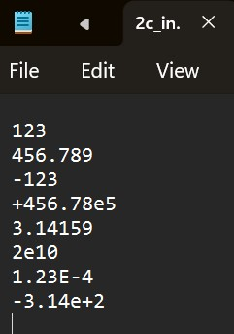

**OUTPUT:**

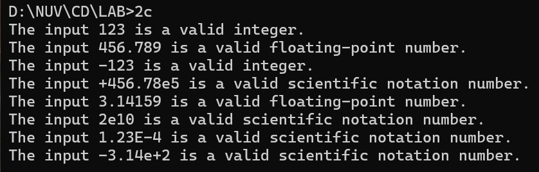

**AIM d:** Write a program to recognize the valid comments.

**PROGRAM CODE:**

#include <stdio.h> void main() {

int state = 0, i = 0; FILE *fptr; fptr = fopen("2d_in.txt", "r"); // Read input from the file char input[100]; fgets(input, 100, fptr); printf("Input string: %s", input); fclose(fptr);

// State machine to detect comments while (input[i] != '\0') { switch (state) { case 0:

if (input[i] == '/') { state = 1; } else { state = 3; } break; case 1: if (input[i] == '*') { state = 4;

} else if (input[i] == '/') { state = 2; } else { state = 3; } break; case 4:

if (input[i] == '*') {

state = 5; } else { state = 4; }

break;

case 5: if (input[i] == '/') { state = 6; } else { state = 4; } break; case 6: if (input[i] != '\0') { state = 3; } break; } i++;

}

// Determine if the comment is valid or invalid if (state == 2) { printf("\nString is a valid single-line comment");

} else if (state == 6) { printf("\nString is a valid multi-line comment");

} else { printf("\nString is an invalid comment");

}

}

**INPUT File:**

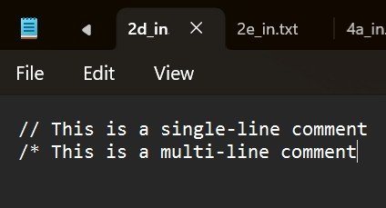

**OUTPUT:**

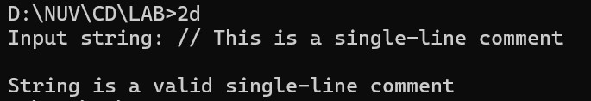

**AIM e:** Program to implement Lexical Analyzer.

**PROGRAM CODE:**

#include <stdio.h> #include <stdlib.h> #include <ctype.h>

#include <string.h>

#define BUFFER_SIZE 1000

// Function declarations void check_keyword_or_identifier(char *lexeme); void recognize_number(char *lexeme); void recognize_operator(char *buffer, int *index); void recognize_comment(char *buffer, int *index); void main() { FILE *f1; char *buffer; char lexeme[50]; char c; int i = 0, f = 0, state = 0; // Open file for reading f1 = fopen("2e_in.txt", "r"); if (f1 == NULL) {

printf("Error: Could not open input.txt\n"); return;

}

// Read the file into memory fseek(f1, 0, SEEK_END); long file_size = ftell(f1); rewind(f1); buffer = (char *)malloc(file_size + 1); fread(buffer, 1, file_size, f1); buffer[file_size] = '\0'; fclose(f1); // Start lexical analysis

while (buffer[f] != '\0') { c = buffer[f]; switch (state) { case 0:

if (isalpha(c) || c == '_') {

state = 1; lexeme[i++] = c;

} else if (isdigit(c)) { state = 2; lexeme[i++] = c;

} else if (c == '/' && (buffer[f + 1] == '/' || buffer[f + 1] == '*')) { recognize_comment(buffer, &f); state = 0;

} else if (strchr("+-*/%=<>!", c)) { recognize_operator(buffer, &f); state = 0;

} else if (strchr(";,{}()", c)) { printf("%c is a symbol\n", c); state = 0; } else if (isspace(c)) { state = 0; } break; case 1:

if (isalnum(c) || c == '_') { lexeme[i++] = c; } else { lexeme[i] = '\0'; check_keyword_or_identifier(lexeme); lexeme[i] = '\0'; i = 0; state = 0; f--; // Go back to recheck the current character } break; case 2:

if (isdigit(c)) { lexeme[i++] = c; } else if (c == '.') { state = 3; lexeme[i++] = c;

} else if (c == 'E' || c == 'e') { state = 4; lexeme[i++] = c; } else { lexeme[i] = '\0'; recognize_number(lexeme); i = 0; state = 0; f--; // Go back to recheck the current character

} break; case 3:

if (isdigit(c)) { lexeme[i++] = c; } else { lexeme[i] = '\0'; recognize_number(lexeme); i = 0; state = 0; f--; // Go back to recheck the current character

} break; case 4:

if (isdigit(c) || c == '+' || c == '-') { state = 5;

lexeme[i++] = c; } else { lexeme[i] = '\0'; recognize_number(lexeme); i = 0; state = 0; f--; // Go back to recheck the current character

} break; case 5:

if (isdigit(c)) { lexeme[i++] = c; } else { lexeme[i] = '\0'; recognize_number(lexeme); i = 0; state = 0; f--; // Go back to recheck the current character

} break; } f++; // Move forward in the buffer

}

// Free dynamically allocated memory free(buffer);

}

// Function to check if the lexeme is a keyword or identifier void check_keyword_or_identifier(char *lexeme) { int i = 0;

char *keywords[] = {

"auto", "break", "case", "char", "const", "continue", "default", "do",

"double", "else", "enum", "extern", "float", "for", "goto", "if",

"inline", "int", "long", "register", "restrict", "return", "short", "signed", "sizeof", "static", "struct", "switch", "typedef", "union", "unsigned",

"void", "volatile", "while"

}; for (i = 0; i < 32; i++) { if (strcmp(lexeme, keywords[i]) == 0) { printf("%s is a keyword\n", lexeme); return;

} } printf("%s is an identifier\n", lexeme);

}

// Function to recognize a number (integer, floating-point, scientific notation) void recognize_number(char *lexeme) { printf("%s is a valid number\n", lexeme);

}

// Function to recognize an operator void recognize_operator(char *buffer, int *index) { char operators[][3] = {"+", "-", "*", "/", "%", "=", "==", "!=", "<", ">", "<=", ">="}; char op[3] = {buffer[*index], buffer[*index + 1], '\0'}; int i = 0;

// Handle two-character operators (e.g., "==" or ">=") for (i = 0; i < 12; i++) { if (strcmp(op, operators[i]) == 0) { printf("%s is an operator\n", op);

(*index)++; // Skip the next character since we used two chars return;

}

}

// Handle single-character operators

printf("%c is an operator\n", buffer[*index]);

}

// Function to recognize comments void recognize_comment(char *buffer, int *index) { if (buffer[*index] == '/' && buffer[*index + 1] == '/') { printf("// is a single-line comment\n"); while (buffer[*index] != '\n' && buffer[*index] != '\0')

(*index)++;

} else if (buffer[*index] == '/' && buffer[*index + 1] == '*') { printf("/* is the start of a multi-line comment\n");

(*index) += 2; while (!(buffer[*index] == '*' && buffer[*index + 1] == '/') && buffer[*index] != '\0')

(*index)++; if (buffer[*index] == '*' && buffer[*index + 1] == '/') { printf("*/ is the end of a multi-line comment\n");

(*index) += 2;

}

}

}

**INPUT File:**

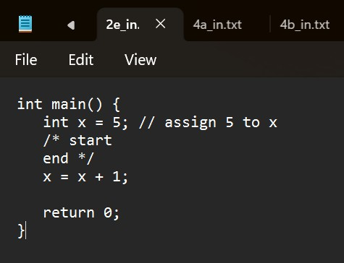

**OUTPUT:**

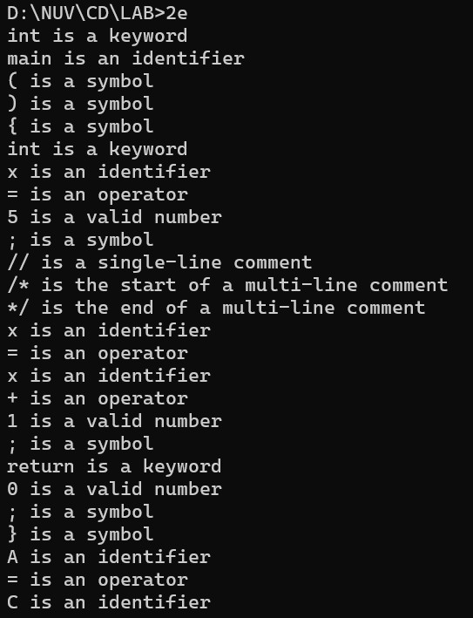

# Practical – 3

**AIM:** To Study about Lexical Analyser Generator (LEX) and Flex(Fast Lexical Analyser)

**What is a Lexical Analyzer Generator?**

A Lexical Analyzer Generator is a tool that automates the creation of a Lexical Analyzer (lexer), which is the first phase of a compiler. Its job is to scan the source code and convert it into a stream of tokens—the basic building blocks like keywords, operators, identifiers, etc.

**What is LEX?**

LEX (short for Lexical Analyzer Generator) was one of the earliest tools developed to help create lexical analyzers. It uses regular expressions to specify token patterns and generates C code that recognizes these patterns.

* Developed in the 1970s as part of the Unix toolchain.
* Usually used with Yacc (Yet Another Compiler Compiler) for syntax analysis.

**Structure of a LEX program:**

%{

// C declarations

%}

%%

[0-9]+ { printf("NUMBER\n"); }

[a-zA-Z]+ { printf("WORD\n"); }

. { printf("UNKNOWN\n"); }

%%

int main() { yylex(); return 0;

}

**What is Flex?**

Flex (Fast Lexical Analyzer Generator) is a free and faster alternative to LEX, and it is more commonly used today.

* Flex is open-source and generates more efficient code.
* It is backward-compatible with LEX but offers extra features and optimizations.
* It produces a C source file (e.g., lex.yy.c) which can be compiled with GCC.

**Advantages of Flex over LEX:**

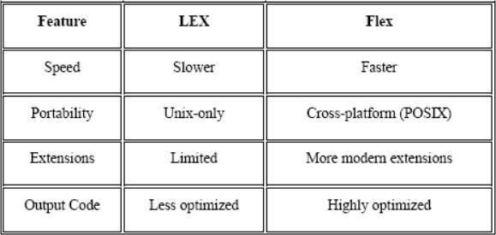

**How It Works**

1. Input: Regular expressions and actions (C code) for each pattern.

1. Processing: Generates a C program (lex.yy.c) that uses a finite state machine (DFA).

1. Output: The compiled lexer reads input, matches patterns, and executes associated actions.

**Use Cases**

* Programming language compilers (e.g., C, Python).
* Interpreters.
* Code analyzers or format checkers.
* Custom parsers in domain-specific languages.

# Practical – 4

**AIM a:** Write a Lex program to take input from text file and count no of characters, no. of lines & no. of words.

**PROGRAM CODE:**

%{

#include<stdio.h> int l=0, w=0, c=0; int in_word=0;

%}

%%

[a-zA-Z] { c++; in_word = 1; }

\n { l++; if (in_word) { w++; in_word=0; } }

[ \t]+ { if (in_word) { w++; in_word=0; } }

. { if (in_word) { w++; in_word = 0; } }

%%

void main() { yyin = fopen("4a_in.txt", "r"); yylex(); printf("Number of characters: %d \nNumber of lines: %d \nNumber of words: %d", c, l, w);

} int yywrap() { return (1);

}

**INPUT File:**

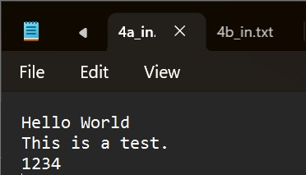

**OUTPUT:**

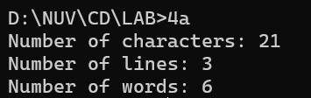

**b:** a Lex program to take input from text file and count number of

vowels and consonants.

**PROGRAM CODE:**

%{

#include<stdio.h> int consonants = 0, vowels = 0;

%}

%%

[aeiouAEIOU] { vowels++; }

[a-zA-Z] { consonants++; }

\n

.

%%

int main() { yyin = fopen("4b_in.txt", "r"); yylex(); printf(" This File contains..."); printf("\n\t%d vowels", vowels); printf("\n\t%d consonants", consonants); return 0; } int yywrap() { return (1);

}

**INPUT File:**

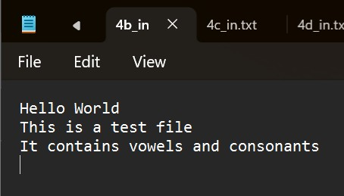

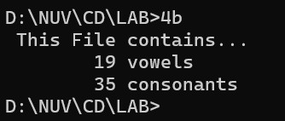

**c:** a Lex program to print out all numbers from the given file.

**PROGRAM CODE:**

%{

#include<stdio.h>

%}

%%

[0-9]+(\.[0-9]+)?([eE][+-]?[0-9]+)? { printf("%s is a valid number \n", yytext);

}

\n ;

. ;

%%

int main() { yyin = fopen("4c_in.txt", "r"); yylex(); return 0; } int yywrap() { return (1);

}

**INPUT File:**

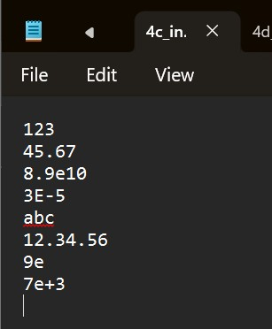

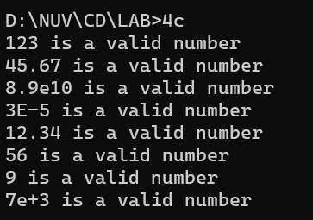

**d:** a Lex program which adds line numbers to the given file and display the same into different file.

**PROGRAM CODE:**

%{

#include<stdio.h> int line_number = 1;

%}

%%

.+ { fprintf(yyout, "%d: %s", line_number, yytext); line_number++;

}

%%

int main() { yyin = fopen("4d_in.txt", "r"); yyout = fopen("fourth_output.txt", "w"); yylex(); printf("done"); return 0; } int yywrap() { return (1);

}

**INPUT File:**

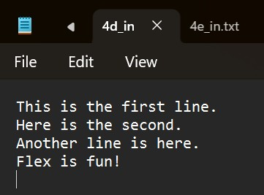



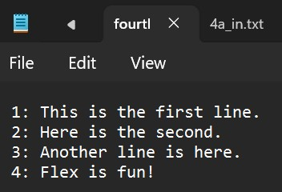

**e:** a Lex program to printout all markup tags and HTML comments in file.

**PROGRAM CODE:**

%{

#include<stdio.h> int num = 0;

%}

%%

"<"[A-Za-z0-9]+">" { printf("%s is a valid markup tag\n", yytext);

}

"<!--"[^-->]*"-->" { num++;

}

\n ;

. ;

%%

int main() { yyin = fopen("4e_in.txt", "r"); yylex();

printf("Number of comments are: %d", num); return 0; } int yywrap() { return (1);

}

**INPUT File:**

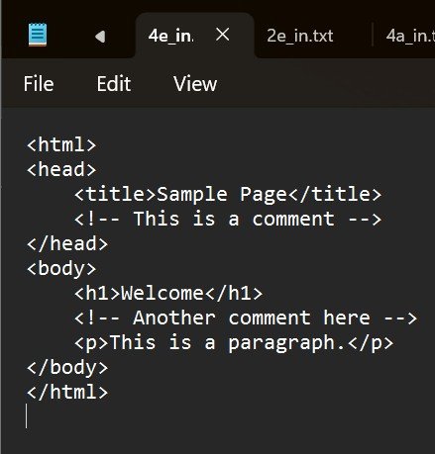

**OUTPUT:**

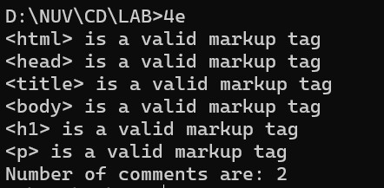

# Practical – 5

**AIM a:** Write a Lex program to count the number of C comment lines from a given C program. Also eliminate them and copy that program into separate file.

**PROGRAM CODE:**

%{

#include<stdio.h> int cmt = 0;

%}

%%

"//".* { fprintf(yyout, "\n"); cmt++;

}

"/*"([^*]|\*+[^*/])"*"+"/" { fprintf(yyout, "\n"); cmt++;

}

.|\n { fprintf(yyout, "%s", yytext);

}

%%

void main(){ yyin = fopen("5a_in.txt", "r"); yyout = fopen("5a_out.txt", "w"); yylex();

printf("%d Comment(s)\n", cmt);

} int yywrap(){ return(1);

}

**INPUT File:**

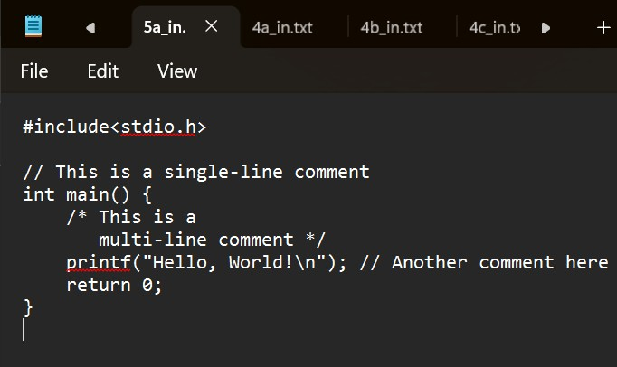

**OUTPUT:**

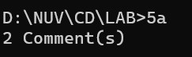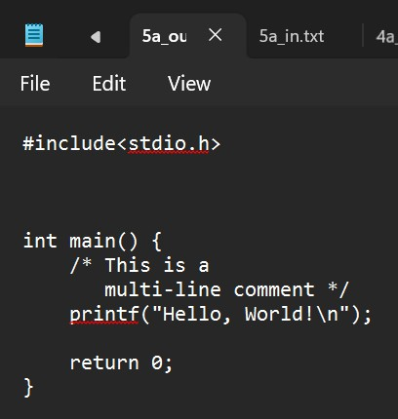

**AIM b:** Write a Lex program to recognize keywords, identifiers, operators, numbers, special symbols, literals from a given C program.

**PROGRAM CODE:**

%{

#include <stdio.h> #include <string.h> int is_keyword(const char *str);

%}

%option noyywrap

%%

"auto"|"break"|"case"|"char"|"const"|"continue"|"default"|"do"|"double"|

"else"|"enum"|"extern"|"float"|"for"|"goto"|"if"|"inline"|"int"|"long"|

"register"|"return"|"short"|"signed"|"sizeof"|"static"|"struct"|"switch"|

"typedef"|"union"|"unsigned"|"void"|"volatile"|"while" { printf("Keyword: %s\n", yytext);

}

[ \t\n]+ ; // Skip whitespace characters

"=="|"!="|"<="|">="|"="|"+"|"-"|"*"|"/"|"%"|"&&"|"||"|"!"|"<"|">" { printf("Operator: %s\n", yytext);

}

[0-9]+(\.[0-9]+)? { printf("Number: %s\n", yytext);

}

\"([^\\\"]|\\.)*\" { printf("String Literal: %s\n", yytext);

}

\'.\' {

printf("Character Literal: %s\n", yytext);

}

[{}()\[\],;.] { printf("Special Symbol: %s\n", yytext);

}

[a-zA-Z_][a-zA-Z0-9_]* {

if (is_keyword(yytext)) printf("Keyword: %s\n", yytext); else printf("Identifier: %s\n", yytext);

} . {

printf("Unrecognized Character: %s\n", yytext);

}

%%

int is_keyword(const char *str) { const char *keywords[] = {

"auto", "break", "case", "char", "const", "continue", "default", "do", "double",

"else", "enum", "extern", "float", "for", "goto", "if", "inline", "int", "long",

"register", "return", "short", "signed", "sizeof", "static", "struct", "switch",

"typedef", "union", "unsigned", "void", "volatile", "while", NULL

}; for (int i = 0; keywords[i] != NULL; i++) { if (strcmp(keywords[i], str) == 0) return 1; } return 0; } int main() {

yylex(); // Start lexical analysis return 0;

}

**INPUT File:**

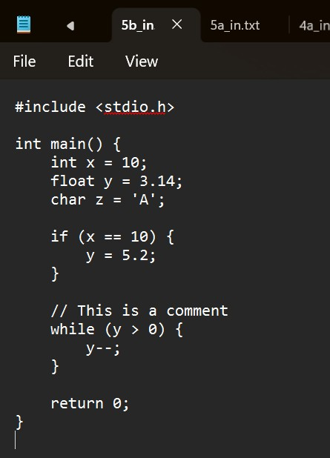

# Practical – 6

**AIM:** Program to implement Recursive Descent Parsing in C.

**PROGRAM CODE:**

#include <stdio.h> #include <stdlib.h> char s[20]; int i = 1; char l; int match(char l); int E1(); int E() { if (l == 'i') { match('i');

E1(); } else { printf("Error parsing string"); exit(1); } return 0; } int E1() { if (l == '+') { match('+'); match('i');

E1(); } else

{ return 0; } } int match(char t) { if (l == t) { l = s[i]; i++; } else { printf("Syntax Error"); exit(1); } return 0; } void main() { printf("Enter the string: "); scanf("%s", &s); l = s[0]; E(); if (l == '$') { printf("parsing successful");

} else { printf("Error while parsing the string\n");

}

}

**OUTPUT:**

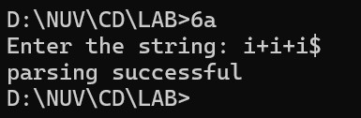

# Practical – 7

**AIM a:** To Study about Yet Another Compiler-Compiler(YACC).

**What is YACC?**

YACC (Yet Another Compiler-Compiler) is a tool used to generate parsers, which are part of the syntax analysis phase of a compiler. It takes a formal grammar (usually written in BNF- like syntax) and produces C code that can parse input sequences according to that grammar.

* Developed by Stephen C. Johnson in the 1970s at Bell Labs.
* Works closely with LEX/Flex, which handles lexical analysis (tokenization).
* YACC focuses on syntax parsing (checking structure of token sequences).

**Components of YACC**

A YACC program consists of three sections, just like LEX:

%{

// C declarations

%}

%%

// Grammar rules with actions

%%

// Supporting C code (like main)

**How YACC Works**

1. Input: A context-free grammar (CFG) with actions (usually in C).

1. Output: A parser in C that uses LALR(1) parsing (Look-Ahead LR).

1. Integration: Uses token definitions from LEX (via yylex()).

Executes specific C actions when grammar rules match.

**Key Features**

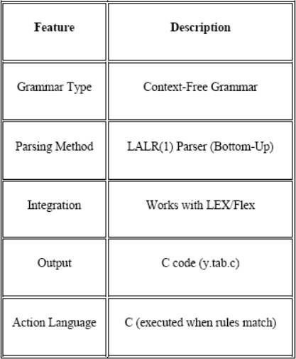

**Use Cases**

* Building compilers/interpreters
* Scripting languages
* Code validators or analyzers
* Structured data parsers (e.g., config files, DSLs)

**b:** Create Yacc and Lex specification files to recognizes arithmetic

expressions involving +, -, * and /.

**PROGRAM CODE:**

**.l file**

%{

#include <stdlib.h> void yyerror(char *);

#include "7b.tab.h"

%}

%%

[0-9]+ {yylval = atoi(yytext); return NUM;}

[a-zA-Z_][a-zA-Z_0-9]* {return id;}

[-+*\n] {return *yytext;}

[ \t] { }

. yyerror("invalid character");

%%

int yywrap() { return 0; }

**.y file**

%{

#include <stdio.h> int yylex(void); void yyerror(char *);

%}

%token NUM

%token id

%%

S: E '\n' { printf("valid syntax"); return(0);

}

E: E '+' T { }

| E '-' T { }

| T { }

T: T '*' F { }

| F { }

F: NUM { }

| id { }

%%

void yyerror(char *s) { fprintf(stderr, "%s\n", s); } int main() { yyparse(); return 0;

}

**OUTPUT:**

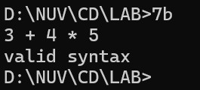

**c:** Create Yacc and Lex specification files are used to generate a calculator

which accepts integer type arguments.

**PROGRAM CODE:**

**.l file**

%{

#include <stdlib.h> void yyerror(char *);

#include "7c.tab.h"

%}

%%

[0-9]+ { yylval = atoi(yytext); return NUM; }

[-+*\n] { return *yytext; }

[ \t] { }

. { yyerror("invalid character"); }

%%

int yywrap() { return 0; }

**.y file**

%{

#include <stdio.h> int yylex(void); void yyerror(char *);

%}

%token NUM

%%

S: E '\n' { printf("%d\n", $1); return(0); }

E: E '+' T { $$ = $1 + $3; }

| E '-' T { $$ = $1 - $3; }

| T { $$ = $1; }

T: T '*' F { $$ = $1 * $3; }

| F { $$ = $1; }

F: NUM { $$ = $1; }

%%

void yyerror(char *s) { fprintf(stderr, "%s\n", s); } int main() { yyparse(); return 0;

}

**OUTPUT:**

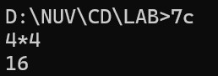

**d: Create Yacc and Lex specification files are used to convert infix**

**expression.**

**PROGRAM CODE:**

**.l file**

%{

#include<stdio.h> #include "7d.tab.h" void yyerror(char *);

%}

%%

[0-9]+ { yylval.num = atoi(yytext); return INTEGER; }

[A-Za-z_][A-Za-z0-9_]* { yylval.str = yytext; return ID; }

[-+;\n*] { return *yytext; }

[ \t] ;

. yyerror("invalid character");

%%

int yywrap() { return 1; }

**.y file**

%{

#include<stdio.h> int yylex(void); void yyerror(char *);

%}

%union { char *str; int num;

}

%token <num> INTEGER

%token <str> ID

%%

S: E '\n' { printf("\n"); }

E: E '+' T { printf("+ "); }

| E '-' T { printf("- "); }

| T { }

T: T '*' F { printf("* "); }

| F { }

F: INTEGER { printf("%d ", $1); }

| ID { printf("%s ", $1); }

%%

void yyerror(char *s) { printf("%s\n", s); } int main() { yyparse(); return 0;

}

**OUTPUT:**

