Lab Manual
Of
Compiler Design
LABORATORY
,
Bachelor of Technology (CSE)
By
Hitanshu Purohit
– 22000386
Third Year, Semester 6
Course In-charge: Vaibhavi Patel


Department of Computer Science and Engineering
School Engineering and Technology
Navrachana University, Vadodara
Spring semester 2025

TABLE OF CONTENT
Sr. No | Experiment Title
1 |  | - Write a program to recognize strings starts with ‘a’ over {a, b}.  - Write a program to recognize strings end with ‘a’.  - Write a program to recognize strings end with ‘ab’. Take the input from text file.  - Write a program to recognize strings contains ‘ab’. Take the input from text file.
2 |  | - Write a program to recognize the valid identifiers.  - Write a program to recognize the valid operators.  - Write a program to recognize the valid number.  - Write a program to recognize the valid comments.  - Write a program to implement Lexical Analyzer.
3 |  | To Study about Lexical Analyzer Generator (LEX) and Flex(Fast Lexical Analyzer)
4 |  | Implement following programs using Lex.  a. Write a Lex program to take input from text file and count no of characters, no. of lines & no. of words.  b. Write a Lex program to take input from text file and count number of vowels and consonants.  c. Write a Lex program to print out all numbers from the given file.  d. Write a Lex program which adds line numbers to the given file and display the same into different file.  e. Write a Lex program to printout all markup tags and HTML comments in file.
5 |  | a. Write a Lex program to count the number of C comment lines from a given C program. Also eliminate them and copy that program into separate file.  b. Write a Lex program to recognize keywords, identifiers, operators, numbers, special symbols, literals from a given C program.
6 |  | Program to implement Recursive Descent Parsing in C.
7 |  | a. To Study about Yet Another Compiler-Compiler(YACC).  b. Create Yacc and Lex specification files to recognizes arithmetic expressions involving +, -, * and / .  c. Create Yacc and Lex specification files are used to generate a calculator which accepts integer type arguments.  d. Create Yacc and Lex specification files are used to convert infix expression to postfix expression.

Practical 1
Aim:
- Write a program to recognize strings starts with ‘a’ over {a, b}.
- Write a program to recognize strings end with ‘a’.
- Write a program to recognize strings end with ‘ab’. Take the input from text file.
- Write a program to recognize strings contains ‘ab’. Take the input from text file.

Input:
- Write a program to recognize strings starts with ‘a’ over {a, b}.

Code:
//strings starts with 'a' over {a, b}.
#include<stdio.h>
int main(){
char input[100];
int state = 0, i=0;
printf("Enter the string: ");
scanf("%s",input);
while(input[i]!='\0'){
switch(state){
case 0:
if(input[i]=='a') state = 1;
else state = 2;
break;
case 1:
if(input[i]=='a' || input[i]=='b') state=1;
else state =2;
break;
case 2:
state = 2;
break;
}
i++;
}
if(state=='0'){
printf("The string is invalid.");
printf("\nState = %d",state);
}
else if(state==1){
printf("The string is valid.");
printf("\nState = %d",state);
}
else if(state==2){
printf("The string is invalid.");
printf("\nState = %d",state);
}
else {
}
return 0;
}

Output:
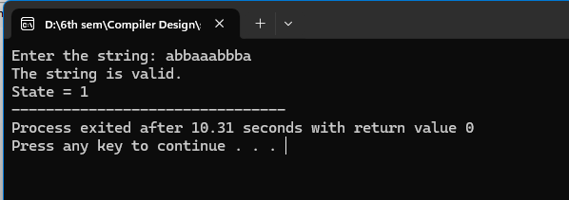
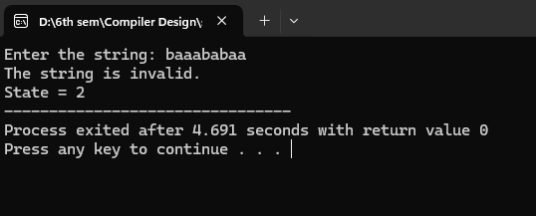

- Write a program to recognize strings end with ‘a’.

Code:

//strings end with 'a'.
#include<stdio.h>
int main(){
char input[100];
int state = 0, i=0;
printf("Enter the string: ");
scanf("%s",input);

while(input[i]!='\0'){
switch(state){
case 0:
if(input[i]=='a') state = 1;
else state = 0;
break;
case 1:
if(input[i]=='a') state=1;
else state =0;
break;
}
i++;
}
if(state==0){
printf("The string is invalid.");
printf("\nState = %d",state);
}
else if(state==1){
printf("The string is valid.");
printf("\nState = %d",state);
}
else {
}
return 0;
}

Output:
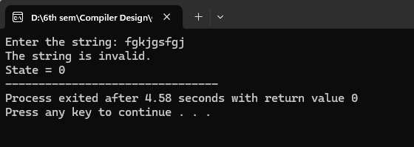
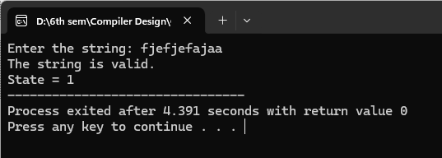

- Write a program to recognize strings end with ‘ab’. Take the input from text file.

Code:
//string ends with ab and take input from a file.
#include <stdio.h>

int main() {
char input[100];
int state = 0, i = 0;
FILE *file; // File pointer

file = fopen("input.txt", "r");
if (file == NULL) {
printf("Error: Could not open file.\n");
return 1;
}

if (fgets(input, sizeof(input), file) == NULL) {
printf("Error: Could not read from file or file is empty.\n");
fclose(file);
return 1;
}

fclose(file);

// Removing newline character, if present
for (i = 0; input[i] != '\0'; i++) {
if (input[i] == '\n') {
input[i] = '\0';
break;
}
}

i = 0; // Reset index for processing the string

while (input[i] != '\0') {
switch (state) {
case 0:
if (input[i] == 'a') {
state = 1;
} else if (input[i] == 'b') {
state = 0;
} else {
state = 0;
}
break;
case 1:
if (input[i] == 'b') {
state = 2;
} else if (input[i] == 'a') {
state = 1;
} else {
state = 0;
}
break;
case 2:
if (input[i] == 'a') {
state = 1;
} else if (input[i] == 'b') {
state = 0;
} else {
state = 0;
}
break;
}
i++;
}

if (state == 0) {
printf("String is invalid.\n");
printf("The state is: %d\n", state);
} else if (state == 1) {
printf("The string is invalid.\n");
printf("The state is: %d\n", state);
} else if (state == 2) {
printf("The string is valid.\n");
printf("The state is: %d\n", state);
}

return 0;
}

Output:
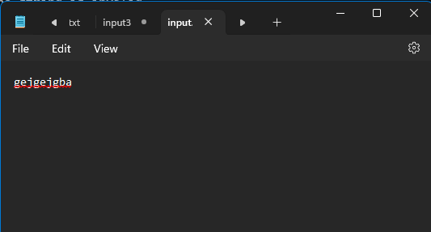
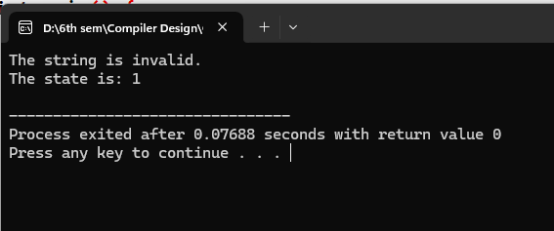
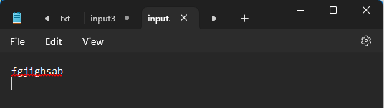
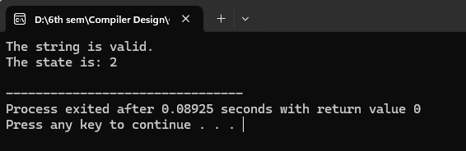

- Write a program to recognize strings contains ‘ab’. Take the input from text file.

Code:
//sting contains ab, and takes input from a file.
#include<stdio.h>
int main(){

char input[100];
int state=0,i=0;
FILE *file;

file=fopen("input1.txt","r");
if(file==NULL){
printf("Error: Couldn't open the file.\n");
return 1;
}

if(fgets(input,sizeof(input),file)==NULL){
printf("Error: Could not read from file or file is empty.\n");
fclose(file);
return 1;
}
fclose(file);

// Removing newline character, if present
for (i = 0; input[i] != '\0'; i++) {
if (input[i] == '\n') {
input[i] = '\0';
break;
}
}

i = 0; // Reset index for processing the string

/*printf("Enter the string: ");
scanf("%s",input);*/

while(input[i] != '\0'){
switch(state){
case 0:
if(input[i]=='a') state = 1;
else if(input[i]=='b') state = 0;
else state = 0;
break;
case 1:
if(input[i]=='a') state = 1;
else if(input[i]=='b') state =2;
else state = 0;
break;
case 2:
if(input[i]=='a' || input[i]=='b') state = 2;
else state = 2;
break;

}
i++;
}

if(state==0){
printf("The sring is invalid.");
printf("\nState is: %d",state);
}
else if(state==1){
printf("The sring is invalid.");
printf("\nState is: %d",state);
}
else if(state==2){
printf("The sring is valid.");
printf("\nState is: %d",state);
}
else{
}
return 0;
}

Output:
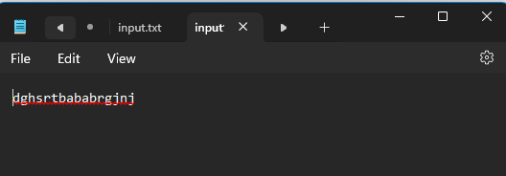
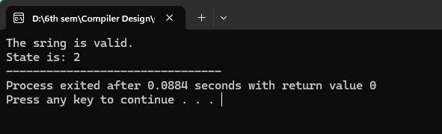
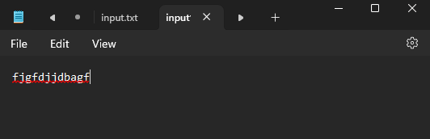
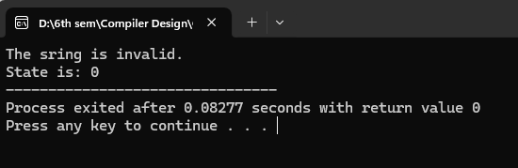

Practical 2
Aim:
- Write a program to recognize the valid identifiers.
- Write a program to recognize the valid operators.
- Write a program to recognize the valid number.
- Write a program to recognize the valid comments.
- Write a program to implement Lexical Analyzer.

Input:
- Write a program to recognize the valid identifiers.

Code:
#include <stdio.h>
#include <ctype.h>
int main()
{
char a[10];
int flag, i=1;

printf("Enter an identifier:");
scanf("%s",&a);

if(isalpha(a[0])){

flag = 1; // If the first character is an alphabet, set flag = 1 (indicating a valid start).

}
else
printf("invalid identifier");

while (a[i] != '\0') {
if (!isalnum(a[i]) && a[i] != '_') {
flag = 0;
break;
}
i++;
}

if(flag == 1){
printf("Valid identifier");
}
//getch();
}

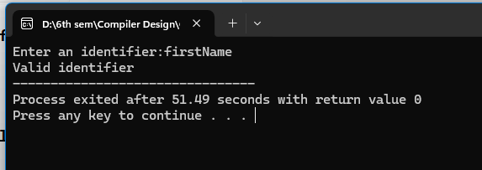
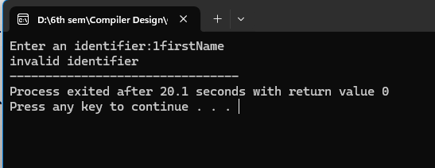

- Write a program to recognize the valid operators.

Code:
//to recognize the valid operators
#include <stdio.h>
#include <string.h>
#include <stdbool.h>

int main() {
char input[50];
const char *validOperators[] = {
"+", "-", "*", "/", "%", // Arithmetic
"=", "+=", "-=", "*=", "/=", "%=", // Assignment
"==", "!=", ">", "<", ">=", "<=", // Relational
"&&", "||", "!", // Logical
"&", "|", "^", "~", "<<", ">>", // Bitwise
"++", "--", // Increment/Decrement
",", ".", "->", // Structure/Union member access
"(", ")", "[", "]", "{", "}", // Parentheses, brackets, braces
"?", ":", // Ternary operator
"sizeof", // Unary operator
"->", "." // Pointer-to-member operators (less common)
};

int numOperators = sizeof(validOperators) / sizeof(validOperators[0]);

printf("Enter a potential C operator (or 'exit' to quit): ");

while (1) {
scanf("%49s", input);

if (strcmp(input, "exit") == 0) {
break;
}

bool found = false;
int i = 0; // Initialize loop counter
while (i < numOperators) { // While loop
switch (strcmp(input, validOperators[i])) { // Switch statement
case 0: // Match found
found = true;
i = numOperators; // A way to break the while loop
break;
default: // No match, go to next operator
i++;
break;
}
}

if (found) {
printf("\"%s\" is a valid C operator.\n", input);
} else {
printf("\"%s\" is NOT a valid C operator.\n", input);
}

printf("Enter another operator (or 'exit' to quit): ");
}

printf("Exiting.\n");
return 0;
}
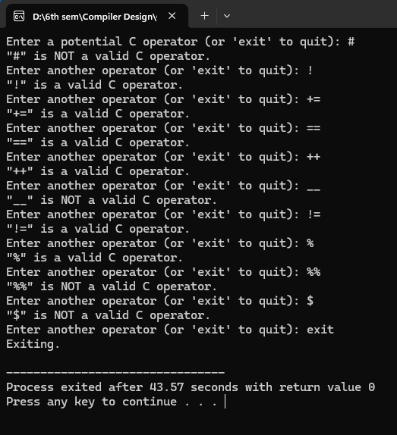

- Write a program to recognize the valid number.

Code:

#include <stdio.h>
#include <ctype.h>
#include <string.h>

void check_valid_number(char *input) {
int state = 0, i = 0;
char lexeme[100];

while (input[i] != '\0') {
char c = input[i];

switch (state) {
case 0:
if (isdigit(c)) {
state = 1; // Transition to integer state
} else if (c == '.') {
state = 2; // Starts with a dot, expecting digits
} else {
printf("Invalid number: %s\n", input);
return;
}
break;

case 1: // Integer state
if (isdigit(c)) {
state = 1;
} else if (c == '.') {
state = 3; // Transition to decimal part
} else if (c == 'E' || c == 'e') {
state = 5; // Transition to exponent part
} else {
printf("%s is a valid number\n", input);
return;
}
break;

case 2: // Starts with a dot
if (isdigit(c)) {
state = 3;
} else {
printf("Invalid number: %s\n", input);
return;
}
break;

case 3: // Decimal part
if (isdigit(c)) {
state = 3;
} else if (c == 'E' || c == 'e') {
state = 5;
} else {
printf("%s is a valid number\n", input);
return;
}
break;

case 5: // Exponent part
if (c == '+' || c == '-') {
state = 6;
} else if (isdigit(c)) {
state = 7;
} else {
printf("Invalid number: %s\n", input);
return;
}
break;

case 6: // Sign after exponent
if (isdigit(c)) {
state = 7;
} else {
printf("Invalid number: %s\n", input);
return;
}
break;

case 7: // Digits after exponent
if (isdigit(c)) {
state = 7;
} else {
printf("%s is a valid number\n", input);
return;
}
break;
}
i++;
}

// If loop exits normally, check if we ended in a valid state
if (state == 1 || state == 3 || state == 7) {
printf("%s is a valid number\n", input);
} else {
printf("Invalid number: %s\n", input);
}
}

int main() {
char input[100];

printf("Enter a number: ");
scanf("%s", input);

check_valid_number(input);

return 0;
}

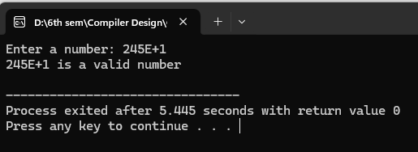

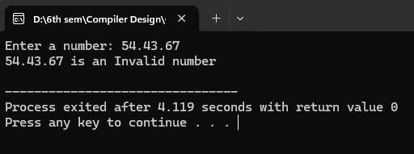

- Write a program to recognize the valid comments.

Code:

//accept only comments single line and multiline both.
#include<stdio.h>
int main(){

char input[100];
int state =0, i=0;
FILE *file;

file = fopen("input3.txt","r");
if(file==NULL){
printf("Error: Couldn't open the file.\n");
return 1;
}

if(fgets(input,sizeof(input),file)==NULL){
printf("Error: Couldn't read the file or file is empty.");
fclose(file);
return 1;
}
fclose(file);

for (i = 0; input[i] != '\0'; i++) {
if (input[i] == '\n') {
input[i] = '\0';
break;
}
}

i = 0;

while(input[i]!='\0'){
switch(state){
case 0:
if(input[i]=='/')state = 1;
else state =3;
break;
case 1:
if(input[i]=='/') state=2;
else if(input[i]=='*') state =4;
else state=3;
break;
case 2:
state = 2;
break;
case 3:
state =3;
break;
case 4:
if(input[i]='*')state=5;
else state=4;
break;
case 5:
if(input[i]=='/') state =6;
else state = 4;
break;
case 6:
state = 3;
break;
}
i++;
}
if(state==0){
printf("This is not a comment.");
printf("\nState is %d",state);
}
else if(state==1){
printf("This is not a comment.");
printf("\nState is %d",state);
}
else if(state==2){
printf("This is a single line comment.");
printf("\nState is %d",state);
}
else if(state==3){
printf("This is not a comment.");
printf("\nState is %d",state);
}
else if(state==4){
printf("This is not a comment.");
printf("\nState is %d",state);
}
else if(state==5){
printf("This is not a comment.");
printf("\nState is %d",state);
}
else if(state==6){
printf("This is a multiline comment.");
printf("\nState is %d",state);
}
return 0;
}

input3.txt:

/*dsjdbhsdbf *gdgsdg *dfd */

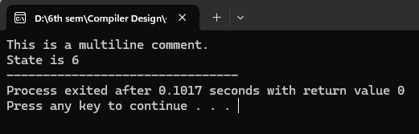

- Write a program to implement Lexical Analyzer.

Code:
#include <stdio.h>
#include <ctype.h>
#include <string.h>

// List of keywords
const char *keywords[] = {"int", "float", "if", "else", "while", "return", "for", "do", "switch", "case"};
#define NUM_KEYWORDS (sizeof(keywords) / sizeof(keywords[0]))

// Function to check if a string is a keyword
int isKeyword(char *str) {
int i;
for (i = 0; i < NUM_KEYWORDS; i++) {
if (strcmp(str, keywords[i]) == 0)
return 1;
}
return 0;
}

// Function to check if a character is an operator
int isOperator(char ch) {
char operators[] = "+-*/=<>!&|";
int i;
for (i = 0; operators[i] != '\0'; i++) {
if (ch == operators[i])
return 1;
}
return 0;
}

void lexicalAnalyzer(char *input) {
int i = 0;
char token[50];
int tokenIndex = 0;

while (input[i] != '\0') {
if (isspace(input[i])) {
i++;
continue;
}

if (isalpha(input[i])) { // Identifiers and Keywords
tokenIndex = 0;
while (isalnum(input[i])) {
token[tokenIndex++] = input[i++];
}
token[tokenIndex] = '\0';
if (isKeyword(token)) {
printf("Keyword: %s\n", token);
} else {
printf("Identifier: %s\n", token);
}
}
else if (isdigit(input[i])) { // Numbers
tokenIndex = 0;
while (isdigit(input[i])) {
token[tokenIndex++] = input[i++];
}
token[tokenIndex] = '\0';
printf("Number: %s\n", token);
}
else if (isOperator(input[i])) { // Operators
printf("Operator: %c\n", input[i]);
i++;
}
else { // Special characters
printf("Special Symbol: %c\n", input[i]);
i++;
}
}
}

int main() {
char input[100];
printf("Enter a string for lexical analysis: ");
fgets(input, sizeof(input), stdin);
lexicalAnalyzer(input);
return 0;
}
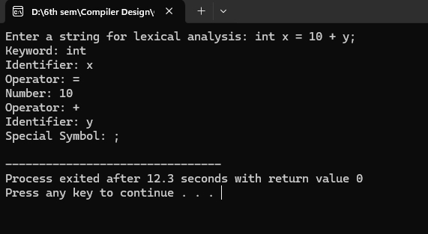

Practical 3
Aim: To Study about Lexical Analyzer Generator (LEX) and Flex(Fast Lexical Analyzer)

Introduction:
A Lexical Analyzer converts an input stream (source code) into a sequence of tokens, which are then used by the parser in a compiler. Lex and Flex are tools designed for this purpose.

1. Lexical Analyzer Generator (LEX)
LEX is a tool used to generate lexical analyzers. It takes a set of regular expressions (token patterns) as input and produces a C program that can identify these tokens.
Working of LEX:
- Specification File:
A LEX program consists of three sections:
  - Definition Section: Declare header files and global variables.
  - Rules Section: Define token patterns using regular expressions.
  - C Code Section: Additional helper functions (optional).
- Compilation Process:
  - The LEX file (.l) is compiled using lex to generate lex.yy.c.
  - The lex.yy.c file is compiled with a C compiler (gcc lex.yy.c -o output).
  - The executable processes input and tokenizes it.
Example LEX Program:
%{
#include <stdio.h>
%}

%%
[0-9]+ { printf("Number: %s\n", yytext); }
[a-zA-Z]+ { printf("Identifier: %s\n", yytext); }
. { printf("Special Symbol: %s\n", yytext); }
%%
int main() {
yylex();
return 0;
}
int yywrap() { return 1; }

Commands to Run:
lex filename.l
gcc lex.yy.c -o output
./output < input.txt

2. Fast Lexical Analyzer (FLEX)
Flex is an improved and faster version of Lex. It provides better performance and extended functionality.
Key Features of FLEX:
- Works similarly to Lex, but faster.
- Generates a more optimized lex.yy.c.
- Supports additional options like debugging and performance tuning.
Example FLEX Program:
(Same structure as LEX)
%{
#include <stdio.h>
%}

%%
[0-9]+ { printf("Number: %s\n", yytext); }
[a-zA-Z]+ { printf("Identifier: %s\n", yytext); }
. { printf("Special Symbol: %s\n", yytext); }
%%

int main() {
yylex();
return 0;
}
int yywrap() { return 1; }

Commands to Run:
flex filename.l
gcc lex.yy.c -o output
./output < input.txt

Comparison: LEX vs FLEX
Feature | LEX | FLEX
Speed | Slower | Faster
Compatibility | Traditional UNIX tool | GNU version, supports more platforms
Debugging | Limited | More debugging options
Performance | Basic optimization | Highly optimized DFA

Conclusion:
- Lex and Flex automate the creation of lexical analyzers.
- Flex is an enhanced version of Lex and is more commonly used today.
- These tools simplify token generation in compiler design.

Practical 4
Aim: Implement following programs using Lex.
- Write a Lex program to take input from text file and count no of characters, no. of lines & no. of words.
- Write a Lex program to take input from text file and count number of vowels and consonants.
- Write a Lex program to print out all numbers from the given file.
- Write a Lex program which adds line numbers to the given file and display the same into different file.
- Write a Lex program to printout all markup tags and HTML comments in file.

Input:
- Write a Lex program to take input from text file and count no of characters, no. of lines & no. of words.

Lex code: (count.l)
%{
#include <stdio.h>
int char_count = 0, word_count = 0, line_count = 0;
%}

%%

\n { line_count++; char_count++; }
[^\n\t ]+ { word_count++; char_count += yyleng; }
. { char_count++; }

%%

int main() {
yylex();
printf("\nNumber of Characters: %d", char_count);
printf("\nNumber of Words: %d", word_count);
printf("\nNumber of Lines: %d\n", line_count);
return 0;
}

int yywrap() {
return 1;
}

Input2.txt code:
Hello World!
Lex is fun.

Compile and run:
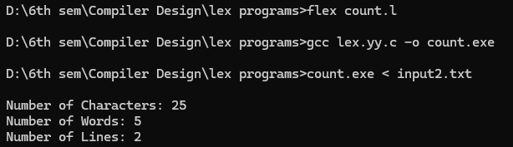

b. Write a Lex program to take input from text file and count number of vowels and consonants.

Lex Code [count1.l]
%{
int vowels = 0;
int consonants = 0;
FILE *yyin;
%}

%%

[aeiouAEIOU] { vowels++; }
[a-zA-Z] { consonants++; }
.|\n { /* Ignore other characters */ }

%%
int yywrap() {
return 1;
}

int main(int argc, char *argv[]) {
if (argc < 2) {
printf("Usage: %s input2.txt\n", argv[0]);
return 1;
}

FILE *file = fopen(argv[1], "r");
if (!file) {
printf("Cannot open file %s\n", argv[1]);
return 1;
}

yyin = file;
yylex();

printf("Number of vowels: %d\n", vowels);
printf("Number of consonants: %d\n", consonants);

fclose(file);
return 0;
}

Input2.txt Code:
Hello World!
Lex is fun.
123
Vaidehi Hirani born on 2nd oct. 2004

Compile and run:
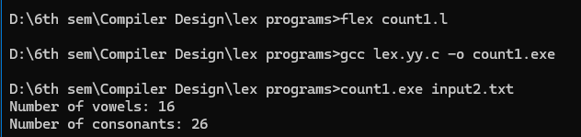

c. Write a Lex program to print out all numbers from the given file.

Lex Code [numbers.l]
%{
#include <stdio.h>
%}

%%

[0-9]+(\.[0-9]+)? { printf("Number found: %s\n", yytext); }
.|\n { /* Ignore all other characters */ }

%%

int yywrap() {
return 1;
}

int main() {
yylex(); // Start the lexical analysis
return 0;
}

Input2.txt Code:
Hello World!
Lex is fun.
123
Vaidehi Hirani born on 2nd oct. 2004

Compile and run:
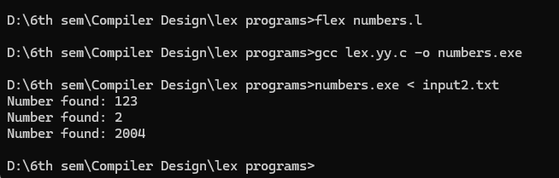

e. Write a Lex program to printout all markup/open tags and HTML comments in file.

Lex Code [tags_comments.l]
%{
#include <stdio.h>
%}

%%

"<!--"([^>]|[\n])*"-->" { printf("HTML Comment found: %s\n", yytext); }
"<"[a-zA-Z][a-zA-Z0-9]*">" { printf("Opening Tag found: %s\n", yytext); }
"</"[a-zA-Z][a-zA-Z0-9]*">" { printf("Closing Tag found: %s\n", yytext); }
"<"[a-zA-Z][^>]*"/>" { printf("Self-closing Tag found: %s\n", yytext); }

.|\n { /* Ignore other content */ }

%%

int yywrap() { return 1; }

int main() {
yylex();
return 0;
}
input3.html code:
<html>
<head>
<!-- This is a comment -->
<title>Page Title</title>
</head>
<body>
<p>Welcome to the page!</p>
<!-- Another comment -->
</body>
</html>

Compile and run:
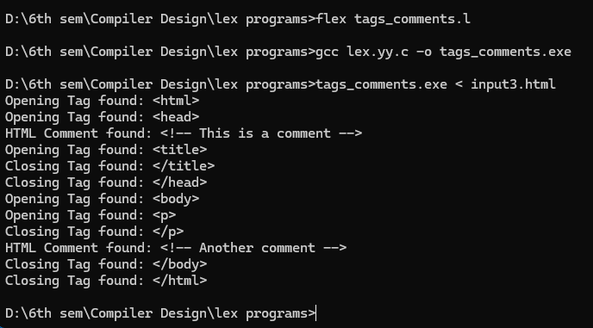

Practical 5
Aim:
- Write a Lex program to count the number of C comment lines from a given C program. Also eliminate them and copy that program into separate file.
- Write a Lex program to recognize keywords, identifiers, operators, numbers, special symbols, literals from a given C program.

Input:

- Write a Lex program to count the number of C comment lines from a given C program. Also eliminate them and copy that program into separate file.

comment.l
%{
#include <stdio.h>
#include <stdlib.h>
int comment_count = 0;
%}

%%
\/\/.* { comment_count++; } // Single-line comments
\/\*[^*]*\*+([^/*][^*]*\*+)*\/ { comment_count++; } // Multi-line comments
.|\n { /* Ignore all characters, since we are not writing to a file */ }
%%

int yywrap() {
return 1;
}

int main() {
yyin = stdin; // Read input from standard input (CMD)
yylex();

printf("Number of Comment Lines: %d\n", comment_count);
return 0;
}
input3.txt
#include <stdio.h>

/* This is a multi-line comment
explaining the main function */
int main() {
// This is a single-line comment
printf("Hello, World!\n"); // Print statement
return 0; /* Return statement */
}

Compile and run:
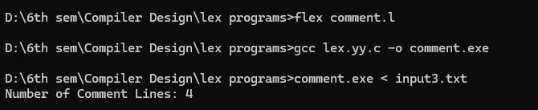

- Write a Lex program to recognize keywords, identifiers, operators, numbers, special symbols, literals from a given C program.

tokenizer.l
%{
#include <stdio.h>
#include <stdlib.h>
%}

DIGIT [0-9]
LETTER [a-zA-Z]
IDENTIFIER {LETTER}({LETTER}|{DIGIT})*
NUMBER {DIGIT}+(\.{DIGIT}+)?
OPERATOR [+\-*/%=><|&!]
SPECIAL [(){}[\];,]
LITERAL \"(\\.|[^"\\])*\"

%%

"auto" { printf("Keyword: %s\n", yytext); }
"break" { printf("Keyword: %s\n", yytext); }
"case" { printf("Keyword: %s\n", yytext); }
"char" { printf("Keyword: %s\n", yytext); }
"const" { printf("Keyword: %s\n", yytext); }
"continue" { printf("Keyword: %s\n", yytext); }
"default" { printf("Keyword: %s\n", yytext); }
"do" { printf("Keyword: %s\n", yytext); }
"double" { printf("Keyword: %s\n", yytext); }
"else" { printf("Keyword: %s\n", yytext); }
"enum" { printf("Keyword: %s\n", yytext); }
"extern" { printf("Keyword: %s\n", yytext); }
"float" { printf("Keyword: %s\n", yytext); }
"for" { printf("Keyword: %s\n", yytext); }
"goto" { printf("Keyword: %s\n", yytext); }
"if" { printf("Keyword: %s\n", yytext); }
"int" { printf("Keyword: %s\n", yytext); }
"long" { printf("Keyword: %s\n", yytext); }
"register" { printf("Keyword: %s\n", yytext); }
"return" { printf("Keyword: %s\n", yytext); }
"short" { printf("Keyword: %s\n", yytext); }
"signed" { printf("Keyword: %s\n", yytext); }
"sizeof" { printf("Keyword: %s\n", yytext); }
"static" { printf("Keyword: %s\n", yytext); }
"struct" { printf("Keyword: %s\n", yytext); }
"switch" { printf("Keyword: %s\n", yytext); }
"typedef" { printf("Keyword: %s\n", yytext); }
"union" { printf("Keyword: %s\n", yytext); }
"unsigned" { printf("Keyword: %s\n", yytext); }
"void" { printf("Keyword: %s\n", yytext); }
"volatile" { printf("Keyword: %s\n", yytext); }
"while" { printf("Keyword: %s\n", yytext); }

{IDENTIFIER} { printf("Identifier: %s\n", yytext); }
{NUMBER} { printf("Number: %s\n", yytext); }
{OPERATOR} { printf("Operator: %s\n", yytext); }
{SPECIAL} { printf("Special Symbol: %s\n", yytext); }
{LITERAL} { printf("Literal: %s\n", yytext); }

[ \t\n] { /* Ignore whitespace and newlines */ }

. { printf("Unknown Token: %s\n", yytext); }

%%

int yywrap() {
return 1;
}

int main() {
yylex();
return 0;
}

input4.txt
int main() {
int a = 10, b = 20;
float c = 3.14;
char d = 'x';
printf("Hello, World!\n");

return 0;
}

Compile and run:
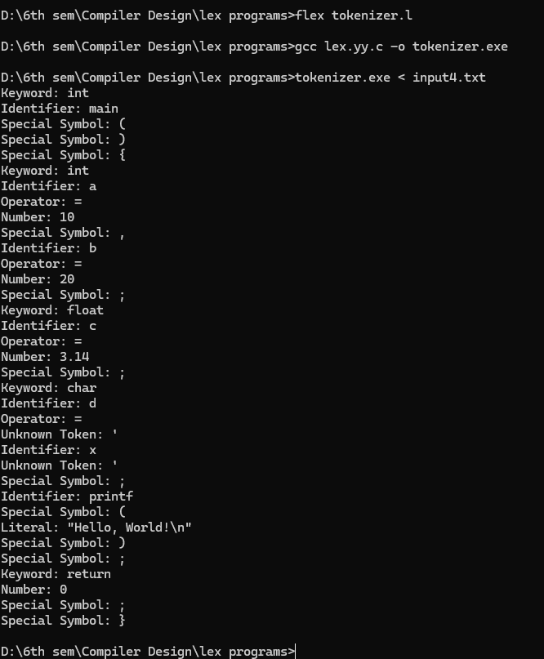

Practical 6
Aim: Program to implement Recursive Descent Parsing in C.

Code:
#include <stdio.h>
#include <string.h>
#define SUCCESS 1
#define FAILED 0
// Function prototypes
int E(), Edash(), T(), Tdash(), F();
const char *cursor;
char string[64];
int main()
{
puts("Enter the string");
scanf("%s", string); // Read input from the user
cursor = string;
puts("");
puts("Input Action");
puts("--------------------------------");
// Call the starting non-terminal E
if (E() && *cursor == '\0')
{ // If parsing is successful and the cursor has reached the end
puts("--------------------------------");
puts("String is successfully parsed");
return 0;
}
else
{
puts("--------------------------------");
puts("Error in parsing String");
return 1;
}
}
// Grammar rule: E -> T E'
int E()
{
printf("%-16s E -> T E'\n", cursor);
if (T())
{ // Call non-terminal T
if (Edash())
{ // Call non-terminal E'
return SUCCESS;
}
else
{
return FAILED;
}
}
else
{
return FAILED;
}
}
// Grammar rule: E' -> + T E' | $
int Edash()
{
if (*cursor == '+')
{
printf("%-16s E' -> + T E'\n", cursor);
cursor++;

if (T())
{ // Call non-terminal T
if (Edash())
{ // Call non-terminal E'
return SUCCESS;
}
else
{
return FAILED;
}
}
else
{
return FAILED;
}
}
else
{
printf("%-16s E' -> $\n", cursor);
return SUCCESS;
}
}
// Grammar rule: T -> F T'
int T()
{
printf("%-16s T -> F T'\n", cursor);
if (F())
{ // Call non-terminal F
if (Tdash())
{ // Call non-terminal T'
return SUCCESS;
}
else
{
return FAILED;
}
}
else
{
return FAILED;
}
}

// Grammar rule: T' -> * F T' | $
int Tdash()
{
if (*cursor == '*')
{
printf("%-16s T' -> * F T'\n", cursor);
cursor++;

if (F())
{ // Call non-terminal F
if (Tdash())
{ // Call non-terminal T'
return SUCCESS;
}
else
{
return FAILED;
}
}
else
{
return FAILED;
}
}
else
{
printf("%-16s T' -> $\n", cursor);
return SUCCESS;
}
}
// Grammar rule: F -> ( E ) | i
int F()
{
if (*cursor == '(')
{
printf("%-16s F -> ( E )\n", cursor);
cursor++;
if (E())
{ // Call non-terminal E
if (*cursor == ')')
{
cursor++;
return SUCCESS;
}
else
{
return FAILED;
}
}
else
{
return FAILED;
}
}
else if (*cursor == 'i')
{
printf("%-16s F -> i\n", cursor);
cursor++;
return SUCCESS;
}
else
{
return FAILED;
}
}
Output:
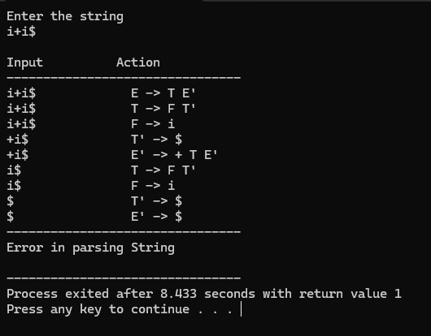
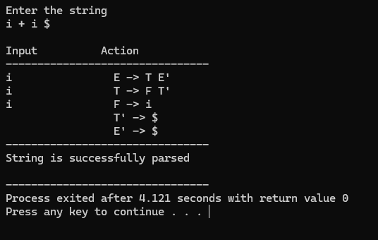

Practical 7
Aim:
- To Study about Yet Another Compiler-Compiler(YACC).
- Create Yacc and Lex specification files to recognizes arithmetic expressions involving +, -, * and / .
- Create Yacc and Lex specification files are used to generate a calculator which accepts integer type arguments.
- Create Yacc and Lex specification files are used to convert infix expression to postfix expression.

Code:
- To Study about Yet Another Compiler-Compiler(YACC).

What is YACC?
- YACC (Yet Another Compiler-Compiler) is a tool used in compiler design to generate parsers. It helps you build the syntax analysis part of a compiler.
- It was developed by Stephen C. Johnson at AT&T Bell Labs.

Why is YACC used?
- Writing a parser manually (like recursive descent) is complex and error-prone.
- YACC automates this by generating C code for the parser from a grammar specification.
- It works well with lex, the lexical analyzer generator.

How does YACC work?
- You write a grammar using BNF (Backus-Naur Form) or similar syntax.
- You assign semantic actions to grammar rules (using C code).
- YACC generates a parser in C that uses a bottom-up parsing algorithm (usually LALR(1)).
- The parser works with lex to analyze tokens.

Structure of a YACC file
A YACC source file has three sections, separated by %%:

%{
// Declarations (C code, headers)
%}

%token ID NUM // Token definitions

%%

E : E '+' T { printf("Adding\n"); }
| T { /* do nothing */ }
;

T : T '*' F { printf("Multiplying\n"); }
| F { /* do nothing */ }
;

F : '(' E ')'
| ID
| NUM
;

%%

// Additional C code (main function etc.)

YACC and LEX Integration
- LEX handles scanning/tokenizing (splits input into tokens).
- YACC handles parsing (checks if token sequence is valid as per grammar).
- They work together to build front ends for compilers.
Advantages of YACC
- Speeds up parser development.
- Helps build robust parsers for programming languages.
- Well-suited for formal language processing tasks.

- Create Yacc and Lex specification files to recognizes arithmetic expressions involving +, -, * and / .

expr.l code:
%{
#include "expr.tab.h"
#include <stdlib.h>
%}

%%

[0-9]+ { yylval.ival = atoi(yytext); return NUMBER; }
[a-zA-Z]+ { yylval.ival = 0; return ID; }
[ \t]+ ; // skip whitespace
\n { return '\n'; }
. { return yytext[0]; }

%%

int yywrap() {
return 1;
}

expr.y code:
%{
#include <stdio.h>
#include <stdlib.h>

void yyerror(const char *s);
int yylex(void);
%}

%union {
int ival;
}

%token <ival> NUMBER
%token <ival> ID
%type <ival> E

%left '+' '-'
%left '*' '/'

%%

input:
E '\n' { printf("Result = %d\n", $1); }
;

E:
E '+' E { $$ = $1 + $3; }
| E '-' E { $$ = $1 - $3; }
| E '*' E { $$ = $1 * $3; }
| E '/' E { $$ = $1 / $3; }
| '-' E { $$ = -$2; }
| '(' E ')' { $$ = $2; }
| NUMBER { $$ = $1; }
| ID { $$ = $1; }
;

%%

int main(void) {
printf("Enter the expression:\n");
yyparse();
return 0;
}

void yyerror(const char *s) {
fprintf(stderr, "Error: %s\n", s);
}

Output:
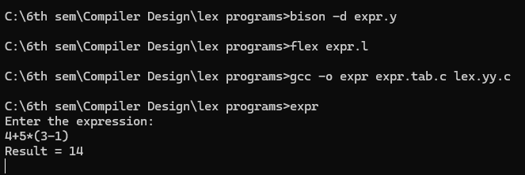
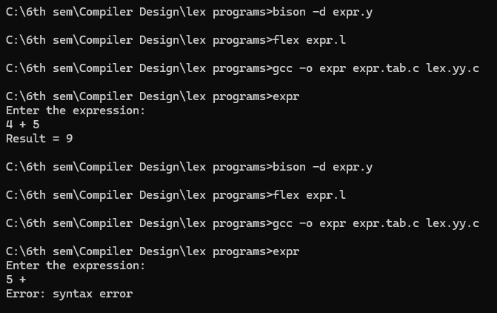

- Create Yacc and Lex specification files are used to generate a calculator which accepts integer type arguments.

calc.l code:

%{
#include "calc.tab.h"
#include <stdlib.h>
%}

%%

[0-9]+ { yylval.ival = atoi(yytext); return NUMBER; }
[ \t]+ ; // skip whitespace
\n { return '\n'; }
. { return yytext[0]; }

%%

int yywrap() {
return 1;
}

calc.y code:

%{
#include <stdio.h>
#include <stdlib.h>

void yyerror(const char *s);
int yylex(void);
%}

%union {
int ival;
}

%token <ival> NUMBER
%type <ival> expr

%left '+' '-'
%left '*' '/'
%start input

%%

input:
expr '\n' { printf("Result = %d\n", $1); }
;

expr:
expr '+' expr { $$ = $1 + $3; }
| expr '-' expr { $$ = $1 - $3; }
| expr '*' expr { $$ = $1 * $3; }
| expr '/' expr {
if ($3 == 0) {
yyerror("Division by zero");
YYABORT; // Exit the parsing process immediately
} else {
$$ = $1 / $3;
}
}
| '(' expr ')' { $$ = $2; }
| NUMBER { $$ = $1; }
;

%%

int main() {
printf("Enter the expression:\n");
return yyparse();
}

void yyerror(const char *s) {
fprintf(stderr, "Error: %s\n", s);
}

Output:
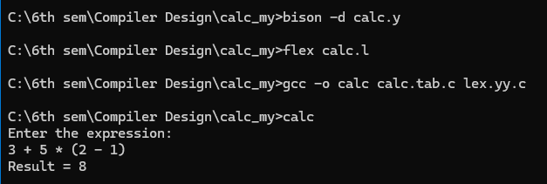
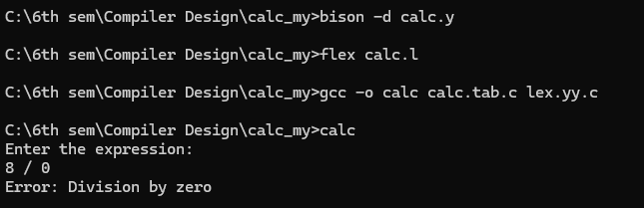

- Create Yacc and Lex specification files are used to convert infix expression to postfix expression.

infix_to_postfix.l code:

%{
#include "infix_to_postfix.tab.h"
#include <stdlib.h>
#include <string.h>
%}

DIGIT [0-9]
WS [ \t\r]+

%%

{DIGIT}+ {
yylval.str = strdup(yytext);
return NUMBER;
}
"(" { return '('; }
")" { return ')'; }
"+" { return '+'; }
"-" { return '-'; }
"*" { return '*'; }
"/" { return '/'; }
{WS} { /* skip whitespace */ }
\n { return '\n'; }
. { return yytext[0]; }

%%

int yywrap() {
return 1;
}

infix_to_postfix.y code:

%{
#include <stdio.h>
#include <stdlib.h>
#include <string.h>
#include <stdarg.h>

// custom asprintf implementation for Windows
int asprintf(char **strp, const char *fmt, ...) {
va_list args;
va_start(args, fmt);
int size = vsnprintf(NULL, 0, fmt, args);
va_end(args);

if (size < 0) return -1;

*strp = (char *)malloc(size + 1);
if (!*strp) return -1;

va_start(args, fmt);
vsnprintf(*strp, size + 1, fmt, args);
va_end(args);

return size;
}

void yyerror(const char *s);
int yylex(void);
%}

%union {
char *str;
}

%token <str> NUMBER
%left '+' '-'
%left '*' '/'
%token '(' ')'

%type <str> expr

%%

input:
/* empty */
| input expr '\n' {
printf("Postfix: %s\n", $2);
free($2);
}
;

expr:
NUMBER { $$ = strdup($1); free($1); }
| expr '+' expr { asprintf(&$$, "%s %s +", $1, $3); free($1); free($3); }
| expr '-' expr { asprintf(&$$, "%s %s -", $1, $3); free($1); free($3); }
| expr '*' expr { asprintf(&$$, "%s %s *", $1, $3); free($1); free($3); }
| expr '/' expr { asprintf(&$$, "%s %s /", $1, $3); free($1); free($3); }
| '(' expr ')' { $$ = $2; }
;

%%

void yyerror(const char *s) {
fprintf(stderr, "Error: %s\n", s);
}

int main() {
printf("Enter an infix expression:\n");
yyparse();
return 0;
}

Output:
