Lab Manual

OF

**Compiler Design Bachelor of Technology (CSE)**

By

Krupa Shivanekar (22000889) 3rd Year, Semester 5 (B2)



Department of Computer Science and Engineering School Engineering and Technology Navrachana University, Vadodara

Autumn Semester (2022-2023)

1. Write a program to recognize the string starting from ‘a’ over {a,b}. Code:

#include<stdio.h> int main()

{

char string[100]; printf("Enter the string: "); scanf("%s", string);

int i=0, state=0; while(string[i]!='\0')

{

switch(state)

{

case 0: if(string[i]=='a') state=1; else if(string[i]=='b')state=2; else state=3;

break;

case 1: if(string[i]=='a') state=1;

else if(string[i]=='b') state=1;

else

state=3; break;

case 2: if(string[i]=='a') state=2;

else if(string[i]=='b') state=2;

else

state=3; break;

case 3: break;

}

i++;

}

if(state==1)

printf("String accepted\n"); else if(state==2)

printf("String not accepted\n"); else

printf("String not recognized\n");

return 0;

}

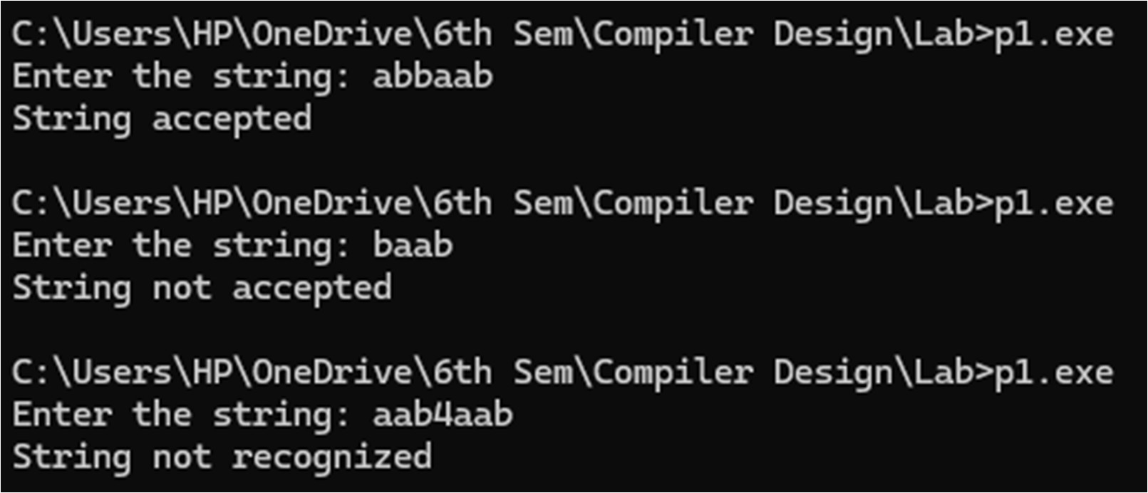Output:

1. Write a program to recognize the string ending on ‘a’ over {a,b}. Code:

#include<stdio.h> int main()

{

char string[100]; int state=0, i=0;

printf("Enter a string: "); scanf("%s", string);

while (string[i]!='\0')

{

switch(state)

{

case 0:

if(string[i]=='a') state=1;

else if(string[i]=='b') state=0; else state=2;

break; case 1:

if(string[i]=='a') state=1;

else if(string[i]=='b') state=0; else state=2;

break; case 2:

break;

} i++;

}

if(state==1)

printf("String accepted\n"); else if(state==0)

printf("String not accepted\n"); else

printf("String not recognized\n");

return 0;

}

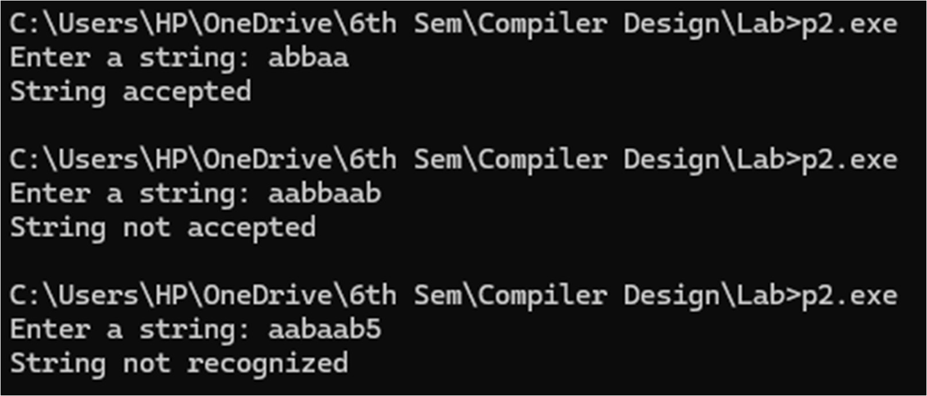Output:

1. Write a program to recognize strings end with ‘ab’. Take the input from text file. Code:

#include <stdio.h> #include <string.h>

int main() {

char string[100];

FILE *file = fopen("input.txt", "r"); if (file == NULL) {

printf("Could not open file input.txt\n"); return 1;

}

while (fgets(string, sizeof(string), file))

{

int i = 0, state = 0; while (string[i] != '\0')

{

switch (state) { case 0:

if (string[i] == 'a') state = 1;

else if (string[i] == 'b') state = 0; else state = 3;

break; case 1:

if (string[i] == 'a') state = 1;

else if (string[i] == 'b') state = 2; else state = 3;

break; case 2:

if (string[i] == 'a') state = 1;

else if (string[i] == 'b') state = 0; else state = 3;

break; case 3:

state = 3; break;

} i++;

}

if (state == 2)

printf("String accepted: %s\n", string); else if (state == 0 || state == 1)

printf("String not accepted: %s\n", string); else

printf("String not recognized: %s\n", string);

}

fclose(file); return 0;

}

Input:

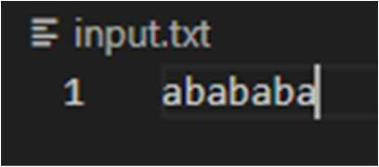

Output:



1. Write a program to recognize strings contains ‘ab’. Take the input from text file.

Code: #include<stdio.h> int main()

{

char string[100];

FILE *file = fopen("4th.txt", "r"); if (file == NULL) {

printf("Could not open file input.txt\n"); return 1;

}

while(fgets(string, sizeof(string), file))

{

int i=0, state=0; while(string[i]!='\0')

{

switch(state)

{

case 0:

if(string[i]=='a') state=1;

else if(string[i]=='b') state=0; break;

case 1:

if(string[i]=='a') state=1;

else if(string[i]=='b') state=2; break;

case 2:

if(string[i]=='a') state=1;

else if(string[i]=='b') state=2; break;

}

i++;

}

if(state==2)

printf("String accepted: %s\n", string); else if(state==0 || state==1)

printf("String not accepted: %s\n", string); else

printf("String not recognized: %s\n", string);

}

}

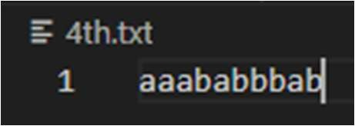Input:

Output:

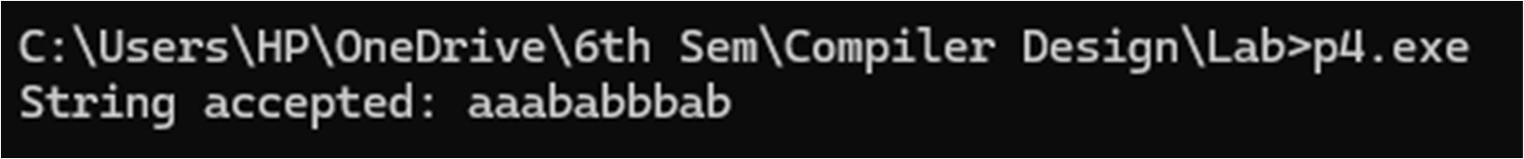

1. Single line comment Code:

#include <stdio.h> #include <string.h>

int main()

{

char string[100];

FILE *file = fopen("comment.txt", "r"); if (file == NULL) {

printf("Could not open file input.txt\n"); return 1;

}

while (fgets(string, sizeof(string), file))

{

int i=0, state=0; while(string[i]!='\0')

{

switch(state)

{

case 0:

if(string[i]=='/') state=1; else state=2;

break; case 1:

if(string[i]=='/') state=3; else state=2;

break; case 2:

break; case 3:

break;

}

i++;

}

if(state==3)

printf("Comment valid: %s\n", string); else

printf("Comment not valid: %s\n", string);

}

}

Output:

1. Multiline Comment Code:

#include <stdio.h> #include <string.h>

int main()

{

char string[1000];

FILE *file = fopen("comment2.txt", "r"); if (file == NULL) {

printf("Could not open file input.txt\n"); return 1;

}

while (fgets(string, sizeof(string), file))

{

int i=0, state=0; while(string[i]!='\0')

{

switch(state)

{

case 0:

if(string[i]=='/') state=1;

else state=2; break;

case 1:

if(string[i]=='/') state=3;

else if (string[i]=='*') state=4; else state=2;

break; case 2:

break; case 3:

break; case 4:

if (string[i]=='*') state=5; else state=4;

case 5:

if(string[i]=='/') state=6; else state=4;

case 6:

break;

}

i++;

}

if(state==3)

printf("Singleline Comment valid: %s\n", string); else if(state==6)

printf("Multiline Comment valid: %s\n", string); else

printf("Comment not valid: %s\n", string);

}

}

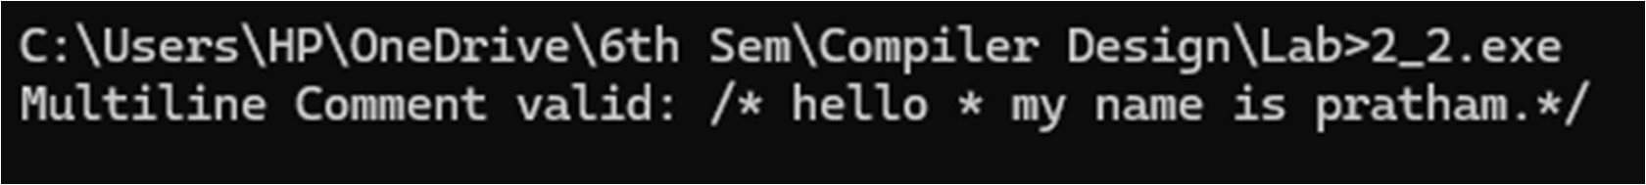Output:

* 1. Write a program to recognize the valid identifiers.

Code:

#include<stdio.h> #include<string.h> #include<ctype.h> #include<stdbool.h>

int main()

{

char string[1000]; printf("Enter the string: ");

scanf("%s", string); // Prevents buffer overflow int i = 0, state = 0;

int num=1; while (num>0)

{

switch (state)

{

case 0: //A

if (string[i] == 'i') state = 1;

else if (isalpha(string[i]) || string[i] == '_') state = 5; break;

case 1: //B

if (string[i] == 'n') state = 2;

else if (isalpha(string[i]) || string[i] == '_' || isdigit(string[i])) state = 5;

else state = 6; break;

case 2: //C

if (string[i] == 't') state = 3;

else if (isalpha(string[i]) || string[i] == '_' || isdigit(string[i])) state = 5;

else state = 6; break;

case 3: //D

if (string[i] == '\0') state = 4;

else if (isalpha(string[i]) || isdigit(string[i]) || string[i] ==

'_') state = 5;

num--; break;

case 4: //E

// No transition needed, final accepting state break;

case 5: //F

if (isalpha(string[i]) || isdigit(string[i]) || string[i] == '_')

state = 5;

else state = 6; // No need for checking '\0' here, it will end

the loop

break;

case 6: //G

// No transition needed, final rejecting state break;

} i++;

}

if (state == 3 || state==4) printf("int is keyword.");

else if (state == 6)

printf("%s is valid identifier.", string); else

printf("%s is invalid identifier.", string);

return 0;

}

Output:

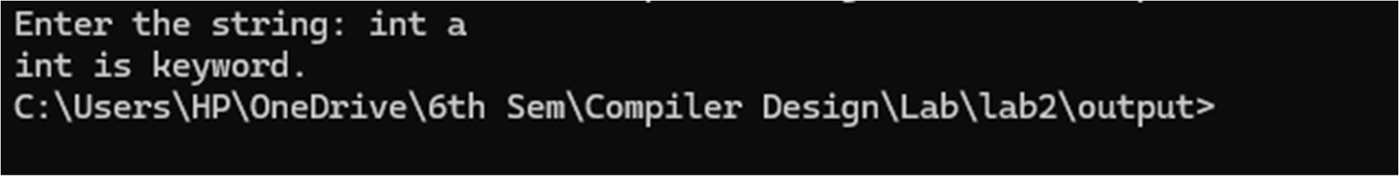

* 1. Write a program to recognize the valid operators. Code:

#include<stdio.h> #include<string.h>

int main()

{

char string[1000]; printf("Enter the string: ");

scanf("%s", string); // Prevents buffer overflow int i = 0, state = 0;

int num=1; while (num>0)

{

switch(state)

{

case 0:

if (string[i] == '+') state = 51; else if(string[i] == '*') state = 51; else if(string[i] == '/') state = 60; else if(string[i] == '=') state = 53; else if(string[i] == '-') state = 54; else if(string[i] == '?') state = 55; else if(string[i] == '<') state = 56; else if(string[i] == '>') state = 59; else if(string[i] == '!') state = 57; else if(string[i] == '&') state = 58; else if(string[i] == '|') state = 61;

else if(string[i] == '~' || string[i] == '^') state = 62; break;

case 51: // Arithmetic

if (string[i] == '\0') state = 51; else if (string[i] == '+') state = 52; else if (string[i] == '=') state = 53; else state = 0;

num--; break;

case 52: // Unary break;

case 53: // Assignment

if(string[i] == '=') state = 56; else state = 0;

num--; break;

case 54: // -

if (string[i] == '\0') state = 51; else if (string[i] == '-') state = 52; else if (string[i] == '=') state = 53; else state = 0;

num--; break;

case 55: // Ternary

if (string[i] == ':') state = 55; else if(string[i] == '\0') state = 0; else state = 0;

num--; break;

case 56: //Relational

if (string[i] == '=') state = 56; else if(string[i] == '<') state = 58; else state = 0;

num--; break;

case 59: // >

if (string[i] == '>') state = 58; else if (string[i] == '=') state = 56; else state = 0;

num--; break;

case 57: // Logical

if (string[i] == '=') state = 56; else if(string[i] == '\0') state = 57; else state = 0;

num--; break;

case 58: // Bitwise

if (string[i] == '&') state = 57; else if(string[i] == '\0') state = 58; else state = 0;

num--; break;

case 60: // "/"

if (string[i] == '\0') state = 51; else state = 0;

num--; break;

case 61: // "|"

if (string[i] == '|') state = 57; else if(string[i] == '\0') state = 58; else state = 0;

num--; break;

case 62: // ~ ^

if (string[i] == '\0') state = 58; else state = 0;

num--; break;

}

i++;

}

if (state == 51) printf("%s is an Arithmatic operator.", string); else if(state == 52) printf("%s is an Unary operator.", string); else if(state == 53) printf("%s is an Assignment operator.", string); else if(state == 55) printf("%s is ternary or conditional operator.",

string);

else if(state == 56) printf("%s is a Relational Operator.", string); else if(state == 57) printf("%s is a Logical operator.", string); else if(state == 58) printf("%s is a Bitwise operator.", string); else

printf("Processing ");

return 0;

}

Output:



* 1. Write a program to recognize the valid number. Code:

#include <stdio.h> #include <string.h> #include <ctype.h> #include <stdbool.h>

int main() {

FILE *file;

char buffer[100]; char lexeme[100]; char c;

int f, i, state;

file = fopen("numbers.txt", "r"); if (file == NULL) {

printf("Error opening file.\n"); return 1;

}

while (fgets(buffer, 100, file)) { buffer[strcspn(buffer, "\n")] = 0; f = 0;

i = 0;

state = 0;

while (buffer[f] != '\0') switch (state) {

case 0:

c = buffer[f];

if (isdigit(c)) { state = 40; lexeme[i++] = c; } else { state = 0; }

break;

case 40:

c = buffer[f];

if (isdigit(c)) { state = 40; lexeme[i++] = c; } else if (c == '.') { state = 41; lexeme[i++] = c; }

else if (c == 'E' || c == 'e') { state = 43; lexeme[i++] = c;

}

else {

lexeme[i] = '\0';

printf("%s is a valid number\n", lexeme);

i = 0;

state = 0; f--;

}

break;

case 41:

c = buffer[f];

if (isdigit(c)) { state = 42; lexeme[i++] = c; } else {

lexeme[i] = '\0';

printf("%s is an invalid number (expected digit after

decimal)\n", lexeme);

}

i = 0;

state = 0; f--;

break;

case 42:

c = buffer[f];

if (isdigit(c)) { state = 42; lexeme[i++] = c; }

else if (c == 'E' || c == 'e') { state = 43; lexeme[i++] = c;

}

else {

lexeme[i] = '\0';

printf("%s is a valid number\n", lexeme); i = 0;

state = 0; f--;

}

break;

case 43:

c = buffer[f];

if (c == '+' || c == '-') { state = 44; lexeme[i++] = c; } else if (isdigit(c)) { state = 45; lexeme[i++] = c; } else {

lexeme[i] = '\0';

printf("%s is an invalid number (expected digit or sign after 'E'/'e')\n", lexeme);

i = 0;

state = 0; f--;

}

break;

case 44:

c = buffer[f];

if (isdigit(c)) { state = 45; lexeme[i++] = c; } else {

lexeme[i] = '\0';

printf("%s is an invalid number (expected digit after sign in exponent)\n", lexeme);

i = 0;

state = 0; f--;

}

break;

case 45:

c = buffer[f];

if (isdigit(c)) { state = 45; lexeme[i++] = c; } else {

lexeme[i] = '\0';

printf("%s is a valid number\n", lexeme); i = 0;

state = 0; f--;

} f++;

}

}

break;

if (state == 40 || state == 41 || state == 42 || state == 45) { lexeme[i] = '\0';

printf("%s is a valid number\n", lexeme);

} else {

printf("%s is an invalid number\n", buffer);

}

}

fclose(file); return 0;

}

Output:

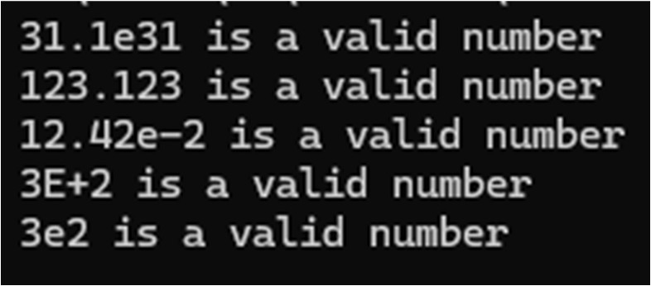

* 1. Write a program to recognize the valid comments.

Code:

#include <stdio.h> #include <string.h>

int main()

{

char string[1000];

FILE *file = fopen("comment2.txt", "r"); if (file == NULL) {

printf("Could not open file input.txt\n"); return 1;

}

while (fgets(string, sizeof(string), file))

{

int i=0, state=0; while(string[i]!='\0')

{

switch(state)

{

case 0:

if(string[i]=='/') state=1; else state=2;

break; case 1:

if(string[i]=='/') state=3;

else if (string[i]=='*') state=4; else state=2;

break; case 2:

break; case 3:

break;

case 4:

if (string[i]=='*') state=5; else state=4;

case 5:

if(string[i]=='/') state=6; else state=4;

case 6:

break;

} i++;

}

if(state==3)

printf("Singleline Comment valid: %s\n", string); else if(state==6)

printf("Multiline Comment valid: %s\n", string); else

printf("Comment not valid: %s\n", string);

}

return 0;

}

Output:



* 1. Program to implement Lexical Analyzer. Code:

#include <stdio.h> #include <stdlib.h> #include <ctype.h> #include <string.h> #define BUFFER_SIZE 1000 void check(char *lexeme);

int main() {

FILE *f1;

char buffer[BUFFER_SIZE], lexeme[50]; // Static buffer for input and lexeme storage

char c;

int f = 0, state = 0, i = 0; f1 = fopen("Input.txt", "r");

fread(buffer, sizeof(char), BUFFER_SIZE - 1, f1); buffer[BUFFER_SIZE - 1] = '\0'; // Null termination fclose(f1);

while (buffer[f] != '\0') { c = buffer[f];

switch (state) { case 0:

if (isalpha(c) || c == '_') { state = 1;

lexeme[i++] = c;

}

else if (c == ' ' || c == '\t' || c == '\n') { state = 0;

}

else if(isdigit(c)) { state = 13; lexeme[i++] = c;

}

else if (c == '/') {

state = 11; // For comment

}

else if (c == ';' || c == ',' || c == '{' || c == '}') { printf(" %c is a symbol\n", c);

state = 0;

}

else if (strchr("+-*/=%?<>!&|~^", c)) {

state = 50; lexeme[i++] = c;

}

else {

state = 0;

}

break;

character

case 1:

if (isalpha(c) || isdigit(c) || c == '_') { state = 1;

lexeme[i++] = c;

} else {

lexeme[i] = '\0'; // Null-terminate the lexeme check(lexeme); // Check if it's a keyword or identifier state = 0;

i = 0;

f--; // Step back to reprocess the current non-alphanumeric

}

break;

case 13:

if(isdigit(c)) { state = 13; lexeme[i++] = c;

}

else if(c=='.') { state=14; lexeme[i++]=c;

}

else if(c=='E'||c=='e') { state=16; lexeme[i++]=c;

}

else {

lexeme[i]='\0';

printf("%s is a valid number\n", lexeme); i=0;

state=0; f--;

}

break;

case 50: // Operator Handling

switch (lexeme[0]) { case '+':

if (c == '+') {

printf("%s is a Unary operator\n", lexeme); state = 0;

}

else if (c == '=') {

printf("%s is an Assignment operator\n", lexeme); state = 0;

}

else {

printf("%s is an Arithmetic operator\n", lexeme); state = 0;

f--;

}

break;

case '-':

if (c == '-') {

printf("%s is a Unary operator\n", lexeme); state = 0;

}

else if (c == '=') {

printf("%s is an Assignment operator\n", lexeme); state = 0;

}

else {

printf("%s is an Arithmetic operator\n", lexeme); state = 0;

f--;

}

break;

case '*':

case '/':

case '%':

if (c == '=') {

printf("%s is an Assignment operator\n", lexeme); state = 0;

}

else {

printf("%s is an Arithmetic operator\n", lexeme); state = 0;

f--;

}

break;

case '=':

if (c == '=') {

printf("%s is a Relational operator\n", lexeme); state = 0;

}

else {

printf("%s is an Assignment operator\n", lexeme); state = 0;

f--;

}

break;

case '<':

case '>':

if (c == '=' || c == lexeme[0]) {

printf("%s is a Relational operator\n", lexeme); state = 0;

}

else {

printf("%s is a Relational operator\n", lexeme); state = 0;

f--;

}

break;

case '!':

case '&':

case '|':

if (c == '=') {

printf("%s is a Logical operator\n", lexeme); state = 0;

}

else if (c == lexeme[0]) {

printf("%s is a Logical operator\n", lexeme); state = 0;

}

else {

printf("%s is a Logical operator\n", lexeme); state = 0;

f--;

}

break;

case '~':

case '^':

printf("%s is a Bitwise operator\n", lexeme); state = 0;

f--;

break;

lexeme);

case '?':

if (c == ':') {

printf("%s is a Ternary or conditional operator\n",

state = 0;

}

else {

state = 0; f--;

}

break;

default:

state = 0; break;

}

lexeme[0] = '\0'; i = 0;

break;

default:

state = 0; break;

}

f++;

}

}

void check(char *lexeme) { char *keywords[] = {

"auto", "break", "case", "char", "const", "continue", "default", "do",

"double", "else", "ef", "extern", "float", "for", "goto", "if",

"inline", "int", "long", "register", "restrict", "return", "short", "signed",

"sizeof", "static", "struct", "switch", "typedef", "union", "unsigned", "void", "volatile", "while"

};

for (int i = 0; i < 32; i++) {

if (strcmp(lexeme, keywords[i]) == 0) {

printf("%s is a keyword\n", lexeme); return;

}

}

printf("%s is an identifier\n", lexeme);

}

Output:

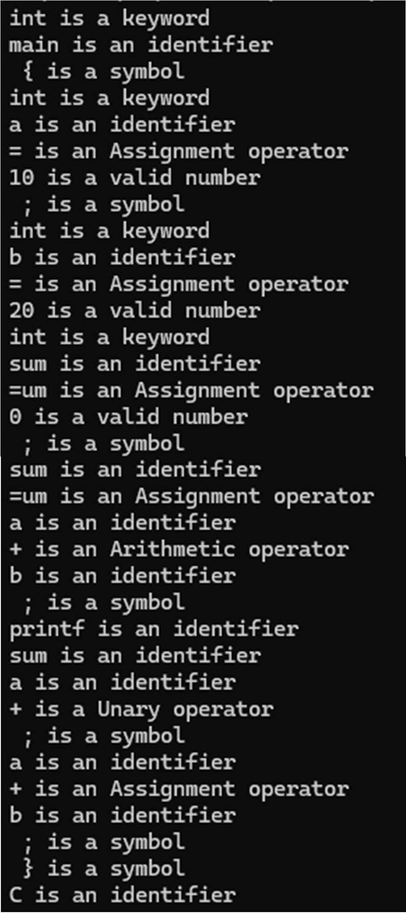

1. **Implement following programs using Lex.**
   1. Write a Lex program to take input from text file and count no of characters, no. of lines & no. of words.

Code:

%{

#include<stdio.h>

int words=0,characters=0,no_of_lines=0;

%}

%%

\n {no_of_lines++,words++;}

. characters++; [\t ]+ words++;

%%

void main(){

yyin = fopen("4_1.txt","r"); yylex();

printf("This file is containing %d words.\n",words); printf("This file is containing %d characters.\n",characters); printf("This file is containing %d no_of_lines.\n",no_of_lines);

}

int yywrap(){ return(1);} Output:

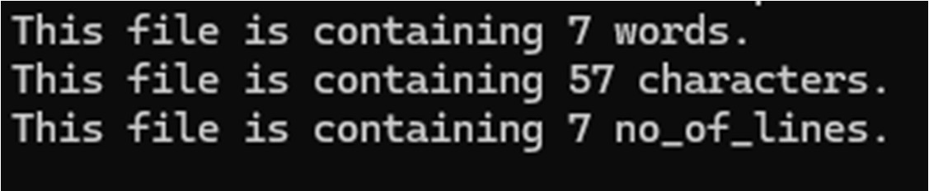

* 1. Write a Lex program to take input from text file and count number of vowels and consonants.

Code:

%{

#include<stdio.h>

int vowels=0, consonant=0;

%}

%%

[aeiouAEIOU] vowels++; [a-zA-Z] consonant++;

. ;

\n ;

%%

void main(){

yyin = fopen("input.txt","r"); yylex();

printf("This file is containing %d vowels.\n",vowels); printf("This file is containing %d consonants.\n",consonant);

}

int yywrap(){ return(1);} Output:

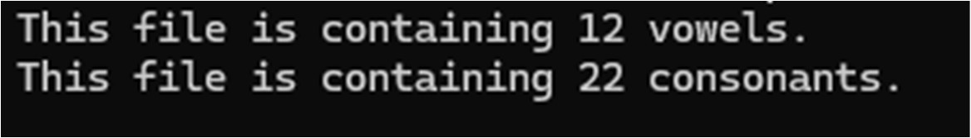

* 1. Write a Lex program to print out all numbers from the given file.

Code:

%{

#include<stdio.h>

%}

%%

[0-9]+(.[0-9]+)?([eE][+-]?[0-9]+)? printf("%s is valid number \n",yytext);

\n ;

. ;

%%

void main() {

yyin = fopen("input.txt","r"); yylex();

}

int yywrap(){return(1);} Output:

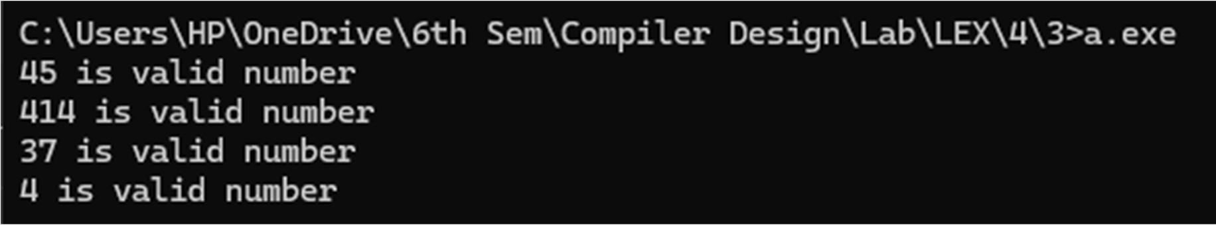

* 1. Write a Lex program which adds line numbers to the given file and display the same into different file.

Code:

%{

int line_number = 1;

%}

%%

.+ {fprintf(yyout,"%d: %s",line_number,yytext);line_number++;}

%%

int main() {

yyin = fopen("input.txt","r");

yyout = fopen("op.txt","w"); yylex();

printf("Done"); return 0;

}

int yywrap(){return(1);} Ouput:

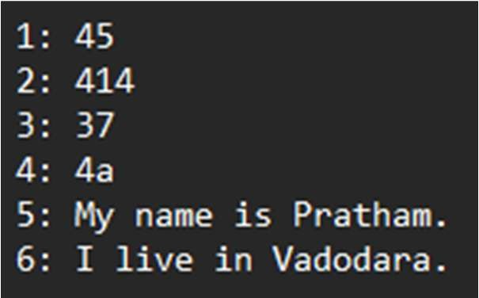

* 1. Write a Lex program to printout all markup tags and HTML comments in file.

Code:

%{

#include<stdio.h> int num=0;

%}

%%

"<"[A-Za-z0-9]+">"|"<"[/A-Za-z0-9]+">" printf("%s is valid markup tag \n",yytext); "<!--"[A-Za-z ]*"-->" num++;

.|\n ;

%%

int main() {

yyin = fopen("htmlfile.txt","r"); yylex();

printf("%d comment",num); return 0;

}

int yywrap(){return(1);}

Output:

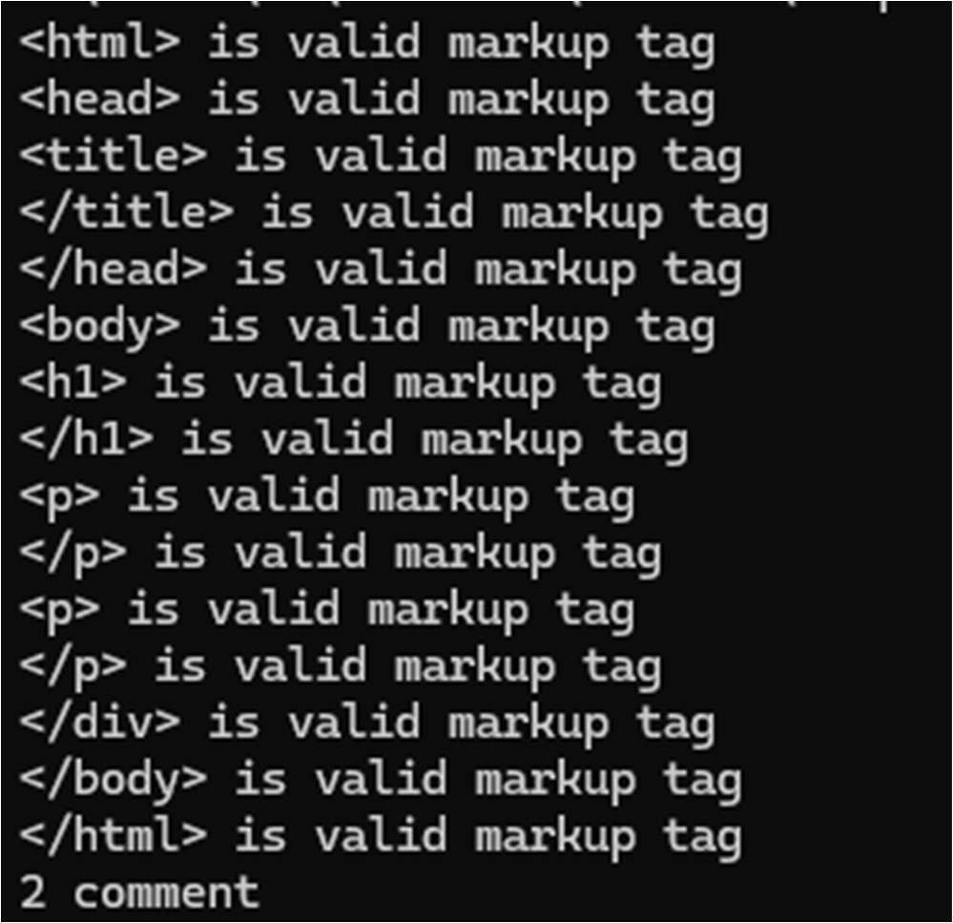

* 1. Write a Lex program to count the number of C comment lines from a given C program. Also eliminate them and copy that program into separate file.

Code:

%{

#include <stdio.h>

int comment_count = 0; FILE *outfile;

%}

%%

"//".* { comment_count++; /* Skip single-line comment */ } "/*"([^*]*\*+)*?"/" { comment_count++; /* Skip multi-line comment */ }

.|\n { fputc(yytext[0], outfile); }

%%

int main(int argc, char **argv) { if (argc < 2) {

printf("Usage: %s <input_file>\n", argv[0]); return 1;

}

FILE *infile = fopen("sample.c", "r"); if (!infile) {

perror("Cannot open input file"); return 1;

}

outfile = fopen("cleaned_code.c", "w"); if (!outfile) {

perror("Cannot open output file"); return 1;

}

yyin = infile; yylex(); fclose(infile); fclose(outfile);

printf("Total number of comments: %d\n", comment_count); return 0;

}

int yywrap(){ return 1;

}

Sample.c :

#include <stdio.h> int main() {

// This is a single-line comment int x = 10;

float y = 20.5;

/*

This is a multi-line comment It should be removed

*/

if (x < y) {

printf("x is less than y\n");

} else {

printf("x is not less than y\n");

}

char c = 'A'; // Character literal return 0;

}

Output:

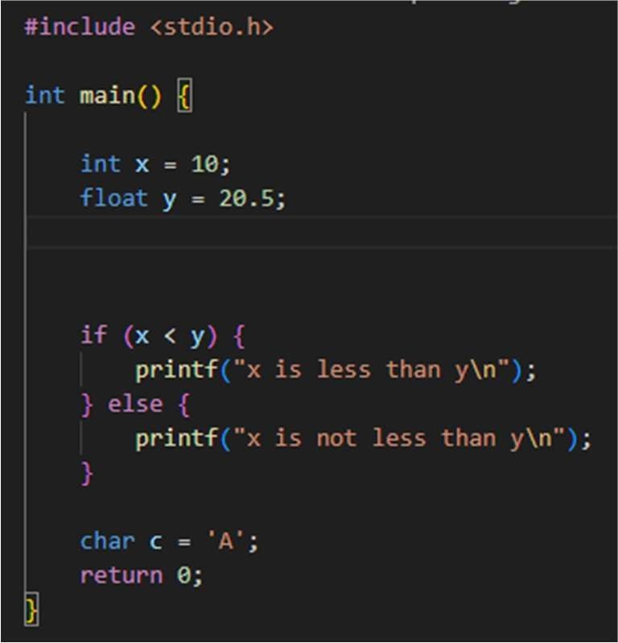

* 1. Write a Lex program to recognize keywords, identifiers, operators, numbers, special symbols, literals from a given C program.

Code:

%{

#include <stdio.h> #include <string.h> #include <ctype.h> FILE *outfile;

// C keywords list char *keywords[] = {

"int", "float", "return", "if", "else", "while", "for", "char", "double",

"do", "switch", "case", "break", "continue", "void", "long", "short",

"unsigned", "signed", "static", "struct", "union", "typedef", "const",

"goto", "enum", "default", "sizeof", "volatile", "register", NULL

};

int is_keyword(const char *word) { for (int i = 0; keywords[i]; i++) {

if (strcmp(keywords[i], word) == 0) return 1;

}

return 0;

}

%}

%%

\"([^"\\]|\\.)*\" { fprintf(outfile, "String literal: %s\n", yytext); }

\'([^'\\]|\\.)\' { fprintf(outfile, "Character literal: %s\n", yytext); } [0-9]+\.[0-9]+ { fprintf(outfile, "Float number: %s\n", yytext); } [0-9]+ { fprintf(outfile, "Integer number: %s\n", yytext); } [a-zA-Z_][a-zA-Z0-9_]* {

if (is_keyword(yytext))

fprintf(outfile, "Keyword: %s\n", yytext); else

fprintf(outfile, "Identifier: %s\n", yytext);

}

"=="|"!="|"<="|">="|"="|"+"|"-"|"*"|"/"|"<"|">" {

fprintf(outfile, "Operator: %s\n", yytext);

}

[{}()[\];,] { fprintf(outfile, "Special symbol: %s\n", yytext); } [ \t\n]+ ; // Skip whitespace

. { fprintf(outfile, "Unknown token: %s\n", yytext); }

%%

int main(int argc, char **argv) { if (argc < 2) {

printf("Usage: %s <input_file>\n", argv[0]); return 1;

}

FILE *infile = fopen("sample.c", "r"); if (!infile) {

perror("Cannot open input file"); return 1;

}

outfile = fopen("tokens.txt", "w"); if (!outfile) {

perror("Cannot open output file"); return 1;

}

yyin = infile; yylex(); fclose(infile); fclose(outfile);

printf("Tokenization complete. Output written to tokens.txt\n"); return 0;

}

int yywrap() { return 1;

}

Sample.c :

#include <stdio.h>

int main() {

int a = 10; float b = 20.5; char c = 'Z';

const char *str = "Hello, World!";

if (a < b) {

printf("a is less than b\n");

} else {

printf("a is not less than b\n");

}

return 0;

}

Output:



Unknown token: # Identifier: include Operator: < Identifier: stdio Unknown token: . Identifier: h Operator: > Keyword: int Identifier: main Special symbol: ( Special symbol: )

Special symbol: { Keyword: int Identifier: a Operator: = Integer number: 10 Special symbol: ; Keyword: float Identifier: b Operator: =

Float number: 20.5 Special symbol: ; Keyword: char Identifier: c Operator: = Character literal: 'Z' Special symbol: ; Keyword: const Keyword: char Operator: * Identifier: str Operator: =

String literal: "Hello, World!" Special symbol: ;

Keyword: if

Special symbol: ( Identifier: a Operator: < Identifier: b Special symbol: ) Special symbol: { Identifier: printf Special symbol: (

String literal: "a is less than b\n" Special symbol: )

Special symbol: ; Special symbol: } Keyword: else Special symbol: { Identifier: printf Special symbol: (

String literal: "a is not less than b\n" Special symbol: )

Special symbol: ; Special symbol: } Keyword: return Integer number: 0 Special symbol: ; Special symbol: }

6.Program to implement Recursive Descent Parsing in C.

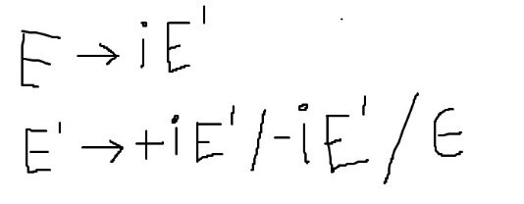

Code:

#include <stdio.h> #include <string.h>

char inp[100]; int l = 0;

void match(char t) { if (inp[l] == t) {

l++;

} else {

printf("Error\n"); exit(0);

}

}

void E();

void E_prime();

void E() {

if (inp[l] == 'i') {

match('i'); E_prime();

}

}

void E_prime() {

if (inp[l] == '+') {

match('+');

match('i'); E_prime();

} else if (inp[l] == '-') { match('-');

match('i'); E_prime();

} else {

return; // epsilon case

}

}

int main() {

printf("Enter expression: "); scanf("%s", inp);

E();

if (inp[l] == '$') { // End of input printf("Success\n");

} else {

printf("Error\n");

}

return 0;

}

Output:



* 1. To Study about Yet Another Compiler-Compiler(YACC).

YACC (Yet Another Compiler Compiler) is a parser generator tool used in compiler design to produce syntax analyzers for context-free grammars. It works closely with Lex, where Lex handles lexical analysis and YACC performs syntax analysis based on grammar rules. YACC generates efficient LALR(1) parsers and allows grammar specification in a structured format with declarations, grammar rules, and associated C actions. It interprets token streams from Lex to understand program structure and syntax. Widely used in building compilers and interpreters, YACC simplifies the implementation of parsing logic for programming languages.

* 1. Create Yacc and Lex specification files to recognizes arithmetic expressions involving +, -, * and / .

Code:

Lex:

%{

#include<stdlib.h> void yyerror(char *); #include "1.tab.h"

%}

%%

[0-9]+ return num;

[-/+*\n] return *yytext; [ \t] ;

. yyerror("invalid");

%%

int yywrap(){ return 1;

}

Yacc:

%{

#include<stdio.h> int yylex(void);

void yyerror(char *);

%}

%token num

%%

S:E'\n' {printf("Valid syntax."); return 0;} E:E'-'T {}

|E'+'T {}

|T {} T:T'/'F {}

|T'*'F {}

|F {}

F:num {}

%%

void yyerror(char *s){ printf("%s\n",s);

}

int main(){

yyparse(); return 0;

}

Output:



* 1. Create Yacc and Lex specification files are used to generate a calculator which accepts integer type arguments.

Code:

Lex:

%{

#include<stdlib.h> #include "1.tab.h" void yyerror(char *);

%}

%%

[0-9]+ {yylval=atoi(yytext); return num;} [-+*/\n] {return *yytext;}

[()/] {return *yytext;} [ \t] ;

. {yyerror("invalid");}

%%

int yywrap(){ return 1;

}

Yacc:

%{

#include<stdio.h> void yyerror(char *); int yylex(void);

%}

%token num

%%

S:E'\n' {printf("%d\n",$1); return 0;} E:E'-'T {$$=$1-$3;}

|T {$$=$1;}

T:T'+'F {$$=$1+$3;}

|F {$$=$1;}

F:F'*'G {$$=$1*$3;}

|G {$$=$1;} G:G'/'H {$$=$1/$3;}

|H {$$=$1;} H:'('E')' {$$=$2;}

|num {$$=$1;}

%%

void yyerror(char *s){ printf("%s\n",s);

}

int main(){

yyparse(); return 0;

}

Output:

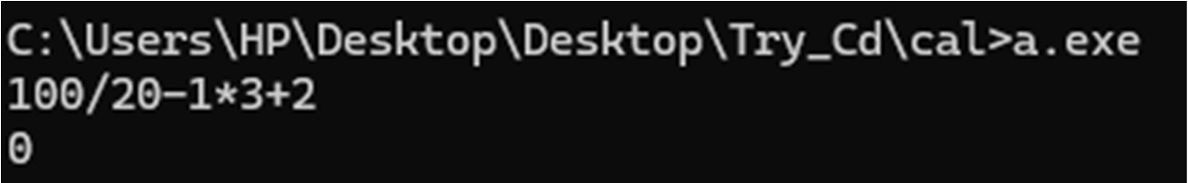

* 1. Create Yacc and Lex specification files are used to convert infix expression to postfix expression. Code:

Lex:

%{

#include<stdlib.h> #include "1.tab.h" void yyerror(char *);

%}

%%

[0-9]+ {yylval.num=atoi(yytext); return INTEGER;} [A-Za-z_][A-Za-z_0-9]* {yylval.str=yytext; return ID;} [-+*/\n] {return *yytext;}

[ \t] ;

. {yyerror("Invalid character.");}

%%

int yywrap(){ return 1;

}

Yacc:

%{

#include<stdio.h> int yylex(void);

void yyerror(char *);

%}

%union{

char *str; int num;

}

%token <num> INTEGER

%token <str> ID

%%

S:E'\n' {printf("\n");}

E:E'-'T {printf("-");}

|T {}

T:T'+'F {printf("+");}

|F {}

F:F'*'G {printf("*");}

|G {}

G:G'/'H {printf("/");}

|H {}

H:INTEGER {printf("%d",$1);}

|ID {printf("%s",$1);}

%%

void yyerror(char *s){ printf("%s\n",s);

}

int main(){

yyparse(); return 0;

}

Output:

