DIGITAL ID CARD
SSUET · Computer Engineering STUDENT ID
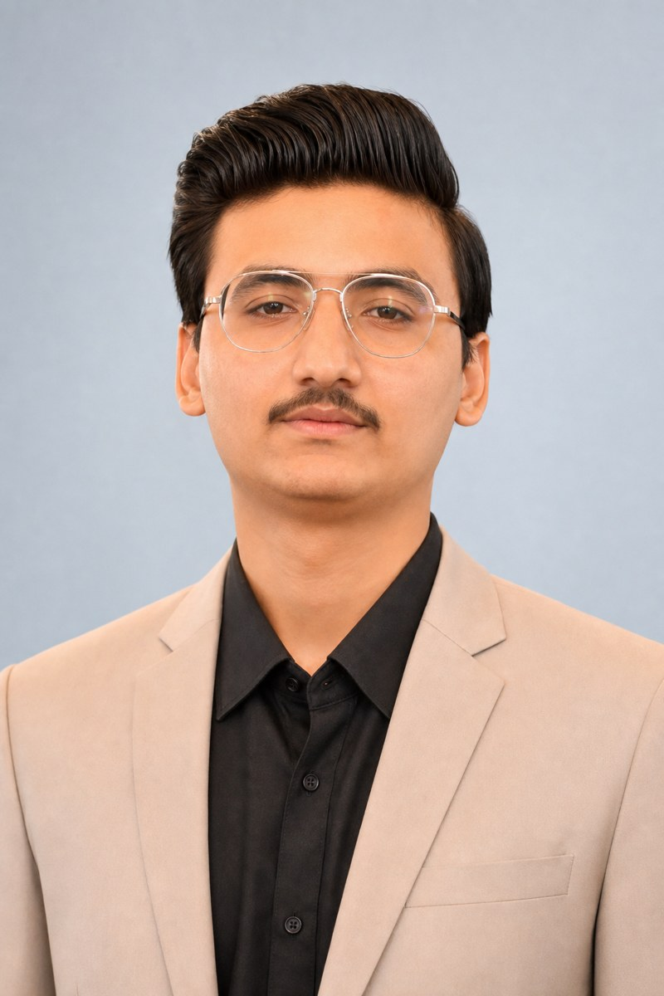 | Nauroz Salim  Full-Stack & Automation Developer  Bachelors in Computer Engineering  Sir Syed University of Engineering & Technology  2022 – 2026 | 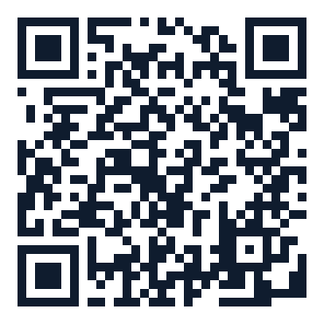  SCAN FOR CV

Scan QR → Nauroz_Salim_CV.docx
LinkedIn · GitHub · SSUET Computer Engineering
Print this page and cut the card. QR opens your Word CV file.

