HealthGraph: Patient Risk Prediction Using Relation-Aware Graph Attention Networks
Naveenya V K
Roll No. 2403717674422030
III M.Sc. AI & ML, Department of Computing – AI & ML
Coimbatore Institute of Technology, Coimbatore – 641 014
19MAM56 Advanced Machine Learning Lab – CAT II Project

Abstract—Thirty-day readmission is a key quality and cost indicator. We present HealthGraph, which models a cohort of diabetic inpatients as a multi-relational graph (clinical similarity, shared diagnoses, shared specialty) and predicts readmission with HealthGAT, a relation-aware GATv2 network implemented from scratch. On the UCI Diabetes-130 dataset we apply leakage-safe feature engineering (out-of-fold target encoding of high-cardinality ICD-9 codes, PCA), tune all models with Optuna, and track experiments in MLflow. Under the published evaluation protocol our pipeline reaches AUROC 0.681, matching or exceeding prior work (0.667). On a strict first-encounter cohort, HealthGAT (AUROC 0.635, ECE 0.005) performs on par with logistic regression and gradient boosting; no difference is significant under DeLong tests. Homophily analysis, relation ablation and a controlled synthetic study, where HealthGAT clearly wins (0.767 against 0.737), show that the graph helps only when its edges carry outcome signal beyond the node features. The model is served through a validated FastAPI/Gradio application that scores unseen patients inductively, containerised with Docker and deployed on AWS EC2.
Index Terms—graph attention networks, GATv2, hospital readmission, patient similarity graph, diabetes, calibration, Optuna, MLflow, FastAPI, Docker, AWS.

I. Introduction
Unplanned hospital readmission within 30 days is a widely used quality indicator. It is costly and often preventable with better discharge planning. Diabetic inpatients are a large, high-risk group. Strack et al. [1] released 101,766 diabetic encounters from 130 US hospitals (1999–2008) and found that inpatient HbA1c testing, done in only 18.4% of encounters, was associated with readmission. The data has become the standard public benchmark for readmission modelling, yet published models plateau at an AUROC of about 0.63–0.69 [2], [3], and clinical scores such as LACE reach about 0.61 on comparable tasks [4], [5].
Almost all published models score each encounter independently. Many of the strongest risk factors, though, are latent and shared: a disease phenotype, the practice style of a care team, the burden of a comorbidity cluster. A single record shows only a noisy trace of each, while patients who share diagnoses or a care team pool that evidence. Graph neural networks (GNNs) use exactly this structure: message passing averages noisy evidence over related patients, and attention [7], [8] learns which neighbours and which relation to trust.
Real-world impact. A well-calibrated risk score at discharge lets hospitals target follow-up calls, medication reconciliation and early clinic visits to the patients most likely to return, which reduces cost and avoidable harm.
Objectives. (i) Build a reproducible, leakage-free pipeline on a real public dataset, with advanced feature engineering and dimensionality reduction. (ii) Design HealthGAT, a relation-aware GATv2 over a multi-relational patient graph, implemented from scratch. (iii) Tune every model with Optuna and track all runs in MLflow. (iv) Benchmark against published results under their own evaluation protocols, with significance tests and error analysis. (v) Deploy a validated real-time inference API and a containerised web UI to the cloud.

II. Literature Review
Readmission prediction on Diabetes-130. Strack et al. [1] used multivariable logistic regression to study HbA1c testing. Recent machine-learning studies report AUROCs of 0.579–0.667: XGBoost 0.667, LR 0.642, RF 0.630 and a deep network 0.579 with an 80/20 split [2]; and XGBoost 0.664, LightGBM 0.660, LR 0.657 and a stacking ensemble 0.665 with nested cross-validation [3]. Both studies use all encounters, so the same patient can appear in training and test folds; [3] acknowledges this explicitly. Gradient-boosted trees [14], [15] are consistently the strongest family, and deep networks have not outperformed them.
Clinical scores. LACE [5] and similar indices are simple and interpretable but discriminate poorly; a systematic review found most readmission models reach C-statistics of only 0.6–0.7 [6].
Graph learning in healthcare. GCN [9] introduced neighbourhood averaging, R-GCN [10] added relation-specific weights, and GAT [7] learned neighbour weights with attention. GATv2 [8] showed that GAT's attention is static and fixed this by applying the non-linearity before the attention vector. In healthcare, GRAM [11] and the Graph Convolutional Transformer [12] model medical-code graphs, and MM-STGNN [4] builds an admission-similarity graph that reaches AUROC 0.79 for 30-day readmission on Mayo Clinic and MIMIC-IV data, versus 0.61 for LACE+.
Research gaps. (1) No published GNN study on Diabetes-130 that we found. (2) Benchmarks mix evaluation protocols with possible patient leakage. (3) GNN papers rarely test whether the graph is homophilous for the outcome, although GNN gains depend on it strongly [13]. (4) Few systems address inductive deployment for unseen patients.

III. Methodology
The complete pipeline is shown in Fig. 1. Every fitted statistic uses training rows only, and the same fitted preprocessor and reference graph are reused at inference time.

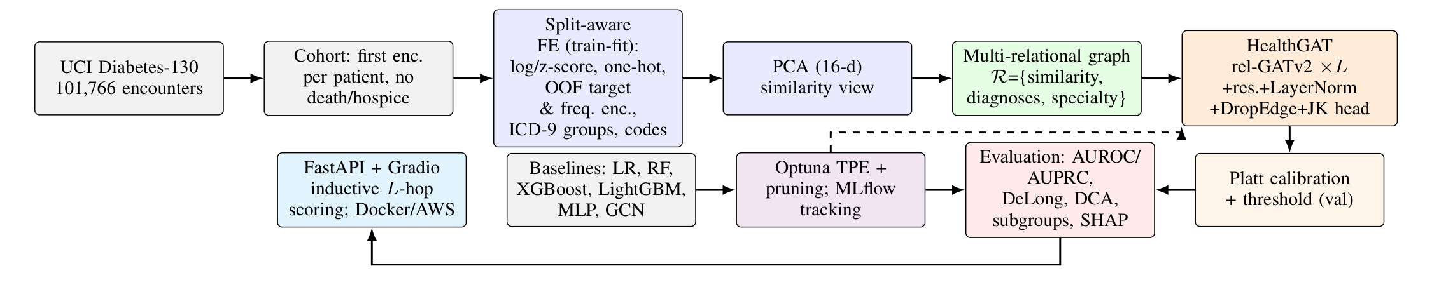
Fig. 1. Block diagram of the HealthGraph pipeline: data and cohort definition, split-aware feature engineering, PCA similarity view, multi-relational graph, HealthGAT, calibration, evaluation, hyperparameter search and deployment.

A. Data Preprocessing Pipeline
The target is y = 1 if readmitted = "<30". The main cohort keeps the first encounter per patient and removes encounters ending in death or hospice, giving 69,973 patients with prevalence 9.0%. Full-batch GAT training on CPU limits the graph experiments to a stratified 20,000-patient subsample; tabular models are also evaluated on the full cohort (Sec. V-B). Splits are stratified 70/15/15 and repeated over three seeds.
Feature engineering is fitted on training rows only. Numeric: eight utilisation counts, log(1+x) for heavy-tailed prior-visit counts, engineered totals (prior visits, number of diabetes drugs, dose changes), z-scored. Low-cardinality categoricals: one-hot, rare levels (<20) dropped. High-cardinality: the admitting specialty (72 levels) and three ICD-9 diagnoses (700+ codes) receive log-frequency encoding and smoothed target encoding μ̂ₖ = (Σᵢ∈ₖ yᵢ + m·ȳ)/(nₖ + m), m = 30, computed out-of-fold (5 folds) for training rows so no row sees its own label. Domain grouping: ICD-9 chapters following [1]. Codes: multi-hot of the 100 most frequent 3-character ICD-9 categories. In total there are 189 input features. Missing values (49% of specialties; HbA1c not measured in 83% of encounters) are kept as explicit categories because absence is informative.
Dimensionality reduction. PCA on the label-free block yields a 16-dimensional similarity view that keeps 81% of the variance (Fig. 2, left) and is used to build k-NN edges. t-SNE [25] and UMAP [26] project the learned embeddings for analysis.

B. Multi-Relational Patient Graph
Each patient is a node, linked by three relations: r₁ clinical similarity (k_s-NN in PCA space), r₂ shared diagnoses (k_c-NN, cosine, on ICD codes) and r₃ shared admitting specialty (k_g random peers, a care-team proxy). Edges are symmetrised and self-loops get their own relation type. Edges use features only, so they cannot leak labels. We measure outcome homophily per relation, P(yⱼ=1 | yᵢ=1, (j,i)∈r), against the base rate (Fig. 2, right).

C. Mathematical Formulation of HealthGAT
An encoder maps xᵢ to hᵢ⁽⁰⁾ = ELU(W₀xᵢ). Each relation-aware GATv2 layer computes, per head h:
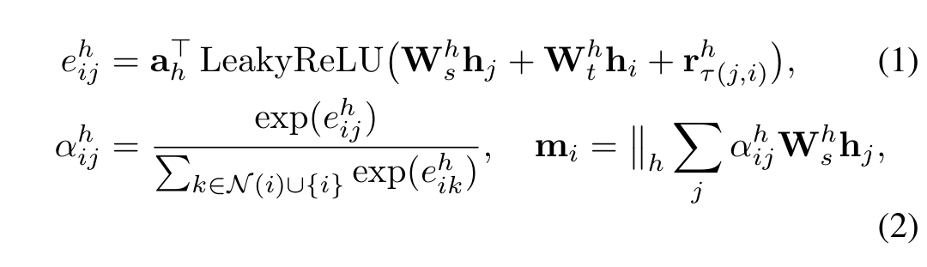
where r_τ is a learned embedding of the edge's relation, letting each head weigh similarity, diagnosis and specialty neighbours differently at far fewer parameters than R-GCN [10]. Applying the non-linearity before aₕ gives dynamic attention [8]. Each layer uses a residual connection, LayerNorm and dropout, and a jumping-knowledge head maps [h⁽⁰⁾ ‖ h⁽ᴸ⁾] to a logit. Training minimises class-weighted binary cross-entropy with AdamW, gradient clipping, DropEdge [16] and early stopping on validation AUPRC. Because the class weighting shifts all logits, Platt scaling [18] p = σ(az+b) is fitted on the validation split (temperature scaling [17] cannot correct a shift); the threshold maximises validation F1.

D. Hyperparameter Search Strategy
Optuna [19] with a TPE sampler maximises validation AUPRC on the seed-0 split. For HealthGAT the space covers hidden size {16, 32}, heads {2, 4}, layers {1, 2, 3}, dropout [0.2, 0.6], DropEdge [0, 0.4], learning rate [3×10⁻⁴, 5×10⁻³] (log), weight decay [10⁻⁴, 2×10⁻²] (log) and graph density k_s ∈ {5, 10, 20}, k_c ∈ {3, 5, 10}, k_g ∈ {0, 4, 8}, with median pruning after 30 epochs. XGBoost, LightGBM and RF have their own TPE studies; logistic regression uses exhaustive grid search over C. The test split is never used for selection. Every trial, per-epoch curve, metric and figure is logged to MLflow [20].

IV. Implementation and Experiments
Environment and computational setup. AMD Ryzen 7 7445HS (6 cores / 12 threads), 15 GB RAM, no GPU; Windows 11; Python 3.14, PyTorch 2.14 (CPU), scikit-learn 1.8, XGBoost 3.2, LightGBM 4.6, Optuna 5.0, MLflow 3.17, SHAP 0.52. All models train full-batch on CPU.
Experimental workflow. A Python package driven by YAML configs runs the stages tune → experiment → ablation → analyze → benchmark (python -m healthgraph all). Each seed re-fits the preprocessor and rebuilds the graph on its training split, and every stage resumes from checkpoints. Twenty-two pytest tests check the layer mathematics, the exactness of inductive inference and the API contract.
Tuning outcome. The HealthGAT study ran 16 trials (9 completed, 5 pruned, 2 interrupted). The best configuration (validation AUPRC 0.146) uses 32 hidden units × 2 heads, 3 layers, dropout 0.46, DropEdge 0.36, learning rate 0.0045, weight decay 0.0018, and k_s=10, k_c=5, k_g=8 (Fig. 3). The tuned graph has 604,990 directed edges over 20,000 patients.
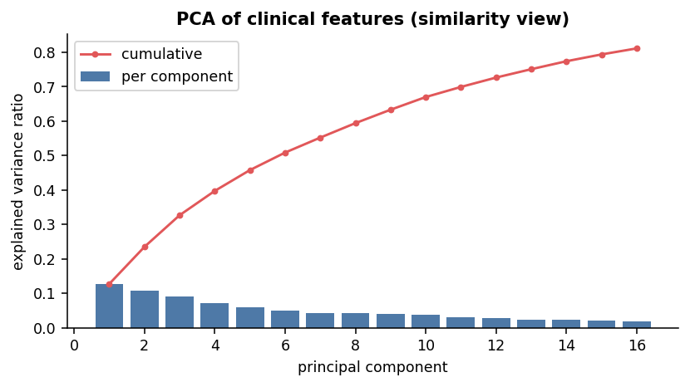 | 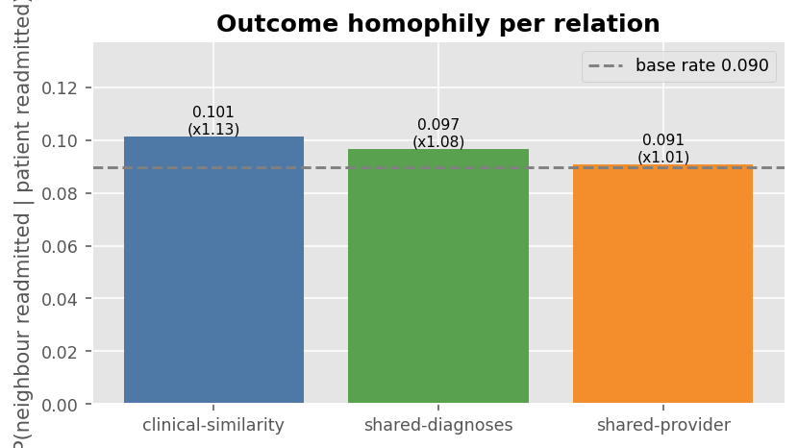
Fig. 2. Left: PCA spectrum of the similarity view. Right: outcome homophily per relation against the 9.0% base rate.

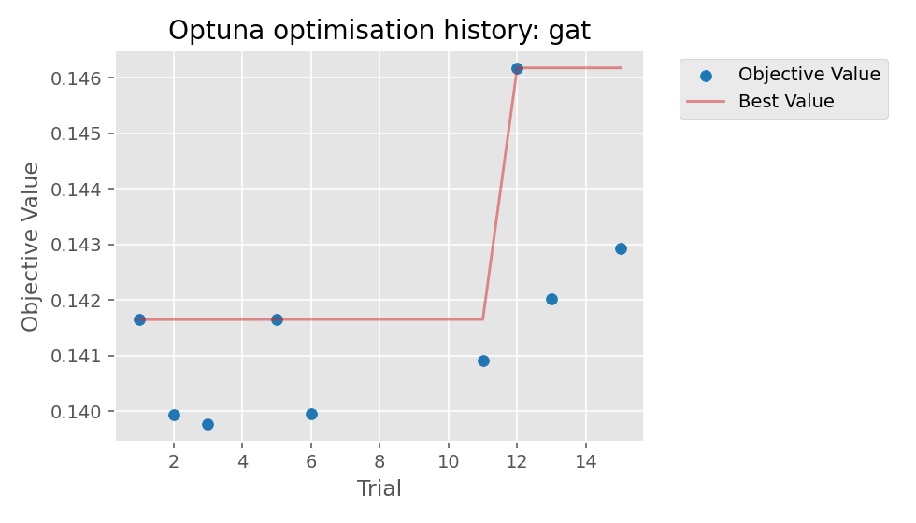 | 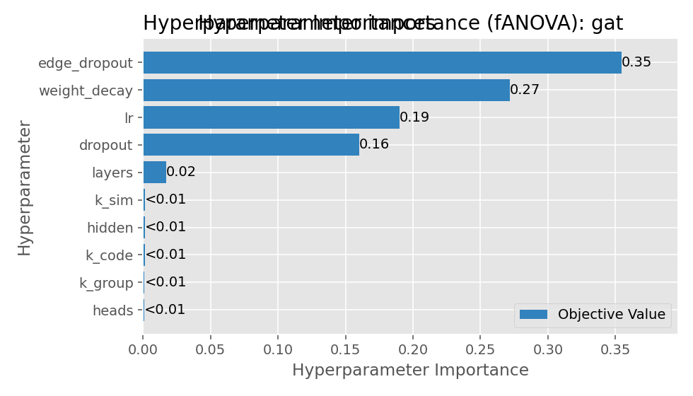
Fig. 3. Optuna search for HealthGAT: optimisation history (left) and fANOVA hyperparameter importance (right).
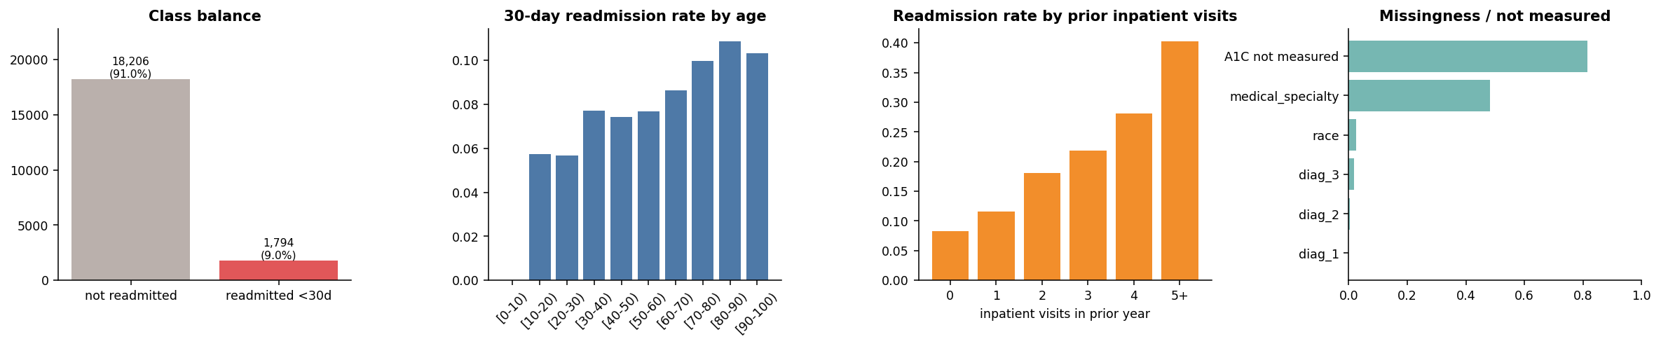
Fig. 4. Exploratory analysis of the 20k-patient cohort: 9.0% prevalence; readmission rises with age and steeply with prior inpatient stays; HbA1c is not measured in most encounters and the specialty is missing for about half.
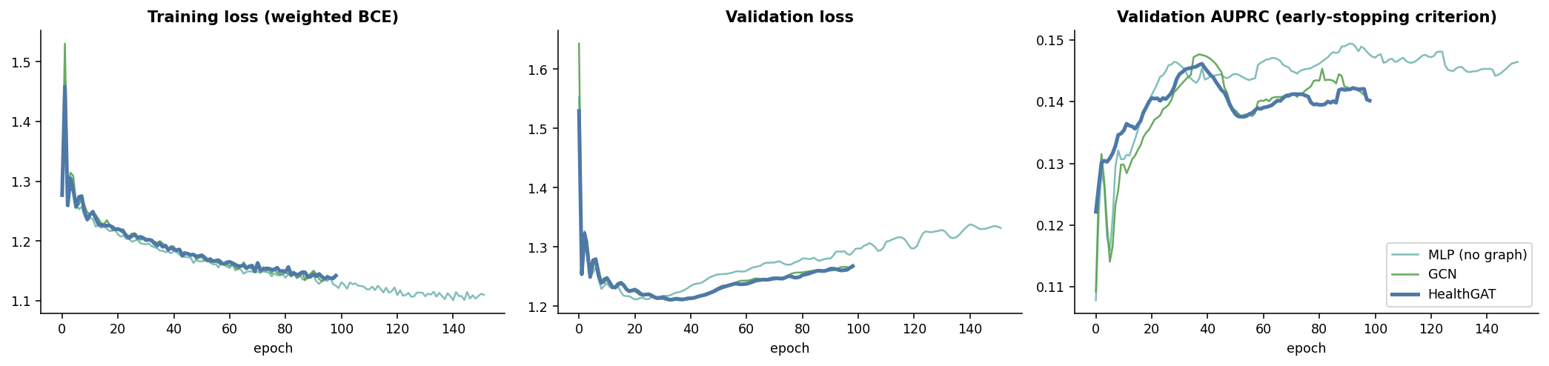
Fig. 5. Training dynamics (seed 0): training loss, validation loss and validation AUPRC (the early-stopping criterion) for MLP, GCN and HealthGAT.

Feature importance and model behaviour. SHAP [24] for XGBoost (Fig. 6) and gradient×input for HealthGAT rank the same drivers at the top: prior inpatient stays, discharge home (protective), length of stay, discharge to nursing or rehabilitation, and the engineered diagnosis target/frequency encodings, confirming the value of the high-cardinality encodings. The embedding projections (Fig. 7) show HealthGAT ordering patients along a risk axis not visible in the raw features.
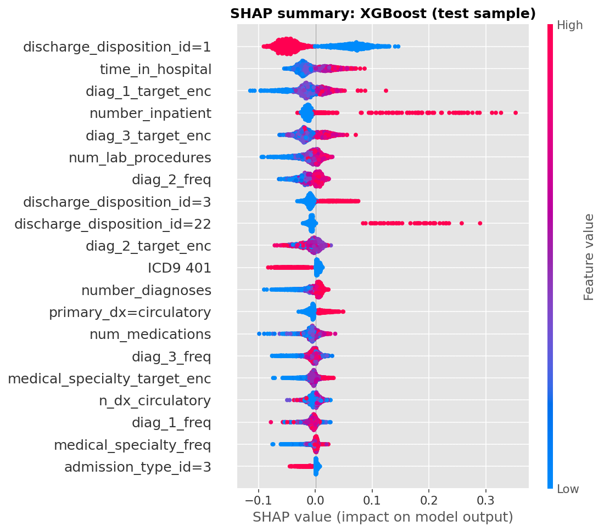
Fig. 6. SHAP summary for XGBoost (2,000 seed-0 test patients).

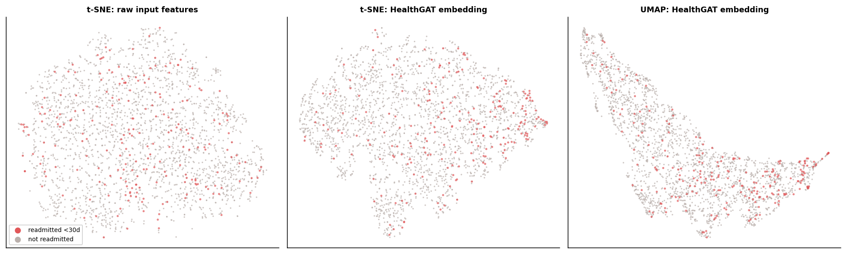
Fig. 7. t-SNE of raw input features against t-SNE and UMAP of the learned HealthGAT representation (2,500 test patients; red = readmitted).

Deployment. A trained GNN must score patients it has never seen. The deployment bundle stores the fitted preprocessor, the reference cohort's features and edges, the weights, Platt parameters and threshold. A new encounter is preprocessed with the same transform and attached to the reference graph with the training rules; because an L-layer GNN only sees L hops, the forward pass runs on that subgraph alone, and a unit test confirms it equals a full-graph pass to within 10⁻⁴. A FastAPI service exposes POST /predict, POST /predict/batch, GET /model/info and GET /health, with Pydantic input validation (enumerated codes, numeric ranges from the data dictionary, an ICD-9 regex, rejection of unknown fields, and refusal of death/hospice dispositions) returning HTTP 422 per-field errors. Responses include the calibrated risk, risk band, follow-up flag, top risk drivers and the most-attended similar patients. A Gradio UI (Fig. 8) is mounted at /ui. The Docker image (python:3.12-slim, CPU PyTorch, non-root, health check) is deployed on AWS EC2 (free-tier t3.micro, Amazon Linux 2023, ap-south-1) by deploy/deploy_aws_ec2.sh, which uses a private S3 bucket and an HTTP-only security group. The live service returns the same predictions as the local container in about 0.4 s. Live UI: http://15.252.73.160/ui — API docs: http://15.252.73.160/docs.

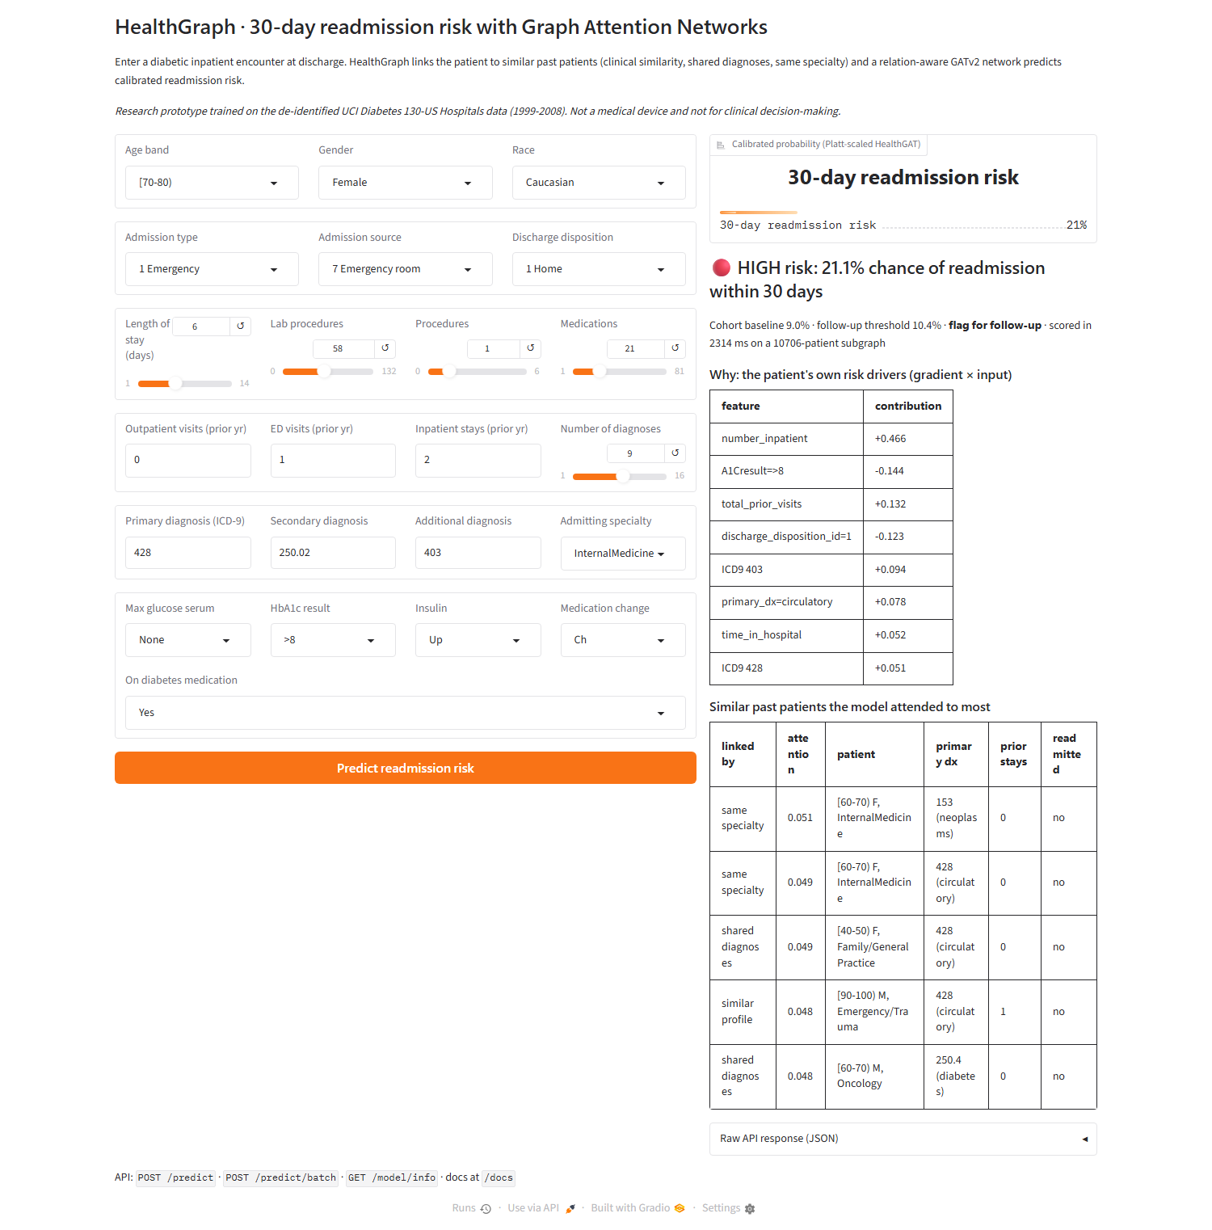
Fig. 8. HealthGraph web UI: encounter form, calibrated risk and band, the patient's own risk drivers, and the most-attended similar past patients.

V. Results and Comparative Analysis

A. Discrimination, Calibration and Significance
Table I gives test-set results on the strict cohort. All seven models land in a narrow band (AUROC 0.616–0.644). The best AUROC is logistic regression's (0.644±0.020), with the MLP (0.642), GCN (0.638) and HealthGAT (0.635±0.028) close behind; random forest has the best AUPRC (0.167). Seed-to-seed spread (sd ≈ 0.02–0.03) is as large as the gaps between models. Paired DeLong tests [21], [22] (Table II) find no significant difference between HealthGAT and any baseline in any seed, apart from one borderline p = 0.047 against the MLP, expected by chance across 18 tests. Tuned XGBoost had the best validation AUPRC yet the lowest test AUROC (0.616): single-split tuning overfits that split.
After Platt scaling every model is well calibrated (ECE ≤ 0.006, Fig. 9). At the tuned threshold HealthGAT flags 49.2% of readmissions with PPV 13.7% (≈1.5× the base rate), and its top risk decile captures 20.4% of readmissions. Decision-curve analysis [23] (Fig. 13) shows positive net benefit over "treat all" for thresholds of roughly 5–20%.

TABLE I
Test-set results on UCI Diabetes-130 (strict cohort, 20k patients; mean±sd over 3 seeds)
Model | AUROC | AUPRC | LogLoss | Brier | ECE | F1 | Sens. | PPV | Top-10%
Logistic Regression | 0.644±0.020 | 0.153±0.019 | 0.291 | 0.080 | 0.006 | 0.222 | 0.520 | 0.142 | 0.195
Random Forest | 0.633±0.021 | 0.167±0.020 | 0.291 | 0.080 | 0.006 | 0.215 | 0.491 | 0.138 | 0.219
XGBoost | 0.616±0.030 | 0.156±0.015 | 0.294 | 0.080 | 0.003 | 0.202 | 0.477 | 0.131 | 0.197
LightGBM | 0.629±0.017 | 0.159±0.016 | 0.292 | 0.080 | 0.006 | 0.213 | 0.457 | 0.141 | 0.219
MLP (no graph) | 0.642±0.019 | 0.154±0.017 | 0.292 | 0.080 | 0.006 | 0.229 | 0.489 | 0.153 | 0.208
GCN | 0.638±0.027 | 0.149±0.018 | 0.292 | 0.080 | 0.006 | 0.216 | 0.476 | 0.140 | 0.190
HealthGAT | 0.635±0.028 | 0.151±0.015 | 0.292 | 0.080 | 0.005 | 0.214 | 0.492 | 0.137 | 0.204

TABLE II
Uncertainty and paired significance tests (95% bootstrap CIs on the seed-0 test set; ΔAUROC = HealthGAT − model, mean over seeds; DeLong p per seed)
Model | AUROC (seed 0) | AUROC 95% CI | AUPRC 95% CI | ΔAUROC | DeLong p (seeds 0,1,2)
Logistic Regression | 0.658 | [0.627, 0.692] | [0.141, 0.212] | -0.0085 | 0.844, 0.249, 0.350
Random Forest | 0.650 | [0.617, 0.686] | [0.145, 0.218] | +0.0020 | 0.601, 0.753, 0.769
XGBoost | 0.632 | [0.598, 0.667] | [0.130, 0.198] | +0.0191 | 0.072, 0.210, 0.565
LightGBM | 0.646 | [0.614, 0.682] | [0.145, 0.221] | +0.0062 | 0.269, 0.675, 0.209
MLP (no graph) | 0.655 | [0.620, 0.690] | [0.143, 0.217] | -0.0066 | 0.826, 0.111, 0.047
GCN | 0.657 | [0.624, 0.691] | [0.140, 0.209] | -0.0023 | 0.868, 0.749, 0.120
HealthGAT | 0.657 | [0.623, 0.691] | [0.139, 0.209]

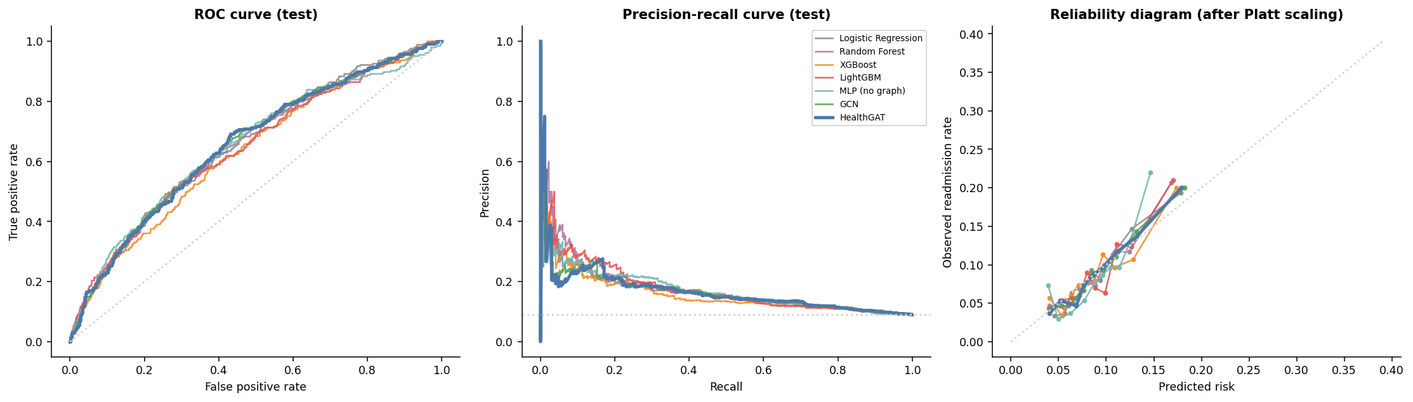
Fig. 9. Seed-0 test set: ROC (left), precision–recall (middle) and reliability diagram after Platt scaling (right).

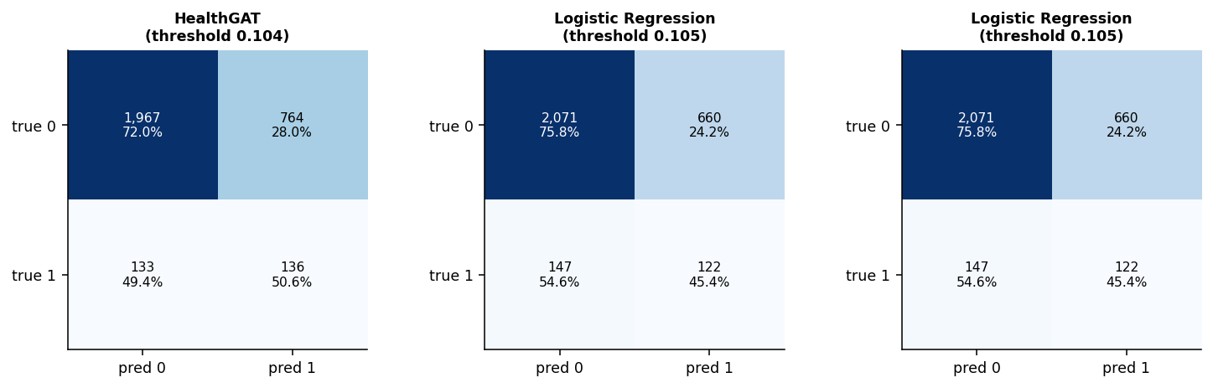
Fig. 10. Confusion matrices at validation-tuned (max-F1) thresholds, seed-0 test set.

B. Comparison with Published Benchmarks
Published numbers use all encounters with encounter-level splits [2], [3], so we re-ran our tuned tabular models under four protocols (Table III). Under the published protocol (P1, 101,766 encounters) our XGBoost reaches 0.681 and logistic regression 0.672, matching or exceeding the best published results (0.667 and 0.664–0.665). A patient-grouped split (P2; under P1 5,047 test patients also appear in training) changes AUROC only slightly (0.680). The cohort definition matters far more: first encounters only (P3) lower AUROC to 0.649–0.655, and the 20k subsample (P4) costs a further 0.01–0.03. On P4, logistic regression gives 0.644 against 0.635 for HealthGAT on the same splits. Cohort definition, not model choice, explains most of the spread in published AUROCs.
TABLE III
Comparison with published results (AUROC; ours: mean±sd, 3 seeds)
Source / protocol | Model | AUROC
Emi-Johnson & Nkrumah 2025 | XGBoost | 0.667
Emi-Johnson & Nkrumah 2025 | Logistic Regression | 0.642
Emi-Johnson & Nkrumah 2025 | Random Forest | 0.630
Emi-Johnson & Nkrumah 2025 | Deep neural network | 0.579
Salim & Ibrahim 2026 | XGBoost (tuned) | 0.664
Salim & Ibrahim 2026 | LightGBM | 0.660
Salim & Ibrahim 2026 | Logistic Regression | 0.657
Salim & Ibrahim 2026 | Random Forest | 0.650
Salim & Ibrahim 2026 | Stacking ensemble | 0.665
P1: all encounters, random split (ours) | Logistic Regression | 0.672±0.002
P1: all encounters, random split (ours) | XGBoost | 0.681±0.004
P1: all encounters, random split (ours) | LightGBM | 0.681±0.002
P2: all encounters, patient-grouped (ours) | Logistic Regression | 0.676±0.009
P2: all encounters, patient-grouped (ours) | XGBoost | 0.680±0.005
P2: all encounters, patient-grouped (ours) | LightGBM | 0.690±0.010
P3: strict cohort (70k) (ours) | Logistic Regression | 0.652±0.007
P3: strict cohort (70k) (ours) | XGBoost | 0.649±0.008
P3: strict cohort (70k) (ours) | LightGBM | 0.655±0.006
P4: strict cohort (20k) (ours) | Logistic Regression | 0.644±0.020
P4: strict cohort (20k) (ours) | XGBoost | 0.616±0.030
P4: strict cohort (20k) (ours) | LightGBM | 0.629±0.017

C. Error Analysis: Why the Graph Does Not Help Here, and When It Does
Homophily. A readmitted patient's clinical-similarity neighbour is readmitted 0.101 of the time (1.13× the base rate), a diagnosis neighbour 0.097 (1.08×) and a same-specialty neighbour 0.091 (1.01×). The graph is barely more homophilous than random, and its signal is largely already in the node features, so message passing has little to add [13].
Ablation and attention. Retraining without each relation (Table IV, Fig. 11) changes AUROC by less than the seed spread (all relations 0.635; self-loops only 0.640). Removing only the clinical-similarity edges was slightly worse in all three seeds (0.625), suggesting they mainly offset noise from the other relations. HealthGAT gives 48% of its attention to similarity neighbours, 26% to diagnosis and 21% to specialty neighbours, with attention lift towards later-readmitted neighbours of only 1.02 (1.00 = uniform).
TABLE IV
Relation ablation for HealthGAT on UCI (retrained per variant, 3 seeds)
Variant | AUROC | AUPRC
all relations | 0.635±0.028 | 0.151±0.015
without clinical-similarity | 0.625±0.030 | 0.143±0.017
without shared-diagnoses | 0.641±0.017 | 0.153±0.011
without shared-provider | 0.638±0.027 | 0.152±0.014
no edges (self-loops only) | 0.640±0.022 | 0.154±0.013

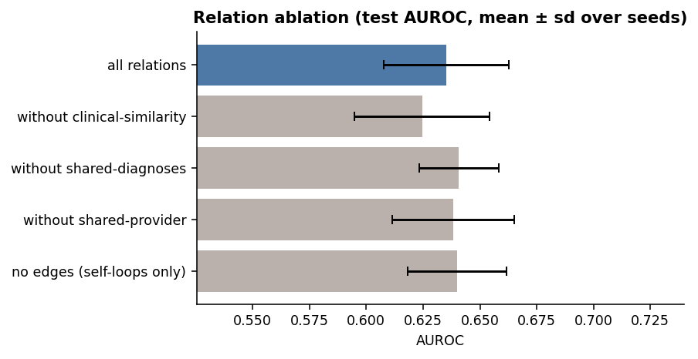
Fig. 11. Relation ablation on UCI (test AUROC, mean±sd over seeds).
Controlled synthetic study. We generated 6,000 synthetic patients with eight latent phenotypes and 120 providers whose hidden quality affects the outcome but leaves only noisy traces in individual records; same-provider edges carry 1.54× outcome enrichment. Here the graph models clearly beat every tabular model (Table V): HealthGAT reaches 0.767 against 0.737 for the identical network without message passing and 0.729 for LightGBM (DeLong p < 0.01 in two of three seeds), closing about a third of the gap to the oracle (0.826). Removing provider edges is the most costly ablation (0.767 → 0.732), about as costly as removing every edge (0.739). The architecture works; whether it helps depends on whether the graph carries outcome signal beyond the node features, which the homophily diagnostic checks before training.
TABLE V
Controlled synthetic study (6,000 patients, known ground-truth risk; mean±sd over 3 seeds)
Model | AUROC | AUPRC | Brier | ECE | Top-10%
Logistic Regression | 0.733±0.012 | 0.332±0.010 | 0.119 | 0.019 | 0.246
Random Forest | 0.732±0.025 | 0.312±0.040 | 0.120 | 0.025 | 0.203
XGBoost | 0.726±0.022 | 0.310±0.019 | 0.121 | 0.020 | 0.211
LightGBM | 0.729±0.017 | 0.306±0.016 | 0.120 | 0.017 | 0.220
MLP (no graph) | 0.737±0.007 | 0.330±0.005 | 0.119 | 0.020 | 0.244
GCN | 0.763±0.007 | 0.375±0.040 | 0.116 | 0.024 | 0.275
HealthGAT | 0.767±0.008 | 0.376±0.042 | 0.116 | 0.026 | 0.280
Oracle (true risk) | 0.826±0.011 | 0.506±0.043 | 0.102 | 0.022 | 0.344

Subgroups and error profile. Calibration holds in every subgroup (largest gap 5.7 percentage points), and discrimination is similar for women and men and for Caucasian and African-American patients (Fig. 12). Performance is weakest within patients who already have prior inpatient stays (AUROC 0.505 for prior inpatient visits = 2+). False negatives (410) average 0.06 prior inpatient stays against 0.72 for true positives: the model mostly misses first readmissions without utilisation history. False positives (2,539) are patients with prior stays (0.45) who were not readmitted. Both point to information the dataset lacks: social factors, post-discharge care and adherence.

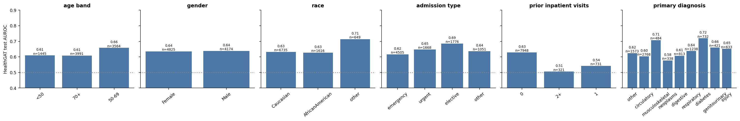
Fig. 12. HealthGAT test AUROC by subgroup (test sets pooled over seeds; n per bar; dotted line = chance).

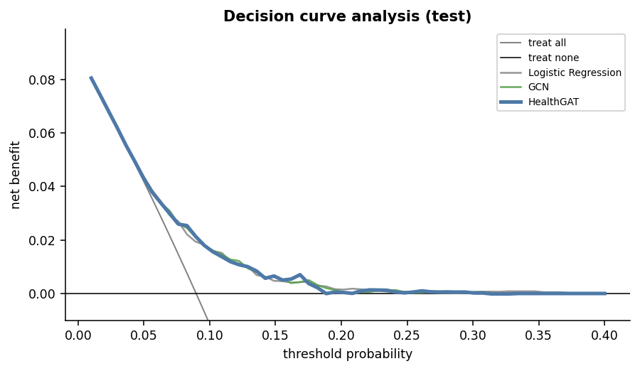
Fig. 13. Decision-curve analysis: net benefit against threshold probability.

VI. Conclusion and Future Scope
We built HealthGraph, an end-to-end system for 30-day readmission risk around a relation-aware GATv2 over a multi-relational patient graph, with leakage-safe feature engineering, automated Optuna tuning, MLflow tracking, a protocol-controlled benchmark and a validated, containerised cloud deployment. Under the published protocol our pipeline matches or exceeds the best reported AUROC on Diabetes-130 (0.681 against 0.667).
On the real data HealthGAT is as accurate and well calibrated as strong tabular baselines but not significantly better (0.635 against 0.644). Its graph is only weakly outcome-homophilous, and the ablation, attention budgets and synthetic study agree: patient graphs help when they encode latent shared factors that individual records do not show (0.767 against 0.737 on synthetic data), and add nothing otherwise. Measure homophily before committing to a GNN, and report results under an explicit cohort definition.
Deployment considerations. The model must be recalibrated and its reference graph refreshed for each new site and period: the data is from 1999–2008, uses ICD-9 and has no post-discharge information. Scoring cost grows with depth L; three-layer configurations led the search by only 0.004 validation AUPRC, so a 2-layer model is a reasonable latency trade-off.
Future scope. (i) Richer, more homophilous relations such as true provider or ward identifiers, shared medications or temporal encounter chains in MIMIC-IV; (ii) heterophily-aware or label-propagation variants [13]; (iii) mini-batch neighbour sampling to train on the full 70k cohort; (iv) prospective validation with fairness auditing across subgroups.
References
[1] B. Strack, J. P. DeShazo, C. Gennings, J. L. Olmo, S. Ventura, K. J. Cios, and J. N. Clore, "Impact of HbA1c measurement on hospital readmission rates: Analysis of 70,000 clinical database patient records," BioMed Research International, vol. 2014, Art. no. 781670, 2014.
[2] O. G. Emi-Johnson and K. J. Nkrumah, "Predicting 30-day hospital readmission in patients with diabetes using machine learning on electronic health record data," Cureus, vol. 17, no. 4, Art. no. e82437, 2025.
[3] S. S. Salim and A. A. Ibrahim, "A machine learning approach for predicting 30-day hospital readmission in patients with diabetes," Healthcare, vol. 14, no. 9, Art. no. 1185, 2026.
[4] S. Tang, A. Tariq, J. A. Dunnmon, U. Sharma, P. Elugunti, D. L. Rubin, B. N. Patel, and I. Banerjee, "Predicting 30-day all-cause hospital readmission using multimodal spatiotemporal graph neural networks," IEEE J. Biomed. Health Inform., vol. 27, no. 4, pp. 2071–2082, 2023.
[5] C. van Walraven et al., "Derivation and validation of an index to predict early death or unplanned readmission after discharge from hospital to the community," CMAJ, vol. 182, no. 6, pp. 551–557, 2010.
[6] D. Kansagara et al., "Risk prediction models for hospital readmission: A systematic review," JAMA, vol. 306, no. 15, pp. 1688–1698, 2011.
[7] P. Veličković, G. Cucurull, A. Casanova, A. Romero, P. Liò, and Y. Bengio, "Graph attention networks," in Proc. ICLR, 2018.
[8] S. Brody, U. Alon, and E. Yahav, "How attentive are graph attention networks?" in Proc. ICLR, 2022.
[9] T. N. Kipf and M. Welling, "Semi-supervised classification with graph convolutional networks," in Proc. ICLR, 2017.
[10] M. Schlichtkrull, T. N. Kipf, P. Bloem, R. van den Berg, I. Titov, and M. Welling, "Modeling relational data with graph convolutional networks," in Proc. ESWC, 2018, pp. 593–607.
[11] E. Choi, M. T. Bahadori, L. Song, W. F. Stewart, and J. Sun, "GRAM: Graph-based attention model for healthcare representation learning," in Proc. ACM SIGKDD, 2017, pp. 787–795.
[12] E. Choi et al., "Learning the graphical structure of electronic health records with graph convolutional transformer," in Proc. AAAI, 2020, pp. 606–613.
[13] J. Zhu, Y. Yan, L. Zhao, M. Heimann, L. Akoglu, and D. Koutra, "Beyond homophily in graph neural networks: Current limitations and effective designs," in Proc. NeurIPS, 2020.
[14] T. Chen and C. Guestrin, "XGBoost: A scalable tree boosting system," in Proc. ACM SIGKDD, 2016, pp. 785–794.
[15] G. Ke et al., "LightGBM: A highly efficient gradient boosting decision tree," in Proc. NeurIPS, 2017, pp. 3146–3154.
[16] Y. Rong, W. Huang, T. Xu, and J. Huang, "DropEdge: Towards deep graph convolutional networks on node classification," in Proc. ICLR, 2020.
[17] C. Guo, G. Pleiss, Y. Sun, and K. Q. Weinberger, "On calibration of modern neural networks," in Proc. ICML, 2017, pp. 1321–1330.
[18] J. Platt, "Probabilistic outputs for support vector machines and comparisons to regularized likelihood methods," in Advances in Large Margin Classifiers. MIT Press, 1999, pp. 61–74.
[19] T. Akiba, S. Sano, T. Yanase, T. Ohta, and M. Koyama, "Optuna: A next-generation hyperparameter optimization framework," in Proc. ACM SIGKDD, 2019, pp. 2623–2631.
[20] M. Zaharia et al., "Accelerating the machine learning lifecycle with MLflow," IEEE Data Eng. Bull., vol. 41, no. 4, pp. 39–45, 2018.
[21] E. R. DeLong, D. M. DeLong, and D. L. Clarke-Pearson, "Comparing the areas under two or more correlated receiver operating characteristic curves: A nonparametric approach," Biometrics, vol. 44, no. 3, pp. 837–845, 1988.
[22] X. Sun and W. Xu, "Fast implementation of DeLong's algorithm for comparing the areas under correlated receiver operating characteristic curves," IEEE Signal Process. Lett., vol. 21, no. 11, pp. 1389–1393, 2014.
[23] A. J. Vickers and E. B. Elkin, "Decision curve analysis: A novel method for evaluating prediction models," Med. Decis. Making, vol. 26, no. 6, pp. 565–574, 2006.
[24] S. M. Lundberg and S.-I. Lee, "A unified approach to interpreting model predictions," in Proc. NeurIPS, 2017, pp. 4765–4774.
[25] L. van der Maaten and G. Hinton, "Visualizing data using t-SNE," J. Mach. Learn. Res., vol. 9, pp. 2579–2605, 2008.
[26] L. McInnes, J. Healy, and J. Melville, "UMAP: Uniform manifold approximation and projection for dimension reduction," arXiv:1802.03426, 2018.

