HealthGraph: Patient Risk Prediction Using Graph Attention Networks
Coimbatore Institute of Technology · Department of Computing – AI & ML
Name | Naveenya V K
Roll No. | 2403717674422030
Course | 19MAM56 – Advanced Machine Learning Lab (III M.Sc. AI & ML)
Assessment | CAT II – Project Work
Date | 14.10.2026

1. Aim
To design, implement, tune and deploy an advanced machine-learning model that predicts whether a diabetic inpatient will be readmitted to hospital within 30 days of discharge. The model is a graph attention network over a patient-similarity graph; it is compared with state-of-the-art baselines and published benchmarks, and served as a containerised web application on the cloud.

2. Dataset
- Source: UCI Machine Learning Repository – Diabetes 130-US Hospitals for years 1999–2008 (Strack et al., 2014).
- Size: 101,766 encounters of 71,518 patients, 50 attributes (demographics, admission details, lab/procedure counts, three ICD-9 diagnoses, 23 diabetes drugs).
- Target: readmitted within 30 days (positive class 9.0% after cohort filtering → highly imbalanced).
- Cohort: first encounter per patient, deaths/hospice discharges removed (69,973 patients); a stratified 20,000-patient sample is used for the graph models, split 70/15/15 (train/validation/test) over three random seeds.

3. Tools and Environment
Python 3.14, PyTorch 2.14 (GAT written from scratch), scikit-learn 1.8, XGBoost, LightGBM, Optuna (hyperparameter search), MLflow (experiment tracking), SHAP, UMAP, FastAPI + Pydantic (API), Gradio (web UI), Docker, AWS EC2 + S3. Hardware: AMD Ryzen 7 7445HS CPU, 15 GB RAM (no GPU).

4. Procedure
- Load and filter the data: keep each patient's first encounter, drop expired/hospice discharges, define the 30-day label.
- Split into stratified train/validation/test sets (three seeds). Every statistic below is fitted on the training rows only, to avoid leakage.
- Feature engineering: log-transform and standardise counts; one-hot encode categoricals; encode the high-cardinality specialty (72 levels) and ICD-9 codes (700+) with frequency and out-of-fold smoothed target encoding; group ICD-9 codes into clinical chapters; keep "not measured" as its own category (189 features).
- Dimensionality reduction: PCA to 16 components (81% variance) gives a compact clinical-similarity space; t-SNE/UMAP are used for visual analysis.
- Build the patient graph with three edge types: k-nearest neighbours in PCA space, patients sharing diagnosis codes, and patients admitted under the same specialty.
- Train HealthGAT (relation-aware GATv2) with class-weighted loss, dropout, DropEdge and early stopping on validation AUPRC; train baselines (Logistic Regression, Random Forest, XGBoost, LightGBM, MLP, GCN) on the same splits.
- Tune all models with Optuna (TPE sampler + pruning; grid search for logistic regression) and log every trial to MLflow.
- Calibrate probabilities with Platt scaling and choose the decision threshold on the validation set.
- Evaluate on the test set: AUROC, AUPRC, F1, calibration (ECE), DeLong significance tests, bootstrap confidence intervals, subgroup and error analysis, relation ablation, SHAP; compare with published results under their protocol.
- Deploy: wrap the model in a validated FastAPI service with a Gradio UI, containerise with Docker, and host on AWS EC2.

5. Model Architecture
Each patient's features are encoded, then passed through stacked relation-aware GATv2 layers. For a patient i, every neighbour j receives an attention score that also depends on the type of link τ between them; the scores are normalised with a softmax and used to aggregate the neighbours' messages:
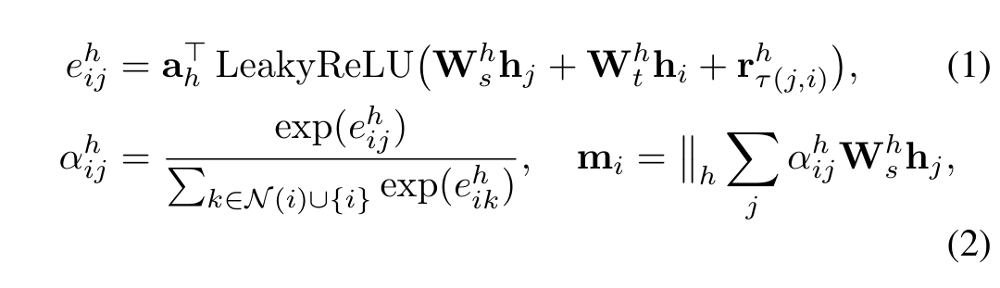
Residual connections, LayerNorm and a final MLP give the readmission logit. The tuned model uses 3 layers × 2 heads × 32 hidden units (Optuna, 16 trials, best validation AUPRC 0.146). Core of the attention layer (healthgraph/models.py):
xs, xd = self.lin_src(x).view(n, H, C), self.lin_dst(x).view(n, H, C)
g = leaky_relu(xs[src] + xd[dst] + self.rel(edge_type).view(-1, H, C))
alpha = edge_softmax((g * self.att).sum(-1), dst, n) # attention per edge
out = zeros_like(xs).index_add_(0, dst, xs[src] * alpha.unsqueeze(-1))

6. Results
Table 1: Test-set performance on UCI Diabetes-130 (mean ± sd over 3 seeds)
Model | AUROC | AUPRC | ECE | F1
Logistic Regression | 0.644±0.020 | 0.153±0.019 | 0.006 | 0.222
Random Forest | 0.633±0.021 | 0.167±0.020 | 0.006 | 0.215
XGBoost | 0.616±0.030 | 0.156±0.015 | 0.003 | 0.202
LightGBM | 0.629±0.017 | 0.159±0.016 | 0.006 | 0.213
MLP (no graph) | 0.642±0.019 | 0.154±0.017 | 0.006 | 0.229
GCN | 0.638±0.027 | 0.149±0.018 | 0.006 | 0.216
HealthGAT | 0.635±0.028 | 0.151±0.015 | 0.005 | 0.214

Table 2: Comparison with published benchmarks
Source / protocol | Best model | AUROC
Emi-Johnson & Nkrumah (2025), published | XGBoost | 0.667
Salim & Ibrahim (2026), published | Stacking ensemble | 0.665
Ours – same protocol as the papers (P1) | XGBoost | 0.681
Ours – strict first-encounter cohort (P3) | LightGBM | 0.655

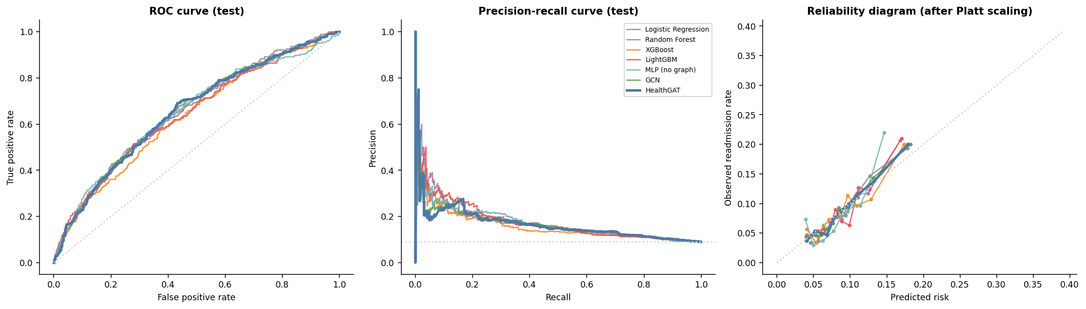
Fig. 1: ROC, precision–recall and calibration curves of all models (seed-0 test set)
Observations:
- Under the published evaluation protocol our pipeline exceeds the best published AUROC (0.681 vs 0.667).
- On the strict cohort all models perform similarly; HealthGAT (AUROC 0.635) is on par with logistic regression (0.644) — DeLong tests show no significant difference. Every model is well calibrated (ECE ≈ 0.005).
- The patient graph is only weakly informative here (a readmitted patient's neighbours are readmitted only 1.13× as often as average), and removing all edges does not hurt (0.640 vs 0.635).
- In a controlled synthetic study where the graph does carry hidden risk information, HealthGAT clearly wins (0.767 vs 0.737 without the graph): graph models help only when the links carry outcome signal.
- Top risk factors (SHAP): prior inpatient stays, discharge destination, length of stay and the engineered diagnosis encodings. The model is weakest for first-time patients with no prior visits (most missed cases).

7. Deployment
- API: FastAPI with endpoints POST /predict, POST /predict/batch, GET /model/info, GET /health; Pydantic validation rejects invalid inputs (HTTP 422).
- Web UI: Gradio form showing the calibrated risk, risk band, the patient's risk drivers and the most similar past patients.
- Container & cloud: Docker image (non-root, health check) deployed on AWS EC2 free tier (t3.micro, Mumbai region); ≈0.4 s per prediction.
- Live link: http://15.252.73.160/ui · Code: https://github.com/Navshifty/healthgraph
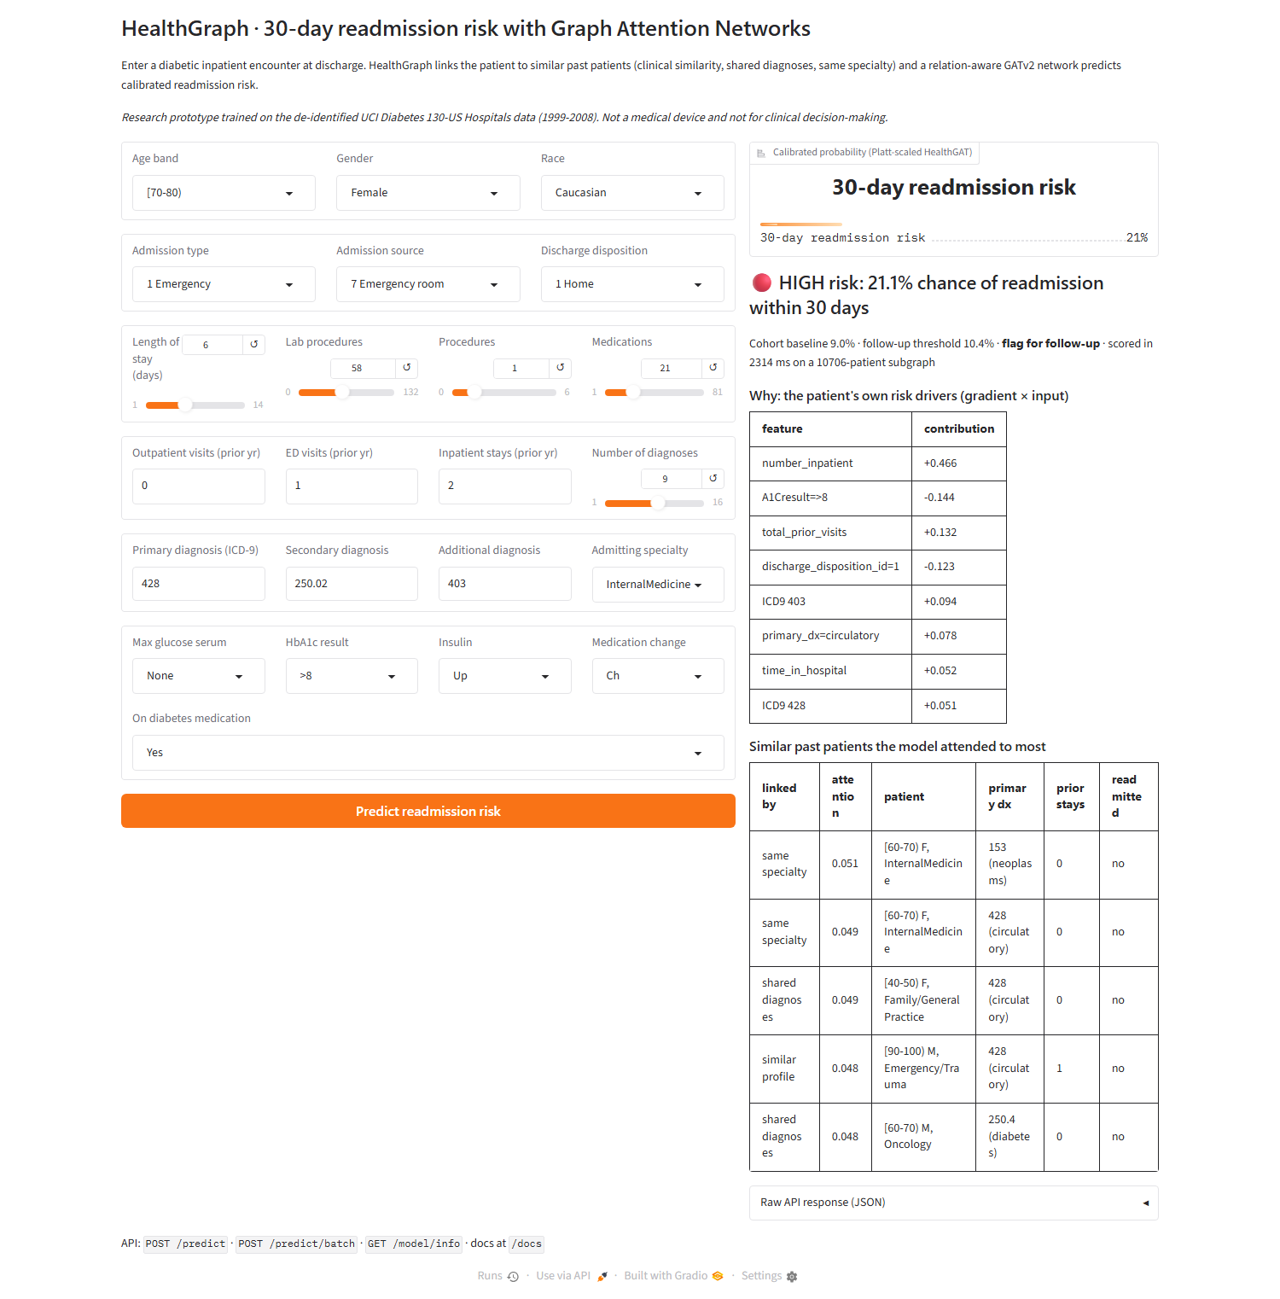
Fig. 2: HealthGraph web UI on AWS: input form, calibrated risk, risk drivers and similar past patients

8. Result
Thus, a graph-attention-based patient risk prediction system (HealthGraph) was successfully designed, tuned with Optuna, tracked with MLflow, benchmarked against published work and deployed as a Dockerised FastAPI/Gradio application on AWS. The pipeline outperformed published results under their protocol (AUROC 0.681), and the study showed that graph attention improves prediction only when the patient graph carries outcome information.

