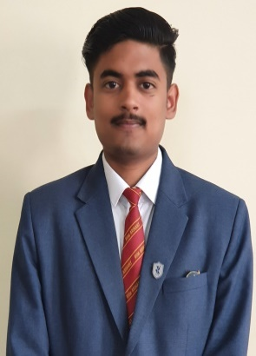

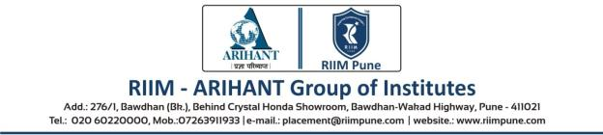**Rohit Singh**

**Specialization: Marketing**

**Date of Birth: 03 August 1997**

**Education Summary**

|  |  |  |  |  |
| --- | --- | --- | --- | --- |
| **Degree/**  **Certificate** | **Stream/**  **Specialization** | **Name of Institution &**  **Board/ University** | **Year of Passing** | **Percentage**  **(%)** |
| MBA | Marketing | Savitribai Phule Pune University, Pune | 2021 | Pursuing |
| B.SC | Hotel Management | Institute Of Hotel Management Catering Technology & Applied Nutrition, Meerut, U.P | 2018 | 66.0 |
| Higher Secondary | Commerce | Nirmala Convent Senior Secondary School, Renukoot (CBSE), U.P | 2015 | 76.0 |
| Senior Secondary | All | Nirmala Convent Senior Secondary School, Renukoot (CBSE), U.P | 2013 | 67.0 |

**Projects / Internships**

**Graduation Project**

**Organization:** Hospitality and Tourism Industry **Duration:**  15 Days

**Project Title:** A Study on consumer Behaviour with Reference to ITC Ltd.

**Project Brief:** To Study the Consumer Behaviour and Customer relationship towards Foods and

Services where we can provide Customer Satisfaction at ITC Hotels Ltd.

**Internship**

**Organization:** Hometown Future Retail **Duration:**  4 Days

**Project Brief:** To Study Retail Store Operation, Consumer Behaviour, and Selling Skills of Homeware

And Furniture department.

**Trainings/Certifications/Workshops /Industrial Visits**

* Business Intelligence Certification by MakeIntern.
* Industrial Visits:
  + Nandan Diary at Baramati.
  + National Stock Exchange, Mumbai.
  + Cotton King at, Baramati.
  + Tech Mahindra, Pune.
* Management Development Program (MDP) by IIM INDORE.
* Capability Certificate Industry 4.0 by Tata Steel.
* Global Collaboration Certificate by X-Culture.
* Digital Marketing Certification Course by Globysn Bussiness School.
* Career Edge Knockdown the Lockdown by TCS-ION Digital Manufacturing Solution.
* The Fundamentals of Digital Marketing by Google.

**Extra-Curricular Activities / Achievements**

* Vice President of College during Graduation.
* Food Committee Head at RIIM, Pune.

**Personal Details**

**Interests** : Watching Hollywood Movies & Series, Playing Out Door Games.

**Languages Known :** English, Hindi, French (Beginner).

**Permanent Address :** I-675 Hindalco Colony Renukoot, Sonebhadra, Uttar Pradesh, Pin Code: 231217

**Contact Details :** 9792470291 & 8417963391