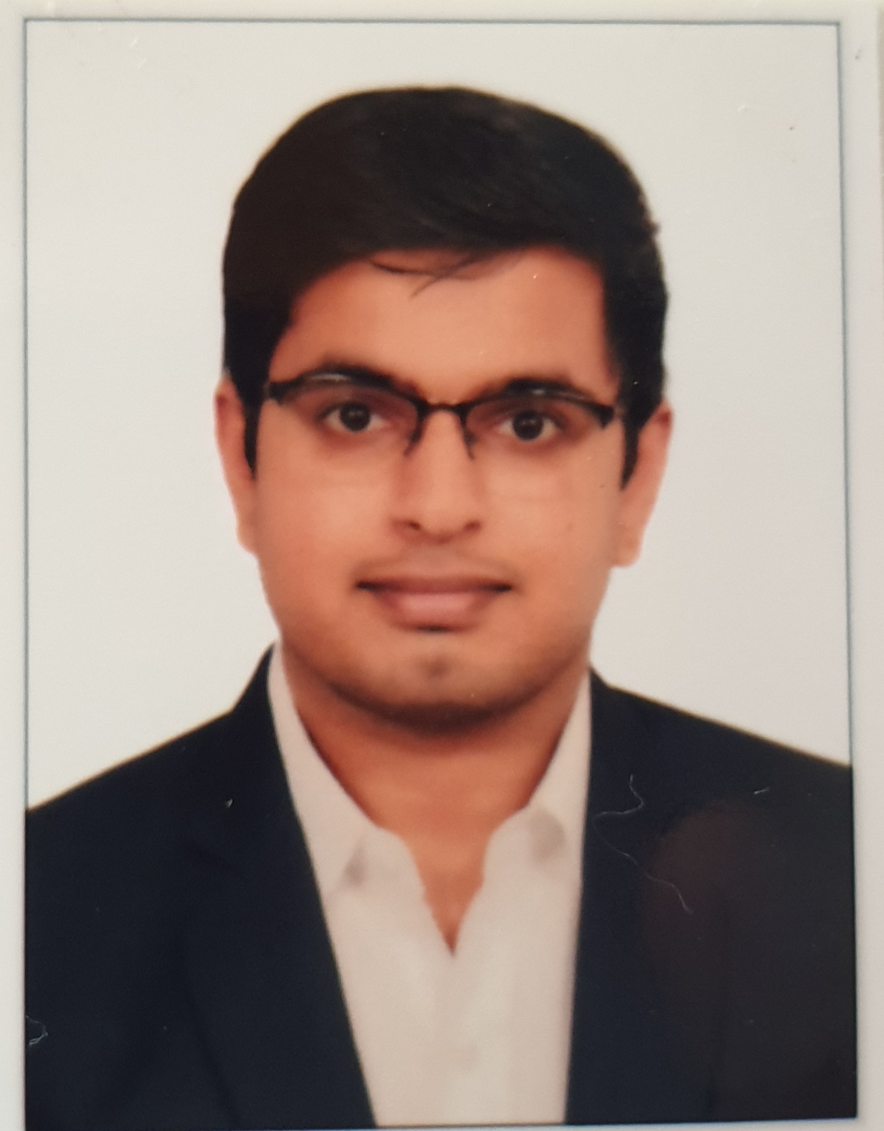

**Mumbai**

Name : Amit Purohit

Address : Runwal Anthurium Mulund West 400080

Mobile no. : 8369901776

Email Id : purohit.amit000@gmail.com

D.O.B : 09th January 1996

**CAREER OBJECTIVE:** Secure a responsible career opportunity to fully utilize my skills, while making a significant contribution to the success of the company.

|  |  |  |  |
| --- | --- | --- | --- |
| **ACADEMIC CREDENTIALS :** | | | |
| **Qualification** | **Institution/University** | **Percentage/CGPA** | **Year** |
| PGPM( MARKETING ) | ICFAI Business School- Mumbai | 7.30/10 | 2018-20 |
| Mcom ( Business management ) | Mulund College of Commerce (MCC) | 8.13/10 | 2017- 19 |
| BMS (finance) | Bedekar college | 6.4/7 | 2014-17 |
| HSC | MCC | 70.15 % | 2014 |
| SSC | Holy Mary Convent High School | 72.36 % | 2012 |

|  |
| --- |
| **ADDITIONAL QUALIFICATIONS** : |
| * International Diploma in Marketing from Finplan institute. |

|  |
| --- |
| **SUMMER INTERNSHIP PROJECT** : COMPONENT MASTERS |
| Project Title: New Business Development Executive |
| Work Involved:   * Call customers from the database provided and explain about the products. * Maintain a record of customer contacted in google sheet and follow up with them periodically. * Maintaining fruitful relationships with existing customers. * Developing sales goals for the team and ensuring they are met. * Dealing with customers unsatisfied with the quality of the product or service. * Contacting potential clients via email or phone to establish rapport and set up meetings. |

|  |
| --- |
| **ADDITIONAL PROJECT UNDERTAKEN :** |
| * Big bazar live project   The project period was for 6 days. My assigned work was customer interaction helping them in downloading and registration process of Future Pay app. Creating awareness and explain the offers going on. Also handling different queries of different customers. |

|  |
| --- |
| **CO-CICURRULAR ACTIVITIES :** |
| * Head boy in 9th and 10th. * Placement cell (Pune campus ). * Volunteers in different events in MCC college. * Participated as a member of eco-friendly ganesh visharjan organized by our college. * Participated as a team member in IBS pune for Marathon |

|  |
| --- |
| **COMPUTER LITERACY:** |
| * MS( Word , Excel, Power Point ) * Email (mail merge, filters, folders, rules) |

|  |
| --- |
| **LINGUISTIC PROFICIENCY** : |
| English, Hindi, Marathi, Marwadi |

|  |
| --- |
| **HOBBIES & INTERESTS** : |
| * Novels , * kabaddi, * Playing shuttle, * A Passion for music and * Teaching kids. |