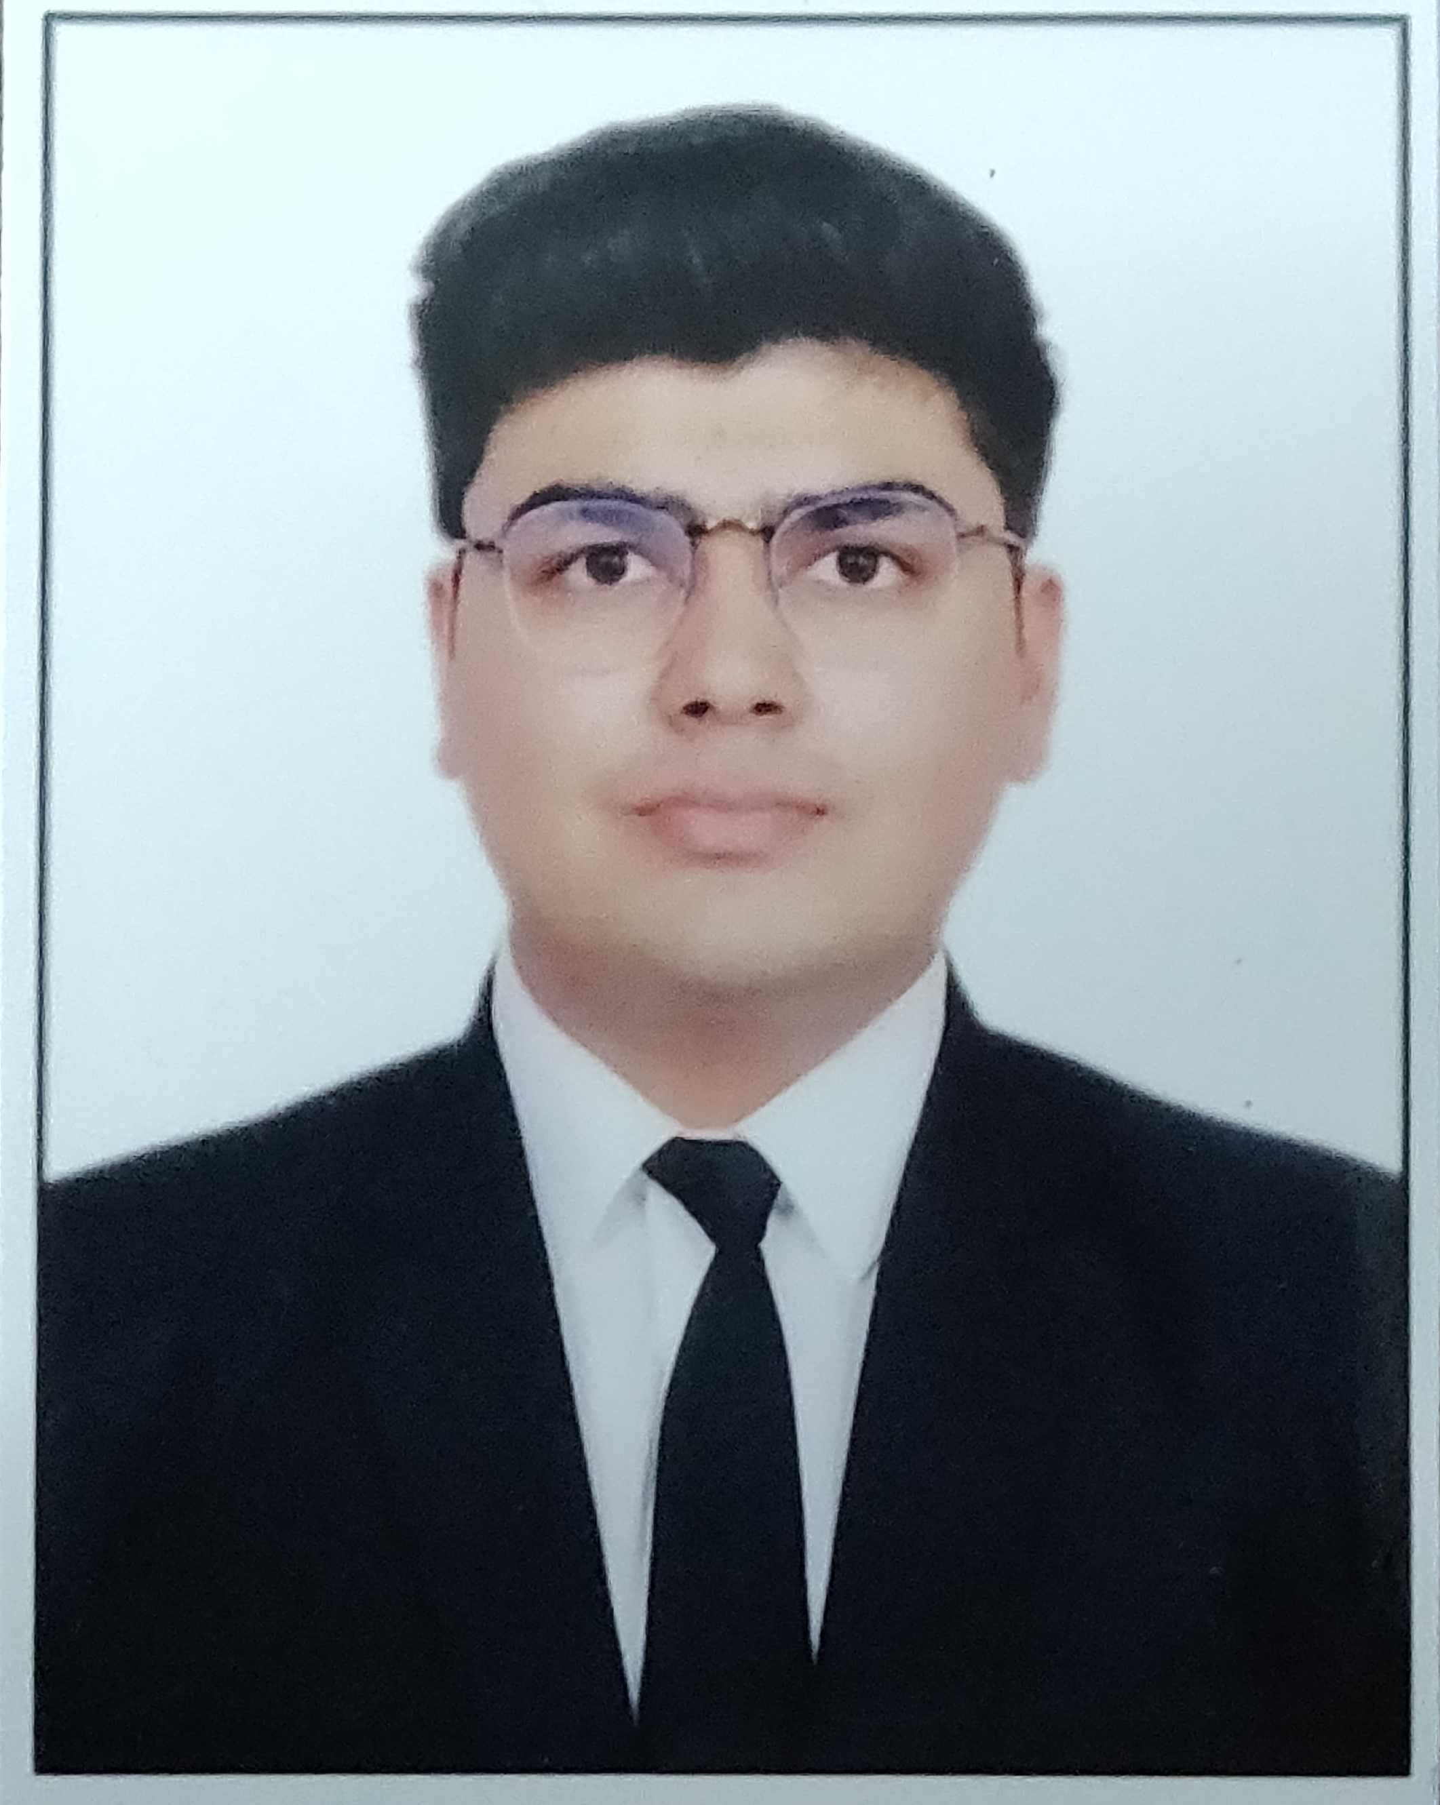

Yash Singhal

**Date of Birth:** 26th July,2001

**Address:** 1190, Fatehganj, Faizabad (Uttar Pradesh) -224001

**Email:** [yashsinghal2607@gmail.com](mailto:yashsinghal2607@gmail.com)

**Mobile Number:** (+91)-7080949419

**Objective**

To associate as an intern, with a reputed organization while utilizing and building upon my skills by continuously contributing to the company and seeking out professional developmentwhile maintaining the integrity and work ethics of the working environment.

**Education**

|  |  |  |  |  |
| --- | --- | --- | --- | --- |
| **S.NO.** | **COURSE** | **INSTITUTION** | **YEAR** | **SCORE** |
| 1. | B.Sc. in Hospitality and Hotel Industry | Institute of Hotel Management, Catering and Nutrition, Pusa | 2019-2020 | Pursuing |
| 2. | ISC – Indian School Certificate | St. George’s College, Mussoorie | 2019 | 88.2% |
| 3. | ICSE- Indian Certificate of Secondary Certificate | St. George’s College, Mussoorie | 2017 | 90.2% |

**Experience**

**•** Worked as an intern for the organisation, GotoChef for 3 months. It is a platform where we have to submit 2 recipes and review 20 products daily.

• Worked as an business development (sales) intern for East Coast Hospitality, Goregaon, Mumbai for a month.

**Achievements**

* **Tree Plantation Drive** organised by my school St. George's College was lead by me

in the year 2018. The whole school had participated in the drive starting from the

students of class 4 to class 12.

* Lead a group of students to participate in make intern start up ideas workshop at IIM Indore in 2018.
* Participated in the **PLAYNOMICS WORKSHOP** on **INTERNATIONAL TRADE** conducted by **Indian School of Business & Finance, New Delhi**.
* Participated in the **MAKEINTERN WORKSHOP** conducted by **IIT Kharagpur** and was selected to lead the team of 5 at IIM INDORE in a Business Start Up Workshop.
* Participated in the **RISPANA TO RISHIPARNA TREE PLATATION DRIVE** launched by CHIEF MINISTER of UTTARAKHAND, MR. TRIVENDRA SING RAWAT in 2018.
* Lead the Tree Plantation Drive organised by my school St. George’s College in 2018.
* Participated in the **All India Art Competition, Spectrum** held at Unison World School.
* Participated in **Javelin Throw & Discuss Throw** at **ASISC Regional Athletic Meet**.
* Member of the school ATHLETICS Team.
* Member of the school FOOTBALL Team.

**Skills**

* **Ms Office(Word, Excel, PowerPoint) –** Intermediate
* **Java(BlueJ) –** Intermediate
* **Communication –** High

**Language Proficiency**

English and Hindi