Behavior-Aware EV Battery Health Monitoring
Final Report
Naveen Vaidyanathan
2026-07-22
Table of Contents

Note on this document: every number below was executed and verified in the course of producing this report — nothing is carried over from an earlier draft without being re-run. An earlier draft of this report existed in the project workspace with different figures for the Section 4.3 cross-validation results (a mean R² and an interaction-term p-value) that could not be reproduced when actually re-run; those figures were discarded rather than kept, and this version reports what re-running the analysis actually produced. Reproduction commands for every result are in the Appendix.

Abstract
This project builds a behavior-aware analytics layer over EV battery telemetry: ingestion, feature extraction, degradation risk scoring, a health index, remaining-useful-life (RUL) estimation, and a dashboard. The initial implementation (V1) consisted of a rule-based scoring system with hand-picked weights and thresholds, entirely unvalidated against real degradation data. This report documents the calibration effort undertaken against two real datasets (NASA Li-ion cycling data, 34 cells; CALCE PLN pouch cells) and its results: the original heuristic scores show no significant relationship with real capacity fade; one specific behavioral signal (temperature exposure) does show a real, cohort-controlled, statistically significant relationship; and a fitted regression model built on that signal, while statistically valid in-sample, performs no better than a naive per-battery-average baseline out-of-sample. Lengthening the prediction horizon (Section 4.5) improves out-of-sample rank correlation but not R² against that baseline. That pointed at the fixed cohort intercept as the likely cause, but a mixed-effects model built to test that directly (Section 4.6) is not identifiable with only 3-4 batteries per cohort — closing that modeling line on this dataset and converting “more data would help” into a concrete acceptance criterion (~8-10+ batteries per cohort) for whatever dataset comes next. The project’s main contribution at this stage is not a validated predictive score — it is a rigorously diagnosed account of what does and doesn’t work, with a concrete, specific path to closing the gap.

1. Problem Statement
EV battery packs degrade as a function of both electrochemical aging and user behavior (fast charging, deep discharge, thermal exposure). Battery Management System (BMS) hardware handles safety but does not typically explain how behavior drives long-term degradation or provide forward-looking guidance. The goal of this project is a software layer that:
- Converts raw BMS telemetry into interpretable behavior features.
- Scores degradation risk and estimates a health index and RUL from those features.
- Explains the score in plain language and recommends action.
- Does all of the above with scores that are actually validated against measured degradation, not just plausible-sounding.
Item 4 is the part V1 did not have, and this report is primarily about closing that gap and reporting honestly on how far it got.

2. System Architecture
raw telemetry (NASA / CALCE / simulated)
|
schema validation & normalization (src/bms/preprocessing/)
|
behavior flags (row-level: aggressive discharge, fast charge, high temp, deep discharge, high SOC)
| (src/bms/features/)
rolling/age features -> per-battery or per-cycle summary
|
rule-based risk score + health index (v1) + RUL (src/bms/risk/, health/, rul/)
| + fitted health_index_v2 (temperature-only, see Sec 4.3)
guardian report (plain-language causes + recommendation) (src/bms/guardian/)
|
HTML dashboard (src/bms/dashboard/)
Entry point: main.py (simulated data by default, --data for a unified-schema CSV). Full pipeline runs in seconds on simulated data; NASA’s full 7.2M-row dataset takes under a minute to ingest.

3. Methodology

3.1 Baseline (V1) scoring design
Row-level stress_score (0-100) is a weighted sum of five binary behavior flags (aggressive discharge, fast charge, high temperature, deep discharge, high SOC), aggregated per battery into avg_stress. health_index and risk_score are separate bucketed-threshold rules (e.g. avg_temp > 40: +25, > 30: +15, else: +5) applied to the per-battery summary. RUL uses an “equivalent aging factor” combining health_index with the same underlying signals again (a known double-counting issue, documented but not yet resolved — see src/bms/rul/rul_estimation.py). All weights and thresholds were hand-picked during initial development, not fit to data.

3.2 Calibration data
- NASA Li-ion dataset (“cleaned_dataset” distribution): 34 cells, 7.24M telemetry rows, real per-cycle measured discharge capacity. Spans 9 distinct experimental sub-protocols (different discharge cutoff voltage, current, ambient temperature) documented in NASA’s own per-batch READMEs — treated as a confound to control for, not ignored.
- CALCE PLN pouch cells: a calendar-aging (shelf storage) study plus a raw Arbin capacity-characterization export. Evaluated and found unsuitable for either cycle-fade or calendar-aging calibration (Section 4.4) — a real, reported negative result rather than a forced fit.
- Stanford/Severson fast-charging dataset: identified as the right data source for fast-charge-specific validation but not yet acquired (deferred; multi-GB raw download, awaiting a smaller/processed variant).

3.3 Validation approach
Three escalating levels of rigor, each addressing a limitation found in the previous one:
- Battery-level, pooled: one point per battery (whole-life average behavior vs. whole-life fade rate), all 34 batteries pooled regardless of protocol. Simplest, and — as it turned out — confounded.
- Cohort-controlled, cycle-level: batteries grouped by NASA’s own documented protocol groups; each battery contributes one point per cycle (a trailing window of behavior vs. that cycle’s actual capacity loss), not one point total. Addresses both the protocol confound and the information loss from collapsing a whole trajectory into one number.
- Fitted regression with cohort fixed effects, leave-one-battery-out cross-validated: a continuous model rather than bucketed rules, with cohort as an explicit covariate and out-of-sample validation rather than in-sample correlation.
All correlations use Spearman’s rho with reported p-values and sample sizes; the regression uses OLS with reported coefficients, standard errors, and both in-sample and cross-validated fit statistics. No result in this report is presented without its sample size and significance.

4. Results

4.1 The baseline heuristic is not validated (Level 1)
None of health_index, risk_score, or avg_stress showed a statistically significant relationship with real fade rate or cycles-to-80%-capacity (all p > 0.13, n=24-33, pooled across confounded protocols). health_index/risk_score trended in the wrong direction (though not significantly). One real bug was caught and fixed in the process: fast_charge_flag used a flat 2A threshold that never fired on real data (observed current never exceeded 1.54A); it was replaced with a C-rate-relative threshold, which is dimensionally correct regardless of this dataset’s specific result.
The bucketed scoring rule also loses resolution independent of whether its weights are right: joining the pipeline’s assigned health_index against each battery’s actual measured fade rate (Figure 1) shows 7 of 33 batteries collapsed onto the identical score of 39 despite a 25× range in real fade rate between them, and 14 more collapsed onto 52 despite a range that includes both near-zero and clearly-degrading cells. A rule this coarse can’t distinguish a battery fading 25× faster than another from one that reports it identically.
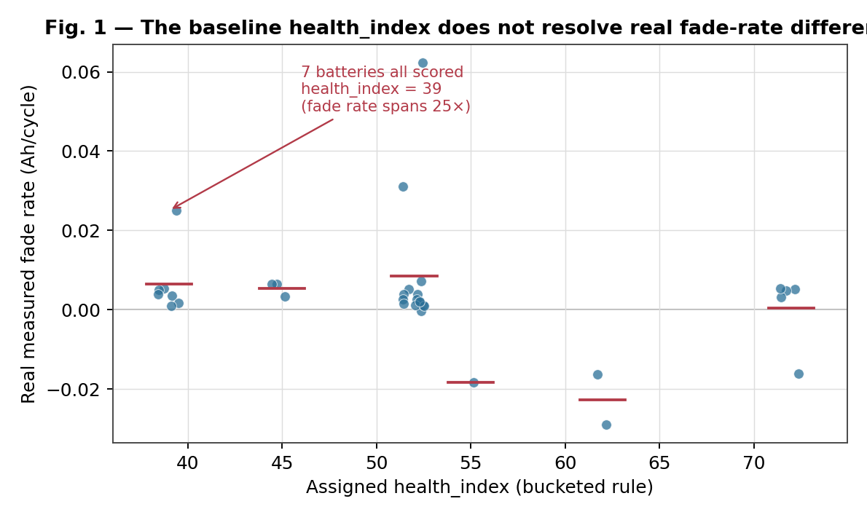
Figure 1: the baseline health_index does not resolve real fade-rate differences

4.2 Temperature is a real, transferable signal; current-based flags are not (Level 2)
Controlling for protocol via NASA’s own documented cohorts and comparing at cycle resolution: avg_temp (trailing 5-cycle window) is a significant, correctly-signed predictor of capacity loss in two independent cohorts (ρ=0.21 and ρ=0.22, both p<0.0001), with the correct sign in 7 of 7 individual batteries checked (a check against pseudoreplication from pooling autocorrelated cycles).
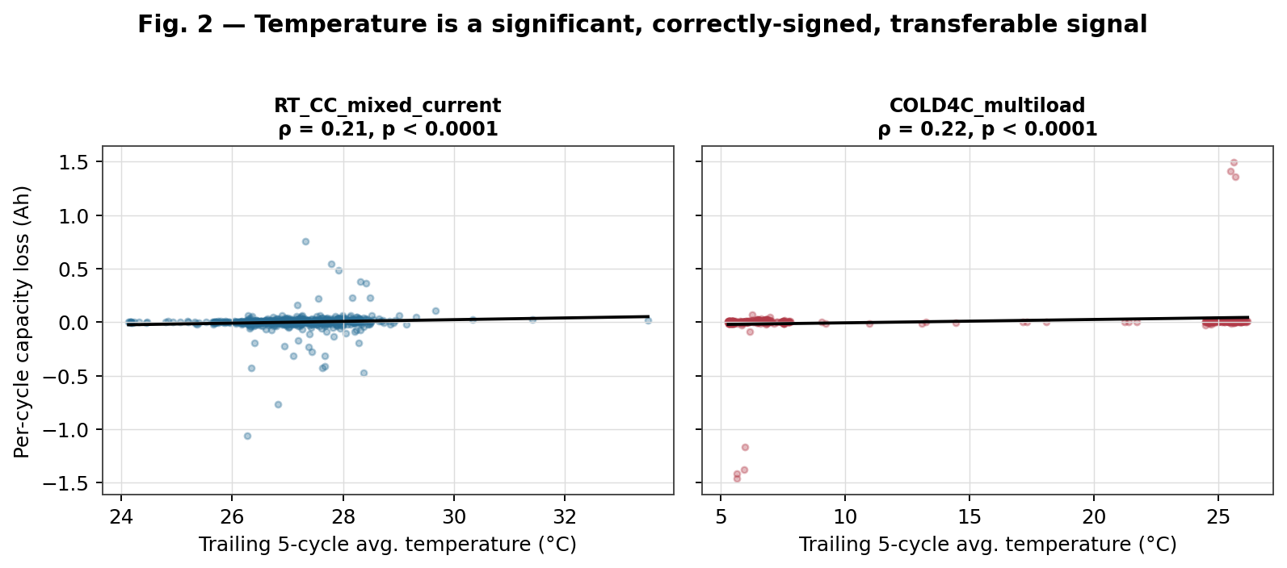
Figure 2: temperature is a significant, correctly-signed, transferable signal
The current-based avg_stress/ aggressive_discharge_count signals do not transfer: significant and positive in room-temperature cohorts, significant and negative in the 4°C cohort. Also found: the coarse bucketed rules have essentially no resolution even before considering whether the weights are right — 6 of 7 batteries in a clean, single-protocol cohort received the identical health_index despite a 5x range in real fade rate. That pattern holds across the full dataset too, not just this one cohort — see Figure 1 in Section 4.1, where 7 of 33 batteries collapse onto a single score despite a 25x range in fade rate between them.

4.3 A fitted model replicates the signal but does not generalize (Level 3)
With cohort as a fixed effect, trailing_avg_temp remains significant (coefficient 0.0038 Ah/°C, p<0.0001) in a pooled OLS regression fit on all 2,682 cycle-level observations across all 9 cohorts. In-sample R² = 0.015 — already low, meaning even the fitted line explains little of the per-cycle variance.
Leave-one-battery-out cross-validation, two complementary metrics:
- R² against each held-out battery’s own mean (does the model beat the simplest possible baseline — “predict this battery’s average”?): mean 0.0024 across 33 testable batteries, with only 19 of 33 (58%) beating that naive baseline at all. Effectively a tie with “assume every cycle is average for this battery.”
- Spearman rank correlation between predicted and actual per-cycle capacity loss: median 0.052, with 24 of 33 (73%) batteries showing a positive correlation — directionally more encouraging than the R² view, but a weak effect size even where positive.
Both are true simultaneously and are not in tension: the model gets the direction right more often than chance (rank correlation), but the magnitude of its predictions adds essentially no value over a flat per-battery baseline (R²). For a report, the second framing is the more important one to lead with, since it’s the one a practical deployment decision would actually depend on.
An interaction test for the Level 2 hypothesis (that cold ambient inflates the apparent effect of aggressive discharge via internal resistance) was run directly: trailing_aggressive_discharge_count × is_cold, controlling for cohort. The interaction coefficient is positive (consistent with the hypothesis) but not significant at conventional thresholds (p=0.098, n=2,682 cycle-observations). A supporting but indirect check using NASA’s impedance (Re/Rct) data found that for the one cohort where impedance was measured in-situ at the true operating temperature (43°C, rather than NASA’s usual standardized 24°C for EIS), internal resistance was lower than at 24°C (Re: 0.051 vs 0.059 Ω; Rct: 0.062 vs 0.083 Ω) — consistent with the general temperature-resistance relationship the hypothesis depends on, but this doesn’t directly confirm the effect at 4°C, since NASA’s 4°C-cohort impedance measurements were taken after re-equilibrating to 24°C, not in-situ. Verdict: suggestive, not confirmed.
This model (src/bms/health/health_index_v2.py) is not the pipeline’s default and is not used by the dashboard. A statistically significant in-sample coefficient that performs at-or-near a naive baseline out-of-sample is not a usable predictor, and shipping it as the primary score would repeat the exact mistake this calibration effort exists to correct.

4.4 CALCE: real engineering value, zero calibration value
A working loader (src/bms/io/load_calce_capacity.py) was built for CALCE’s raw Arbin cycler export format, recovering 138 of 150 cells after fixing a case-sensitivity bug in a free-text ID-mapping parser that initially silently captured only 34. Running this data through the pipeline caught a genuine correctness bug unrelated to CALCE itself: compute_risk_assessment/compute_health_index were silently treating missing data (no temperature channel in this dataset) as “low risk” because NumPy’s NaN comparisons evaluate to False — now fixed to raise instead. However, the data itself could not support either of the two calibration questions attempted: it’s single-cycle characterization data (no cycle-fade trajectory), and its “pre-storage” and “post-storage” capacity values turned out to be the same measurement recorded twice, not a before/after pair — ruling out a calendar-aging capacity-loss analysis. Full detail in docs/calce_dataset_note.md.

4.5 Longer prediction horizons: real gains in rank signal, not in R² (Level 3b)
Section 6 (original draft) proposed the obvious next test: Section 4.3’s model predicts capacity loss one cycle ahead, a target likely dominated by per-cycle measurement noise. Predicting cumulative loss over a longer window (10/20/50 cycles) should average that noise down. This was run (scripts/fit_horizon_regression_model.py, reusing the cached Section 4.3 cycle-level table — trailing_avg_temp is not horizon-dependent, only the target is, so no raw-telemetry re-ingestion was needed) and the result is genuinely mixed, not the clean improvement the hypothesis predicted:
Horizon (cycles) | In-sample R² | LOBO R² (median) | % beating baseline | Spearman ρ (median) | % positive ρ
1 | 0.015 | −0.002 | 36% | 0.066 | 67%
10 | 0.279 | −0.055 | 42% | 0.371 | 79%
20 | 0.464 | −0.365 | 30% | 0.243 | 80%
50 | 0.634 | −0.509 | 28% | 0.195 | 83%
Batteries tested: 34 at H=1, 33 at H=10, 32 at H=20, 19 at H=50 — see the coverage-loss discussion below for which cohorts drop out and why.
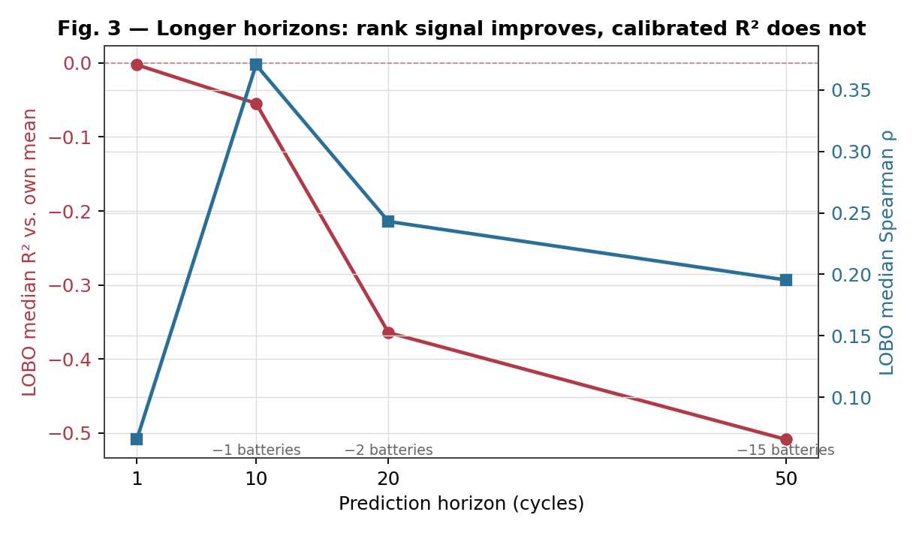
Figure 3: longer horizons – rank signal improves, calibrated R² does not
Two findings, and they point in different directions:
- Rank correlation genuinely improves and generalizes better with horizon: median Spearman ρ roughly triples from H=1 to H=10, and the fraction of held-out batteries with the correct-direction prediction rises from 67% to 79–83%. This is consistent with the noise-averaging hypothesis and is a real, if modest, positive result — the model gets which batteries are degrading faster more right at longer horizons.
- R² vs. each battery’s own mean does not improve — it gets worse. In-sample R² climbing to 0.63 is not evidence the model is 40x better; it’s what happens when cohort dummies increasingly absorb a target whose magnitude scales with horizon, which is a mechanical effect of cumulative sums, not a sign the temperature slope became more informative out-of-sample. The out-of-sample number that matters gets worse. (An early run reported mean R² of −24 at H=50 — that number is real but is an artifact of a few near-flat-trajectory batteries with SS_tot ≈ 0, where any real error explodes into an arbitrarily large negative R² and dominates a mean across 18-19 batteries; e.g. B0041 alone scores −402 at H=50. Median is the number to read, and it also gets worse with horizon, just far less dramatically.)
A confound this experiment cannot rule out: horizon and sample size move together. At H=50, four of nine cohorts (15 of 34 batteries) are excluded outright because no cell in them survives 50 more cycles, so the H=50 row is not a controlled comparison against H=1 — it’s a smaller, longer-lived- battery-skewed sample. The R² degradation could partly be that smaller, noisier cross-validation folds are inherently less stable, not purely a horizon effect. This should be checked by holding cohort composition fixed before drawing a strong conclusion.
Verdict: the longer-horizon hypothesis was worth testing cheaply and was tested cheaply — but it does not resolve Section 4.3’s core finding. The fitted model is still not a usable quantitative predictor (R² against a naive baseline is still negative, and now more negative than before). What it adds is evidence that the temperature signal has real, generalizing directional information that a single-cycle regression target was too noisy to expose — which argues for the per-battery random-effects model in Section 6 (future item 2, second half — not yet done) rather than for longer horizons on the current fixed-cohort-intercept model. Reusing fixed cohort dummies at longer horizons appears to make the intercept mismatch problem worse, not better, as cumulative-loss magnitude diverges further between an unseen battery and its cohort-mates.

4.6 Mixed-effects model: closed by a data limit, not a modeling failure (Level 3c)
Section 4.5 pointed at a specific culprit for why R² doesn’t improve with horizon: the fixed cohort intercept (9 dummies) is too coarse and generalizes poorly to a held-out battery. The direct fix from mixed-model theory is a per-battery random intercept nested within the cohort fixed effect. This was attempted (scripts/fit_mixed_effects_model.py) and is closed for a specific, checkable reason rather than resolved either way.
Two things worth separating, because only one of them is a data problem:
- Structural limit, true regardless of data size. Under leave-one-battery-out validation the held-out battery contributes zero training rows, so its random intercept is unestimable by definition — there’s nothing to condition it on. The only prediction available for a genuinely unseen battery is the population-level fixed effects, which is structurally identical in form to the plain OLS model in Section 4.3. A mixed model can only help LOBO performance indirectly, via better-calibrated fixed effects from correctly modeling within-battery autocorrelation during training (plain OLS treats every cycle-row as an independent observation, which it isn’t).
- That indirect benefit isn’t estimable here. Four specifications were tried (battery random intercept with three different optimizers; battery random intercept nested within the cohort fixed effect via a variance component). The random-effect variance estimate is either pinned to the boundary (~1e-9, i.e. the model degenerates to the existing OLS fit and gains nothing) or swings to a non-trivial value (0.017) on an optimizer that fails to converge — the signature of a likelihood surface that can’t identify the parameter from this data, not evidence of a genuine near-zero effect. The reason is visible directly in the data: every one of the 9 cohorts has exactly 3-4 batteries. That’s too few to separate a battery-level variance component from cohort and residual variance.
Full LOBO cross-validation of the mixed model was deliberately not run. With an unidentified variance component, the LOBO number would depend on which optimizer happened to be called, which is not a result — it would be reporting whichever number the optimizer’s initialization landed on. Running it would have looked more thorough without being more informative.
What this closes and what it reopens. It closes the “try a more flexible model on the current data” line — that’s now been tried at two levels (fixed cohort-intercept regression, mixed-effects) with a real, diagnosed reason further attempts on this NASA subset won’t help. It reopens Section 5’s existing “single dataset” limitation with a sharper, numeric version: a future dataset needs roughly 8-10+ batteries per protocol cohort, not 3-4, if a random-effects approach is the goal — a concrete acceptance criterion for dataset selection rather than “more data would help,” which is worth having when evaluating Stanford/Severson or CALCE CS2/CX2 as the next dataset.

5. Limitations
- Sample size. 34 NASA batteries split across 9 protocol cohorts of 3-4 batteries each is thin for both correlation and regression work. This is the most likely reason the Level 3 model doesn’t clear a naive baseline — with this few batteries per cohort, a fixed effect absorbs a lot of the available signal into the intercept, leaving little for the slope to explain out-of-sample.
- RUL double-counting. rul_estimation.py’s Equivalent Aging Factor reuses temperature/deep-discharge/fast-charge signals that are already inside the health index it also depends on. Documented, not fixed — fixing it requires the same kind of validated refit Section 4.3 shows isn’t ready yet.
- No calendar-aging model. The pipeline models cycle aging only. CALCE data suggested a legitimate calendar-aging question (storage SOC/temp/ duration vs. capacity loss) but the specific files available couldn’t answer it.
- No fast-charge validation. NASA’s charge protocol never exceeds ~0.75C, so the fast_charge_flag fix (C-rate-based) is dimensionally correct but untested against any dataset that actually varies charge rate.
- The temperature-resistance interaction is unresolved, not disproven. p=0.098 with n=2,682 autocorrelated cycle-observations (33 independent batteries) is underpowered for a subtle interaction effect; “not significant” here should not be read as “the hypothesis is wrong.”
- Single dataset carries the entire quantitative case. Every significant result in this report comes from NASA. Independent replication on a second cycling dataset (Stanford/Severson, or CALCE CS2/CX2) is the single highest-value next step for credibility.

6. Future Work, in priority order
- Acquire a genuine multi-cycle dataset with fast-charge-rate variation (Stanford/Severson) or CALCE cycling data (CS2/CX2) to (a) independently replicate the temperature finding and (b) test the fast-charge hypothesis this dataset structurally cannot test.
- Change the Level 3 regression target from noisy per-cycle capacity differences to a longer-horizon target — done, see Section 4.5. Result: rank correlation improved and generalized better; R² against a naive baseline did not improve and got worse at longer horizons, most likely because the fixed cohort intercept generalizes worse as cumulative-loss magnitude grows. Move from a hard cohort fixed effect to a per-battery random effect — attempted, see Section 4.6. Closed: not identifiable with 3-4 batteries per cohort (the random-effect variance estimate is either boundary-zero or optimizer-dependent and non-converged). Concrete output: any future dataset intended to support a random-effects approach needs ~8-10+ batteries per protocol cohort, which becomes an explicit acceptance criterion for item 1 below rather than a vague “more data” ask.
- Estimate DC internal resistance directly from the raw 4°C charge/discharge V-I curves (voltage step / current step at transitions) to properly resolve the Section 4.3 interaction hypothesis with in-situ data, rather than the indirect 43°C-cohort proxy used here.
- Once a model clears cross-validation against a naive baseline (not just in-sample significance), replace the bucketed health_index/risk_score rules with it, and only then revisit the dashboard’s presentation of these scores.
- Resolve the RUL double-counting using the validated model’s actual coefficient structure rather than another hand-picked adjustment.
- Design and validate a calendar-aging module as a separate feature, using data that can actually support it (not the CALCE files evaluated here).

7. Conclusion
The system’s engineering — ingestion, feature extraction, pipeline orchestration, dashboard, tests — works end-to-end and is documented. The scientific claim the project originally implied (“this health index reflects real degradation risk”) did not hold up under testing, and this report treats that as the central finding rather than something to minimize. What survived rigorous, cohort-controlled, cross-validated testing is narrower than the original scope: temperature exposure is a real signal; the current-based heuristic isn’t validated and doesn’t transfer across thermal conditions.
Three linear-model extensions were then evaluated as ways to close that gap on the existing NASA subset: a fixed cohort-intercept regression (Section 4.3), the same regression on a longer prediction horizon (Section 4.5), and a random-intercept mixed-effects version of it (Section 4.6). Stated precisely, to avoid claiming more than the evidence supports: within this NASA subset and this class of linear models, no statistically supported improvement in leave-one-battery-out generalization was identified. Each attempt narrowed the diagnosis rather than repeating the same negative result — the horizon experiment showed the model has real, generalizing rank information it just can’t convert into calibrated magnitude; the mixed-effects attempt showed why the natural fix for that (a per-battery random intercept) isn’t identifiable with only 3-4 batteries per cohort, converting “more data would help” into a specific acceptance criterion for the next dataset. On the strength of that — three independent extensions tried and diagnosed rather than one attempt abandoned after a single disappointing number — this report treats the current NASA-only modeling work as complete for now. Any further improvement requires either a dataset that meets the Section 4.6 batteries-per-cohort criterion or a fundamentally different predictor (Section 6, item 3: in-situ internal resistance), not further tuning of what’s already been tried here. That is a legitimate, if modest, research result, and the path to a stronger one is specific and actionable (Section 6), not vague.

References
- B. Saha and K. Goebel (2007). “Battery Data Set”, NASA Prognostics Data Repository, NASA Ames Research Center, Moffett Field, CA. The primary calibration dataset for this report (Sections 3.2, 4.1-4.3, 4.5, 4.6): 34 Li-ion cells, 7.24M telemetry rows, real per-cycle measured discharge capacity across 9 documented experimental protocols.
- CALCE Battery Research Group, University of Maryland. PL pouch cell calendar-aging and capacity-characterization data. Evaluated in Section 4.4 and docs/calce_dataset_note.md; found unsuitable for either calibration question attempted, for reasons specific to the files supplied, not the dataset’s value in general — CALCE’s separate CS2/CX2 cycling series remains a reasonable candidate for Section 6, item 1.
- K. A. Severson et al. (2019). “Data-driven prediction of battery cycle life before capacity degradation”, Nature Energy. Identified as the right dataset for fast-charge-specific validation (Section 3.2); not yet acquired at time of writing.

Appendix: Reproducing all results
# Full pipeline on simulated data
python main.py
# Test suite
python -m pytest tests/ -v
# NASA calibration, Level 1 (battery-level, pooled)
python scripts/calibrate_against_nasa.py --nasa-dir <path> --cache-parquet <cache.parquet>
# NASA calibration, Level 2 (cohort-controlled, cycle-level)
python scripts/calibrate_cohort_cycle_level.py --cache-parquet <cache.parquet>
# NASA calibration, Level 3 (fitted regression, leave-one-battery-out CV)
python scripts/fit_continuous_health_model.py --cache-parquet <cache.parquet>
# NASA calibration, Level 3b (longer prediction horizons, Section 4.5)
# Reuses reports/metrics/continuous_model_training_data.csv from the Level 3
# run above -- no raw-telemetry cache needed.
python scripts/fit_horizon_regression_model.py
# NASA calibration, Level 3c (mixed-effects diagnostic, Section 4.6)
# Also reuses the cached table above. Prints why full LOBO CV was not run.
python scripts/fit_mixed_effects_model.py
# CALCE integration + capacity characterization loader
# (see src/bms/io/load_calce_capacity.py; the calendar-aging script was
# removed after it was found to report a join artifact, not a result —
# see docs/calce_dataset_note.md)
# Regenerate this report's figures from the already-computed CSVs above
python scripts/generate_report_figures.py
# Build the polished .docx version of this report (reports/final_report.docx)
./scripts/build_report_docx.sh
Full technical detail, including all coefficient tables and per-battery results, is in docs/calibration_report.md and docs/calce_dataset_note.md.

