Construction of an Arbitrage-Checked Foreign Exchange Implied Volatility Surface from Delta-Quoted Market Instruments
Navy
July 2026
Code and reproducible notebook: github.com/NavyBlueCheese/fx-vol-surface
Abstract
Foreign exchange options are quoted in delta space rather than strike space: per tenor, the market publishes an at-the-money volatility, risk reversals, and butterflies at fixed delta levels. Turning these five numbers per tenor into a continuous, arbitrage-free implied volatility surface requires precise handling of FX delta conventions, which vary by currency pair and tenor and include a premium-adjusted variant whose call delta is not monotonic in strike, and correct treatment of the quoted butterfly, which is a market-strangle (broker fly) quote rather than a direct measure of smile convexity. This paper documents fxvol, an open-source Python engine that implements Garman-Kohlhagen pricing with a full analytic Greek set, all four FX delta conventions with correct branch selection for premium-adjusted deltas, the Reiswich-Wystup market-strangle calibration at the 25-delta and 10-delta wings, shape-preserving smile interpolation in total variance with a C1 wing extrapolation, linear-in-total-variance term interpolation, and static no-arbitrage diagnostics based on call convexity, the Durrleman condition, and calendar monotonicity. The central acceptance criterion is that the calibrated surface must reprice its own inputs. On the illustrative data used throughout, quotes are recovered from the finished surface with a worst error of about 1e-11 volatility points against a tolerance target of 0.01. As a byproduct of the arbitrage diagnostics, we show that the common practice of hard flat-in-volatility wing extrapolation creates a genuine negative-density butterfly violation at the outermost quoted strikes, and we propose a minimal C1 smoothing that removes it.
Keywords: FX options; implied volatility surface; delta conventions; risk reversal; butterfly; market strangle; static arbitrage
JEL classification: C63, G13, G15

1. Introduction
An FX options desk does not observe a volatility surface. It observes, per tenor, a small set of delta-quoted instruments: the at-the-money (ATM) volatility, the 25-delta and 10-delta risk reversals, and the 25-delta and 10-delta butterflies. Everything else the desk needs, from the volatility at an arbitrary strike to the price and Greeks of a vanilla, the implied risk-neutral density, and the inputs to exotic pricing models, must be constructed from those quotes. The construction is deceptively easy to get almost right: a surface built with the wrong delta convention, or with the butterfly treated as a smile-convexity number, looks entirely plausible while being silently wrong by amounts that matter at desk precision.
The quoting conventions themselves are documented by Reiswich and Wystup (2010, 2012) and Clark (2011), and the static no-arbitrage conditions in total-variance space are developed by Gatheral (2006) and Gatheral and Jacquier (2014). What is less commonly available is an end-to-end, openly verifiable implementation whose correctness is demonstrated rather than asserted. This paper documents such an implementation and adopts a single overriding acceptance criterion: the finished surface must reprice the exact quotes it was built from, to a tolerance far inside anything tradeable. The contributions are:
- A forward-form Garman-Kohlhagen pricing core with the full analytic Greek set, including vanna and volga, validated against central finite differences.
- A complete treatment of the four FX delta conventions (spot or forward, each premium-adjusted or unadjusted), configurable per currency pair and per tenor, including a robust strike solver for the premium-adjusted call delta, which is not monotonic in strike and requires explicit selection of the market branch.
- An implementation of the Reiswich-Wystup market-strangle butterfly calibration, in which the quoted butterfly is mapped to the scalar price of a single-volatility strangle and the smile wing volatilities are solved to reprice that scalar under the risk-reversal constraint.
- A smile and term-structure interpolation scheme, monotone cubic in total variance within tenor and linear in total variance across tenors, with a documented C1 wing extrapolation whose design was driven by the project's own arbitrage diagnostics.
- Static no-arbitrage checks (call-price convexity, the Durrleman g(k) condition, and calendar monotonicity of total variance) that report violations with their location and never silently modify quotes.
- An adversarial test suite of 209 tests at roughly 94 percent line coverage, whose headline test is the round trip described above, run for both an unadjusted pair (EURUSD) and a premium-adjusted pair (USDJPY style).
All numerical results are reproducible from the repository: a Jupyter notebook regenerates every table and figure in this paper from the shipped sample data. The data is realistically shaped but is not live market data. Section 2 describes the quote set and quoting mechanics, Section 3 the methodology, Section 4 the arbitrage diagnostics, Section 5 the results, and Section 6 the software validation. Section 7 discusses limitations and the two extensions (vanna-volga exotic pricing and SABR smile calibration) that the architecture anticipates.

2. Market Data and Quoting Mechanics
Throughout, the FX rate S is quoted as units of domestic (quote) currency per one unit of foreign (base) currency; for EURUSD the euro is foreign and the dollar is domestic. Option prices are expressed in domestic currency per unit of foreign notional. Rates are continuously compounded and the forward satisfies covered interest parity, F = S exp((rd - rf) T). Volatilities and rates are decimals internally and percent in data files, converted once at the input boundary.
Per tenor the market quotes three instrument types at delta levels of 25 and 10. The ATM volatility refers to a strike that is itself a convention (Section 3.3). The risk reversal RR = sigma(delta call) - sigma(delta put) measures the smile's skew at that delta level. The butterfly BF measures convexity, but the quoted number is a market-strangle (broker fly) quote: it states that a strangle struck at the two strikes generated by the single volatility sigma_ATM + BF has a given price. It is not the average of the smile's wing volatilities minus the ATM volatility, although the two coincide when the risk reversal is zero. The naive relations sigma(25dc) = sigma_ATM + BF25 + RR25/2 and sigma(25dp) = sigma_ATM + BF25 - RR25/2 hold only for the smile strangle and are used only as solver seeds.
Table 1 shows the illustrative EURUSD quote set used throughout, with spot 1.0850, a domestic (USD) rate of 4.30 percent, and a foreign (EUR) rate of 2.50 percent. The negative 25-delta risk reversal at every tenor (euro puts over euro calls) reflects the typical euro downside skew, and both butterflies widen with tenor. Figure 1 plots the three quote term structures.
Table 1. Sample EURUSD market quotes (volatilities in percent)
tenor | T (years) | forward | ATM | 25d RR | 25d BF | 10d RR | 10d BF
1W | 0.0192 | 1.085375 | 7.60 | -0.15 | 0.18 | -0.28 | 0.55
1M | 0.0822 | 1.086606 | 7.90 | -0.20 | 0.20 | -0.37 | 0.65
3M | 0.2521 | 1.089934 | 8.20 | -0.28 | 0.23 | -0.52 | 0.78
6M | 0.5014 | 1.094836 | 8.50 | -0.35 | 0.25 | -0.66 | 0.90
1Y | 1.0000 | 1.104707 | 8.90 | -0.45 | 0.28 | -0.85 | 1.05
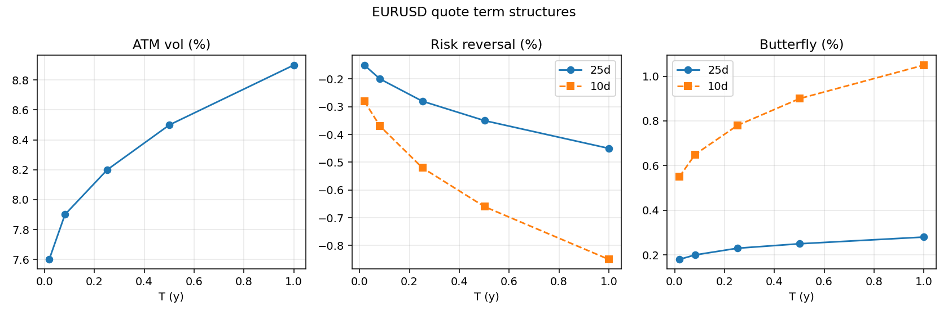
Figure 1. Quote term structures of the sample EURUSD data set: ATM volatility, 25-delta and 10-delta risk reversals, and butterflies.

3. Methodology

3.1 Pricing model and Greeks
Vanillas are priced with the Garman-Kohlhagen (1983) model in forward form. With forward F, strike K, volatility sigma, year fraction T, domestic discount factor df_d = exp(-rd T), and phi = +1 for calls and -1 for puts:
d1 = (ln(F/K) + sigma^2 T / 2) / (sigma sqrt(T)), d2 = d1 - sigma sqrt(T)
V = phi df_d (F N(phi d1) - K N(phi d2))
The forward form keeps the delta conventions straight and makes put-call parity, C - P = df_d (F - K), an identity of the implementation rather than a property to hope for. The engine exposes the full analytic Greek set: spot and forward delta, gamma, vega, vanna (the cross derivative of price with respect to spot and volatility), volga (the second derivative with respect to volatility), theta, and the domestic and foreign rhos. Vanna and volga receive dedicated finite-difference tests because vanna-volga pricing of exotics consumes them directly. In the test suite every Greek agrees with a central finite difference at tight tolerance across moneyness and maturity, and put-call parity holds to machine precision.

3.2 Delta conventions and the premium-adjusted inversion
A quoted 25 delta is ambiguous until two choices are fixed. First, spot delta versus forward delta: market practice uses spot delta up to and including one year and forward delta beyond, with the cutoff itself configurable (Clark 2011). Second, premium adjustment: when the option premium is paid in the foreign (base) currency, the premium is itself a position in the underlying and is subtracted from the delta (Reiswich and Wystup 2010). Whether a pair is premium-adjusted follows from its premium currency and is a per-pair configuration; EURUSD is unadjusted while USDJPY is adjusted. The four resulting call deltas are N(d1) for the unadjusted forward delta, exp(-rf T) N(d1) for the unadjusted spot delta, (K/F) N(d2) for the premium-adjusted forward delta, and exp(-rf T) (K/F) N(d2) for the premium-adjusted spot delta; put deltas replace N(x) with -N(-x).
For the unadjusted conventions the delta-to-strike inversion is closed form, K = F exp(-d1 sigma sqrt(T) + sigma^2 T / 2) with d1 = phi Ninv(phi delta). The premium-adjusted call delta is the dangerous case: as a function of strike it rises to an interior maximum and then falls, so a quoted delta corresponds to two strikes. The market convention refers to the higher-strike branch, on which delta is decreasing in strike. The engine locates the turning point exactly by solving sigma sqrt(T) N(d2) = n(d2) in d2, which has a single root, and then root-finds with Brent's method only on the branch to the right of the resulting strike. Requests above the attainable maximum raise an error rather than returning a wrong strike. Figure 2 exhibits the non-monotonicity, the turning point, and the two strikes sharing one delta, with the market branch marked. Every convention passes strike-to-delta-to-strike round trips at machine precision in the test suite, deep wings included.
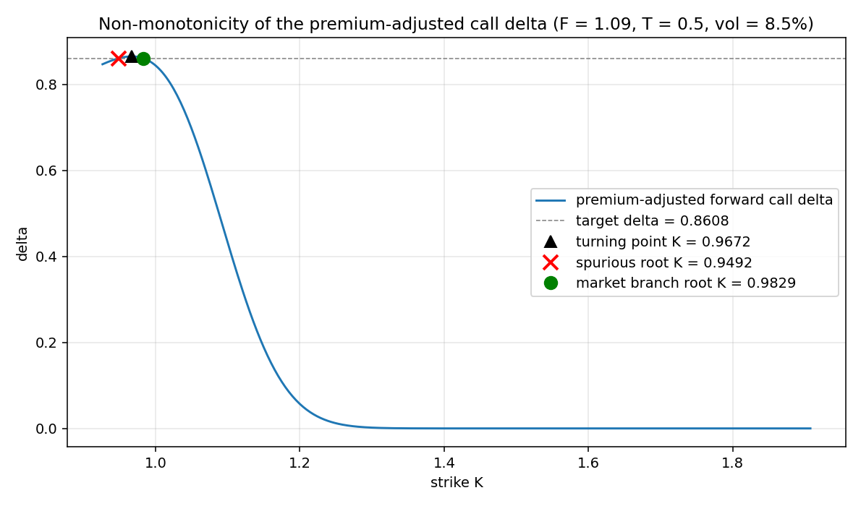
Figure 2. Non-monotonicity of the premium-adjusted forward call delta (F = 1.09, T = 0.5, vol = 8.5 percent). The dashed target delta intersects the curve twice; the engine returns the higher-strike market root and rejects targets above the marked maximum.

3.3 ATM conventions
The default ATM convention is the delta-neutral straddle (DNS): the strike at which a straddle has zero net delta in the pair's own delta convention. For unadjusted deltas this gives K_ATM = F exp(+sigma^2 T / 2). For premium-adjusted deltas the sign flips, K_ATM = F exp(-sigma^2 T / 2), because the straddle delta is proportional to N(d2) - N(-d2) rather than N(d1) - N(-d1). The DNS strike is identical under spot and forward delta styles since the foreign discount factor scales both legs equally. ATM-forward and ATM-spot conventions are also supported. The test suite verifies that the solved ATM strike yields a straddle delta of zero to machine precision under all four conventions and that the premium-adjusted strike sits below the forward while the unadjusted strike sits above it.

3.4 Market strangle versus smile strangle
This is the step most implementations get wrong. The quoted butterfly encodes one scalar observable: the price of the market strangle. The procedure implemented here, following Reiswich and Wystup (2012), runs per wing level (25 delta, then 10 delta) as follows. First, form the market strangle volatility sigma_ms = sigma_ATM + BF. Second, compute the market strangle strikes: the call strike at delta +level and the put strike at delta -level, both using the single volatility sigma_ms in the pair's delta convention. Third, compute the market strangle price:
v_ms = Call(K_c_ms, sigma_ms) + Put(K_p_ms, sigma_ms)
This price is what the butterfly quote means. Fourth, solve for the smile wing volatilities (sigma_c, sigma_p) subject to two constraints: the risk-reversal constraint sigma_c - sigma_p = RR, and the strangle-repricing constraint that the smile strangle, struck at delta plus and minus the level using the smile's own wing volatilities, reprices v_ms:
Call(K_c, sigma_c) + Put(K_p, sigma_p) = v_ms
The risk-reversal constraint reduces the problem to a one-dimensional root find in sigma_c, solved with Brent's method on an expanding bracket seeded by the naive volatility sigma_ATM + BF + RR/2, which is exact when the risk reversal is zero. Convergence and the reprice residual are asserted after solving; the calibrator never returns an unverified smile. Table 2 reports the 25-delta calibration per tenor. The smile-strangle butterfly, (sigma_c + sigma_p)/2 - sigma_ATM, systematically differs from the quoted market-strangle butterfly whenever the risk reversal is nonzero, and the gap widens with the skew: from under a tenth of a basis point of volatility at one week to about 2 basis points at one year at the 25-delta wing, and about 3.5 basis points at the one-year 10-delta wing. A naive construction that plugs the quoted butterfly into the smile-strangle algebra is therefore biased at exactly the strikes where exotic hedging happens. The reprice residuals in the last column are at machine precision.
Table 2. Market-strangle calibration of the 25-delta wing (volatilities in percent; v_ms in domestic price units)
tenor | sigma_ms | v_ms | sigma_25c | sigma_25p | quoted BF | smile BF | gap (vol pts)
1W | 7.780 | 0.00348783 | 7.704 | 7.854 | 0.180 | 0.179 | 0.0008
1M | 8.100 | 0.00752195 | 7.998 | 8.198 | 0.200 | 0.198 | 0.0023
3M | 8.430 | 0.01373144 | 8.284 | 8.564 | 0.230 | 0.224 | 0.0059
6M | 8.750 | 0.02015087 | 8.564 | 8.914 | 0.250 | 0.239 | 0.0109
1Y | 9.180 | 0.03000835 | 8.934 | 9.384 | 0.280 | 0.259 | 0.0207

3.5 Smile interpolation and wing extrapolation
The calibration yields five nodes per tenor, the 10-delta put, 25-delta put, ATM, 25-delta call, and 10-delta call, as strike-volatility pairs. Within the quoted range the smile is interpolated with a shape-preserving monotone cubic (PCHIP) through the nodes in (k, w) coordinates, where k = ln(K/F) is forward log-moneyness and w = sigma^2 T is total implied variance. PCHIP avoids the overshoot a natural cubic spline exhibits through only five points, and interpolation through the nodes guarantees that the surface returns the calibrated volatilities exactly at the node strikes.
Wing extrapolation deserves its own discussion because it is where arbitrage enters. The obvious choice, holding volatility flat beyond the outermost node, is continuous but not differentiable there: the volatility slope jumps to zero. That kink is a concentrated negative contribution to the implied density, and the project's own arbitrage checker flagged it as a genuine butterfly violation at every 10-delta strike during development. The production scheme therefore keeps flat volatility as the asymptote but decays the edge slope exponentially over a configurable band, half the node span by default, which makes the smile C1 at the last node and keeps the density bounded. Figure 3 compares the implied density near the 10-delta call strike under both schemes: the hard flat wing produces a negative density spike, a real static-arbitrage violation rather than numerical noise, while the C1 wing keeps the density positive through the same region. The hard mode remains available in the library for comparison, and the arbitrage checker flags it as expected. A Malz (1997) quadratic smile in forward call delta is included as a closed-form seed and sanity model.
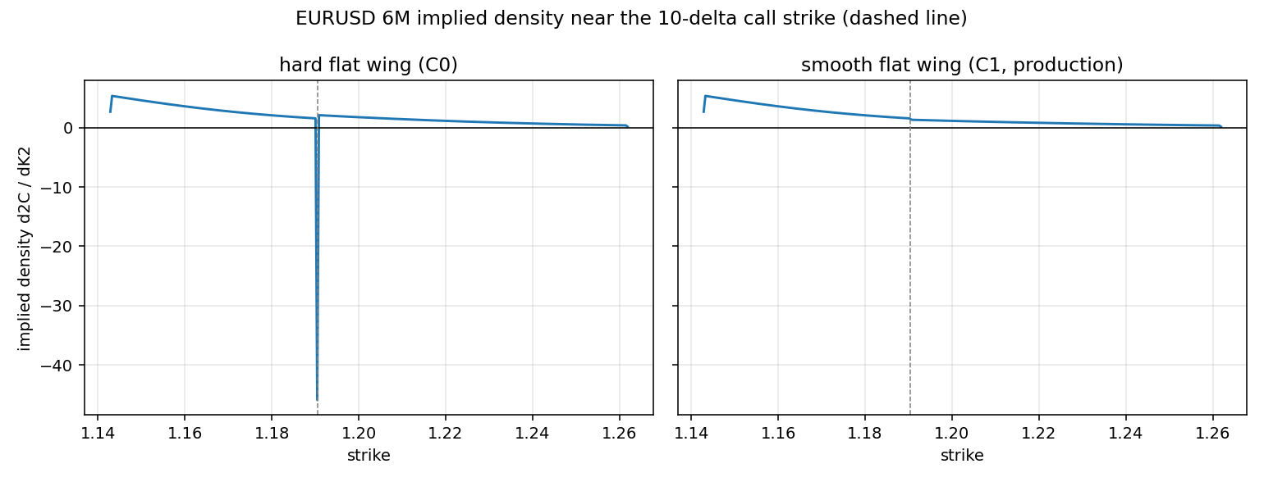
Figure 3. EURUSD 6M implied density near the 10-delta call strike (dashed line). Left: hard flat-in-volatility wing (C0), showing the negative density spike at the kink. Right: the production C1 smooth-flat wing.

3.6 Term-structure interpolation
Across tenors the surface interpolates linearly in total variance at constant forward log-moneyness: for T between pillars Ti and Ti+1, w(k, T) = (1 - lam) wi(k) + lam wi+1(k) with lam = (T - Ti)/(Ti+1 - Ti), where each pillar's total variance is evaluated at the strike Ki = Fi exp(k) so that moneyness is held constant relative to each pillar's own forward (Gatheral 2006). Variance is additive in time, which makes this the standard scheme and keeps calendar arbitrage controllable. Outside the pillar range, volatility is held flat at constant k, so extrapolated total variance grows proportionally with T and cannot create calendar arbitrage. Zero curves are interpolated linearly in maturity and forwards follow from covered interest parity, so the forward used in any query is consistent with the discount factors used in pricing. Figure 4 shows total variance in T at several moneyness levels: piecewise linear, continuous through the pillars, and strictly increasing, which is the calendar no-arbitrage condition.
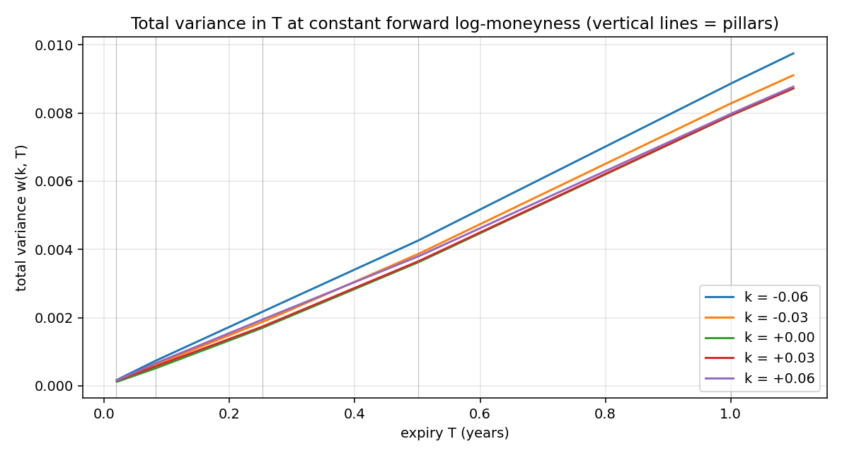
Figure 4. Total variance against maturity at five constant forward log-moneyness levels; vertical lines mark the pillar tenors.

4. No-Arbitrage Diagnostics
The engine treats arbitrage checks as diagnostics, never as silent repairs. Three static conditions are checked on a dense grid per pillar, and any violation is reported with the tenor, strike, and magnitude. First, undiscounted call prices must be non-increasing and convex in strike; the second derivative is the undiscounted risk-neutral density and must be non-negative. Second, as the rigorous formulation in total-variance space, the Durrleman condition is evaluated with derivatives taken in log-moneyness:
g(k) = (1 - k w'/(2w))^2 - (w'^2/4)(1/w + 1/4) + w''/2 >= 0
Nonnegative g(k), together with a wing time-value condition, is equivalent to a nonnegative implied density (Gatheral and Jacquier 2014). Third, the calendar condition requires total variance w(k, T) to be non-decreasing in T at every fixed k across adjacent pillars. The test suite additionally verifies that deliberately broken inputs are caught: a volatility frown triggers located convexity and Durrleman violations, and a term structure whose short-tenor variance exceeds the next pillar's triggers located calendar violations. The clean sample surface passes all checks; Figure 5 plots the Durrleman diagnostic per tenor, comfortably positive across the quoted range and the extrapolation band.
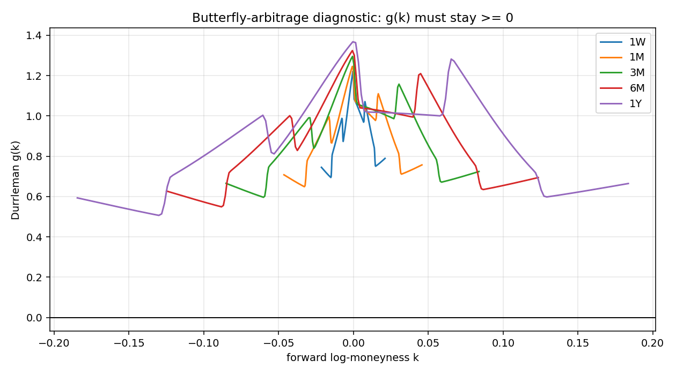
Figure 5. Durrleman butterfly-arbitrage diagnostic g(k) per tenor; the surface admits a nonnegative implied density wherever g(k) is nonnegative.

5. Results

5.1 Calibrated smiles and the surface
Table 3 lists the calibrated five-node smiles. Strikes widen with maturity, the put wings carry higher volatilities than the call wings (negative risk reversal), and the ATM strike sits slightly above the forward as the unadjusted delta-neutral-straddle convention implies. Figure 6 shows the smile slices with their calibrated nodes, Figure 7 the full surface, and Figure 8 the implied risk-neutral density at one year, which is positive throughout, left-skewed relative to lognormal, and smooth through the node strikes.
Table 3. Calibrated smile nodes per tenor (strike / volatility in percent)
tenor | 10d put | 25d put | ATM | 25d call | 10d call
1W | 1.0696 / 8.289 | 1.0775 / 7.854 | 1.0854 / 7.600 | 1.0933 / 7.704 | 1.1010 / 8.009
1M | 1.0527 / 8.731 | 1.0699 / 8.198 | 1.0869 / 7.900 | 1.1038 / 7.998 | 1.1208 / 8.361
3M | 1.0284 / 9.230 | 1.0600 / 8.564 | 1.0909 / 8.200 | 1.1217 / 8.284 | 1.1537 / 8.710
6M | 1.0053 / 9.712 | 1.0520 / 8.914 | 1.0968 / 8.500 | 1.1420 / 8.564 | 1.1905 / 9.052
1Y | 0.9742 / 10.340 | 1.0435 / 9.384 | 1.1091 / 8.900 | 1.1759 / 8.934 | 1.2515 / 9.490
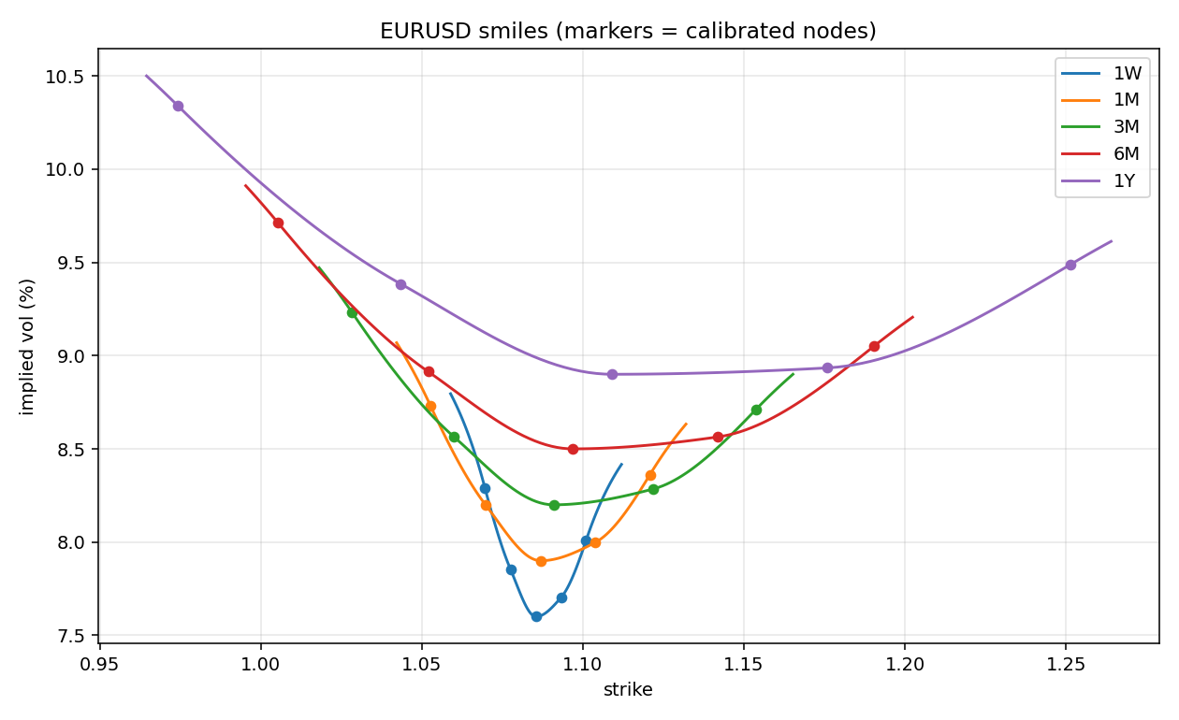
Figure 6. Smile slices for all five tenors; markers are the calibrated nodes.
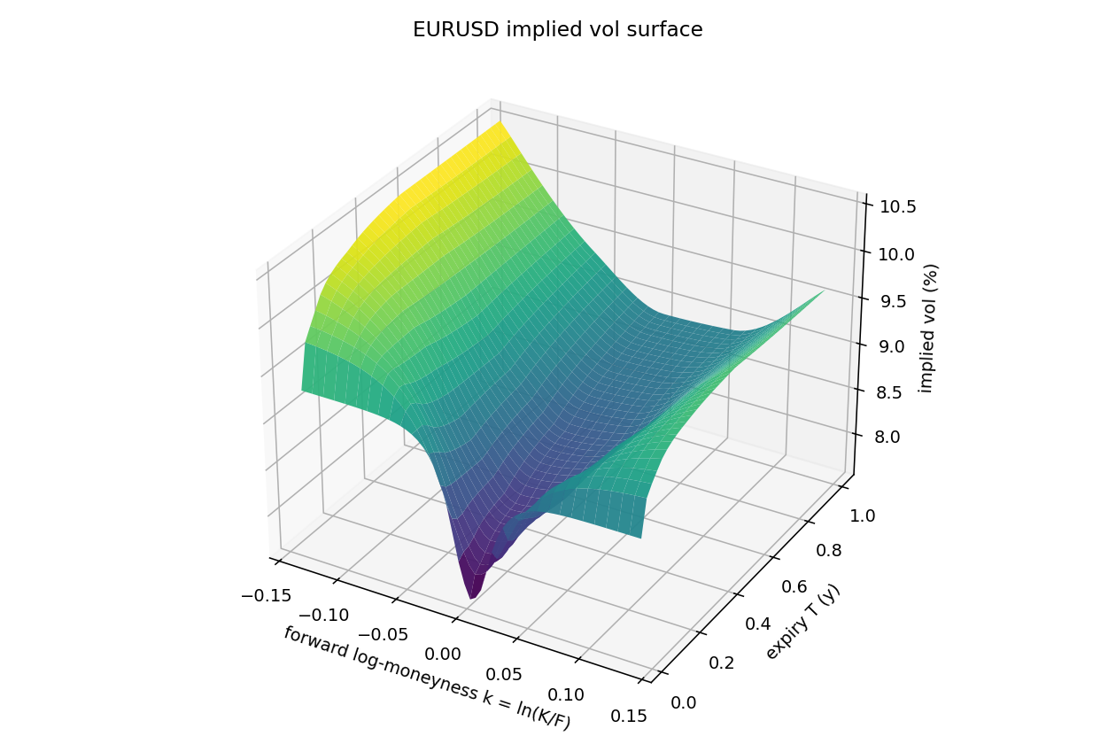
Figure 7. The constructed EURUSD implied volatility surface over forward log-moneyness and maturity.
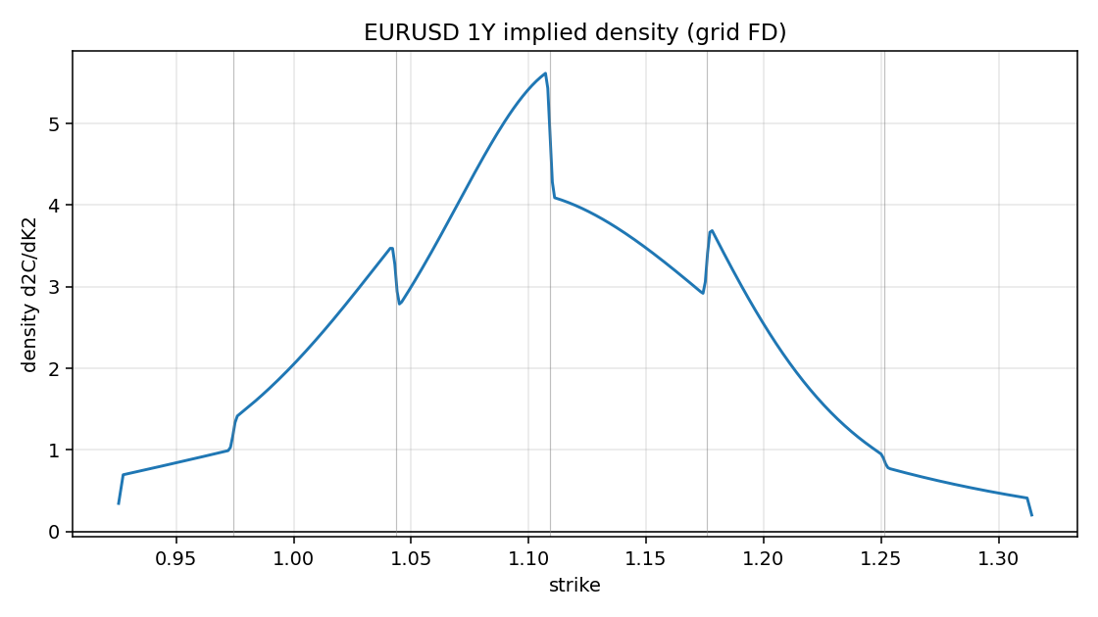
Figure 8. Implied risk-neutral density at the one-year tenor, computed as the second strike derivative of undiscounted call prices; vertical lines mark the calibrated node strikes.

5.2 The headline round trip: the surface reprices its inputs
The acceptance criterion for the whole project: starting from the finished surface rather than any intermediate calibration object, recover the quotes and compare with the inputs. The ATM volatility is recovered as the fixed point of the ATM-strike map on the smile; the risk reversal from the smile volatilities at the plus and minus delta smile strikes; the butterfly by inverting the market-strangle definition, that is, solving for the volatility premium b such that a single-volatility strangle at sigma_ATM + b reprices the smile strangle. The targets were 0.01 volatility points and 1e-6 in price. Table 4 reports the achieved absolute errors: the worst across all tenors and all five quotes is 1.225e-11 volatility points, roughly eight orders of magnitude inside tolerance.
Table 4. Round-trip absolute errors, quotes implied back from the finished surface (volatility points)
tenor | ATM | 25d RR | 25d BF | 10d RR | 10d BF
1W | 0.00e+00 | 1.55e-12 | 6.09e-13 | 3.44e-12 | 7.40e-12
1M | 0.00e+00 | 9.42e-14 | 8.67e-16 | 3.67e-12 | 4.97e-12
3M | 0.00e+00 | 7.34e-13 | 4.87e-13 | 5.25e-12 | 5.76e-12
6M | 0.00e+00 | 1.05e-12 | 1.10e-12 | 9.64e-12 | 1.22e-11
1Y | 0.00e+00 | 2.83e-12 | 1.57e-12 | 2.67e-12 | 3.72e-12

5.3 A premium-adjusted pair
To exercise the premium-adjusted machinery end to end, the same pipeline is run on a synthetic USDJPY-style market: premium in US dollars, the base currency, hence premium-adjusted deltas, with a 2-year pillar beyond the 1-year cutoff additionally exercising the forward-delta regime. The round trip holds at the same precision as for EURUSD, the delta-neutral-straddle ATM strike sits below the forward at every tenor (the premium-adjusted sign flip of Section 3.3), the 2-year pillar switches to forward delta as configured, and the resulting surface passes all arbitrage checks.

6. Software Validation
The engine ships with an adversarial pytest suite of 209 tests, including Hypothesis property-based tests, at roughly 94 percent line coverage; the ruff linter and the mypy type checker both pass clean. The test categories mirror where FX surface implementations actually fail. The headline round-trip test catches any convention or calibration error anywhere in the stack, for an unadjusted and a premium-adjusted pair. Convention round trips across all four delta conventions, deep wings included, catch wrong delta formulas or wrong discounting. The premium-adjusted branch test constructs a target delta hit by two strikes, exhibits both roots, and asserts that the market root is returned; it fails against any naive inversion. Delta-neutral-straddle tests, including the premium-adjusted sign flip, catch wrong ATM conventions. Greeks are checked against central finite differences, vanna and volga specifically. Market-strangle repricing, exactness of the risk-reversal constraint, and recovery of the naive algebra at zero risk reversal pin down the butterfly calibration. Deliberately broken surfaces, a volatility frown and a collapsing term variance, verify that the arbitrage checker actually detects and locates violations, while the clean sample passes. Property-based tests assert pricing monotonicities and bounds on randomized inputs. Numerical tolerances and day-count choices are configuration rather than literals, and all solvers assert convergence and reprice accuracy, raising on failure instead of returning unverified numbers.

7. Limitations and Future Work
- The tenor calendar uses calendar-day rolls with an act/365 fixed day count and no holiday calendar or cut times; a business-day calendar is an isolated extension point in the data layer.
- Arbitrage checks diagnose and locate violations but deliberately do not repair them; an optional repair mode would need to be explicit about which quotes it moves.
- The interpolated smile is a market-consistent interpolant, not a dynamics model; Greeks are sticky-strike by construction.
- Two extensions are architected for but not implemented: vanna-volga pricing of exotics, which consumes the calibrated ATM and wing instruments together with their vega, vanna, and volga, all already exposed; and SABR smile calibration (Hagan et al. 2002), which will implement the same SmileModel interface the interpolated smile satisfies, so the surface, arbitrage, and visualization layers need no changes.

References
Clark, I. J. (2011). Foreign Exchange Option Pricing: A Practitioner's Guide. Wiley.
Garman, M. B. and Kohlhagen, S. W. (1983). Foreign currency option values. Journal of International Money and Finance, 2(3), 231-237.
Gatheral, J. (2006). The Volatility Surface: A Practitioner's Guide. Wiley.
Gatheral, J. and Jacquier, A. (2014). Arbitrage-free SVI volatility surfaces. Quantitative Finance, 14(1), 59-71.
Hagan, P. S., Kumar, D., Lesniewski, A. S., and Woodward, D. E. (2002). Managing smile risk. Wilmott Magazine, September, 84-108.
Malz, A. M. (1997). Estimating the probability distribution of the future exchange rate from option prices. Federal Reserve Bank of New York.
Reiswich, D. and Wystup, U. (2010). A guide to FX options quoting conventions. The Journal of Derivatives, 18(1), 58-68.
Reiswich, D. and Wystup, U. (2012). FX volatility smile construction. Wilmott Magazine, January.

