Activity2

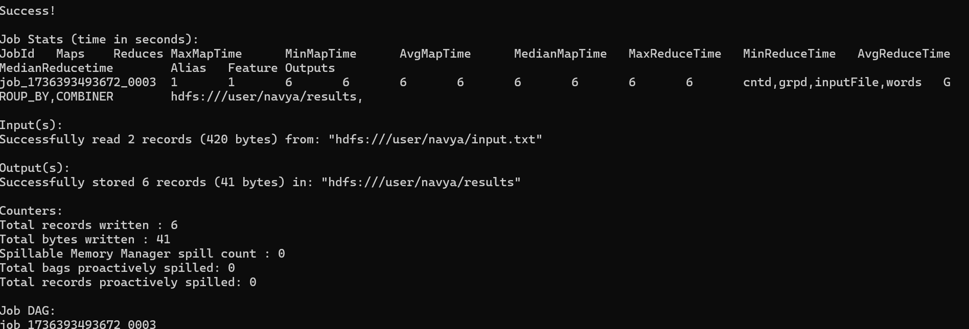

Activity3:

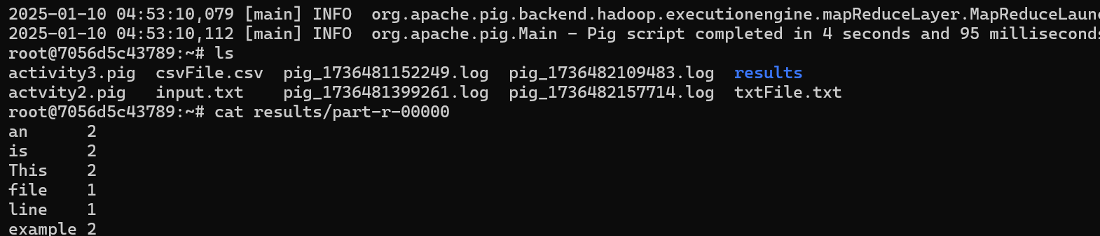

Activity 4:

Activity5

