Activity5:

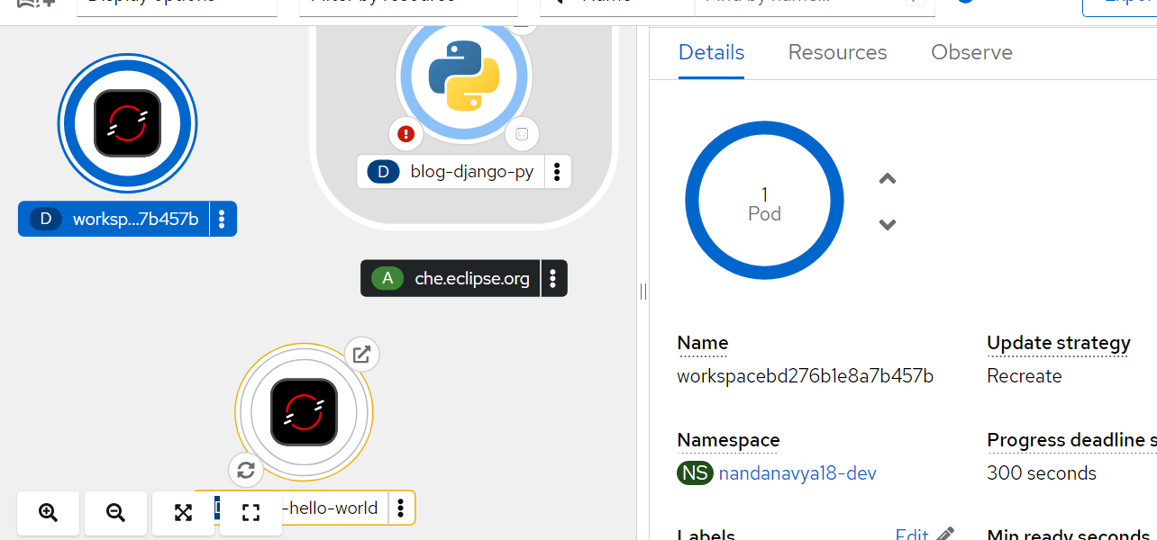

Activity 6:

Activity7

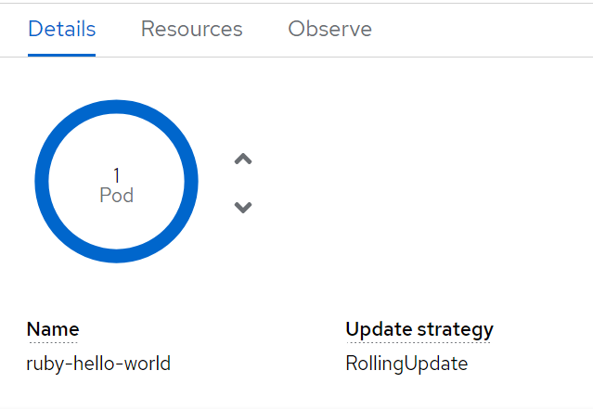

Activity 4:

