

**SCHOOL OF ARCHITECTURE, COMPUTING & ENGINEERING**

INDIVIDUAL CW REPORT

StudentName: Yoganand Devabhakthuni

Student Number:

Module Leader:

Module Code: CN7023

Introduction

Artificial Intelligence (AI) is defined as a field in computer science that imitates human thinking processes, learning ability and storage of knowledge. As the population increases, demand for food is high. The MATLAB- based neural network process using the computer architecture has been designed to help classification of input in a variety of formats, including text, pictures, audio, etc. AI in Food industry helps to segregate the food based on color, texture and size. ML involves training the system with different types of inputs to the machine and train the machine to provide exact output. In Convolution Neural Networks (CNN) approach, an image can be recognized and processed through pixels, and mainly used for image recognition and classification. Algorithm can be used and required libraries were added and create a Dataset, provide dataset as input, label the images, resize and finally test the Dataset. Image is converted into pixels and finally provide results. Here we will be providing various Fruits Images as Inputs and Algorithm detects the condition of fruits. Fruit identification, ripeness and Quality Grading can be done through different Algorithms. Also, able to sort defective and normal items in fruits.

Background study

Food is essential for the survival of living things. Fruits are healthy and good for Health. Various applications were employed to detect specific defects and identify fruits in the wholesale and retail stores. Various technological tools include fruit sorting machinery, fruit scanning machinery and sensing related instruments. Technology should be improved inorder to increase productivity. Productivity could be increased by providing a seed with good Quality. Now-a-days people shows interest on Organic seed/vegetable. By using Artificial Neutral Network (ANN), classification and prediction of parameters is simpler which leads to demand of ANN over past years. The Convolutional Neural Network (CNN) is by far the most efficient method ofiprocessing images. In artificial neural networks (ANNs), convolutional neural networks (CNNs) operate with a minimum ofione layer oficonvolution. The quality ofiCNNs has significantly improved. Kaggle is also one of the Algorithm used for AI. Deep Learning also uses it. Because of AI, Manual intervention of Human Being is reduced and handled by system. According to Gonzalez-Fernandez, ANN is applicable to a different kind of problems and situations, adaptable and flexible.

Multilayer perceptron (MLP), radial basis function networks (RBFNN), and Kohonen self-organizing algorithms are the most efective types of NN when it comes to solving real problems. The most common network that is used for prediction and pattern recognition is the multilayer perceptron.

Simulation

used the Tensorflow library in Python and MATLAB as the software system for simulation.Imported various libraries and train the system with test data and evaluate the Results.

Dataset

The dataset to identity fruits from photos was utilized by Fruits-360.

Model: Used various libraries were downloaded.

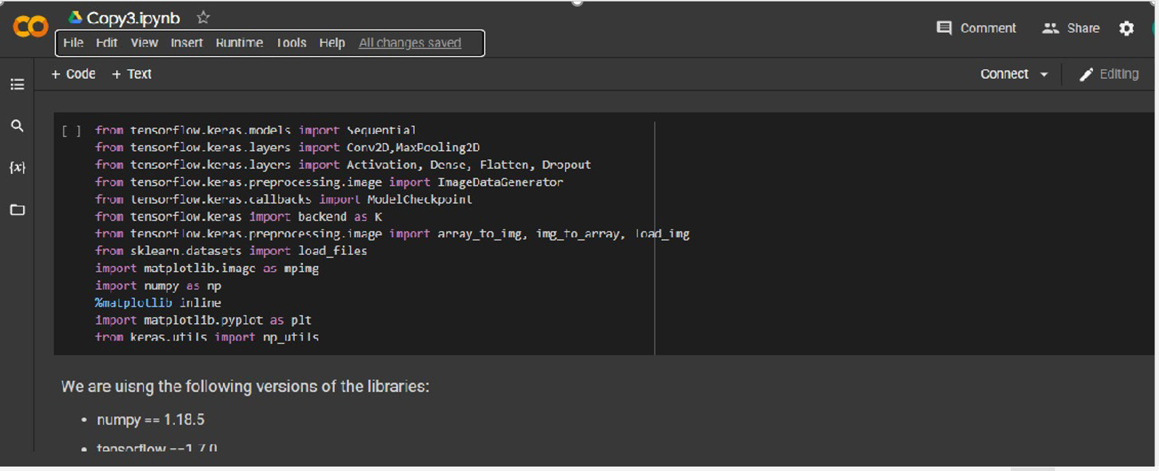

Sample Data:

Initially we inport data and required libraries to run our code. Dataset contains images of variety of fruits.The fruits are scaled to an image ofi100 to 100 pixels. To provide coaching and testing, all photos were hand-picked from the 360 information set, revealed on the official Kaggle website. Pixels can be easily identified by different colours.

We have used different categories of fruits to evaluate accuracy of grading. Used seventeen epochs.

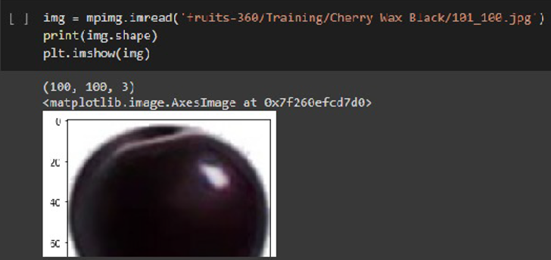

Figure 1 sample fruit

Figure 2 Sample Fruit

Inorder to train the data we will provide various Images of Fruits as Input and train the machine to provide accurate result. We will train the system by using testing data and finally validate the Image to get accuracy of the model which helps to distinguish between various fruits.

Training, testing and validation ofidataset

Training Set : Train the model - Train the data with batches.

Validation Set: Evaluate the model

Test Set: Report the final accuracy of the model

Training set shape: (41322, 100, 100, 3)

Validation set shape: (7000, 100, 100, 3)

Test set shape: (6877, 100, 100, 3)

Image Pixels: 100*100 pixels

Scaling features from 0-255 to 0-1

If the space and memory reduce for the Pixel and thereby processing speed will be increased.

Vector set of first train set:

We can only see 1 and all Zero’s that are showing in below Image.

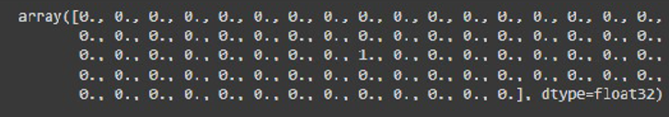

Network Architecture

CNN is a multilayer, feed-forward neural networks (FFNN) which can quickly identify, classify, and recognize any features in an image. It is used mainly with visual data, such as image classification. A CNN can be prepared to do image analysis tasks including object recognition, segmentation, classification, and image processing.

Tensor Flow based Model:

Tensorflow is an open source software for numerical computation. It was originally created to conduct machine learning and deep neural networks research. Tensorflow provides neural network architectures and scripts to retrain the networks for users who wants to apply them in different contexts

Initially we sequential model. Then add Conv2D with 16 Filters and Kernel size of 2 and input shape (100, 100, 3) and then add Max Pooling2d with pool size 2. Now we must add more by increasing filters. Let’s say now we have Conv2D with 32 filters and kernel size is of 2 and Input shape is (100,100,3). And then increase the filters to 64 with same kernel and Input. At every stage we will use MaxPooling2D with pool-size-2. Followed by DropOut, Flatten, Dense. And finally activation softmax.

Layers of Model:

* First layer (Convolution #1), with sixteen filters with kernel Size two with input size and padding must be provided to sequential function.
* The Second layer (Convolution #2) with Thirty two filters and Sixty Four Filters with Kernel size as 2.
* Now we will add Dropout, Flatten and Dense
* The last layer of our Model is six Neurons and an activation softmax.

Results:

Essentially our images can belong to one of multiple possible categories, which is why we use this function. We will measure accuracy when we compile the model, and when we fit the model we will evaluate how well our network can perform on test batches. I picked 17 epochs since it gave me the best accuracy on the test batches when I compiled the model.

used the Tensorflow library in Python and MATLAB as the software system for simulation.

After compiling the model, the accuracy will be 98 percent and the loss will be 0.0386 which is a pretty

decent performance.

Optimizer is a function that used to change the features of Neutral Network such as learning rate(how the model learn with features) inorder to reduce the losses.

Metrics Setting:

Metrics = accuracy (because we are going to calculate the percentage of correct predictions and overall predictions on Validation Set

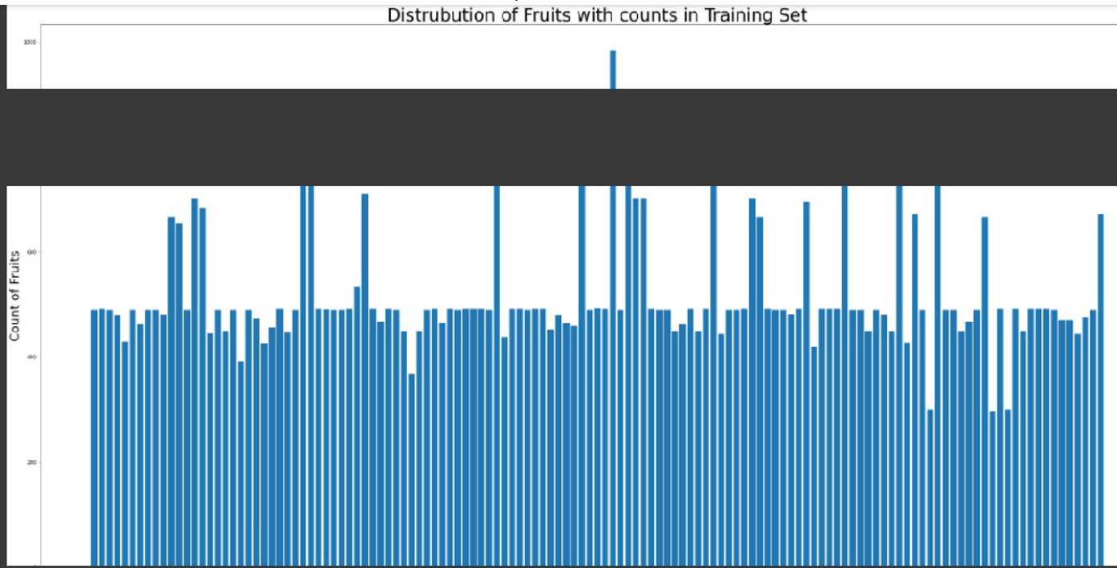

Experimental Result.

We used the Fruit Dataset to discover the better classification performance of Network. The Network is trained for 10 epochs with a batch size of 15.The accuracy of proposed model is 98.74%. The results of CNN model are exceptionally Good and promising to use real-world application. 65% of data is used for training and 30% for Model testing and 5% for accuracy testing. By looking into metrics, we can get accuracy for our Model. The prediction values obtained from the developed model were validated by comparing with the experimental values, and the results were almost consistent with prediction values from the developed model

Conclusion

It discusses a replacement methodology for rating fruits. Used CNN for 400 Samples and check results. Results were achieved. When we provide any Input to the System, Machine can predict and confirm the Input and provide output by considering color, texture etc. By this we can easily identity type of Fruit. Food Grading can be done at industry level. ANN is found to be more common for the classification task. Another method that has been utilized for the prediction and classifcation of the food samples is by using the machine learning (ML) method. ML can be used in solving complicated tasks which involves a huge amount of data and variables but does not have pre-existing equations or formula. Food Industry has lot of advantages through Artificial Intelligence (AI).

Reference list:

Adak MF, Yumusak, N (2016) Classification of E-nose aroma data of four fruit types by ABC-based neural network. Sensors 16(3). https://doi.org/10.3390/s16030304

Uçar A, Özalp R (2017) Efficient android electronic nose design for recognition and perception of fruit odors using Kernel Extreme Learning Machines. Chemom Intell Lab Syst 166:69–80. https://doi.org/10.1016/j.chemolab.2017.05.013

Astray G, Albuquerque BR, Prieto MA, Simal-Gandara J, Ferreira ICFR, Barros L (2020) Stability assessment of extracts obtained from Arbutus unedo L. fruits in powder and solution systems using machine-learning methodologies. Food Chem 333(January) 127460. https://doi.org/10.1016/j.foodchem.2020.127460

Castro W, Oblitas J, De-La-Torre M, Cotrina C, Bazan K, AvilaGeorge H (2019) Classification of cape gooseberry fruit according to its level of ripeness using machine learning techniques and different color spaces. IEEE Access 7:27389–27400. https://doi.org/10.1109/ACCESS.2019.2898223

Baietto M, & Wilson AD (2015) Electronic-nose applications for fruit identifcation, ripeness and quality grading. In Sensors (Switzerland) 15(1):899–931. <https://doi.org/10.3390/s150100899>

Xu JL, Sun DW (2017) Identifcation of freezer burn on frozen salmon surface using hyperspectral imaging and computer vision combined with machine learning algorithm d’apprentissage automatique. Int J Refrig 74:149–162. https://doi.org/10.1016/j.ijrefrig.2016.10.014

Porep JU, Kammerer DR, Carle R (2015) On-line application of near infrared (NIR) spectroscopy in food production. Trends

Food Sci Technol 46(2):211–230. https://doi.org/10.1016/j.tifs.2015.10.002

