**Assignment-2**

**NAME : K.NAVYA SRI.**

**ENROLL NO : 2503A52L12**

**BATCH : 16**

**1. Install PyCharm**

PyCharm is an IDE by JetBrains for Python development.

**Steps:**

1. Go to [PyCharm Download page](https://www.jetbrains.com/pycharm/download/).
2. Choose **Community Edition (Free)** or **Professional (Paid)**.
3. Download the installer for your OS (Windows/Mac/Linux).
4. Run the installer and follow the setup wizard.
   * On Windows: Check **Add “bin” folder to the PATH** and **Create Desktop Shortcut** if asked.
5. After installation, open PyCharm.

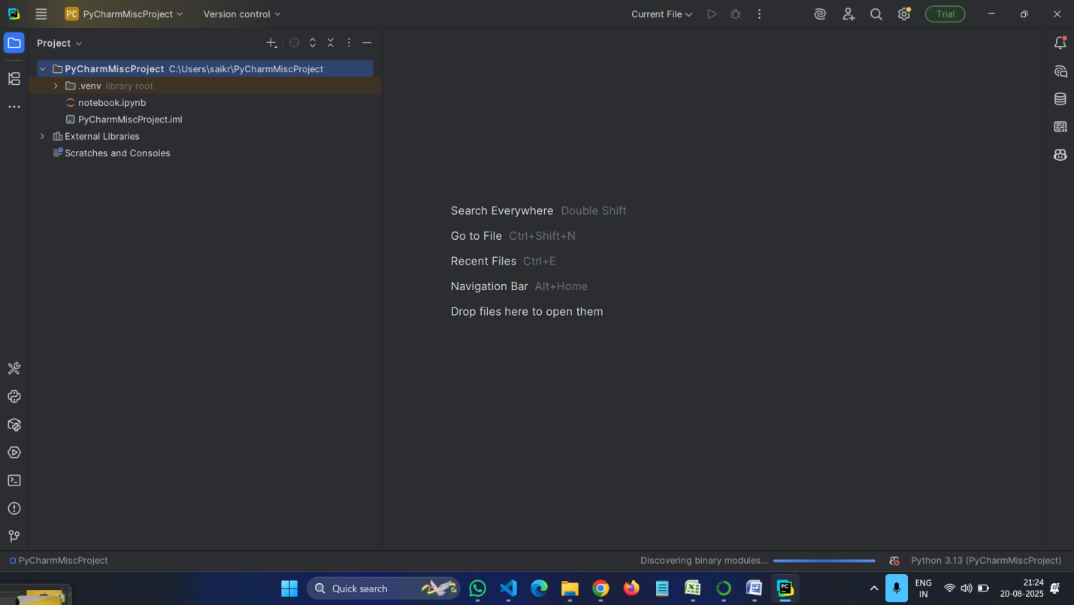

## 2. Install ****JetBrains Plugins in PyCharm****

PyCharm allows you to add plugins for extra features.

**Steps:**

1. Open **PyCharm**.
2. Go to **File > Settings > Plugins** (or Preferences > Plugins on Mac).
3. In the **Marketplace** tab:
   * Search and install useful plugins (example: **Python packages**, **Markdown**, **Database Tools**, etc.).
4. Restart PyCharm after installing plugins.

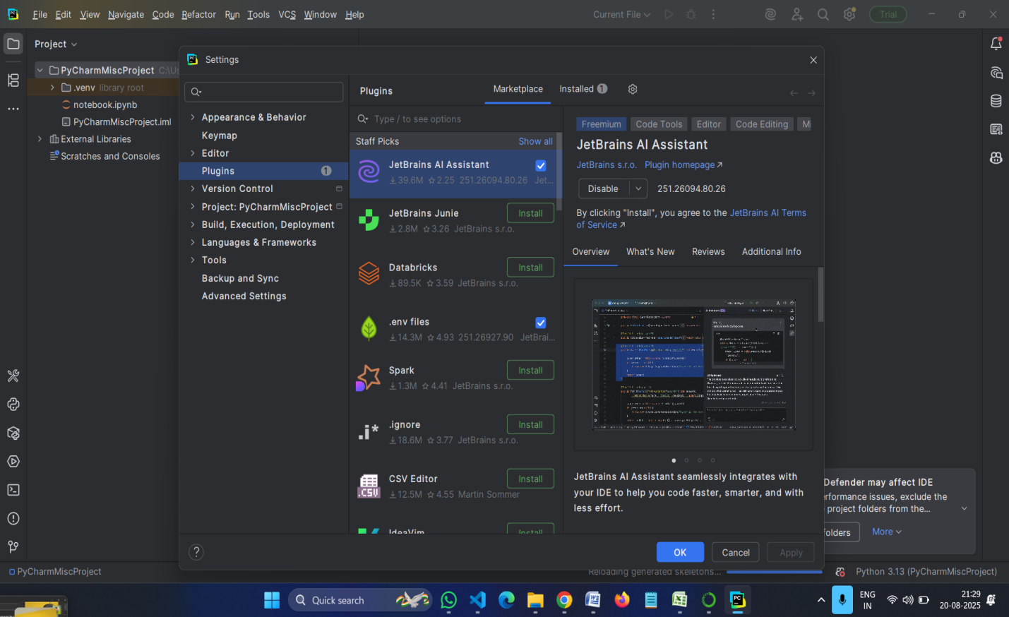

## 3. Install ****GitHub Copilot in PyCharm****

GitHub Copilot also works in JetBrains IDEs like PyCharm.

**Steps:**

1. Open **PyCharm**.
2. Go to **File > Settings > Plugins**.
3. In the **Marketplace** tab, search for **GitHub Copilot**.
4. Click **Install**.
5. After installation, restart PyCharm.
6. Sign in with your **GitHub account** when prompted.
   * A browser window will open → authorize PyCharm to use GitHub Copilot.
7. After successful login, GitHub Copilot will start suggesting code completions in PyCharm.

