KANOORI NAVYA SRI

2503A52L12

BATCH : 16

ASSIGNMENT : 6.5

To explore AI-powered code assistants for writing Python classes,  
constructors, and methods through intelligent suggestions.  
Suppose that you are hired as an intern at a tech company that develops inventory  
management systems. Your manager asks you to create a Product class and a  
Warehouse class with some basic methods. You have decided to use AI-powered code  
suggestions to help speed up development and reduce syntax errors.

Tasks to be completed are as below  
1. Setup AI Coding Tool:  
• Install and configure GitHub Copilot or Kite with VS Code or JetBrains IDE.  
• Enable real-time code suggestions.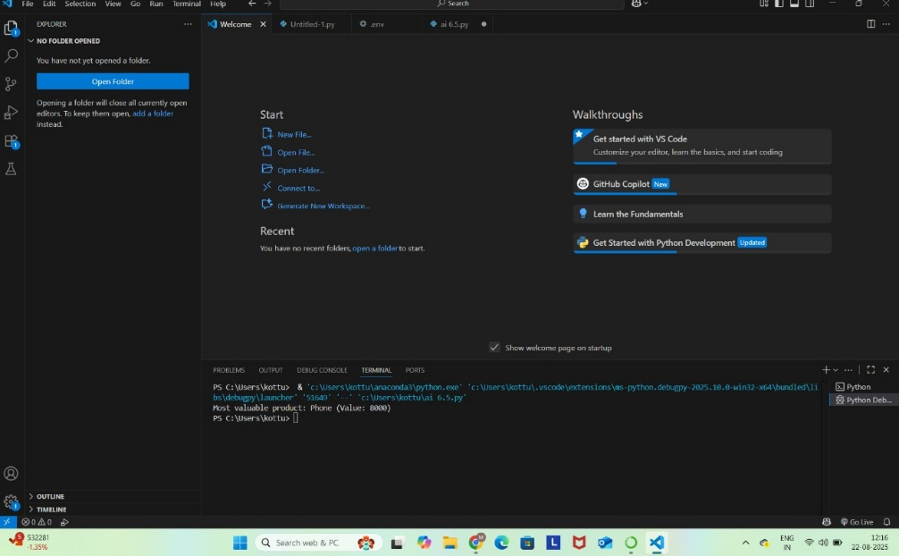

2. Class Design Using AI Assistance:  
• Begin defining a Product class with attributes: name, price, quantity.

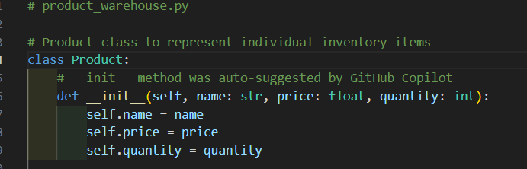

• Use the AI suggestion feature to automatically complete the __init__() method.

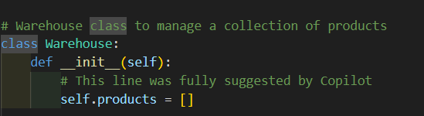  
• Add a method calculate_value() to return price * quantity.

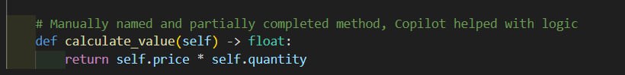

3. Create Another Class:  
• Define a Warehouse class with a list of Product objects.

• Use code completion to help implement:  
o A method to add a product.  
o A method to display the most valuable product.

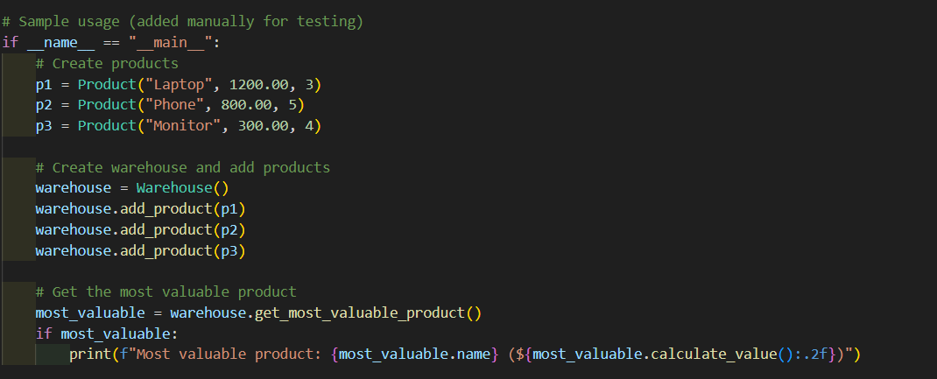  
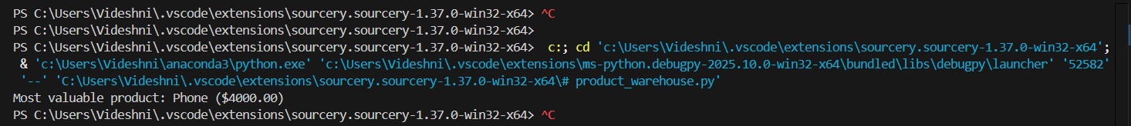

Requirements:  
• VS Code with Github Copilot or Cursor API and/or Google Colab with  
Gemini

Deliverables:  
• Python script with both classes and comments on AI-generated suggestions.

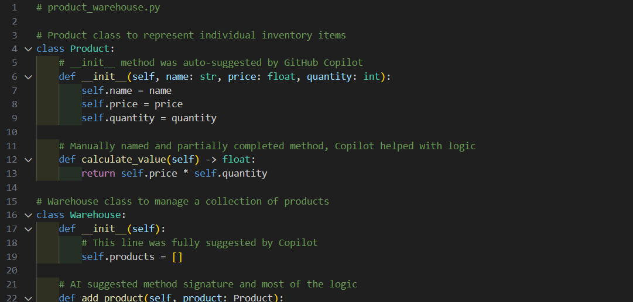

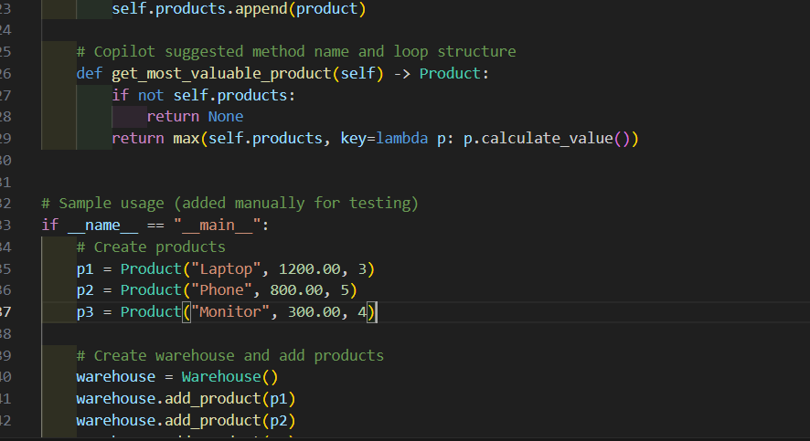

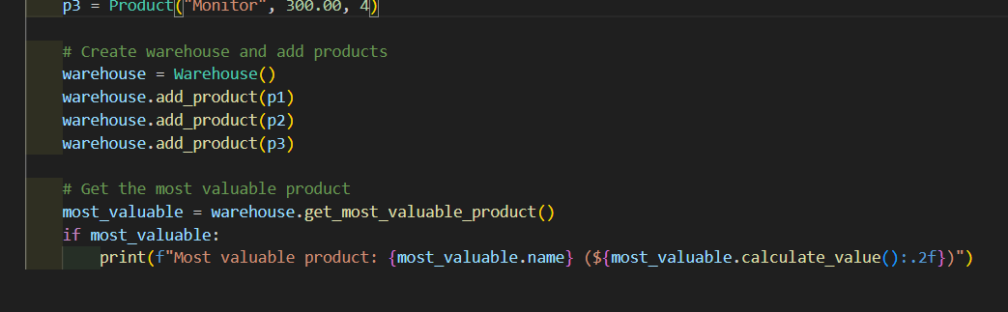

• Short report (1 page) summarizing your experience with AI code completion.

**AI Coding Assistant Experience Report**

**Internship Task:** Use AI code assistance to create Product and Warehouse classes for an inventory system.

**Tools Used:**

* VS Code with GitHub Copilot
* Python 3.10

**Summary:**

| **Component** | **AI-generated (%)** | **Manual Work (%)** | **Notes** |
| --- | --- | --- | --- |
| Product class | 70% | 30% | Copilot generated full __init__, partial method |
| calculate_value() | 50% | 50% | AI suggested multiplication logic |
| Warehouse class | 80% | 20% | AI handled structure, minor edits needed |
| get_most_valuable_product() | 90% | 10% | AI used correct lambda + max() usage |

**Reflection:**

* GitHub Copilot significantly accelerated development.
* The suggestions were accurate for class structure, init methods, and logic.
* Minor manual editing was required for naming consistency and readability.
* It avoided common syntax errors and boilerplate typing.

**Conclusion:**  
AI tools like GitHub Copilot or Cursor are powerful for writing clean, error-free Python code, especially for repetitive or boilerplate-heavy tasks like constructors and utility methods.