1.What are the two values of the Boolean data type? How do you write them?

a. The two values of Boolean data type is True and False. We can write as 1- True and 0 - False

2. What are the three different types of Boolean operators?

a. The 3 boolean operators are AND, OR, NOT

3. Make a list of each Boolean operator's truth tables (i.e. every possible combination of Boolean values for the operator and what it evaluate ).

a.

AND operator

A = False , B = False, A AND B = False

A = False, B = True, A AND B = False

A = True, B= False, A AND B = False

A = True, B = True, A AND B = True

OR Operator

A = False , B = False, A OR B = False

A = False, B = True, A OR B = True

A = True, B= False, A OR B = True

A = True, B = True, A OR B = True

NOT operator:

A = False , A NOT = True

A = True, A NOT = False

4. What are the values of the following expressions?

(5 > 4) and (3 == 5) -------🡪 False

not (5 > 4) -----------------🡪 False

(5 > 4) or (3 == 5) ---------🡪 True

not ((5 > 4) or (3 == 5))---🡪 False

(True and True) and (True == False)-🡪 False

(not False) or (not True) ---🡪 True

5. What are the six comparison operators?

a. Less than (<)

Less than or equal to (<=)

Greater than (>)

Greater than or equal to (>=)

Equal to (==)

Not equal to (!=)

6. How do you tell the difference between the equal to and assignment operators?Describe a condition and when you would use one.

Assignment operator is represented using =

Eg: a = 10, here we are assigning a value of 10 to variable a

Equal to is represented using ==

When we use a==10, we are checking if the value stored inside variable a is 10 or not.

The output of equal to operator is a Boolean value

7. Identify the three blocks in this code:

spam = 0

if spam == 10:

Block11

print('eggs')

if spam > 5:

Block2

print('bacon')

else:

print('ham')

Block3

print('spam')

print('spam')

8. Write code that prints Hello if 1 is stored in spam, prints Howdy if 2 is stored in spam, and prints Greetings! if anything else is stored in spam.

spam = int(input("Enter Spam value"))

if spam == 1:

print("Hello")

elif spam == 2:

print("Howdy")

else:

print("Greetings!")

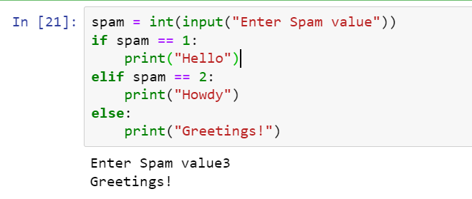

9.If your programme is stuck in an endless loop, what keys you’ll press?

a. CTRL + C

10. How can you tell the difference between break and continue?

a. Break is used to terminate the entire loop. Continue terminates the current iteration and proceeds with the next iteration of loop.

11. In a for loop, what is the difference between range(10), range(0, 10), and range(0, 10, 1)?

a. the functionality of all the 3 is same. In range(10) since the start index and step size is not mentioned the default start index is 0 and the step size is 1. All the 3 resolve to same behaviour.

12. Write a short program that prints the numbers 1 to 10 using a for loop. Then write an equivalent program that prints the numbers 1 to 10 using a while loop.

for i in range(1,11):

print(i)

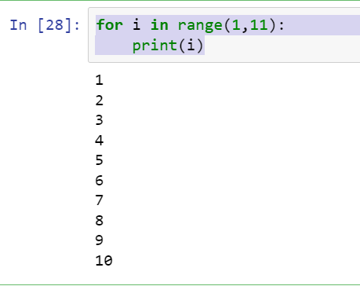

i = 1

while(i<11):

print(i)

i=i+1

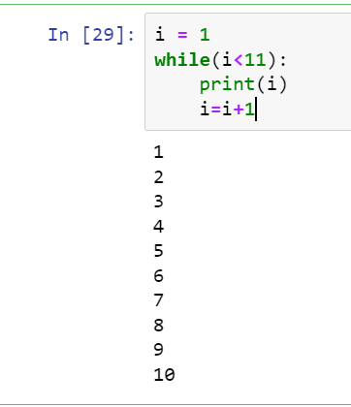

13. If you had a function named bacon() inside a module named spam, how would you call it after importing spam?

a. spam.bacon()