1. What exactly is []?

a. Empty list

2. In a list of values stored in a variable called spam, how would you assign the value 'hello' as the third value? (Assume [2, 4, 6, 8, 10] are in spam.)

a. spam[2]= ‘hello’

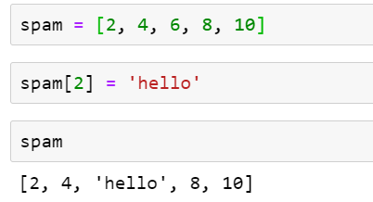

Let's pretend the spam includes the list ['a', 'b', 'c', 'd'] for the next three queries.

3. What is the value of spam[int(int('3' \* 2) / 11)]?

a. ‘d’

‘3’\*2 = ‘33’ and int(‘33’) = 33 and 33/11 = 3.0 and int(3.0) = 3 finally spam[3]=’d’

4. What is the value of spam[-1]?

a. ‘d’

5. What is the value of spam[:2]?

a. [‘a’,’b’]

Let's pretend bacon has the list [3.14, 'cat,' 11, 'cat,' True] for the next three questions.

6. What is the value of bacon.index('cat')?

a. 1

7. How does bacon.append(99) change the look of the list value in bacon?

a. Element 99 gets appended at last index of bacon i.e at 5th position and the length of list bacon increases from to 5 to 6.

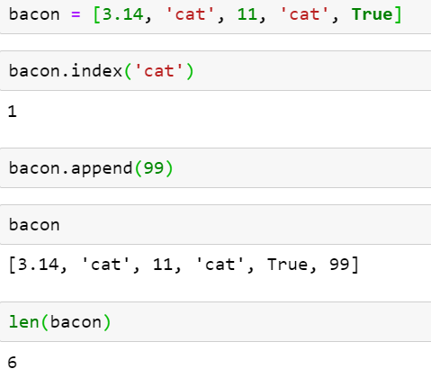

8. How does bacon.remove('cat') change the look of the list in bacon

a. The string ‘cat’ at the first occurrence of the list gets deleted i.e at index 1, the length of string reduces to 5 and the index of all the elements after ‘cat’ reduces by 1 unit.

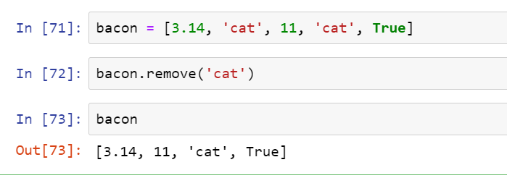

9. What are the list concatenation and list replication operators?

a. List concatenation operator is + and list replication operator is \*

10. What is difference between the list methods append() and insert()?

a. append() is used to add elements at the end of the list. Insert() is used to add the elements at a specified index.

11. What are the two methods for removing items from a list?

a. remove(), pop(),del()

12. Describe how list values and string values are identical.

a. Both lists and strings are sequential, they can be indexed.

13. What's the difference between tuples and lists?

a. Lists are mutable whereas tuples are immutable.

14. How do you type a tuple value that only contains the integer 42?

a. t = (42,)

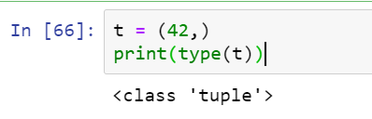

15. How do you get a list value's tuple form? How do you get a tuple value's list form?

a. we can get list value’s in tuple form as tuple() and tuple values in list form as list()

16. Variables that "contain" list values are not necessarily lists themselves. Instead, what do they contain?

a. They have references to list values

17. How do you distinguish between copy.copy() and copy.deepcopy()?

a. copy.copy() function will do a shallow copy of a list, while the copy.deepcopy() function will do a deep copy of a list. That is, only copy.deepcopy() will duplicate any lists inside the list