1. What does an empty dictionary's code look like?

a. a = {}

2. What is the value of a dictionary value with the key 'foo' and the value 42?

a. {'foo': 42}

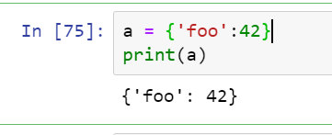

3. What is the most significant distinction between a dictionary and a list?

a. The items in list are sequential and where as in dictionary the items are stored unorderly.

The data in dictionary is stored in key value pairs

4. What happens if you try to access spam['foo'] if spam is {'bar': 100}?

a. Key Error

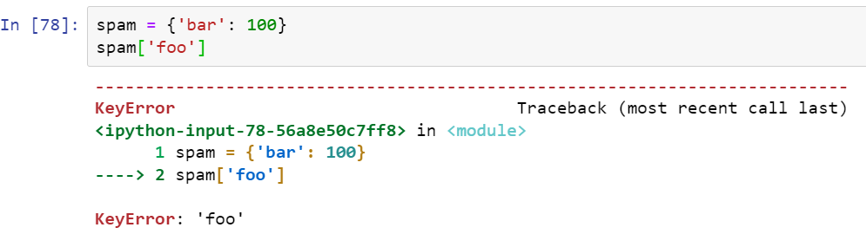

5. If a dictionary is stored in spam, what is the difference between the expressions 'cat' in spam and 'cat' in spam.keys()?

a. There is no difference

6. If a dictionary is stored in spam, what is the difference between the expressions 'cat' in spam and 'cat' in spam.values()?

a. ‘cat’ in spam checks whether there is a key named key cat in spam dictionary.

‘cat’ in spam.values() checks if there is a value named cat for any key in the dict.

7. What is a shortcut for the following code?

if 'color' not in spam:

spam['color'] = 'black'

1. spam['color']= 'black'

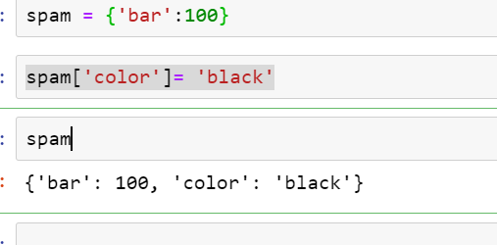

8. How do you "pretty print" dictionary values using which module and function?

a. pprint.pprint

