1. What are escape characters, and how do you use them?

a. Backslash (\) is an escape character. It is used for representing white spaces where \t represents tab, \n is for newline.

2. What do the escape characters n and t stand for?

a. n stands for newline and t stands for tab

3. What is the way to include backslash characters in a string?

a. we can include backslash characters in a string as “\\”

4. The string "Howl's Moving Castle" is a correct value. Why isn't the single quote character in the word Howl's not escaped a problem?

a. Because we have enclosed the entire string in double quotes.

5. How do you write a string of newlines if you don't want to use the n character?

a. by using end in the print statement.

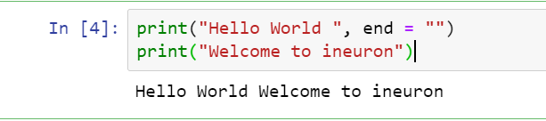

6. What are the values of the given expressions?

'Hello, world!'[1]--🡪’e’

'Hello, world!'[0:5] ---🡪 ‘Hello’

'Hello, world!'[:5]-----🡪 ‘Hello’

'Hello, world!'[3:]----🡪 ‘lo, world!'

7. What are the values of the following expressions?

'Hello'.upper() -----------🡪 ‘HELLO’

'Hello'.upper().isupper()-🡪 True

'Hello'.upper().lower()--🡪 ‘hello’

8. What are the values of the following expressions?

'Remember, remember, the fifth of July.'.split() -🡪 ['Remember,', 'remember,', 'the', 'fifth', 'of', 'July.']

'-'.join('There can only one.'.split()) -🡪 'There-can-only-one.'

9. What are the methods for right-justifying, left-justifying, and centering a string?

a. right-justifying – r.just(), left justifying – l.just(), centering – center()

10. What is the best way to remove whitespace characters from the start or end?

a. strip()

