**1)Create web pages using Basic HTML Tags, Table, List, Image, and Frame Tags HTML**

**HTML Tags**

**Tags: Character formatting:**

<html>

<head>

<title>Character tags</title>

</head>

<body bgcolor="pink">

<b>bold face</b><br><br>

<i>italic tag</i><br><br>

<u>underline tag</u><br><br>

<big>Big tag</big><br><br>

<small>Small tag</small><br><br>

<strong>Strong tag</strong><br><br>

<sub>Qualification</sub><br><br>

<sup>x 2</sup><br><br>

</body>

</html>

**OUTPUT**

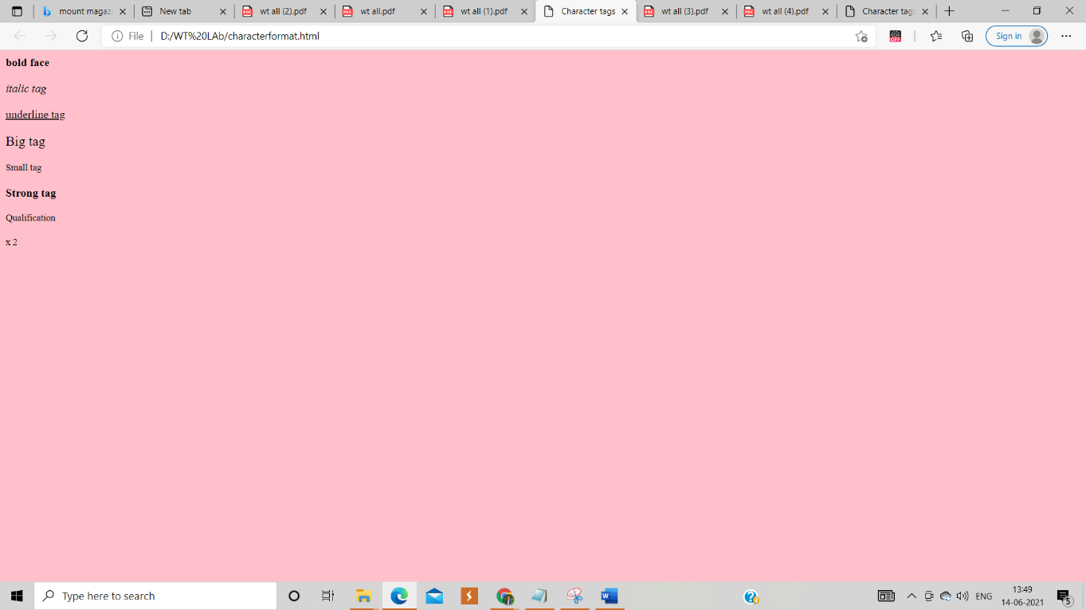

**Block formatting:**

<html>

<head>

<title>Bold Formatting</title>

</head>

<body bgcolor="pink"><br>

<p align="center">This is formatting</p>

<h1 align="left">This is h1</h1>

<h2 align="right">This is h2</h2>

<h3 align="center">This is h3</h3>

<h4>This is h4</h4>

<h5>This is h5</h5>

<h6 align="left">This is h6</h6>

<p>this is hr</p>

<hr align="center" size="10"/>

<basefont size="50">this is web</basefont>

<tt>navya prasanna</tt><br>

<PRE>this is aditya</PRE>

<marquee align="right">hii sambattula</marquee>

<font face="Blackadder ITC" size="20" color="Green">This is wt lab</font>

</body>

</html>

**OUTPUT:**

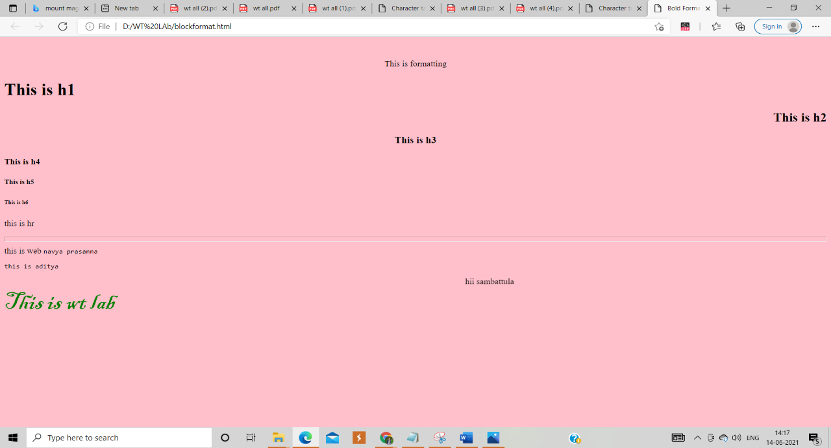

**Lists**

**Orderd Lists:**

<html>

<head>

<title>Ordered lists</title>

</head>

<body>

<h4>Microsoft packages</h4>

<ol type="1">

<li>Wordpad

<li>PowerPoint

<li>Ms-Excel

</ol>

<h4>Lists</h4>

<ol type="A" start=25>

<li>ordered list

<li>unordered list

<li>nested list

</ol>

<h4>Scripting language</h4>

<ol type="I" start=4>

<li>java Script

<li>jscript

</ol>

<h4>Database application</h4>

<ol type="i" start=5>

<li>SQL

<li>Mysql

<li>Oracel

</ol>

</body>

</html>

**OUTPUT:**

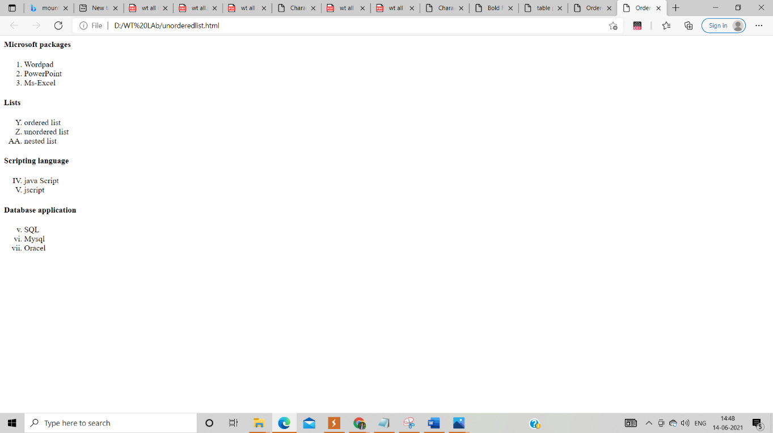

**Unordered list:**

<html>

<head>

<title>UnOrdered lists</title>

</head>

<body>

<h4>Microsoft packages</h4>

<ul>

<li>Wordpad

<li>PowerPoint

<li>Ms-Excel

</ul>

<h4>Lists</h4>

<ul type="square">

<li>ordered list

<li>unordered list

<li>nested list

</ul>

<h4>Scripting language</h4>

<ul type="disc">

<li>java Script

<li>jscript

</ul>

<h4>Database application</h4>

<ul type="circle">

<li>SQL

<li>Mysql

<li>Oracel

</ul>

</body>

</html>

**OUTPUT:**

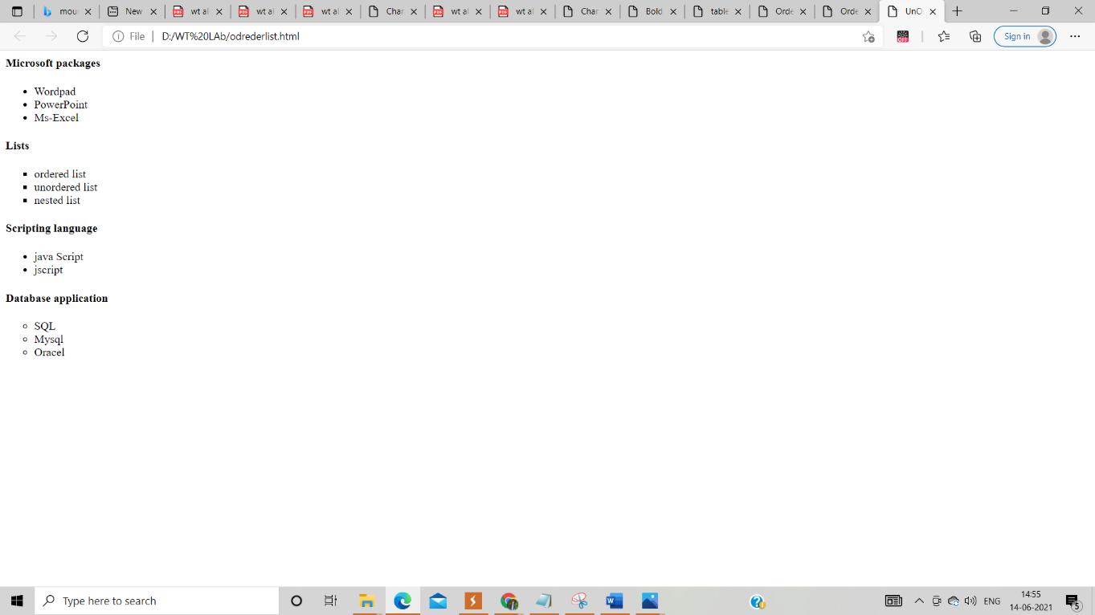

**Tables:**

<html>

<head>

<title>table page</title>

</head>

<body bgcolor="cyan">

<table align="left" cellpadding="2" cellspacing="2" border="3" bgcolor="pink">

<tr>

<th colspan="4">Sample Table</th>

</tr>

<tr>

<th>HEAD1</th>

<td rowspan="3">CELL2</td>

<th>HEAD3</th>

<th>HEAD4</th>

<tr>

<td>CELL1</td>

<td>CELL3</td><td>CELL4</td>

</tr>

<tr>

<td>CELL5</td>

<td colspan="2" align="center">CELL6</td>

</tr>

</table>

</body>

</html>

**OUTPUT:**

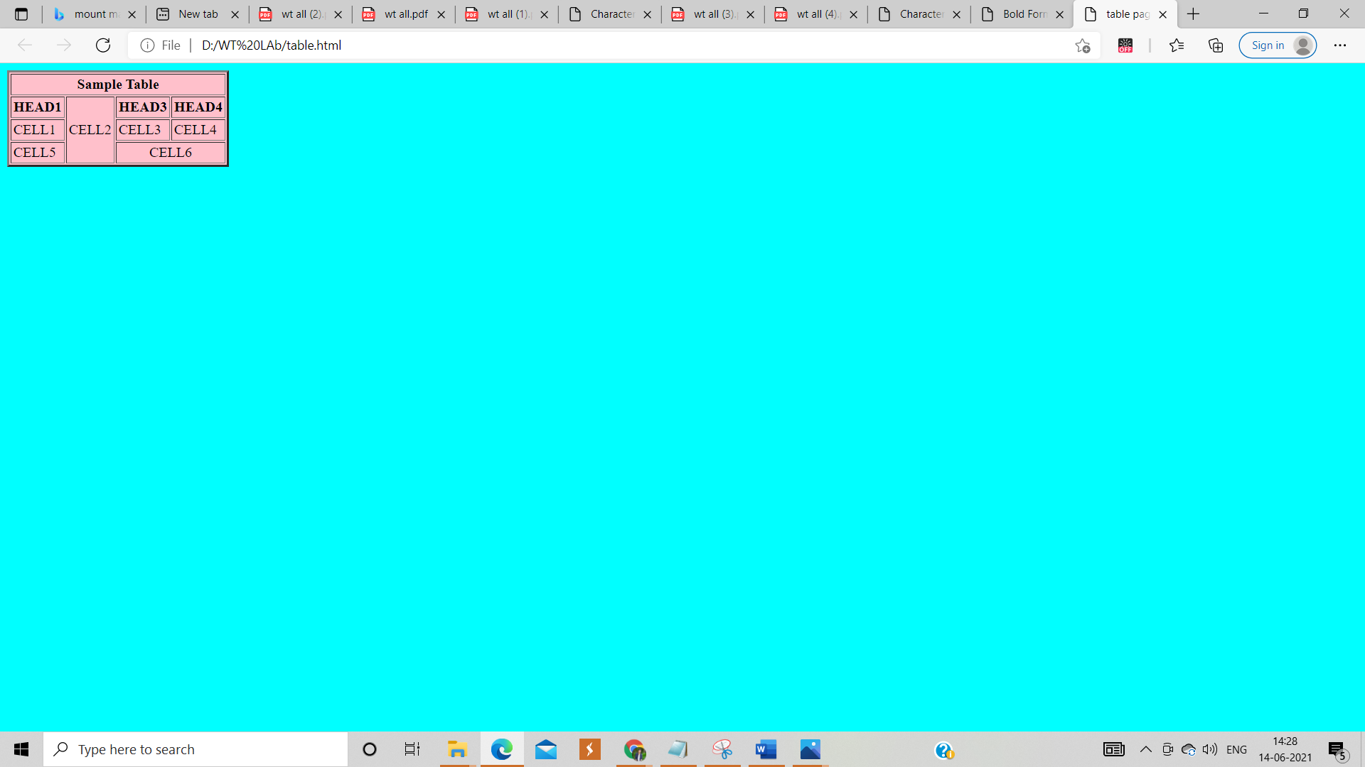

**IMAGES:**

**<**html>

<head>

<title>IMAGE Tags</title>

</head>

<body>

<center>

<img src="D:\WT LAb\image.jpg"height=700$,width=100%>

</centre>

</body>

</html>

**OUTPUT:**

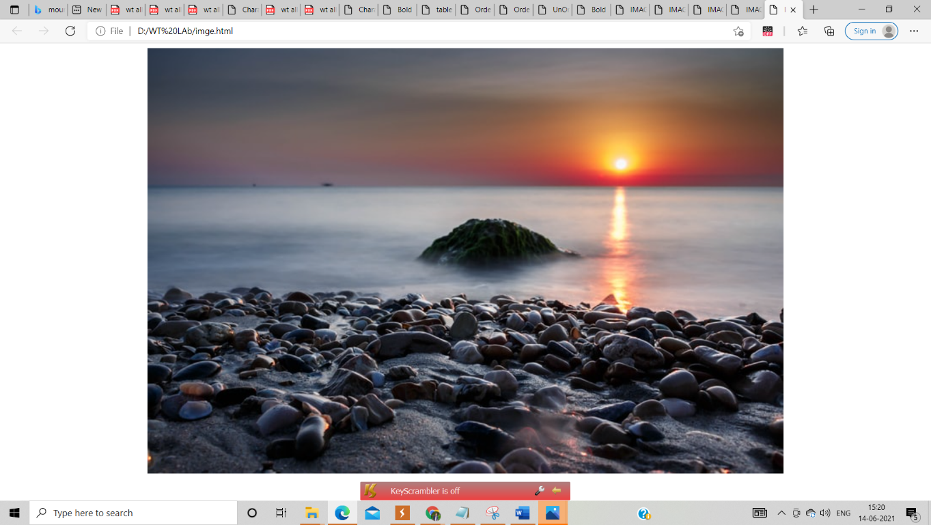

**Frame:**

**First.html**

<html>

<body bgcolor="pink">

<font size=5> <p>This is first frame</p> </font>

</body>

</html>

**Second.html**

<html>

<body bgcolor="pink">

<font size=5> <p>This is second frame</p> </font>

</body>

</html>

**Frame.html**

<frameset cols="45%,55%">

<frame name="fr1" src="first.html" noresize scrolling="yes">

<frame name="fr2" src="second.html" noresize scrolling="yes">

</frameset>

**OUTPUT:**

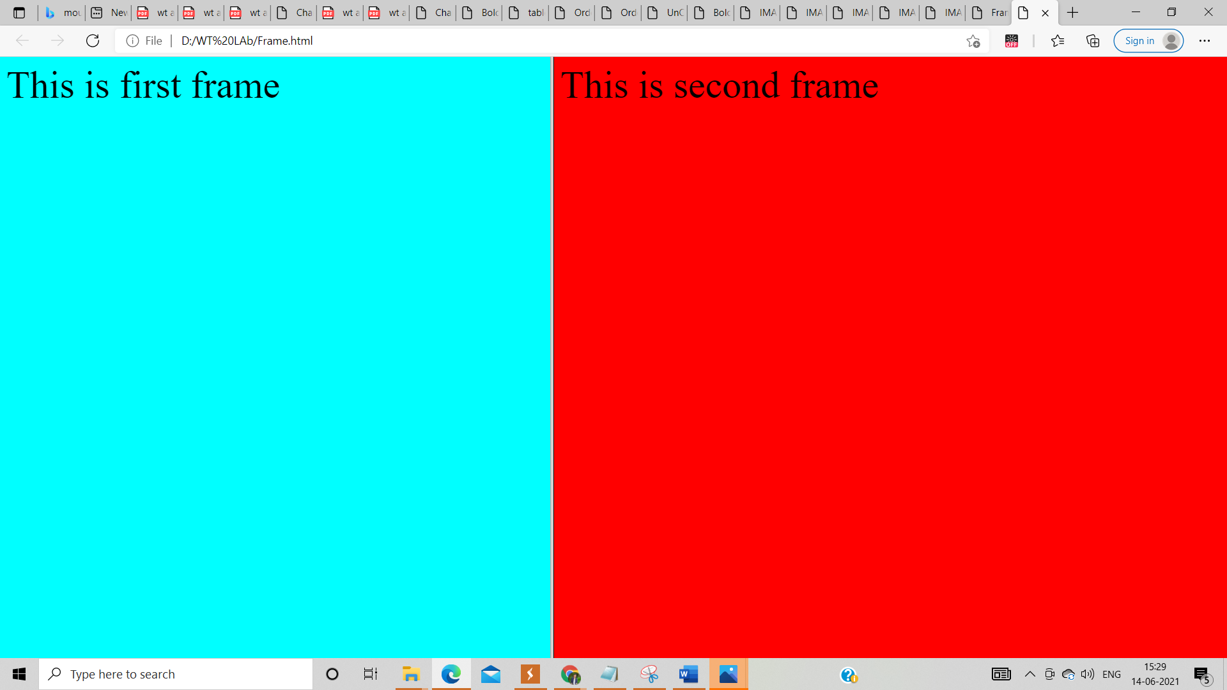

**1)First.html**

<html>

<body bgcolor="pink">

<font size=5> <p>This is first frame</p> </font>

</body>

</html>

**2)Second.html**

<html>

<body bgcolor="pink">

<font size=5> <p>This is second frame</p> </font>

</body>

</html>

**3)Third.html**

<html>

<body bgcolor="pink">

<font size=5> <p>This is third frame</p> </font>

</body>

</html>

**4)Link.html**

<html>

<body bgcolor="cyan">

<font size=5 color="green">

<a href="first.html" target="first">first frame</a></br>

<a href="second.html" target="second">second frame</a></br>

<a href="third.html" target="third">third frame</a>

</font></body></html>

**5)Frame.html**

<frameset cols="45%,*">

<frame name="fr1" src="link.html" noresize>

<frameset rows=25%,45%,*>

<frame name="first" noresize>

<frame name="second" noresize>

<frame name="third" noresize>

</frameset>

</frameset**>**

**OUTPUT:**

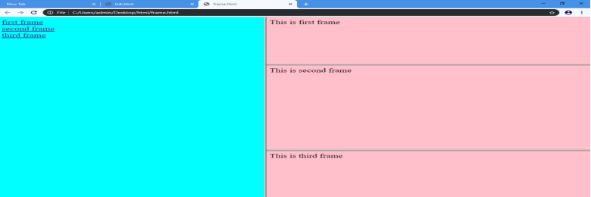

**2) Using Form Tags**

**2.1)Create a Login form**

<html>

<head><title>Login Page</title>

</head>

<body bgcolor="orange">

<form action="validate.php" method="post">

<table align="center">

<tr><td>Login</td><td><input type="text" name="login" size="30" maxlength="20"

value=""></td></tr>

<tr><td>Password</td><td><input type="password" name="pwd" size="20"

maxlength="20"></td></tr>

<tr valign="middle"><td><input type="submit" value="submit"></td>

<td><input type="reset"></td></tr>

</table>

</form>

</body>

</html>

**OUTPUT:**

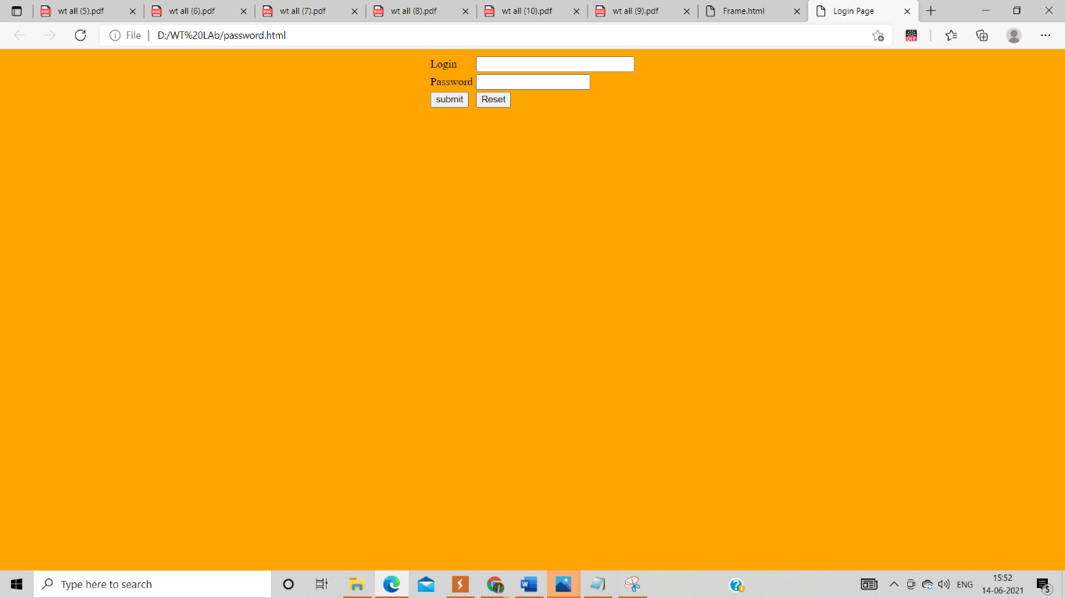

**2..2)Create a “registration form” with the following fields a) Name (Text field) ;b) Password (password field); c) E-mail id (text field); d) Phone number (text field) ;e) Sex (radio button); f) Date of birth (3 select boxes); g) Languages known (check boxes – English, Telugu, Hindi, Tamil) ;h) Address (text area)**

<html>

<head><title>Registration Page</title>

</head>

<body bgcolor="yellow">

<center>

<h3 align="center"><u>Registration Form</u></h3>

<table border="4">

<tr>

<td><form name="f1" action="" method="post" onsubmit="">

<table cellspacing="10" cellpadding="5">

<tr><td>Name</td><td><input type="text" name="Name" size="20" maxlength="20"

value=""></td></tr>

<tr><td>Password</td><td><input type="password" name="pwd" size="20"

maxlength="20"></td></tr>

<tr><td>Email id</td><td><input type="text" name="mail id" size="20" maxlength="20"

value=""></td></tr>

<tr><td>Phone Number</td><td><input type="text" name="no" size="20" maxlength="20"

value=""></td></tr>

<tr><td>Sex</td><td><input type="radio" name="Gender" value="male">Male

<input type="radio" name="Gender" value="female">Female</td></tr>

<tr><td>Date of birth</td><td><select>

<option>DD<option>01<option>02<option>03<option>04<option>05<option>06

<option>07<option>08<option>09<option>10<option>11<option>12<option>13

<option>14<option>15<option>16<option>17<option>18<option>19<option>20

<option>21<option>22<option>23<option>24<option>25<option>26<option>27

<option>28<option>29<option>30<option>31</select>

<select>

<option>MM<option>01<option>02<option>03<option>04<option>05<option>06

<option>07<option>08<option>09<option>10<option>11<option>12 </select>

<select>

<option>YYYY<option>1999<option>2000<option>2001<option>2003<option>2004

<option>2005 <option>2006<option>2007<option>2008<option>2009<option>2010

<option>2011<option>2012<option>2013<option>2014<option>2015<option>2016

<option>2017 <option>2018<option>2019 <option>2020 <option>2021 </select>

<tr><td>Languages Known</td><td><input type="checkbox" name="Language"

value="English">English

<input type="checkbox" name="Language" value="Telugu">Telugu

<input type="checkbox" name="Language" value="Hindi">Hindi

<input type="checkbox" name="Language" value="Tamil">Tamil</td></tr>

<tr><td>Address</td><td><textarea name="Address" rows="5" cols=25"></textarea>

<tr valign="middle"><td><input type="submit" value="submit"></td>

<td><input type="reset"></td></tr>

</tr></table>

</center>

</table>

</form>

</body>

</html>

**OUTPUT:**

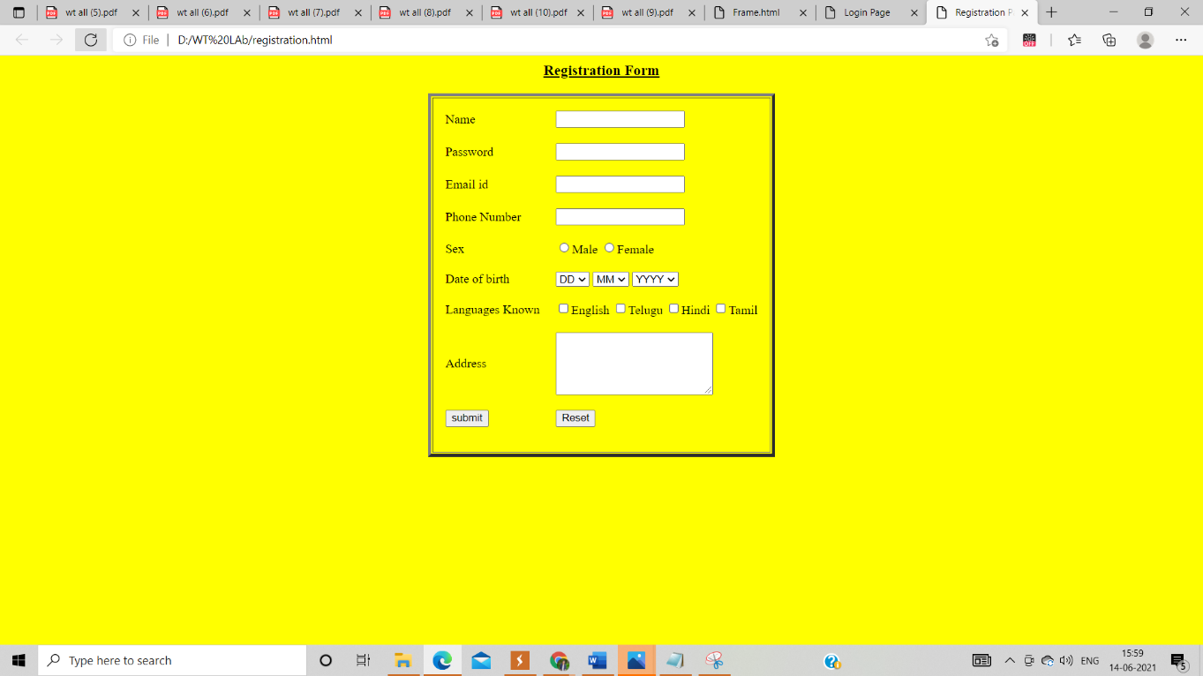

**3.1) Design a web page using CSS (Cascading Style Sheets) which includes the**

**following:**

**3.1.1) Use different font, styles: In the style definition you define how each**

**selector should work (font, color etc). Then, in the body of your pages, you refer to**

**these selectors to activate the styles.**

html>

<head>

<title>Usage of differnt fonts, colors </title>

<link rel="Stylesheet"type="text/css"href="in.css"/>

</head>

<body style="background-color:powderblue;">

<h1>This is the Header H1 </h1>

<h2>This is the Header H2 </h2>

<h3>This is the Header H3 </h3>

<p>This is a Paragraph </p>

</body>

</html>

**HTML:**

h1

{

color:indigo;

font-family:Trebuchet MS;font-size:18t;

text-decoration:underline;

}

h2

{

color:coral;

font-family:caSteller;font-size:20pt;

text-decoration:underline;

}

h3

{

color:greenyellow;

font-family:Arial Black;font-fize:20pt;

text-decoration:blink;

}

p

{

color:magneta;

font-family:fantasy;size=15pt;

font-style:italic;

}

**OUTPUT:**

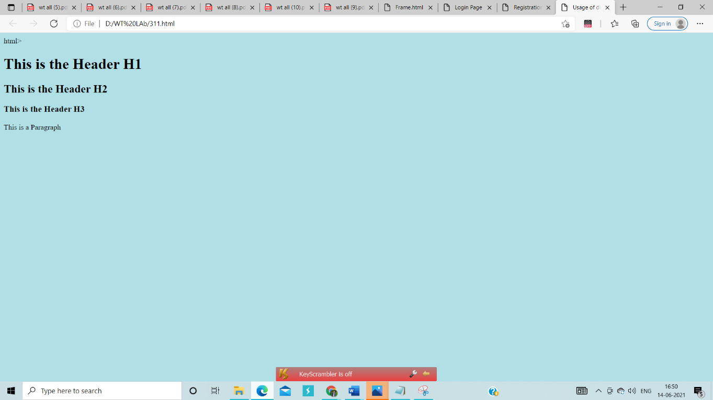

**3.1.2) Set a background image for the web page and control the repetition of the**

**image with the background-repeat property.**

v3.1.2) Set a background image for the web page and control the repetition of the

image with the background-repeat property.

<html>

<head>

<title> Background Image </title>

<style type="text/css">

body

{

background-image:url('friends.jpg');

background-repeat:no-repeat;

}

</style>

</head>

<body bgcolor="azure">

<body text="black">

<h1> Life is better with Friends </h1>

</body>

</html>

**Output:**

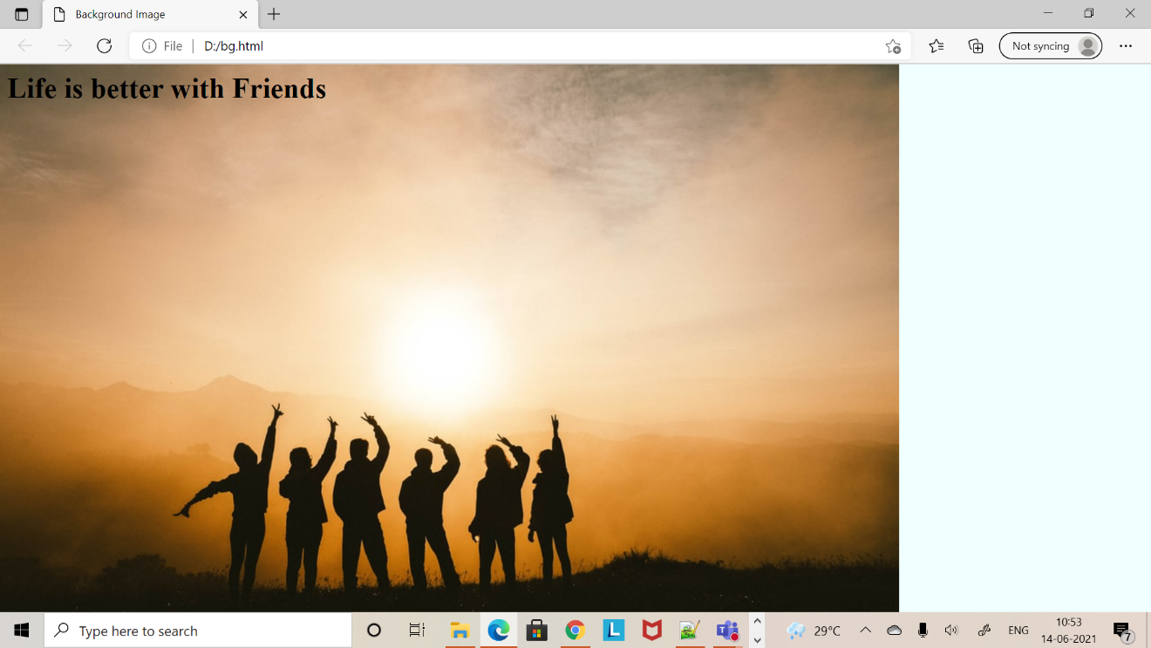

**3.1.3) Define styles for link as visited, active, hover & link.**

<html>

<head>

<title> CSS Webpage </title>

<style type="text/css">

body

{

background-image:url('plain.jpg');

background-repeat:no-repeat;

background-size:cover;

}

p

{

color:navy;

font-size:20pt;

font-family:coral;

background-image:url('friends.jpg');

}

a:link{font-size:20pt;background-color:white;}

a:hover{font-size:20pt;backgroud-color:pink;cursor:crosshair;}

a:active{font-size:20pt;background-color:cyan;cursor:help;}

a:visted{font-size:20pt;background-color:tan;}

</style>

</head>

<body>

<br>

<p>

Web technology refers to the means by which computers communicate with each other using markup languages and multimedia packages.

It gives us a way to interact with hosted information, like websites.

Web technology involves the use of hypertext markup language (HTML) and cascading style sheets (CSS).

</p>

<a href="link.html"><center>Register</center></a>

<br>

</body>

</html>

**Output:**

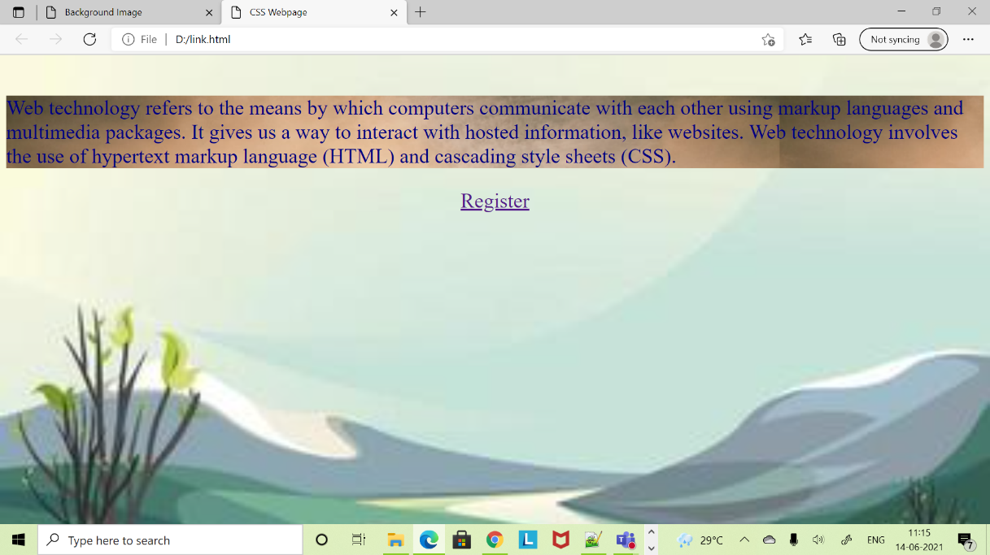

**3.2) Write a JavaScript that takes a number from one text field in the range of 0-999 and display it in other text field in words. If the number is out of range, it should show “out of range” and if it is not a number, it should show “not a number” message in the result box**

<script language="javascript">

function convert_number_to_words(number)

{

hyphen='-';

conjunction='and';

separator='.';

dictionary={0:'zero',1:'one',2:'two',3:'three',4:'four',5:'five',6:'six',7:'seven',8:'eight',

9:'nine',10:'ten',11:'eleven',12:'twelve',13:'thirteen',14:'fourteen',15:'fifteen',16:'sixteen',

17:'seventeen',18:'eighteen',19:'nineteen',20:'twenty',30:'thirty',40:'fourty',50:'fifty',

60:'sixty',70:'seventy',80:'eighty',90:'ninety',100:'hundred',};

if(number<0 || number>999)

{

alert("enter a number range between 0 and 999");

return "";

}

switch(true)

{

case(number<21):

string=dictionary[number];

break;

case(number<100):

tens=parseInt(number/10)*10;

units=number%10;

string=dictionary[tens];

if(units){

string+=hyphen+dictionary[units];

}

break;

case(number<1000):

hundreds=parseInt(number/100);

remainder=number%100;

string=dictionary[hundreds]+ ' ' +dictionary[100];

if(remainder){

string+=conjunction+convert_number_to_words(remainder);

}

break;

default:

break;

}

return string;

}a=prompt("Enter a number");

num=parseInt(a);

document.write(convert_number_to_words(num));

</script>

**OUTPUT**

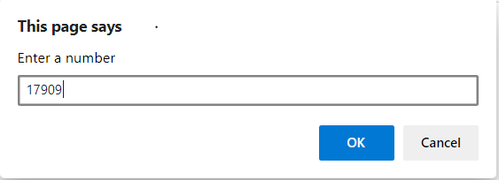

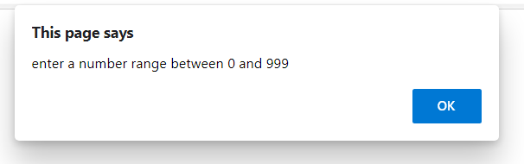

**4) Java Script & XML 4.1) Write a JavaScript to validate the following fields in a registration page created in week 2**

**a. Name (start with alphabet and followed by alphanumeric and the length should not be less than 6 characters)**

**b. Password (it allows alphanumeric, special symbols and should not be less than 6 characters)**

**c. E-mail (should not contain invalid email addresses)**

<html>

<head><h1 align=center>Welcome to Validation

Checking</h1><hr width=50%>

<script language="javascript">

function validation()

{

var x=f.un.value;var len=x.length;

var val=x.charCodeAt(0); var p=f.pw.value;

var c=f.cpw.value;var a=f.email.value;

var atpos=a.indexOf("@");var dotpos=a.lastIndexOf(".");

if(len<6||x==""||x==null)

{

alert("check your username! must be minimum 6 characters");

}

else if(val<65 || val>90&&val<97 || val>122)

{

alert("username must be begin with an alphabet");

return fasle;

}

else if(p==" || c==" || p.length<6 || c.length<6 || p!=c)

{

alert("password and confirm password should be same and greater than 6 characters!");

return false;

}

else if(atpos<6 || dotpos<atpos+6 || dotpos+2>=a.length)

{

alert("Not a Valid email id");

return false;

}

else

alert("Congratulations!you have submitted successfully");

}

</script>

</head>

<body>

<table align=center border=I><form name="f" action="success.html" onsubmit="return validation();" method="post">

<tr><td>User Name:</td>

<td><input type="text" name="un"/></td></tr>

<tr><td>Password:</td>

<td><input type="password" name="pw"/></td></tr>

<tr><td>Confirm Password:</td>

<td><input type="password" name="cpw"/></td></tr>

<tr><td>E-mail ID:</td>

<td><input type="text" name="email"/></td></tr>

<tr><td></td>

<td><input type="Submit" name="Submit"/></td></tr>

</form></table></body></html>

**OUTPUT:**

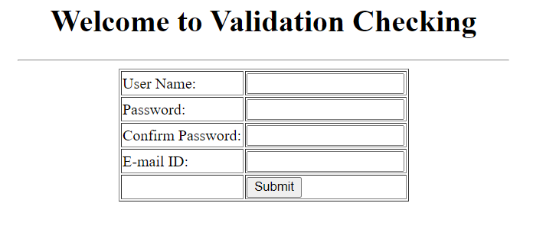

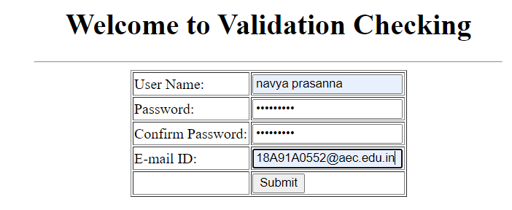



**4.2) Write an XML file which will display the Book information which includes the following:**

**a) Title of the book ;b) Author Name ;c) ISBN number ;d) Publisher name**

**e) Edition ;f) Price**

**Write a Document Type Definition (DTD) to validate the above XML file and display the details in**

**a table (to do this use XSL).**

**Book.dtd:**

<!ELEMENT bookdetails(books+)>

<!ELEMENT books(title,author,isbn,publisher,edition,price)>

<!ELEMENT title(#PCDATA)>

<!ELEMENT author(#PCDATA)>

<!ELEMENT isbn(#PCDATA)>

<!ELEMENT publisher(#PCDATA)>

<!ELEMENT edition(#PCDATA)>

<!ELEMENT price(#PCDATA)>

Book.xml:

<?xml version="1.0"?>

<!DOCTYPE bookdetails SYSTEM "book.dtd">

<?xml-stylesheet type="text/xsl" href="book.xsl"?>

<bookdetails>

<books>

<title>C</title>

<author>Balaguruswamy</author>

<isbn>123456</isbn>

<publisher>Oxford</publisher>

<edition>Edition-II</edition>

<price>$30.00</price>

</books>

<books>

<title>C++</title>

<author>yaswanth kanethkar</author>

<isbn>654321</isbn>

<publisher>Tata McHill</publisher>

<edition>Edition-I</edition>

<price>$35.00</price>

</books>

<books>

<title>JAVA</title>

<author>Herbert Schildt</author>

<isbn>789456</isbn>

<publisher>Cenage</publisher>

<edition>Edition-IV</edition>

<price>$50.00</price>

</books></bookdetails>Book.xsl:

<?xml version="1.0"?>

<xsl:stylesheet version="2.0" xmlns:xsl="http://www.w3.org/1999/XSL/Transform">

<xsl:template match="/">

<html>

<head><center>Book Details</center></head>

<body>

<hr width="50%"/>

<table border="1" align="center">

<tr>

<th>TITLE</th>

<th>AUTHOR</th>

<th>ISBN</th>

<th>PUBLISHER</th>

<th>EDITION</th>

<th>PRICE</th>

</tr>

<xsl:for-each select="bookdetails/books">

<tr>

<td><xsl:value-of select="title"/></td>

<td><xsl:value-of select="author"/></td>

<td><xsl:value-of select="isbn"/></td>

<td><xsl:value-of select="publisher"/></td>

<td><xsl:value-of select="edition"/></td>

<td><xsl:value-of select="price"/></td>

</tr>

</xsl:for-each>

</table></body></html></xsl:template>

</xsl:stylesheet>

**OUTPUT**

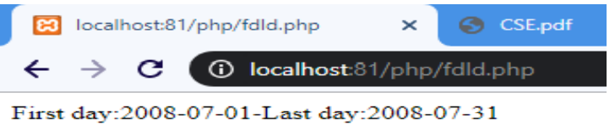

**Sambattula Navya Prasanna**

**18A91A0552**