ASSIGNMENT-6

1.

(B) 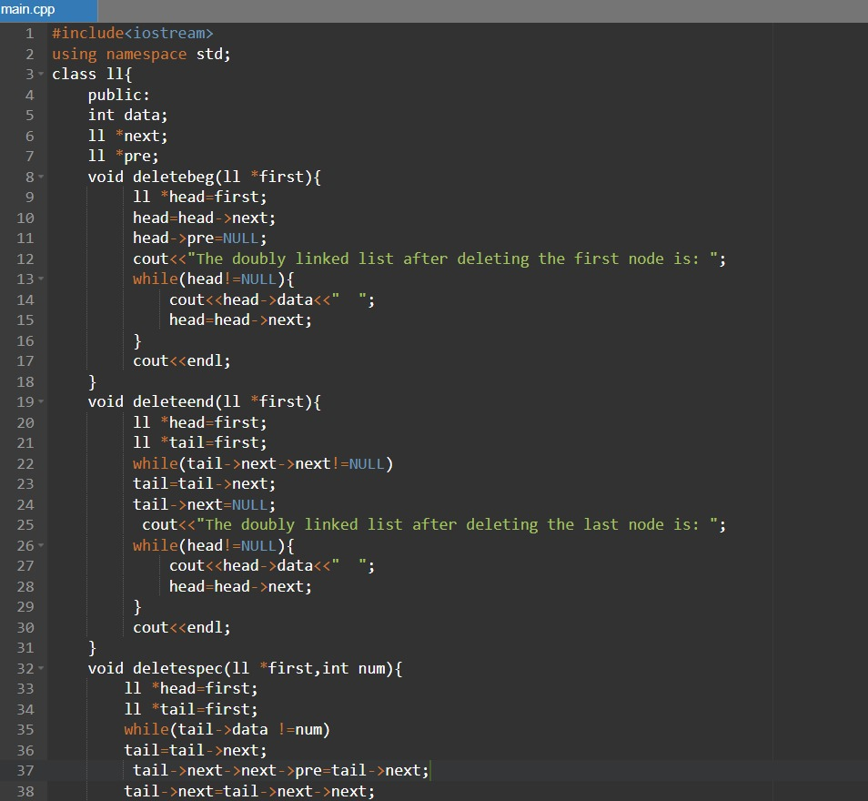

3.

