ASSIGNMENT-5

1.

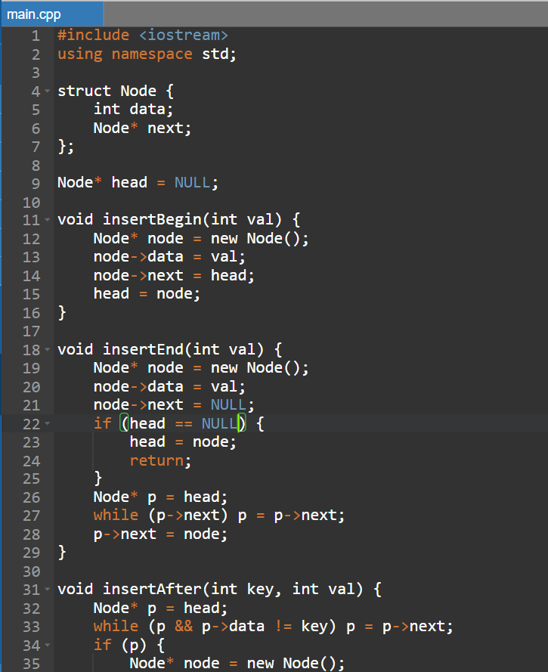

3.

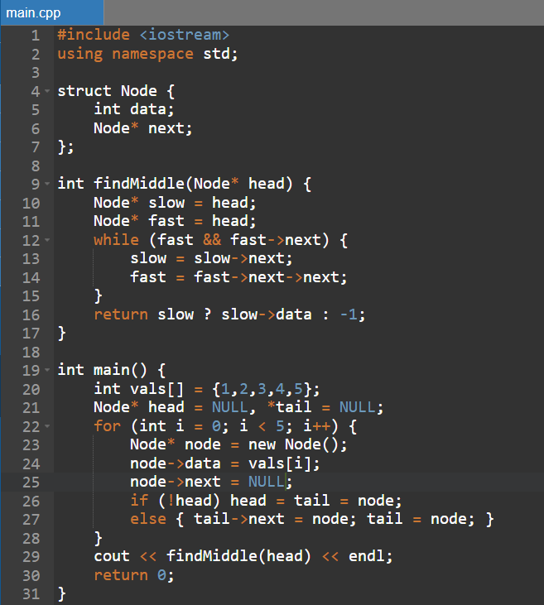

4. 