
IILM UNIVERSITY, GREATER NOIDA, U.P.
School of Computer Science and Engineering
PROJECT REPORT
on
"Indian Startup Funding Analysis (2020–2025): An End-to-End Exploratory Data Analysis of the Indian Startup Ecosystem"
Submitted in partial fulfilment of the requirement for the award of the degree of
Bachelor of Technology in Computer Science and Engineering
(Specialization: Data Science & Big Data Analytics)
Batch: 2023–2027
Submitted By:
Name of Student: Navya Vashistha
Roll Number: CS-23411266
Project Domain: Data Analytics / Exploratory Data Analysis
Dataset Source: Kaggle – Indian Startup Funding Dataset (2020–2025)

TABLE OF CONTENTS
Chapter 1 Project Description 3
1.1 Introduction 3
1.2 Problem Statement 3
1.3 Project Objectives 3
1.4 Scope of the Project 3
1.5 Dataset Description 3
1.6 Technologies and Tools Used 4
1.7 Analysis Architecture 4
1.8 Methodology / Approach 4
Chapter 2 Exploratory Data Analysis & Results 5
Chapter 3 Key Insights & Findings 7
Chapter 4 Recommendations 8
Chapter 5 Conclusion 9
Bibliography / References 10
Appendix Repository Structure & Evidence 11

LIST OF FIGURES
Figure 1.1 Conceptual Data-Analysis Pipeline 4
Figure 2.1 Distribution of Investment Stages (Seed vs Series A vs Others) 6
Figure A.1 Project README as published on GitHub 12

LIST OF TABLES
Table 1.1 Dataset Description 3
Table 1.2 Tools & Skills Used 4
Table 2.1 Results Summary 6

CHAPTER 1 – PROJECT DESCRIPTION

1.1 Introduction
This report documents an independent Data Analytics project, “Indian Startup Funding Analysis (2020–2025),” undertaken as part of the B.Tech CSE (Data Science & Big Data Analytics) curriculum at IILM University, Greater Noida, U.P. The project is an end-to-end Exploratory Data Analysis (EDA) of the Indian startup ecosystem, examining funding trends across industries, cities, investment types, and time, and backing the visual findings with statistical validation.
The complete analysis, code, and documentation for this project are maintained on GitHub as part of a broader Data Analytics portfolio, and the notebook was developed and executed in Google Colab using Python.

1.2 Problem Statement
The Indian startup ecosystem has seen significant shifts in investor behaviour over the past five years. This project analyzes funding data from 2020–2025 to answer key questions: Which industries are attracting the most investment? Are traditional startup hubs (like Bangalore) still leading, or is funding shifting to other cities? How has overall funding activity trended year over year? Which investment stages are most common? Do funding differences between the top sectors actually hold up statistically, or just visually?

1.3 Project Objectives
- To validate and clean the raw startup funding dataset for completeness and consistency.
- To engineer time-based features (Year, Month) from the raw Date column for trend analysis.
- To analyze funding distribution across industries, cities, investment types, and time periods.
- To identify the most funded startups and investment-stage patterns within the dataset.
- To statistically validate whether the funding difference between the top two industries is significant.
- To translate each analytical finding into a clear, business-relevant insight.

1.4 Scope of the Project
The analysis is limited to the dataset described below and covers the period 2020–2025. The project focuses on descriptive and inferential statistics (EDA plus a two-sample t-test) rather than predictive modelling; forecasting and machine-learning extensions are identified as future scope in Chapter 4.

1.5 Dataset Description
Attribute | Details
Source | Kaggle – Indian Startup Funding Dataset (2020–2025)
Records | 1,100 startups
Columns | Startup, Industry, SubVertical, City, Investors, Investment Type, Investment Amount (USD), Date
Coverage | 14 industries across 10 major Indian cities
Data Quality | No missing values or duplicate records found during validation
Table 1.1: Dataset Description

1.6 Technologies and Tools Used
Category | Tools / Skills
Programming | Python
Data Manipulation | Pandas, NumPy
Data Cleaning | Missing-value checks, duplicate checks, dtype conversion
Feature Engineering | Date parsing, Year/Month extraction
Visualization | Matplotlib, Seaborn
Statistics | Descriptive statistics, Hypothesis Testing (t-test) via SciPy
Environment | Google Colab
Version Control | Git & GitHub
Table 1.2: Tools & Skills Used

1.7 Analysis Architecture
As this is a self-contained analytics project rather than a live-system assessment, the “architecture” below represents the conceptual data pipeline followed from raw data to final insight.
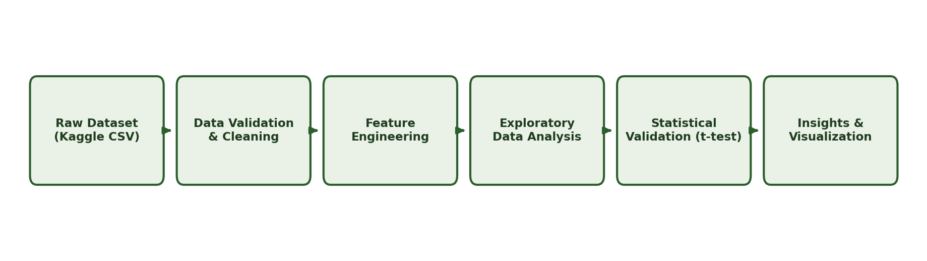
Figure 1.1: Conceptual Data-Analysis Pipeline

1.8 Methodology / Approach
1. Data Validation – Loaded the dataset and checked structure, data types, and completeness (no missing values or duplicates found).
2. Feature Engineering – Converted the Date column to datetime format and extracted Year and Month for time-based analysis.
3. Exploratory Data Analysis – Analyzed funding patterns across industries, cities, investment types, and time periods.
4. Statistical Testing – Ran an independent two-sample t-test to check whether the funding difference between the top two industries (AgriTech and E-commerce) was statistically significant, rather than relying on visual comparison alone.
5. Insight Documentation – Translated each finding into a business-relevant takeaway.

CHAPTER 2 – EXPLORATORY DATA ANALYSIS & RESULTS

2.1 Executive Summary
An end-to-end EDA was carried out on the Indian Startup Funding dataset (2020–2025). The analysis covered industry-wise and city-wise funding distribution, yearly funding trends, investment-type and investment-amount distributions, and identification of the top-funded startups. A two-sample t-test was additionally used to verify whether the apparent funding gap between the two leading industries was statistically meaningful.

2.2 Data Validation & Cleaning Results
The dataset was loaded and checked for structure, data types, and completeness. No missing values or duplicate records were found, so no imputation or de-duplication was required before analysis. The Date column was converted to datetime format and Year/Month features were extracted for time-based analysis.

2.3 Industry-wise Funding Trend
AgriTech received the highest total funding in the dataset, surpassing traditionally dominant sectors such as E-commerce and FinTech — suggesting growing investor confidence in agricultural technology over the 2020–2025 window.

2.4 City-wise Distribution
Pune emerged as the top-funded city, ahead of Bangalore and Mumbai — challenging the common assumption that startup funding is concentrated only in India's traditional tech hubs.

2.5 Yearly Funding Trend (2020–2025)
Overall funding activity peaked in 2021 and again in 2024, with a sharp decline in 2025, potentially reflecting broader market corrections following aggressive funding cycles in the preceding years.

2.6 Investment Type Distribution
Seed funding was the most common investment stage in the dataset (350 instances), followed by Series A (220 instances), with the remaining 530 records spread across later stages such as Series B, Series C, and Pre-seed — indicating that most funding activity captured in this dataset occurred at the early stage of the startup lifecycle.
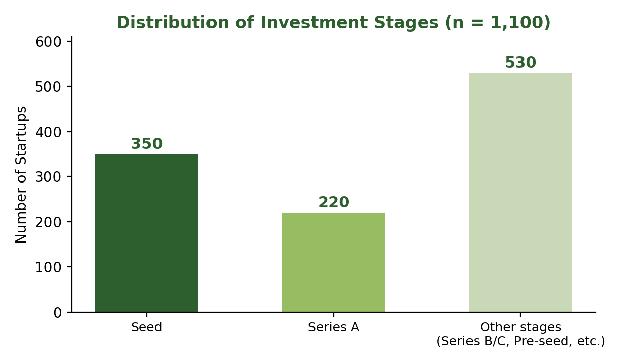
Figure 2.1: Distribution of Investment Stages (Seed vs Series A vs Others)

2.7 Investment Amount Distribution
Most startups received funding within a moderate range, with a small number of large outlier deals pulling the average well above the median — a distribution pattern typical of startup funding data. A log-scaled view of investment amount was used to make this skew easier to interpret visually.

2.8 Statistical Validation (t-test)
A t-test comparing AgriTech and E-commerce funding levels returned a p-value of 0.546, showing no statistically significant difference between the two — a reminder that a higher observed total does not always indicate a meaningfully different underlying pattern.

2.9 Visualizations Generated
- Total Funding by Industry
- Total Funding by City
- Yearly Funding Trend (2020–2025)
- Distribution of Investment Types
- Distribution of Investment Amount (log-scaled)
- Top 10 Most Funded Startups

2.10 Results Summary Table
Analysis | Method | Result | Observation
Industry-wise Funding | Aggregation (Total) | AgriTech highest | Surpassed E-commerce and FinTech
City-wise Funding | Aggregation (Total) | Pune highest | Ahead of Bangalore and Mumbai
Yearly Trend | Time-series aggregation | Peaked 2021 & 2024 | Sharp decline in 2025
Investment Type | Frequency count | Seed most common | 350 Seed, 220 Series A
Investment Amount | Distribution / log-scale | Right-skewed | Outliers pull mean above median
AgriTech vs E-commerce | Two-sample t-test | p = 0.546 | Not statistically significant
Table 2.1: Results Summary

CHAPTER 3 – KEY INSIGHTS & FINDINGS
Beyond the individual chart-level observations in Chapter 2, the exercise of stepping back and consolidating findings into business-relevant takeaways is itself a core EDA skill. The insights below summarize what the analysis says about the Indian startup funding landscape for 2020–2025, and where those conclusions should be read with appropriate caution.

3.1 Summary of Insights
- Industry Trend: AgriTech's lead over traditionally dominant sectors like E-commerce and FinTech suggests a broadening of investor confidence beyond the usual favourites.
- City-wise Distribution: Pune's position ahead of Bangalore and Mumbai indicates that startup funding is no longer as concentrated in India's traditional tech hubs as commonly assumed.
- Funding Trend Over Time: The 2021 and 2024 peaks followed by a sharp 2025 decline point to cyclical investor behaviour rather than steady, linear growth.
- Investment Type: The dominance of Seed and Series A funding (570 of 1,100 records) shows that most captured activity is concentrated at the early stage of the startup lifecycle.
- Investment Distribution: The gap between mean and median funding amounts, driven by a small number of large outlier deals, is a pattern typical of startup ecosystems worldwide.
- Statistical Validation: The t-test result (p = 0.546) is an important caution — a higher total for one industry does not by itself prove a meaningfully different funding pattern; visual trends should be checked statistically before being treated as conclusions.

3.2 Limitations
A few limitations are worth noting when interpreting these findings. The dataset is a single static snapshot of 1,100 records rather than a live feed, so it may not capture every funding round announced in the market during 2020–2025. Investment amounts are recorded in USD without adjustment for inflation or exchange-rate movement across the five-year window, and the statistical validation in this project covers only one pairwise industry comparison (AgriTech vs. E-commerce) rather than every possible pair. These limitations do not invalidate the findings but do mean they should be read as indicative of patterns in this dataset rather than as a definitive, real-time picture of the Indian startup ecosystem.

CHAPTER 4 – RECOMMENDATIONS
Based on the findings of this analysis, the following recommendations are proposed for extending the project and for stakeholders interested in the Indian startup funding landscape:
- Extend the dataset beyond 2025 and automate periodic refreshes to keep the analysis current.
- Incorporate startup valuation and exit data (acquisitions/IPOs) to complement funding-amount analysis.
- Apply correlation and regression analysis to examine relationships between city, industry, and investment stage.
- Extend statistical testing (ANOVA) across all industries and cities rather than a single pairwise comparison.
- Build an interactive dashboard (e.g., Power BI/Tableau) on top of the cleaned dataset for non-technical stakeholders.
- Explore a predictive model to estimate a startup's likely funding stage or amount range from its industry, city, and investor profile.
Of these, extending the statistical testing to a full ANOVA across industries and building an interactive dashboard are the most immediately actionable next steps, since both build directly on the cleaned dataset and code already produced for this project, while the predictive-modelling and valuation-data extensions represent a longer-term direction for the portfolio.

CHAPTER 5 – CONCLUSION
This project provided hands-on, end-to-end experience in exploratory data analysis — from data validation and feature engineering through visualization and statistical hypothesis testing — using Python, Pandas, Matplotlib/Seaborn, and SciPy. Working with the Indian Startup Funding dataset (2020–2025) surfaced findings that challenged some common assumptions, such as the dominance of Bangalore in startup funding and the implicit assumption that a higher total funding figure automatically means a meaningfully different pattern.
Beyond the specific findings, the project reinforced the importance of pairing visual, exploratory findings with statistical validation before drawing conclusions, and of documenting each insight in a way that is useful to a non-technical, business-oriented reader. This aligns directly with the analytical skill set being developed through the Data Science & Big Data Analytics specialization at IILM University.
The complete notebook, along with the README documenting the problem statement, dataset, methodology, and insights, is published on GitHub as part of an ongoing Data Analytics portfolio, alongside other independent projects covering ETL pipelines and AI-augmented risk analysis. Together, these projects form a consistent record of applying the full analytics workflow — from raw data to a validated, well-documented insight — to real-world, publicly available datasets.

BIBLIOGRAPHY / REFERENCES
- Kaggle, Indian Startup Funding Dataset (2020–2025).
- Pandas Documentation – pandas.pydata.org
- NumPy Documentation – numpy.org/doc
- Matplotlib Documentation – matplotlib.org
- Seaborn Documentation – seaborn.pydata.org
- SciPy Documentation (stats module) – docs.scipy.org
- Navya Vashistha, Data-Analytics-Journey GitHub Repository – github.com/Navya2057/Data-Analytics-Journey

APPENDIX – REPOSITORY STRUCTURE & EVIDENCE

Repository Structure
Indian_Startup_Funding_Analysis.ipynb # Full analysis notebook
README.md # Project documentation

How to Run
- Clone the repository or download the notebook.
- Open in Google Colab or Jupyter Notebook.
- Install dependencies: pandas, numpy, matplotlib, seaborn, scipy.
- Run all cells sequentially.

Author
Navya Vashistha — B.Tech CSE (Data Science & Big Data Analytics), IILM University, Greater Noida | GitHub: github.com/Navya2057

Screenshot Evidence – Project README on GitHub
The screenshot below shows the published README of the project repository on GitHub, documenting the problem statement, dataset, and analysis approach exactly as summarized in this report.
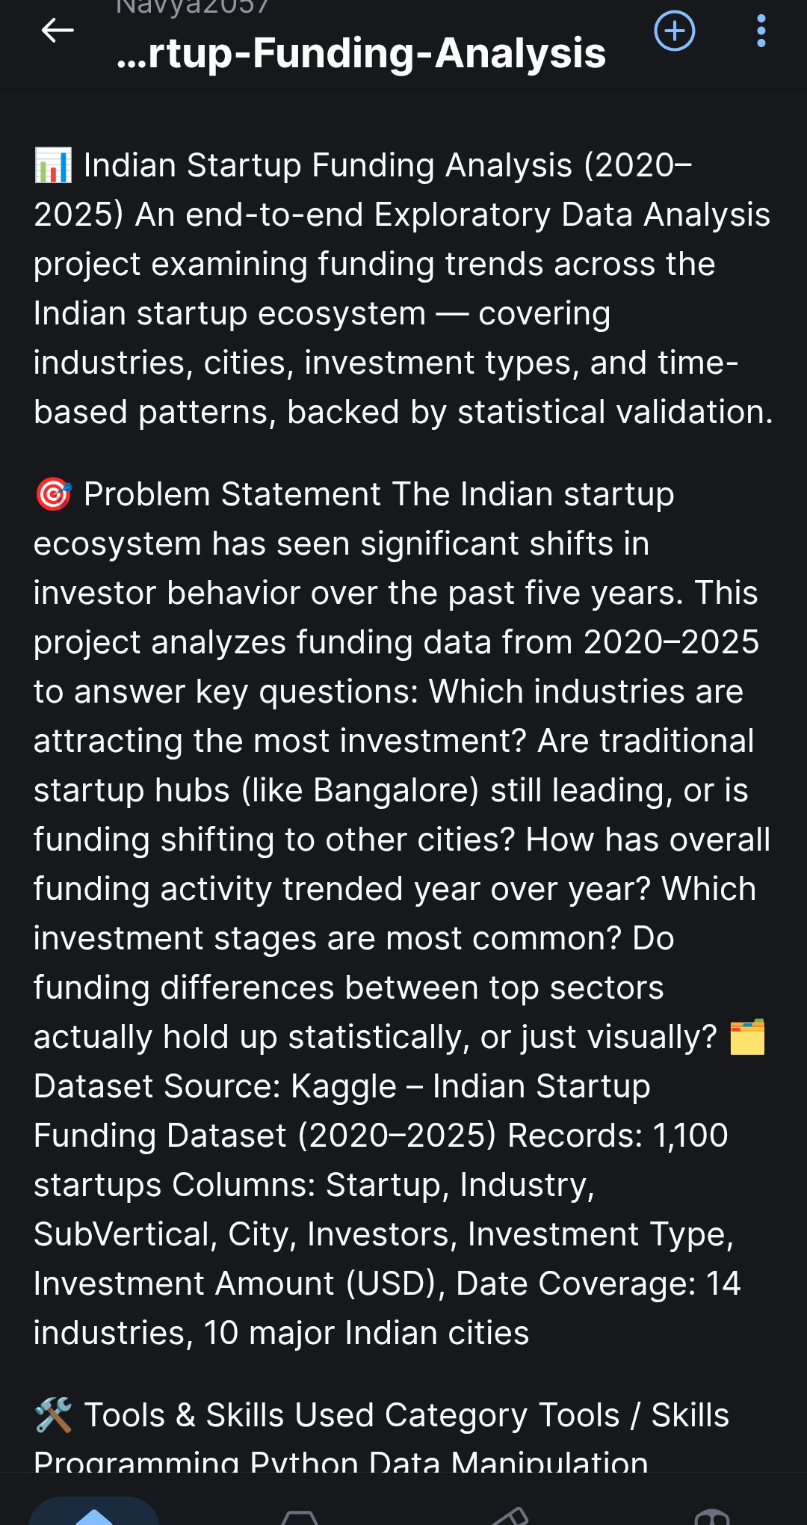
Figure A.1: Project README as published on GitHub (Data-Analytics-Journey repository)

