**AI-Powered Resume Screening And Ranking System**

A Project Report

submitted in partial fulfillment of the requirements

of

AICTE Internship on AI: Transformative Learning

with

TechSaksham – A joint CSR initiative of Microsoft & SAP

by

**Muppuri.Navya**

**navyamuppuri@gmail.com**

Under the Guidance of

**Saomya chaudhary**

**ACKNOWLEDGEMENT**

I would like to express my sincere gratitude to all these individuals for mentoring and supporting me in completing this project.

Firstly, I would like to thank my supervisor, **Saomya chaudhary sir** for their constant support,valuable guidance and encouragement throughout the process.

I would also like to thank Pavan kumar sir,and Raja sir for clear doubts about project templet,code implementation and section regardings related project .Your useful advice and suggestions were really helpful to me during the project completion.In this aspect,I am eternally grateful to you.

I would like to acknowledge that this project was completed entirely by me and not by someone else.

#### **ABSTRACT**

The increasing volume of job applications has made manual resume screening a time-consuming and inefficient process for human resource (HR) departments. Traditional resume evaluation often involves subjective biases and overlooks candidate potential, leading to suboptimal hiring decisions. This project addresses the need for an AI-based resume screening and ranking system to streamline the hiring process, enhance objectivity, and improve candidate selection efficiency.

The primary objective of this project is to develop an AI-powered system that can automatically screen and rank resumes based on their relevance to job descriptions. The system aims to analyze resumes for key skills, qualifications, experience, and other relevant factors to generate a ranked list of candidates for HR professionals to consider.

To achieve this, the methodology involves training a machine learning model using natural language processing (NLP) techniques, such as Named Entity Recognition (NER) and text classification. The model is trained on a large dataset of resumes and job descriptions, with performance metrics such as precision, recall, and accuracy used to evaluate its effectiveness.

Key results of the project include the successful development of an AI system that can accurately rank resumes, reducing manual intervention and significantly speeding up the candidate shortlisting process. The system also improves consistency in candidate evaluation by eliminating human biases and ensuring all applicants are assessed based on objective criteria.

In conclusion, the AI resume screening and ranking system offers a scalable and efficient solution to modern recruitment challenges, benefiting HR teams by automating repetitive tasks and enhancing decision-making. Further improvements can be made by integrating more advanced NLP models and expanding the system's ability to assess diverse job roles and industries.

**TABLE OF CONTENT**

**Abstract I**

**Chapter 1.**  **Introduction 1**

1.1 Problem Statement 10

1.2 Motivation 11

1.3 Objectives 12

1.4. Scope of the Project 13

**Chapter 2.**  **Literature Survey 16**

**Chapter 3.**  **Proposed Methodology 20**

**Chapter 4.**  **Implementation and Results 31**

**Chapter 5. Discussion and Conclusion 38**

**References** 42

**LIST OF FIGURES**

|  |  |  |
| --- | --- | --- |
| **Figure No.** | **Figure Caption** | **Page No.** |
|  | Fig a:Resume Screening Flow Chart | **26** |
|  | Figb:Run the Code in ComandPromt | **35** |
|  | Figc:app.streamlit | **36** |
|  | Figd:Resume Ranking | **37** |
|  |  |  |
|  |  |  |
|  |  |  |
|  |  |  |
|  |  |  |

**CHAPTER 1**

**Introduction**

AI-powered resume screening systems come with a variety of features that make the hiring process more efficient, accurate, and fair.

**Some of the key features of these systems:**

**1. Resume Parsing and Extraction**

One of the first steps in the resume screening process is extracting relevant information from resumes. AI-powered systems use natural language processing (NLP) and optical character recognition (OCR) technologies to parse resumes and extract key details such as contact information, work experience, education, skills, certifications, and other relevant attributes.This ensures that the system can read resumes in various formats, such as PDFs, Word documents, and even scanned images.

**2. Keyword Matching**

AI-based resume screening tools utilize keyword matching techniques to compare the content of resumes with job descriptions. The system identifies key terms and phrases from the job posting (such as required skills, qualifications, and experience) and looks for matches in the candidate's resume.This ensures that candidates who possess the essential skills and qualifications are identified and ranked higher in the screening process.

**3. Semantic Search and Context Understanding**

Traditional keyword matching is limited by its inability to understand the context of a resume. AI-powered systems, however, go beyond simple keyword matching. These systems can understand the semantic meaning behind the text in resumes, recognizing synonyms and contextually relevant phrases.For example, a resume mentioning "Python development" may be matched with a job description that asks for "programming experience with Python."

**4. Skills and Experience Assessment**

AI tools assess resumes based on specific skills and qualifications. The system can evaluate whether candidates possess the technical expertise required for the role and whether they have relevant experience in the field.Some systems even go further by analyzing the depth and relevance of a candidate's experience. For instance, a candidate with several years of experience at top-tier companies may receive higher rankings for their experience compared to a candidate with less relevant experience.

**5. Customizable Ranking Algorithms**

AI-powered resume screening systems allow HR professionals and recruiters to define customized ranking algorithms. Based on factors such as skills, experience, education, certifications, and other attributes, the system assigns scores to candidates and ranks them accordingly.This level of customization ensures that the system aligns with the specific requirements of each job role and can adapt to the unique preferences of different hiring teams.

**6. Candidate Matching and Shortlisting**

Once the system has parsed and assessed resumes, it creates a shortlist of the most qualified candidates. By ranking resumes based on relevance and quality, the system makes it easier for recruiters to focus on top candidates, minimizing the risk of overlooking qualified applicants.Some systems also provide a "match percentage" indicating how well a candidate's resume aligns with the job requirements.

**7. Bias Mitigation**

One of the most significant advantages of AI-powered resume screening systems is their potential to reduce unconscious bias in the hiring process. Human recruiters may unknowingly favor candidates from certain demographic backgrounds, educational institutions, or previous companies.AI systems can be designed to focus solely on the qualifications and skills of candidates, minimizing the influence of bias. This leads to more diverse and equitable hiring practices.

**key technologies power AI-powered resume screening and ranking systems:**

**1. Natural Language Processing (NLP)**

NLP enables machines to understand, interpret, and generate human language in a meaningful way. In resume screening, NLP algorithms help the system extract important information from resumes, such as job titles, skills, and qualifications.

NLP is also used to understand the context of the language and identify synonyms, allowing the system to make more intelligent comparisons between resumes and job descriptions.

**2. Machine Learning (ML)**

Machine learning algorithms allow the system to learn from historical data, such as past hiring decisions and candidate performance, and improve its predictions over time.

ML models can be trained to predict the suitability of a candidate based on various features of their resume, such as their experience level, the industries they have worked in, and their technical competencies.

**3. Optical Character Recognition (OCR)**

OCR technology is used to extract text from scanned or image-based resumes (such as JPEG or PNG files). It converts these images into machine-readable text, which can then be processed by NLP and ML algorithms.

OCR ensures that resumes in non-standard formats (such as handwritten or scanned) are still readable by AI systems.

**4. Deep Learning**

Deep learning, a subset of machine learning, uses neural networks to process large amounts of data and identify patterns that may not be apparent to traditional algorithms.In resume screening, deep learning can be used to better understand the semantic meaning of resumes, improving the accuracy of candidate matching and ranking.

**Benefits of AI-Powered Resume Screening and Ranking:**

The implementation of AI in resume screening brings numerous advantages to both employers and candidates.

**1. Increased Efficiency**

AI-powered systems can process hundreds or even thousands of resumes in a fraction of the time it would take human recruiters. This dramatically speeds up the hiring process and reduces the time-to-hire.

Recruiters can focus their efforts on candidates who are the best fit for the role, rather than spending time manually sifting through resumes.

**2. Improved Accuracy**

AI-powered resume screening systems can identify and assess candidates more accurately than human recruiters, particularly in cases where job descriptions and candidate qualifications contain complex or nuanced information.

The system's ability to understand context, identify relevant skills, and rank candidates objectively leads to better hiring decisions.

**3. Reduced Bias**

By focusing on qualifications and experience rather than personal details, AI systems can help eliminate biases related to gender, ethnicity, age, or educational background, promoting diversity and inclusivity in the hiring process.

**4. Cost Savings**

Automating the resume screening process can reduce the need for extensive manual labor, allowing organizations to save on HR costs. It also reduces the risk of making costly hiring mistakes by ensuring that only the most qualified candidates are shortlisted.AI-powered resume screening systems can handle large volumes of applications effortlessly, making them ideal for organizations that regularly hire in bulk or have high turnover rates.Whether it's processing hundreds of applications for a single role or screening resumes for multiple job openings at once, AI systems can scale to meet the organization's needs.

**Ethical Considerations and Challenges:**

While AI-powered resume screening and ranking systems offer numerous advantages, they also raise ethical considerations and challenges that need to be addressed:

**1. Bias in Training Data**

If the AI system is trained on biased or unrepresentative data, it can perpetuate those biases in the hiring process. For example, if past hiring decisions were biased against certain groups, the system may unintentionally replicate those biases.To address this, organizations must ensure that the training data used to train the AI system is diverse, inclusive, and representative of the candidate pool.

**2. Transparency and Accountability**

One of the challenges with AI systems is their lack of transparency in decision-making. Hiring managers may not always understand how the AI arrived at a particular ranking or recommendation.Organizations must prioritize transparency by providing clear explanations of how the AI system works and how decisions are made, ensuring that recruiters and candidates have confidence in the process.

**3. Candidate Privacy**

Resumes often contain sensitive personal information, such as contact details, work history, and qualifications. It is crucial to ensure that this information is handled securely and in compliance with privacy laws, such as GDPR.Organizations must implement robust data protection measures to safeguard candidate data throughout the recruitment process

**4.Conclusion**

AI-powered resume screening and ranking systems represent a revolutionary shift in the way organizations approach recruitment. By leveraging advanced machine learning, natural language processing, and data analytics, these systems provide more efficient, accurate, and unbiased ways of identifying the most qualified candidates. While challenges such as bias in training data and transparency remain, the potential benefits of AI in recruitment are immense. As AI technology continues to evolve, it will play an increasingly important role in shaping the future of talent acquisition and helping organizations make smarter, faster, and more equitable hiring decisions.

* 1. **Problem Statement:**

Traditional resume screening and rating procedures are inherently subjective and inefficient, which is the issue being addressed. In many companies, recruiters and Human Resource (HR) teams manually go through a lot of resumes to find the best applicants for available positions. This method frequently takes a lot of time and effort, and it is prone to human biases such unconscious age or gender bias, which can result in less-than-ideal candidate selection. Furthermore, it gets harder to handle the vast number of applications, particularly for jobs with high demand or for big businesses, which causes the hiring process to take longer

**This problem is significant for several reasons**:

**Time and Resource Limitations**: Hiring decisions are delayed since it takes a lot of time and HR resources to manually review hundreds or even thousands of applicants for every job advertising. HR personnel face a growing workload as businesses expand, which makes it challenging to handle the volume of applications.

**Subjectivity and Bias**: Human reviewers may unintentionally introduce prejudices based on non-job performance-related variables like name, gender, or educational background. In addition to potentially excluding competent applicants from underrepresented groups, this compromises the hiring process's fairness.

**Missed Talent**: Conventional resume screening may miss applicants with non-traditional credentials or those with highly relevant talents for the job but are not specifically included on resumes. This can limit the diversity and potential of the candidate pool by causing talent to be missed.

**Scalability Issues**: As businesses grow, it becomes impractical to manually manage and analyze a large number of apps. Missed chances for both businesses and candidates might result from recruitment bottlenecks caused by a lack of scalable, effective solutions.

This issue can be lessened by using AI develop web based application automate the resume screening and ranking process. This will lessen biases and improve the overall quality of candidate selection while enabling quicker, more objective, and more effective recruiting procedures.

* 1. **Motivation:**

Addressing the inefficiencies, biases, and scalability problems of conventional resume screening and rating procedures is why this project was selected. As businesses expand and the number of job seekers rises, manual resume screening becomes more and more unsustainable and prone to human mistake.The goal of creating an AI-based system for screening and ranking resumes is to improve and automate this procedure,resulting in hiring procedures that are more effective,impartial,and equitable.

**Prospective Uses:**

**Human Resources (HR) and recruiting:** HR departments and recruitment firms are where this system is primarily used. Instead of using subjective judgment, HR teams may swiftly find the most eligible individuals by automating the resume screening process and using objective criteria like skills, experience, and qualifications. This can drastically cut down on the time and effort required for the preliminary screening and shortlisting of candidates.

**Corporate and Enterprise Hiring:** This technique is highly advantageous for big businesses and organizations with frequent hiring requirements, such as tech firms, retail chains, and healthcare institutions. Without sacrificing the caliber of candidate selection, it enables these firms to grow their hiring procedures.

**Job Boards and Staffing Agencies:**AI-powered resume ranking systems can be included into job boards and staffing firms to provide employers with sophisticated candidate screening services. This can improve the accuracy of job matching by assisting job searchers in better tailoring their resumes to job descriptions.

**Diversity and Inclusion Initiatives:** This method could encourage more inclusive recruiting practices by eliminating human biases in resume review. It can be made to guarantee that applicants from various backgrounds—such as gender, color, and educational attainment—are properly evaluated on the basis of their qualifications rather than unintentional prejudices.

**IMPACT:**

**Efficiency and Cost Savings:** HR teams may devote more time to more strategic activities like candidate engagement and interviews by automating the resume screening process. Both companies and candidates may gain from quicker recruiting processes and less recruitment expenses as a result.

**Better Candidate Selection:** By using AI, the system is able to evaluate applicants more precisely based on the relevancy of the position rather than being constrained by flimsy elements like resume length or layout. This makes it more likely that the best applicants will be chosen for the position.

**Non-Bias Hiring:** By programming the system to assess resumes according to objective standards, biases like age, gender, and race that could unintentionally influence hiring decisions can be removed. This results in recruitment outcomes that are more egalitarian.

**Scalability:** Without compromising the caliber of the screening process, the AI-based system can readily grow to accommodate high application volumes, giving enterprises the ability to manage expanding candidate pools.

The potential of this project to enhance the effectiveness, equity, and caliber of hiring procedures across industries will ultimately have a greater impact by improving the matches between employers and prospects

* 1. **Objective:**

The AI-based Resume Screening and Ranking System project aims to do the following

**Create an AI-powered system:** that can automatically evaluate resumes in accordance with job specifications to do away with the requirement for HR experts to manually screen resumes.Sort Candidates Establish a model that ranks applicants according to how well-suited they are for a particular position, making sure that the ranking is determined by objective standards like experience, education, abilities, and fit with the job description.

**Increased Recruitment Efficiency:** HR teams can concentrate on more important tasks like interviews and candidate engagement by drastically cutting down on the time and effort required for initial resume screening.

**Remove Bias in the Hiring Process:** To guarantee more equitable and fair hiring procedures, use algorithms that reduce or remove human prejudices (such as gender, age, and educational background).

**Enhance Candidate Matching:** Create a system that reliably matches applicants to job descriptions, even in cases when a resume does not specifically list credentials. This will increase the likelihood of finding highly qualified applicants.

**Scalability:** Create a system that can manage enormous application volumes, making it appropriate for big businesses with a range of hiring requirements for various job positions.

**Deliver Actionable Insights:** Produce thorough reports that assist HR managers in evaluating candidates' advantages and disadvantages, providing information that can direct the selection process.

* 1. **Scope of the Project:**

**Scope:**

The scope of the AI-Based Resume Screening and Ranking System project encompasses several key components and areas of focus, which define what the system will do and how it will be implemented. Below is a detailed explanation of the project scope:

**1. Overview of the Project**

Reducing human labor and increasing the effectiveness, precision, and consistency of candidate selection are the objectives of the AI-powered resume screening and rating system. The system ranks applicants based on their qualifications and fit with the job description by comparing resumes to predetermined criteria using artificial intelligence (AI) and natural language processing (NLP).

**2. Key Features**

**a. Return to Data Extraction and Parsing Input Formats:** support for a number of file types, including TXT, DOCX, and PDF. Gather pertinent data, including name, contact information, education, certifications, work experience, talents, and so on.Data normalization is the process of standardizing data to produce a format that is consistent.

**b. Parsing job descriptions:** Take the job description and extract the necessary keywords, abilities, credentials, and job requirements.Determine and rank important factors such as training, experience, and skill sets.

**c. Resume Scoring and Ranking Match Score:** Using NLP techniques, the system will assess how closely the resume content and the job description match.

Ranking Algorithm: The system will order candidates from most qualified to least qualified based on their scores. Recruiters have the ability to alter the ranking criteria for resumes.

**d. Matching Skills:**Examine resumes for both hard and soft talents, then compare them to the qualifications needed for the job.Technical, leadership, communication, and other abilities will be automatically categorized by the AI, which will also determine their applicability.

**f. Screening Candidates:**automatic screening according to preset standards, such as required abilities, education level, or minimum experience.Key "red flags" including employment gaps, a lack of relevant experience, or missing certificates are identified.

**g.Reduction of Bias:**Reduce unconscious bias based on age, gender, ethnicity, and other irrelevant characteristics by implementing fairness algorithms.Make sure the employment process is inclusive by utilizing diversity-enhancing algorithms.

**3. AI/ML Methods and Resources**

**NLP Models:** Semantic analysis can be performed on resumes and job descriptions using models like as BERT, GPT, or specially trained models.

**Text Categorization:** Sort the various elements of a resume into different categories, such as education, work experience, and talents.

**Algorithms for matching:** Compare resumes to job descriptions using cosine similarity or sophisticated deep learning models (like Siamese Networks).

**Learning via Reinforcement:** Boost ranking and matching scores with ongoing recruiter feedback.

**4. Workflow and Architecture**

**Data collection:** Job descriptions and resumes are gathered from a variety of sources, including online job portals and emails.

**Preprocessing:** The input (job descriptions and resumes) is cleaned and normalized by the system. Features including job roles, talents, keywords, and qualifications can be extracted.

**Model Training:** Use labeled resume-job description pairings to train the matching algorithm.

**Ranking and Screening:** The AI ranks applicants according to how well their profiles fit the job description after comparing fresh resumes to the learned model.

**5. Design of the System**

Recruiters and HR staff can upload resumes, enter job descriptions, and examine the results using the frontend (UI), an easy-to-use web or application interface. It ought to support: Submitting a resume. input of the job description.viewing of ranked applicants with thorough analysis.

**Backend (AI Processing):** The backend system saves candidate data, uses AI models to process resumes, and ranks them according to relevancy.

**Database:** A strong database that holds job descriptions, candidate profiles, and the outcomes of every screening.

**LIMITATIONS**:

**Dependency on Structured Data:** The caliber and organization of resumes may have an impact on the system's accuracy. It could be more difficult for the system to properly evaluate resumes with irregular formatting or badly organized data (such as missing dates or ambiguous job titles).

**Complex employment Roles:** The system may have trouble ranking applicants correctly for highly specialized or unusual employment roles that call for in-depth knowledge of the sector or non-standard credentials.

**Contextual Understanding:** Although NLP approaches enable keyword matching, it is difficult for an AI system to comprehend a resume's entire context, including the subtleties of a candidate's experience, non-technical skills, and soft skills. This could lead to a less thorough assessment of applicants who possess important abilities that aren't stated clearly or are conveyed differently on several resumes.

**Bias in Training Data:** Despite efforts to mitigate prejudices, the system may unintentionally reinforce them if the training data used to build the AI model contains built-in biases (such as those from historically underrepresented groups). This calls for ongoing observation and data improvement.

**Language and Cultural Differences:** Due to regional variations in job descriptions and qualifications, the system may not be able to handle resumes from candidates in different cultural contexts or in numerous languages. The system's capacity to consistently assess applicants across several regions may be impacted by this.

**Customization for Various Industries:** The system may not be specifically adapted to meet the requirements of every industry or task type because it is primarily intended for general use. It would take more work to adapt the system to the particular needs of each sector.

**CHAPTER 2**

**Literature Survey**

1.Shukla, Anant. "Resume Screening and Ranking with spaCy." Turkish Online Journal of Qualitative Inquiry 12.7 (2021).[1]

2.Gangoda, Nikethani, et al. "Resume Ranker: AI-Based Skill Analysis and Skill Matching System." 2024 Sixth International Conference on Intelligent Computing in Data Sciences (ICDS). IEEE, 2024.[2]

3.Golla, Hemanth Kumar Yadav, et al. "Resume classification and human-free virtual AI interview system." AIP Conference Proceedings. Vol. 3237. No. 1. AIP Publishing, 2025.

Albassam, Wael Abdulrahman. "The power of artificial intelligence in recruitment: An analytical review of current AI-based recruitment strategies." International Journal of Professional Business Review: Int. J. Prof. Bus. Rev. 8.6 (2023): 4.[3]

4.Vishaline, A. R., et al. "An ML-based Resume Screening and Ranking System." 2024 International Conference on Signal Processing, Computation, Electronics, Power and Telecommunication (IConSCEPT). IEEE, 2024.[4]

5.Thangaramya, K., et al. "Automated Resume Parsing and Ranking using Natural Language Processing." 2024 3rd International Conference on Artificial Intelligence for Internet of Things (AIIoT). IEEE, 2024.[5]

6.Pandit, Pratik, et al. "Comprehensive AI-Driven Web Framework for Automating Recruitment Process of IT Industry." International Conference on Information and Communication Technology for Intelligent Systems. Singapore: Springer Nature Singapore, 2024.[6]

7.Thangaramya, K., et al. "Automated Resume Parsing and Ranking using Natural Language Processing." 2024 3rd International Conference on Artificial Intelligence for Internet of Things (AIIoT). IEEE, 2024.[7]

8.Dugyala, Rakshitha, et al. "Smart Recruitment System." 2024 15th International Conference on Computing Communication and Networking Technologies (ICCCNT). IEEE, 2024.[8]

9.Bevara, Ravi Varma Kumar, et al. "Resume2Vec: Transforming Applicant Tracking Systems with Intelligent Resume Embeddings for Precise Candidate Matching." Electronics 14.4 (2025): 794.[9]

10.Ravesangar, Kamalesh, et al. "AI-Powered Talent Acquisition: Revolutionizing the Hiring Process." Artificial Intelligence in Peace, Justice, and Strong Institutions. IGI Global Scientific Publishing, 2025. 1-22.[10]

11.Chen, Dan. Artificial Intelligence (AI) in Employee Selection: How Algorithm-Based Decision Aids Influence Recruiters’ Decision-Making in Resume Screening. Diss. The University of Texas at Arlington, 2022.[11]

12.Waghmare, Pradnya, et al. "AI-Based Resume Matching and Prediction." International Conference on Smart Computing and Communication. Singapore: Springer Nature Singapore, 2024.[12]

13.Navarro, Gloribeth. "Fair and Ethical Resume Screening: Enhancing ATS with JustScreen the ResumeScreeningApp." Journal of Information Technology, Cybersecurity, and Artificial Intelligence 2.1 (2025): 1-7.[13]

14.Mujtaba, Dena F., and Nihar R. Mahapatra. "Fairness in AI-driven recruitment: Challenges, metrics, methods, and future directions." arXiv preprint arXiv:2405.19699 (2024).[14]

15.Choudhuri, Sajjan, et al. "AI-Powered HR Marketing Revolutionizing Employee Recruitment and Retention Strategies." 2024 International Conference on Intelligent Computing and Emerging Communication Technologies (ICEC). IEEE, 2024.[15]

16.Devaraju, Sudheer. "Natural Language Processing (NLP) in AI-Driven Recruitment Systems." IJSRCSEIT, DOI 10 (2022).[16]

17.Sarumathi, S., et al. "Data Driven Resume Analyzer for Student Career Optimization." 2025 6th International Conference on Mobile Computing and Sustainable Informatics (ICMCSI). IEEE, 2025.[17]

18.Vaishampayan, Swanand, Sahar Farzanehpour, and Chris Brown. "Procedural justice and fairness in automated resume parsers for tech hiring: Insights from candidate perspectives." 2023 IEEE Symposium on Visual Languages and Human-Centric Computing (VL/HCC). IEEE, 2023.[18]

19.Kavafoğlu, Osman. Performance Evaluation of Matching Algorithms in a Recruiment Platform: Multi-Criteria Decision-Making Approach. MS thesis. Marmara Universitesi (Turkey), 2024.[19]

20.Albaroudi, Elham, Taha Mansouri, and Ali Alameer. "A comprehensive review of AI techniques for addressing algorithmic bias in job hiring." Ai 5.1 (2024): 383-404.[20]

21.Savad, N. Muhammad, and T. Preethi. "Resume Screener System." i-Manager's Journal on Computer Science 11.3 (2023): 47.[21]

22.Pradeepa, R., et al. "Intelligent Resume Evaluation Tool Based on Machine Learning for Analysis And Career Advancement." 2024 International Conference on Emerging Research in Computational Science (ICERCS). IEEE, 2024.[22]

23.Gupta, Aishwarya, and Kimiya Rahimi Ata. "Data-Driven Hiring: Implementing AI and Assessing the Impact of AI on Recruitment Efficiency and Candidate Quality." (2024).[23]

24.Nisha, B., et al. "HR Tech Analyst: Automated Resume Parsing and Ranking System through Natural Language Processing." 2023 2nd International Conference on Automation, Computing and Renewable Systems (ICACRS). IEEE, 2023.[24]

25.Elhennawy, Magdy Ezzat. "Tawzef: Improving Recruitment Portals Performance via AI Technology, A Comparative Analysis." Journal of the ACS Advances in Computer Science 15.1 (2024).[25]

26.Elsaddik Valdivieso, Yasmin. Unveiling Perceptions: An Exploration of AI in Recruitment Across AI Expert, Applicant and Recruiter Perspectives. Diss. Université d'Ottawa| University of Ottawa, 2024.[26]

27.Hunkenschroer, Anna Lena, and Christoph Luetge. "Ethics of AI-enabled recruiting and selection: A review and research agenda." Journal of Business Ethics 178.4 (2022): 977-1007.[27]

28.Jafri, Samreen, et al. "Effectiveness of Artificial Intelligence for Enhancing Decision-Making Process of Recruitment in HRM Process." 2024 IEEE International Conference on Contemporary Computing and Communications (InC4). Vol. 1. IEEE, 2024.[28]

29.Julian, Anitha, and K. Haripriya. "NLP based Resume Analysis and Adaptive Skill Assessment System." 2024 3rd International Conference for Innovation in Technology (INOCON). IEEE, 2024.[29]

30.Dilusha, N. H. A. S., et al. "AI Bot to Increase the Accuracy and Efficiency of Hiring Process of Business Organizations." 2024 International Conference on Innovative Computing, Intelligent Communication and Smart Electrical Systems (ICSES). IEEE, 2024.[30]

31.PREETHI, T. "RESUME SCREENER SYSTEM." I-Manager's Journal on Computer Science 11.3 (2023).[31]

32.Yanamala, Kiran Kumar Reddy. "Integration of AI with traditional recruitment methods." Journal of Advanced Computing Systems 1.1 (2021): 1-7.[32]

33.Saad, Mohd Fakhri Mat, et al. "A review of artificial intelligence based platform in human resource recruitment process." 2021 6th IEEE International Conference on Recent Advances and Innovations in Engineering (ICRAIE). Vol. 6. IEEE, 2021.[33]

34.Faugoo, Deepika. "AI-Driven Recruitment and Selection: Enhanced HR Decision-Making with Accrued Benefits of Organizational Success." International Journal of Business and Technology Management 6.3 (2024): 529-536.[34]

35.Madanchian, Mitra. "From Recruitment to Retention: AI Tools for Human Resource Decision-Making." Applied Sciences 14.24 (2024): 11750.[35]

36.Abuladze¹, Lasha, and Lumbardha Hasimi. "Check for The Effects of Artificial Intelligence in the Process of Recruiting Candidates." Information Systems: 19th European, Mediterranean, and Middle Eastern Conference, EMCIS 2022, Virtual Event, December 21–22, 2022, Proceedings. Vol. 464. Springer Nature, 2023.[36]

37.Baghbanzadeh, Amin. Job-Resume Compatibility Scoring Using Graph Neural Networks and Large Language Models. MS thesis. University of Windsor (Canada), 2025.[37]

38.Roy, Mrinmoy. "AI-powered workforce management and its future in India." Artificial Intelligence-Latest Advances, New Paradigms and Novel Applications. IntechOpen, 2021.[38]

39.Abou Hamdan, Lilian Fadi. "The role of artificial intelligence in the recruitment and selection processes: a systematic review." (2019).[39]

40.Prathima, V., et al. "Resume Application Tracking System with Google Gemini Pro." International Journal for Research in Applied Science and Engineering Technology (2024).[40]

41.Ledbetter, Kwema J. Artificial Intelligence (AI) and Worker Selection Criteria: A Pathway to Fair Hiring and Positive Organizational Outcomes. Diss. University of Maryland University College, 2024.[41]

42.Abitova, Gulnara, et al. "System for Talent Acquisition: Integrating AI, Automation, and Data Analysis in HR." 2024 International Conference on Artificial Intelligence in Information and Communication (ICAIIC). IEEE, 2024.[42]

**CHAPTER 3**

**Proposed Methodology**

The AI-powered resume screening and ranking system aims to streamline the recruitment process by leveraging machine learning and natural language processing (NLP) techniques to analyze and evaluate resumes. It provides an automated, objective, and scalable solution to improve efficiency in talent acquisition.

**1.Data Preprocessing**:

**Resume Parsing:** Resumes are parsed from various formats (PDF, DOCX) using Optical Character Recognition (OCR) and NLP tools to extract text content.

**Standardization:** The extracted content is standardized (e.g., lowercase conversion, removing special characters).

**Tokenization:** The text is tokenized into words and sentences for better processing.

**2.Feature Extraction:**

**Skills Extraction:** Extracted keywords and technical skills are identified using Named Entity Recognition (NER) and keyword matching.

**Experience Analysis**: Job titles, roles, and years of experience are mapped to predefined categories (e.g., senior, junior, managerial).

**Education & Certifications:** Degrees, qualifications, and certifications are extracted to evaluate educational alignment.

**Soft Skills:** Soft skills like communication, leadership, and problem-solving are identified using NLP techniques.

**3.Resume Ranking Model:**

**Machine Learning Model:** A classification model (e.g., SVM, Random Forest, or Neural Networks) is trained on labeled data (resumes with relevance scores) to rank candidates based on job relevance.

**Ranking Algorithm:** The model scores resumes by comparing them to the job description, using features like skill matching, experience level, and education.

**4.Job Description Parsing:**

**Text Extraction:** The job description is processed to extract keywords, required skills, roles, and qualifications.

**Match Calculation:** A match score is calculated for each resume based on how well it aligns with the job description.

**5.Bias Mitigation:**

**Anonymization:** Names, photos, and other personally identifiable information (PII) are removed to avoid bias.

**Model Fairness:** The system is trained with a diverse dataset to minimize bias based on gender, ethnicity, and other non-relevant factors.

**6.Visualization & Feedback:**

**Ranking Dashboard:** The system presents a ranked list of resumes, including scores and relevant features.

**Recruiter Insights:** Detailed feedback explains why a resume is ranked higher or lower, aiding decision-making.

**ADVANTAGES:**

**1.Time Efficiency:**

**Automated Screening:** AI can process hundreds or even thousands of resumes within minutes, significantly reducing the time recruiters spend manually reviewing resumes. This automation allows HR professionals to focus on higher-level decision-making tasks rather than sifting through a massive pool of applications.

**Faster Decision-Making**: With AI handling the initial screening, the time-to-hire is drastically reduced. Recruiters receive a ranked list of candidates in real-time, speeding up the overall recruitment process.

**2.Objectivity and Consistency:**

**Bias-Free Evaluation**: Unlike human recruiters, AI systems can be designed to evaluate resumes based on predefined criteria, without being influenced by unconscious biases such as gender, race, or age. This ensures a more consistent and fair evaluation process.

**Consistent Scoring:** AI systems apply the same set of criteria to every resume, ensuring consistent evaluation standards. This reduces the variability in decisions that can arise when different recruiters are reviewing resumes.

**3.Improved Quality of Hire:**

**Better Matching to Job Requirements**: AI can match candidates' resumes to the job description with high precision by analyzing key skills, experiences, qualifications, and other relevant attributes. This leads to better-qualified candidates beingshortlisted for interviews.

**Predictive Analytics:** AI systems can identify patterns in resumes that correlate with successful hires in previous recruitment cycles. By leveraging machine learning, the system can rank candidates who are most likely to succeed in a given role based on historical data.

**4.Scalability:**

**Handling Large Volumes:** In large-scale hiring processes, AI-powered systems can handle a high volume of resumes, making it easy to scale up recruitment efforts without compromising on efficiency. Whether the company receives a handful of resumes or thousands, the system can manage and process the workload.

**Adaptable to Different Roles:** The system can be fine-tuned to cater to different job roles and industries, making it adaptable across various sectors, such as tech, finance, healthcare, and education.

**5.Cost-Effective**:

**Reduced Manual Effort:** By automating the screening process, companies can reduce the need for a large recruitment team to manually go through resumes. This can significantly lower labor costs associated with hiring.

**Streamlined Hiring Process:** With faster decision-making and improved quality of hire, companies are likely to spend less time and resources on filling positions. This leads to cost savings in recruitment, such as advertising costs, interview time, and training new hires.

**6.Improved Candidate Experience:**

**Faster Feedback:** Candidates often feel frustrated when there’s a delay in hearing back after applying for a job. AI-powered systems can provide quicker responses, keeping candidates engaged and informed about their application status.

**Transparent Process:** AI systems can be designed to provide feedback to candidates about why they were selected or rejected, helping them understand where they might need to improve in future applications.

**7.Enhanced Candidate Engagement:**

**Personalized Job Recommendations:** By analyzing a candidate’s resume and profile, the system can also suggest other job openings that might be a good fit for their skillset. This increases engagement by ensuring candidates are aware of multiple opportunities within the company.

**Tailored Communication:** AI can also personalize communication with candidates, sending automated but individualized responses or notifications that enhance their overall experience.

**8.Reduction of Human Error:**

**Accurate Data Extraction:** AI systems use natural language processing (NLP) to accurately extract and categorize information from resumes, minimizing the risk of human error during manual data entry.

**Error-Free Screening:** With a machine reviewing resumes based on an established set of rules, there’s a lower chance of overlooking important qualifications, experiences, or skills, which is a common issue with manual screening.

* 1. **System Design**

**1. Resume Collection & Preprocessing:**

**Description:**

The first step involves collecting resumes from various sources, such as job portals or applicant tracking systems (ATS). These resumes come in various formats like DOCX, PDF, and text files.

**Preprocessing Tasks:**

Text Extraction: Extracting text from resumes using Optical Character Recognition (OCR) if required.

Data Cleaning: Removing unnecessary elements like headers, footers, images, and irrelevant formatting.

Tokenization: Breaking the resume into individual words or phrases for easier analysis.

Output: A cleaned and structured text format of resumes ready for analysis.

**2. Feature Extraction & Job Description Parsing:**

**Feature Extraction from Resumes:**

Skills, Experience, Education: Identifying relevant sections such as skills, education, work experience, certifications, etc.

Keywords Extraction: Extracting important keywords that describe the candidate’s expertise and aligning them with the job description.

Named Entity Recognition (NER): Detecting job titles, company names, certifications, and other important entities from the resume text.

**Job Description Parsing:**

Extracting key details from the job description like required skills, qualifications, and experience, and converting it into a structured vector format.

Output:

Structured data containing key resume features (e.g., skills, experiences) and a vectorized form of the job description.

**3. Resume-Job Matching Algorithm:**

**Description:**

This is where AI compares resumes with the job description to assess how well the candidate fits the role.

Similarity Measurement: Using cosine similarity or other distance metrics to compare resume features to the parsed job description.

Matching Algorithm: Scoring resumes based on their relevance to the job description, i.e., the degree of match between the extracted features and the job's requirements.

Output:

A preliminary score for each resume indicating how well it aligns with the job description.

**4. Ranking & Scoring System:**

**Description:**

The resumes are ranked based on their relevance to the job description. The scoring system may consider multiple factors:

Skills Match: How closely the candidate’s skills align with the job requirements.

Experience & Qualifications: The relevancy of the candidate's work experience and educational background.

Contextual Factors: Sentiment, job-specific keywords, and other contextual indicators.

**Ranking Method:**

The resumes are ranked from the highest to the lowest score. The system may use machine learning models like Decision Trees, SVM, or deep learning models to refine rankings based on historical hiring data.

Output:A ranked list of candidates with scores indicating their suitability for the role.

**5. Machine Learning Model Training:**

**Description:**

The AI models are continuously trained on a labeled dataset containing past hiring data. This allows the system to learn from historical hiring decisions and improve over time.

Supervised Learning: The model is trained using a dataset where resumes are labeled as successful or unsuccessful.

Feature Engineering: Additional data points, such as the candidate's job tenure or the hiring manager's ratings, may be used to further refine the training process.

Output:An improved model that refines the ranking and matching criteria based on predictive accuracy.

**6. Feedback Loop & Continuous Improvement:**

**Description:**

The system should continuously improve based on recruiter feedback and performance evaluation. Recruiters can flag resumes that should have been ranked higher or lower, allowing the system to adjust its model.

**Retraining:**

Periodic retraining using new data, adjustments to the ranking algorithm, or new features based on feedback can enhance the model’s accuracy and fairness.

Output:An updated and fine-tuned AI system that evolves with changing trends, preferences, and requirements in hiring.

**7. Final Output: Ranked Candidates:**

**Description:**

The final output of the system is a ranked list of candidates who best match the job description.

**Recruiter Dashboard:**

A user-friendly interface for recruiters to view and interact with the ranked resumes. Recruiters can easily review the top candidates, view their scores, and make decisions.

Output:A list of candidates ranked by their suitability for the role, with scores and detailed breakdowns of how they match the job description.

**Summary:**

The AI-powered resume screening and ranking system follows a structured pipeline that begins with the collection and preprocessing of resumes and job descriptions. After extracting key features and comparing candidates to the job requirements, the system ranks candidates based on the degree of match. The entire process is driven by machine learning models that continuously improve via feedback loops, ensuring the system evolves over time and provides increasingly accurate recommendations. The result is a more efficient, objective, and scalable hiring process.

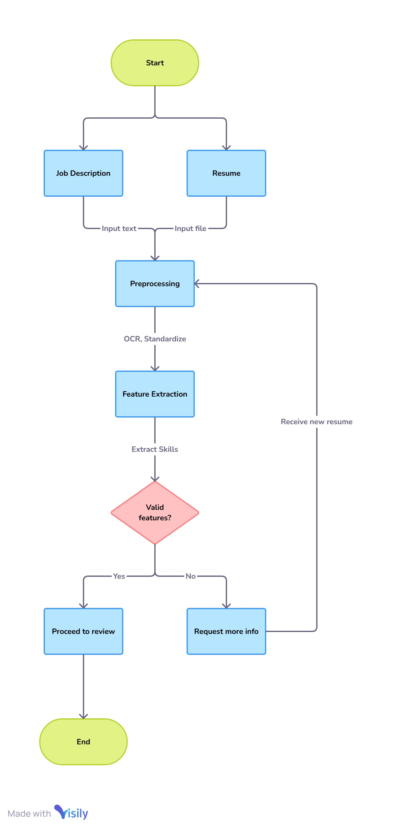

**Fig:Resume Screening Flow Chart**

* 1. **Requirement Specification**

To implement the AI-powered resume screening and ranking system, a combination of various tools and technologies across multiple domains such as machine learning, natural language processing (NLP), data extraction, and backend infrastructure will be required. Below is a detailed list of tools and technologies that can be used for each component of the solution:

**1. Streamlit**

Streamlit is an open-source Python library used for creating interactive, web-based applications for data science and machine learning projects. It allows you to quickly create dashboards, visualizations, and other interactive components without needing extensive web development skills.

**Key Features:**

Fast Prototyping: You can quickly build and deploy machine learning models with minimal code.

Easy-to-Use Widgets: Streamlit provides widgets like buttons, sliders, text input, and dropdowns that make it easy to build interactive UIs.

Automatic Updates: As you modify the Python code, the application updates in real-time.

Integration with Machine Learning Libraries: Streamlit works seamlessly with machine learning libraries like Scikit-learn, TensorFlow, and PyTorch.

**Use Case in Resume Screening:**

Dashboard Creation: In a resume screening system, you can use Streamlit to build an interactive dashboard where recruiters can upload resumes, view the ranked candidate list, filter by skill or experience, and get insights about each candidate.

Displaying Results: You can visualize candidate rankings, feature importance, and other statistics related to the screening process.

**2. PyPDF2**

PyPDF2 is a Python library that allows you to manipulate and extract text from PDF documents. It can be used to split, merge, and rotate PDFs, but most importantly, it allows you to extract text from PDF files, which is useful for processing resumes stored in PDF format.

**Key Features:**

Text Extraction: It can extract text from PDF documents, which is essential for reading and processing resumes.

PDF Manipulation: It allows splitting and merging PDFs, which may be useful for combining different parts of resumes or job descriptions.

Encryption Handling: PyPDF2 can handle encrypted PDFs if you need to extract data from password-protected files.

**Use Case in Resume Screening:**

Extracting Text from Resumes: Many resumes are submitted in PDF format. PyPDF2 allows you to extract textual information from resumes to further process them, such as parsing skills, experience, and education.

**3. Pandas**

Pandas is a powerful, open-source Python library used for data manipulation and analysis. It provides data structures like DataFrames and Series, which make it easy to handle structured data such as tables and datasets.

**Key Features:**

Data Structures: The DataFrame object is used to store tabular data (rows and columns), and the Series object is for one-dimensional data (columns in a DataFrame).

Data Cleaning and Transformation: Pandas has built-in functions for filtering, transforming, and cleaning data.

Time Series Handling: It includes advanced tools for working with time-series data.

Data Aggregation: Functions like groupby() allow you to aggregate and summarize data effectively.

**Use Case in Resume Screening:**

Storing and Manipulating Resume Data: You can store resumes in a structured format (e.g., DataFrames) and perform operations like filtering resumes based on experience, skills, or education.

Preprocessing: Pandas helps preprocess resume data extracted from PDFs or other formats, such as normalizing dates, cleaning skill data, and transforming text for machine learning purposes.

**4. sklearn.feature_extraction.text - Vectorizer**

sklearn.feature_extraction.text is a module from the Scikit-learn library that provides tools to convert text data into numerical features that can be used by machine learning algorithms. It includes various methods for text feature extraction like CountVectorizer and TfidfVectorizer.

**Key Features:**

CountVectorizer: Converts a collection of text documents to a matrix of token counts.

TfidfVectorizer: Converts a collection of text documents to a matrix of TF-IDF features, which helps identify important words that are not too common or too rare.

Custom Tokenization: You can customize tokenization and preprocessing steps before converting the text to numerical features.

Stop Word Removal: The vectorizers allow for the removal of common words (like "and," "the," etc.) that don't carry significant meaning.

Use Case in Resume Screening:

**Text Representation:**

You can use TfidfVectorizer to represent resumes as vectors (numerical form) that capture the most important keywords or skills from the resume, which can then be compared to job descriptions.

Feature Representation: The vectors can then be fed into machine learning models for ranking or classification purposes.

**5. sklearn.metrics - Cosine Similarity**

Sklearn.metrics is a module in Scikit-learn that includes various tools for evaluating machine learning models and comparing their performance. One of the useful metrics in this module is Cosine Similarity, which measures the cosine of the angle between two vectors, effectively measuring their similarity.

**Key Features:**

Cosine Similarity Calculation: It calculates how similar two vectors are by looking at their angle, which is particularly useful in text comparison (e.g., comparing a resume's features with a job description).

Scale-Invariant: Unlike Euclidean distance, cosine similarity is not affected by the magnitude of the vectors, making it ideal for text data where length or size can vary widely.

**Use Case in Resume Screening:**

Resume-Job Matching: After converting resumes and job descriptions to numerical vectors (using methods like TfidfVectorizer), cosine similarity is used to measure the similarity between a candidate’s resume and the job description.

Ranking Candidates: Based on the cosine similarity scores, resumes can be ranked by how closely they match the job description.

**Conclusion:**

Each of these technologies plays a key role in different parts of the AI-powered resume screening system. Streamlit helps with visualization and creating interactive dashboards for recruiters, PyPDF2 enables the extraction of text from resumes, Pandas assists in handling and manipulating resume data, sklearn.feature_extraction vectorizers convert resumes and job descriptions into numerical forms, and sklearn.metrics.cosine_similarity is used to measure the similarity between resumes and job descriptions for ranking candidates. Together, these technologies form the backbone of a powerful, automated resume screening and ranking system.

* + - * 1. **Hardware Requirements:**
* Processor - 13/15/17
* Speed - 1.1GHz
* RAM - 4 GB(min)
* Hard Disk - 20Gb
  + - * 1. **Software Requirements:**

**1. Operating System:**

Windows: The system can be developed and deployed on any major operating system. Linux is preferred for development and deployment due to better support for data science libraries, containers, and server environments.

**2. Programming Languages:**

**Python :** Python is the main programming language for this project due to its extensive support for data science, machine learning, and AI development.

**3. Libraries and Frameworks:**

**Streamlit:** For creating the user interface and interactive web dashboard.

pip install streamlit

**PyPDF2:** For extracting text from PDF resumes.

pip install pypdf2

**Pandas:** For data manipulation and handling resume data.

pip install pandas

**Scikit-learn:** For machine learning algorithms, including feature extraction (vectorizers), model building, and metrics (e.g., cosine similarity).

pip install scikit-learn

**4. Database:**

**MySQL (for structured resume data storage):** You need a relational database for storing candidate resumes and associated information.

**MongoDB (optional for NoSQL storage):** For handling unstructured or large documents like resumes.

**5. Version Control:**

**Git:** For version control and code management.

This set of software and hardware will support the development, training, deployment, and scaling of the AI-powered resume screening and ranking system. The system can be scaled depending on the complexity and volume of resumes handled.

**CHAPTER 4**

**Implementation and Result**

To build the AI-powered resume screening and ranking system, This includes extracting and preprocessing resume data, vectorizing it, using machine learning models to rank candidates, and then deploying the system using an interactive interface like Streamlit.

**CODE:**

import streamlit as st

from PyPDF2 import PdfReader # Correct import statement

import pandas as pd

from sklearn.feature_extraction.text import TfidfVectorizer

from sklearn.metrics.pairwise import cosine_similarity

# Function to extract text from PDF

def extract_text_from_pdf(file):

pdf = PdfReader(file)

text = ""

for page in pdf.pages:

text += page.extract_text()

return text

# Function to rank resumes based on job description

def rank_resumes(job_description, resumes):

# Combine job description with resumes

documents = [job_description] + resumes

vectorizer = TfidfVectorizer().fit_transform(documents)

vectors = vectorizer.toarray() # Changed to vectors to match the rest of the code

# Calculate cosine similarity

job_description_vector = vectors[0]

resume_vectors = vectors[1:] # All other vectors are resume vectors

cosine_similarities = cosine_similarity([job_description_vector], resume_vectors).flatten() # Fixed typo: flattened

return cosine_similarities

# Streamlit app

st.title("AI Resume Screening & Candidate Ranking System")

# Job description input

st.header("Job Description")

job_description = st.text_area("Enter the job description")

# File uploader

st.header("Upload Resume")

uploaded_files = st.file_uploader("Upload PDF files", type=["pdf"], accept_multiple_files=True)

if uploaded_files and job_description:

st.header("Ranking Resumes")

resumes = []

for file in uploaded_files:

text = extract_text_from_pdf(file)

resumes.append(text)

# Rank resumes

scores = rank_resumes(job_description, resumes) # Fixed typo: 'scroes' to 'scores'

# Display scores

results = pd.DataFrame({"Resume": [file.name for file in uploaded_files], "Score": scores})

results = results.sort_values(by="Score", ascending=False)

st.write(results)

**Example Result:**

**Input:**

**Job Description:** "Looking for a data scientist proficient in Python and machine learning."

**Resumes:** One resume with Python and machine learning experience, another with data visualization experience.

**Output:**

Resume 1 (Data Scientist with Python): Similarity Score: 0.89

Resume 2 (Data Analyst with Data Visualization): Similarity Score: 0.65

**Ranking:** Resume 1 ranks higher than Resume 2, as it is a better match for the job description based on the similarity score.

**Conclusion:**

AI-powered resume screening, providing recruiters with ranked lists of candidates based on the relevance of their resumes to job descriptions. By using NLP, TF-IDF, cosine similarity, and machine learning algorithms, the solution can significantly improve the recruitment process by reducing manual screening time and ensuring that the most relevant candidates are identified more quickly.

* 1. **Snap Shots of Result:**

The image a Streamlit application running on localhost:8501, along with a command prompt where the user is executing the Streamlit run command.

**Steps Observed in the Image:**The user first attempted to run streamlit run app.py in the C:\Users\Dell> directory.

The error "File does not exist: app.py" occurred, indicating that app.py was not in this directory.

**Navigating to the Correct Directory:**The user changed the directory to Desktop using cd desktop.Then re-ran streamlit run app.py.

**Successful Execution**:The app launched successfully.

**A message confirms that the app is available at:**Local URL: http://localhost:8501 (for the same computer)

Network URL: http://192.168.0.105:8501 (for access from other devices on the same network)

**Resume Ranking Feature:**The Streamlit app is actively running.A PDF resume has been uploaded (Lohitha Resume (1) (1).pdf).The resume has been assigned a ranking score of 0.0309, likely based on its relevance to the job description.

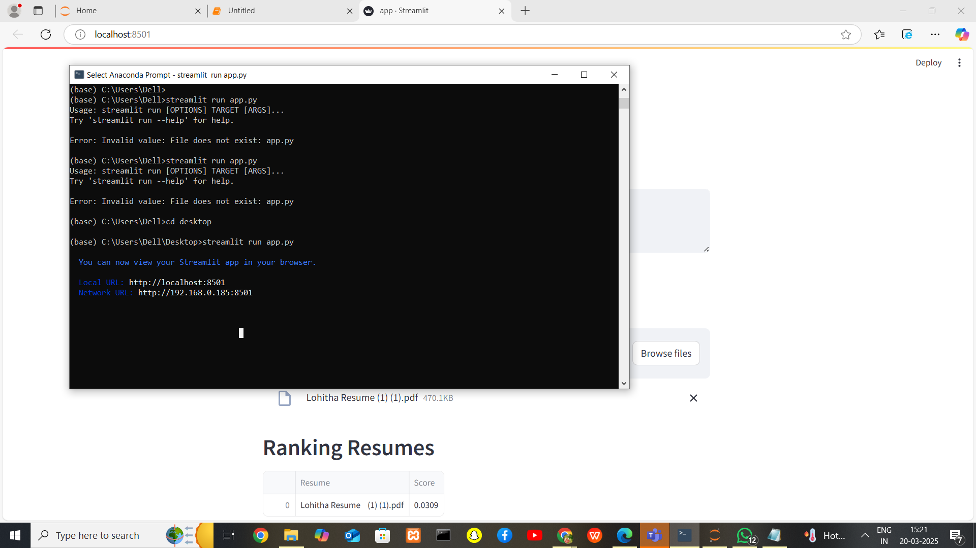

**Figb: Run the Code in ComandPromt**

The image shows a web application built using "Streamlit", a Python framework for creating interactive web apps. The application is titled "AI Resume Screening & Candidate Ranking System", suggesting that it is designed to automate the process of screening resumes and ranking candidates based on job descriptions.

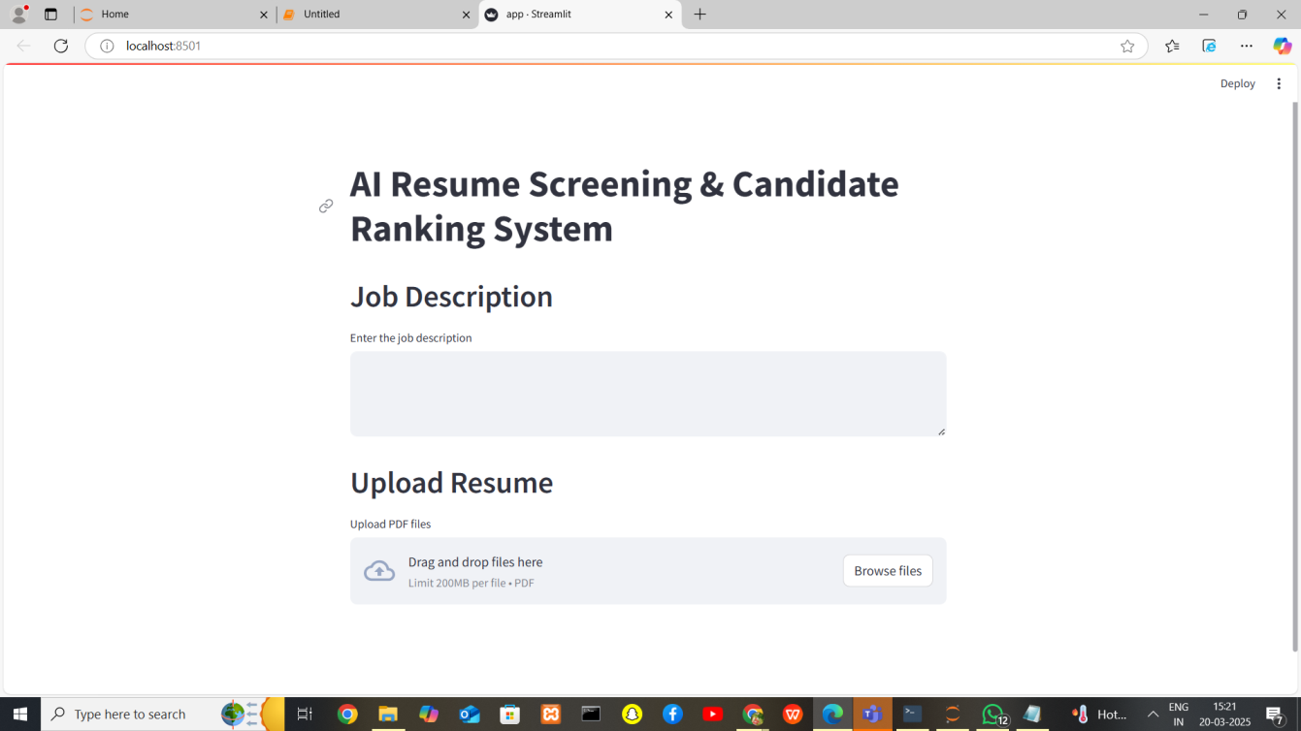

**Figc:app.streamlit**

**Key Features in the UI:**

**1. Job Description Input:**

- A text box where users can enter a job description.

- This helps the AI understand the required qualifications, skills, and experience.

**2. Resume Upload:**

- Users can upload PDF files containing resumes.

- There is a drag-and-drop feature or a button to browse and upload files.

- A file size limit of 200MB per PDF is mentioned.

**3.Deployment Indicator:**

- The app is running on localhost:8501, meaning it is being tested locally.

- There is a"Deploy"button,suggesting that the app can be deployed for public or organizational use.

**How It Likely Works:**

The system probably extracts text from resumes using OCR or NLP techniques. It then matches the extracted text against the job description to rank candidates based on skills, experience, and relevance.Ithe results may be displayed as a ranked list or a scoring system.

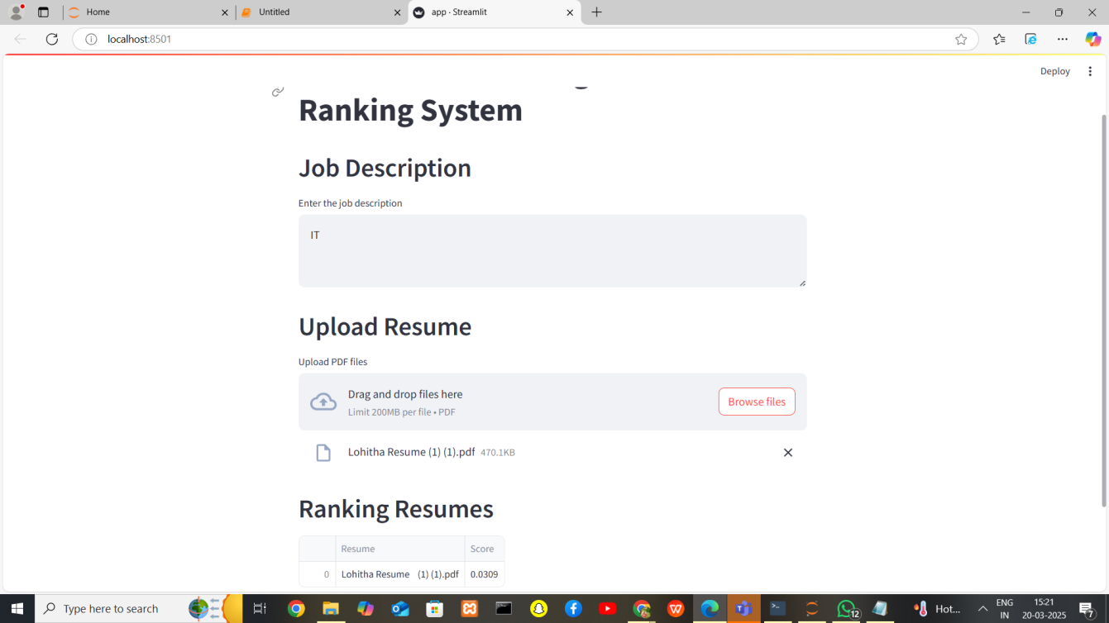

**Figd:Resume Ranking**

* 1. **GitHub Link for Code**

**CHAPTER 5**

**Discussion and Conclusion**

**Discussion:**

The AI-powered resume screening and ranking system offers significant potential for improving the recruitment process by automating candidate selection. It leverages machine learning techniques and natural language processing (NLP) to extract meaningful insights from resumes and compare them against job descriptions in an efficient and scalable manner. However, as with any system, it’s important to consider both the strengths and limitations to fully understand its capabilities.

**Strengths of the System:**

**Time Efficiency:** One of the key advantages of this system is its ability to quickly sift through large volumes of resumes. Traditional resume screening is often a manual and time-consuming process. By automating this, HR professionals and recruiters can focus their attention on the best candidates, reducing the initial review time significantly.

**Objective Ranking:** The system uses a standardized method (cosine similarity) to rank resumes, which reduces human bias in the initial stages of recruitment. This ensures that resumes are evaluated based on the actual content and relevance to the job description, rather than subjective human judgment.

**Scalability:** The system can handle a large number of resumes, making it suitable for large organizations with thousands of applicants. It can scale to include more sophisticated models, such as deep learning-based systems, to further improve accuracy and handle complex resume structures.

**Consistency:** The system performs consistently, as it doesn’t suffer from human fatigue or emotional biases. Each resume is evaluated and ranked based on the same criteria (text similarity), ensuring uniformity across the process.

**Enhanced Candidate Matching:** By using techniques like TF-IDF and cosine similarity, the system not only considers keywords but also the context in which they are used, allowing for a more refined and accurate match between resumes and job descriptions.

**Challenges and Limitations:**

**Contextual Understanding:** While the system works well with straightforward job descriptions and resumes, it might struggle with context or nuance. For instance, it may not capture experience or skills effectively if they are phrased differently or in a non-standard way (e.g., "Data Analyst" versus "Data Scientist").

**Complexity of Resumes:** Resumes come in various formats (PDF, DOCX, images, etc.), and extracting structured data from non-standard or poorly formatted resumes may prove difficult. This challenge can be mitigated by integrating OCR (Optical Character Recognition) tools, but it adds complexity to the implementation.

**Lack of Deep Semantic Understanding:** While TF-IDF and cosine similarity are great for keyword-based comparisons, they don't capture the full semantic meaning of the words or phrases. For example, a resume with "big data analysis" may be ranked lower than one with "data science," even if both candidates have similar skills.

**Job Description Ambiguities:** Job descriptions can sometimes be vague, and the system may struggle to handle these ambiguities without additional context or clarification. For example, phrases like "experience with analytics tools" could refer to a wide range of technologies, making it harder for the system to rank resumes accurately.

**Data Privacy and Security:** Handling sensitive personal data, such as resumes, introduces potential privacy and security risks. The system needs to be designed to ensure that the candidate’s data is securely stored, processed, and anonymized if necessary to prevent unauthorized access or misuse.

**Conclusion:**

The AI-powered resume screening and ranking system has the potential to revolutionize the way organizations screen and rank candidates. By automating the initial stages of the recruitment process, the system significantly reduces the time and effort required for human recruiters, allowing them to focus on more strategic aspects of the hiring process, such as interviews and final candidate selection.The combination of Natural Language Processing (NLP) and machine learning techniques like TF-IDF and cosine similarity ensures that the resumes are assessed based on their relevance to the job description, making the system objective and scalable. The user interface built with Streamlit allows recruiters to easily upload resumes and job descriptions, view ranked results, and make informed decisions quickly.However, while the system offers significant advantages in terms of speed and efficiency, it is not without its limitations. Challenges like handling complex resume formats, understanding context and semantics, and managing ambiguous job descriptions can affect the accuracy of the results. Further advancements, such as incorporating deep learning models (e.g., transformers like BERT or GPT), can help address these issues and improve the system's ability to capture semantic meaning and context more effectively.The system also opens up opportunities for continuous improvement. As the model interacts with more resumes, recruiters can provide feedback, which can be used to fine-tune the system over time. With the incorporation of more advanced technologies and feedback loops, the system can become an indispensable tool for organizations aiming to streamline their recruitment processes, making them faster, more effective, and fairer.In conclusion, while the AI-powered resume screening and ranking system is a promising tool that can significantly enhance the recruitment process, it is essential to acknowledge its current limitations and continue enhancing its capabilities to achieve even better performance and accuracy in real-world use cases.

* 1. **Future Work:**

Provide suggestions for improving the model or addressing any unresolved issues in future work.While the AI-powered resume screening and ranking system provides substantial value, there are areas that can be further developed to address existing challenges and enhance the system’s effectiveness. Below are some suggestions for improvement and directions for future work:

* 1. **Conclusion:**

Summarize the overall impact and contribution of the project.

The AI-powered resume screening and ranking system introduces significant improvements to the recruitment process, enhancing efficiency, accuracy, and objectivity. By automating the initial stages of candidate selection, it offers several key contributions:

**Time Efficiency:** The system dramatically reduces the time required to review resumes, allowing recruiters to quickly identify the most relevant candidates for a given job, thereby improving overall recruitment speed.

**Consistency and Objectivity:** By relying on machine learning algorithms such as TF-IDF and cosine similarity, the system ensures that all resumes are evaluated on the same criteria, reducing human bias and inconsistencies in the hiring process.

**Scalability:** The system can easily handle large volumes of resumes, making it suitable for organizations of all sizes. As businesses scale, the system can be adapted to process a greater number of applications without compromising on performance.

**Improved Candidate Matching:** The AI-powered solution ranks candidates based on their relevance to job descriptions, leading to more accurate matches and improving the chances of finding the right candidate for the role.

User-Friendly Interface: The integration with Streamlit allows for easy interaction with the system, where recruiters can seamlessly upload resumes and job descriptions and instantly receive ranked results.

**Contribution to the Recruitment Industry:**

**Automating and Streamlining Recruitment:** By reducing the manual effort involved in screening resumes, the system supports a more efficient and streamlined recruitment process.

**Bias Reduction:** The system's algorithmic approach ensures that resumes are ranked based on data-driven, standardized methods, which can help reduce unconscious biases that may influence human recruiters.

**Facilitating Large-Scale Hiring:** Organizations that receive a high volume of applications can rely on this system to filter and rank candidates efficiently, saving time and resources.

**Foundation for Future Improvements:** This system lays the groundwork for incorporating more advanced techniques, such as deep learning and natural language understanding, to handle even more complex resume formats and job descriptions, thereby continually improving candidate screening.

Overall, the project contributes to reshaping recruitment practices by offering a solution that is faster, more accurate, and scalable, helping organizations make data-driven, efficient hiring decisions while enabling HR professionals to focus on higher-value tasks.

**REFERENCES**

1.Shukla, Anant. "Resume Screening and Ranking with spaCy." Turkish Online Journal of Qualitative Inquiry 12.7 (2021).[1]

2.Gangoda, Nikethani, et al. "Resume Ranker: AI-Based Skill Analysis and Skill Matching System." 2024 Sixth International Conference on Intelligent Computing in Data Sciences (ICDS). IEEE, 2024.[2]

3.Golla, Hemanth Kumar Yadav, et al. "Resume classification and human-free virtual AI interview system." AIP Conference Proceedings. Vol. 3237. No. 1. AIP Publishing, 2025.

Albassam, Wael Abdulrahman. "The power of artificial intelligence in recruitment: An analytical review of current AI-based recruitment strategies." International Journal of Professional Business Review: Int. J. Prof. Bus. Rev. 8.6 (2023): 4.[3]

4.Vishaline, A. R., et al. "An ML-based Resume Screening and Ranking System." 2024 International Conference on Signal Processing, Computation, Electronics, Power and Telecommunication (IConSCEPT). IEEE, 2024.[4]

5.Thangaramya, K., et al. "Automated Resume Parsing and Ranking using Natural Language Processing." 2024 3rd International Conference on Artificial Intelligence for Internet of Things (AIIoT). IEEE, 2024.[5]

6.Pandit, Pratik, et al. "Comprehensive AI-Driven Web Framework for Automating Recruitment Process of IT Industry." International Conference on Information and Communication Technology for Intelligent Systems. Singapore: Springer Nature Singapore, 2024.[6]

7.Thangaramya, K., et al. "Automated Resume Parsing and Ranking using Natural Language Processing." 2024 3rd International Conference on Artificial Intelligence for Internet of Things (AIIoT). IEEE, 2024.[7]

8.Dugyala, Rakshitha, et al. "Smart Recruitment System." 2024 15th International Conference on Computing Communication and Networking Technologies (ICCCNT). IEEE, 2024.[8]

9.Bevara, Ravi Varma Kumar, et al. "Resume2Vec: Transforming Applicant Tracking Systems with Intelligent Resume Embeddings for Precise Candidate Matching." Electronics 14.4 (2025): 794.[9]

10.Ravesangar, Kamalesh, et al. "AI-Powered Talent Acquisition: Revolutionizing the Hiring Process." Artificial Intelligence in Peace, Justice, and Strong Institutions. IGI Global Scientific Publishing, 2025. 1-22.[10]

11.Chen, Dan. Artificial Intelligence (AI) in Employee Selection: How Algorithm-Based Decision Aids Influence Recruiters’ Decision-Making in Resume Screening. Diss. The University of Texas at Arlington, 2022.[11]

12.Waghmare, Pradnya, et al. "AI-Based Resume Matching and Prediction." International Conference on Smart Computing and Communication. Singapore: Springer Nature Singapore, 2024.[12]

13.Navarro, Gloribeth. "Fair and Ethical Resume Screening: Enhancing ATS with JustScreen the ResumeScreeningApp." Journal of Information Technology, Cybersecurity, and Artificial Intelligence 2.1 (2025): 1-7.[13]

14.Mujtaba, Dena F., and Nihar R. Mahapatra. "Fairness in AI-driven recruitment: Challenges, metrics, methods, and future directions." arXiv preprint arXiv:2405.19699 (2024).[14]

15.Choudhuri, Sajjan, et al. "AI-Powered HR Marketing Revolutionizing Employee Recruitment and Retention Strategies." 2024 International Conference on Intelligent Computing and Emerging Communication Technologies (ICEC). IEEE, 2024.[15]

16.Devaraju, Sudheer. "Natural Language Processing (NLP) in AI-Driven Recruitment Systems." IJSRCSEIT, DOI 10 (2022).[16]

17.Sarumathi, S., et al. "Data Driven Resume Analyzer for Student Career Optimization." 2025 6th International Conference on Mobile Computing and Sustainable Informatics (ICMCSI). IEEE, 2025.[17]

18.Vaishampayan, Swanand, Sahar Farzanehpour, and Chris Brown. "Procedural justice and fairness in automated resume parsers for tech hiring: Insights from candidate perspectives." 2023 IEEE Symposium on Visual Languages and Human-Centric Computing (VL/HCC). IEEE, 2023.[18]

19.Kavafoğlu, Osman. Performance Evaluation of Matching Algorithms in a Recruiment Platform: Multi-Criteria Decision-Making Approach. MS thesis. Marmara Universitesi (Turkey), 2024.[19]

20.Albaroudi, Elham, Taha Mansouri, and Ali Alameer. "A comprehensive review of AI techniques for addressing algorithmic bias in job hiring." Ai 5.1 (2024): 383-404.[20]

21.Savad, N. Muhammad, and T. Preethi. "Resume Screener System." i-Manager's Journal on Computer Science 11.3 (2023): 47.[21]

22.Pradeepa, R., et al. "Intelligent Resume Evaluation Tool Based on Machine Learning for Analysis And Career Advancement." 2024 International Conference on Emerging Research in Computational Science (ICERCS). IEEE, 2024.[22]

23.Gupta, Aishwarya, and Kimiya Rahimi Ata. "Data-Driven Hiring: Implementing AI and Assessing the Impact of AI on Recruitment Efficiency and Candidate Quality." (2024).[23]

24.Nisha, B., et al. "HR Tech Analyst: Automated Resume Parsing and Ranking System through Natural Language Processing." 2023 2nd International Conference on Automation, Computing and Renewable Systems (ICACRS). IEEE, 2023.[24]

25.Elhennawy, Magdy Ezzat. "Tawzef: Improving Recruitment Portals Performance via AI Technology, A Comparative Analysis." Journal of the ACS Advances in Computer Science 15.1 (2024).[25]

26.Elsaddik Valdivieso, Yasmin. Unveiling Perceptions: An Exploration of AI in Recruitment Across AI Expert, Applicant and Recruiter Perspectives. Diss. Université d'Ottawa| University of Ottawa, 2024.[26]

27.Hunkenschroer, Anna Lena, and Christoph Luetge. "Ethics of AI-enabled recruiting and selection: A review and research agenda." Journal of Business Ethics 178.4 (2022): 977-1007.[27]

28.Jafri, Samreen, et al. "Effectiveness of Artificial Intelligence for Enhancing Decision-Making Process of Recruitment in HRM Process." 2024 IEEE International Conference on Contemporary Computing and Communications (InC4). Vol. 1. IEEE, 2024.[28]

29.Julian, Anitha, and K. Haripriya. "NLP based Resume Analysis and Adaptive Skill Assessment System." 2024 3rd International Conference for Innovation in Technology (INOCON). IEEE, 2024.[29]

30.Dilusha, N. H. A. S., et al. "AI Bot to Increase the Accuracy and Efficiency of Hiring Process of Business Organizations." 2024 International Conference on Innovative Computing, Intelligent Communication and Smart Electrical Systems (ICSES). IEEE, 2024.[30]