**REPOSITORY**

A repository is like a folder for your project. Your project's repository contains all of your project's files and stores each file's revision history. You can also discuss and manage your project's work within the repository.

Repositories can be public or private. Public repositories are visible to everyone. Only the owner and collaborators can view or contribute to a private repository .

**DIFFERENT TYPES OF REPOSITORY**

1. Local repository
2. Remote repository

**LOCAL REPOSITORY**

A local repository is within a domain that is not the global repository. Use  
local repositories for development.

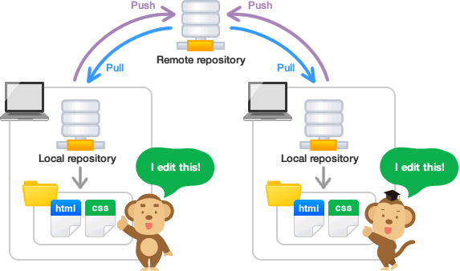

**REMOTE REPOSITORY :**

We can store the files on web is called remote repository

Remote repository is to share metadata between repositires across multiple domain.

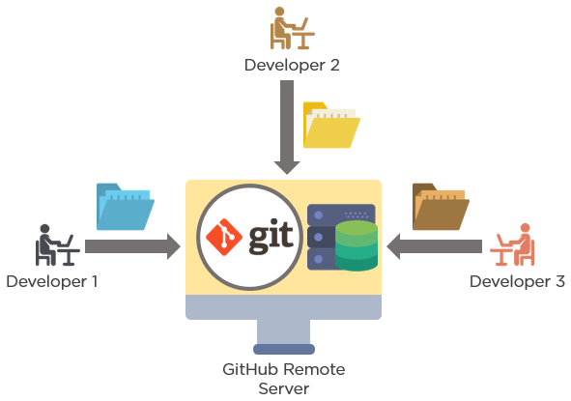

**GIT**

Git is a Distributed Version Control tool that is used to store different versions of a file in a remote or local repository. It is used to track changes in the source code.

It allows multiple developers to work together. Git is a popular, free and open source version control system.

GitHub it is a web based version control system and it allows multiple developers to work together.

**COMMMANDS**

**Branch** : It is used to list all the branches**.**

**Syntax: git branch**

**git branch [branch name]** : create a new branch

**git branch -d [branch name] :** delete the branch

**PUSH** : This command sends the committed changes of master branch to your remote repository.

**Synatx : git push[variable name] master**

**git push [variable name ] [branch] :** This command sends the branch commits to your e remote repository

**git push -all [variable name**] : Pushes all branches to your remote repository.

**git push [variable name ] [branch name] :** Deletes a branch on your remote repository

**PULL**

**Syntax : git pull [repository link] :** fetches and merges changes on the remote server to your working d directory.

**SWITCH TO BRANCH** :

**Syntax** : **git checkout** : Used to switch from one branch to another branch.

**git checkout -b** : used to switch from one branch to another branch and also create new r branch.