 | ABES Engineering College, Ghaziabad  Department of Electronics & Communication Engineering  B. Tech (1st Year)
Annexure VIII (F)

Session: 2025-26 Semester: Ist Section: All
Subject Code: 25EC101 Subject Name: Basic Electronics Engineering

Assignment-4/ Model Questions-4

Date of Issue: ……………… Date of submission: ……….
S. No. | Description | CO and KL | Marks with Marking Scheme
 | Design the following amplifier circuits using Op-amp with gain of 20. The value of resistances should not exceed beyond 40 KΩ:  - Inverting amplifier  - Non-inverting amplifier | CO4 and K3 | 2
 | Derive the gain for the Inverting Amplifier and Non-Inverting Amplifier. | CO4 and K3 | 2
 | Draw & explain voltage transfer curve of Op-amp. | CO4 and K2 | 2
 | Find the output of the given Circuit:  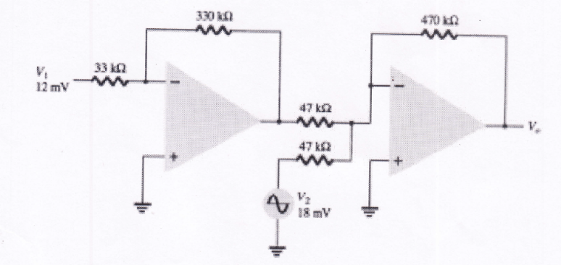 | CO4 and K3 | 2
 | Describe the ideal characteristics of op-amp. | CO4 and K2 | 2

CO-Course Outcomes mapped with respective question
KL- Bloom’s Knowledge Level (K₁,K₂,K₃,K₄,K₅,K₆)
K₁ – RememberK₂ – UnderstandK₃ – ApplyK₄ – AnalyzeK₅ – EvaluateK₆– Create

