Heart disease Prediction and Identification with Deep Learning on Neural Networks

Praneeth Babu Chouturi ^{#1}, Shruthi Sathineni ^{#2}, Karthik Bathula ^{#3,} Navya Sri Bonthu ^{#4}

Heart-related diseases are among the most widely recognized reasons for death around the world. Patients are frequently asymptomatic until a deadly occasion occurs, and in any event, when they are under perception, prepared work force is required to recognize a heart abnormality. Somewhat recently, there has been expanding proof of how deep learning can be utilized to recognize such oddities, because of the accessibility of Electrocardiograms (ECG) in computerized design. New advancements in innovation have permitted to take advantage of such information to fabricate models ready to dissect the examples in the event of heart beats, and spot abnormalities from them. In this work, master cardiologists across various clinics and nations, and can recognize 7 sorts of signs: Typical, AF, Tachycardia, Bradycardia, Arrhythmia, Other or Boisterous. [1][2]

The determination of heart illness has turned into a troublesome clinical errand in the current clinical examination. This finding relies upon the point by point and exact examination of the patient's clinical test information on a singular's wellbeing history. The huge improvements in the field of profound learning look to make astute mechanized frameworks that help specialists both to anticipate and to decide the illness with the web of things with Deep learning. Certainty adjustment is an especially important issue in a medical care setting like the one tended to in this composition: when a neural network model makes an expectation, it is vital that this result can be relied upon.[3]

The Deep learning algorithm will be applied in the prediction of the heart disease with different type of attributes with the dataset.

Keywords:
Heart Disease, Deep Learning, ECG, Chest Pain, Healthcare.

Introduction:
Heart diseases or also known as cardiac diseases are generally caused by the narrowing of coronary arteries which supply blood to the heart. There are methods like Angiography, which is used for detecting heart diseases, but it is very costly and is prone to certain reactions in a patient’s body. This prevents widespread use of these techniques in countries with large poor populations. There is a need of developing healthcare products that provide quality results at an affordable rate. The healthcare organizations are also looking for clinical tests which can be performed without invasion at a cheap rate. The development of a computer-based decision support system for the diagnosis of various diseases can help organizations cater to the need of millions of people around the world. The rapid growth of machine learning and deep learning algorithms has helped research in various industries including medical. The availability of large-scale medical diagnosis data has helped in training these algorithms. The clinical support system can be developed using these algorithms which helps in reducing cost and increasing accuracy. Various clinical features can be utilized by machine learning algorithms for categorizing the risk profile of the patients. There are certain features like age, sex, heredity which are not in control while features like blood pressure, smoking, drinking habits are in control of the patient. The proposed algorithm uses a combination of these features for categorizing healthy and non-healthy patients. There has been considerable research in the field of healthcare in the last few years particularly after the Covid pandemic. It has been observed that heart diseases are one of the deadliest diseases which cause maximum deaths of human lives in the world according to the world health organization. It is also observed that more than 24% of the deaths in India are due to various forms of heart disease. So, there is a need to develop an early diagnosis system that prevents the deaths which are occurring due to heart disease.

Motivation:
The Deep learning will be the python-based application which contributes to find out the heart disease early stage. It will be helpful for the human to detect at early and to take necessary treatments in the correct time.

Objective:
The objective of heart disease identification with deep learning is to detect the heart disease in the early stage itself with the available attributes. In this work, the dataset containing the heart disease will be taken into consideration. The pre-processing will be applied into the dataset and the noisy and null value data will be removed from the dataset. After the data will be analysed and visualized for further processing. The Deep learning algorithm will be chosen to make the prediction.
The dataset will be divided into two parts. The first part of dataset is 70% taken to provide training to the Deep learning algorithm and the remaining 30% of data is taken to testing part.

Related Work:
The application will be developed with Google Collab Python Tool as the project can be directly executed in any type of computer systems with internet connection. There is no need of any specific software to be installed in the user system. The Collab Tool helps to develop and run the application directly inside the cloud server where the Python library files are installed. The deep learning algorithm libraries are build inside the Collab. It helps the project to use the deep learning algorithm in the finding of heart disease.
The project evaluation can be tested with the deep learning algorithm prediction results. Since the Deep learning algorithm will be used to predict the disease, the accuracy of the algorithm result will be helpful to evaluate the results. The accuracy score of the algorithm in the heart disease identification helps to evaluate the dataset.

The task included examination of the heart disease patient dataset with appropriate information handling. Then, at that point, various models were prepared, and expectations are made with Deep Learning model. The machine learning library and deep learning libraries Sklearn and Kera’s' are applied into the application.

Proposed Solution:
The proposed method uses the possibility of Deep Learning which depends on the conviction that working of human cerebrum by making the right associations can be imitated involving silicon and wires as living neurons and dendrites.

The proposed application will have dataset heart.csv is downloaded from gaggle website, it has 300 rows, and 14 columns present. Most of the columns in a dataset are noisy and contain lots of information. But with feature engineering do, will get more good results. The first step is to import the libraries and load data. After that will take a basic understanding of data like its shape, sample, is there are any NULL values present in the dataset. Understanding the data is an important step for prediction or any Deep learning project. It is good that there are no NULL values.
Data Description:
This dataset contains the fields needed for the analysing of the heart disease dataset. Exploratory examination is a cycle to investigate and comprehend the information and information relationship in a total profundity with the goal that it makes highlight designing and Deep Learning demonstrating steps smooth and smoothed out for expectation. Exploratory examination assists with validating our presumptions or misleading.

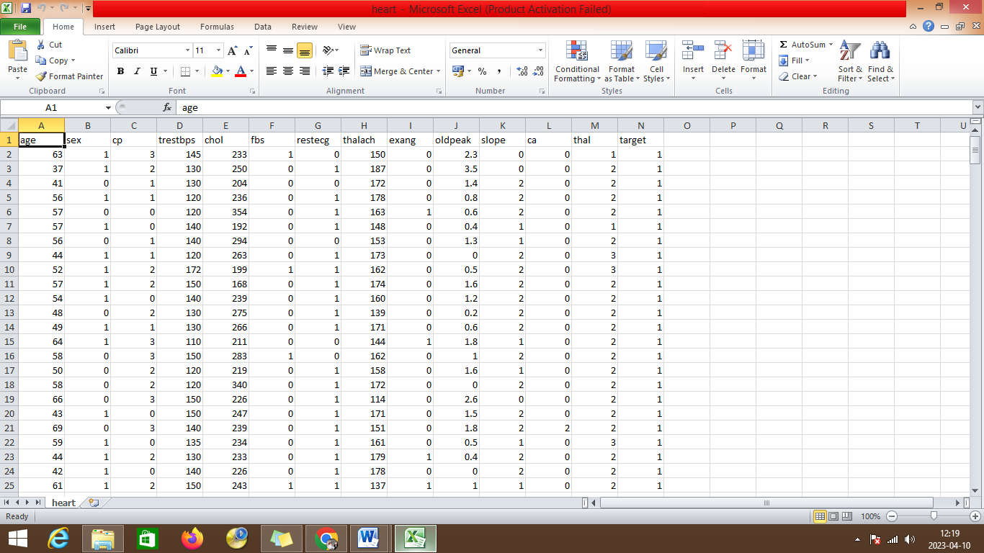

Results:
It will begin from the principal segment and investigate every section and comprehend what influence it makes on the objective segment. At the necessary step, we will likewise perform preprocessing and include designing undertakings. The point in acting top to bottom exploratory examination is to get ready and clean information for better Deep Learning demonstrating to accomplish elite execution and summed up models. So it should begin with breaking down and setting up the dataset for expectation.

Modules:
1) Dataset collection
2) Data cleaning
3) Data Analysis
4) Deep learning Modeling
5) Report

1) Dataset collection:
The information about the heart disease dataset with different types of attributes are collected from different type of patients.
2) Data Cleaning:
The large dataset contains more noisy and improper data which have to be pre-processed to produce the quality dataset for further pruning. The data is cleaned and processed with initial stage of removing the null values.

3) Data Analysis
Exploratory analysis is a process to explore and understand the data and data relationship in a complete depth so that it makes feature engineering and machine learning modelling steps smooth and streamlined for prediction. It helps to prove our assumptions true or false. In other words, it helps to perform hypothesis testing.
4) Deep learning Modelling
Deep learning modelling helps to find the best algorithm with the best hyper parameters to achieve maximum accuracy. The dataset is split into 2 variants. 70% of records are taken as training data and used to train the machine learning algorithm. The remaining 30% of dataset is applied to testing which helps to predict the process.
5) Report:
The Data is visualized based on the output of the Deep Learning, learning algorithm and the data is mapped with different types of graphs to analyse and visualize the exact data to the user for the prediction. Marplot libraries are implemented to map the results based on the user requirements.
SYSTEM SPECIFICAION
HARDWARE REQUIREMENTS
- Processor Intel(R) Pentium(R) CPU G2010 @
- Clock Speed 2.80GHz
- RAM 2.00 GB
- Hard Disk 1 TB HDD
- Monitor 15.6 Inches
- Mouse Logitech B100 Wired Optical Mouse
- Keyboard Full-size island-style keyboard with number keypad
- Display Card Super Video Graphics Adapter

SOFTWARE REQUIREMENTS
- Operating System : Windows 10
- Front-End Tool : Python in Google Colab

SYSTEM ARCHITECTURE DIAGRAM

Training, test data

Data Cleaning

Data preprocess

Deep Learning Algorithm implementation

Heart Disease Dataset

DIAGRAM
The heart disease dataset is given as input to the application and the pre-processing is applied, next the data cleaning is performed after the training and test data are splitted down and passed into Deep Learning algorithm and the heart disease prediction is done.

Heart Disease prediction

Load Packages:
First step has to import the necessary packages to the application:
//---AI Libray files
from keras.models import Sequential
from keras.layers import Dense

import numpy as np
import pandas as pd
import matplotlib.pyplot as plt
import seaborn as sns

%matplotlib inline

import os
print(os.listdir())

import warnings
warnings.filterwarnings('ignore')

Next the dataset would be connected from the Google colab. Initially the dataset is uploaded into the Google colab folder. Then the python file should connect to the path from the Google colab folder.

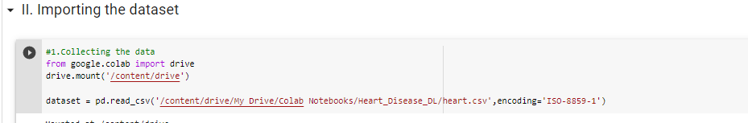
The information has an extremely straightforward design with elements. Each column is related with the heart disease attributes.
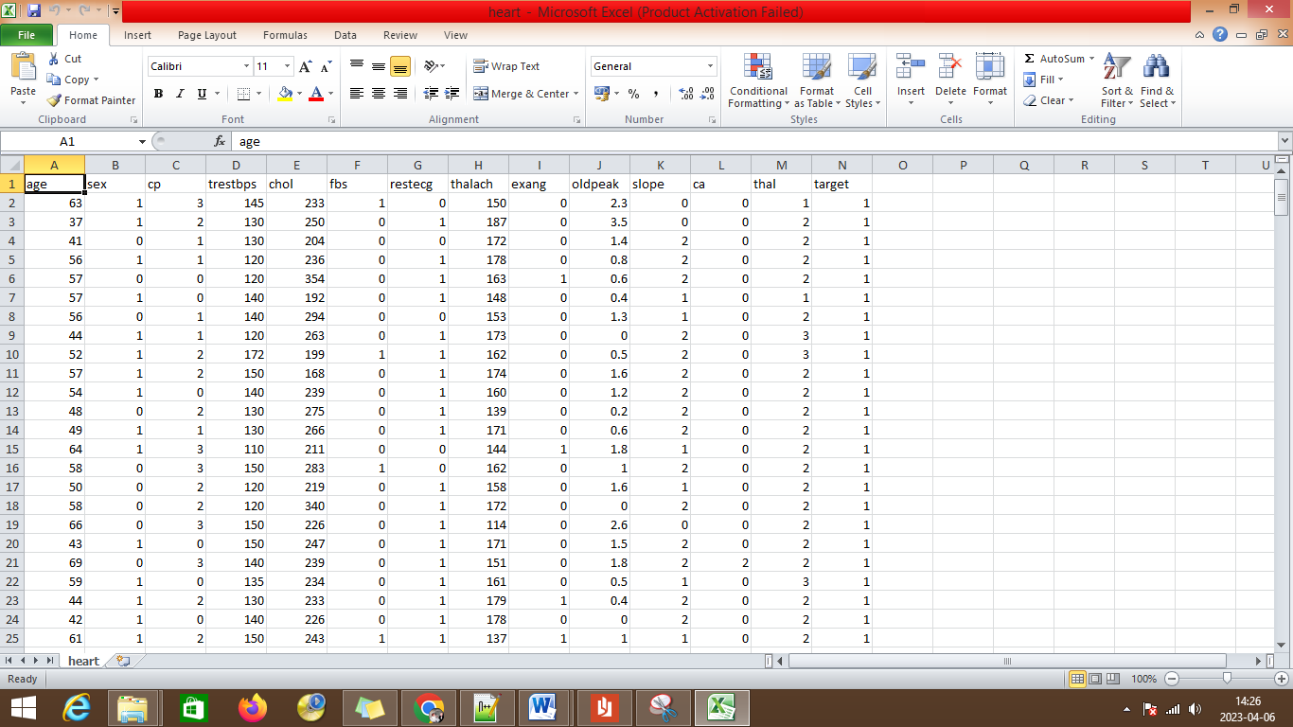

The label has been set with different label description features of:
- age
- sex
- cp
- trestbps
- cholestral
- fbs
- restecg
- oldpeak
- slope
- ca
- thal
- target

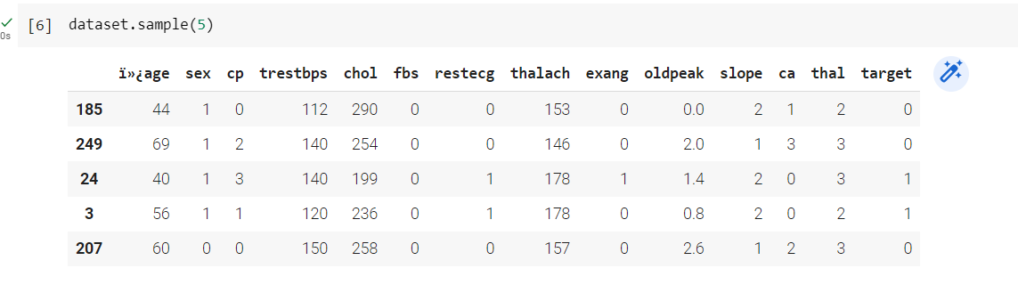
The dictionary shows the records displayed with head values of first 5 records from the dataset. The bar plot can be used to address the heart disease attributes.

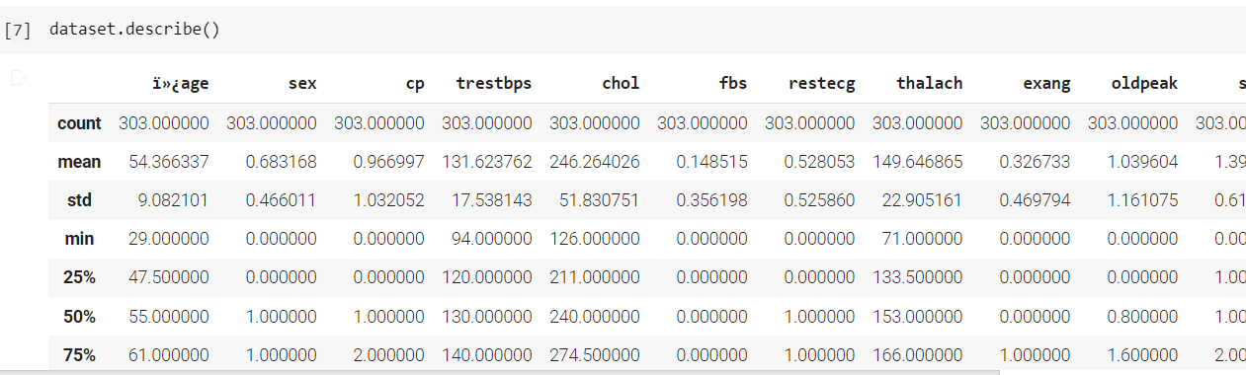
The describe function describes the coun, mean,max,min statastical reports for the coumns of age,sex,cp, chol and other fields.
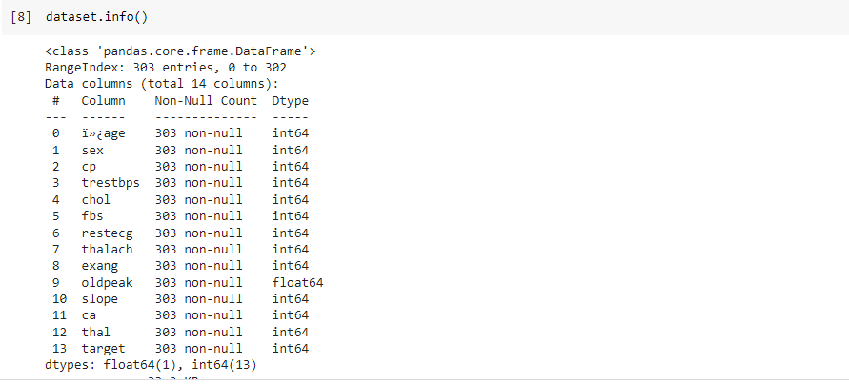
The information about the data is displayed with the data type.
Attributes Exploration:
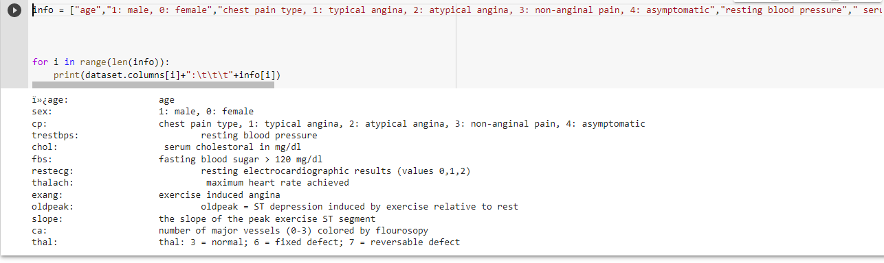
The heart disease dataset attributes are explored for further analyzing.
Below are the values:
sex: 1: male, 0: female
cp: chest pain type, 1: typical angina, 2: atypical angina, 3: non-anginal pain, 4: asymptomatic
trestbps: resting blood pressure
chol: serum cholestoral in mg/dl
fbs: fasting blood sugar > 120 mg/dl
restecg: resting electrocardiographic results (values 0,1,2)
thalach: maximum heart rate achieved
exang: exercise induced angina
oldpeak: oldpeak = ST depression induced by exercise relative to rest
slope: the slope of the peak exercise ST segment
ca: number of major vessels (0-3) colored by flourosopy
thal: thal: 3 = normal; 6 = fixed defect; 7 = reversable defect

Analysing :
The target variables are analyzed
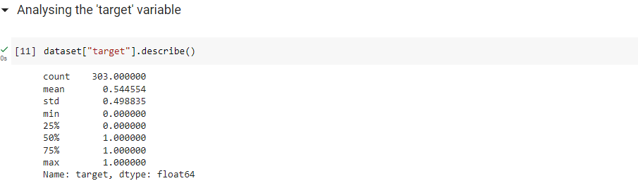

Corrlelation of data:
The correlation of data with respect to the attributes are linked and displayed.
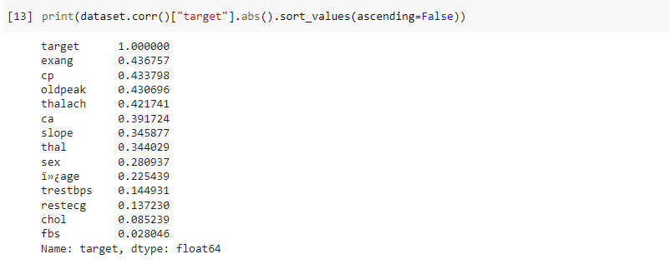
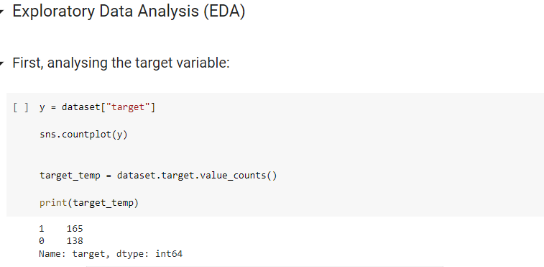
The target variable is assigned to the y variable.

Implementation with Algorithms:
The testing and training variables are split and passed into the algorithm for the heart disease prediction.
Keras model of Deep Learning:
Keras is a brain network Application Programming Connection point for Python that is firmly coordinated with Tensor Stream, which is utilized to construct AI models. Keras' models offer a straightforward, easy to understand method for characterizing a brain organization, which will then, at that point, be fabricated.
Keras is a strong and simple to-involve free open-source Python library for creating and assessing profound learning models. It is important for the Tensor Flow library and permits you to characterize and prepare brain network models in only a couple of lines of code.
Keras Deep Learning working process:
- Dataset load
- Keras Model Definition
- Keras Model Compilation
- Keras Model Fit and evaluation
- Predictions
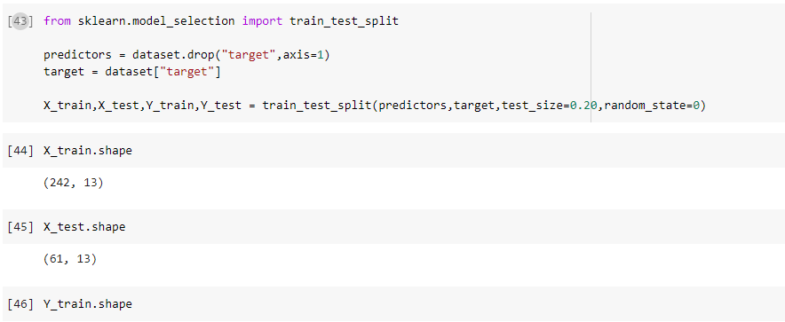
The testing size is 20% and the training size is 80% of the dataset.

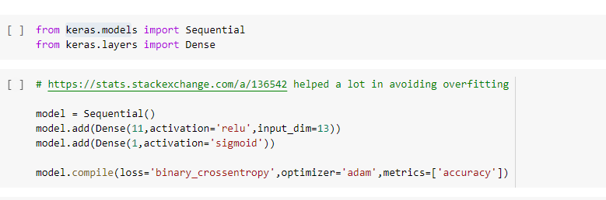

Preliminary Results:
The accuracy of the neural network is given below:
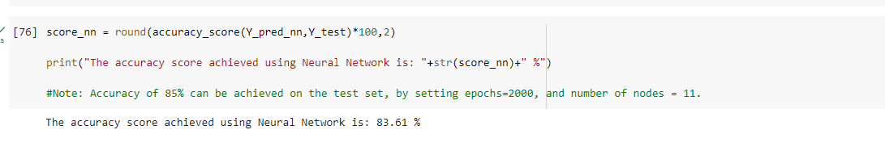

The final results are compared with different type of algorithm accuracy levels.
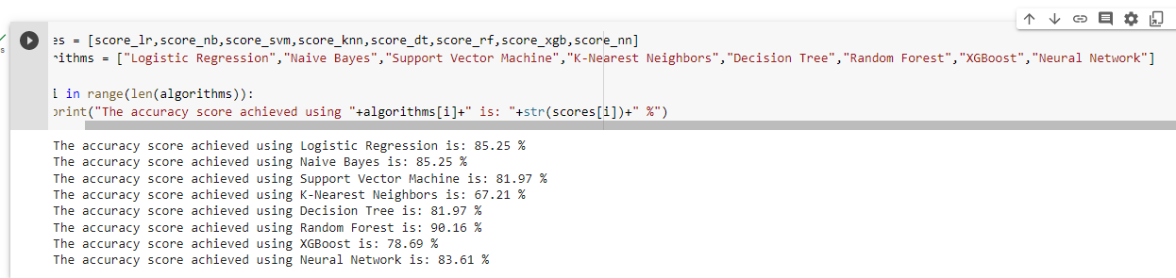

Conclusion and Future Enhancement:
The heart disease with different type of algorithms is compared and the accuracy levels were identified and compared. The Deep learning algorithm provides the better accuracy levels for the prediction. In future the large dataset can be used for the prediction which will help to increase the efficiency of the algorithm in predictions.

References/Bibliography:
[1]. Samiul based shuvo 1, shams nafisa ali 1, (student member, ieee), soham irtiza swapnil1, mabrook s. al-rakhami 2, (senior member, ieee), and abdu gumaei “CardioXNet: A Novel Lightweight Deep Learning Framework for Cardiovascular Disease Classification Using Heart Sound Recordings”. February 24, 2021, date of publication March 2, 2021, date of current version March 9, 2021.IEEE.
[2]. Eun s. lee 1, (member, ieee), byeong g. choi 2, (member, ieee), myung y. kim1, (Member, IEEE), AND SEUNG H. HAN 3, (Member, IEEE)” An Imbalanced-DataProcessingAlgorithmforthe Prediction of Heart Attack in Stroke Patients”. January 14, 2021, date of publication February 8, 2021, date of current version February 16, 2021, IEEE.
[3]. Hao ren2,1∗ aslan b. wong1∗, wanmin lian3∗, weibin cheng2, ying zhang1, jianwei he1. “Interpretable Pneumonia Detection by Combining Deep Learning and Explainable Models with Multisource Data” 10.1109/ACCESS.2021.3090215, IEEE Access.
[4] G. Liang and L. Zheng, “A transfer learning method with deep residual network for pediatric pneumonia diagnosis,” Computer methods and programs in biomedicine, vol. 187, p. 104964, 2020
[5] D. Margaritis, “Learning bayesian network model structure from data,” 2003.
[6] X.-W. Chen, G. Anantha, and X. Lin, “Improving bayesian network structure learning with mutual information-based node ordering in the k2 algorithm,” IEEE Transactions on Knowledge and Data Engineering, vol. 20, no. 5, pp. 628–640, 2008.
[7] S. Watanabe, “A widely applicable bayesian information criterion,” Journal of Machine Learning Research, vol. 14, no. Mar, pp. 867–897, 2013.
[8] J. Yao, J. E. Burns, D. Forsberg, A. Seitel, A. Rasoulian,P.Abolmaesumi, K.Hammernik,M.Urschler,B.Ibragimov,R.Korezetal.,“Amulti-center milestonestudyofclinicalvertebralctsegmentation,”ComputerizedMedical Imaging and Graphics, vol. 49, pp. 16–28, 2016.
[9] H. R. Roth, L. Lu, A. Seff, K. M. Cherry, J. Hoffman, S. Wang, J. Liu, E. Turkbey, and R. M. Summers, “A new 2.5 d representation for lymph node detection using random sets of deep convolutional neural network observations,” in International conference on medical image computing and computer-assisted intervention. Springer, 2014, pp. 520–527.
[10] H. R. Roth, L. Lu, A. Farag, H.-C. Shin, J. Liu, E.B.Turkbey, and R.M.Summers,“Deeporgan:Multi-level deep convolutionaln etworksfor automatedpancreassegmentation,”inInternationalconferenceonmedical image computing and computer-assiste dintervention. Springer,2015,pp. 556–564.
[11] L. Yao, E. Poblenz, D. Dagunts, B. Covington, D. Bernard, and K.Lyman,“Learningtodiagnosefromscratchbyexploitingdependencies among labels,” CoRR, vol. abs/1710.10501, 2017. [Online]. Available: http://arxiv.org/abs/1710.10501
[12] , “Learning to diagnose from scratch by exploiting dependencies among labels,” arXiv preprint arXiv:1710.10501, 2017.
[13] https://colab.research.google.com/
[14] https://www.tutorialspoint.com/google_colab/what_is_google_colab.htm
[15] https://www.codingforentrepreneurs.com/courses/python-google-colab-sheets-drive/

