INTERNSHIP REPORT

Week 1: SAP BTP Integration Suite (IS/CPI) Basics and System Setup

Submitted By
Navya Maragoni

Internship Program
Yuva Internship Program

Organization / Platform
SAP Business Technology Platform (SAP BTP)

Report Duration
Week 1

Submitted On
29-06-2026

Academic Year
2025–2026

Table of Contents
S. No. | Contents | Page No.
1 | Introduction | 3
2 | SAP BTP Overview | 4
3 | SAP Integration Suite Overview | 6
4 | SAP Cloud Integration (CPI) | 8
5 | SAP BTP IS/CPI Architecture | 11
6 | Components of SAP Integration Suite | 15
7 | Features and Benefits of SAP Integration Suite (SAP IS/CPI) | 18
8 | Step-by-Step System Setup | 23
9 | Challenges Faced During System Setup | 25
10 | Reflection | 26
11 | Conclusion | 27

1. Introduction
In today's digital era, organizations rely on multiple software applications and cloud platforms to manage their business operations. These applications often need to exchange data and communicate seamlessly to ensure efficient business processes. SAP Business Technology Platform (SAP BTP) provides a comprehensive cloud platform that enables businesses to integrate applications, analyze data, develop extensions, and automate workflows within a secure and scalable environment.
One of the key services offered by SAP BTP is the SAP Integration Suite, which provides powerful tools for connecting SAP and non-SAP applications, cloud services, on-premise systems, databases, and third-party APIs. Within the SAP Integration Suite, SAP Cloud Integration (CPI) is the core integration capability that enables developers to design, implement, monitor, and manage integration flows (iFlows) for secure and reliable data exchange between different systems.
SAP Integration Suite supports a wide range of communication protocols and adapters, including REST, SOAP, OData, SFTP, JDBC, IDoc, and SuccessFactors adapters, making it a versatile solution for enterprise integration scenarios. It also offers advanced capabilities such as message transformation, routing, exception handling, security management, API integration, and business process automation.
The objective of this report is to provide an overview of SAP Business Technology Platform Integration Suite and Cloud Integration, explain its architecture, components, and key functionalities, and document the complete process of setting up a SAP BTP Integration Suite practice environment. The report also discusses the challenges encountered during the setup process, the solutions implemented, and the knowledge gained through this practical exercise.
This documentation serves as a record of the learning experience and demonstrates an understanding of both the theoretical concepts and the practical implementation of SAP BTP Integration Suite. The experience gained through this exercise provides a strong foundation for developing enterprise integration solutions using SAP Cloud Integration.

2. SAP BTP Overview

What is SAP BTP?
SAP Business Technology Platform (SAP BTP) is SAP's integrated cloud platform that enables organizations to develop, integrate, automate, and extend business applications. It provides a unified environment where businesses can build new applications, enhance existing SAP solutions, analyze data, and integrate systems across cloud and on-premise environments.
SAP BTP acts as the foundation for digital transformation by bringing together application development, data management, analytics, artificial intelligence, automation, and integration capabilities on a single platform. It allows organizations to innovate rapidly while maintaining security, scalability, and flexibility.
Unlike traditional development platforms that focus only on application creation, SAP BTP offers a comprehensive set of services that support the entire application lifecycle, from development and integration to deployment, monitoring, and management.

Key Pillars of SAP BTP
SAP BTP is built around several core technology pillars that work together to provide a complete enterprise platform.

1. Application Development
This pillar provides tools and services for developing new business applications and extending existing SAP applications without modifying the core system. Developers can build cloud-native applications using various programming languages and frameworks while taking advantage of SAP's development services.

2. Data and Analytics
SAP BTP enables organizations to collect, manage, and analyze data from multiple sources. It provides advanced analytics and reporting capabilities that help businesses gain valuable insights and make data-driven decisions.

3. Integration
The Integration pillar enables seamless communication between SAP and non-SAP systems. Through SAP Integration Suite, organizations can connect cloud applications, on-premise systems, databases, APIs, and third-party services using secure and reliable integration mechanisms.

4. Artificial Intelligence
SAP BTP includes AI and machine learning capabilities that help organizations automate repetitive tasks, improve decision-making, and build intelligent business applications.

5. Automation
Automation services allow businesses to streamline workflows, automate business processes, and reduce manual effort using tools such as workflow management and robotic process automation.

Key Features of SAP BTP
Some of the important features of SAP BTP include:
- Cloud-based platform with high scalability and availability.
- Secure environment with authentication and authorization mechanisms.
- Seamless integration between SAP and third-party applications.
- Support for application development and extension.
- Advanced analytics and data management capabilities.
- Built-in monitoring and lifecycle management tools.
- Support for API management and event-driven architecture.
- Flexible deployment across public cloud, private cloud, and hybrid environments.

Benefits of SAP BTP
SAP BTP offers several advantages to organizations:
- Accelerates digital transformation initiatives.
- Simplifies integration across diverse business systems.
- Reduces development time through reusable services and components.
- Enables rapid innovation without affecting core ERP systems.
- Improves business efficiency through automation and intelligent technologies.
- Provides a scalable and secure platform for enterprise applications.
- Supports hybrid and multi-cloud deployment strategies.

Importance of SAP BTP
As organizations increasingly adopt cloud technologies, the need for a centralized platform to manage applications, data, and integrations has become essential. SAP BTP addresses this need by providing a comprehensive ecosystem where businesses can innovate, extend their SAP landscape, and integrate various enterprise systems efficiently. Its flexibility, security, and extensive range of services make it one of the leading enterprise cloud platforms for modern business solutions.

3. SAP Integration Suite Overview

What is SAP Integration Suite?
SAP Integration Suite is a cloud-based Integration Platform as a Service (iPaaS) offered as part of SAP Business Technology Platform (SAP BTP). It enables organizations to securely connect SAP applications, non-SAP systems, cloud applications, on-premise systems, databases, APIs, and business partners through a unified integration platform.
Modern enterprises often use multiple applications from different vendors to manage various business processes. These applications need to exchange information continuously to ensure smooth business operations. SAP Integration Suite provides the tools and services required to enable seamless communication between these systems while ensuring security, reliability, and scalability.

Purpose of SAP Integration Suite
The primary objective of SAP Integration Suite is to simplify enterprise integration by providing pre-built connectors, integration content, and tools that reduce development effort. It allows organizations to automate business processes, exchange data in real time, expose and consume APIs, and integrate applications without making significant changes to existing systems.
By using SAP Integration Suite, businesses can improve operational efficiency, reduce manual intervention, enhance data consistency, and accelerate digital transformation initiatives.

Key Capabilities
SAP Integration Suite offers several capabilities that support different integration scenarios:
- Cloud Integration: Enables the design, development, deployment, and monitoring of integration flows (iFlows) for connecting different systems.
- API Management: Allows organizations to create, publish, secure, monitor, and manage APIs for internal and external consumers.
- Integration Advisor: Simplifies B2B and Electronic Data Interchange (EDI) integrations by providing intelligent mapping and document guidelines.
- Open Connectors: Provides pre-built connectors for integrating with popular third-party cloud applications such as Salesforce, Microsoft Dynamics, ServiceNow, and many others.
- Event Mesh: Supports event-driven communication by enabling applications to exchange information asynchronously using events.

Advantages of SAP Integration Suite
SAP Integration Suite provides several benefits to organizations:
- Simplifies integration between SAP and non-SAP applications.
- Supports both cloud-to-cloud and cloud-to-on-premise integration.
- Offers a large collection of standard adapters and pre-built integration packages.
- Enables secure communication using industry-standard authentication and encryption mechanisms.
- Provides centralized monitoring and error handling.
- Supports reusable integration artifacts, reducing development effort.
- Scales efficiently to handle enterprise-level integration requirements.

Common Integration Scenarios
SAP Integration Suite is widely used in various business scenarios, including:
- Integrating SAP S/4HANA with SAP SuccessFactors for employee data synchronization.
- Connecting SAP ERP with Salesforce to exchange customer and sales information.
- Integrating e-commerce platforms with SAP systems for order processing.
- Exchanging business documents such as invoices and purchase orders with external partners.
- Consuming third-party REST and SOAP APIs to retrieve or send business data.
- Automating workflows involving multiple enterprise applications.

Importance in Enterprise Integration
In today's business environment, organizations depend on numerous applications operating across different platforms. Without an integration platform, data exchange between these systems can become complex, time-consuming, and error-prone. SAP Integration Suite addresses these challenges by providing a centralized and secure platform for designing, deploying, and managing integrations. Its comprehensive set of tools and services enables organizations to build connected, agile, and intelligent business landscapes, making it an essential component of modern enterprise architecture.

4. SAP Cloud Integration (CPI)

What is SAP Cloud Integration (CPI)?
SAP Cloud Integration (CPI), also known as Cloud Integration, is a core capability of SAP Integration Suite that enables seamless integration between SAP and non-SAP applications. It is a cloud-based integration service that allows organizations to exchange data securely between cloud applications, on-premise systems, databases, web services, and third-party applications.
SAP CPI follows the Integration Platform as a Service (iPaaS) model, providing a centralized platform for designing, developing, deploying, and monitoring integration scenarios. It eliminates the need for complex point-to-point integrations by enabling reusable and scalable integration solutions.

Architecture of SAP CPI
SAP CPI facilitates communication between different systems through Integration Flows (iFlows). An iFlow defines the complete integration logic, including message processing, routing, transformation, and communication with sender and receiver systems.
A typical integration process consists of:
- Sender System: The application that initiates the communication by sending data.
- Sender Adapter: Receives data from the sender using protocols such as HTTP, REST, SOAP, OData, SFTP, IDoc, or JMS.
- Integration Flow (iFlow): Processes the message by performing routing, mapping, validation, transformation, and exception handling.
- Receiver Adapter: Sends the processed data to the target application.
- Receiver System: The destination system that receives the final message.
This architecture ensures secure, reliable, and efficient communication between enterprise applications.

Key Components of SAP CPI
SAP CPI provides several components that help build robust integration solutions:

Integration Flows (iFlows)
Integration Flows are the heart of SAP CPI. They define the complete business integration process, including data routing, message transformation, security, and communication between systems.

Adapters
Adapters enable communication between different applications and protocols. SAP CPI provides a wide range of standard adapters, including:
- HTTP
- REST
- SOAP
- OData
- SFTP
- JDBC
- IDoc
- SuccessFactors
- Mail
- JMS
- XI Adapter
These adapters allow seamless connectivity between SAP and non-SAP systems.

Message Mapping
Message Mapping is used to transform data from one format to another. It allows developers to map source fields to target fields and perform various transformation functions without writing extensive code.

Content Modifier
The Content Modifier is used to create or modify message headers, properties, and the message body during integration processing. It helps in dynamic data handling and simplifies integration logic.

Groovy Scripts
Groovy scripting provides advanced customization capabilities when standard mapping functions are insufficient. Developers can implement custom business logic, manipulate XML or JSON data, and perform complex transformations using Groovy.

Exception Handling
SAP CPI includes exception handling mechanisms that detect integration failures and provide meaningful error information. This helps developers troubleshoot issues quickly and maintain reliable integrations.

Key Features of SAP CPI
SAP Cloud Integration offers numerous features, including:
- Cloud-based integration platform.
- Graphical drag-and-drop iFlow development.
- Support for multiple communication protocols.
- Secure message processing with encryption and authentication.
- Message transformation using graphical mapping and scripts.
- Real-time and asynchronous integration capabilities.
- Monitoring and logging of integration messages.
- Reusable integration packages and artifacts.
- Support for API integration and event-driven scenarios.

Benefits of SAP CPI
Organizations using SAP CPI gain several advantages:
- Simplifies enterprise application integration.
- Reduces development and maintenance effort.
- Enables rapid deployment of integration scenarios.
- Supports hybrid integration between cloud and on-premise systems.
- Improves data consistency across business applications.
- Provides high availability, scalability, and security.
- Offers centralized monitoring and lifecycle management.

Business Applications of SAP CPI
SAP CPI is widely used in enterprise environments for various integration scenarios, such as:
- Synchronizing employee data between SAP SuccessFactors and SAP S/4HANA.
- Integrating customer information between SAP ERP and Salesforce.
- Processing orders between e-commerce platforms and SAP systems.
- Connecting external REST APIs with SAP applications.
- Exchanging business documents such as invoices, purchase orders, and delivery information.
- Automating business processes involving multiple enterprise systems.

Summary
SAP Cloud Integration is the primary integration service within SAP Integration Suite and plays a vital role in connecting diverse business applications. Its powerful integration capabilities, extensive adapter library, graphical development environment, and secure communication mechanisms enable organizations to build scalable, reliable, and efficient enterprise integration solutions. As businesses continue to adopt hybrid and cloud-based architectures, SAP CPI has become an essential technology for achieving seamless digital connectivity.

5. SAP BTP IS/CPI Architecture

Overview
The architecture of SAP Business Technology Platform (SAP BTP) Integration Suite and SAP Cloud Integration (CPI) is designed to enable secure, reliable, and scalable communication between different enterprise applications. It supports the integration of SAP systems, non-SAP applications, cloud services, on-premise systems, databases, and external APIs through a centralized integration platform.
SAP BTP provides the underlying cloud infrastructure and services, while SAP Integration Suite offers the integration capabilities. Within Integration Suite, SAP Cloud Integration (CPI) is responsible for designing, executing, and monitoring integration flows (iFlows) that facilitate data exchange between systems.

Architecture Components
The SAP BTP IS/CPI architecture consists of the following major components:

1. Sender System
The sender system is the application or service that initiates the communication by sending data to SAP Cloud Integration. It can be an SAP system, a third-party application, a database, or a web service.
Examples of sender systems include:
- SAP S/4HANA
- SAP SuccessFactors
- Salesforce
- Web applications
- REST APIs
- Databases

2. Sender Adapter
The sender adapter receives data from the sender system using a supported communication protocol. SAP CPI provides numerous adapters that simplify connectivity with different systems.
Common sender adapters include:
- HTTP
- REST
- SOAP
- OData
- SFTP
- IDoc
- JDBC
- JMS

3. Integration Flow (iFlow)
The Integration Flow (iFlow) is the core component of SAP Cloud Integration. It contains the business logic required to process incoming messages and route them to the appropriate destination.
An iFlow may perform several operations, such as:
- Message routing
- Content modification
- Data transformation
- Message mapping
- Validation
- Exception handling
- Security processing
- Groovy scripting
- Calling external APIs
The graphical design environment allows developers to create integration flows using drag-and-drop components without extensive coding.

4. Receiver Adapter
After processing the message, the receiver adapter converts and sends the data to the destination application using the required communication protocol.
Supported receiver adapters include:
- REST
- SOAP
- OData
- SFTP
- Mail
- JDBC
- IDoc
- SuccessFactors
- JMS

5. Receiver System
The receiver system is the final destination where the processed data is delivered. It may be another SAP application, a third-party cloud application, a database, or an external business partner system.

Message Flow in SAP CPI
The overall message flow follows these steps:
- The sender application sends a request to SAP CPI.
- The sender adapter receives the incoming message.
- The Integration Flow processes the message by performing routing, mapping, validation, and transformation.
- Business rules or custom logic are applied if required.
- The receiver adapter converts the processed message into the required format.
- The receiver system receives the final processed data.
This process enables secure and efficient communication between heterogeneous enterprise systems.

Security in SAP CPI Architecture
Security is an important aspect of SAP Cloud Integration. SAP CPI provides multiple security mechanisms to ensure that data is transmitted securely.
These include:
- User authentication
- OAuth 2.0
- Basic Authentication
- Client Certificates
- SSL/TLS encryption
- Secure credential management
- Role-based authorization
These features protect sensitive business data during communication between systems.

Monitoring and Management
SAP Cloud Integration includes comprehensive monitoring capabilities that allow administrators and developers to monitor integration processes in real time.
Monitoring features include:
- Message Monitoring
- Integration Flow Monitoring
- Error Logs
- Trace Mode
- Performance Monitoring
- Retry Mechanisms
- Alert Notifications
These tools help identify issues quickly and ensure the reliable execution of integration scenarios.

Architecture Diagram
The following diagram illustrates the high-level architecture of SAP BTP Integration Suite and SAP Cloud Integration.
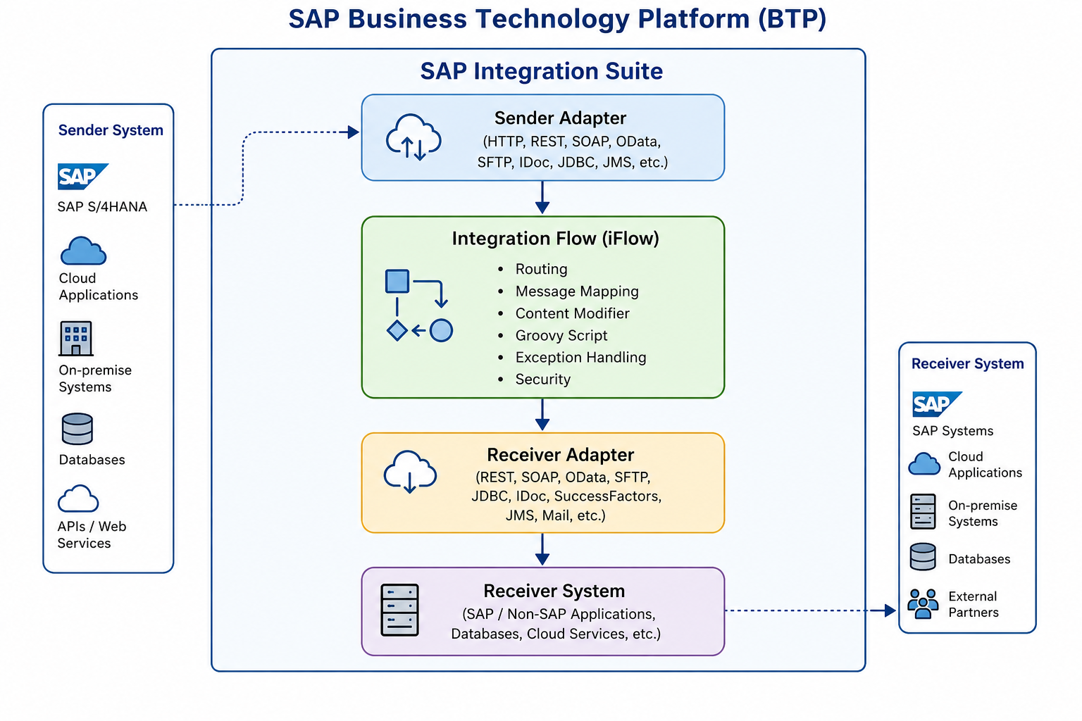
The SAP BTP IS/CPI architecture provides a flexible and scalable framework for integrating enterprise applications. By using adapters, integration flows, message transformation, and secure communication mechanisms, organizations can connect diverse systems efficiently while ensuring data integrity, reliability, and high performance. Its centralized architecture simplifies enterprise integration and supports modern cloud, hybrid, and on-premise integration scenarios.

6. Components of SAP Integration Suite

Overview
SAP Integration Suite is a comprehensive integration platform that provides a collection of services for connecting applications, data, processes, APIs, and business partners. These services enable organizations to integrate SAP and non-SAP systems, automate business processes, and securely exchange information across cloud and on-premise environments.
The major components of SAP Integration Suite are described below.

1. Cloud Integration
Cloud Integration is the core component of SAP Integration Suite. It enables developers to design, develop, deploy, and monitor integration scenarios between various enterprise applications.
Using a graphical development environment, developers can create Integration Flows (iFlows) that define how data moves from a sender system to a receiver system. Cloud Integration supports message routing, transformation, validation, exception handling, and secure communication.
Key Features:
- Graphical iFlow development
- Support for SAP and non-SAP applications
- Message mapping and transformation
- Large collection of communication adapters
- Monitoring and error handling
- Secure data transmission

2. API Management
API Management enables organizations to create, publish, secure, monitor, and manage Application Programming Interfaces (APIs). It allows businesses to expose backend services to internal developers, external partners, or customers while maintaining security and governance.
API Management also provides traffic control, authentication, analytics, and version management, ensuring reliable API usage across enterprise applications.
Key Features:
- API creation and publishing
- API security using OAuth and API keys
- Traffic management and rate limiting
- API monitoring and analytics
- Version control and lifecycle management

3. Integration Advisor
Integration Advisor simplifies business-to-business (B2B) integration by providing intelligent tools for creating message mappings and business document guidelines.
It uses machine learning and predefined industry standards to reduce manual effort when integrating business documents such as invoices, purchase orders, and shipping notifications.
Key Features:
- Intelligent message mapping
- Support for EDI standards
- Business document validation
- Reusable mapping templates
- Faster B2B integration development

4. Open Connectors
Open Connectors provides pre-built connectors for integrating SAP applications with popular third-party cloud applications. Instead of developing custom integrations, organizations can use these ready-made connectors to communicate with external platforms.
Examples include Salesforce, Microsoft Dynamics, ServiceNow, Dropbox, Slack, HubSpot, and many other cloud services.
Key Features:
- Hundreds of pre-built connectors
- Standardized REST APIs
- Simplified third-party integration
- Reduced development effort
- Unified authentication and connectivity

5. Event Mesh
Event Mesh supports event-driven communication between distributed applications. Instead of continuously polling systems for updates, applications publish events whenever important business activities occur.
Other applications subscribed to these events receive notifications instantly, enabling real-time communication and loosely coupled system architecture.
Examples include:
- Order created
- Invoice generated
- Product updated
- Customer registered
Key Features:
- Asynchronous messaging
- Publish/Subscribe model
- Event-driven architecture
- Reliable message delivery
- High scalability

Benefits of SAP Integration Suite Components
Each component contributes to enterprise integration in different ways:
- Cloud Integration enables seamless application and data integration.
- API Management provides secure API exposure and governance.
- Integration Advisor accelerates B2B and EDI integrations.
- Open Connectors simplify integration with third-party cloud applications.
- Event Mesh enables real-time, event-driven communication between systems.
Together, these components help organizations build scalable, secure, and efficient integration solutions while reducing development effort and improving business agility.

Summary
SAP Integration Suite combines multiple integration capabilities into a single cloud platform. Each component addresses a specific integration requirement, whether it is connecting applications, managing APIs, integrating business documents, connecting external cloud services, or enabling event-driven communication. By using these components together, organizations can create flexible, reliable, and future-ready integration landscapes that support modern business processes.

7. Features and Benefits of SAP Integration Suite (SAP IS/CPI)

Overview
SAP Integration Suite provides a comprehensive set of tools and services that enable organizations to connect applications, automate business processes, and securely exchange data across different systems. Its cloud-based architecture, extensive connectivity options, and enterprise-grade security make it a reliable integration platform for businesses of all sizes.

Key Features of SAP Integration Suite

1. Cloud-Based Integration Platform
SAP Integration Suite is a fully managed cloud service available on SAP Business Technology Platform (SAP BTP). Organizations can build and deploy integration solutions without maintaining on-premise infrastructure, reducing hardware and maintenance costs.

2. Seamless Application Integration
The platform enables seamless integration between SAP and non-SAP applications, cloud services, on-premise systems, databases, and third-party platforms. This allows businesses to maintain consistent data across multiple enterprise applications.

3. Extensive Adapter Library
SAP Integration Suite provides a wide range of pre-built adapters for different communication protocols and applications, including:
- HTTP
- REST
- SOAP
- OData
- SFTP
- JDBC
- IDoc
- JMS
- SuccessFactors
- Mail
These adapters simplify connectivity and reduce development effort.

4. Graphical Integration Flow (iFlow) Development
Developers can create integration scenarios using a graphical drag-and-drop interface. Integration Flows (iFlows) define how data is received, processed, transformed, and delivered between systems, minimizing the need for extensive coding.

5. Message Mapping and Transformation
SAP Integration Suite provides powerful message mapping capabilities that allow data to be transformed between different formats such as XML, JSON, CSV, and IDoc. It also supports custom transformations using Groovy scripts for complex business requirements.

6. API Management
The platform enables organizations to create, publish, secure, monitor, and manage APIs. API Management ensures controlled access to backend services while providing analytics and lifecycle management for enterprise APIs.

7. Secure Communication
Security is one of the major strengths of SAP Integration Suite. It supports various authentication and encryption mechanisms, including:
- Basic Authentication
- OAuth 2.0
- Client Certificates
- SSL/TLS Encryption
- Secure Credential Storage
- Role-Based Authorization
These mechanisms help protect sensitive business information during data transmission.

8. Monitoring and Error Handling
SAP Integration Suite includes built-in monitoring tools that allow administrators to track integration flows and identify issues quickly.
Monitoring capabilities include:
- Message Monitoring
- Integration Flow Monitoring
- Error Logs
- Trace Mode
- Retry Mechanisms
- Performance Monitoring
These features help ensure reliable integration operations.

9. Reusable Integration Content
The platform offers pre-packaged integration content and reusable templates that accelerate development and reduce implementation time. Organizations can also create reusable integration artifacts for future projects.

10. Scalability and High Availability
Being a cloud-native platform, SAP Integration Suite automatically scales according to workload demands. It provides high availability and reliable performance for enterprise-level integration scenarios.

Benefits of SAP Integration Suite

Improved Connectivity
SAP Integration Suite connects SAP and non-SAP applications through a single platform, eliminating the need for multiple point-to-point integrations and simplifying enterprise connectivity.

Increased Business Efficiency
By automating data exchange between systems, organizations can reduce manual tasks, minimize errors, and improve overall business productivity.

Faster Development
Graphical development tools, reusable integration packages, and pre-built adapters significantly reduce development time and simplify the creation of integration solutions.

Enhanced Data Consistency
Automatic synchronization of data between multiple business applications ensures that information remains accurate, consistent, and up to date across the organization.

Lower Operational Costs
As a cloud-based platform, SAP Integration Suite reduces infrastructure, maintenance, and operational costs while providing enterprise-grade reliability and security.

Strong Security
Built-in authentication, authorization, encryption, and secure credential management protect sensitive business data during communication between systems.

Easy Monitoring and Maintenance
Centralized monitoring dashboards enable administrators to identify issues quickly, troubleshoot integration errors, and maintain system performance with minimal effort.

Future-Ready Integration Platform
SAP Integration Suite supports modern integration approaches such as API-led connectivity, event-driven architecture, hybrid integration, and cloud-native application development, making it suitable for current and future business requirements.

Summary
SAP Integration Suite combines powerful integration capabilities with enterprise-grade security, scalability, and ease of use. Its comprehensive feature set enables organizations to connect diverse systems, automate business processes, manage APIs, and exchange data securely across cloud and on-premise environments. By reducing development effort, improving operational efficiency, and supporting modern integration architectures, SAP Integration Suite plays a crucial role in accelerating digital transformation and enabling connected enterprise ecosystems.

8.Step-by-Step System Setup

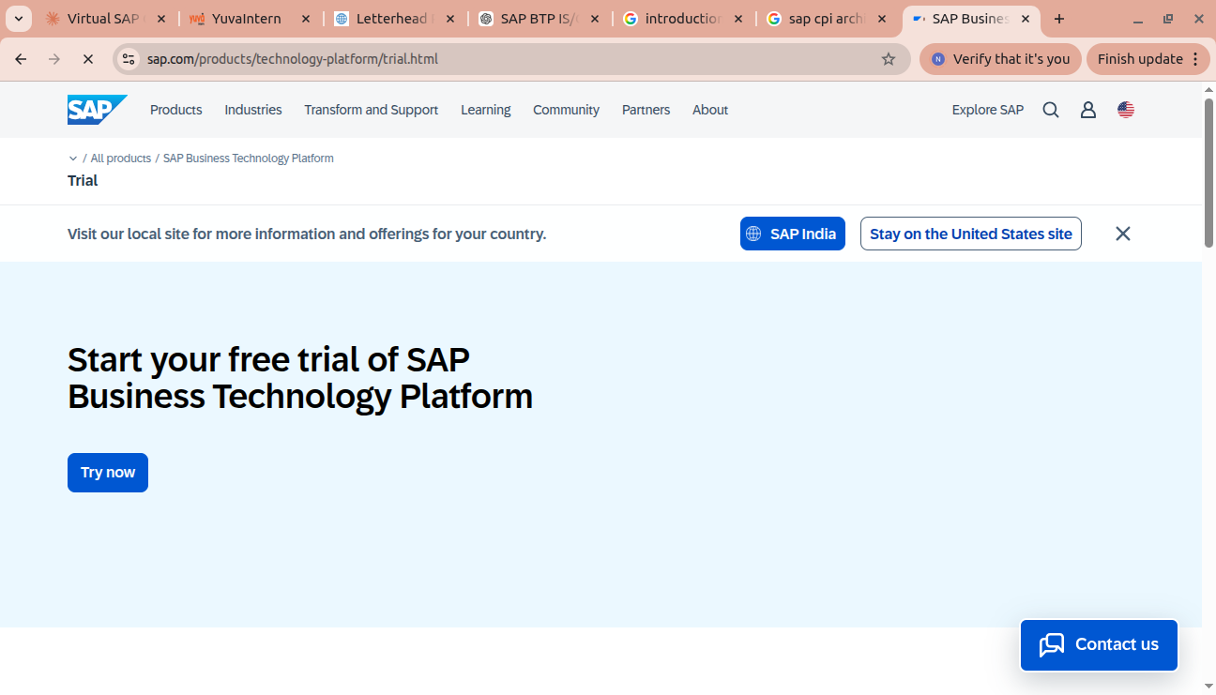

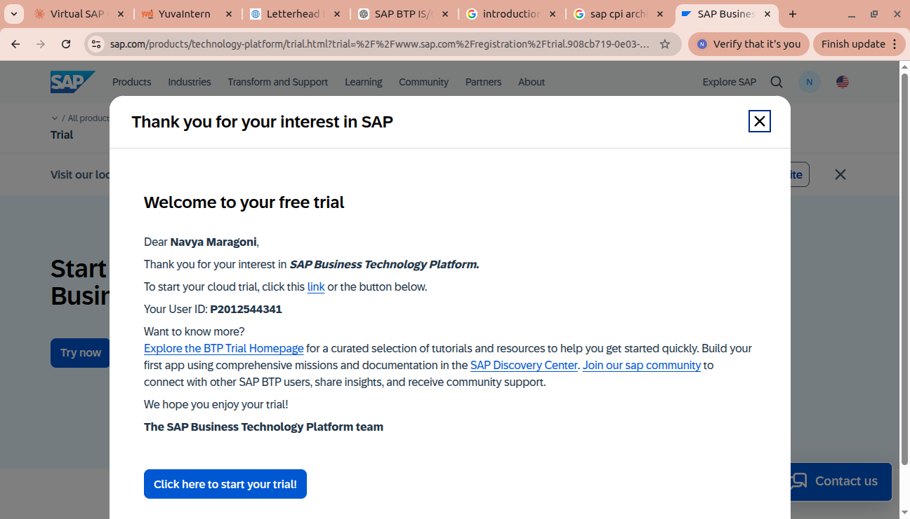

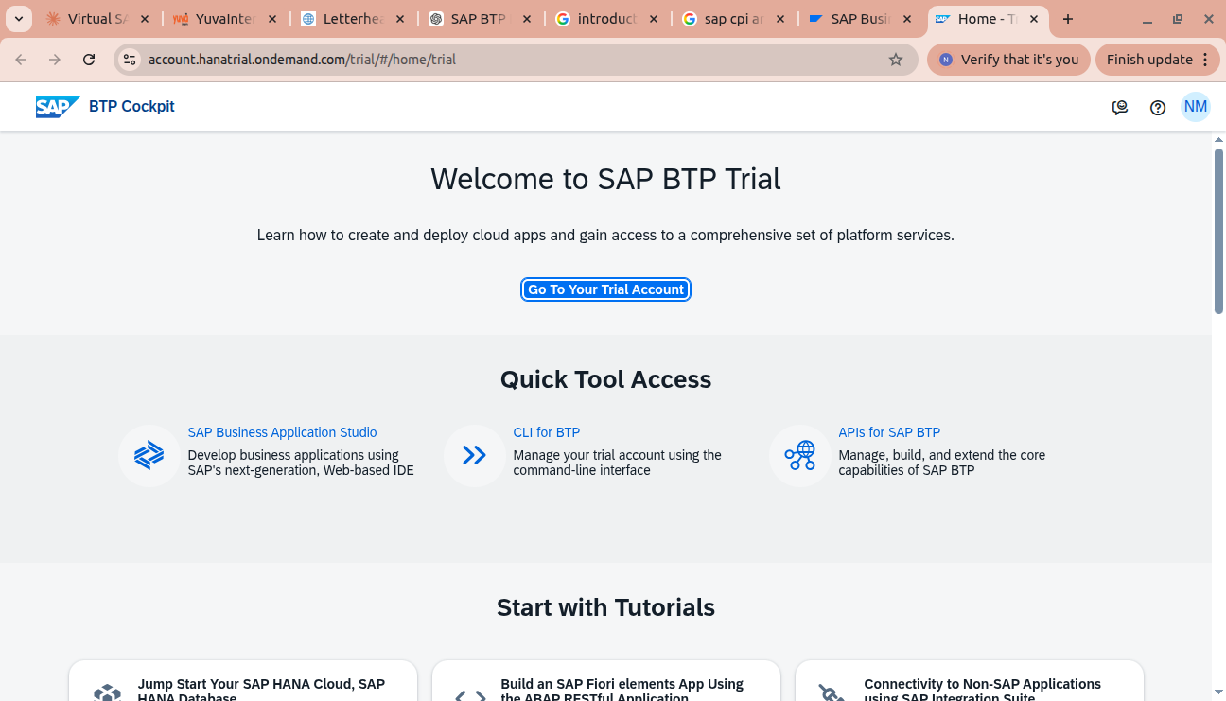

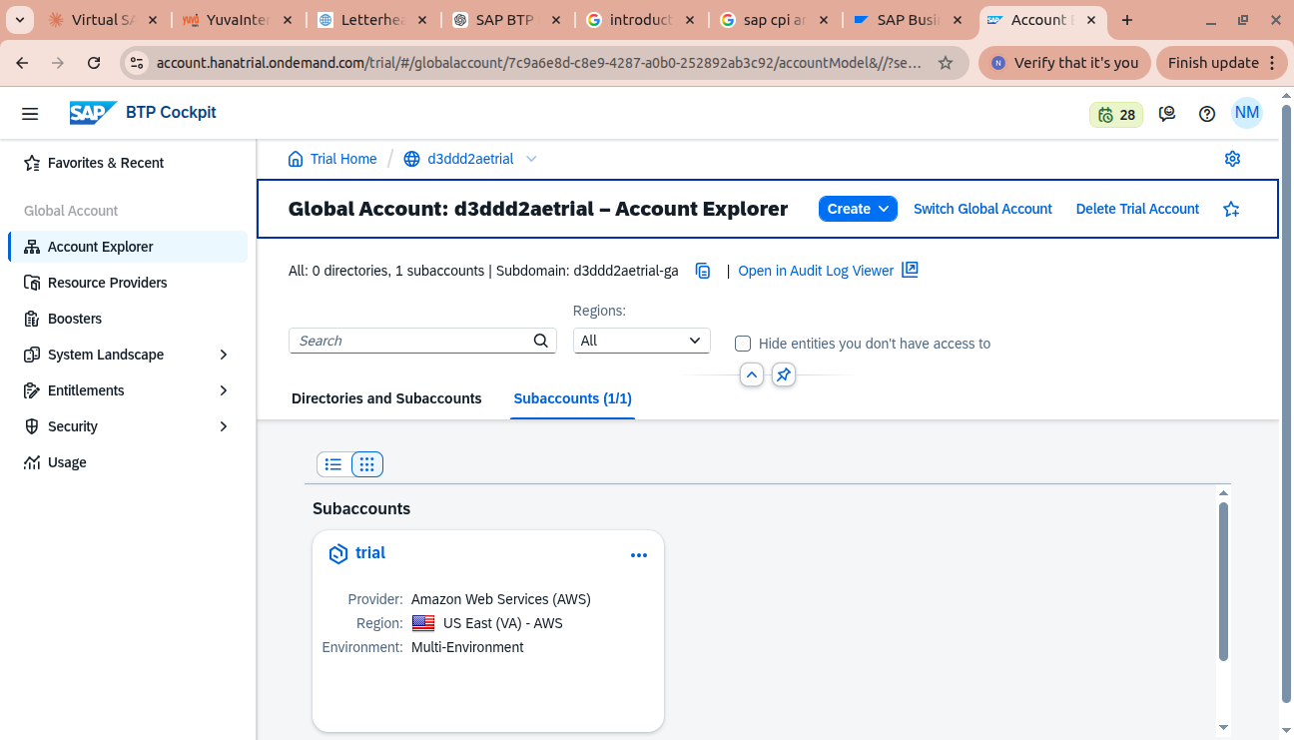

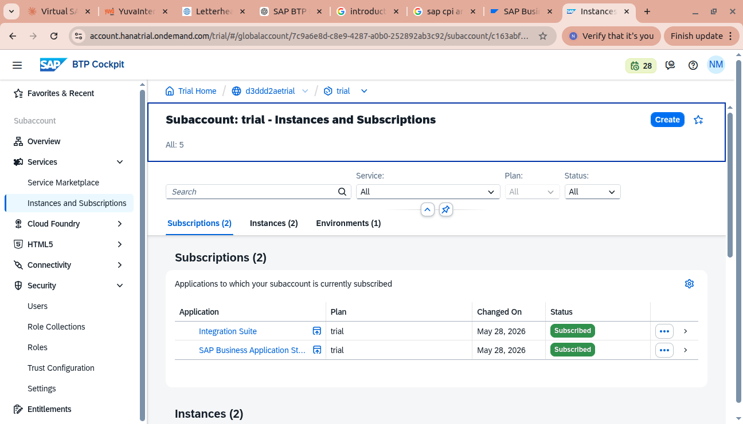

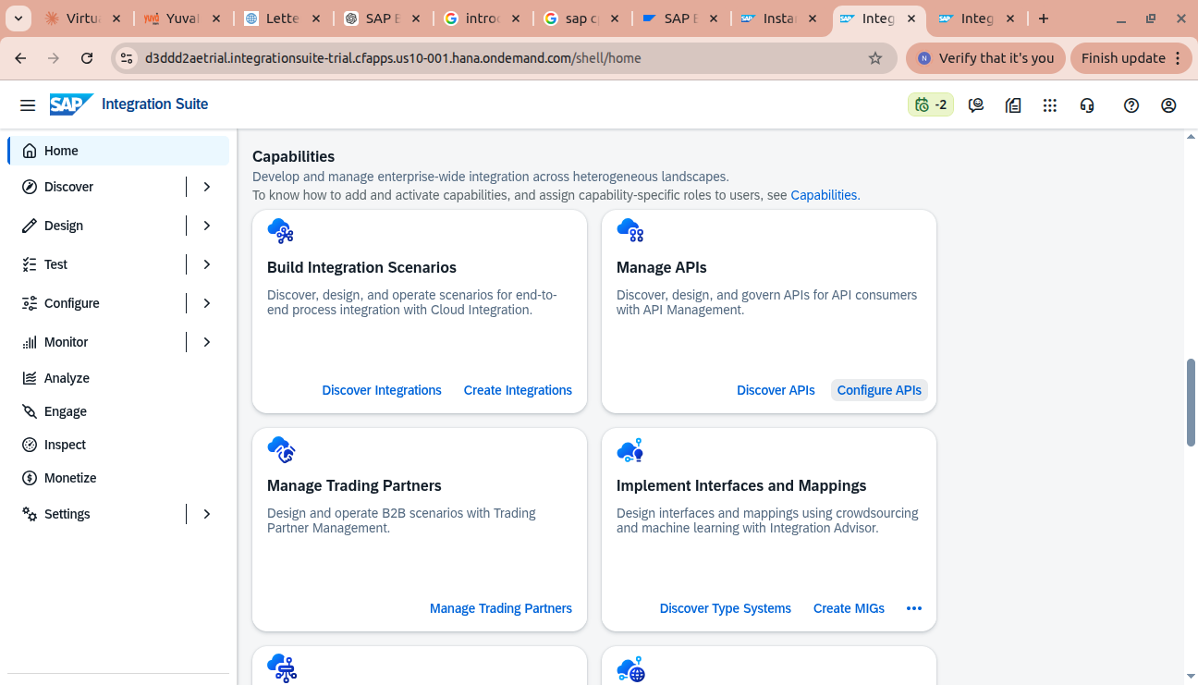

Challenges Faced During System Setup

Challenge 1: Unable to Access SAP BTP Trial After Entering a Registered Email
While attempting to register for the SAP BTP Trial account, I entered a valid and already registered business email address on the SAP Trial registration page. However, after clicking the Next button, the page repeatedly redirected back to the same email entry screen instead of proceeding to the next step of the registration process.
This behavior prevented me from accessing the trial environment even though the email address was valid and previously registered.
Troubleshooting Performed:
- Verified that the email address was correctly entered.
- Confirmed that the email account was already registered with SAP.
- Refreshed the browser and retried the registration process.
- Attempted the process using a different browser and an incognito/private browsing window.
- Cleared the browser cache and cookies to eliminate any session-related issues.
Resolution
The issue appeared to be related to a browser session or SAP Trial portal behavior rather than the email itself. After clearing the browser session and signing in through the SAP Universal ID login page, the registration process proceeded successfully, allowing access to the SAP BTP Trial environment.
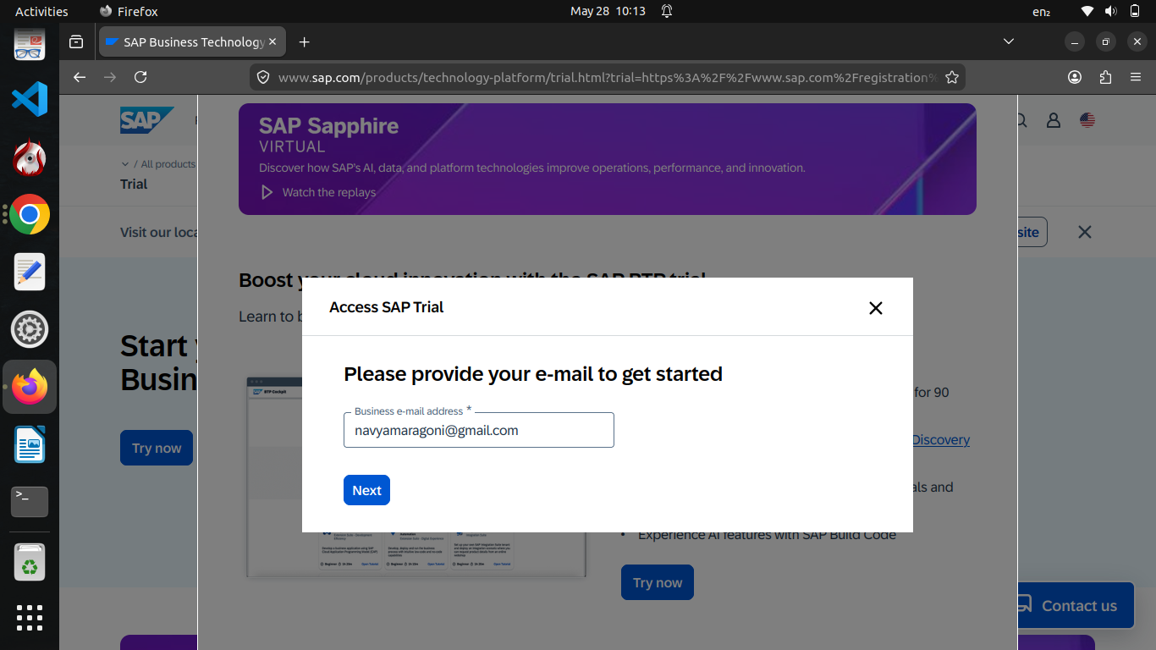
Learning Outcome This experience highlighted the importance of troubleshooting browser-related issues and verifying user sessions when working with cloud-based platforms. It also emphasized that authentication problems may not always be caused by incorrect credentials but can result from cached sessions or portal-specific behavior.

10. Reflection
Completing the SAP BTP Integration Suite (SAP IS/CPI) Basics and System Setup task provided me with a strong understanding of both the theoretical concepts and the practical aspects of enterprise integration. Before this activity, I had a basic understanding of SAP Integration Suite, but working with the platform allowed me to gain deeper insights into how cloud-based integration solutions are developed and managed.
Through this task, I learned about the architecture of SAP Business Technology Platform, the role of SAP Integration Suite in connecting SAP and non-SAP applications, and the importance of SAP Cloud Integration (CPI) in enabling secure and reliable communication between enterprise systems. I also explored the major components of SAP Integration Suite, including Cloud Integration, API Management, Integration Advisor, Open Connectors, and Event Mesh, and understood how each component contributes to modern enterprise integration.
The practical setup of the SAP BTP Trial environment helped me understand the account hierarchy, including Global Accounts, Subaccounts, service subscriptions, and role assignments. Documenting each step with screenshots improved my understanding of the platform configuration process and highlighted the importance of careful system administration during initial setup.
During the setup process, I encountered a registration issue where the SAP Trial portal repeatedly redirected me to the email registration page despite using a valid and registered email address. Troubleshooting this issue helped me understand that cloud platform setup may involve browser sessions, authentication, and portal-related factors in addition to configuration steps. Resolving such issues strengthened my problem-solving skills and emphasized the importance of systematic troubleshooting.
Overall, this task enhanced both my technical knowledge and practical experience with SAP BTP Integration Suite. It provided a solid foundation for learning advanced SAP Cloud Integration concepts such as designing Integration Flows (iFlows), working with adapters, message mapping, API integration, security configurations, and monitoring integration processes. The knowledge gained from this exercise will be valuable for future projects involving enterprise application integration and cloud-based business solutions.

11. Conclusion
SAP Business Technology Platform (SAP BTP) and SAP Integration Suite provide a robust and scalable platform for integrating enterprise applications, automating business processes, and enabling secure communication between SAP and non-SAP systems. Through this study, I gained a comprehensive understanding of the architecture, components, features, and benefits of SAP Integration Suite, as well as the role of SAP Cloud Integration (CPI) in modern enterprise integration.
The practical system setup provided valuable hands-on experience in configuring a SAP BTP Trial environment and familiarized me with the essential steps involved in accessing and using SAP Integration Suite. Although minor challenges were encountered during the setup process, they were addressed through systematic troubleshooting, enhancing my understanding of cloud platform configuration and user authentication.
Overall, this task strengthened my knowledge of enterprise integration concepts and provided a solid foundation for working with SAP Cloud Integration. The experience gained from this activity will be beneficial for developing, deploying, and managing integration solutions in real-world business environments. It also prepares me for exploring advanced SAP Integration Suite capabilities such as integration flow development, API management, message transformation, and cloud-based application integration in future learning and professional projects.

