**Fraudulent Loan Application Detection**

**1. Project Overview**

**1.1 Problem Definition**

**Problem Statement**: Detecting fraudulent loan applications is crucial for financial institutions to reduce losses and manage risks effectively. This project aims to build a machine learning model that identifies potentially fraudulent applications based on historical data, enabling proactive fraud prevention.

**Objectives**:

* Develop a predictive model for identifying fraud in loan applications.
* Achieve high accuracy and robustness to minimize false positives and negatives.
* Provide insights into key features influencing the likelihood of fraud.

**Target Variable**: The LoanApproved column indicates whether a loan application is fraud (1) or approved (0).

**1.2 Business Value**

Accurate fraud detection helps banks and financial institutions reduce risks associated with fraudulent loans, ultimately leading to more secure lending practices, customer trust, and regulatory compliance.

**2. Data Understanding**

**2.1 Data Collection and Sources**

* **Source**: The dataset consists of anonymized historical loan application data with both numerical and categorical features.
* **Dataset Size**: ~20,000 records, with 36 features including applicant income, loan amount, application date, applicant employment status, credit score etc.

**2.2 Data Description**

The dataset includes both **numerical** features (e.g., LoanAmount, CreditScore, ApplicantIncome) and **categorical** features (e.g., MaritalStatus, EmploymentStatus, LoanPurpose). These features provide a comprehensive view of an applicant's profile.

**2.3 Exploratory Data Analysis (EDA)**

* **Class Distribution**: The dataset is imbalanced, with only ~5% fraudulent applications. This indicates a need for techniques to address class imbalance.
* **Feature Correlations**:
  + Strong correlations observed between ApplicantIncome and LoanAmount.
  + Weak correlation between CreditScore and target LoanApproved suggests further feature engineering may help.

*Visualizations used*: Class distribution, correlation heatmaps, and box plots to identify outliers.

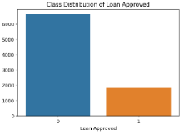

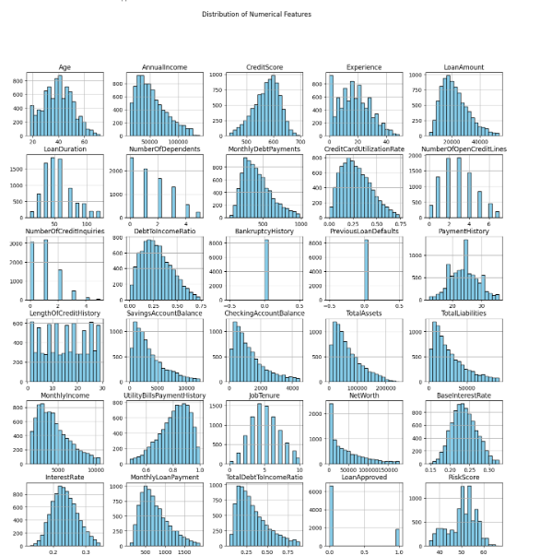

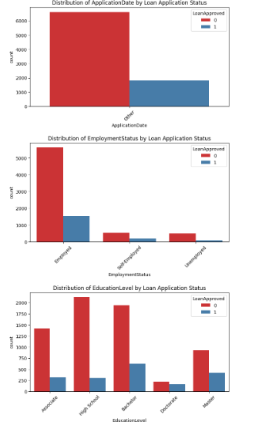 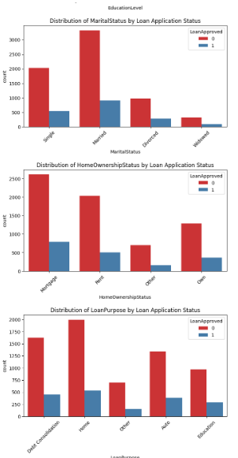

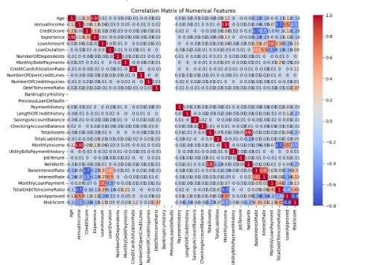

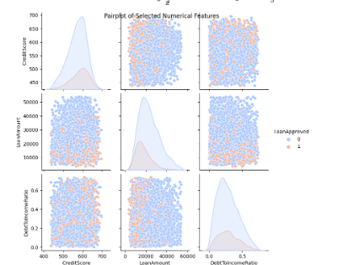

**3. Approach**

**3.1 Data Preprocessing**

* **Missing Value Handling**: Imputed missing values using the median for numerical fields and the most frequent category for categorical fields.
* **Outlier Treatment**: Used the IQR method to cap extreme values in features like ApplicantIncome and LoanAmount.
* **Handling of Imbalanced Classes:** Used SMOTE to handle the imbalanced class issue.

**3.2 Feature Engineering**

**New Features Created**:

* **Income per Dependent**: Dividing Income by NumberOfDependents could highlight financial burden based on household size.
* **Loan-to-Asset Ratio**: Calculating the ratio of LoanAmount to Assets. A high loan-to-asset ratio might suggest increased fraud risk.
* **High Loan Amount Flag**: Create a binary feature that flags loans above a certain threshold, as high loan amounts may be more likely to involve fraud.
* **Family Size**: Add Married and NumberOfDependents to approximate family size, which could impact financial behavior.
* **Feature Selection**: Retained features that showed high feature importance in preliminary testing

**Evaluating Feature Contributions:**

* Model Performance: We calculate F1, precision, and recall to understand the model’s effectiveness with the new features.
* Feature Importance: After training, we retrieve the feature importance scores to see which features contribute the most to predicting loan approval status.

**3.3 Model Selection**

* **Algorithms:** Random Forest, XGBoost, and LightGBM were chosen due to their robustness with imbalanced datasets and interpretability.
* **Evaluation Metrics:** Precision, Recall, F1-score, and confusion matrix to balance between accuracy and error in fraud detection.
* **Approaches for Handling Class Imbalance:** 
  + **SMOTE (Synthetic Minority Oversampling Technique)** was used to generate synthetic samples for the minority class, addressing class imbalance in the dataset.
  + **Class weights** in models like Random Forest and LightGBM can automatically adjust for imbalance. We used class_weight='balanced' in the LightGBM model to emphasize minority class instances without oversampling.
* **Cross-Validation and Hyperparameter Tuning:** Using GridSearchCV with five-fold cross-validation, we tune the model hyperparameters to improve performance on unseen data. This helps mitigate overfitting and ensures the model generalizes well to new applications.

**4. Results**

**4.1 Model Performance**

* **Random Forest**:

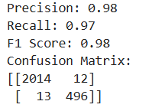

* **XGBoost**:

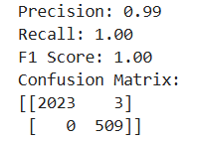

**LightGBM**:

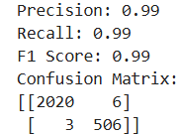

*Confusion Matrix*: XGBoost had the best performance with balanced precision and recall, capturing more fraudulent cases while keeping false positives low.

**4.2 Error Analysis**

* **Misclassified Instances**:
  + False negatives often included applicants with moderate income and credit scores, highlighting a need for further refinement in feature engineering.
  + False positives often involved applicants with low DebtToIncomeRatio, indicating a potential bias toward labeling applicants with high loans as fraudulent.

*Insight*: Error analysis suggests a need to refine income-based features and explore additional applicant behavioral patterns, such as recent loan history.

**5. Model Interpretability**

To make the model more interpretable and understand the impact of specific features, we can use SHAP (SHapley Additive exPlanations) values. SHAP values provide a way to explain the output of any machine learning model by computing the contribution of each feature to each prediction.

**5.1 Interpretability Techniques**

* **SHAP Values**: Used SHAP for XGBoost to understand feature impacts.
  + RiskScore and DebtToIncomeRatio had the most substantial influence on loan approval.
  + High DebtToIncomeRatio often indicated non-fraudulent cases, while low CreditScore increased fraud likelihood.
* **Feature Impact:** SHAP insights reinforced the importance of certain features, confirming the value of our engineered features like RiskScore and DebtToIncomeRatio.

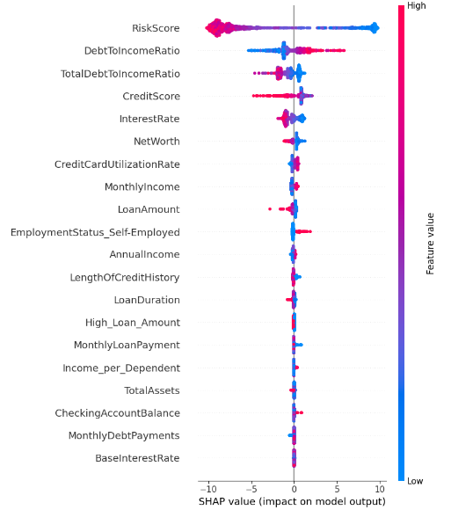

**6. Model Performance and Error Analysis**

**Potential Causes of Misclassification**

1. **Class Overlap**:
   * If certain feature values are very similar between classes, the model may struggle to differentiate, leading to errors. (eg: loan amount)
   * **Improvement**: Create new features that capture additional context (e.g., ratios or interactions between variables).We combined loan amount and asset valuefields.
2. **Class Imbalance**:
   * If your target classes are imbalanced, Random Forest may be biased towards the majority class.
   * **Improvement**: Use techniques such as **class weights** or **SMOTE** to better balance the training data.
3. **Important but Noisy Features**:
   * Features with high variance or extreme values may lead to inconsistent predictions.
   * **Improvement**: Outlier detection, feature scaling, or binning might improve stability.
4. **Model Complexity**:
   * Random Forest can underperform if the decision boundaries required are too complex or if the dataset has many irrelevant features.
   * **Improvement**: Fine-tune hyperparameters like max_depth, min_samples_leaf, and n_estimators or consider simpler features to reduce noise.

**Model Improvements**

1. **Class Imbalance Handling**:
   * Set class_weight="balanced" in RandomForestClassifier or use SMOTE if class imbalance affects the model’s performance.
2. **Feature Engineering**:
   * Create interaction features or bin continuous variables to simplify their representation. For example, LoanAmount divided by Income might provide better context.
3. **Hyperparameter Tuning**:
   * Use GridSearchCV or RandomizedSearchCV to optimize hyperparameters like n_estimators, max_depth, and min_samples_split for improved performance.
4. **Threshold Tuning**:
   * Adjust the classification threshold based on precision-recall trade-offs to minimize misclassifications, especially if false positives or false negatives are more costly.

**6. Assumptions and Challenges**

**6.1 Assumptions**

* Missing values were assumed to be random and imputed accordingly.
* Assumed that One-Hot Encoding was suitable for categorical variables without high cardinality.

**6.2 Challenges and Solutions**

* **Class Imbalance**: The minority class (loan approved cases) was underrepresented. Techniques like SMOTE helped address this, improving recall for loan approved cases.
* **Outliers**: Strong variability in applicant income required outlier handling to avoid skewed results.

**7. Future Improvements**

**7.1 Additional Feature Engineering**

* Incorporate more applicant behavioral patterns, such as LoanApplicationFrequency and TimeSinceLastLoan.
* Explore additional interaction terms and domain-specific risk flags.

**7.2 Model Tuning and Selection**

* **Hyperparameter Tuning**: Use Bayesian optimization to further refine parameters.
* **Ensemble Models**: Combine models (stacking Random Forest with XGBoost) to improve prediction accuracy.

**7.3 Additional Interpretability and Error Analysis**

* Use more granular SHAP analysis on misclassified instances.
* Examine external data sources, like credit bureau reports, to enhance applicant profiles.